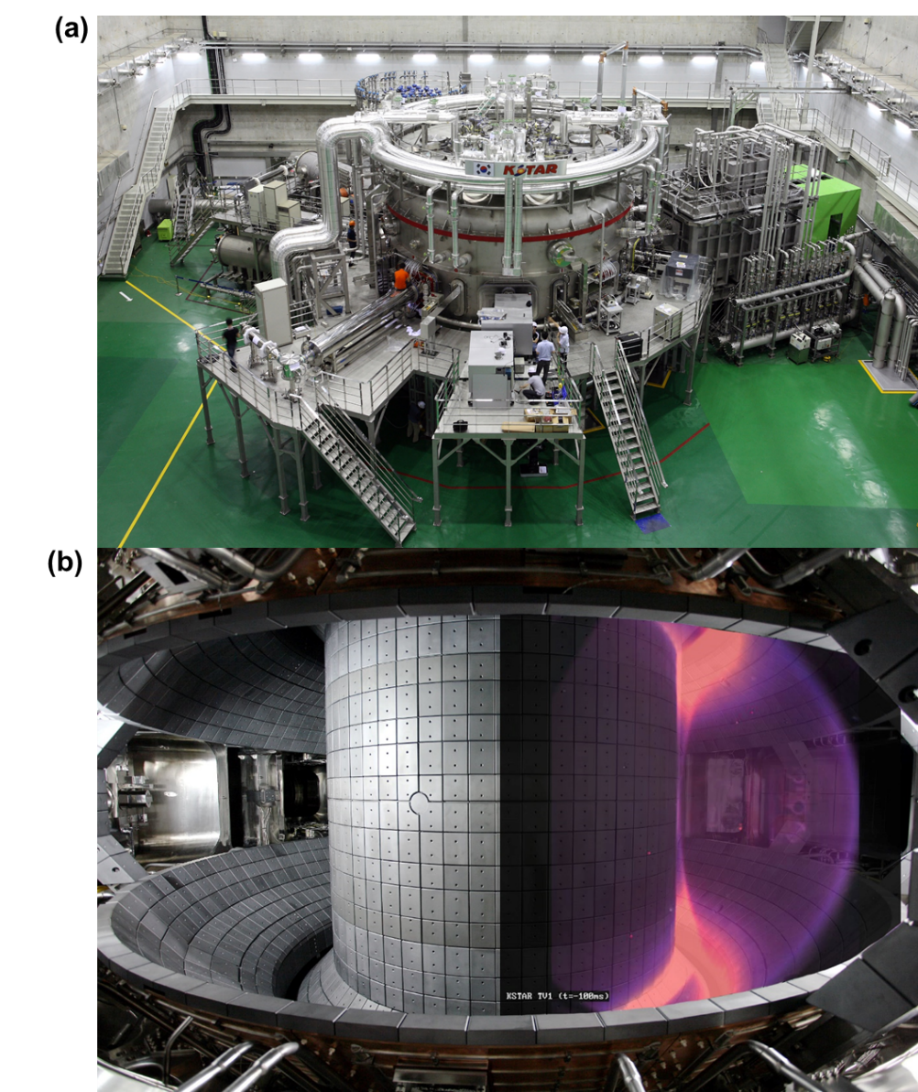
Extended Fig. 1. (a) The Korean Superconducting Tokamak Advanced Research (KSTAR) device at KFE, Republic of Korea. (b) The fusion plasmas confined in KSTAR.

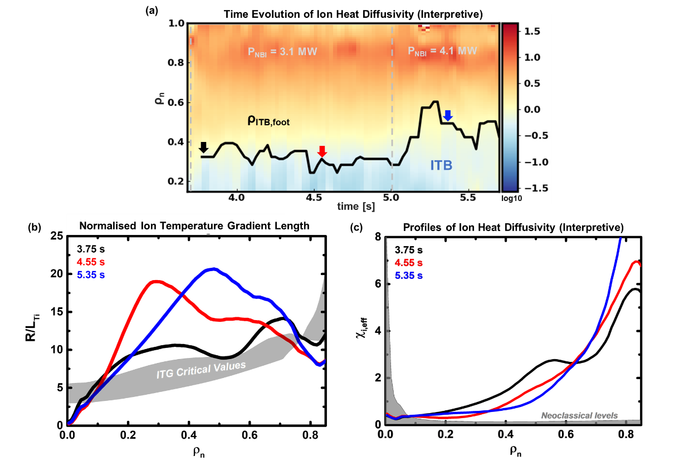Extended Extended Fig. 2. The ITB characteristics of FIRE mode (shot 22663); (a) Time evolution of the thermal ion heat diffusivity in ρ_{n} calculated from power balance analysis, which represents the transport of thermal ion’s energy. They are calculated with TRIASSIC incorporating NUBEAM, NCLASS, and ASTRA. The normalised ion temperature gradient length profile (b) and the thermal ion heat diffusivity profile (c) calculated from the power balance analysis at 3.75 s, 4.55 s, and 5.35 s. The black, red, and blue curves correspond to the time points indicated by arrows in (a). The ITG critical values and the neoclassical heat diffusivity are presented in gray in (b)

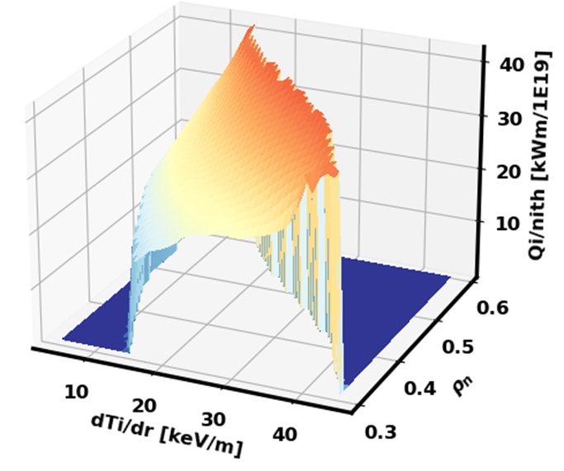
Extended Fig. 3. The ITB characteristics of FIRE mode (shot 22663); “S-curve” in the 3-D landscape of the flux-gradient space. The normalised ion energy flux to the thermal ion density versus the ion temperature gradient are plotted for $ρ_{n}$ = 0.3, 0.4, 0.5, and 0.6 from 3.7 s to 5.7 s. The transport bifurcation occurs at $ρ_{n}\sim 0.3$ where the ITB foot locates when the ITB was formed.

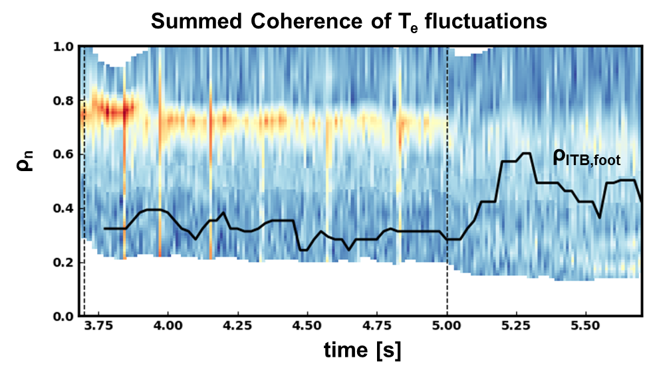
Extended Fig. 4. The ITB characteristics of FIRE mode (shot 22663); the fluctuation of the electron temperature measured by Electron Cyclotron Emission Imaging (ECEI). The coherence between poloidally adjacent channels near Z = 0 m is summed over frequency 0-250 kHz to represent the amplitude of turbulence. $ρ_{ITB,foot}$ is plotted in the black line to show the time evolution of the ITB region. As ITB expands outwards to $ρ_{n}$~0.6, the edge fluctuations are significantly reduced. The black dashed line indicates the NBI heating timings.

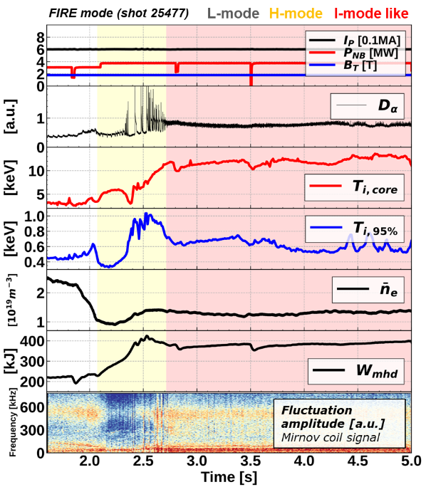
Extended Fig. 5. The time evolution of main parameters of a FIRE mode from L-mode to an I-mode like edge via H-mode. A strong weakly coherent modes are observed in the I-mode like phase in the magnetic fluctuation detected by Mirnov coils. The ion temperature close to the edge (T_{i,95%}) in I-mode like phase is increased compared with the L-mode phase which could imply the formation of an ETB.

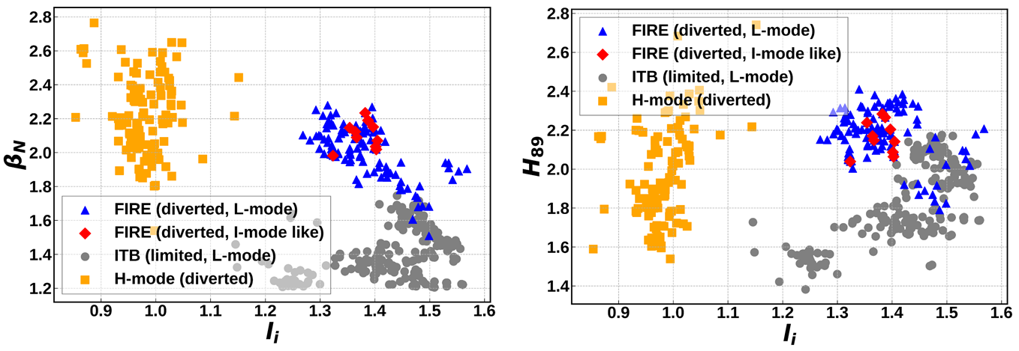
Extended Fig. 6. The stationary operation regime in terms of normalized plasma pressure to magnetic pressure β_{N}, confinement enhancement factor H₈₉ and internal inductance l_{i}. They are calculated with magnetic EFIT. Yellow squares present H-modes including hybrid modes. Gray circles are conventional ITB discharges with the limited configuration and blue triangles are FIRE modes with the L-mode edge at the diverted configuration. Red diamonds present FIRE modes with the I-mode like edge at the diverted configuration.

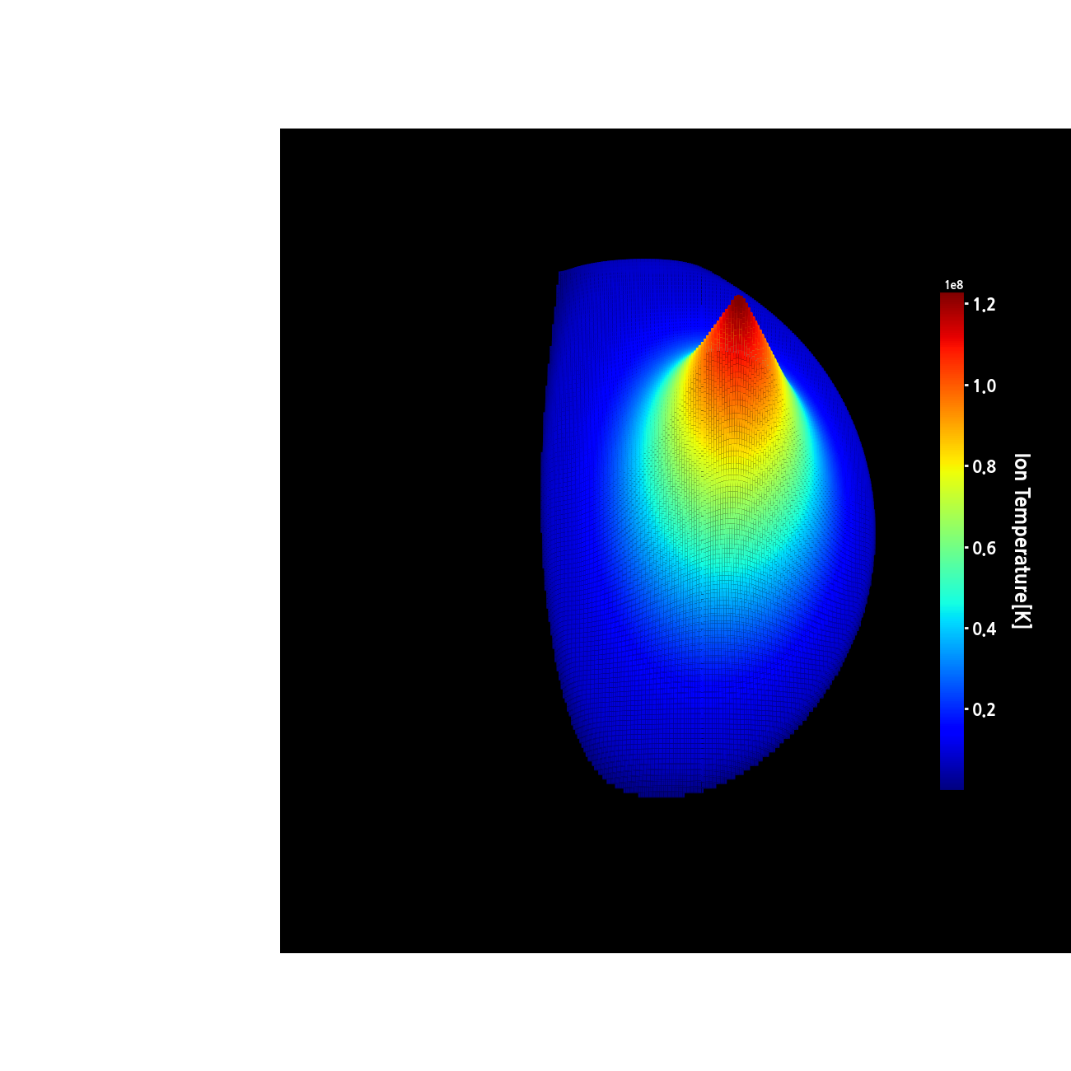
Extended Movie 1. Ion temperature (3-D) from the CES diagnostic in FIRE mode (shot 25860) presented in Fig. 1. Visible CES, ECE, TS, and Mirnov coil measurements are transformed into the audible sound so that one can diagnose the plasma via the sound. An outstanding sound around 6 s corresponds to the plasma instability.

