Non-linear associations of plasma 25-hydroxyvitamin D with serum homocysteine and hyperhomocysteinemia in Chinese adults: a cross-sectional study
Jinghan Yang^{1,2}, Qiang Dai³, Jiaxing Ke^{1,2}, Feng Peng^{1,2}, Dajun Chai^{1,2}, Fangfang Fan⁴, Ping Li⁵, Xinzheng Lu⁶, Yan Zhang⁷, Jingang Yang⁸, Ningling Sun⁹, Xianhui Qin¹⁰, Jianping Li¹¹, Hanping Shi^{12,13,14,#}, Jinxiu Lin^{1,2,#}
¹ Department of Cardiology, the First Affiliated Hospital, Fujian Medical University, Fuzhou 350005, China;
² The Higher Educational Key Laboratory for Cardiovascular Disease of Fujian Province, Clinical Research Center for Metabolic Heart Disease of Fujian Province;
³ Yinjiang Autonomous County Health Bureau, Tongren City, Guizhou Province, China.
⁴ Department of Cardiovascular Disease, Peking University First Hospital, Beijing 100034, China;
⁵ Department of Cardiovascular Medicine, The Second Affiliated Hospital, Jiangxi Medical College, Nanchang University, Nanchang, Jiangxi, China;
⁶ Department of Cardiology, First Affiliated Hospital, Nanjing Medical University, Nanjing, China;
⁷ Department of Cardiology, Peking University First Hospital, Beijing, China;
⁸ Coronary Heart Disease Center, Department of Cardiology, Fuwai Hospital, National Center for Cardiovascular Diseases, Chinese Academy of Medical Science and Peking Union Medical College, Beijing, China;
⁹ Department of Hypertension at Heart Center, Peking University People's Hospital, Beijing, China;
¹⁰Division of Nephrology, Nanfang Hospital, Southern Medical University, Guangzhou, China, National Clinical Research Center for Kidney Disease, Guangzhou, China;
¹¹ Department of Cardiology, Peking University First Hospital, Beijing 100871, China;
¹² Department of Gastrointestinal Surgery/Clinical Nutrition, Capital Medical University Affiliated Beijing Shijitan Hospital, Beijing, China;
¹³Beijing International Science and Technology Cooperation Base for Cancer Metabolism and Nutrition, Haidian District, Beijing, China;
¹⁴Key Laboratory of Cancer FSMP for State Market Regulation, Haidian District, Beijing, China.
* Correspondence:
Jinxiu Lin, 20 Cha-Zhong Road, Fuzhou City 350004, Fujian Province, China; Tel: (+86) 13950393026; Email: linjinxiu1965@126.com
Hanping Shi, No. 10, Tieyi Road, Yangfangdian, Haidian District 100038, Beijing; Email: shihp@ccmu.edu.cn
Supplementary Figures
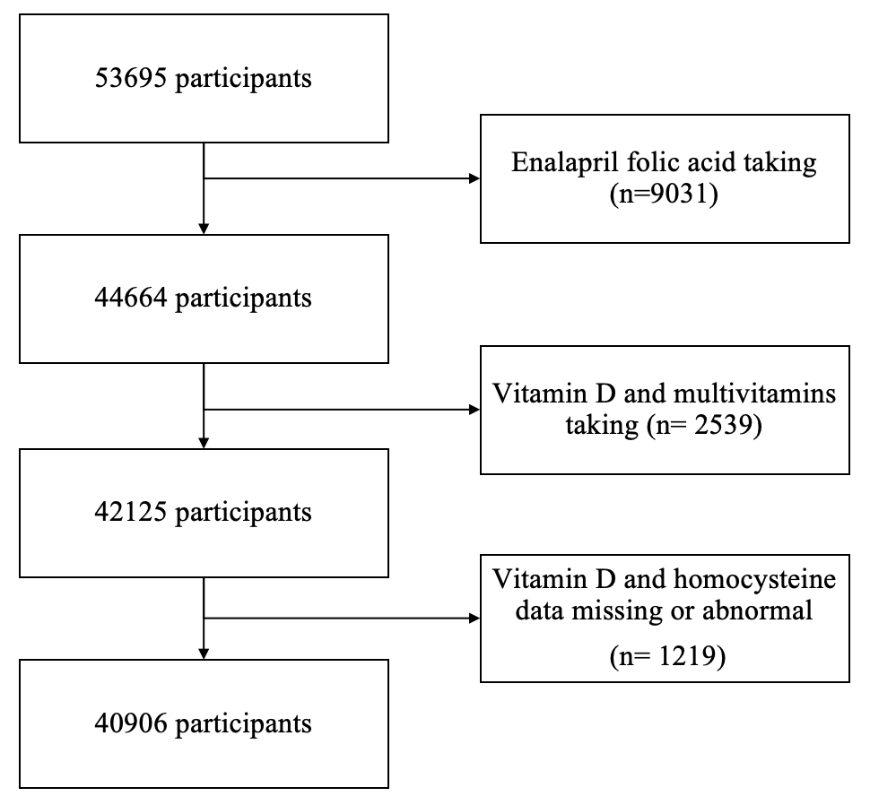
Figure S1. Flowchart

Figure S2. Density map of plasma 25(OH)D and Serum Hcy by gender. Notes: 25(OH)D, 25-hydroxyvitamin D; Hcy, Homocysteine

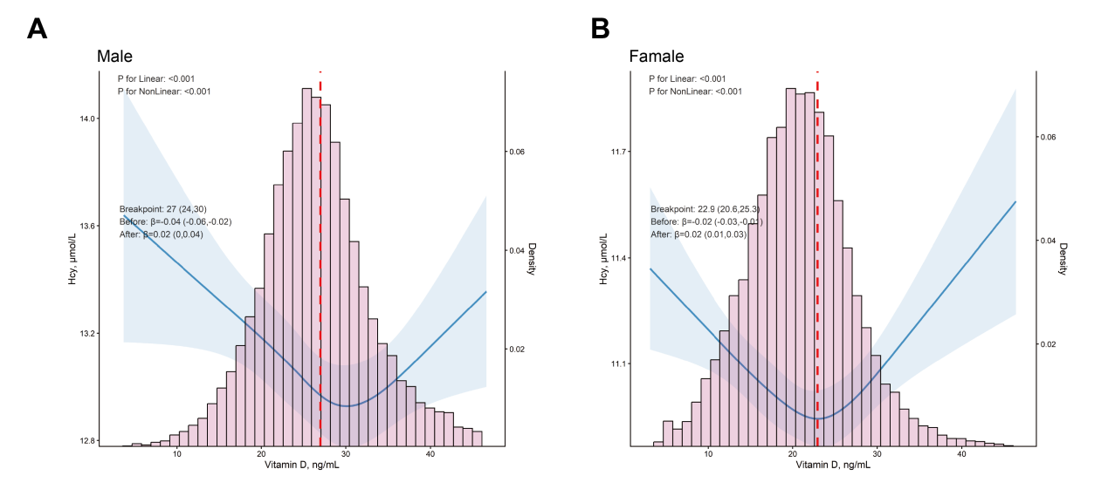
Figure S3. RCS Curve for plasma 25(OH)D and Serum Hcy in Males and Females
Notes: 25(OH)D, 25-hydroxyvitamin D; Hcy, Homocysteinemia

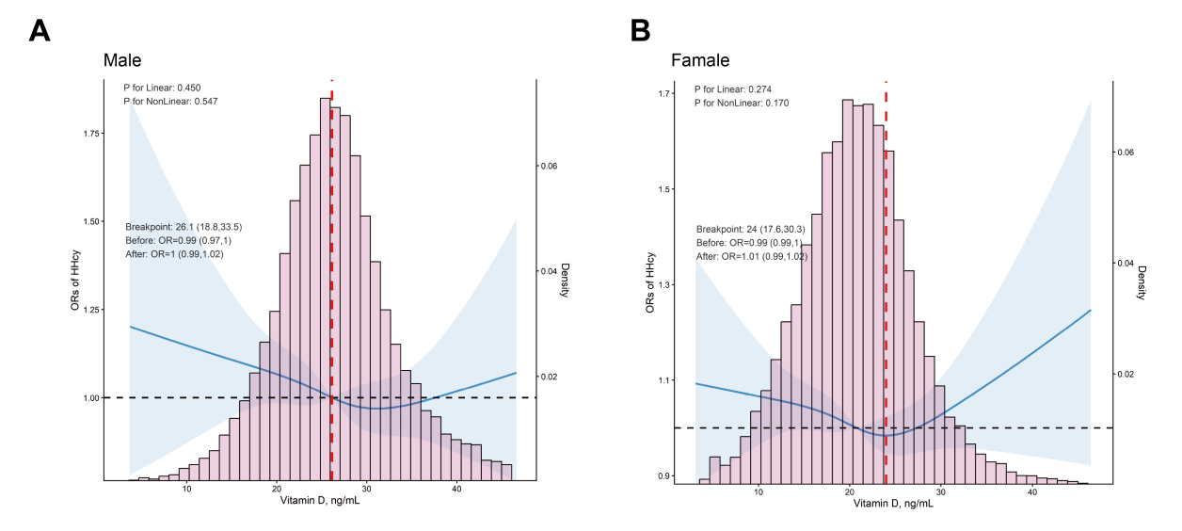
Figure S4. RCS Curve for Plasma 25(OH)D and Serum HHcy in Males and Females
Notes: 25(OH)D, 25-hydroxyvitamin D; HHcy, Hyperhomocysteinemia

Supplementary Tables
Table S1. Sensitivity analysis of Multiple Linear Regression Model for plasma 25(OH)D and serum Hcy
 |  |  |  |  | Adjusted model
25(OH)D | N | Hcy | Crude model |  | Model 1 |  | Model 2 |  | Model 3
(ng/ml) |  | median  (IQR) | beta  (95%CI) | P | beta  (95%CI) | P | beta  (95%CI) | P | beta  (95%CI) | P
Continuous | 43324 | 11.3(9.6-13.5) | 0.07(0.07,0.07) | <0.001 | -0.01(-0.01,-0.00) | 0.026 | -0.01(-0.01,-0.00) | <0.001 | -0.01(-0.01,-0.00) | 0.020
Quintiles
Q4 (24.3~28.1) | 8659 | 11.5(9.8-13.7) | ref |  | ref |  | ref |  | ref
Q1 (<17.3) | 8665 | 10.7(9.1-12.8) | -0.81(-0.91,-0.71) | <0.001 | 0.24(0.15,0.34) | <0.001 | 0.24(0.14,0.34) | <0.001 | 0.20(0.10,0.29) | <0.001
Q2 (17.3~21.1) | 8665 | 11(9.4-13.1) | -0.55(-0.65,-0.45) | <0.001 | 0.18(0.08,0.27) | <0.001 | 0.19(0.09,0.29) | <0.001 | 0.17(0.07,0.26) | <0.001
Q3 (21.1~24.3) | 8663 | 11.3(9.6-13.3) | -0.30(-0.40,-0.19) | <0.001 | 0.09(-0.00,0.19) | 0.057 | 0.10(0.00,0.19) | 0.043 | 0.10(0.00,0.19) | 0.039
Q5 (≥28.1) | 8672 | 12.1(10.2-14.5) | 0.60(0.50,0.70) | <0.001 | 0.18(0.09,0.28) | <0.001 | 0.11(0.01,0.21) | 0.026 | 0.14(0.04,0.23) | 0.004
P for trend |  |  |  | <0.001 |  | 0.027 |  | 0.325 |  | 0.061
Categories
Q4 (24.3~28.1)1 | 8659 | 11.5(9.8-13.7) | ref |  | ref |  | ref |  | ref
Q1-Q3 (<24.3) | 25993 | 11(9.3-13.1) | -0.55(-0.63,-0.47) | <0.001 | 0.17(0.09,0.25) | <0.001 | 0.17(0.09,0.25) | <0.001 | 0.15(0.07,0.23) | <0.001
Q5 (≥28.1)1 | 8672 | 12.1(10.2-14.5) | 0.60(0.50,0.70) | <0.001 | 0.19(0.09,0.28) | <0.001 | 0.11(0.02,0.21) | 0.022 | 0.14(0.05,0.23) | 0.003
P for trend1 |  |  |  | <0.001 |  | <0.001 |  | 0.013 |  | 0.002
Notes: Model 1 adjusted for Age, Sex; Model 2 adjusted for Model 1 + (BMI, WHR, Smoke, Alcohol, Exercise, Sleep Quality, TC, LDL-c, TG, UA, Glu, eGFR); Model 3 adjusted for Model 2 + (Folate, Vitamin B₁₂, and MTHFR C677T). Abbreviation: 25(OH)D, 25-hydroxyvitamin D; Hcy, Homocysteine

Table S2. Sensitivity analysis of Logistic Regression Model for plasma VD and serum HHcy
 |  |  |  |  | Adjusted model
25(OH)D | N | HHcy | Crude model |  | Model 1 |  | Model 2 |  | Model 3
(ng/ml) |  | Event (%) | OR  (95%CI) | P | OR  (95%CI) | P | OR  (95%CI) | P | OR  (95%CI) | P
Continuous | 43324 | 30064(69.4) | 1.04(1.04,1.04) | <0.001 | 1.00(0.99,1.00) | 0.119 | 1.00(0.99,1.00) | 0.016 | 1.00(0.99,1.00) | 0.267
Quintiles
Q4 (24.3~28.1) | 8659 | 6256(72.2) | ref |  | ref |  | ref |  | ref
Q1 (<17.3) | 8665 | 5366(61.9) | 0.62(0.59,0.67) | <0.001 | 1.11(1.03,1.19) | 0.005 | 1.13(1.04,1.22) | 0.004 | 1.10(1.01,1.19) | 0.024
Q2 (17.3~21.1) | 8665 | 5699(65.8) | 0.74(0.69,0.79) | <0.001 | 1.10(1.02,1.18) | 0.010 | 1.11(1.03,1.20) | 0.010 | 1.10(1.01,1.19) | 0.028
Q3 (21.1~24.3) | 8663 | 5981(69.0) | 0.86(0.80,0.91) | <0.001 | 1.06(0.99,1.14) | 0.096 | 1.07(0.99,1.16) | 0.098 | 1.07(0.99,1.16) | 0.105
Q5 (≥28.1) | 8672 | 6762(78.0) | 1.36(1.27,1.46) | <0.001 | 1.08(1.00,1.17) | 0.038 | 1.06(0.97,1.15) | 0.181 | 1.09(1.00,1.19) | 0.058
P for trend |  |  |  | <0.001 |  | 0.157 |  | 0.428 |  | 0.134
Categories
Q4 (24.3~28.1)1 | 8659 | 6256(72.2) | ref |  | ref |  | ref |  | ref
Q1-Q3 (<24.3) | 25993 | 17046(65.6) | 0.73(0.69,0.77) | <0.001 | 1.09(1.03,1.15) | 0.005 | 1.10(1.03,1.18) | 0.005 | 1.09(1.02,1.16) | 0.016
Q5 (≥28.1)1 | 8672 | 6762(78.0) | 1.36(1.27,1.46) | <0.001 | 1.08(1.01,1.17) | 0.036 | 1.06(0.97,1.15) | 0.173 | 1.09(1.00,1.19) | 0.056
P for trend1 |  |  |  | <0.001 |  | 0.023 |  | 0.108 |  | 0.039
Notes: Model 1 adjusted for Age, Sex; Model 2 adjusted for Model 1 + (BMI, WHR, Smoke, Alcohol, Exercise, Sleep Quality, TC, LDL-c, TG, UA, Glu, eGFR); Model 3 adjusted for Model 2 + (Folate, Vitamin B₁₂, and MTHFR C677T). Abbreviation: 25(OH)D, 25-hydroxyvitamin D; HHcy, Hyperhomocysteinemia

