Supplementary Appendix

1. Common definitions and analytic notes
Index time. For RBC-transfused patients, index time was defined as the start of the first RBC transfusion episode. In the risk-set and overlap-weighted transfusion-versus-no-transfusion comparison, controls were evaluated at the corresponding index time while still under observation and before any RBC transfusion had begun.
Responder definition. ΔSvO₂ was defined as the change in SvO₂ from 0 hours to 60 minutes after index. Responders were defined as ΔSvO₂ ≥ +5 percentage points.
Time-course variables (0–6 h). SvO₂, hemoglobin, and DO₂i were evaluated at 0, 1, 2, 4, and 6 hours after index. In overlap-weighted analyses, figures show weighted means with 95% confidence intervals. Delta analyses were referenced to the event-specific baseline (event_id), such that the 0-hour delta was 0 for each event.
Definition of DO₂i. Oxygen delivery index (DO₂i) was calculated as CI × CaO₂ × 10, where CaO₂ was approximated from hemoglobin and oxygen saturation. When arterial oxygen saturation was unavailable, SpO₂ was used as a surrogate.
Covariate balance and statistics. Covariate balance was assessed using absolute standardized mean differences (|SMD|), with |SMD| < 0.1 considered adequate balance. In transfusion-versus-no-transfusion sensitivity analyses, group-by-time interactions were tested using mixed-effects models. In the continuous ΔSvO₂ analysis, multivariable linear regression was used to estimate β coefficients with 95% confidence intervals.

2. Subgroup analysis with modified Hb cutoff
Objective. To assess whether the inverse association between baseline SvO₂ category and ΔSvO₂ was preserved when higher lower-bound Hb thresholds were applied.
The supplementary figure displays all four modified Hb cutoff strata (Hb ≥ 9, Hb ≥ 10, Hb ≥ 11, and Hb ≥ 12 g/dL). The Hb ≥ 11 g/dL and Hb ≥ 12 g/dL strata should be interpreted cautiously because of sparse sample sizes.

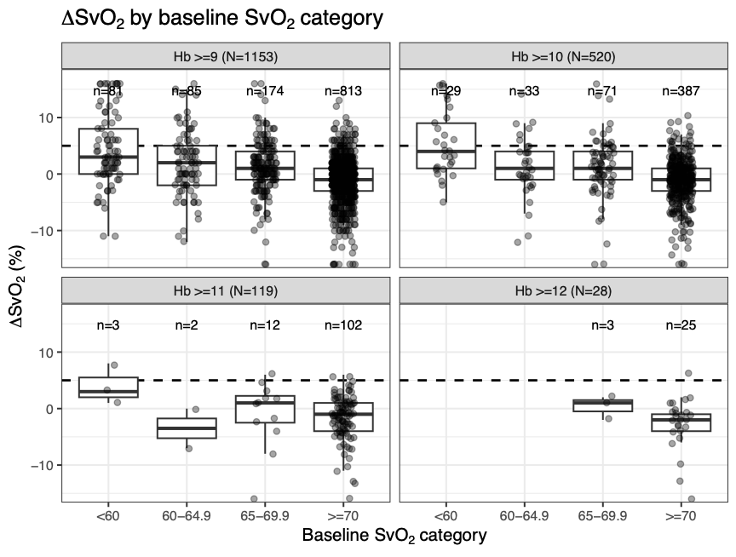
Supplementary Figure S1. Subgroup analysis with modified Hb cutoff: ΔSvO₂ by pre-transfusion SvO₂ category.
The figure shows the Hb ≥ 9 g/dL, Hb ≥ 10 g/dL, Hb ≥ 11 g/dL, and Hb ≥ 12 g/dL subgroups. Boxplots with overlaid individual observations are shown, and the dashed horizontal line indicates ΔSvO₂ = 5%.

3. Sensitivity analysis: transfusion vs no transfusion (6-hour window), overlap weighting
Objective. To compare short-term physiological trajectories between patients who received RBC transfusion and contemporaneous patients who did not receive transfusion within the 6-hour window.
Methods. Three propensity-score approaches—propensity-score matching (PSM), inverse probability of treatment weighting (IPTW), and overlap weighting (OW)—were evaluated. Overlap weighting achieved the best covariate balance and was therefore selected for comparative trajectory analyses. Time-course comparisons used event-specific baselines and mixed-effects models with group, time, and group-by-time interaction terms.
Table S1. Comparison of propensity-score approaches for the transfusion vs no-transfusion sensitivity analysis.
Method | N total | Transfusion | No transfusion | ESS (Tx) | ESS (No Tx) | Max |SMD|
OW | 2707 | 715 | 1992 | 623 | 1123 | 0.0108
IPTW | 2707 | 715 | 1992 | 328 | 1706 | 0.0686
PSM | 1172 | 586 | 586 | 586 | 586 | 0.0943
ESS values are rounded to the nearest whole number. OW indicates overlap weighting.
Results. In the overlap-weighted cohort, trajectories of SvO₂, Hb, and DO₂i over 0–6 hours differed significantly between groups (all group-by-time interaction P < 0.001). The transfusion group showed upward trajectories in SvO₂, a clear rise in hemoglobin, and an increase in DO₂i, whereas the no-transfusion group showed flat or downward trends.

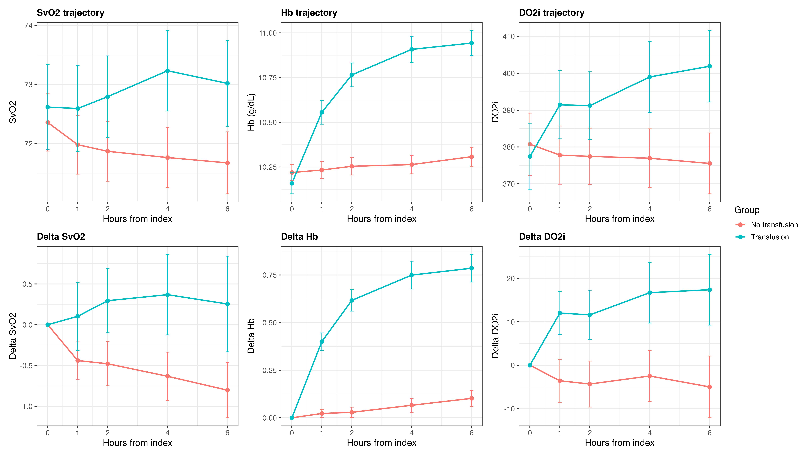
Supplementary Figure S2. Overlap-weighted 0–6-hour trajectories of SvO₂, Hb, and DO₂i in the transfusion and no-transfusion groups.
Upper panels show raw trajectories and lower panels show changes from the baseline. Values are overlap-weighted means with 95% confidence intervals. Group-by-time interactions were significant for all three variables (all P < 0.001).

4. Sensitivity analysis: continuous ΔSvO₂
Objective. To examine predictors of ΔSvO₂ when analyzed as a continuous outcome rather than a binary responder classification.
Methods. The dependent variable was continuous ΔSvO₂ (60-minute post-index minus 0-hour pre-index SvO₂). Independent variables included age, sex, hemoglobin, baseline SvO₂, SpO₂, cardiac index, and ejection fraction.
Table S2. Multivariable linear regression for predictors of continuous ΔSvO₂.
Variable | β coefficient | 95% CI | P value
Age (per year) | 0.003 | −0.016 to 0.022 | 0.757
Male sex | −0.157 | −0.755 to 0.441 | 0.607
Hemoglobin (g/dL) | −0.137 | −0.471 to 0.197 | 0.423
Baseline SvO₂ (per 1% increase) | −0.231 | −0.262 to −0.199 | <0.001
SpO₂ (%) | −0.224 | −0.417 to −0.031 | 0.023
Cardiac index (L/min/m²) | 0.636 | 0.537 to 0.735 | <0.001
Ejection fraction (%) | −0.009 | −0.028 to 0.010 | 0.377
Outcome variable: continuous ΔSvO₂ (60-minute post-index minus 0-hour pre-index SvO₂).

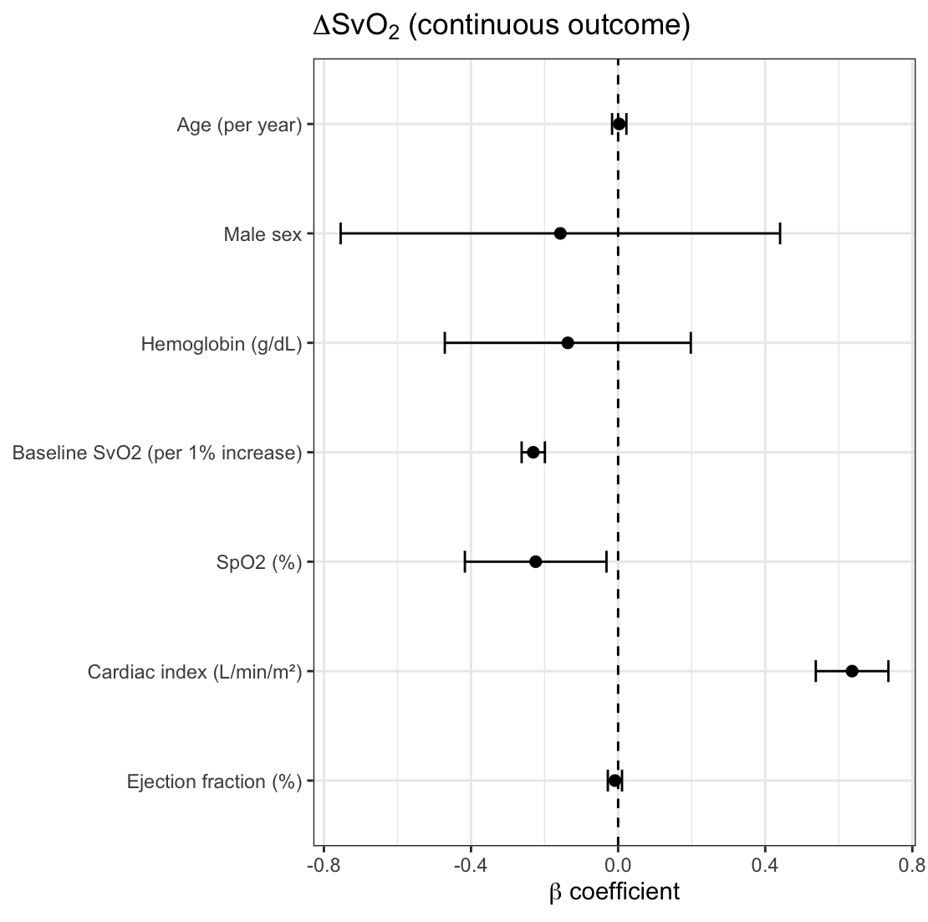
Supplementary Figure S3. β coefficients (95% CI) from the multivariable linear regression using continuous ΔSvO₂ as the outcome.
Points indicate β coefficients and whiskers indicate 95% confidence intervals.

