Supplementary
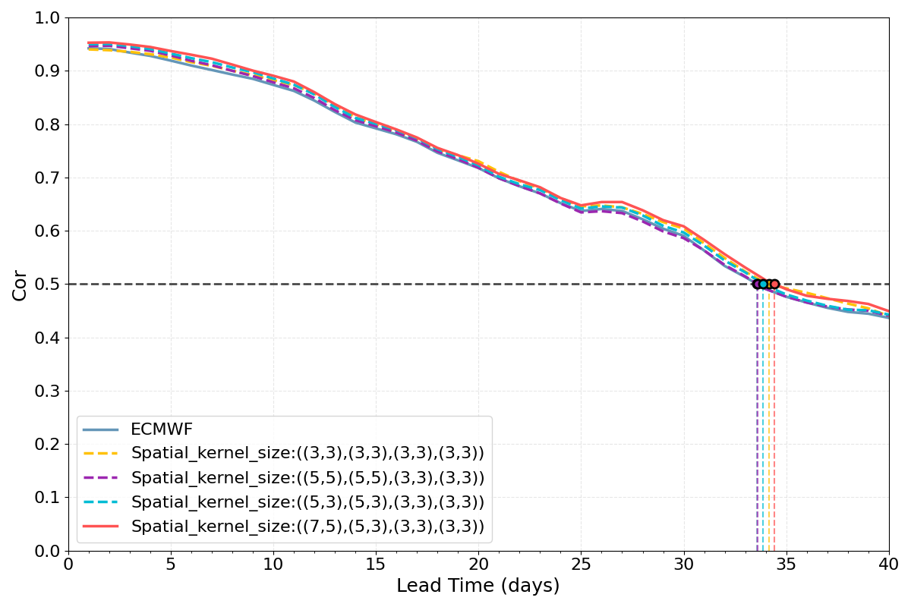
Supplementary Figure S1. Ablation study on 2D convolutional kernel sizes in the U-Net architecture. The bivariate correlation skill is shown for the ECMWF model forecasts corrected by PCC-MJO variants employing different spatial kernel configurations. The kernel sizes in the parentheses (e.g., (7,5), (5,3), (3,3), (3,3)) correspond to the spatial receptive fields of the consecutive layers in the encoder, which are applied in reverse order in the decoder.
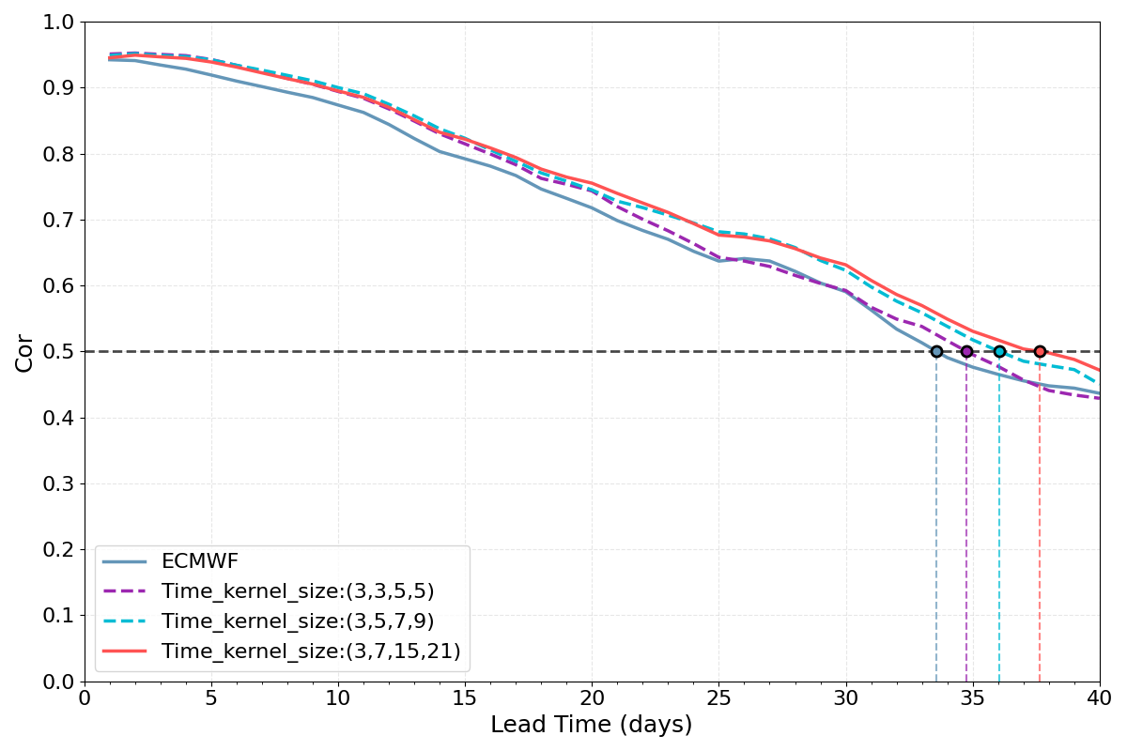
Supplementary Figure S2. Ablation study on temporal convolutional kernel sizes in the 3D U-Net. The bivariate correlation skill is shown for the ECMWF model forecasts corrected by PCC-MJO variants employing different temporal kernel configurations. The kernel sizes in the parentheses (e.g., (3, 7, 15, 21)) correspond to the temporal receptive fields of the consecutive layers in the encoder, which are applied in reverse order in the decoder.
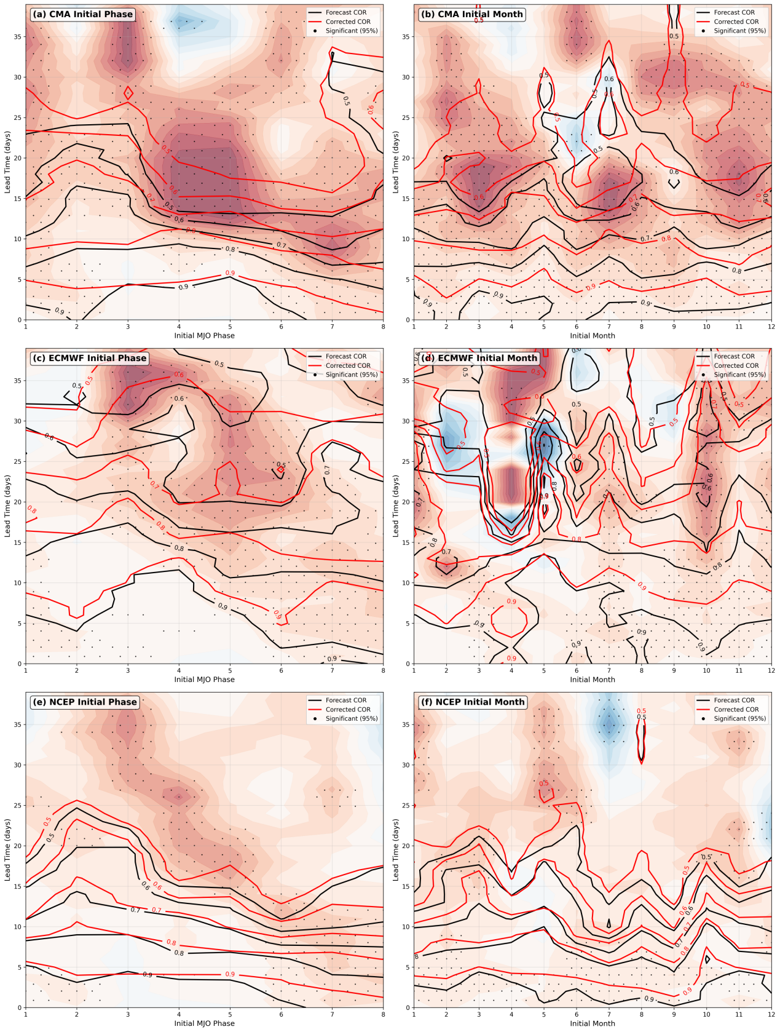
Supplementary Figure S3. Dependence of MJO forecast skill improvement on initial condition. The skill (COR) of raw (black contours) and AI-corrected (red contours) forecasts is shown as a function of initial MJO phase (left column; a, c, e) and initial calendar month (right column; b, d, f), for CMA (a-b), ECMWF (c-d), and NCEP (e-f) models. The shading indicates the difference in COR (corrected minus raw), with red (blue) representing an improvement (degradation). Stippling denotes where the improvement is statistically significant at the 95% confidence level based on Steiger's Z-test. All results are computed from the test dataset (the last 20% of the data).
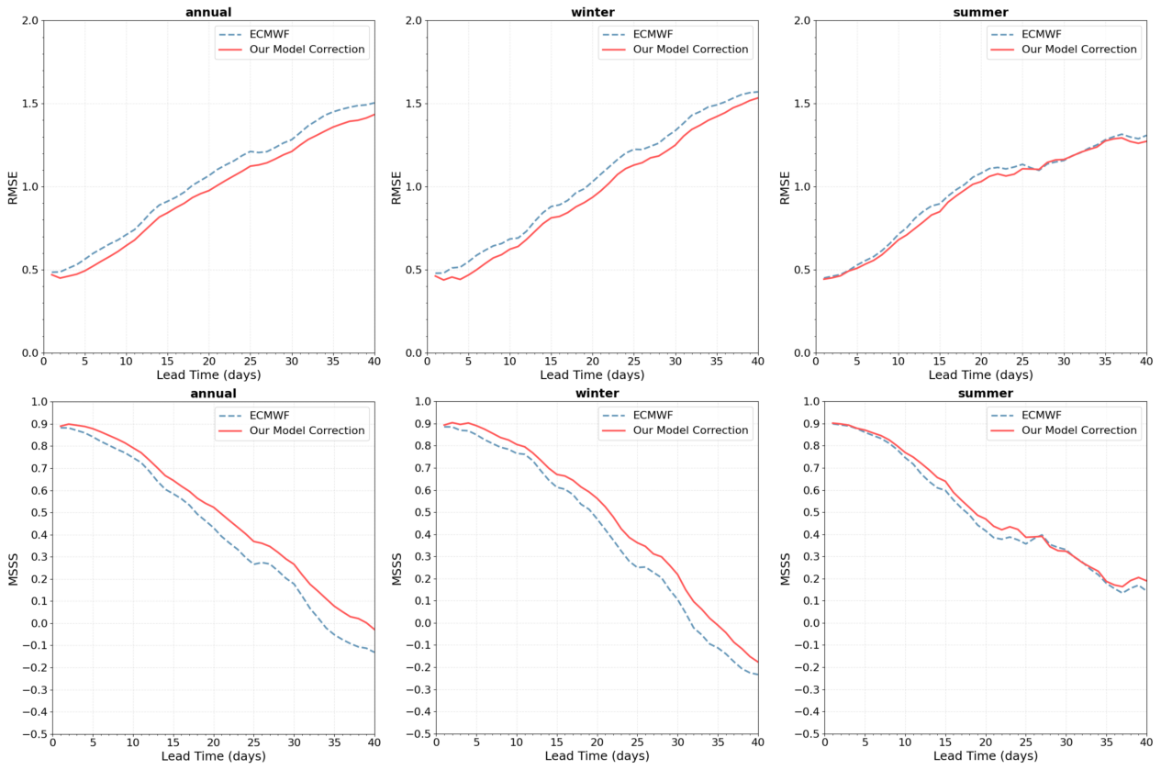
Supplementary Figure S4. Comprehensive evaluation of forecast error and skill improvement using ECMWF data. (a-c) Bivariate root mean square error (RMSE) and (d-f) Murphy's Mean Square Skill Score (MSSS) for raw (blue) and AI-corrected (red) MJO forecasts, evaluated over the (a, d) entire year, (b, e) boreal winter (NDJFM), and (c, f) boreal summer (MJJAS). A lower RMSE and a higher MSSS indicate better forecast performance. The consistent reduction in RMSE and increase in MSSS across all seasons demonstrate the robust skill improvement brought by the AI correction. All results are computed from the test dataset (the last 20% of the data).
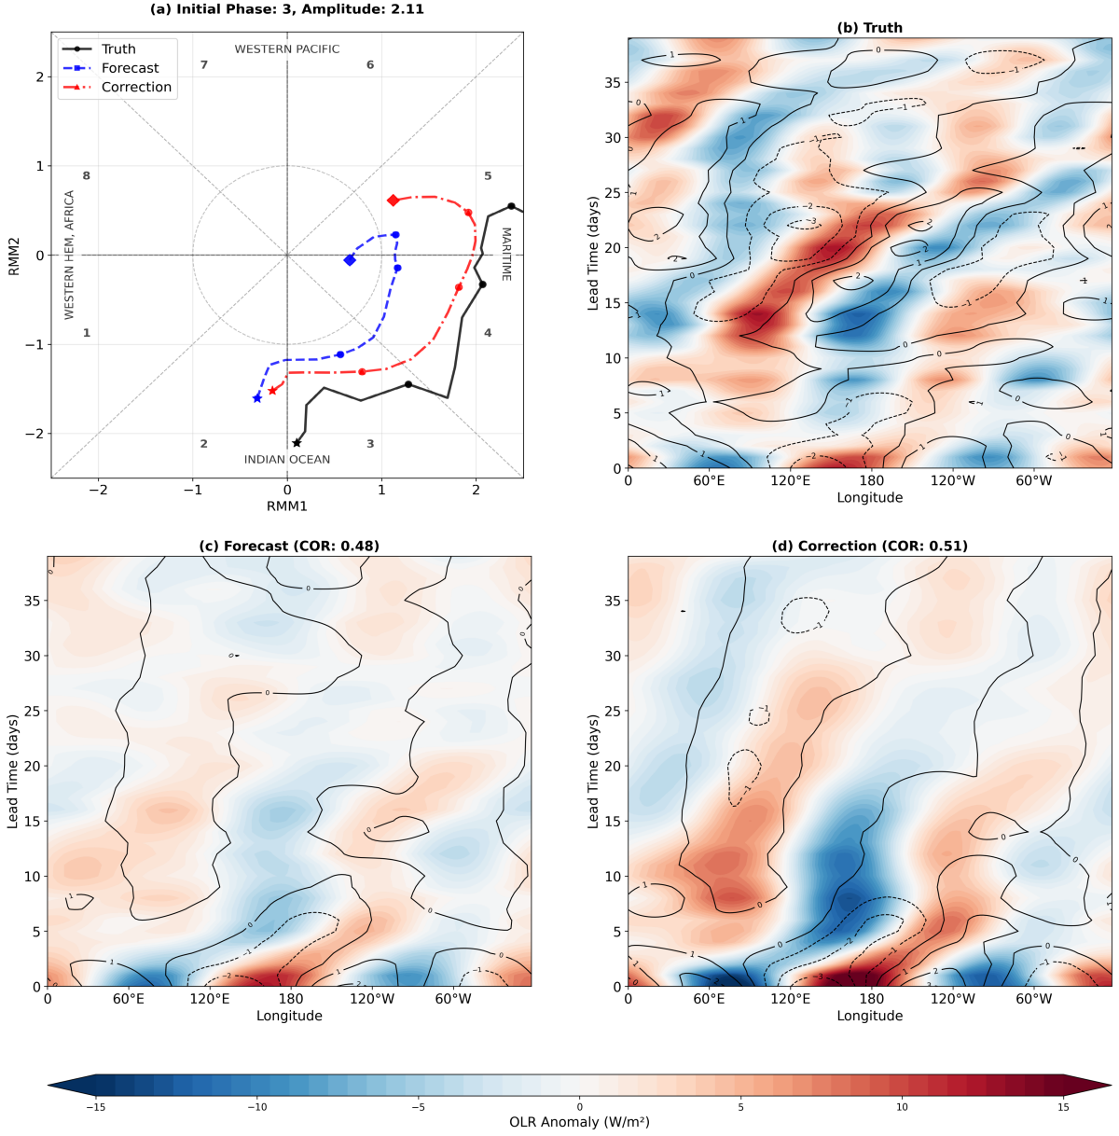
Supplementary Figure S5. Case study of an MJO event initialized in Phase 3 (Amplitude = 2.11), demonstrating forecast improvement after physics-guided design correction. (a) RMM phase-space trajectories from observation (NCEPII, black), raw ECMWF forecast (blue), and AI-corrected forecast (red). (b–d) Hovmöller diagrams of equatorial-averaged (15°S–15°N) OLR anomalies (shading) and 850-hPa zonal wind (U850, contours) for (b) observation, (c) raw forecast, and (d) AI-corrected forecast. The pattern correlation coefficient (PCC) of OLR relative to observations is shown for forecasts.
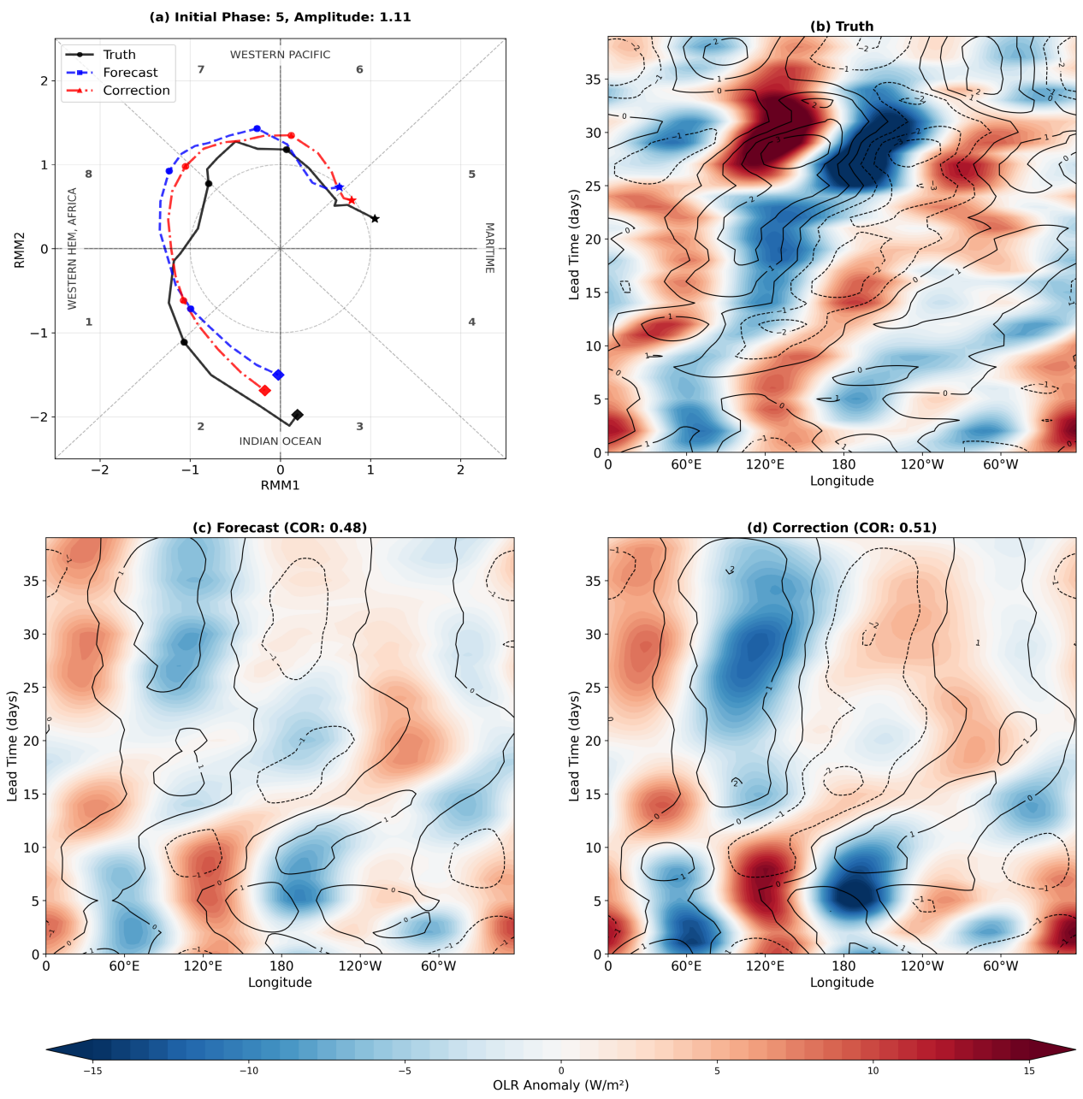
Supplementary Figure S6. As in Supplementary Figure S5, but for an MJO event initialized in Phase 5 (Amplitude = 1.11).
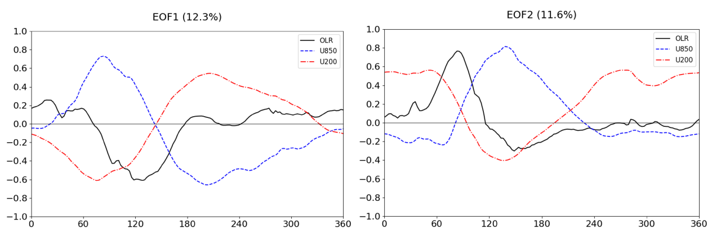
Supplementary Figure S7. Observed spatial patterns of the leading MJO modes. The first two empirical orthogonal function (EOF) modes of the combined fields of outgoing longwave radiation (OLR, black), 850-hPa zonal wind (U850, blue), and 200-hPa zonal wind (U200, red) anomalies over the tropics (15°S–15°N), derived from the ERAS/NCEPII reanalysis. (a) EOF1 and (b) EOF2 account for 12.3% and 11.6% of the total variance, respectively. These patterns, which form the basis of the RMM index (Wheeler and Hendon, 2004), represent the canonical spatial structures of the MJO and serve as the physical benchmark for interpreting the AI model's behavior.

