Search Strategy
Search Strategy for Systematic Review
Registration: PROSPERO (CRD420261290916)
Planned search date: 31 January 2026
Limits: Humans, Adults (18+ YEARS); Language restriction English and Spanish
Platform | Structured Query Language | Results
PubMed/MEDLINE (via PubMed) | ("Sleeve Gastrectomy"[Mesh] OR  "sleeve gastrectomy"[tiab] OR "gastric sleeve"[tiab] OR  "vertical gastrectomy"[tiab] OR (("bariatric surgery"[Mesh] OR "Obesity, Morbid/surgery"[Mesh]) AND ("sleeve"[tiab] OR "vertical"[tiab])))AND("Pain, Postoperative/prevention and control"[Mesh] OR "Analgesia"[Mesh] OR "Anesthesia, Conduction"[Mesh] OR "Anti-Inflammatory Agents, Non-Steroidal"[Mesh] OR  "Adjuvants, Anesthesia"[Mesh] OR  (analgesi*[tiab] OR "pain control"[tiab] OR "pain management"[tiab]) OR  ("multimodal analgesia"[tiab] OR "opioid free"[tiab] OR "opioid-sparing"[tiab]) OR  ("transversus abdominis plane"[tiab] OR "TAP block"[tiab]) OR  ("nerve block"[tiab] OR "regional anesthesia"[tiab]))  AND( ("preemptive"[tiab] OR "pre-emptive"[tiab] OR "preventive"[tiab] OR "preincisional"[tiab] OR "pre-operative"[tiab] OR "before incision"[tiab]) OR  ("postoperative"[tiab] OR "post-operative"[tiab] OR "end of surgery"[tiab] OR "after surgery"[tiab]))  AND("Randomized Controlled Trial"[pt] OR  randomized[tiab] OR  randomised[tiab] OR  randomly[tiab] OR trial[tiab] OR groups[tiab]) | 136
Scopus | ( TITLE-ABS-KEY ( "sleeve gastrectomy" OR "gastric sleeve" OR "vertical gastrectomy" ) AND ( "bariatric surgery" AND ( sleeve OR vertical ) ) )  AND  ( TITLE-ABS-KEY ( "postoperative pain" OR analgesia OR "pain management" OR "TAP block" OR "transversus abdominis plane" OR "nerve block" OR "regional anesthesia" OR "multimodal analgesia" ) )  AND  ( TITLE-ABS-KEY ( preemptive OR "pre-emptive" OR preventive OR preincisional OR "pre-operative" OR "before incision" OR postoperative OR "post-operative" OR "end of surgery" ) )  AND  ( TITLE-ABS-KEY ( randomized OR randomised OR randomly OR trial OR groups ) AND ( LIMIT-TO ( DOCTYPE , "ar" ) ) )  AND  ( LIMIT-TO ( SUBJAREA , "MEDI" ) OR LIMIT-TO ( SUBJAREA , "NURS" ) ) AND ( LIMIT-TO ( EXACTKEYWORD , "Human" ) OR LIMIT-TO ( EXACTKEYWORD , "Adult" ) ) | 288
Cochrane Central Register of Controlled Trials (Central) | #1 MeSH descriptor: [Sleeve Gastrectomy] this term only  #2 (sleeve gastrectom* or gastric sleeve or vertical gastrectom*):ti,ab,kw  #3 MeSH descriptor: [Bariatric Surgery] this term only  #4 (bariatric surger* and (sleeve or vertical)):ti,ab,kw  #5 #1 OR #2 OR #3 OR #4  #6 MeSH descriptor: [Pain, Postoperative] this term only  #7 MeSH descriptor: [Analgesia] this term only  #8 MeSH descriptor: [Anesthesia, Conduction] this term only  #9 (analgesi* or "pain control" or "pain management" or "TAP block" or "transversus abdominis plane" or "nerve block" or "regional anesthesia"):ti,ab,kw  #10 #6 OR #7 OR #8 OR #9  #11 (preemptive or "pre-emptive" or preventive or preincisional or "pre-operative" or "before incision"):ti,ab,kw  #12 (postoperative or "post-operative" or "end of surgery" or "after surgery"):ti,ab,kw  #13 #11 OR #12  #14 #5 AND #10 AND #13 | 78
LILACS (via BVS) | tw:(("gastrectomia vertical" OR "gastrectomía vertical" OR "manga gástrica" OR "cirugía bariátrica") AND ("bloqueo del plano transverso abdominal" OR "bloqueo TAP" OR analgesia OR "dolor postoperatorio") AND (preventivo OR preincisional OR "preoperatorio" OR postoperatorio) AND (ensayo clínico controlado aleatorio OR aleatorizado)) | 15
ClinicalTrials.gov and WHO ICTRP | Sleeve Gastrectomy and TAP block | 1 and 0

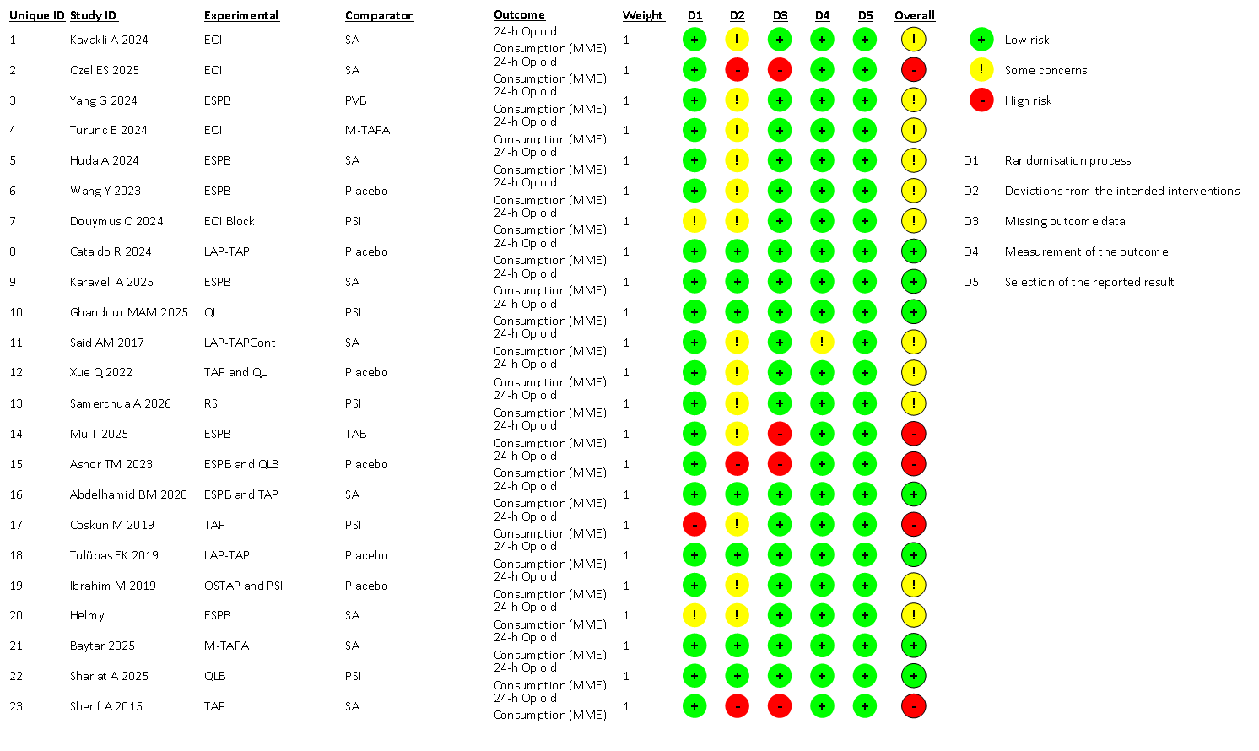
Fig. 1 Supplementary material, Risk of bias summary of each study by ROB-2 tool

Table 1: League table of comparative opioid-sparing effects of analgesic fascial plane blocks on 24-hour postoperative opioid consumptions following laparoscopic sleeve gastrectomy

EOI | - | - | -0.93 [-30.74; 28.88] | - | - | - | - | -37.50 [-69.27; -5.73] | - | - | - | -11.85 [-32.95; 9.24]
-5.28 [-41.44; 30.88] | PVB | -2.10 [-31.98; 27.78] | - | - | - | - | - | - | - | - | - | .
-7.38 [-27.75; 12.99] | -2.10 [-31.98; 27.78] | ESPB | - | 7.30 [-23.09; 37.69] | -5.18 [-26.28; 15.92] | - | - | - | - | - | -6.70 [-28.01; 14.60] | -13.26 [-28.25; 1.72]
-6.46 [-29.22; 16.30] | -1.18 [-40.73; 38.37] | 0.92 [-25.00; 26.83] | M-TAPA | - | - | - | - | - | - | - | - | -7.63 [-37.57; 22.31]
-7.73 [-31.56; 16.09] | -2.46 [-37.71; 32.80] | -0.36 [-19.08; 18.36] | -1.27 [-30.71; 28.17] | QL | -2.15 [-31.91; 27.61] | - | - | -0.58 [-21.63; 20.47] | - | - | -12.03 [-33.34; 9.29] | .
-8.94 [-30.42; 12.55] | -3.66 [-37.13; 29.82] | -1.56 [-16.66; 13.54] | -2.48 [-29.51; 24.56] | -1.20 [-19.88; 17.48] | TAP | - | - | 2.80 [-28.06; 33.66] | - | - | -1.92 [-31.69; 27.85] | -19.46 [-40.59; 1.68]
-9.96 [-43.11; 23.20] | -4.68 [-47.11; 37.75] | -2.58 [-32.71; 27.55] | -3.50 [-41.02; 34.02] | -2.22 [-31.80; 27.35] | -1.02 [-31.27; 29.22] | OSTAP | - | -1.62 [-31.43; 28.19] | - | - | -8.00 [-37.83; 21.83] | .
-11.51 [-48.44; 25.43] | -6.23 [-52.50; 40.05] | -4.13 [-39.47; 31.21] | -5.05 [-46.21; 36.12] | -3.77 [-37.82; 30.27] | -2.57 [-37.51; 32.37] | -1.55 [-41.99; 38.90] | RS | -2.00 [-31.79; 27.79] | - | - | - | .
-13.51 [-35.33; 8.32] | -8.23 [-43.64; 27.18] | -6.13 [-25.13; 12.88] | -7.05 [-35.46; 21.37] | -5.77 [-22.25; 10.71] | -4.57 [-22.83; 13.69] | -3.55 [-30.91; 23.81] | -2.00 [-31.79; 27.79] | PSI | - | - | -6.38 [-36.24; 23.48] | .
-15.50 [-47.10; 16.10] | -10.22 [-50.51; 30.07] | -8.12 [-35.15; 18.91] | -9.04 [-44.89; 26.81] | -7.76 [-35.23; 19.71] | -6.56 [-34.35; 21.23] | -5.54 [-40.08; 29.00] | -3.99 [-44.76; 36.77] | -0.88 [-15.82;14.06] | LAP-TAP | - | -0.53 [-21.59; 20.54] | .
-16.56 [-50.83; 17.70] | -11.29 [-55.52; 32.94] | -9.19 [-41.80; 23.43] | -10.10 [-47.57; 27.36] | -8.83 [-44.91; 27.25] | -7.63 [-41.34; 26.08] | -6.61 [-49.65; 36.44] | -5.06 [-51.56; 41.44] | -2.51 [-13.91; 8.89] | -1.07 [-42.39; 40.26] | LAP-TAPCont | - | -3.10 [-32.84; 26.64]
-16.03 [-39.58; 7.53] | -10.75 [-45.09; 23.60] | -8.65 [-25.59; 8.29] | -9.57 [-38.57; 19.44] | -8.29 [-25.92; 9.34] | -7.09 [-25.22; 11.04] | -6.07 [-33.43; 21.30] | -4.52 [-39.42; 30.38] | -3.03 [-10.65; 4.59] | -0.53 [-21.59; 20.54] | 0.54 [-35.01; 36.09] | Placebo | .
-19.66 [-36.69; -2.64] | -14.39 [-47.13; 18.36] | -12.29 [-25.69; 1.11] | -13.20 [-35.99; 9.58] | -11.93 [-32.37; 8.51] | -10.73 [-26.61; 5.15] | -9.71 [-40.83; 21.42] | -8.16 [-43.90; 27.59] | -3.98 [-13.08; 5.11] | -4.17 [-32.86; 24.53] | -3.10 [-32.84; 26.64] | -3.64 [-23.13; 15.85] | SA

Negative values favor the treatment in the row, indicating lower pain scores. Statistically significant results (where the 95% CIs does not cross zero) are highlighted in yellow.

Table 2: League table of network meta-analysis for postoperative pain intensity at 2 hours (MD with 95% Cis)

EOI | - | - | - | - | - | - | - | -2.47 [-4.62; -0.32] | . | -2.00 [-3.78; -0.22]
-0.80 [-3.16; 1.56] | M-TAPA | - | - | - | - | - | - | . | . | -1.75 [-3.55; 0.05]
-0.88 [-2.58; 0.82] | -0.08 [-2.15; 1.99] | TAP | - | 0.01 [-1.60;1.62] | 0.47 [-0.73; 1.66] | - | - | . | -0.75 [-2.36; 0.86] | -2.78 [-4.08; -1.48]
-0.77 [-3.61; 2.06] | 0.03 [-3.21; 3.26] | 0.11 [-2.54; 2.75] | OSTAP | - | - | - | - | -0.20 [-2.93; 2.53] | -2.28 [-5.01; 0.45] | .
-0.90 [-2.63; 0.83] | -0.09 [-2.32; 2.14] | -0.02 [-1.19; 1.15] | -0.12 [-2.67; 2.42] | QL | -0.19 [-1.80; 1.42] | - | - | -0.80 [-2.44; 0.84] | -1.34 [-2.47; -0.20] | .
-0.90 [-2.56; 0.75] | -0.10 [-2.12; 1.91] | -0.03 [-0.95; 0.89] | -0.13 [-2.77; 2.50] | -0.01 [-1.17; 1.15] | ESPB | - | -0.66 [-2.29; 0.97] | . | -1.72 [-3.33; -0.11] | -1.21 [-2.23; -0.20]
-0.89 [-3.16; 1.37] | -0.09 [-2.56; 2.38] | -0.01 [-1.98; 1.95] | -0.12 [-3.29; 3.05] | 0.00 [-2.13; 2.14] | 0.01 [-1.89; 1.92] | LAP-TAPCont | - | . | . | -1.66 [-3.34; 0.02]
-1.56 [-3.88; 0.76] | -0.76 [-3.36; 1.83] | -0.69 [-2.56; 1.18] | -0.79 [-3.89; 2.30] | -0.67 [-2.67; 1.33] | -0.66 [-2.29; 0.97] | -0.67 [-3.18; 1.84] | PVB | . | . | .
-1.66 [-3.33; 0.00] | -0.86 [-3.27; 1.54] | -0.79 [-2.36; 0.78] | -0.89 [-3.37; 1.58] | -0.77 [-2.09; 0.55] | -0.76 [-2.31; 0.79] | -0.77 [-3.09; 1.54] | -0.10 [-2.35; 2.15] | PSI | -2.08 [-4.81; 0.65] | .
-2.36 [-4.15; -0.56] | -1.56 [-3.81; 0.69] | -1.48 [-2.67; -0.29] | -1.59 [-4.06; 0.89] | -1.46 [-2.53; -0.40] | -1.45 [-2.64; -0.27] | -1.47 [-3.62; 0.68] | -0.79 [-2.81; 1.22] | -0.69 [-2.17; 0.78] | Placebo | .
-2.55 [-4.07; -1.04] | -1.75 [-3.55; 0.05] | -1.67 [-2.69; -0.66] | -1.78 [-4.46; 0.91] | -1.66 [-2.97; -0.34] | -1.65 [-2.55; -0.74] | -1.66 [-3.34; 0.02] | -0.99 [-2.85; 0.88] | -0.89 [-2.48; 0.71] | -0.19 [-1.53; 1.15] | SA

Negative values favor the treatment in the row, indicating lower pain scores. Statistically significant results (where the 95% CIs does not cross zero) are highlighted in yellow.

Table 3: League table for network meta-analysis of pain intensity at 6 hours after LSG
RS | - | - | - | - | - | - | - | - | -1.67 [-4.25; 0.91] | - | -
-0.72 [-3.79; 2.34] | QL | -0.34 [-2.68; 2.00] | - | 0.00 [-2.34; 2.34] | - | - | - | - | -0.80 [-3.17; 1.57] | -1.49 [-3.14; 0.17] | -
-0.85 [-3.99; 2.30] | -0.12 [-1.69; 1.45] | ESPB | - | -1.10 [-2.84; 0.64] | - | - | - | -0.66 [-3.02; 1.70] | - | -1.20 [-2.87; 0.47] | -1.65 [-2.89; -0.41]
-0.75 [-4.20; 2.70] | -0.02 [-2.53; 2.48] | 0.10 [-2.44; 2.64] | OSTAP | - | - | - | - | - | -0.80 [-3.26; 1.66] | -1.40 [-3.86; 1.06] | -
-1.09 [-4.17; 1.99] | -0.37 [-1.93; 1.19] | -0.25 [-1.49; 0.99] | -0.35 [-2.87; 2.18] | TAP | - | - | - | - | -1.00 [-3.51; 1.51] | -0.59 [-2.93; 1.75] | -2.18 [-3.94; -0.42]
-1.07 [-4.63; 2.48] | -0.35 [-2.67; 1.97] | -0.23 [-2.50; 2.05] | -0.32 [-3.24; 2.59] | 0.02 [-2.31; 2.35] | LAP-TAP | - | - | - | - | -0.95 [-2.77; 0.87] | -
-1.44 [-5.04; 2.15] | -0.72 [-3.08; 1.64] | -0.60 [-2.50; 1.30] | -0.69 [-3.79; 2.40] | -0.35 [-2.40; 1.70] | -0.37 [-3.27; 2.53] | EOI | -0.33 [-2.75; 2.09] | - | - | - | -1.16 [-2.86; 0.54]
-1.50 [-5.25; 2.25] | -0.78 [-3.37; 1.81] | -0.66 [-2.84; 1.52] | -0.76 [-4.03; 2.51] | -0.41 [-2.72; 1.90] | -0.43 [-3.52; 2.66] | -0.06 [-1.93; 1.81] | M-TAPA | - | - | - | -1.50 [-3.89; 0.89]
-1.51 [-5.44; 2.43] | -0.78 [-3.61; 2.05] | -0.66 [-3.02; 1.70] | -0.76 [-4.22; 2.70] | -0.41 [-3.07; 2.25] | -0.43 [-3.71; 2.84] | -0.06 [-3.09; 2.96] | -0.00 [-3.21; 3.21] | PVB | - | - | -
-1.67 [-4.25; 0.91] | -0.95 [-2.59; 0.70] | -0.82 [-2.62; 0.97] | -0.92 [-3.21; 1.36] | -0.58 [-2.26; 1.10] | -0.60 [-3.04; 1.84] | -0.23 [-2.73; 2.27] | -0.17 [-2.89; 2.55] | -0.16 [-3.13; 2.80] | PSI | - | -
-2.02 [-5.08; 1.03] | -1.30 [-2.74; 0.14] | -1.18 [-2.55; 0.19] | -1.28 [-3.56; 1.01] | -0.93 [-2.39; 0.52] | -0.95 [-2.77; 0.87] | -0.58 [-2.84; 1.67] | -0.52 [-3.02; 1.97] | -0.52 [-3.24; 2.21] | -0.35 [-1.98; 1.28] | Placebo | -
-2.74 [-5.99; 0.52] | -2.01 [-3.82; -0.21] | -1.89 [-3.03; -0.76] | -1.99 [-4.68; 0.70] | -1.65 [-3.02; -0.27] | -1.67 [-4.13; 0.80] | -1.30 [-2.82; 0.23] | -1.24 [-3.09; 0.62] | -1.23 [-3.85; 1.38] | -1.07 [-3.05; 0.91] | -0.71 [-2.38; 0.95] | SA

Results highlighted in yellow represent statistically significant comparisons, with negative values favoring the treatment listed in the row.

Table 4: League table for network meta-analysis of pain intensity at 12 hours after LSG (Mean Difference with 95% CIs)
RS | - | - | - | - | - | - | - | -1.66 [-3.75; 0.43] | - | - | - | -
-1.06 [-3.53; 1.40] | ESPB | 0.69 [-1.12; 2.50] | - | - | -0.33 [-2.19; 1.53] | -0.92 [-2.25; 0.41] | - | - | - | - | -1.23 [-2.53; 0.07] | -1.43 [-2.42; -0.44]
-1.05 [-3.49; 1.39] | 0.01 [-1.18; 1.20] | QL | - | - | - | 0.02 [-1.79; 1.83] | - | -0.20 [-2.03; 1.63] | - | - | -1.43 [-2.70; -0.15] | -
-1.08 [-3.95; 1.78] | -0.02 [-2.13; 2.09] | -0.04 [-2.15; 2.08] | OSTAP | - | - | - | - | -0.60 [-2.75; 1.55] | - | - | -1.20 [-3.35; 0.95] | -
-1.36 [-3.93; 1.21] | -0.30 [-1.64; 1.04] | -0.31 [-1.91; 1.28] | -0.28 [-2.59; 2.04] | EOI | - | - | 0.00 [-1.85; 1.85] | -1.10 [-3.35; 1.15] | - | - | - | -0.96 [-2.30; 0.38]
-1.39 [-4.48; 1.70] | -0.33 [-2.19; 1.53] | -0.34 [-2.55; 1.86] | -0.31 [-3.12; 2.51] | -0.03 [-2.32; 2.26] | PVB | - | - | - | - | - | - | -
-1.44 [-3.88; 1.01] | -0.38 [-1.33; 0.57] | -0.39 [-1.60; 0.82] | -0.35 [-2.48; 1.77] | -0.08 [-1.48; 1.33] | -0.05 [-2.14; 2.04] | TAP | - | -0.00 [-2.17; 2.17] | - | - | -0.73 [-2.54; 1.08] | -1.56 [-2.94; -0.18]
-1.46 [-4.26; 1.34] | -0.40 [-2.05; 1.25] | -0.41 [-2.31; 1.49] | -0.37 [-2.92; 2.18] | -0.10 [-1.52; 1.33] | -0.07 [-2.55; 2.42] | -0.02 [-1.74; 1.70] | M-TAPA | - | - | - | - | -1.00 [-2.88; 0.88]
-1.66 [-3.75; 0.43] | -0.60 [-1.91; 0.71] | -0.61 [-1.87; 0.65] | -0.58 [-2.54; 1.39] | -0.30 [-1.80; 1.20] | -0.27 [-2.54; 2.01] | -0.22 [-1.49; 1.05] | -0.20 [-2.07; 1.67] | PSI | - | - | -0.60 [-2.75; 1.55] | -
-1.98 [-5.31; 1.36] | -0.92 [-3.41; 1.58] | -0.93 [-3.46; 1.60] | -0.89 [-3.89; 2.10] | -0.62 [-3.35; 2.12] | -0.59 [-3.70; 2.53] | -0.54 [-3.07; 2.00] | -0.52 [-3.44; 2.40] | -0.32 [-2.92; 2.28] | LAP-TAP | - | -0.33 [-2.59; 1.93] | -
-2.04 [-5.15; 1.07] | -0.98 [-3.03; 1.08] | -0.99 [-3.28; 1.30] | -0.95 [-3.82; 1.91] | -0.68 [-2.84; 1.48] | -0.65 [-3.42; 2.13] | -0.60 [-2.72; 1.53] | -0.58 [-2.93; 1.77] | -0.38 [-2.68; 1.93] | -0.06 [-3.24; 3.12] | LAP-TAPCont |  | -0.52 [-2.38; 1.34]
-2.31 [-4.76; 0.14] | -1.25 [-2.30; -0.19] | -1.26 [-2.38; -0.14] | -1.22 [-3.19; 0.74] | -0.95 [-2.49; 0.59] | -0.92 [-3.05; 1.22] | -0.87 [-2.01; 0.27] | -0.85 [-2.70; 1.00] | -0.65 [-1.92; 0.63] | -0.33 [-2.59; 1.93] | -0.27 [-2.51; 1.97] | Placebo | -
-2.56 [-5.05; -0.06] | -1.50 [-2.38; -0.61] | -1.51 [-2.85; -0.17] | -1.47 [-3.66; 0.71] | -1.20 [-2.30; -0.10] | -1.17 [-3.23; 0.89] | -1.12 [-2.15; -0.09] | -1.10 [-2.53; 0.33] | -0.90 [-2.26; 0.47] | -0.58 [-3.17; 2.01] | -0.52 [-2.38; 1.34] | -0.25 [-1.50; 1.00] | SA

Results highlighted in yellow represent statistically significant comparisons, with negative values favoring the treatment listed in the row.

Table 5: League table for network meta-analysis of pain intensity 24 hours after LSG (Mean Difference with 95% CIs)
OSTAP | - | - | -0.30 [-1.58; 0.98] | - | - | - | - | - | - | -1.10 [-2.38; 0.18] | - | -
-0.10 [-1.58; 1.38] | LAP-TAPCont | - | - | - | - | - | - | - | - | - | - | -1.27 [-2.09; -0.45]
-0.28 [-1.58; 1.03] | -0.18 [-1.16; 0.80] | EOI | -0.93 [-2.26; 0.40] | - | - | - | - | -0.34 [-1.28; 0.60] | - | - | - | -0.92 [-1.56; -0.28]
-0.46 [-1.62; 0.69] | -0.36 [-1.42; 0.70] | -0.19 [-0.96; 0.59] | PSI | - | 1.00 [-0.29; 2.29] | 0.00 [-1.57; 1.57] | -0.51 [-1.18; 0.16] | - | - | -0.80 [-2.08; 0.48] | - | -
-0.49 [-1.69; 0.70] | -0.40 [-1.31; 0.52] | -0.22 [-0.87; 0.43] | -0.03 [-0.66; 0.60] | ESPB | -0.50 [-1.09; 0.10] | - | 0.33 [-0.44; 1.10] | - | -0.34 [-1.11; 0.43] | -0.32 [-0.85; 0.20] | - | -0.76 [-1.23; -0.29]
-0.51 [-1.71; 0.70] | -0.41 [-1.35; 0.54] | -0.23 [-0.92; 0.45] | -0.04 [-0.67; 0.58] | -0.01 [-0.43; 0.40] | TAP | - | -0.00 [-0.72; 0.72] | - | - | -0.33 [-1.05; 0.39] | - | -1.28 [-1.93; -0.63]
-0.46 [-2.41; 1.49] | -0.36 [-2.26; 1.53] | -0.19 [-1.94; 1.56] | 0.00 [-1.57; 1.57] | 0.03 [-1.66; 1.72] | 0.04 [-1.64; 1.73] | RS | - | - | - | - | - | -
-0.59 [-1.77; 0.60] | -0.49 [-1.50; 0.52] | -0.31 [-1.06; 0.44] | -0.13 [-0.67; 0.42] | -0.09 [-0.60; 0.41] | -0.08 [-0.59; 0.43] | -0.13 [-1.79; 1.54] | QL | - | - | -0.48 [-1.00; 0.05] | - | -
-0.62 [-2.02; 0.79] | -0.52 [-1.60; 0.56] | -0.34 [-1.05; 0.37] | -0.15 [-1.09; 0.78] | -0.12 [-0.93; 0.68] | -0.11 [-0.95; 0.73] | -0.15 [-1.99; 1.68] | -0.03 [-0.93; 0.87] | M-TAPA | - | - | - | -0.75 [-1.66; 0.16]
-0.83 [-2.26; 0.59] | -0.74 [-1.93; 0.46] | -0.56 [-1.57; 0.45] | -0.37 [-1.37; 0.62] | -0.34 [-1.11; 0.43] | -0.33 [-1.20; 0.55] | -0.37 [-2.23; 1.49] | -0.25 [-1.17; 0.68] | -0.22 [-1.33; 0.90] | PVB | - | - | -
-0.94 [-2.09; 0.22] | -0.84 [-1.83; 0.15] | -0.66 [-1.39; 0.07] | -0.47 [-1.09; 0.14] | -0.44 [-0.88; -0.01] | -0.43 [-0.92; 0.06] | -0.47 [-2.16; 1.21] | -0.35 [-0.82; 0.12] | -0.32 [-1.20; 0.56] | -0.10 [-0.99; 0.78] | Placebo | -0.33 [-1.33; 0.67] | -
-1.27 [-2.80; 0.26] | -1.17 [-2.58; 0.23] | -0.99 [-2.23; 0.24] | -0.81 [-1.98; 0.36] | -0.78 [-1.87; 0.31] | -0.76 [-1.87; 0.35] | -0.81 [-2.77; 1.15] | -0.68 [-1.79; 0.42] | -0.65 [-1.99; 0.68] | -0.44 [-1.77; 0.90] | -0.33 [-1.33; 0.67] | LAP-TAP | -
-1.37 [-2.60; -0.13] | -1.27 [-2.09; -0.45] | -1.09 [-1.63; -0.55] | -0.91 [-1.58; -0.23] | -0.87 [-1.29; -0.46] | -0.86 [-1.33; -0.39] | -0.91 [-2.62; 0.80] | -0.78 [-1.37; -0.19] | -0.75 [-1.46; -0.04] | -0.53 [-1.41; 0.34] | -0.43 [-0.99; 0.12] | -0.10 [-1.24; 1.04] | SA

Results highlighted in yellow represent statistically significant comparisons, with negative values favoring the treatment listed in the row.

Table: League table of network PONV after LSG
QL | - | 0.88 [0.19; 4.06] | 0.68 [0.08; 5.46] | - | - | - | - | 0.29 [0.07; 1.15] | - | 0.39 [0.12; 1.30] | -
0.89 [0.10; 8.14] | OSTAP | - | - | - | - | - | - | 0.63 [0.06; 6.54] | - | 0.26 [0.03; 2.39] | -
0.72 [0.22; 2.38] | 0.81 [0.08; 8.16] | TAP | 1.54 [0.46; 5.15] | - | - | - | - | - | - | 0.83 [0.18; 3.82] | 0.13 [0.03; 0.52]
0.71 [0.20; 2.55] | 0.79 [0.08; 8.32] | 0.98 [0.38; 2.58] | ESPB | 1.08 [0.21; 5.42] | - | - | - | - | - | 0.21 [0.03; 1.36] | 0.56 [0.17; 1.84]
0.76 [0.10; 6.00] | 0.85 [0.05; 14.80] | 1.06 [0.16; 6.96] | 1.08 [0.21; 5.42] | PVB | - | - | - | - | - | - | -
0.60 [0.05; 7.17] | 0.67 [0.03; 15.60] | 0.83 [0.08; 9.03] | 0.84 [0.08; 9.06] | 0.78 [0.04; 13.84] | M-TAPA | 0.71 [0.11; 4.64] | - | - | - | - | -
0.43 [0.08; 2.19] | 0.48 [0.04; 6.02] | 0.59 [0.14; 2.61] | 0.60 [0.14; 2.60] | 0.56 [0.06; 4.94] | 0.71 [0.11; 4.64] | EOI | - | 1.00 [0.09; 11.50] | - | - | 0.46 [0.13; 1.61]
0.42 [0.08; 2.09] | 0.47 [0.04; 5.25] | 0.58 [0.11; 3.13] | 0.59 [0.10; 3.34] | 0.55 [0.05; 5.87] | 0.70 [0.04; 11.19] | 0.98 [0.13; 7.57] | LAP-TAP | - | - | 0.73 [0.22; 2.44] | -
0.39 [0.13; 1.22] | 0.44 [0.05; 3.79] | 0.55 [0.13; 2.31] | 0.56 [0.13; 2.47] | 0.52 [0.06; 4.66] | 0.66 [0.05; 7.98] | 0.92 [0.18; 4.80] | 0.94 [0.16; 5.45] | PSI | 0.73 [0.13; 4.01] | 0.42 [0.05; 3.27] | -
0.29 [0.04; 2.22] | 0.32 [0.02; 5.01] | 0.40 [0.04; 3.72] | 0.41 [0.04; 3.91] | 0.38 [0.02; 6.09] | 0.48 [0.02; 9.87] | 0.68 [0.06; 7.21] | 0.69 [0.06; 7.94] | 0.73 [0.13; 4.01] | RS | - | -
0.31 [0.11; 0.90] | 0.34 [0.04; 2.80] | 0.43 [0.13; 1.39] | 0.43 [0.12; 1.52] | 0.40 [0.05; 3.11] | 0.51 [0.04; 6.25] | 0.72 [0.14; 3.77] | 0.73 [0.22; 2.44] | 0.78 [0.22; 2.82] | 1.06 [0.13; 8.95] | Placebo | -
0.20 [0.05; 0.81] | 0.22 [0.02; 2.48] | 0.28 [0.10; 0.80] | 0.28 [0.10; 0.77] | 0.26 [0.04; 1.76] | 0.33 [0.04; 3.02] | 0.47 [0.15; 1.49] | 0.48 [0.08; 2.98] | 0.51 [0.11; 2.34] | 0.69 [0.07; 6.79] | 0.65 [0.16; 2.60] | SA

Results are presented as Odds Ratios (95% CIs). Numbers in the cell represent the comparison of the row-defining treatment versus column-defining treatment. OR ˂1 favors the row-defining treatment (lower incidence of PONV). Statistically significant results are highlighted in yellow.

Fig. 2 Funnel Plot and Asymmetry tests, MME 24 h
Funnel Plot  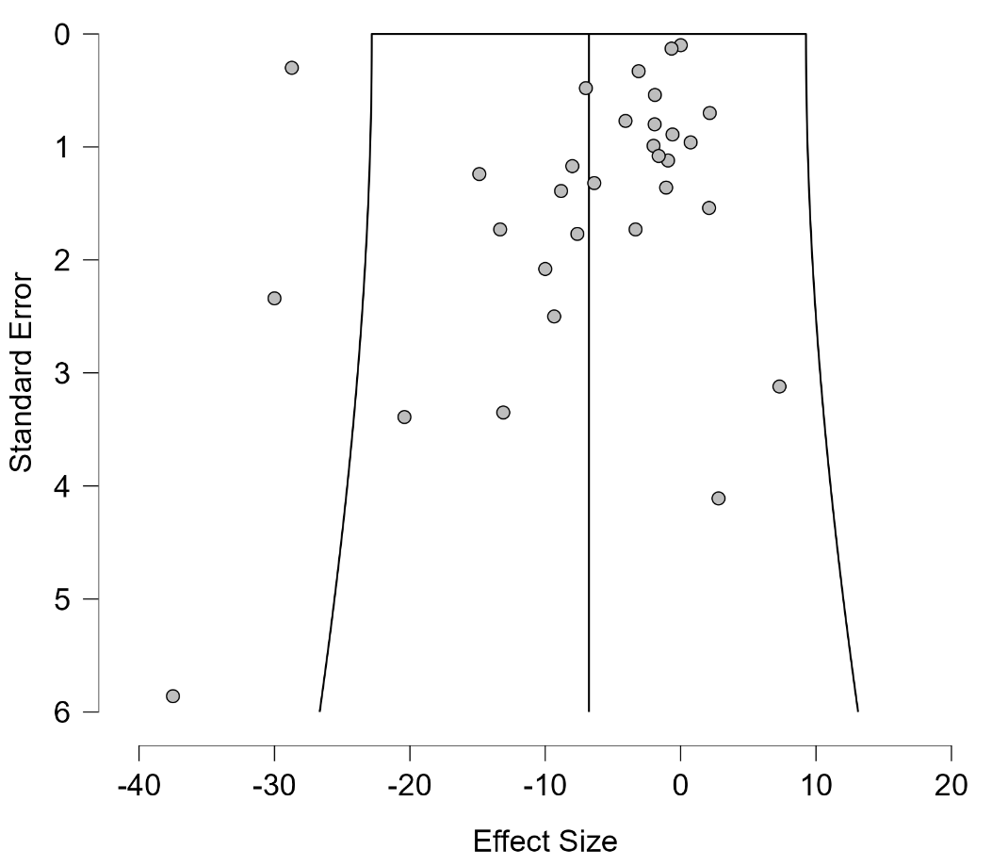 | Funnel Plot Asymmetry Tests
  Weighted Regression Test for Funnel Plot Asymmetry (Egger´s Test)
   | Asymmetry Test |  |  | Limit Estimate μ
  Estimates | t | df | p | Estimate | Lower 95% CI | Upper 95% CI
  31 | -1.381 | 29 | .178 | -1.172 | -4.187 | 1.843

Fig. 3 Funnel Plot and Asymmetry tests, Pain 2 h
Funnel Plot  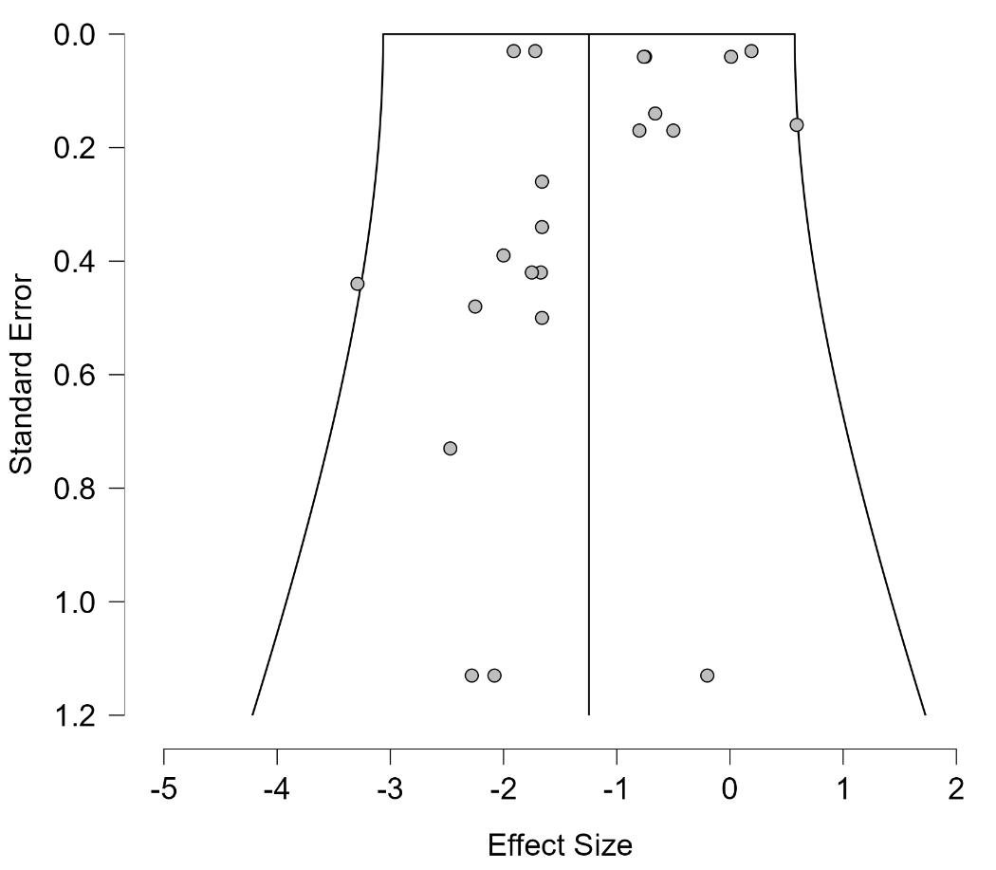 | Funnel Plot Asymmetry Tests
  Weighted Regression Test for Funnel Plot Asymmetry (Egger´s test)
   | Asymmetry Test |  |  | Limit Estimate μ
  Estimates | t | df | p | Estimate | Lower 95% CI | Upper 95% CI
  22 | -0.085 | 20 | .933 | -0.894 | -1.416 | -0.373

Fig. 4. Funnel Plot and Asymmetry tests, Pain 6 h
Funnel Plot  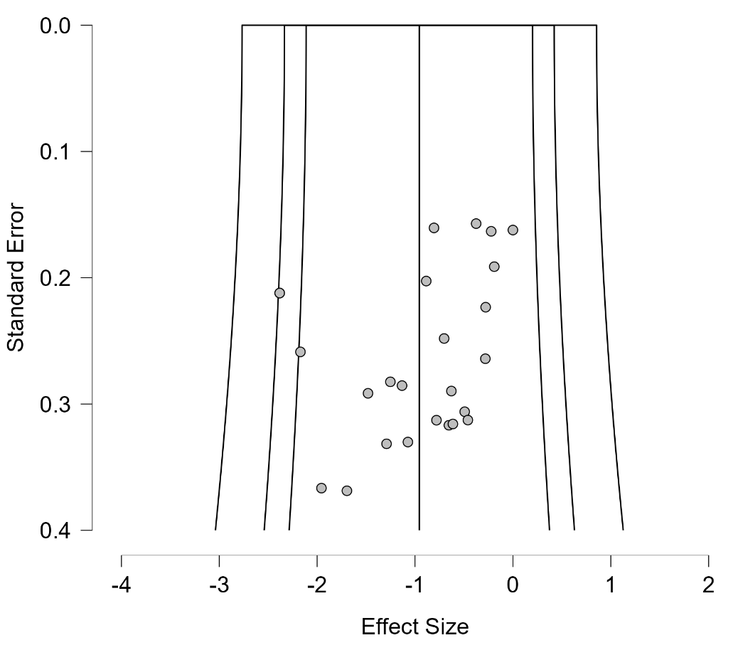 | Funnel Plot Asymmetry Tests
  Weighted Regression Test for Funnel Plot Asymmetry (Egger´s test)
   | Asymmetry Test |  |  | Limit Estimate μ
  Estimates | t | df | p | Estimate | Lower 95% CI | Upper 95% CI
  25 | -1.823 | 23 | .081 | 0.080 | -0.997 | 1.157

Fig. 5 Funnel Plot and Asymmetry tests, Pain 12 h
Funnel Plot  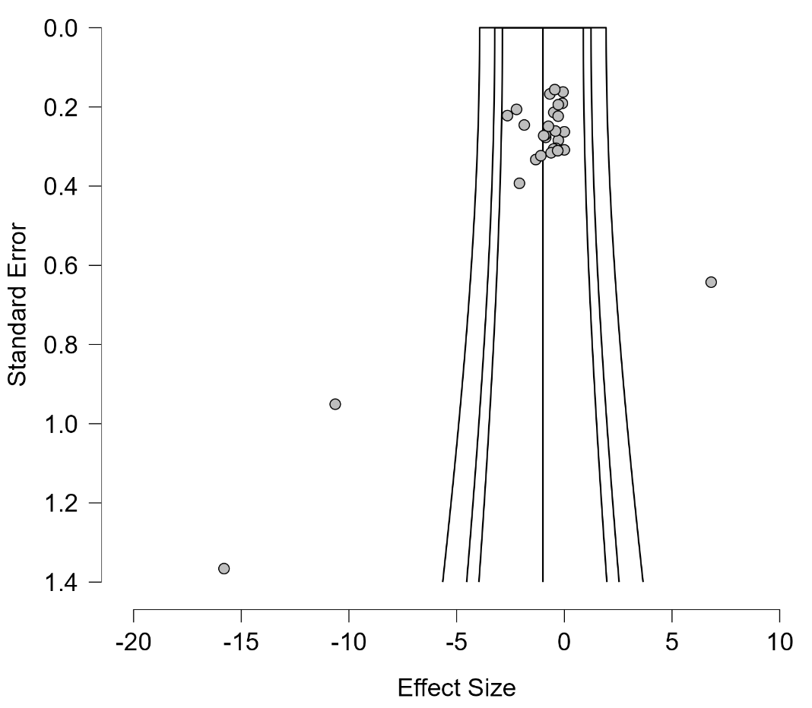 | Funnel Plot Asymmetry Tests
  Weighted Regression Test for Funnel Plot Asymmetry (Egger´s test)
   | Asymmetry Test |  |  | Limit Estimate μ
  Estimates | t | df | p | Estimate | Lower 95% CI | Upper 95% CI
  29 | -1.573 | 27 | .127 | 0.230 | -1.069 | 1.529

Fig. 6 Funnel Plot and Asymmetry tests, Pain 24 h
Funnel Plot  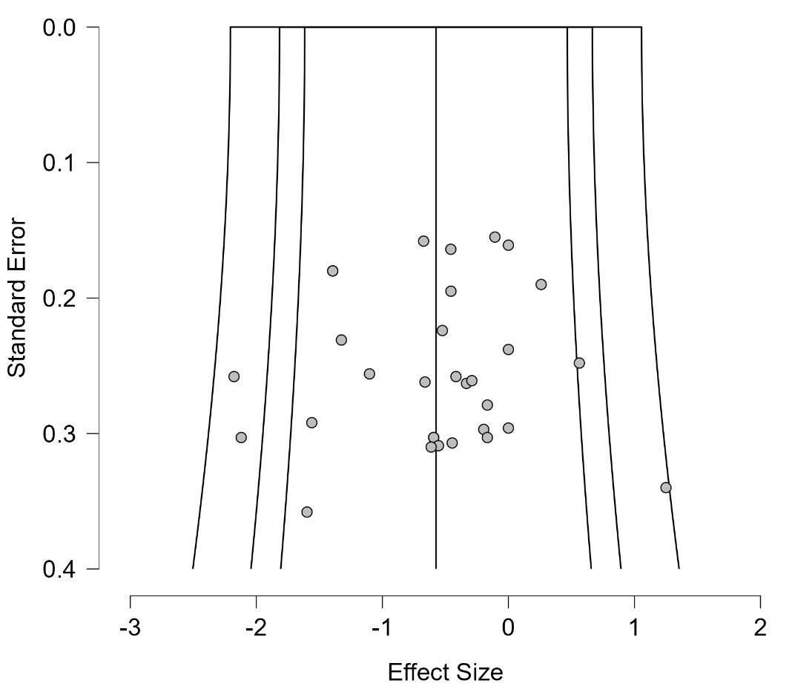 | Funnel Plot Asymmetry Tests
  Weighted Regression Test for Funnel Plot Asymmetry (Egger´s test)
   | Asymmetry Test |  |  | Limit Estimate μ
  Estimates | t | df | p | Estimate | Lower 95% CI | Upper 95% CI
  31 | -0.377 | 29 | .709 | -0.377 | -1.381 | 0.628

Fig. 7. Funnel Plot and Asymmetry tests, PONV
Funnel Plot  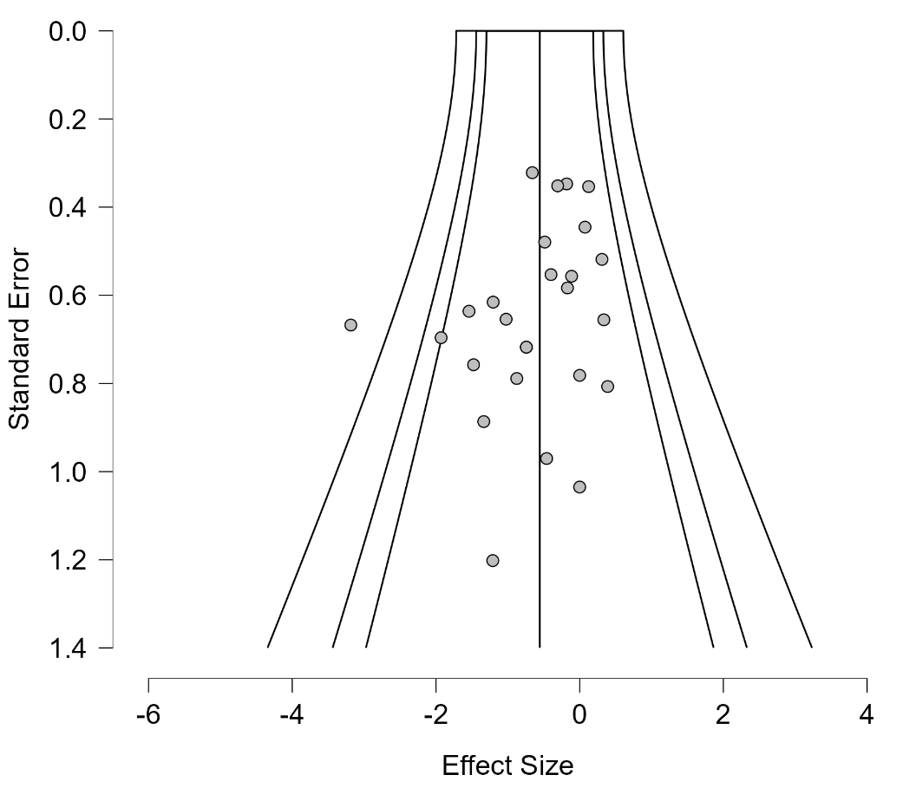 | Funnel Plot Asymmetry Tests
  Weighted Regression Test for Funnel Plot Asymmetry (Egger´s test)
   | Asymmetry Test |  |  | Limit Estimate μ
  Estimates | t | df | p | Estimate | Lower 95% CI | Upper 95% CI
  26 | -1.770 | 24 | .089 | 0.179 | -0.641 | 0.999

