Journal- Archives of Microbiology
Biomolecular Characterization of Bacillus tequilensis A1C1 Isolated from Soil and Chromatographic Analysis of D-serine in its Cellular Fraction
Shikha Kapil¹, Monika Bhattu², Tarun Kumar¹, Vipasha Sharma^{1*}
¹University Institute of Biotechnology, Chandigarh University, Gharuan Mohali (Punjab) Pin:140413, India
²University Centre for Research & Development, Chandigarh University, Gharuan Mohali (Punjab) Pin:140413, India
*Corresponding Author: sharma.vipasha@gmail.com
*ORCID ID- https://orcid.org/0000-0001-6903-0513
Supplementary material
Fig.S1 Observation was calculated after 24hrs of incubation on M9 minimal salt media agar plate: A; results were observed after 48hrs of incubation on modified minimal media agar plate: B. Out of 31 isolated, only 9 samples were grown on the modified minimal media agar plate. b-Ca1C1, d-Ca1C2, f-Ca2C2, h-Ca2C3, j-A1C1, l-A1C2, n-Rm2C2 q-Rm2C3, s-Ms5C2 are the isolates obtained after the primary screening. c- as a control (E. coli, MTCC-40) in each Petri plate.
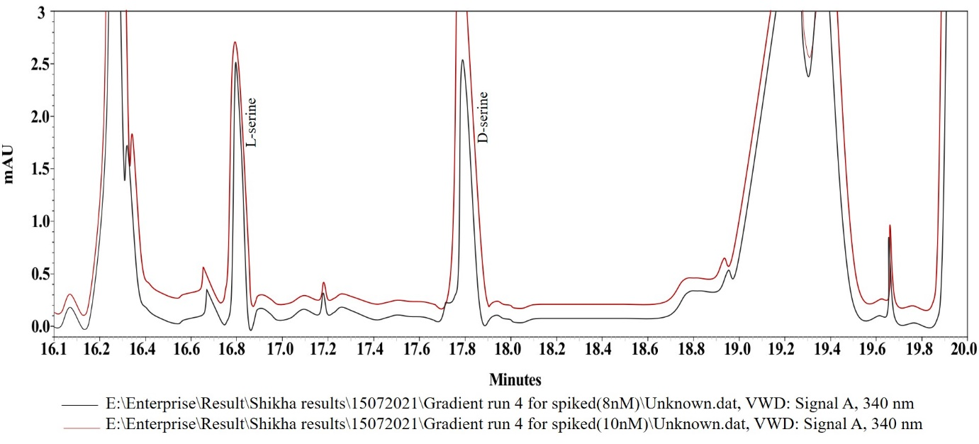
Fig. S2 Elution profile of the spiked D-serine of concentration 8nM and 10nM in the bacterial cellular fraction.

Table. S1 Brief description of the sample and collecting sites from various districts of northern India.
S.no. | Site of sample collection |  | Coordinates | Total number of colonies | Colonies on M9 media supplemented with L-Serine
 | Sample 1 | Bilaspur (H.P) | 31°46’25.02” N 76°78’55.34” E | 2 | 2
 | Sample 2 | Hamirpur (H.P) | 31°37’27.14” N 76°34’9.25” E | 9 | 2
 | Sample 3 | Solan (H.P) | 30°50’13.79” N 76°57’41.13” E | 2 | 2
 | Sample 4 | Mohali (Punjab) | 30°42’16.73” N 76°43’4.34” E | 14 | 3
 | Sample 5 | Srinagar (J&K) | 34°5’1.17” N 74°47’50.53” E | 4 | NA
NA- Not any
Table.S2 Similarity score of Bacillus tequilensis A1C1 to its nearby species.
Hit taxon name | Hit strain name | Accession number | Similarity
Bacillus tequilensis | KCTC 13622(T) | AYTO01000043 | 99.93
Bacillus cabrialesii | TE3(T) | MK462260 | 99.86
Bacillus inaquosorum | KCTC 13429(T) | AMXN01000021 | 99.86
Bacillus subtilis | NCIB 3610(T) | ABQL01000001 | 99.78
Bacillus stercoris | JCM 30051(T) | CP002905 | 99.78
Bacillus spizizenii | NRRL B-23049(T) | CP002905 | 99.78
Bacillus halotolerans | ATCC 25096(T) | LPVF01000003 | 99.64
Bacillus vallismortis | DV1-F-3(T) | JH600273 | 99.64
Bacillus nakamurai | NRRL B-41091(T) | LSAZ01000028 | 99.57
Bacillus velezensis | CR-502(T) | AY603658 | 99.55

Table. S3 BLAST analysis hits of A1C1.
Hit taxon name | Hit strain name | Accession number | Similarity
Bacillus tequilensis | B12-Q-2 | OK325875.1 | 100
Bacillus subtilis | LSRBMoFPIKRGCFTRI23 | MT133330.1 | 99.93
Bacillus subtilis | SBTS18 | MN382369.1 | 99.93
Bacillus subtilis | SBTS18 | MN382369.1 | 99.93
Bacillus subtilis subsp. subtilis | KACC16064 | MK240367.1 | 99.93
Bacillus subtilis subsp. subtilis | KACC15955 | MK240366.1 | 99.93
Bacillus subtilis subsp. subtilis | KACC15951 | MK240364.1 | 99.93
Bacillus tequilensis strain | MITCV1 | MG461176.1 | 99.93
Bacillus vallismortis | CA6B | MG397007.1 | 99.93
Bacillus subtilis | KmS1200905 | MG011556.1 | 99.93

Table. S4 Comparison of antimicrobial activity of Intracellular and extracellular fractions with standard drugs.
Sample | Zone in mm
 | MTCC 40 | MTCC 11949
Ampicillin | 17.66±0.3 | 14.33±0.3
Penicillin | 17.33±0.3 | 14.66±0.3
Intracellular fractions | ND | ND
Extracellular fractions | 4.66±0.3 | 2.33±0.3
ND - Not detected, Values are Mean ± S.D of three independent values (n=3).
Table. S5 Concentration range of standards (Std.) with the area used for the preparation of calibration curve.
Sr. No. | Sample | Concentration (nM) | Area
 | Std. | 5 | 357502±0.30
 | Std. | 10 | 589741±0.32
 | Std. | 20 | 1206413±0.40
 | Std. | 30 | 1581926±0.35
Values are Mean ± S.D of three independent values (n=3).

