Dissolved organic matter composition and stability in headwater catchments of the northern hemisphere are influenced by land use, but chemogeography persists

Authors: Philipp Maurischat^{1,2}, Sara E. Anthony^{3,4}, Alba Camacho-Santamans^{5,6}, Lukas Hallberg⁷, Carolina Jativa^{5,8}, Abagael N. Pruitt⁹, Elise D. Snyder^{9,14}, Emma M. Thrift-Cahall⁹, Anna E.S. Vincent^{9,10}, Maarten Wynants^{7, 11, 12}, Alberto Zannella¹³, Magdalena Zofia Bieroza⁷

Supplementary Materials

Table S1: Abiotic and biotic information of the investigated watersheds
Catchment | ID | Land use / Land cover [%] |  |  |  |  |  | Climate |  | Slope [%] |  | Soil |  |  |  |  | Area [km²]*
Catchment | ID | Crop-land | Pasture | Deciduous forest | Coniferous Forest | Urban | Wetland | Mean precipitation [mm] | Mean temperature [°C] | Mean | SD | Dominant Type | Dominant Texture | Mean pH | Topsoil  Organic carbon [%] | Hydromorphic soils [%] | Area [km²]*
Sweden 1 | SjoSE | 29.5 | - | 7 | 61.2 | - | - | 507.7 | 7.3 | 2.27 | 2.93 | Leptosol/Cambisol | Sandy Loam | 6.03 | 3.7 | - | 9.7
Sweden 2 | AkrSE | 26.2 | - | 5 | 61.4 | - | 4.9 | 507.7 | 7.3 | 2.03 | 2.17 | Dystric Cambisol | Loam | 5.35 | 4.7 | - | 7.88
Sweden 3 | GamSE | 31.5 | 10.2 | 0.2 | 55.4 | - | - | 584.9 | 7.3 | 2.14 | 2.39 | Regosol | Sandy Loam | 5.14 | 1.4 | - | 8.1
Sweden 4 | TorSE | 93.2 | 3.1 | - | - | 2.2 | - | 690.4 | 8.4 | 1.52 | 1.32 | Cambisol | Loam | 6.16 | 3.27 | - | 13.07
Sweden 5 | MarSE | 91.4 | - | 2.3 | - | 4.3 | - | 657.3 | 8.7 | 1.52 | 1.68 | Calcaric Cambisol | Loam | 8.22 | 1.1 | - | 10.88
Sweden 6 | KalSE | 89.7 | 2 | 5.2 | - | 1.6 | - | 657.3 | 8.7 | 1.57 | 1.78 | Calcaric Cambisol | Loam | 8.22 | 1.1 | - | 42.34
Sweden 7 | TvaSE | 70.6 | 3 | 13.9 | 4.9 | 5.6 | - | 798.5 | 8.2 | 1.99 | 3.38 | Dystric Cambisol | Loam | 5.38 | 4.77 | - | 16.33
Sweden 8 | HagSE | 26.6 | 3.5 | 6 | 55.1 | 7 | 0.8 | 537 | 6.7 | 2 | 2.76 | Podzol/ Dystric Cambisol | Sandy Loam | 5.23 | 6.43 | - | 121.71
USA 1 | SoyUS | 88.2 | 0.5 | 0.3 | - | 10.6 | 0.1 | 1062.8 | 11.5 | 1.2 | 0.98 | Luvic Phaeozem | Silt Loam | 6.4 | 2.1 | - | 87.89
USA 2 | ShaUS | 59.4 | 6.4 | 10.1 | 0.3 | 12 | 11.7 | 1055.1 | 10.6 | 1.72 | 3.12 | Haplic Luvisol | Loam | 6.14 | 1.59 | - | 947.46
USA 3 | KirUS | 95 | 0.1 | 0.1 | - | 4.2 | 0.1 | 1031.5 | 10.8 | 1.36 | 1.56 | Luvic Phaeozem | Silt Loam | 6.4 | 2.1 | - | 32.1
USA 4 | SprUS | - | - | 0.3 | - | 98.6 | - | 981.4 | 10 | 1.89 | 1.62 | Luvic Phaeozem | Silt Loam | 6.4 | 2.1 | - | 8.97
USA 5 | JudUS | 72.8 | 5.6 | 9.7 | 9.7 | 9.7 | 5.3 | 1055.1 | 10.6 | 1.53 | 2.79 | Haplic Luvisol | Loam | 6.2 | 1.6 | - | 536.27
USA 6 | EagUS | 44.2 | 5.6 | 12.9 | 12.9 | 12.9 | 20.3 | 956 | 10 | 1.57 | 2.86 | Haplic Luvisol | Loam | 6.12 | 1.6 | - | 2387.21
Germany 1 | ABSDE | 54.6 | 9.7 | 16.7 | 0.2 | 17.3 | - | 676.7 | 9.2 | 0.79 | 0.68 | Luvic Arenosol | Loamy Sand | 5.91 | 0.36 | - | 10.76
Germany 2 | SttDE | 57.6 | 9.6 | 11.3 | 14.9 | 5 | - | 676.7 | 9.2 | 2.21 | 4.52 | Luvic Arenosol | Loamy Sand | 5.9 | 0.3 | - | 14.29
Germany 3 | KoSDE | 55.3 | 29.1 | 9.7 | 1.1 | 3.6 | 0.5 | 586.7 | 9.7 | 1.56 | 2.38 | Haplic Luvisol | Silt Loam | 5.87 | 9.86 | 45 | 89.66
Germany 4 | FosDE | 42.5 | 0.5 | 10.5 | - | 45.6 | - | 682.1 | 9.6 | 1.9 | 3.08 | Haplic Luvisol | Silt Loam | 6.09 | 1.56 | 0 | 58.72
Germany 5 | LacDE | 30.2 | 5.2 | 8.5 | 53.6 | 1.9 | 0.5 | 665.3 | 9.8 | 2.54 | 4.17 | Haplic Podzol | Sandy Loam | 5.05 | 5.05 | 8 | 427.76
Germany 6 | HumDE | 57.6 | 8.7 | 23.5 | 6 | 3.6 | - | 726 | 9.6 | 2.4 | 6.04 | Luvisol/ Cambisol | Silt Loam /Clay | 6.74 | 0.88 | 25 | 106.7
Spain 1 | SFeES | - | - | 85.8 | - | - | 12 | 680 | 14.3 | 4.45 | 1.97 | Dystric Regosol | Sandy Loam | 5.66 | 1.2 | - | 2.61
Spain 2 | GuaES | - | - | 93.2 | - | 0.3 | 4.6 | 662.7 | 15.6 | 4.23 | 3.75 | Dystric Regosol | Sandy Loam | 5.66 | 1.2 | - | 12.87
Spain 3 | BreES | - | - | 91.1 | 7.5 | 0.1 | - | 662.7 | 15.6 | 3.98 | 3.75 | Dystric Regosol | Sandy Loam | 5.66 | 1.2 | - | 11.04
Spain 4 | RieES | - | - | 96.4 | 1.6 | - | - | 662.7 | 15.6 | 4.34 | 4.09 | Dystric Regosol | Sandy Loam | 5.66 | 1.2 | - | 5.97
Spain 5 | FdRES | - | - | 98.7 | - | - | - | 662.7 | 15.6 | 4.44 | 2.77 | Dystric Regosol | Sandy Loam | 5.66 | 1.2 | - | 13.07
Spain 6 | CDoES | 1.2 | 0.2 | 93 | 3.6 | - | - | 680 | 14.3 | 3.53 | 2.28 | Dystric Regosol | Sandy Loam | 5.66 | 1.2 | - | 9.35
Spain 7 | RdOES | - | - | 63.9 | 8.1 | 25.8 | - | 680 | 14.3 | 2.48 | 1.95 | Dystric Regosol | Sandy Loam | 5.66 | 1.2 | - | 6.78
Spain 8 | MonES | - | - | 0.6 | 18.3 | 76.1 | - | 662.7 | 15.6 | 1.66 | 0.72 | Dystric Regosol | Sandy Loam | 5.66 | 1.2 | - | 1.30
Spain 9 | AiPES | - | - | 22.1 | 4.8 | 70.7 | - | 662.7 | 15.6 | 2.2 | 0.84 | Dystric Regosol | Sandy Loam | 5.66 | 1.2 | - | 3.86*
* Upstream area of watershed from sampling point

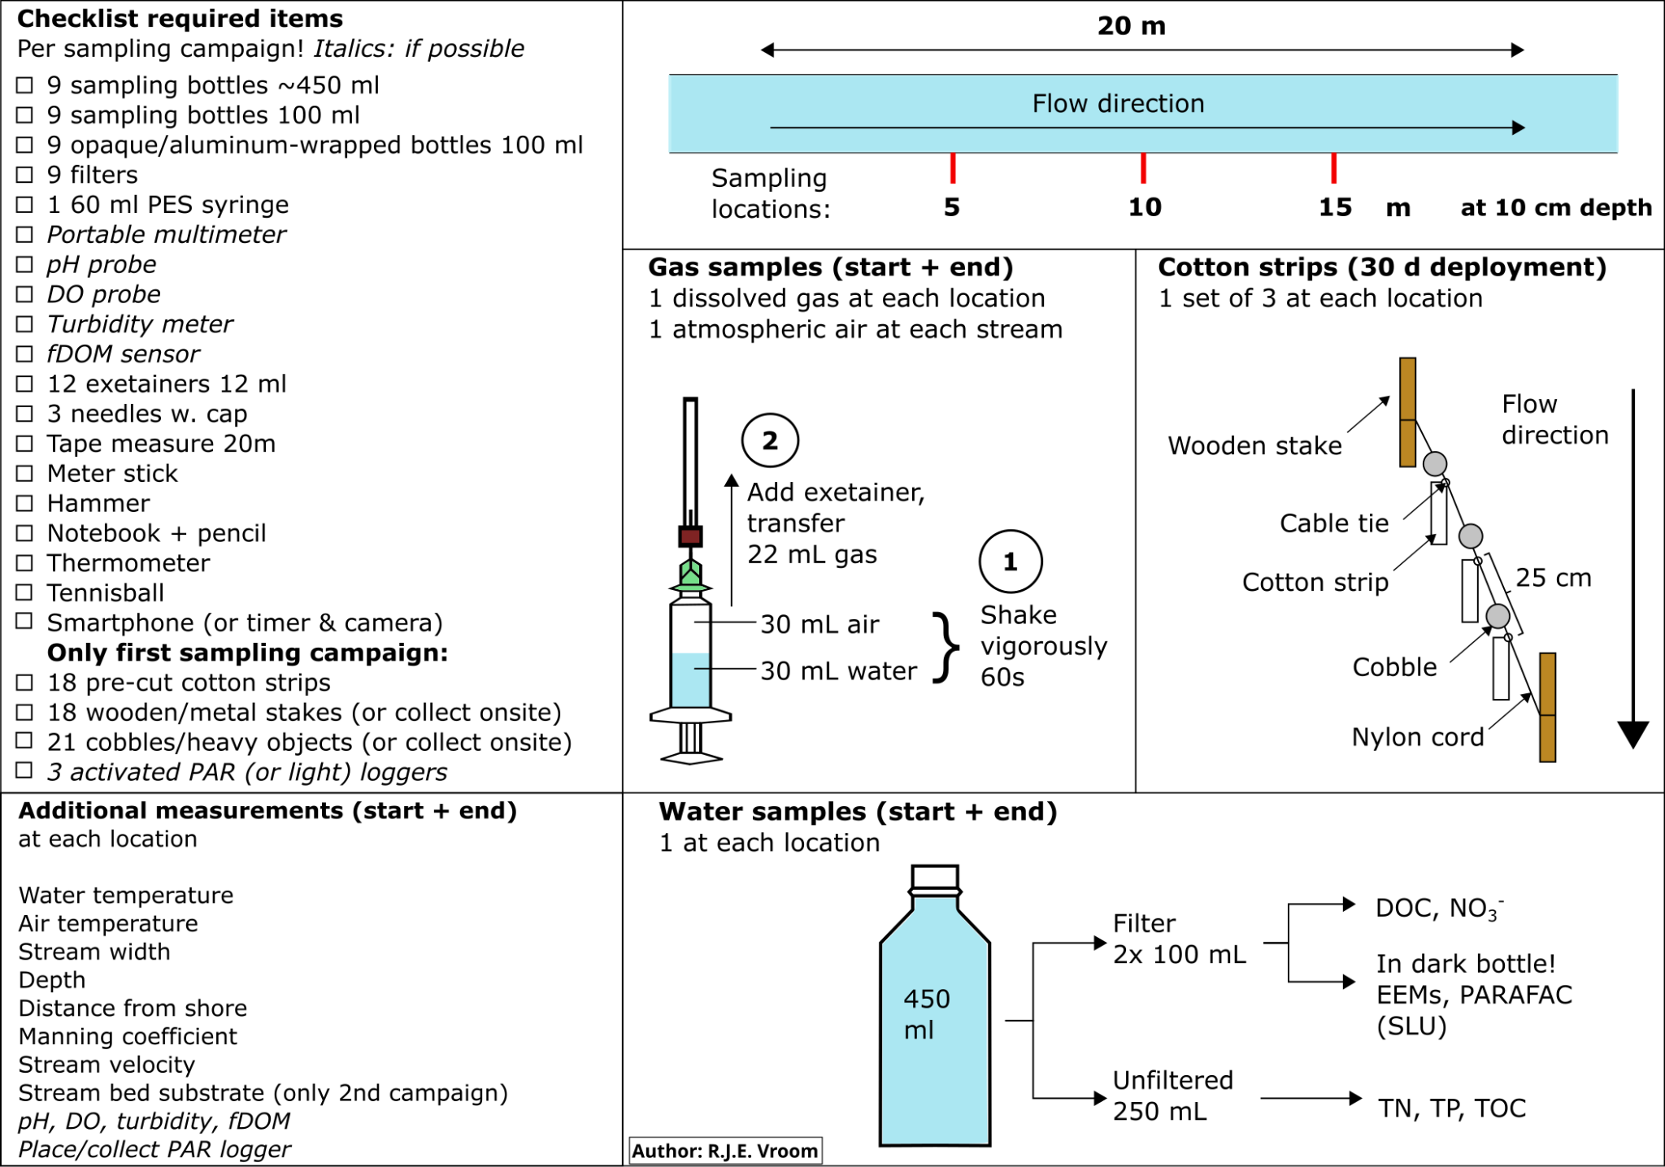
Figure S1: General sampling scheme for the coordinated distributed experiment forming the explicit guideline for CDE participant groups
Table S2: Nutrient and DOC instrument details of individual CDE partners
Group | Parameter | Detection method | Instrument
Sweden | NH₄ | Colorimetric ion analysis | Gallery Aqua Master, ThermoFischer, USA
Sweden | NO₃ | Colorimetric ion analysis | Seal, AutoAnalyzer 500
Sweden | SRP | Colorimetric ion analysis | Gallery Aqua Master, ThermoFischer, USA
Sweden | DOC | High-temperature oxidation | Shimadzu TOC‑VCPH, Shimadzu, Japan
Spain | NH₄ | Ion chromatography | Metrohm 930 Compact IC Flex, Herisau, Switzerland
Spain | NO₃ | Ion chromatography | Metrohm 930 Compact IC Flex, Herisau, Switzerland
Spain | SRP | Ion chromatography | Metrohm 930 Compact IC Flex, Herisau, Switzerland
Spain | DOC | High-temperature oxidation | varioTOC Cube, Elementar, Langenselbold, Germany
Germany 1 (Hannover) | NH₄ | Ion chromatography | Metrohm 930 Compact IC Flex, Herisau, Switzerland
Germany 1 (Hannover) | NO₃ | Ion chromatography | Metrohm 930 Compact IC Flex, Herisau, Switzerland
Germany 1 (Hannover) | SRP | Ion chromatography | Metrohm 930 Compact IC Flex, Herisau, Switzerland
Germany 1 (Hannover) | DOC | High-temperature oxidation | varioTOC Cube, Elementar, Langenselbold, Germany
Germany 2 (Rostock) | NH₄ | Continuous Flow Analyzer | AA3, Seal Analytical, Norderstedt, Germany
Germany 2 (Rostock) | NO₃ | Continuous Flow Analyzer | AA3, Seal Analytical, Norderstedt, Germany
Germany 2 (Rostock) | SRP | Continuous Flow Analyzer | AA3, Seal Analytical, Norderstedt, Germany
Germany 2 (Rostock) | DOC | High-temperature catalytic oxidation | Multi N/C 2100 S, Analytic Jena, Germany
USA | NH₄ | Colorimetric ion analysis | Lachat QuickChem Autoanalyzer, Lachat Instruments, Loveland, CO
USA | NO₃ | Colorimetric ion analysis | Lachat QuickChem Autoanalyzer, Lachat Instruments, Loveland, CO
USA | SRP | Colorimetric ion analysis | Lachat QuickChem Autoanalyzer, Lachat Instruments, Loveland, CO
USA | DOC | High-temperature oxidation | Shimadzu TOC-L analyser, Columbia, Maryland, USA

Table S3: Greenhouse Gas analysis instrument details of individual CDE partners
Group | Instrument | CH4 Detection method | CO2 Detection method
Sweden 1 | GasScouter G4301 | Cavity-ring-down spectrophotometer
Sweden 2 | Perkin Elmer Clarus 500 GC | FID | TCD
Spain | Agilent Technologies 7820A GC | FID | + Methanizer
Germany 1 + US | Agilent Technologies 7890B GC | FID | TCD
Germany 2 | Shimadzu GC-2014 | FID | ECD

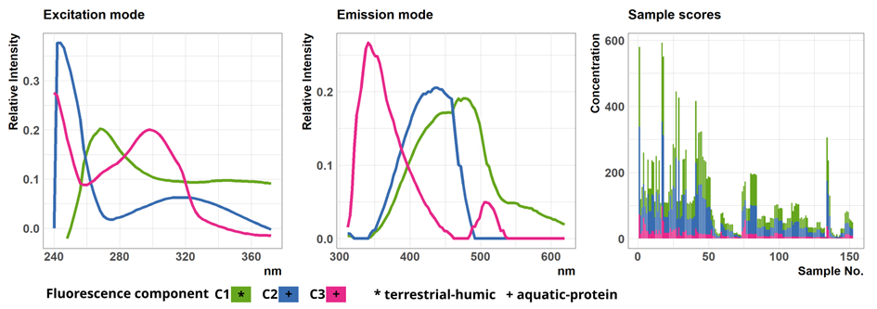
Figure S2: Excitation / emission loadings and sample scores of the fitted three component PARAFAC model. Component composition was verified using the OpenFluor database (Wünsch et al. 2014).
Table S4: Comparison results for PARAFAC resolved EEMs and the OpenFluor database
PARAFAC-Component | Component type | Study used for verification | Study DOI
C1 | terrestrial-borne humic-like | Dainard & Gueguen (2013) | 10.1016/j.marchem.2013.10.007
C1 | terrestrial-borne humic-like | Chen et al. (2017) | 10.1016/j.watres.2017.05.022
C1 | terrestrial-borne humic-like | Yamashita et al. (2010) | 10.1016/j.dsr2.2010.02.016
C2 | microbial produced and temperature sensitive | Gao and Gueguen 2017 | 10.1016/j.dsr.2016.12.014
C2 | microbial produced and temperature sensitive | Wünsch et al. (2018) | 10.1016/j.marchem.2018.08.010
C2 | microbial produced and temperature sensitive | Murphy et al. (2018) | 10.1021/acs.est.8b02648
C3 | essential proteinaceous material | Catala et al. (2015) | 10.1038/ncomms6986
C3 | essential proteinaceous material | Murphy et al. (2011) | 10.1021/es103015e
C3 | essential proteinaceous material | Retelletti Brogi et al. (2018) | 10.1016/j.scitotenv.2018.01.251

Table S5: Statistical testing documentation for group-wise comparisons. Performed was: Kruskal-Wallis test with Dunns post-hoc test including Bonferroni correction for multiple pairwise testing. Initial unadjusted alpha (α) level = 0.05.
Country
Variable: A₂₅₄ (UV 254 nm)
Comparison | Z | P adjusted | Sig (α<0.01)
Germany - Spain | 2.0814 | 0.2244 | -
Germany - Sweden | -6.8349 | 0.0000 | *
Spain - Sweden | -7.6677 | 0.0000 | *
Germany - USA | 0.7804 | 1.0000 | -
Spain - USA | -1.5340 | 0.7502 | -
Sweden - USA | 8.2196 | 0.0000 | *
Variable: UV E2:E3
Comparison | Z | P adjusted | Sig (α<0.01)
Germany - Spain | -2.0119 | 0.2654 | -
Germany - Sweden | -3.0051 | 0.0159 | -
Spain - Sweden | -0.2519 | 1.0000 | -
Germany - USA | -0.7011 | 1.0000 | -
Spain - USA | 1.5258 | 0.7623 | -
Sweden - USA | 2.4480 | 0.0862 | -
Variable: UV spectral slope
Comparison | Z | P adjusted | Sig (α<0.01)
Germany - Spain | 0.3994 | 1.0000 | -
Germany - Sweden | 1.2240 | 1.0000 | -
Spain - Sweden | 0.5502 | 1.0000 | -
Germany - USA | 1.8187 | 0.4137 | -
Spain - USA | 1.0543 | 1.0000 | -
Sweden - USA | 0.7148 | 1.0000 | -
Variable: F Index
Comparison | Z | P adjusted | Sig (α<0.01)
Germany - Spain | 3.3881 | 0.0042 | *
Germany - Sweden | 6.2132 | 0.0000 | *
Spain - Sweden | 1.3431 | 1.0000 | -
Germany - USA | -0.4361 | 1.0000 | -
Spain - USA | -3.8762 | 0.0006 | *
Sweden - USA | -7.1667 | 0.0000 | *
Variable: Freshness Index
Comparison | Z | P adjusted | Sig (α<0.01)
Germany - Spain | 2.2100 | 0.1626 | -
Germany - Sweden | 4.8827 | 0.0000 | *
Spain - Sweden | 1.5379 | 0.7445 | -
Germany - USA | -0.1795 | 1.0000 | -
Spain - USA | -2.4435 | 0.0873 | -
Sweden - USA | -5.4499 | 0.0000 | *
Variable: HIX (Humification Index)
Comparison | Z | P adjusted | Sig (α<0.01)
Germany - Spain | 3.7299 | 0.0011 | *
Germany - Sweden | -3.5770 | 0.0021 | *
Spain - Sweden | -6.8269 | 0.0000 | *
Germany - USA | -1.1868 | 1.0000 | -
Spain - USA | -4.8382 | 0.000 | *
Sweden - USA | 2.5205 | 0.0703 | -
Variable: DOC
Comparison | Z | P adjusted | Sig (α<0.01)
Germany - Spain | 0.6351 | 1.0000 | -
Germany - Sweden | -7.3134 | 0.0000 | *
Spain - Sweden | -6.6227 | 0.0000 | *
Germany - USA | -4.4751 | 0.0000 | *
Spain - USA | -4.3994 | 0.0001 | *
Sweden - USA | 2.0880 | 0.2208 | -
Variable: SUVA₂₅₄
Comparison | Z | P adjusted | Sig (α<0.01)
Germany - Spain | 1.4953 | 0.8090 | -
Germany - Sweden | 2.6696 | 0.0456 | -
Spain - Sweden | 0.6123 | 1.0000 | -
Germany - USA | 7.2731 | 0.0000 | *
Spain - USA | 4.8209 | 0.0000 | *
Sweden - USA | 5.2715 | 0.0000 | *
Variable: PARAFAC Component 1
Comparison | Z | P adjusted | Sig (α<0.01)
Germany - Spain | 2.4132 | 0.0949 | -
Germany - Sweden | -6.4360 | 0.0000 | *
Spain - Sweden | -7.7033 | 0.0000 | *
Germany - USA | 0.3238 | 1.0000 | -
Spain - USA | -2.2480 | 0.1474 | -
Sweden - USA | 7.2810 | 0.0000 | *
Variable: PARAFAC Component 2
Comparison | Z | P adjusted | Sig (α<0.01)
Germany - Spain | 2.4785 | 0.0792 | -
Germany - Sweden | -6.5657 | 0.0000 | *
Spain - Sweden | -7.8764 | 0.0000 | *
Germany - USA | 0.4595 | 1.0000 | -
Spain - USA | -2.2064 | 0.11641 | -
Sweden - USA | 7.5719 | 0.0000 | *
Variable: PARAFAC Component 3
Comparison | Z | P adjusted | Sig (α<0.01)
Germany - Spain | 2.6725 | 0.0452 | -
Germany - Sweden | -4.7267 | 0.0000 | *
Spain - Sweden | -6.6167 | 0.0000 | *
Germany - USA | 1.6878 | 0.5487 | -
Spain - USA | -1.4154 | 0.9416 | -
Sweden - USA | 6.9663 | 0.0000 | *
Variable: PARAFAC Aquatic
(Combined: Component 2+Component 3)
Comparison | Z | P adjusted | Sig (α<0.01)
Germany - Spain | 2.6083 | 0.0546 | -
Germany - Sweden | -6.2159 | 0.0000 | *
Spain - Sweden | -7.7357 | 0.0000 | *
Germany - USA | 0.8930 | 1.0000 | -
Spain - USA | -1.9910 | 0.2789 | -
Sweden - USA | 7.6798 | 0.0000 | *
Variable: PARAFAC Aquatic RELATIVE
(Combined: Component 2+Component 3)
Comparison | Z | P adjusted | Sig (α<0.01)
Germany - Spain | 0.19193855 | 1.0000 | -
Germany - Sweden | -0.08075227 | 1.0000 | -
Spain - Sweden | -0.26893386 | 1.0000 | -
Germany - USA | 1.26387738 | 1.0000 | -
Spain - USA | 0.82174806 | 1.0000 | -
Sweden - USA | 1.49803845 | 0.804 | -
Variable: PARAFAC HUMIC RELATIVE
(Component 1)
Comparison | Z | P adjusted | Sig (α<0.01)
Germany - Spain | -0.19193855 | 1.0000 | -
Germany - Sweden | 0.08075227 | 1.0000 | -
Spain - Sweden | 0.26893386 | 1.0000 | -
Germany - USA | -1.26387738 | 1.0000 | -
Spain - USA | -0.82174806 | 1.0000 | -
Sweden - USA | -1.49803845 | 0.8047 | -
Variable: CO₂-C
Comparison | Z | P adjusted | Sig (α<0.01)
Germany - Spain | 0.1198 | 1.0000 | -
Germany - Sweden | -8.2957 | 0.0000 | *
Spain - Sweden | -6.8286 | 0.0000 | *
Germany - USA | -2.3406 | 0.1155 | -
Spain - USA | -2.0312 | 0.2534 | -
Sweden - USA | 6.1107 | 0.0000 | *
Variable: CH₄-C
Comparison | Z | P adjusted | Sig (α<0.01)
Germany - Spain | -0.0960 | 1.0000 | -
Germany - Sweden | -7.1759 | 0.0000 | *
Spain - Sweden | -5.6992 | 0.0000 | *
Germany - USA | -3.1050 | 0.0114 | -
Spain - USA | -2.4340 | 0.0896 | -
Sweden - USA | 4.1351 | 0.0002 | *
Variable: NH₄-N
Comparison | Z | P adjusted | Sig (α<0.01)
Germany - Spain | NA | NA | NA
Germany - Sweden | -0.1865 | 1.0000 | -
Spain - Sweden | NA | NA | NA
Germany - USA | 0.0680 | 1.0000 | -
Spain - USA | NA | NA | NA
Sweden - USA | 0.2465 | 1.0000 | -
Variable: SRP (PO₄-P)
Comparison | Z | P adjusted | Sig (α<0.01)
Germany - Spain | 5.5132 | 0.0000 | *
Germany - Sweden | 1.4252 | 0.9245 | -
Spain - Sweden | -4.2771 | 0.0001 | *
Germany - USA | 3.3557 | 0.0047 | *
Spain - USA | -3.0870 | 0.0121 | -
Sweden - USA | 1.7691 | 0.4613 | -
Variable: NO₃-N
Comparison | Z | P adjusted | Sig (α<0.01)
Germany - Spain | 4.1446 | 0.0002 | *
Germany - Sweden | 4.9678 | 0.0000 | *
Spain - Sweden | -0.2958 | 1.0000 | -
Germany - USA | 3.9469 | 0.0005 | *
Spain - USA | -1.1753 | 1.0000 | -
Sweden - USA | -1.1678 | 1.0000 | -
Variable: Water Temp
Comparison | Z | P adjusted | Sig (α<0.01)
Germany - Spain | -4.5067 | 0.0000 | *
Germany - Sweden | -2.0721 | 0.2295 | -
Spain - Sweden | 3.0886 | 0.0121 | -
Germany - USA |  | 0.0000 | *
Spain - USA | -1.1869 | 1.0000 | -
Sweden - USA | -5.7405 | 0.0000 | *
Variable: DO (Dissolved Oxygen)
Comparison | Z | P adjusted | Sig (α<0.01)
Germany - Spain | -0.5553 | 1.0000 | -
Germany - Sweden | -0.8538 | 1.0000 | -
Spain - Sweden | -0.1087 | 1.0000 | -
Germany - USA | -1.9497 | 0.3073 | -
Spain - USA | -0.9812 | 1.0000 | -
Sweden - USA | -1.1494 | 1.0000 | -
Variable: Water pH
Comparison | Z | P adjusted | Sig (α<0.01)
Germany - Spain | 0.2332 | 1.0000 | -
Germany - Sweden | 1.6703 | 0.5691 | -
Spain - Sweden | 1.1010 | 1.0000 | -
Germany - USA | -2.8798 | 0.0239 | -
Spain - USA | -2.5326 | 0.0679 | -
Sweden - USA | -4.7129 | 0.0000 | *
Variable: Electrical Conductivity
Comparison | Z | P adjusted | Sig (α<0.01)
Germany - Spain | 3.1959 | 0.0084 | *
Germany - Sweden | 5.3224 | 0.0000 | *
Spain - Sweden | 0.7708 | 1.0000 | -
Germany - USA | -1.5517 | 0.7244 | -
Spain - USA | -4.4596 | 0.0000 | *
Sweden - USA | -7.2097 | 0.0000 | *
Variable: OM stability (Mean Tensile Loss degree day)
Comparison | Z | P adjusted | Sig (α<0.01)
Germany - Spain | 2.8851 | 0.0235 | -
Germany - Sweden | 1.6272 | 0.6222 | -
Spain - Sweden | -1.8139 | 0.4181 | -
Germany - USA | 4.0225 | 0.0003 | *
Spain - USA | 1.0173 | 1.0000 | -
Sweden - USA | 3.1323 | 0.0104 | -
Land Use Class (LULC)
Variable: A₂₅₄ (UV 254 nm)
Comparison | Z | P adjusted | Sig (α<0.01)
Agriculture - Forest | -2.6547 | 0.0238 | -
Agriculture - Urban | -0.8038 | 1.0000 | -
Forest - Urban | 0.9076 | 1.0000 | -
Variable: UV E2:E3
Comparison | Z | P adjusted | Sig (α<0.01)
Agriculture - Forest | -0.6441 | 1.0000 | -
Agriculture - Urban | 0.5694 | 1.0000 | -
Forest - Urban | 0.9393 | 1.0000 | -
Variable: UV spectral slope
Comparison | Z | P adjusted | Sig (α<0.01)
Agriculture - Forest | -1.7907 | 0.2200 | -
Agriculture - Urban | -4.7896 | 0.0000 | *
Forest - Urban | -3.3831 | 0.0022 | *
Variable: F Index
Comparison | Z | P adjusted | Sig (α<0.01)
Agriculture - Forest | 6.9561 | 0.0000 | *
Agriculture - Urban | -1.3477 | 0.5332 | -
Forest - Urban | -5.6272 | 0.0000 | *
Variable: Freshness Index
Comparison | Z | P adjusted | Sig (α<0.01)
Agriculture - Forest | 3.9321 | 0.0003 | *
Agriculture - Urban | -3.4839 | 0.0015 | -
Forest - Urban | -5.7414 | 0.0000 | *
Variable: (HIX) Humification Index
Comparison | Z | P adjusted | Sig (α<0.01)
Agriculture - Forest | 2.3194 | 0.0611 | -
Agriculture - Urban | 2.0776 | 0.1133 | -
Forest - Urban | 0.5007 | 1.0000 | -
Variable: DOC
Comparison | Z | P adjusted | Sig (α<0.01)
Agriculture - Forest | -1.0912 | 0.8256 | -
Agriculture - Urban | -1.5651 | 1.3526 | -
Forest - Urban | -0.7737 | 1.0000 | -
Variable: SUVA₂₅₄
Comparison | Z | P adjusted | Sig (α<0.01)
Agriculture - Forest | -1.5566 | 0.3587 | -
Agriculture - Urban | 2.1744 | 0.0890 | -
Forest - Urban | 3.1565 | 0.0048 | *
Variable: PARAFAC C1
Comparison | Z | P adjusted | Sig (α<0.01)
Agriculture - Forest | -0.8858 | 1.0000 | -
Agriculture - Urban | -0.7270 | 1.0000 | -
Forest - Urban | -0.1287 | 1.0000 | -
Variable: PARAFAC C2
Comparison | Z | P adjusted | Sig (α<0.01)
Agriculture - Forest | -0.9133 | 1.0000 | -
Agriculture - Urban | -0.8944 | 1.0000 | -
Forest - Urban | -0.2689 | 1.0000 | -
Variable: PARAFAC C3
Comparison | Z | P adjusted | Sig (α<0.01)
Agriculture - Forest | -1.4287 | 0.4592 | -
Agriculture - Urban | -3.1848 | 0.0043 | *
Forest - Urban | -2.1004 | 0.1071 | -
Variable: PARAFAC Aquatic Protein
(Combined: Component 2+Component 3)
Comparison | Z | P adjusted | Sig (α<0.01)
Agriculture - Forest | -1.1854 | 0.7076 | -
Agriculture - Urban | -1.3756 | 0.5069 | -
Forest - Urban | -0.5510 | 1.0000 | -
Variable: PARAFAC Aquatic Protein RELATIVE
(Combined: Component 2+Component 3)
Comparison | Z | P adjusted | Sig (α<0.01)
Agriculture - Forest | -1.782407 | 0.2240 | -
Agriculture - Urban | -4.400285 | 0.0000 | *
Forest - Urban | -3.022090 | 0.0075 | *
Variable: PARAFAC terrestrial RELATIVE
(Component 1)
Comparison | Z | P adjusted | Sig (α<0.01)
Agriculture - Forest | 1.782407 | 0.2240 | -
Agriculture - Urban | 4.400285 | 0.0000 | *
Forest - Urban | 3.022090 | 0.0075 | *
Variable: CO₂-C
Comparison | Z | P adjusted | Sig (α<0.01)
Agriculture - Forest | -1.0628 | 0.8636 | -
Agriculture - Urban | -0.3804 | 1.0000 | -
Forest - Urban | 0.3261 | 1.0000 | -
Variable: CH₄-C
Comparison | Z | P adjusted | Sig (α<0.01)
Agriculture - Forest | -1.1246 | 0.7823 | -
Agriculture - Urban | 0.3603 | 1.0000 | -
Forest - Urban | 1.0651 | 0.8605 | -
Variable: SRP (PO₄-P)
Comparison | Z | P adjusted | Sig (α<0.01)
Agriculture - Forest | 1.5025 | 0.3989 | -
Agriculture - Urban | -2.0266 | 0.1281 | -
Forest - Urban | -2.8618 | 0.0126 | -
Variable: NH₄-N
Comparison | Z | P adjusted | Sig (α<0.01)
Agriculture - Forest | 0.6207 | 1.000 | -
Agriculture - Urban | -3.9861 | 0.0002 | *
Forest - Urban | -4.0041 | 0.0002 | *
Variable: NO₃-N
Comparison | Z | P adjusted | Sig (α<0.01)
Agriculture - Forest | 2.9608 | 0.0092 | *
Agriculture - Urban | 0.2122 | 1.0000 | -
Forest - Urban | -1.6767 | 0.2808 | -
Variable: Water Temperature
Comparison | Z | P adjusted | Sig (α<0.01)
Agriculture - Forest | 1.8176 | 0.2074 | -
Agriculture - Urban | -2.7433 | 0.0182 | -
Forest - Urban | -3.7292 | 0.0006 | *
Variable: Dissolved Oxygen (DO)
Comparison | Z | P adjusted | Sig (α<0.01)
Agriculture - Forest | 2.1876 | 0.0860 | -
Agriculture - Urban | 4.4303 | 0.0000 | *
Forest - Urban | 2.7385 | 0.0185 | -
Variable: Water pH
Comparison | Z | P adjusted | Sig (α<0.01)
Agriculture - Forest | 4.0432 | 0.0002 | *
Agriculture - Urban | 1.5532 | 0.3611 | -
Forest - Urban | -1.1377 | 0.7657 | -
Variable: Electrical Conductivity
Comparison | Z | P adjusted | Sig (α<0.01)
Agriculture - Forest | 6.2223 | 0.0000 | *
Agriculture - Urban | -4.3296 | 0.0000 | *
Forest - Urban | -7.8223 | 0.0000 | *
Variable: OM stability (Mean Tensile Loss degree day)
Comparison | Z | P adjusted | Sig (α<0.01)
Agriculture - Forest | 0.7230 | 1.0000 | -
Agriculture - Urban | 1.5060 | 0.3962 | -
Forest - Urban | 1.0628 | 0.8636 | -

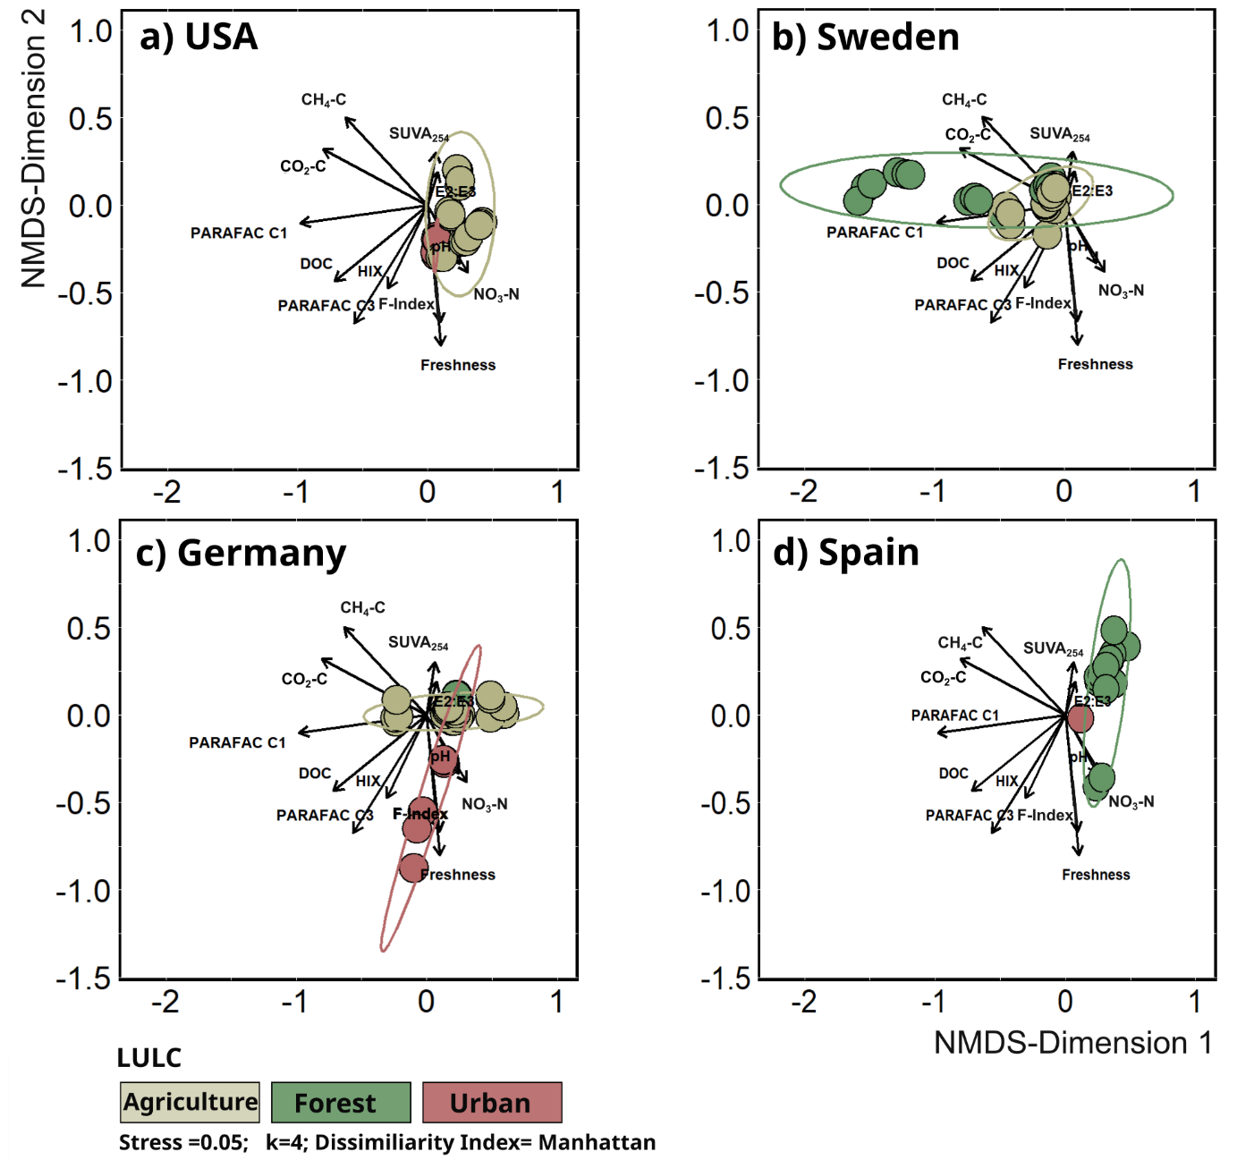
Figure S3: Non-metric dimensional scaling (NMDS) for the dataset filtered for countries with a LULC overlay. Included variable loadings were linear trend fitted onto the NMDS plane, collinear variables were excluded. Ellipses are calculated on assumed normal distribution for 95 % probability. Note that no explained variance can be given for NMDS ordination plots.

