Supplementary File
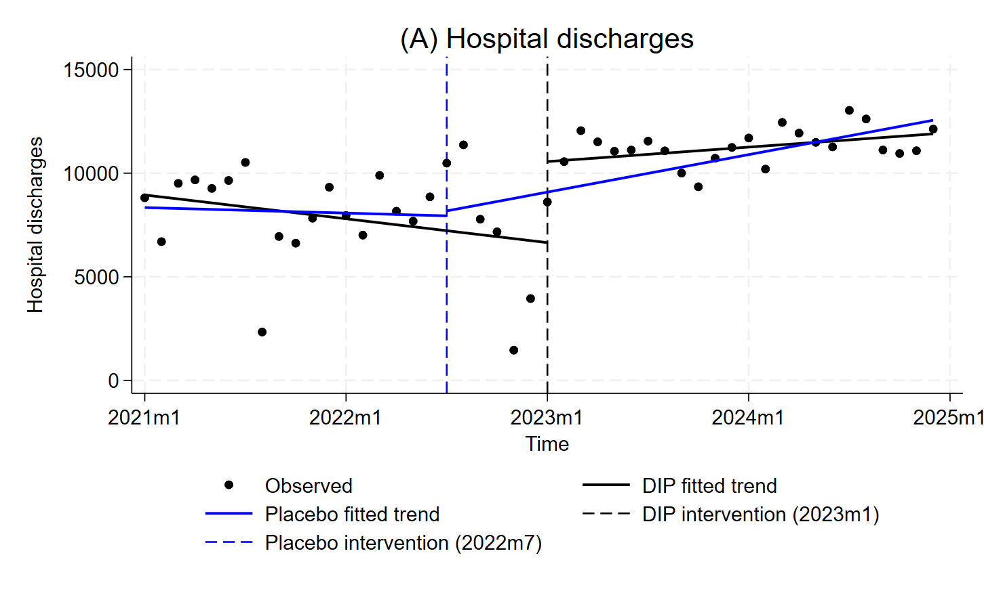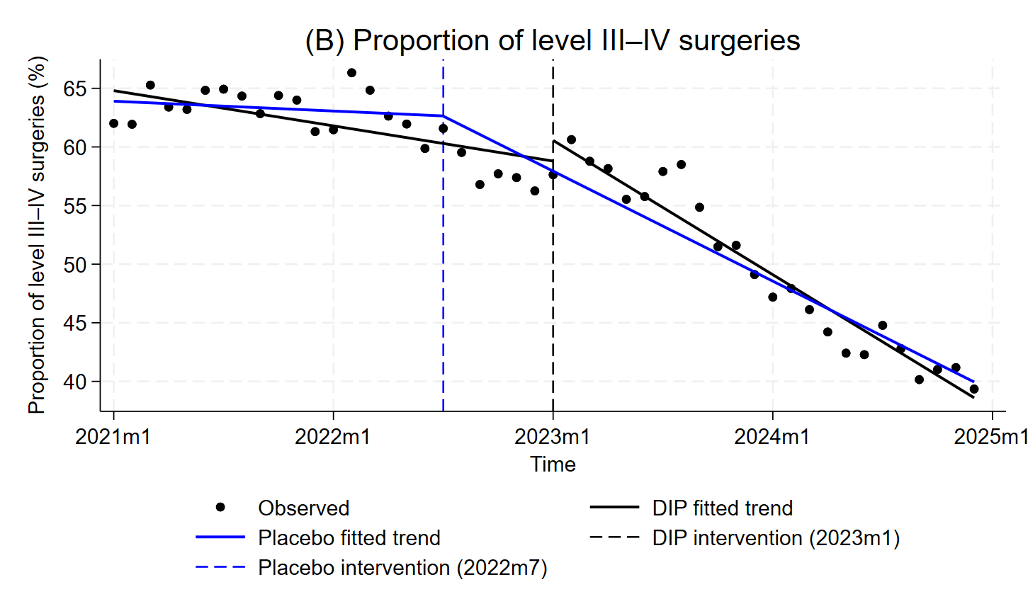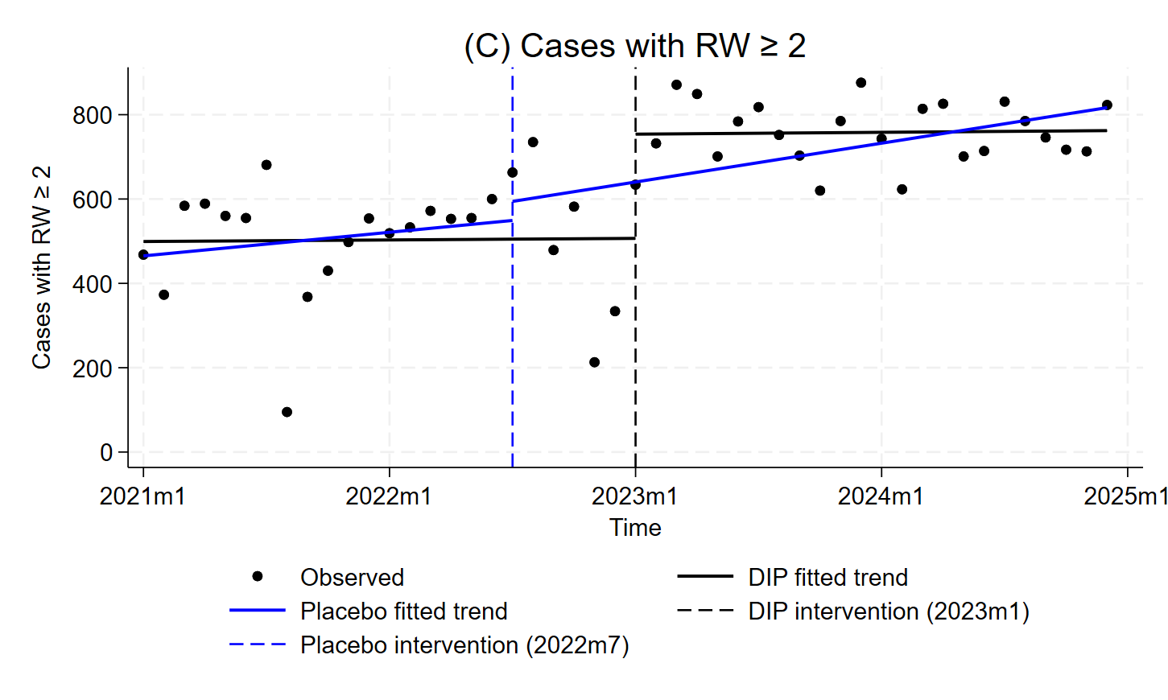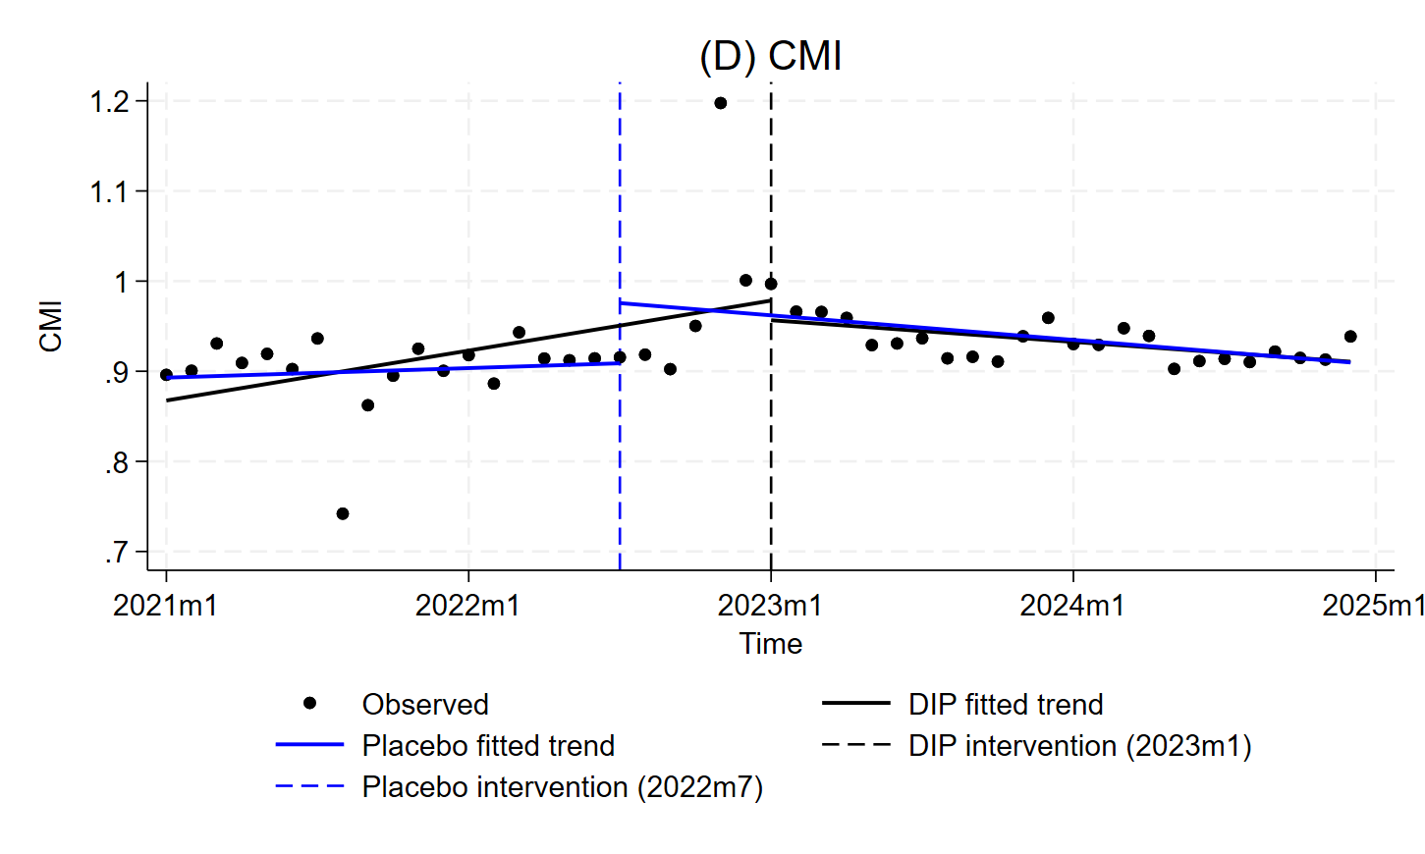
Fig. S1 Placebo test for service capacity indicators under the DIP reform. Hospital discharges and Cases with RW ≥ 2 showed no significant changes at the placebo intervention point. A significant slope change was observed for the proportion of level III–IV surgeries (p < 0.001), and a significant level change for CMI (p < 0.05). Overall, the placebo test supports the robustness of the main ITSA findings.
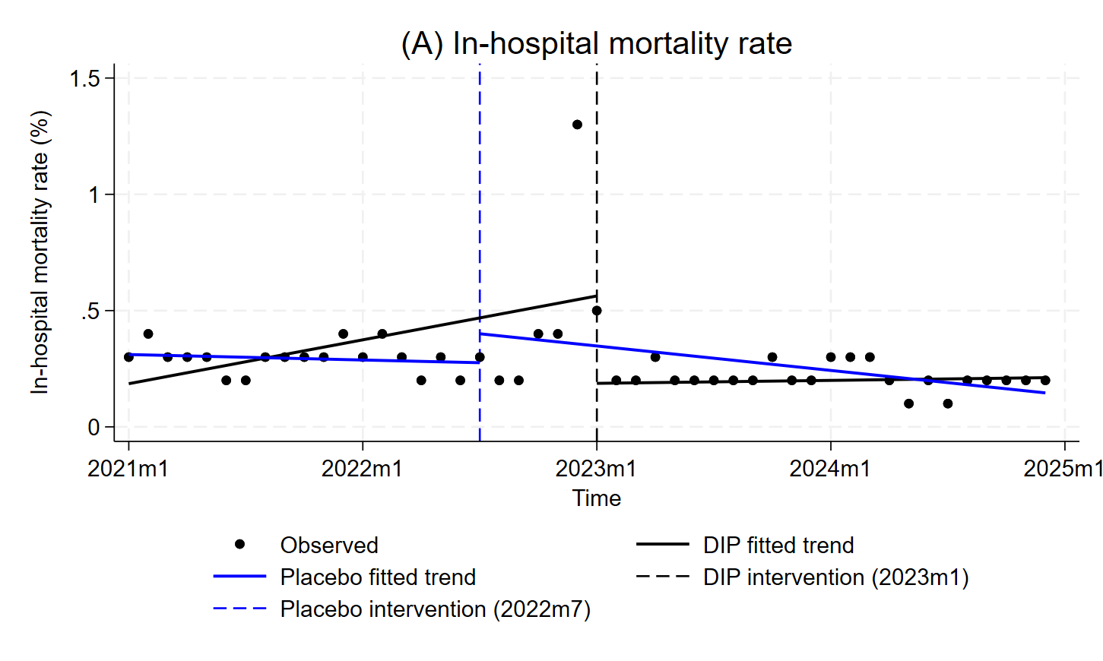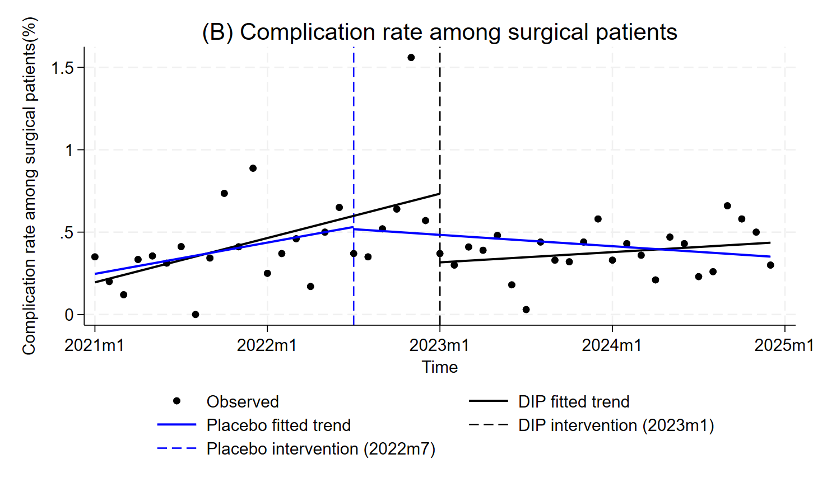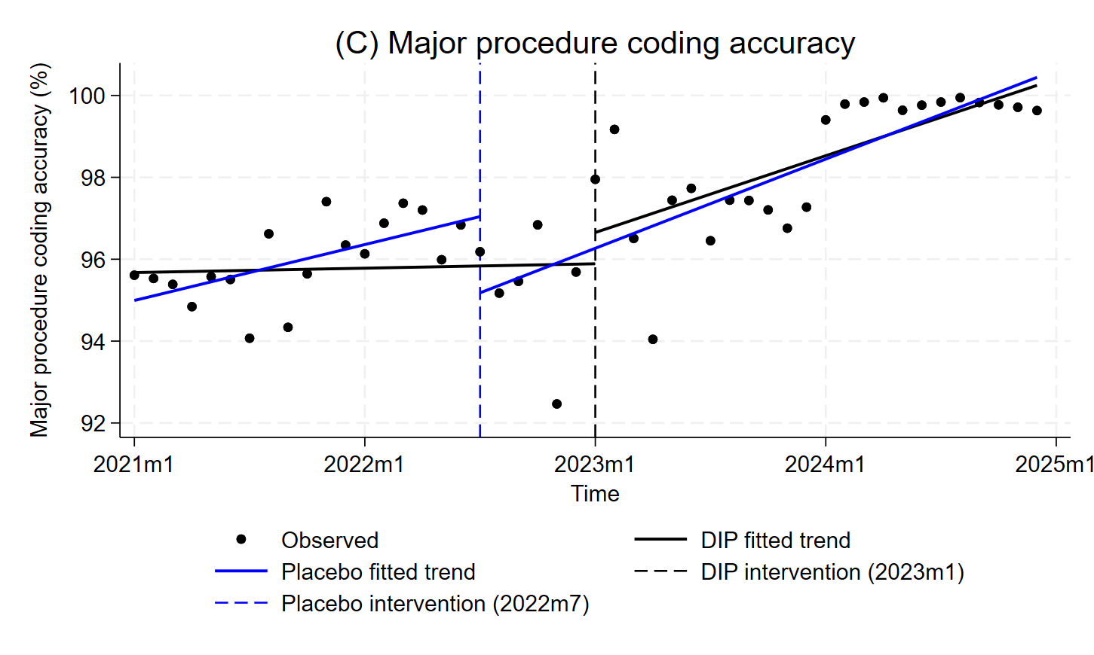
Fig. S2 Placebo test for quality-of-care indicators under the DIP reform. In-hospital mortality rate and complication rate among surgical patients showed no significant changes at the placebo intervention point. A significant level change was observed for major procedure coding accuracy (p < 0.01). Overall, the placebo test supports the robustness of the main ITSA findings.
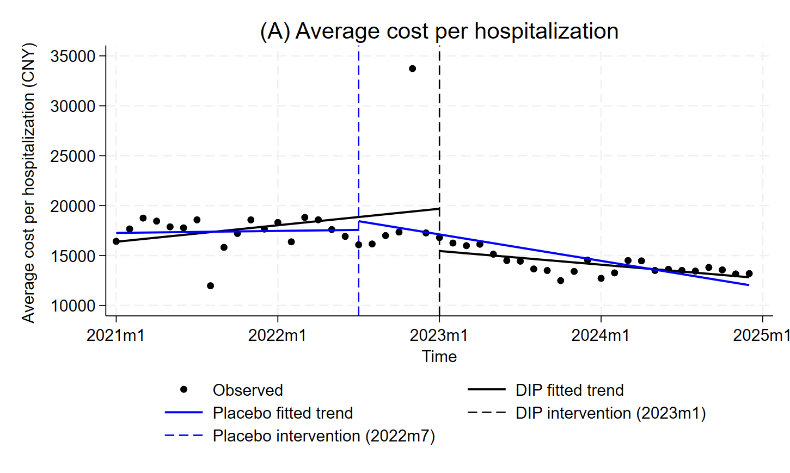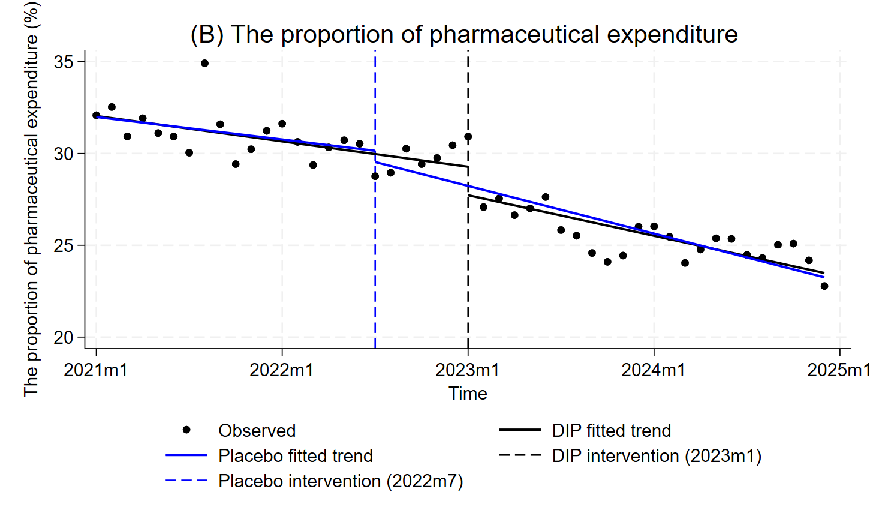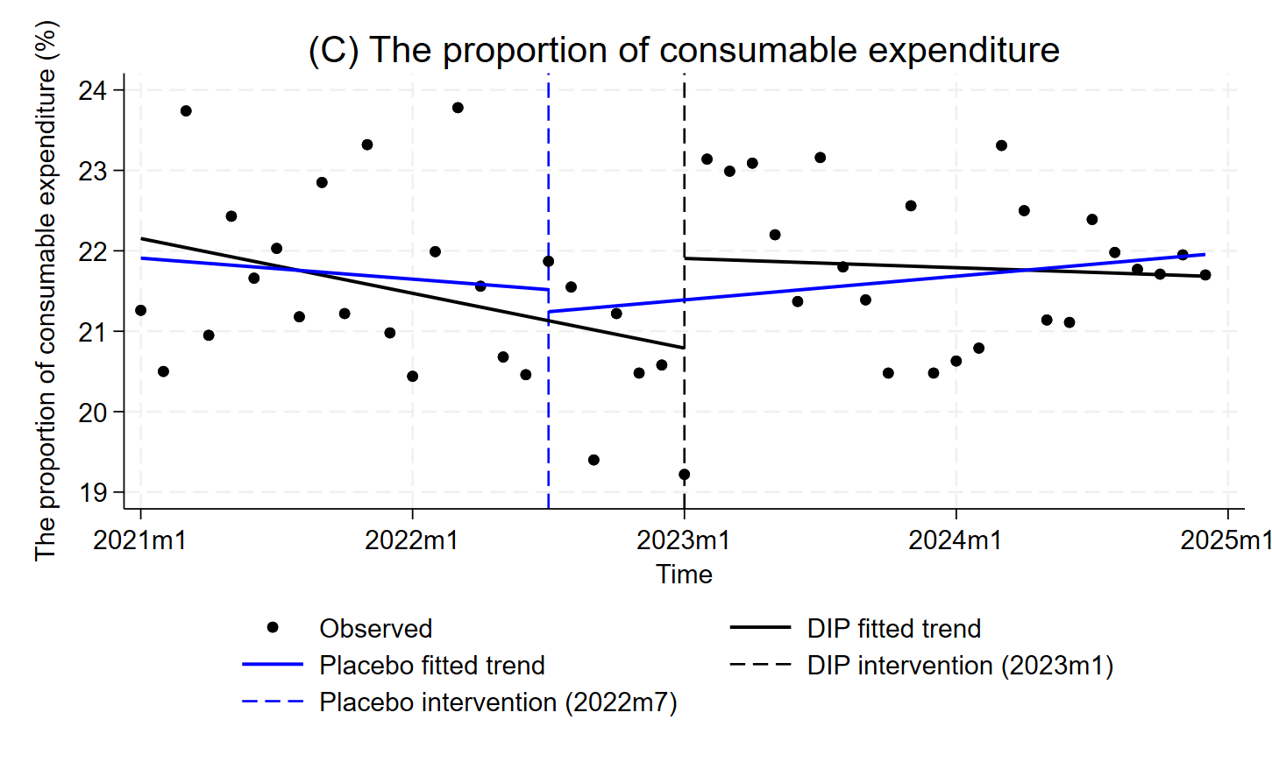
Fig. S3 Placebo test for cost control indicators under the DIP reform. Average cost per hospitalization, the proportion of pharmaceutical expenditure and the proportion of consumable expenditure showed no statistically significant changes at the placebo intervention point, confirming the robustness of the main ITSA findings
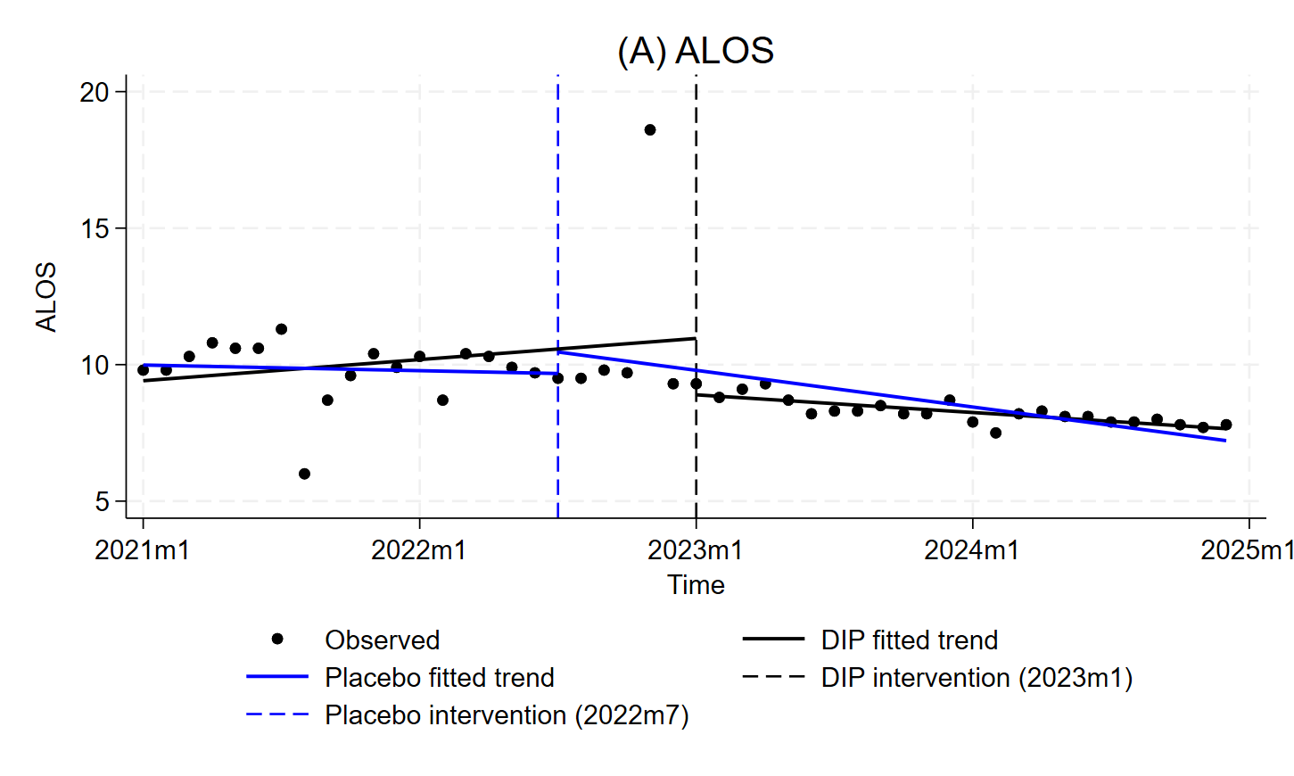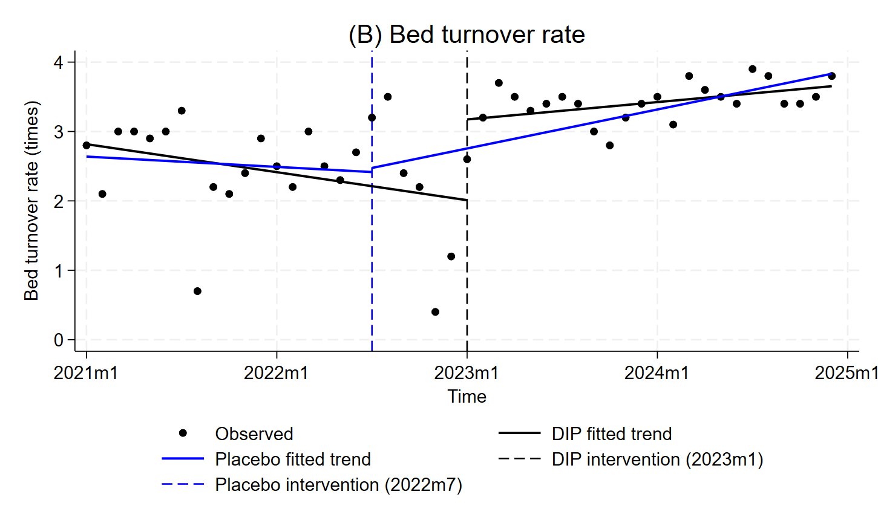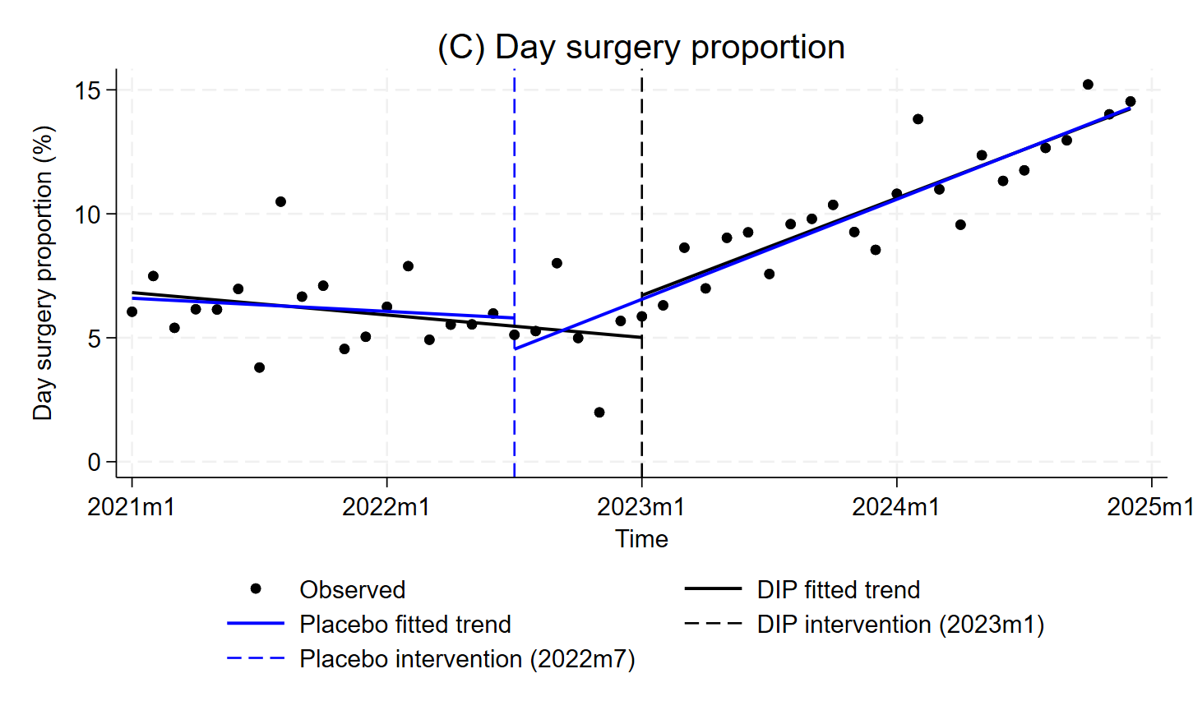
Fig. S4 Placebo test for resource efficiency indicators under the DIP reform. ALOS and bed turnover rate showed no significant changes at the placebo intervention point. A significant slope change was observed for day surgery proportion (p < 0.001). Overall, the placebo test supports the robustness of the main ITSA findings.

