Supplementary materials for

Chemically localized solvent-anion interactions enable ultra-high-loading practical lithium metal batteries operating at −70 ℃

Xuezhong Li ^{1, 2, †}, Chi Fang ^{3, †}, Weiliang Yi ⁴, Zhifang Wei ⁴, Wenqing Li ¹, Taisen Zuo ^{5, 6}, He Cheng ^{5, 6}, Phakkhananan Pakawanit ⁷, Sarayut Tunmee ⁷, Genming Lai ^{3, *}, Jiaxin Zheng ³, Bao Qiu ^{4, *}, Wei Deng ^{1, 2, *}, Yongbing Tang ^{1, 2, *}

1. Advanced Energy Storage Technology Research Center, Shenzhen Institutes of Advanced Technology, Chinese Academy of Sciences, Shenzhen, 518055, China
2. University of Chinese Academy of Sciences (UCAS), Beijing, 100049, China
3. School of Advanced Materials, Peking University, Shenzhen Graduate School, Shenzhen, 518055, China
4. Ningbo Institute of Materials Technology and Engineering, Chinese Academy of Sciences, Ningbo 315201, PR China
5. Spallation Neutron Source Science Center, Dongguan, 523000, China
6. Institute of High Energy Physics, Chinese Academy of Sciences, Beijing, China.
7. Synchrotron Light Research Institute, Nakhon Ratchasima, 30000, Thailand
† These authors contribute equally.
∗ Correspondence: w.deng@siat.ac.cn, genmingl@pku.edu.cn, qiubao@nimte.ac.cn, tangyb@siat.ac.cn
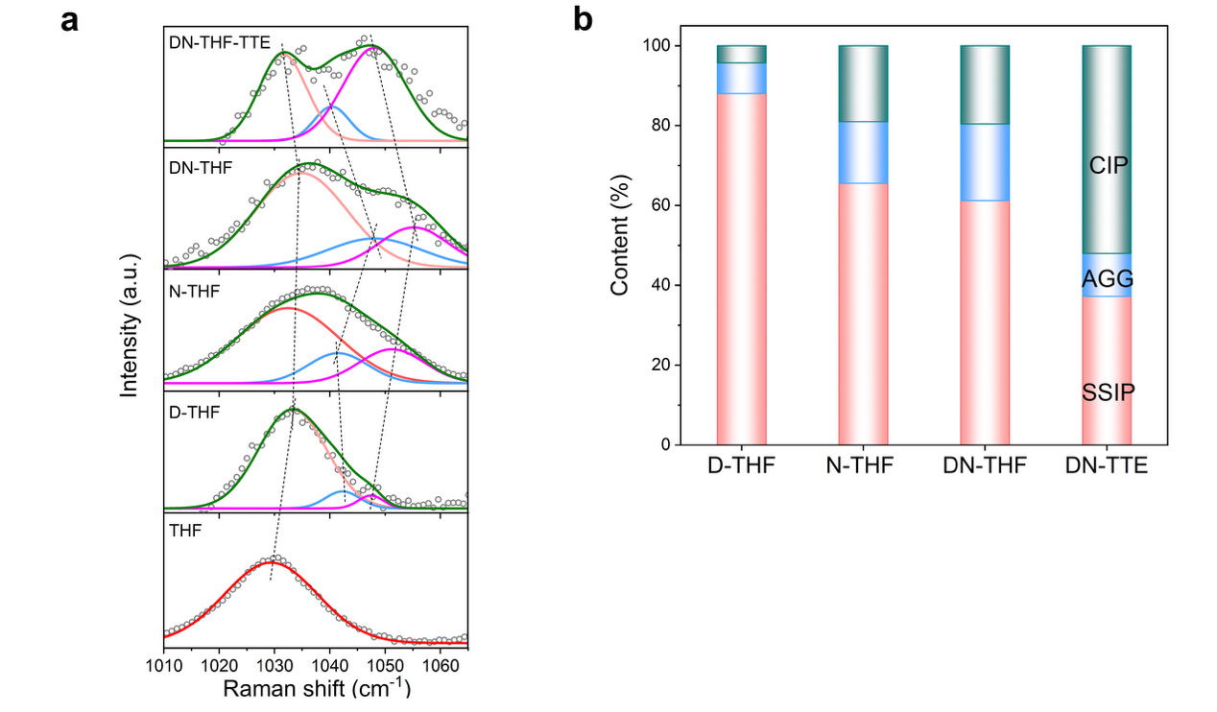
Supplementary Figure 1. (a) Raman spectra of different electrolytes, D-THF, LiNO₃-THF (N-THF), DN-THF and DN-THF-TTE. (b) The proportions of AGGs, CIPs, and SSIPs solvation structure in each electrolyte.

Supplementary Figure 2. The ionic conductivity of different electrolytes under different temperatures.

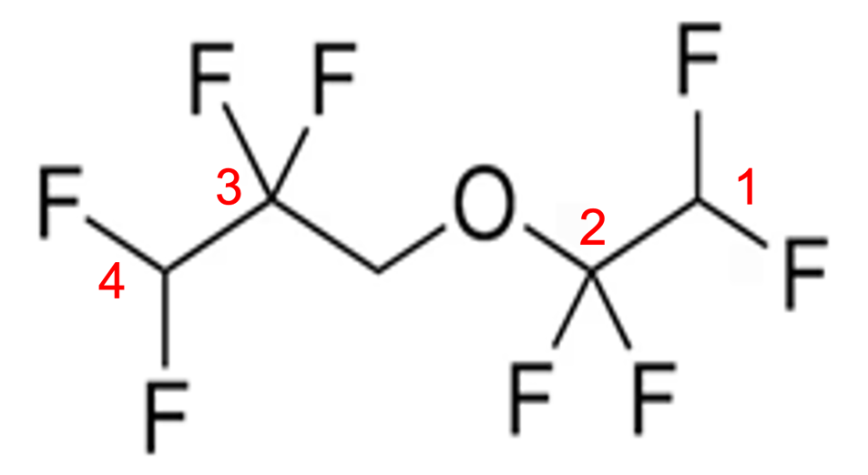
Supplementary Figure 3. The different F sites in TTE.

Supplementary Table 1. The calculated binding energy for different solvent-anion pairs.
Pairs | Binding energy (kcal/mol)
Li⁺-DFOB⁻ | -132.55
Li⁺-NO₃⁻ | -171.23
THF-DFOB⁻ | -35.67
THF-NO₃⁻ | -23.48
DFOB⁻-NO₃⁻ | -4.86
TTE-DFOB⁻ | 54.58
TTE-NO₃⁻ | -43.92
Li⁺-TTE | -55.18

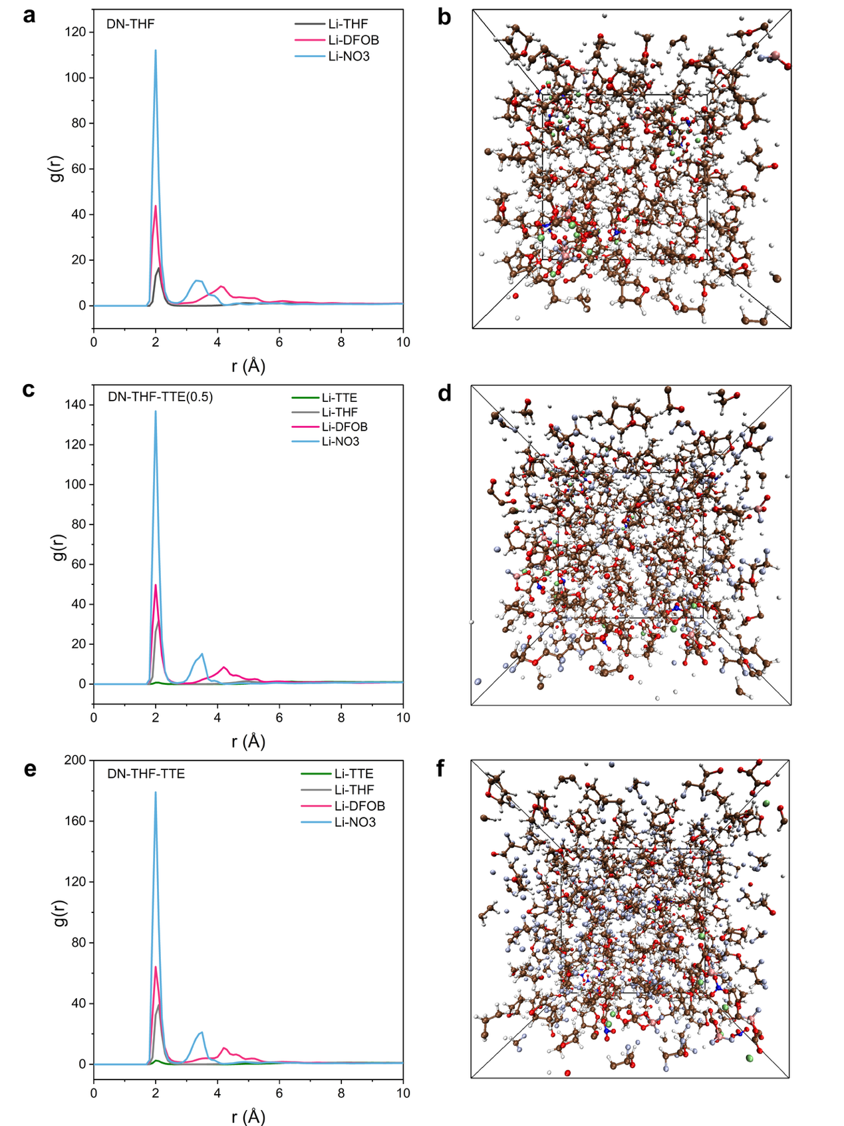
Supplementary Figure 4. Results from MD simulations for the three electrolytes. (a, c, e) Radial distribution functions and (b, d, f) corresponding snapshots of the simulation boxes for the DN-THF (a, b), DN-THF-TTE (0.5) (c, d), and DN-THF-TTE (e, f) electrolytes, respectively.

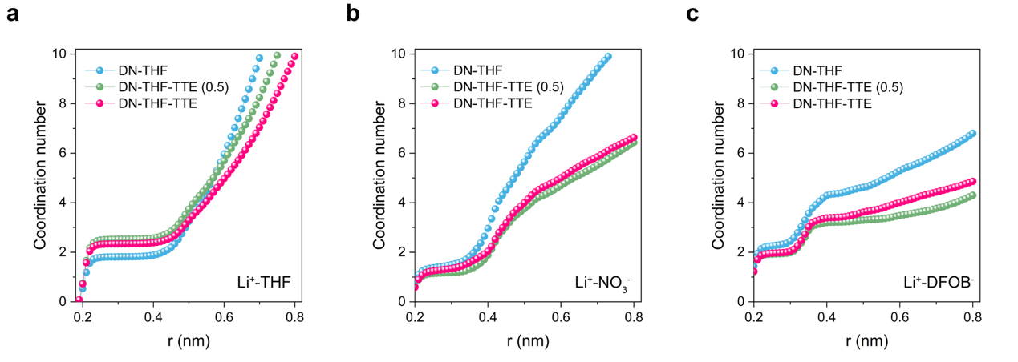
Supplementary Figure 5. Coordination number of (a) Li⁺-THF, (b) Li-NO₃⁻ and (c) Li⁺-DFOB⁻ in DN-THF, DN-THF-TTE(0.5) and DN-THF-TTE.

Supplementary Table 2. The population distribution of Li⁺-(THF)_{x} coordination states from the MD simulations
Label | THF | TTE | DFOB⁻ | NO₃⁻ | Stat | Content (%)
DN-THF | 0 | / | 2 | 2 | 5.00% | 5%
DN-THF | 1 | / | 0 | 3 | 1.00% | 24%
DN-THF | 1 | / | 1 | 2 | 5.00% | 24%
DN-THF | 1 | / | 2 | 1 | 8.00% | 24%
DN-THF | 1 | / | 2 | 2 | 3.00% | 24%
DN-THF | 1 | / | 3 | 1 | 1.00% | 24%
DN-THF | 1 | / | 4 | 0 | 4.00% | 24%
DN-THF | 1 | / | 4 | 1 | 2.00% | 24%
DN-THF | 2 | / | 0 | 2 | 10.00% | 58%
DN-THF | 2 | / | 0 | 3 | 7.00% | 58%
DN-THF | 2 | / | 1 | 1 | 5.00% | 58%
DN-THF | 2 | / | 1 | 2 | 7.00% | 58%
DN-THF | 2 | / | 2 | 0 | 1.00% | 58%
DN-THF | 2 | / | 2 | 1 | 20.00% | 58%
DN-THF | 2 | / | 3 | 0 | 1.00% | 58%
DN-THF | 2 | / | 3 | 1 | 5.00% | 58%
DN-THF | 3 | / | 0 | 1 | 2.00% | 14%
DN-THF | 3 | / | 0 | 2 | 4.00% | 14%
DN-THF | 3 | / | 1 | 1 | 3.00% | 14%
DN-THF | 3 | / | 2 | 0 | 4.00% | 14%
DN-THF | 3 | / | 2 | 1 | 1.00% | 14%
DN-THF | 4 | / | 0 | 1 | 1.00% | 1%
DN-THF-TTE(0.5) | 0 | 1 | 1 | 2 | 2.00% | 2%
DN-THF-TTE(0.5) | 1 | 0 | 1 | 2 | 7.00% | 11%
DN-THF-TTE(0.5) | 1 | 0 | 2 | 1 | 3.00% | 11%
DN-THF-TTE(0.5) | 1 | 1 | 1 | 1 | 1.00% | 11%
DN-THF-TTE(0.5) | 2 | 0 | 0 | 2 | 13.00% | 33%
DN-THF-TTE(0.5) | 2 | 0 | 1 | 1 | 9.00% | 33%
DN-THF-TTE(0.5) | 2 | 0 | 1 | 2 | 5.00% | 33%
DN-THF-TTE(0.5) | 2 | 0 | 2 | 0 | 2.00% | 33%
DN-THF-TTE(0.5) | 2 | 0 | 2 | 1 | 3.00% | 33%
DN-THF-TTE(0.5) | 2 | 0 | 3 | 0 | 1.00% | 33%
DN-THF-TTE(0.5) | 3 | 0 | 0 | 1 | 6.00% | 43%
DN-THF-TTE(0.5) | 3 | 0 | 0 | 2 | 7.00% | 43%
DN-THF-TTE(0.5) | 3 | 0 | 1 | 1 | 6.00% | 43%
DN-THF-TTE(0.5) | 3 | 0 | 2 | 0 | 24.00% | 43%
DN-THF-TTE(0.5) | 4 | 0 | 0 | 1 | 8.00% | 11%
DN-THF-TTE(0.5) | 4 | 0 | 1 | 0 | 1.00% | 11%
DN-THF-TTE(0.5) | 4 | 0 | 2 | 0 | 2.00% | 11%
DN-THF-TTE | 0 | 0 | 2 | 2 | 4.00% | 6%
DN-THF-TTE | 0 | 1 | 1 | 1 | 1.00% | 6%
DN-THF-TTE | 0 | 1 | 2 | 2 | 1.00% | 6%
DN-THF-TTE | 1 | 0 | 1 | 2 | 7.00% | 16%
DN-THF-TTE | 1 | 1 | 0 | 2 | 4.00% | 16%
DN-THF-TTE | 1 | 1 | 1 | 1 | 4.00% | 16%
DN-THF-TTE | 1 | 1 | 1 | 2 | 1.00% | 16%
DN-THF-TTE | 2 | 0 | 0 | 2 | 8.00% | 37%
DN-THF-TTE | 2 | 0 | 1 | 1 | 7.00% | 37%
DN-THF-TTE | 2 | 0 | 1 | 2 | 11.00% | 37%
DN-THF-TTE | 2 | 0 | 2 | 0 | 2.00% | 37%
DN-THF-TTE | 2 | 0 | 2 | 1 | 4.00% | 37%
DN-THF-TTE | 2 | 0 | 3 | 0 | 4.00% | 37%
DN-THF-TTE | 2 | 1 | 3 | 0 | 1.00% | 37%
DN-THF-TTE | 3 | 0 | 1 | 1 | 5.00% | 9%
DN-THF-TTE | 3 | 0 | 2 | 0 | 3.00% | 9%
DN-THF-TTE | 3 | 1 | 1 | 0 | 1.00% | 9%
DN-THF-TTE | 4 | 0 | 0 | 1 | 4.00% | 24%
DN-THF-TTE | 4 | 0 | 1 | 0 | 19.00% | 24%
DN-THF-TTE | 4 | 0 | 2 | 0 | 1.00% | 24%

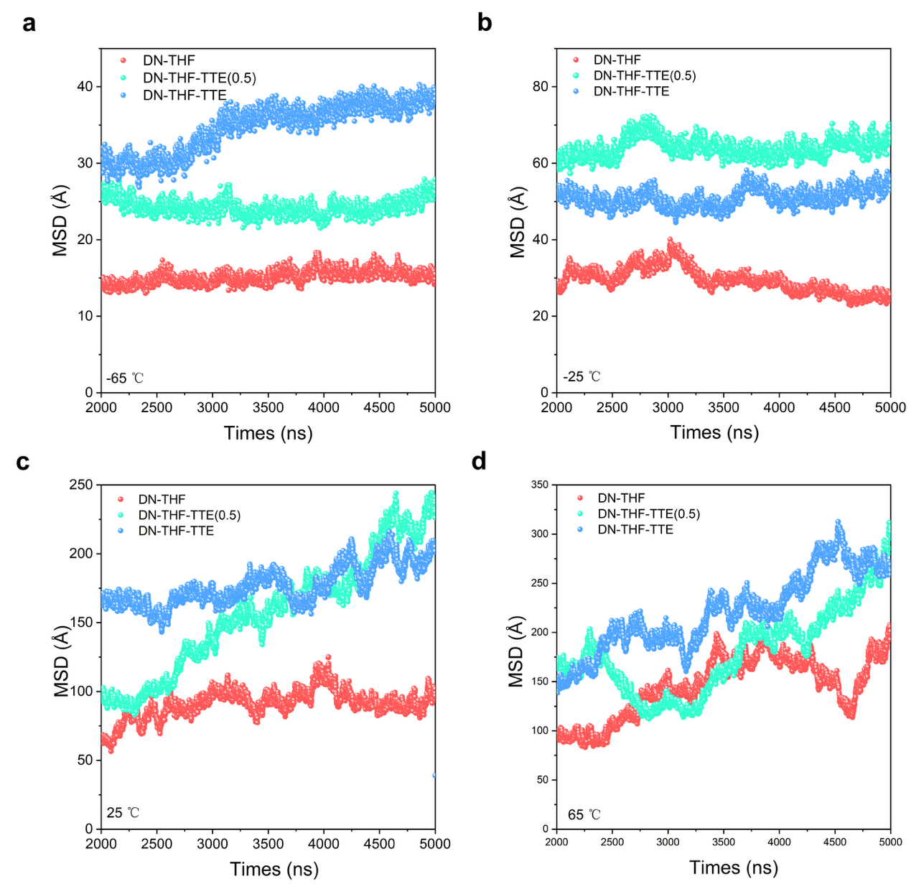
Supplementary Figure 6. The MSD results from MD simulation for DN-THF, DN-THF-TTE (0.5) and DN-THF-TTE at (a) −65 ℃, (b) −25 ℃, (c) 25 ℃ and (d) 65 ℃.

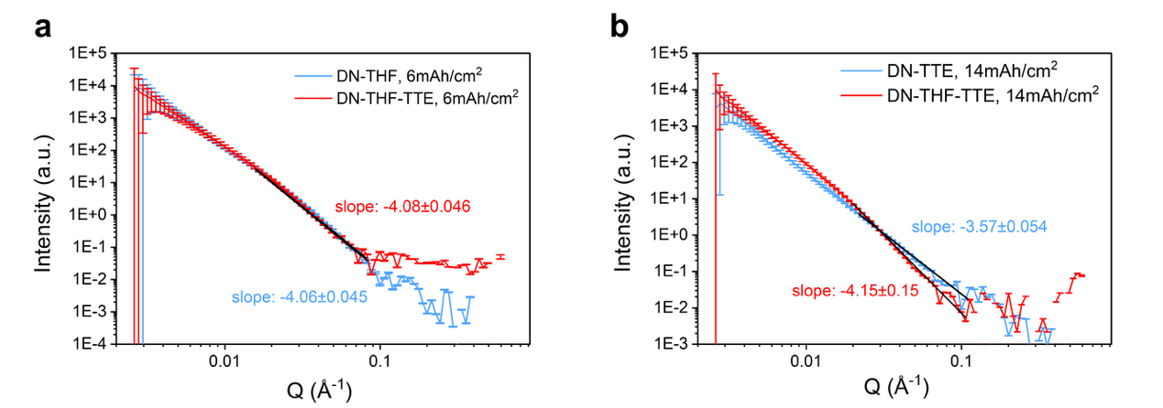
Supplementary Figure 7. SANS curves for Li metal plated in selected electrolytes to an areal capacity of (a) 6.0 mAh/cm² and (b) 14.0 mAh/cm².

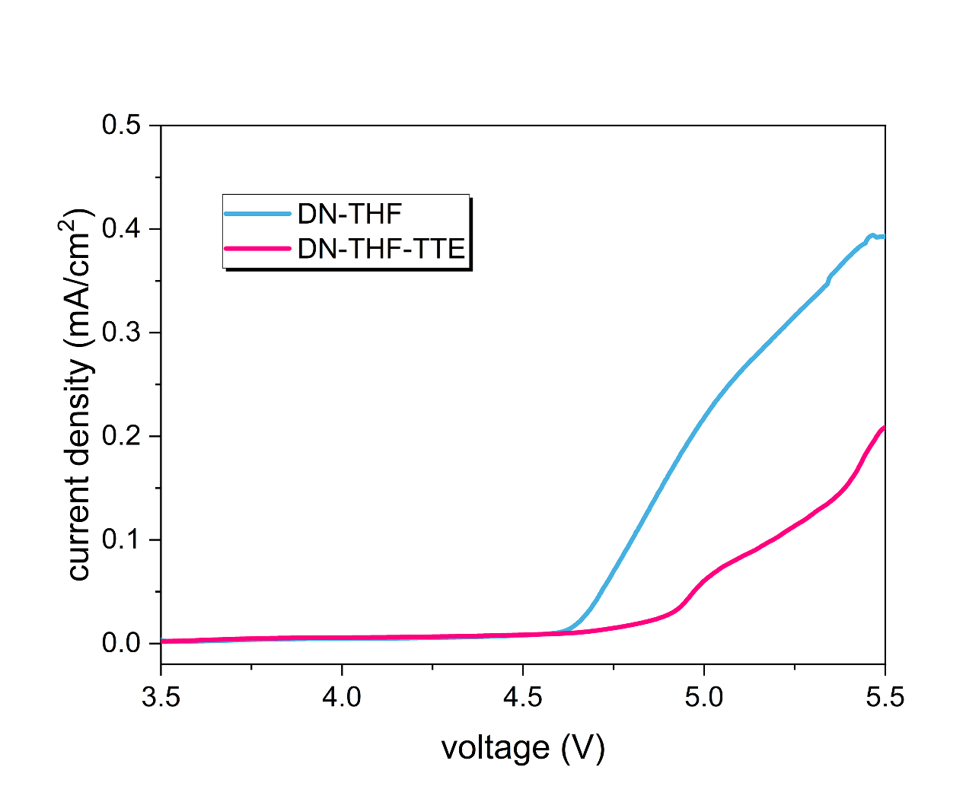
Supplementary Figure 8. (a) Linear sweep voltammetry (LSV) curves for DN-THF and DN-THF-TTE.

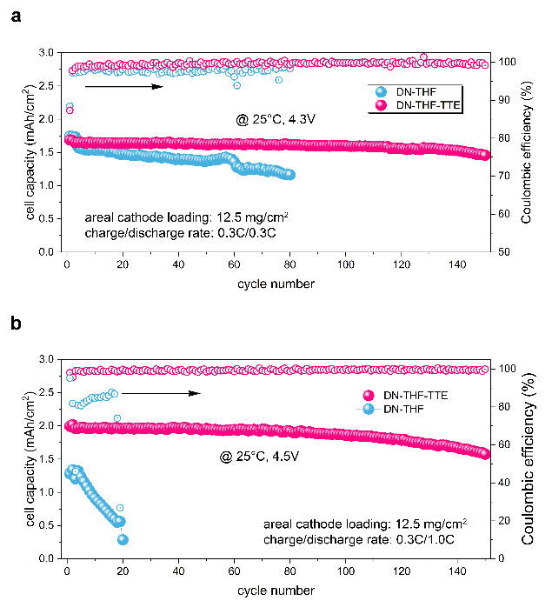
Supplementary Figure 9. The cycling performance electrolyte DN-THF and DN-THF-TTE at room temperature for (a) 4.3V, (b) 4.5V.

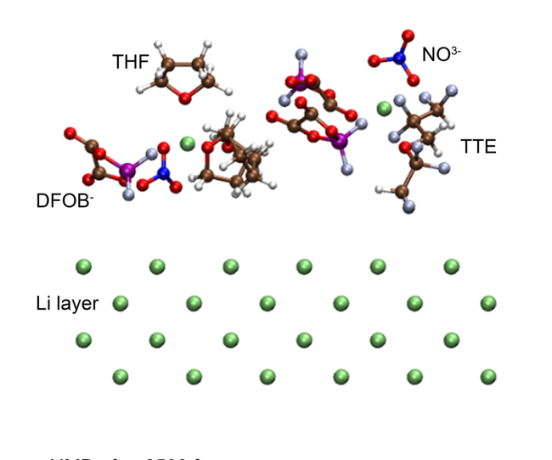
Supplementary Figure 10. The snapshot of the initial structure for AIMD.

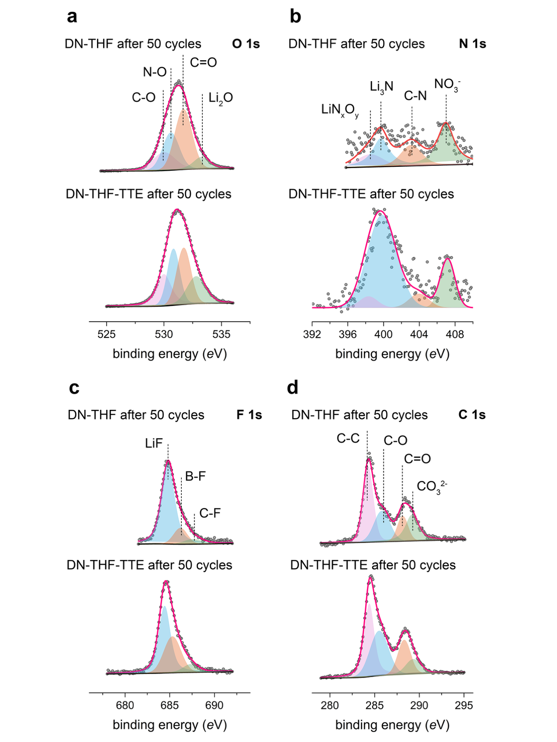
Supplementary Figure 11. The XPS spectra of (a) O1s, (b) N1s, (c) F1s and (d) C1s for Li metal surface after 50 cycles of plating in Li symmetrical cells with DN-THF and DN-THF-TTE electrolyte.

Supplementary Figure 12. Low-temperature cycling performance of cell with DN-THF-TTE electrolyte under −30 ℃ and −40 ℃.

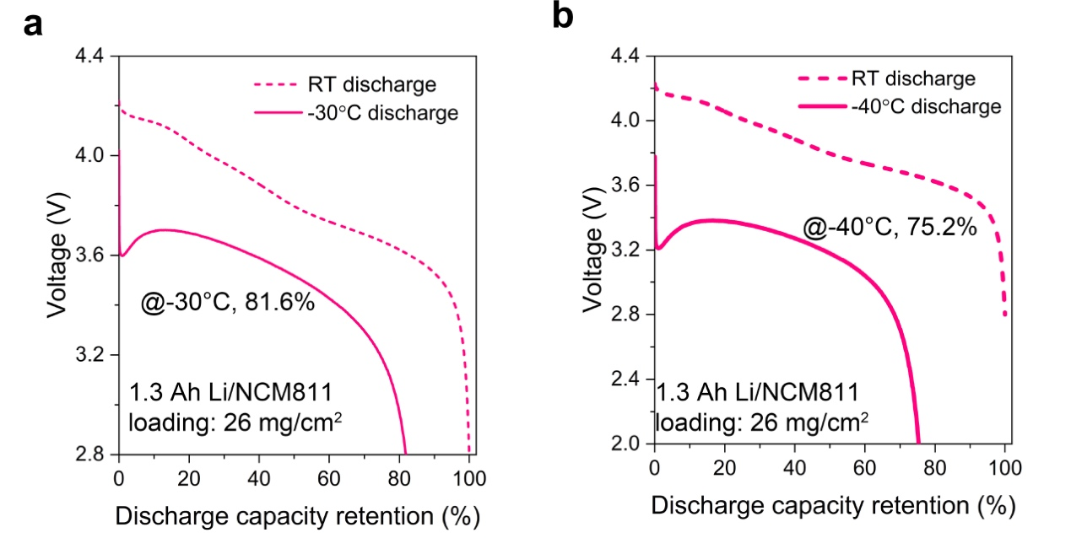
Supplementary Figure 13. Evaluation of Li/NCM811 pouch cells. Low-temperature discharge performance of a ~1.3 Ah cell using the DN-THF-TTE electrolyte at (a) −30 ℃ and (b) −40 ℃.

Supplementary Table 3. The comparison of areal cathode loading, active material ratio and low-temperature discharge performances with previous literatures.
Ref. | Active material ratio  (%) | Areal cathode loading  (mg/cm²) | −30℃ | −40℃ | −50℃ | −60℃ | −70℃
Ref.(1) | 90 | 11.0 |  |  | 61%
Ref.(2) | 90 | 21.5 |  |  |  | 73%
Ref.(3) | 80 | 8.0 | 83%
Ref.(4) | 90 | 20.69 |  |  |  | 66%
Ref.(5) | 80 | 1.62 |  |  | 73%
Ref.(6) | 90 | 5.6 |  |  |  | 67%
Ref.(7) | 85 | 12.5 |  |  |  | 61%
Ref.(8) | 95 | 26.0 |  |  | 67%
Ref.(9) | 90 | 9.5 |  |  |  |  | 92%
Ref.(10) | 80 | 9.0 |  | 73%
Ref.(11) | 96 | 13.0 |  | 38%
Ref.(12) | 90 | 10.8 |  |  | 39%
This work | 96 | 26.0 |  |  | 68%

Supplementary Figure 4. The detailed parameters and mass of each part of Li/NCM811 pouch cell.
Components | Cell parameters | Values
Cathode | Cathode type | NCM811
Cathode | Cathode areal loading (mg/cm²) | 26.0
Cathode | Ratio of active cathode material (%) | 96
Cathode | Areal capacity of cathode (mAh/cm²) | 5.0
Cathode | Electrode size (cm²) | 6.2*7.2
Cathode | Number of electrode sheets | 25
Cathode | Thickness of Al foil (μm) | 12
LMA | Thickness of LMA (μm) | 50
Electrolyte | Injection ratio (g/Ah) | 1.00
Electrolyte | Total mass of electrolyte (g) | 15.50
Separator | Thickness of separator (μm) | 16.0
Pouch cell | N/P ratio | 2.14
Pouch cell | Charge/discharge rate (C) | 0.05C/0.05C
Pouch cell | Capacity (Ah) | 10.31
Pouch cell | Energy (Wh) | 39.34
Pouch cell | Mass of cell (g) | 93.67
Pouch cell | Energy density (Wh/kg) | 420.0

Reference:
1. Q. Wang, C. Zhao, Z. Yao, J. Wang, F. Wu, S. G. H. Kumar, S. Ganapathy, S. Eustace, X. Bai, B. Li, Entropy‐driven liquid electrolytes for lithium batteries. Adv. Mater. 35, 2210677 (2023).
2. X. Yin, B. Li, H. Liu, B. Wen, J. Liu, M. Bai, Y. Zhang, Y. Zhao, X. Cui, Y. Su, Solvent-derived organic-rich SEI enables capacity enhancement for low-temperature lithium metal batteries. Joule 9, (2025).
3. Y. Li, Y. Huang, X. Han, J. Wu, H. Shen, S. Wang, S. Ding, S. Zhu, B. Han, Y. Huang, Temperature-adaptive fluorine in electrolyte for lithium–metal batteries at low temperatures. ACS Energy Lett. 10, 3610-3619 (2025).
4. W. Zhang, Y. Lu, Q. Feng, H. Wang, G. Cheng, H. Liu, Q. Cao, Z. Luo, P. Zhou, Y. Xia, Multifunctional electrolyte additive for high power lithium metal batteries at ultra-low temperatures. Nat. Commun. 16, 3344 (2025).
5. J. Holoubek, M. Yu, S. Yu, M. Li, Z. Wu, D. Xia, P. Bhaladhare, M. S. Gonzalez, T. A. Pascal, P. Liu, An all-fluorinated ester electrolyte for stable high-voltage Li metal batteries capable of ultra-low-temperature operation. ACS Energy Lett. 5, 1438-1447 (2020).
6. X. Zhang, T. Yang, Z. Huang, Q. Zhang, S. Jia, J. Kang, C. He, N. Zhao, Y. Zhang, Z. Chen, Fluorinated hybrid diluent modulated electrolyte for wide-temperature 508.5 Wh kg^{–1} lithium metal batteries. ACS Energy Lett. 10, 4428-4438 (2025).
7. R. Gu, D. Zhang, S. Xu, X. Guo, Y. Xiao, Z. Sheng, Q. Xu, J. Xu, S. Zhu, K. Liao, Thermoresponsive ether-based electrolyte for wide temperature operating lithium metal batteries. Nat. Commun. 16, 5474 (2025).
8. Z. Xiao, X. Liu, F. Hai, Y. Li, D. Han, X. Gao, Z. Huang, Y. Liu, Z. Li, W. Tang, Wide temperature 500 Wh kg⁻¹ lithium metal pouch cells. Angew. Chem. Int. Ed., e202503693 (2025).
9. Z. Li, W. Wang, W. Zhang, Y. Chen, X. Yun, T. Teng, C. Zheng, L. Xu, M. Tang, Y. Zhao, Data-assisted design of temperature-resistant weakly solvating electrolyte for all-climate 500 Wh/kg lithium-metal batteries. ACS nano, (2025).
10. W. Dou, Y. Tang, X. Xie, X. Liang, H. Qin, Z. Xiao, Y. Liu, C. Liang, X. Li, X. Ou, Weakly solvating molecule‐enabled localized high‐concentration electrolytes for ultralow temperature batteries with high‐nickel cathode/lithium‐metal anode. Adv. Funct. Mater., e17231 (2025).
11. G. Raghavendran, A. Liu, O. Borodin, N. Hahn, K. Leung, N. R. Park, T. Nivarty, M. Li, A. Larson, Y. Yin, Recoverable aggregate-rich liquefied gas electrolytes for enabling high-voltage lithium metal batteries. Energy Environ. Sci. 18, 8889-8906 (2025).
12. Z. Li, Y. Liao, H. Ji, X. Lin, Y. Wei, S. Hao, X. Hu, L. Yuan, Z. Huang, Y. Huang, A tetrahydropyran‐based weakly solvating electrolyte for low‐temperature and high‐voltage lithium metal batteries. Adv. Energy Mater. 15, 2404120 (2025).

