Supporting Information

Solvent-hybridization strategy enables high-voltage lithium metal batteries with practical wide-temperature operational capability

Ying Zhang^{1,#}, Shaoqing Liu^{1,#}, Xiang Li¹, Ting He¹, Hui Wei¹, Muhammad Sultan Irshad¹, Qin Wang³, Zaiping Guo^{2,*}, Jianwen Liu^{1,*}

¹ College of New Energy and Electrical Engineering & Ministry of Education Key Laboratory for Green Preparation and Application of Functional Materials, Hubei University, Wuhan 430062, P. R. China
² Department of Materials Science and Engineering, City University of Hong Kong, Kowloon Hong Kong 999077, P. R. China
³ Hubei WanRun New Energy Technology Co., Ltd., Shiyan 442500, P. R. China

# These authors contributed to this work equally.
* Corresponding authors. E-mail: zaipiguo@cityu.edu.hk (Prof. & Dr. Zaiping Guo); jianwen@hubu.edu.cn (Prof. & Dr. Jianwen Liu).

Supplementary Fig. 1. Viscosities of the commonly used solvents at 30 °C.

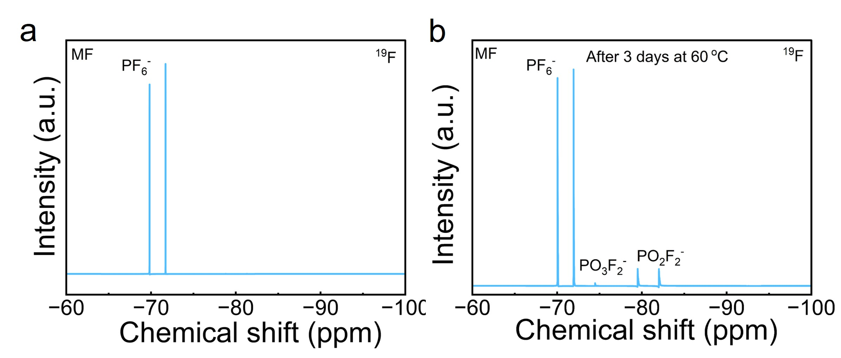
Supplementary Fig. 2. ¹⁹F NMR spectra of MF electrolyte at 60 °C before and after 3 days.

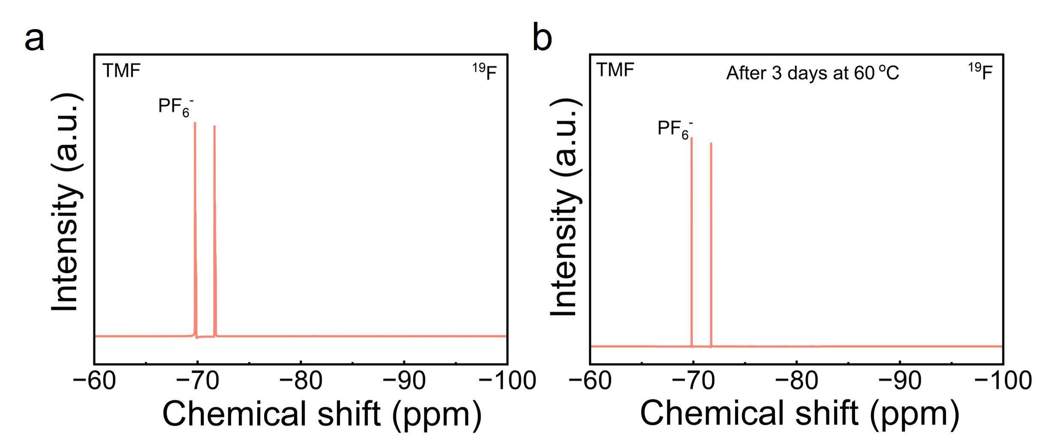
Supplementary Fig. 3. ¹⁹F NMR spectra of TMF electrolyte at 60 °C before and after 3 days.

Supplementary Fig. 4. FTIR spectroscopies of the two electrolytes and TEP, MP, FEC solvents.

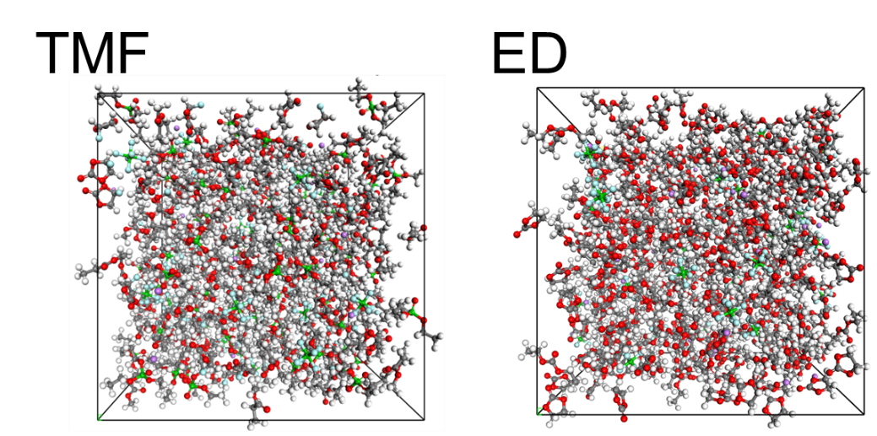
Supplementary Fig. 5. MD snapshots of TMF and ED.

Supplementary Fig. 6. Mean squared displacement (MSD) curves of Li⁺ ions in TMF and ED.

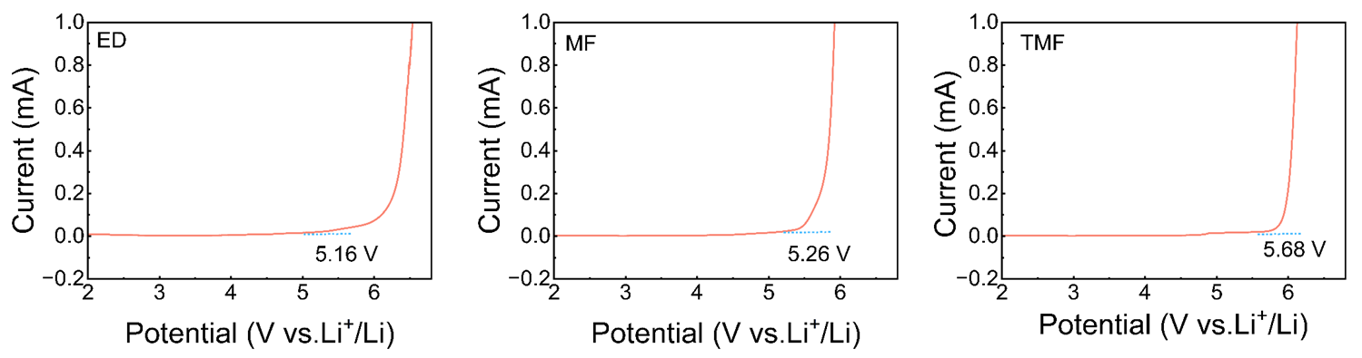
Supplementary Fig. 7. Electrochemical stabilization windows of different electrolytes.

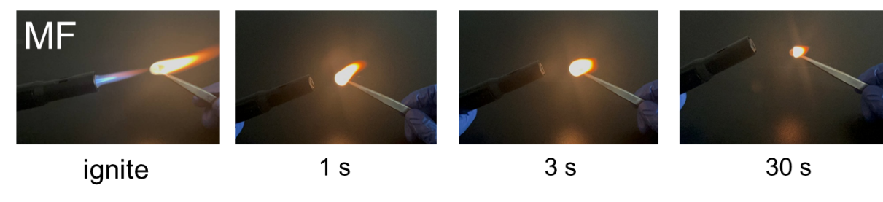
Supplementary Fig. 8. Ignition tests of MF electrolyte.

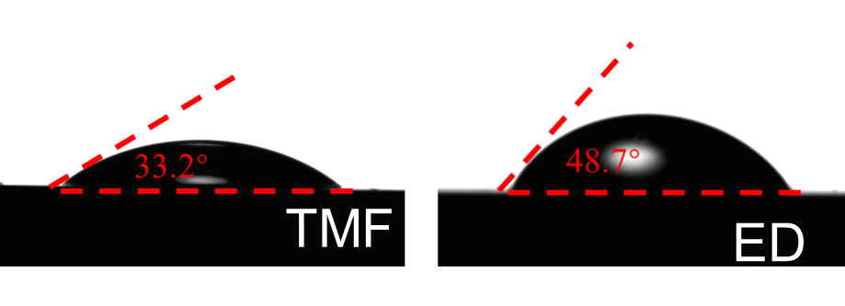
Supplementary Fig. 9. Contact angles of different electrolytes with diaphragm.

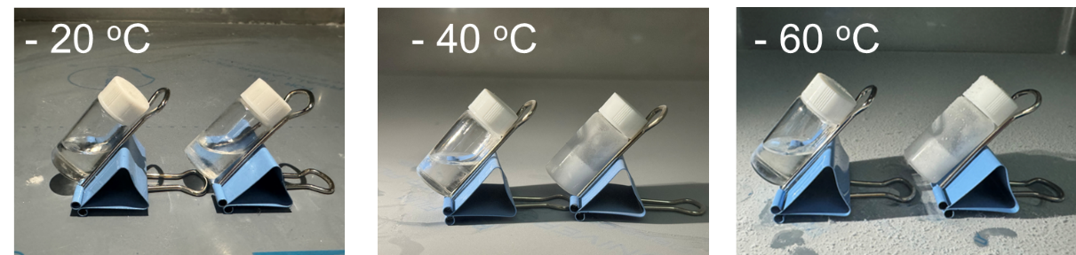
Supplementary Fig. 10. Optical photographs of TMF (left) and ED (right) electrolytes at varying temperatures

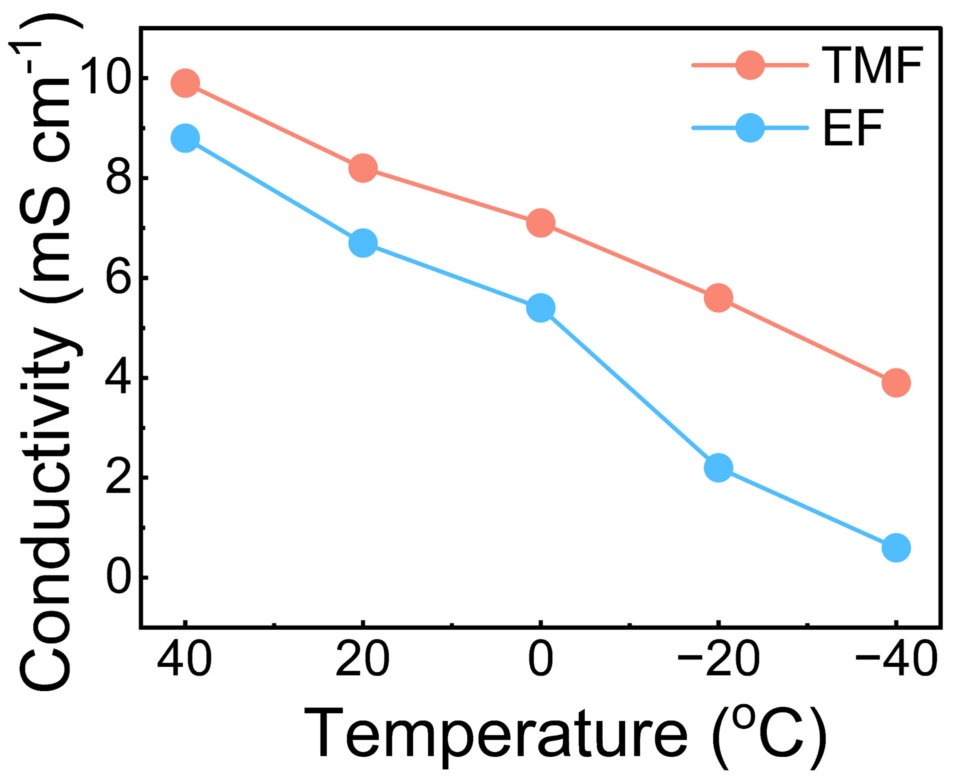
Supplementary Fig. 11. Ion conductivities of different electrolytes at different temperatures.
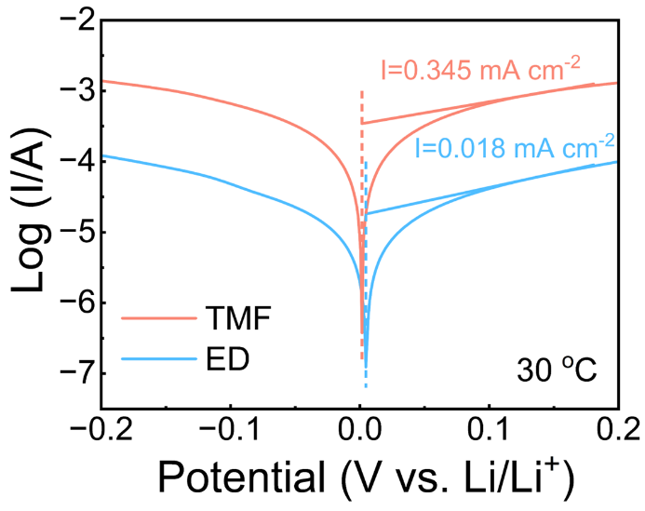
Supplementary Fig. 12. Tafel plots of TMF and ED at 30 °C.

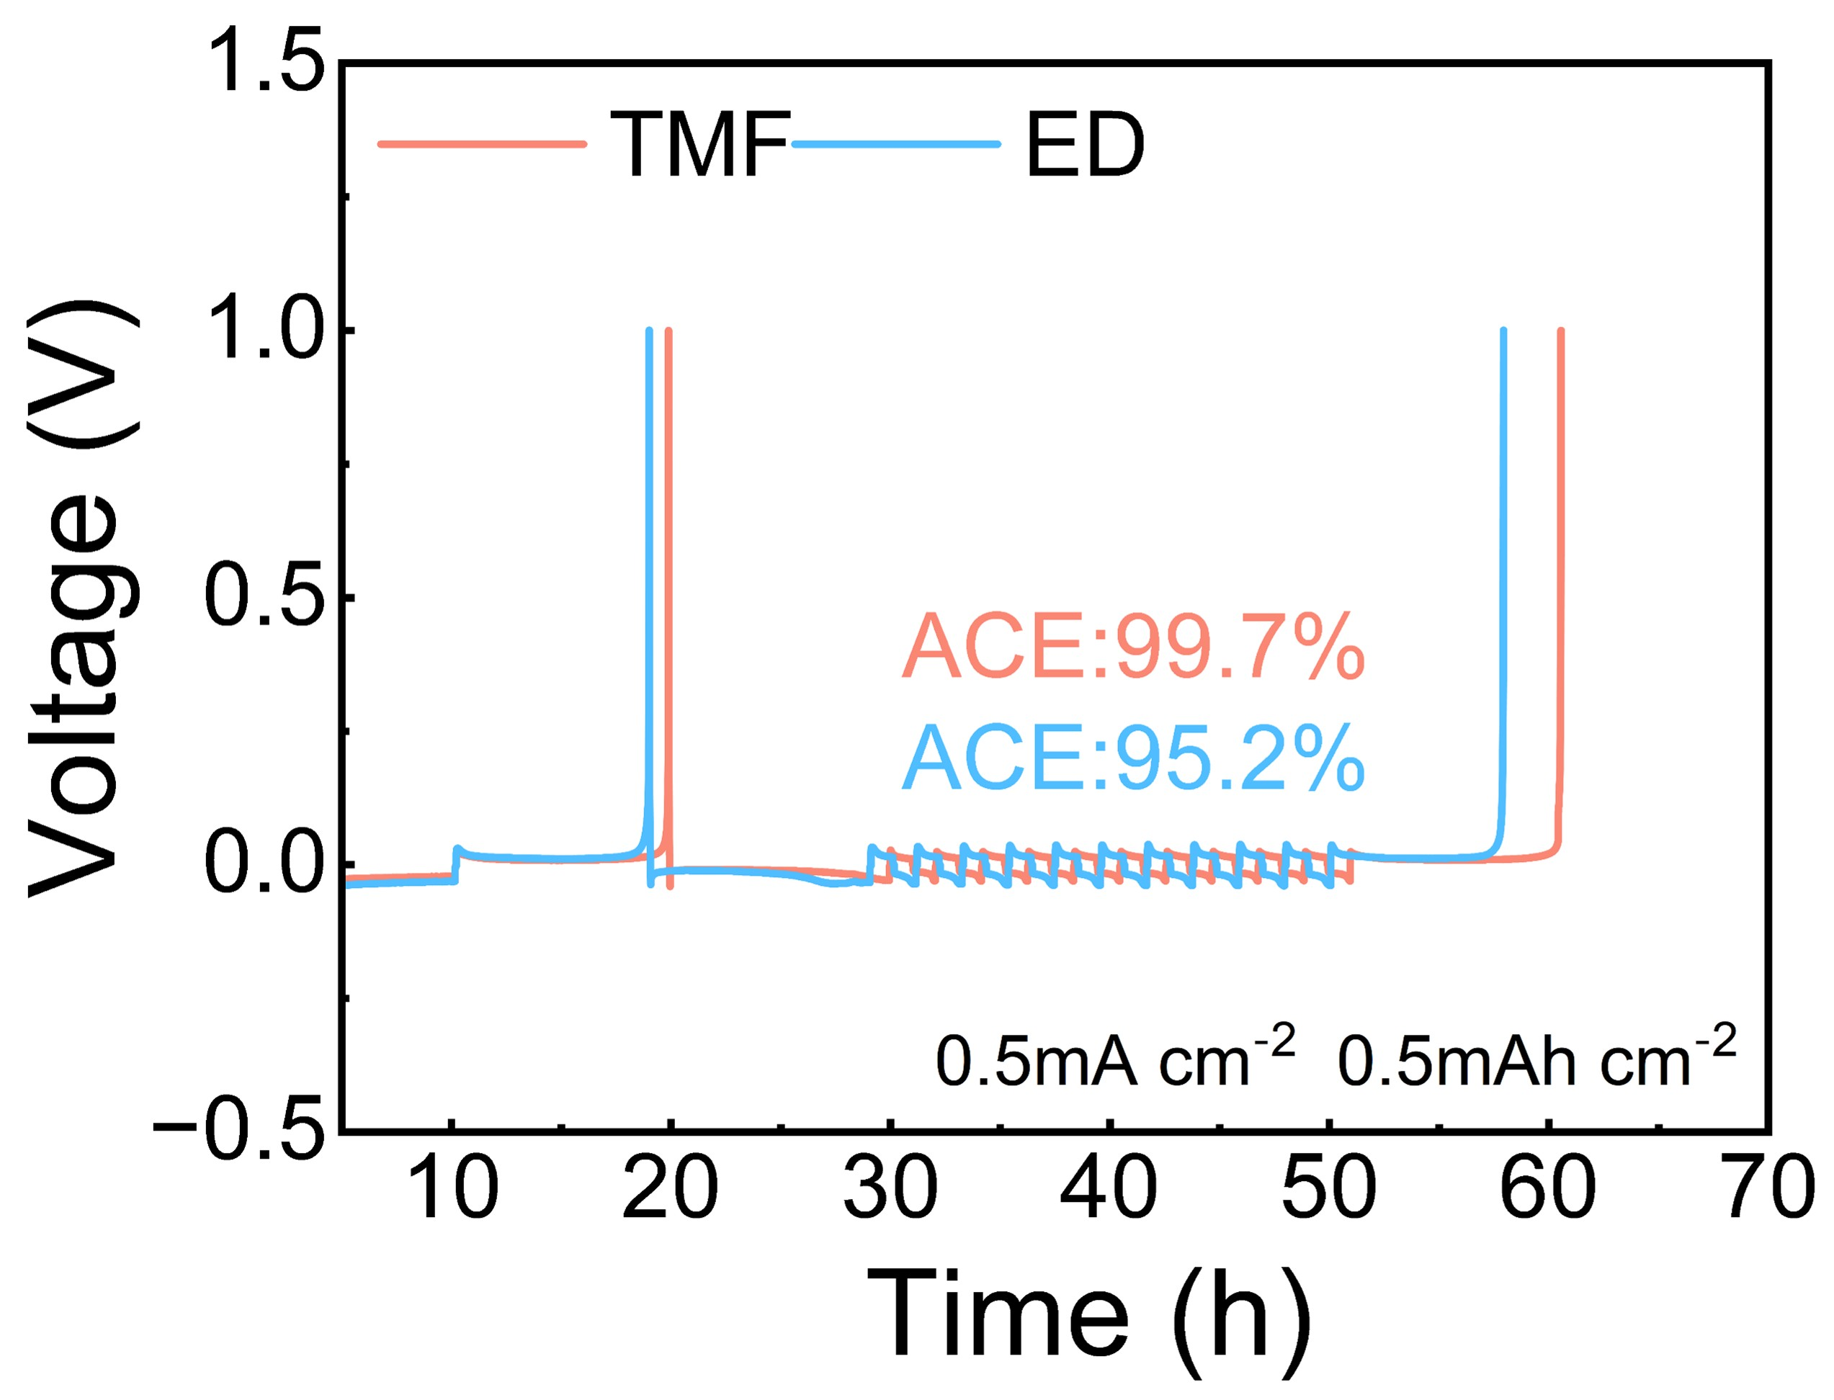
Supplementary Fig. 13. Measured ACEs of Li||Cu cells with TMF and ED at 0.5 mA cm⁻² by the Aurbach method.

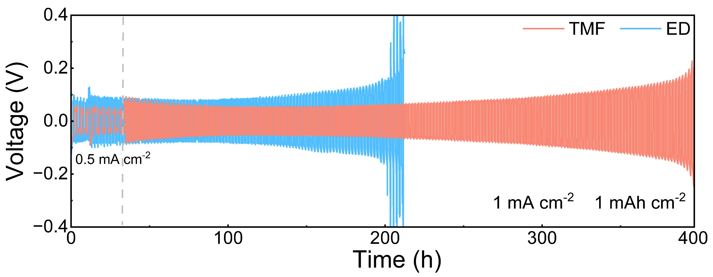
Supplementary Fig. 14. Voltage-Time profiles of different electrolytes in Li||Li symmetric cells at 1 mA cm⁻².

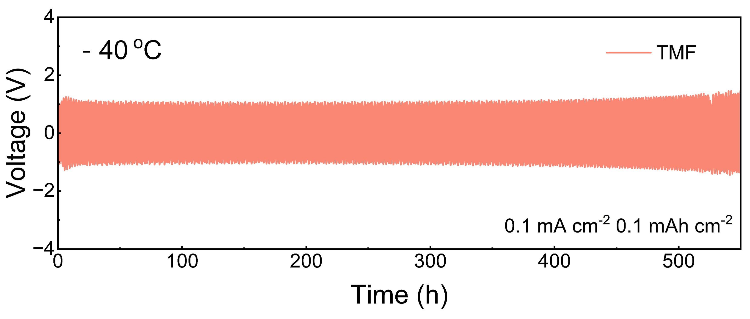
Supplementary Fig. 15. Voltage-Time profile of a Li||Li symmetric cell with TMF electrolyte at -40 °C.

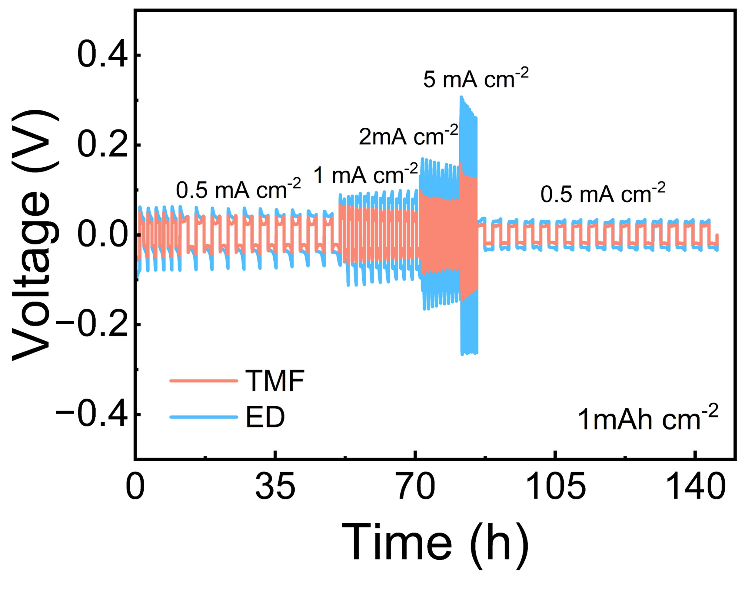
Supplementary Fig. 16. Rate capability of Li||Li symmetric cells with different electrolytes from 0.5 to 5 mA cm⁻².

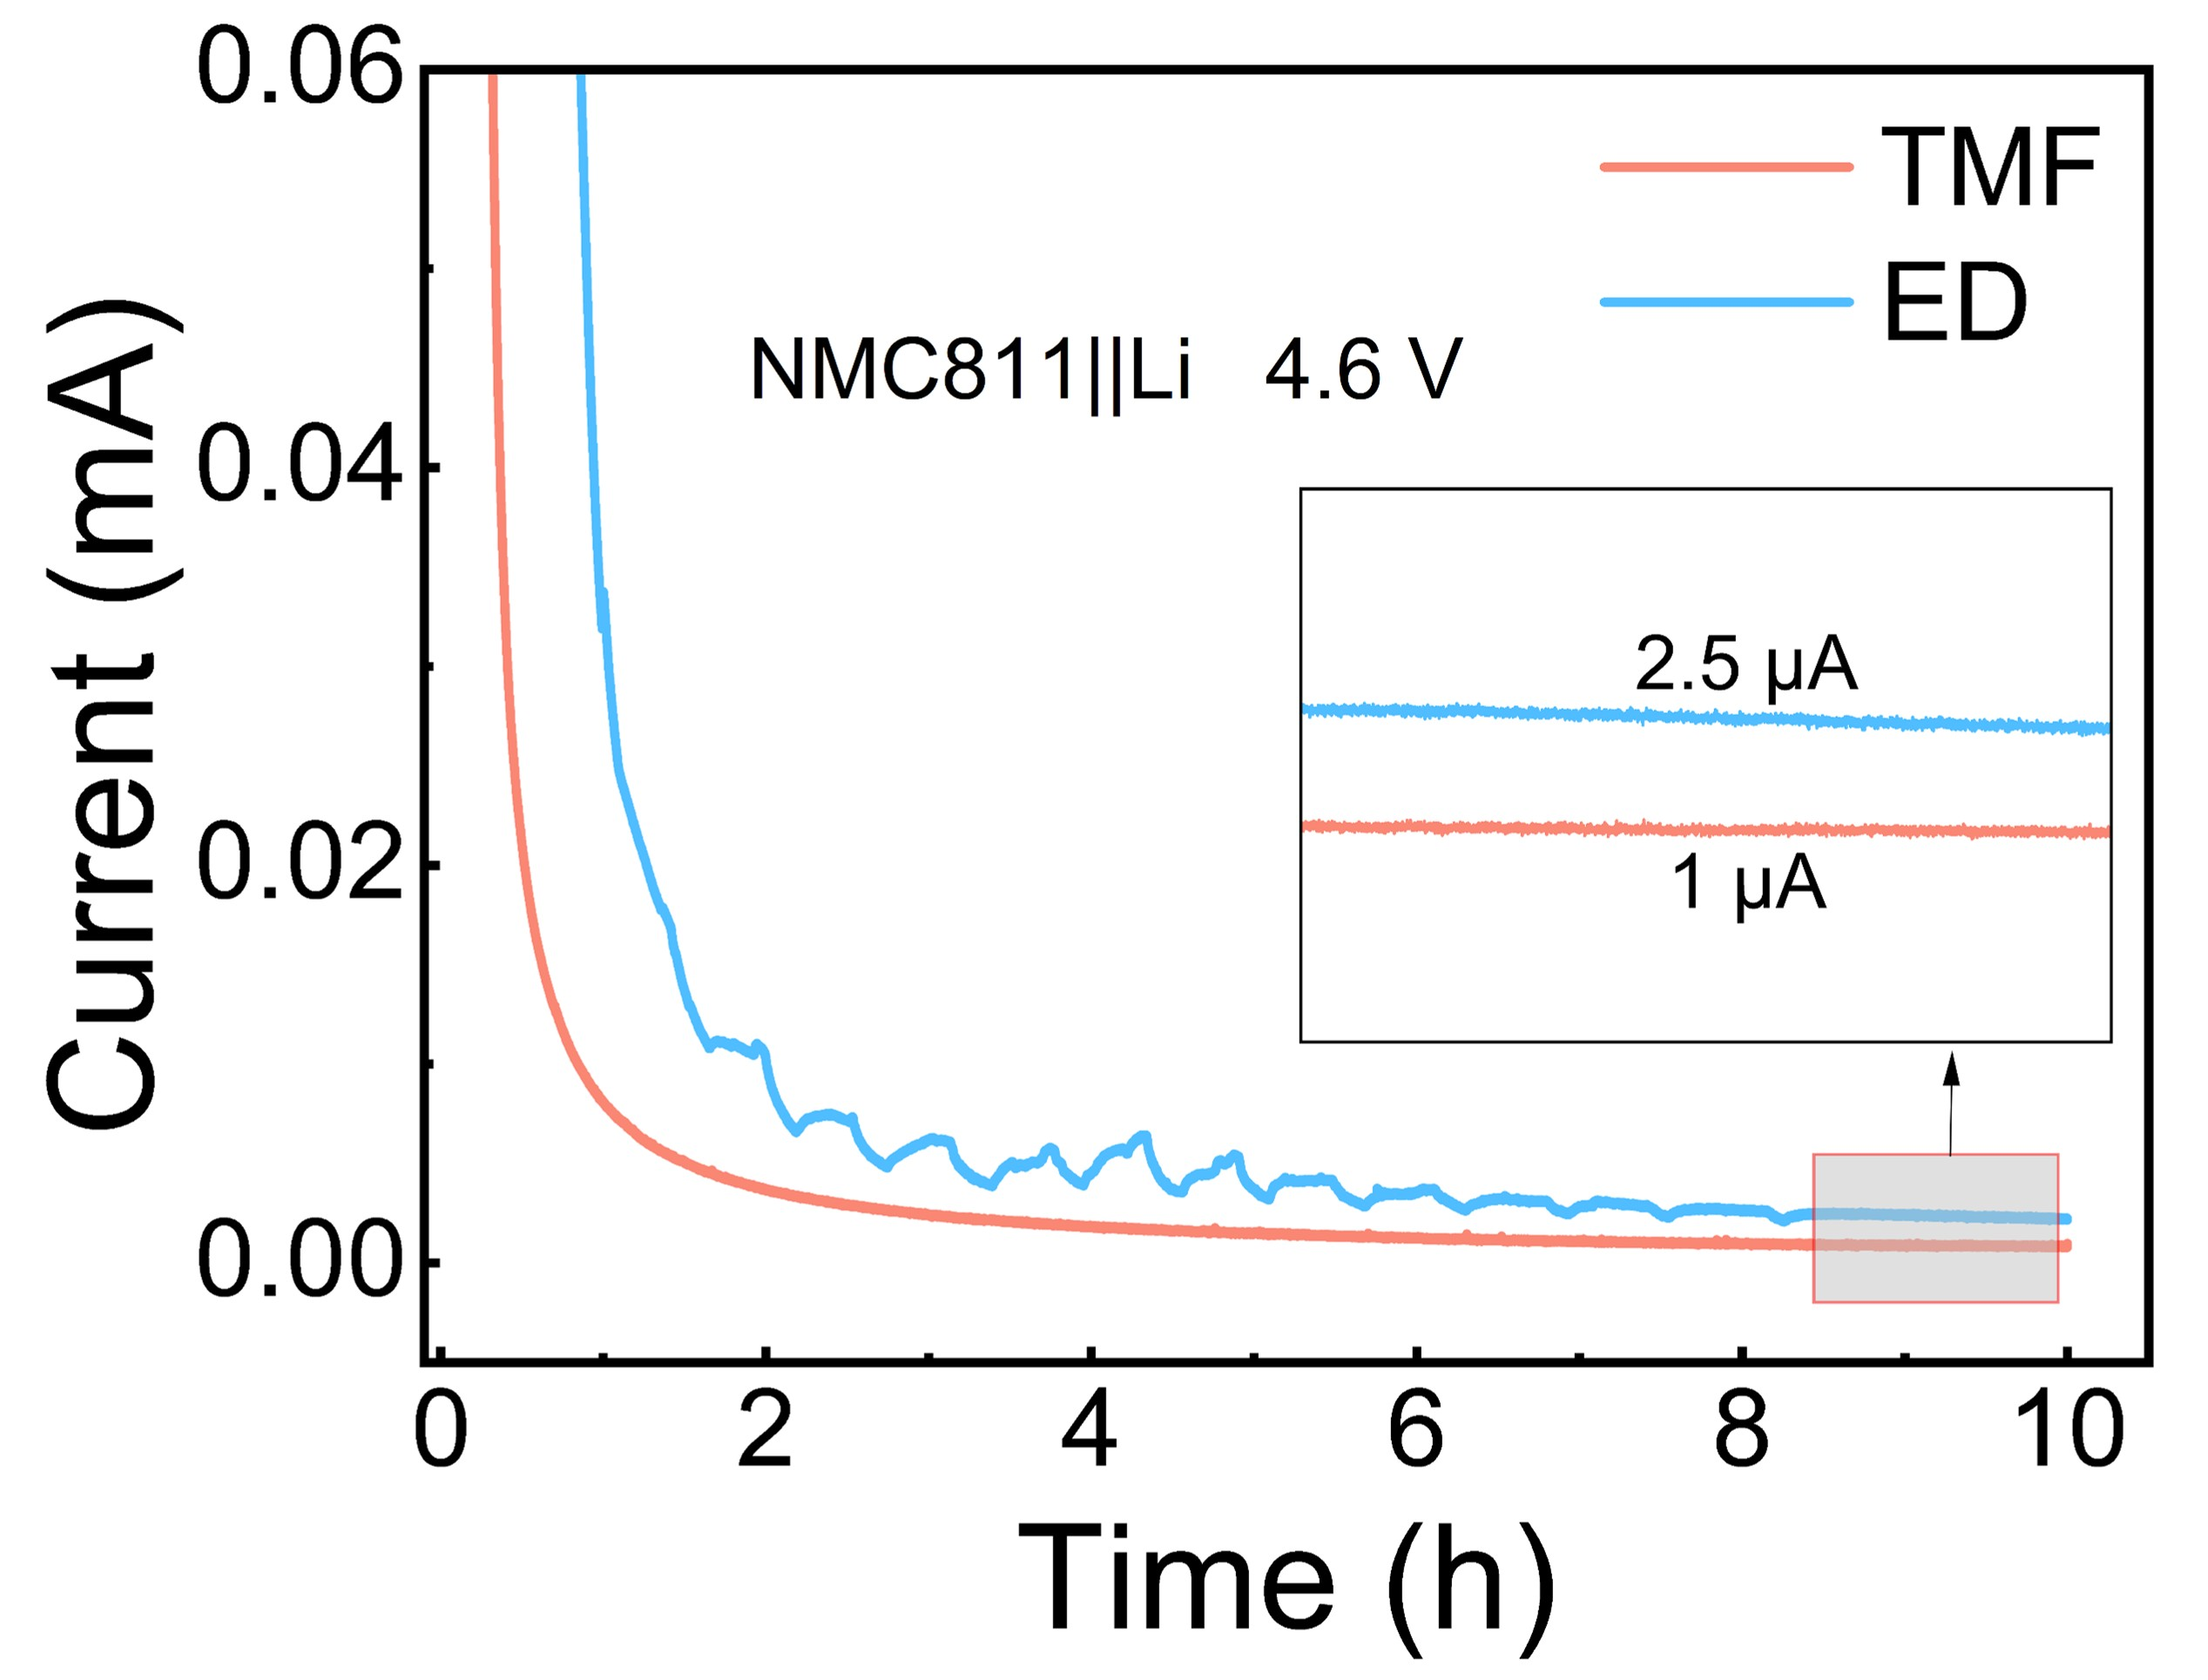
Supplementary Fig. 17. Stability tests of NMC811 with different electrolytes.

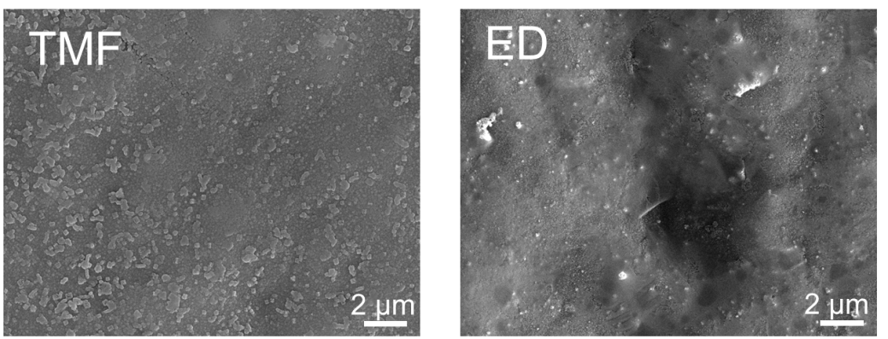
Supplementary Fig. 18. SEM images of Al foil after potentiostatic polarization.

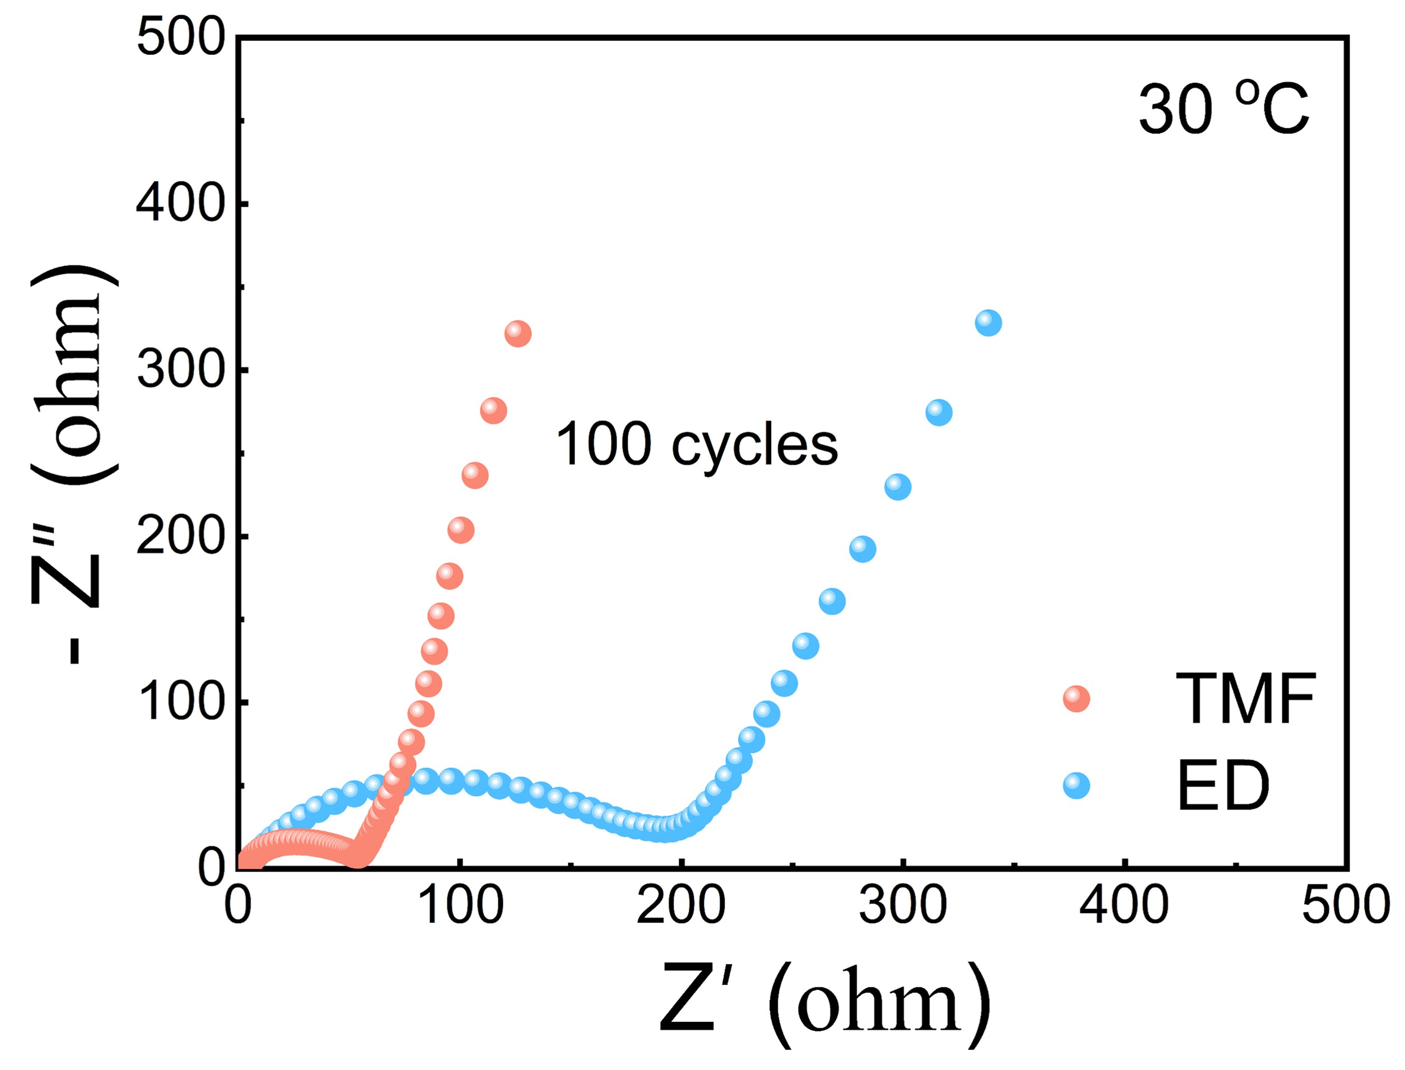
Supplementary Fig. 19. Nyquist plots of NMC811||Li cells with TMF and ED electrolytes after 100 cycles at 30 °C.

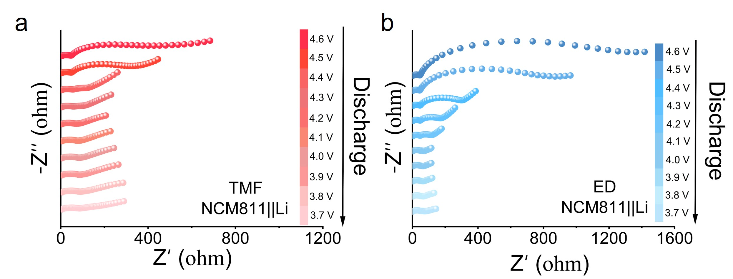
Supplementary Fig. 20. In situ Nyquist plots of cells with different electrolytes during discharge at 30 °C.
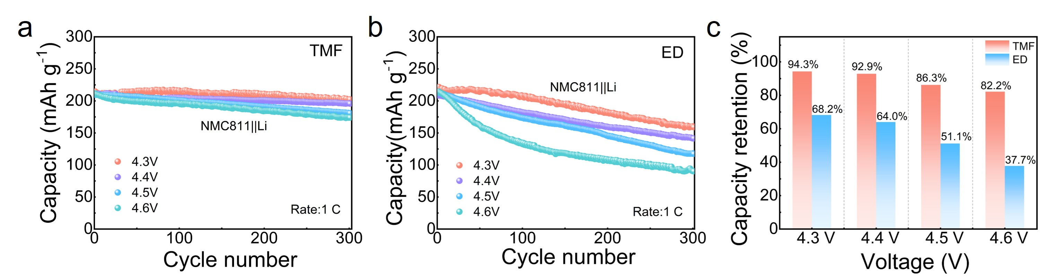
Supplementary Fig. 21. Cells performance at different cut-off voltages using different electrolytes.

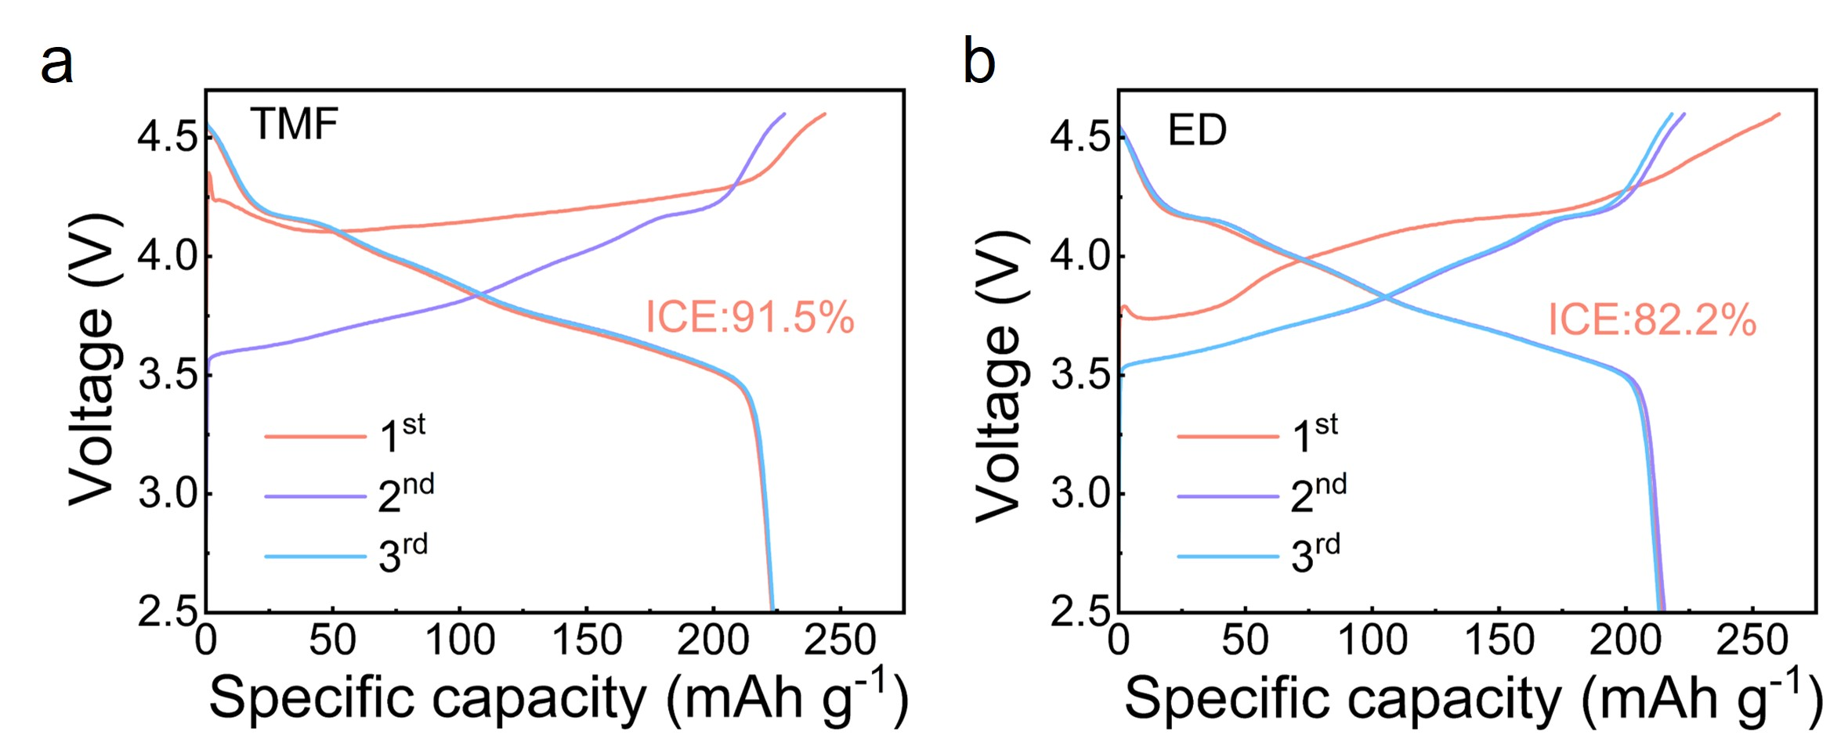
Supplementary Fig. 22. Charge-discharge curves of NMC811||Li cells during the first three cycles at 0.2 C using different electrolytes.

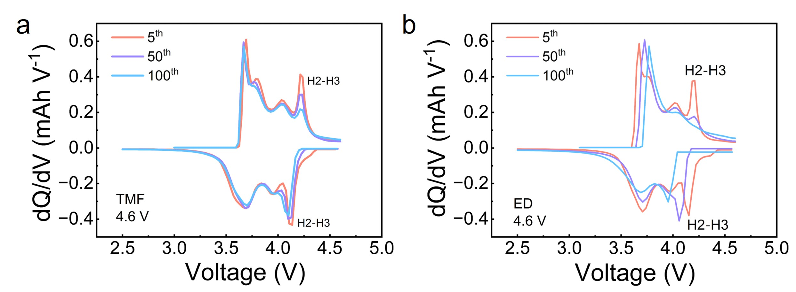
Supplementary Fig. 23. dQ/dV vs. voltage curves for cells with different electrolytes.

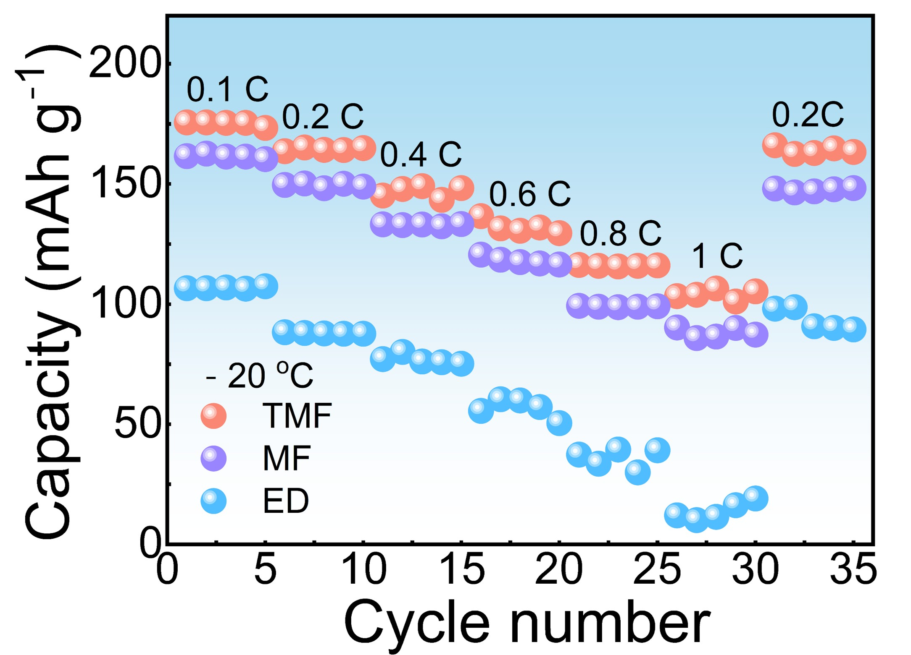
Supplementary Fig. 24. Rate capability of NMC811||Li cells with different electrolytes at -20 °C.

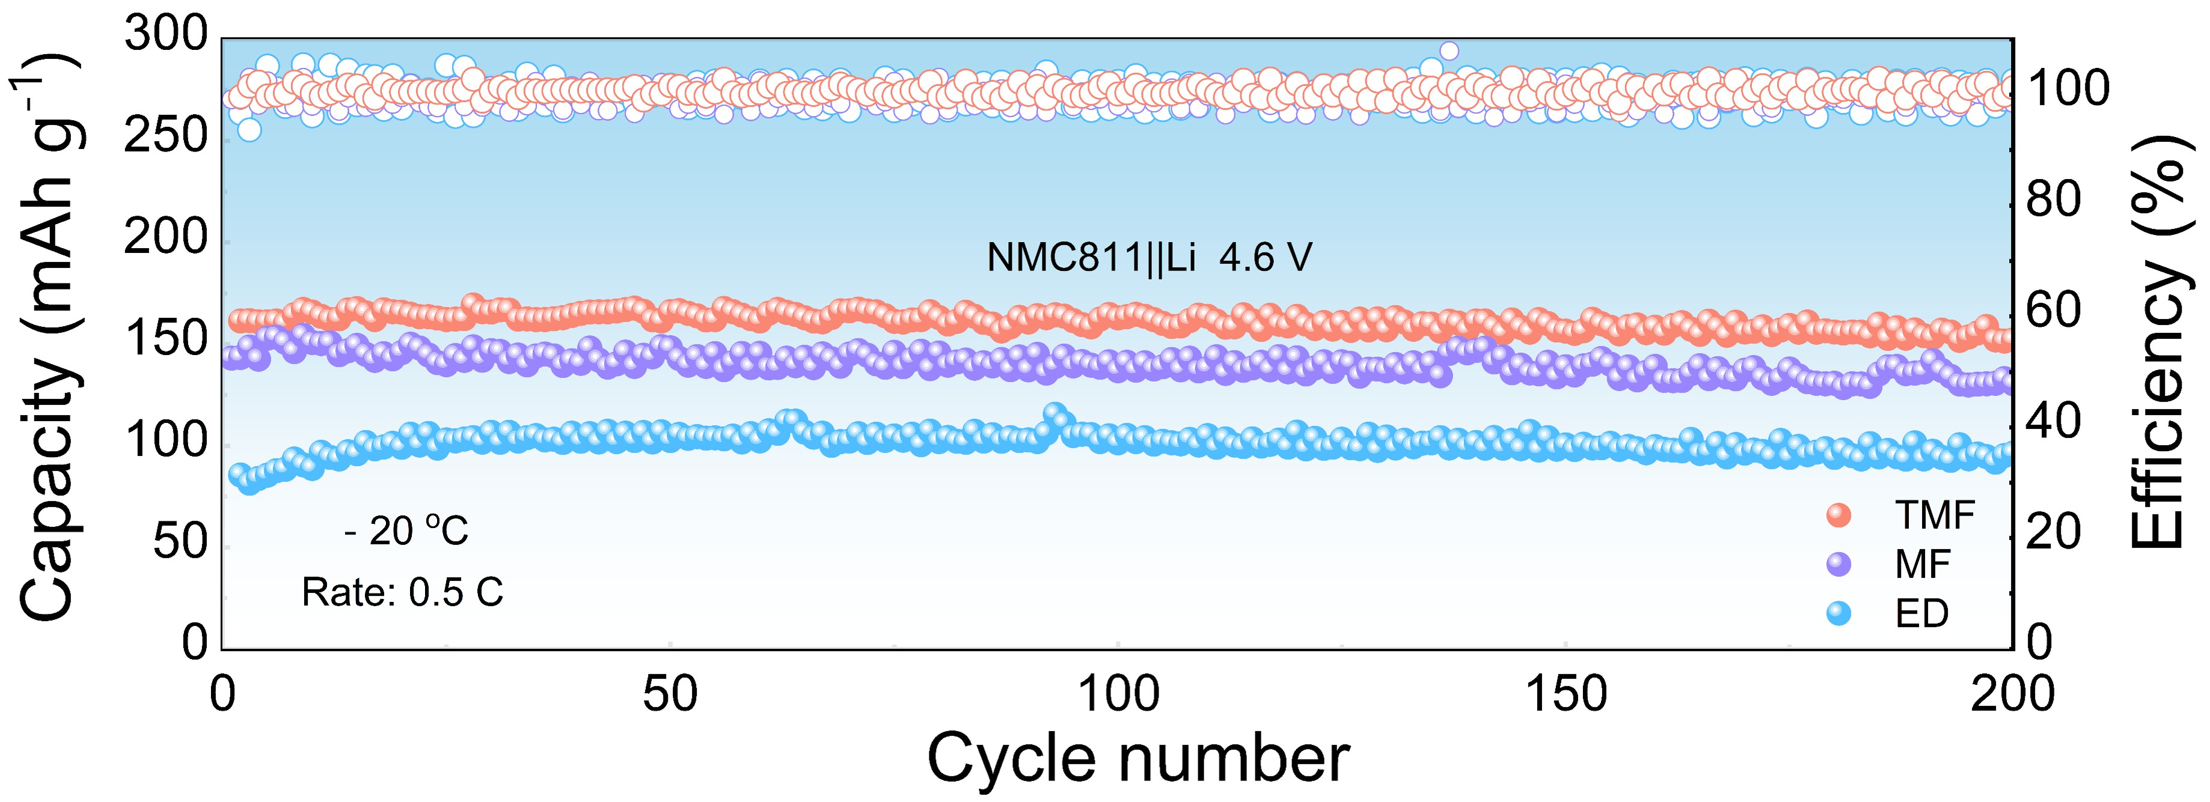
Supplementary Fig. 25. Cycling performance of NMC811||Li cells with different electrolytes at -20 °C and 4.6 V.

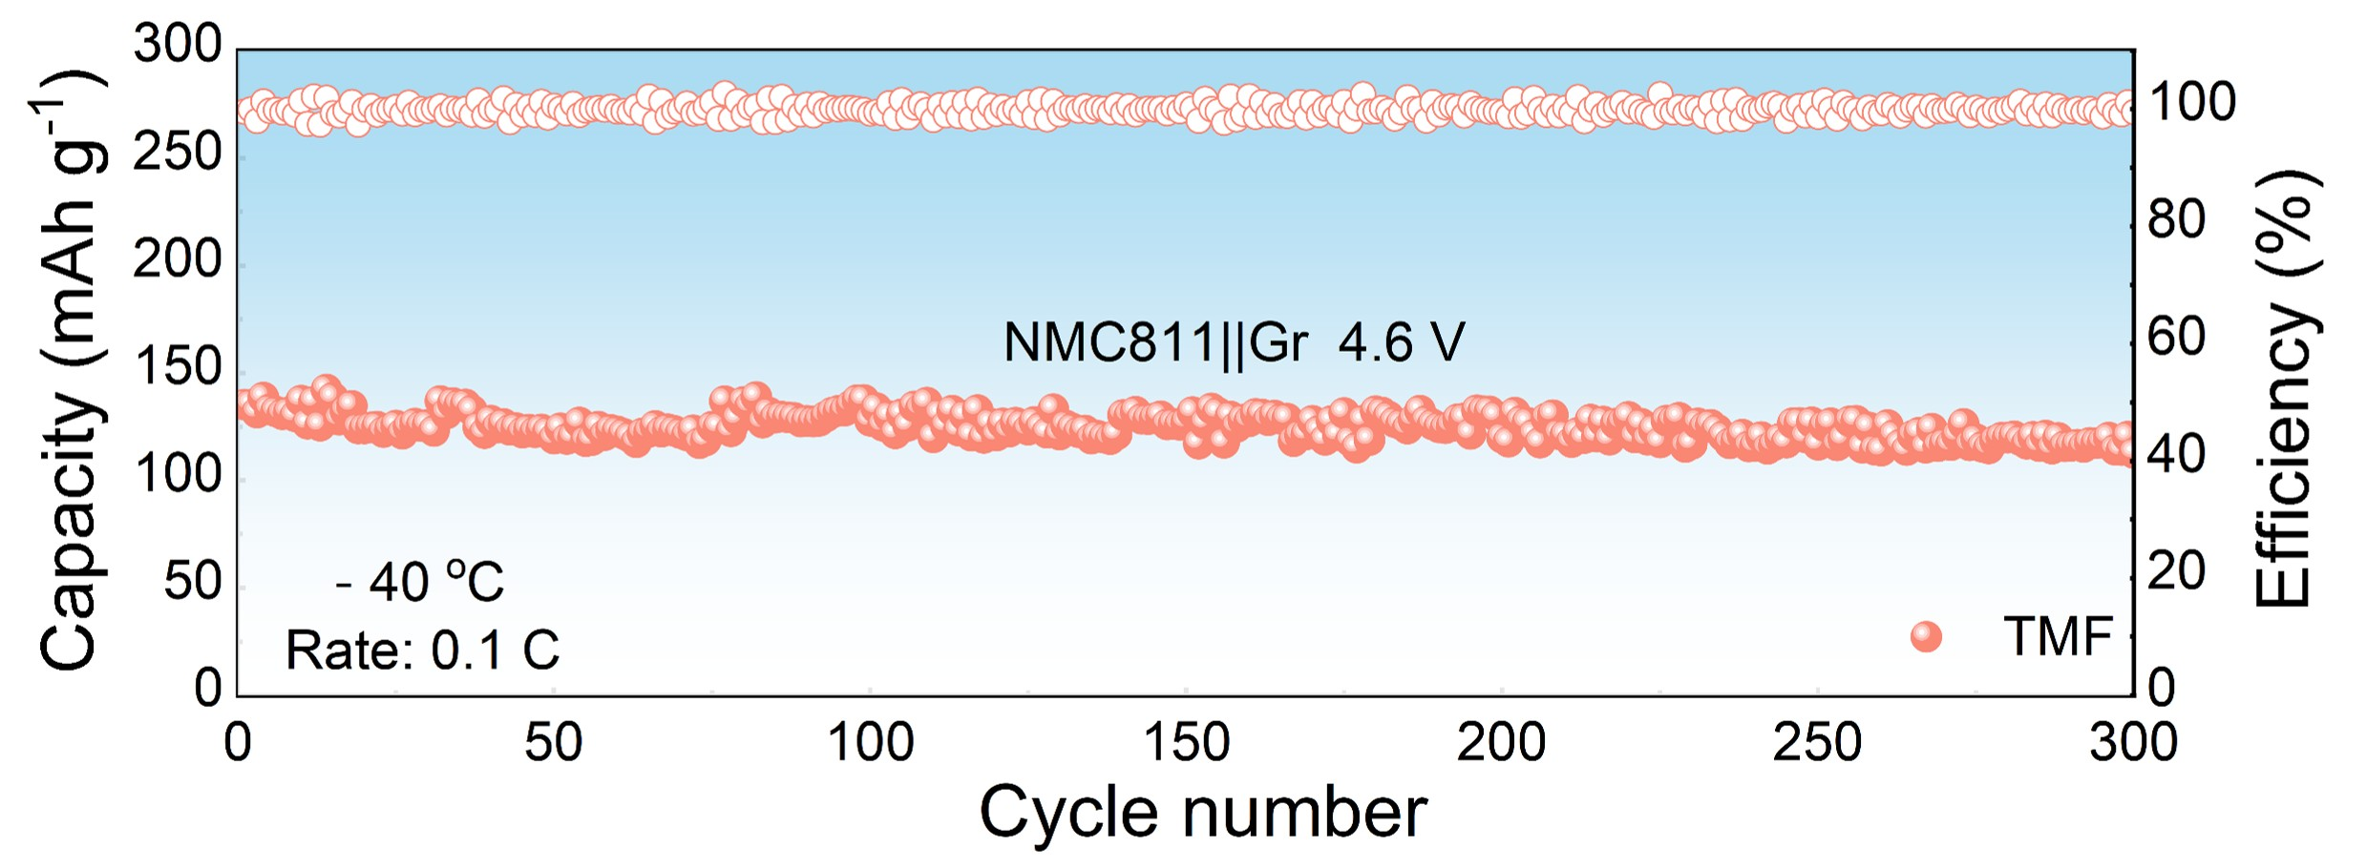
Supplementary Fig. 26. Cycling performance of NMC811||Gr cells with TMF electrolyte at -40 °C and 4.6 V.

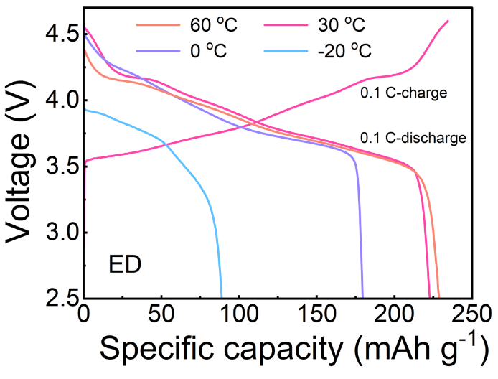
Supplementary Fig. 27. The discharge curves of the NMC811||Li battery using ED electrolyte at different temperatures.

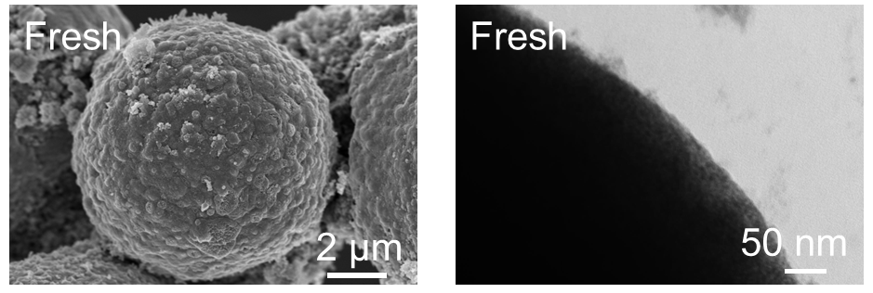
Supplementary Fig. 28. SEM and TEM images of the NMC811 cathode before cycling.

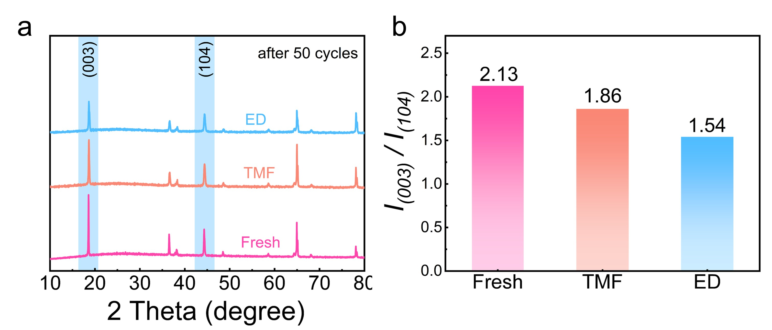
Supplementary Fig. 29. XRD patterns of NMC811 cathodes before cycling and after cycling with TMF and ED electrolytes, along with the ratio of I ₍₀₀₃₎/I ₍₁₀₄₎ in the XRD patterns.

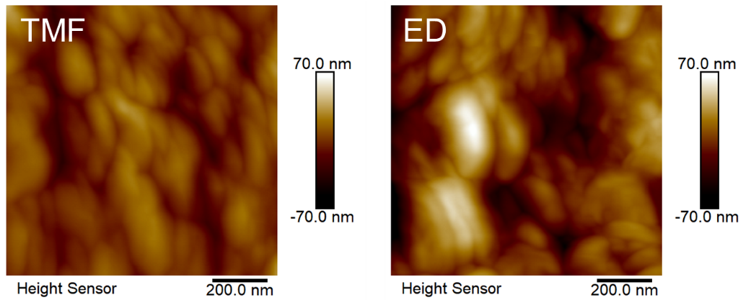
Supplementary Fig. 30. 2D AFM images of the NMC811 cathode after cycling in different electrolytes.

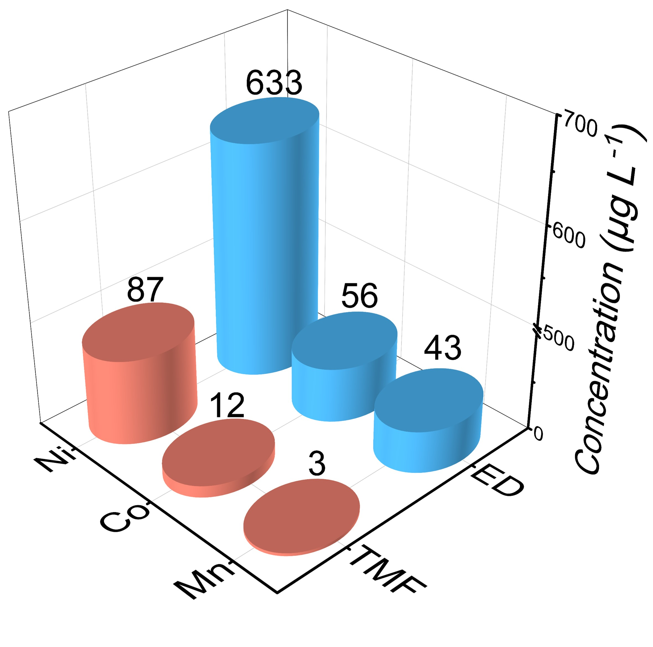
Supplementary Fig. 31. Dissolution of metals (Ni, Co, Mn) from the NMC811 cathode cycled in different electrolytes.

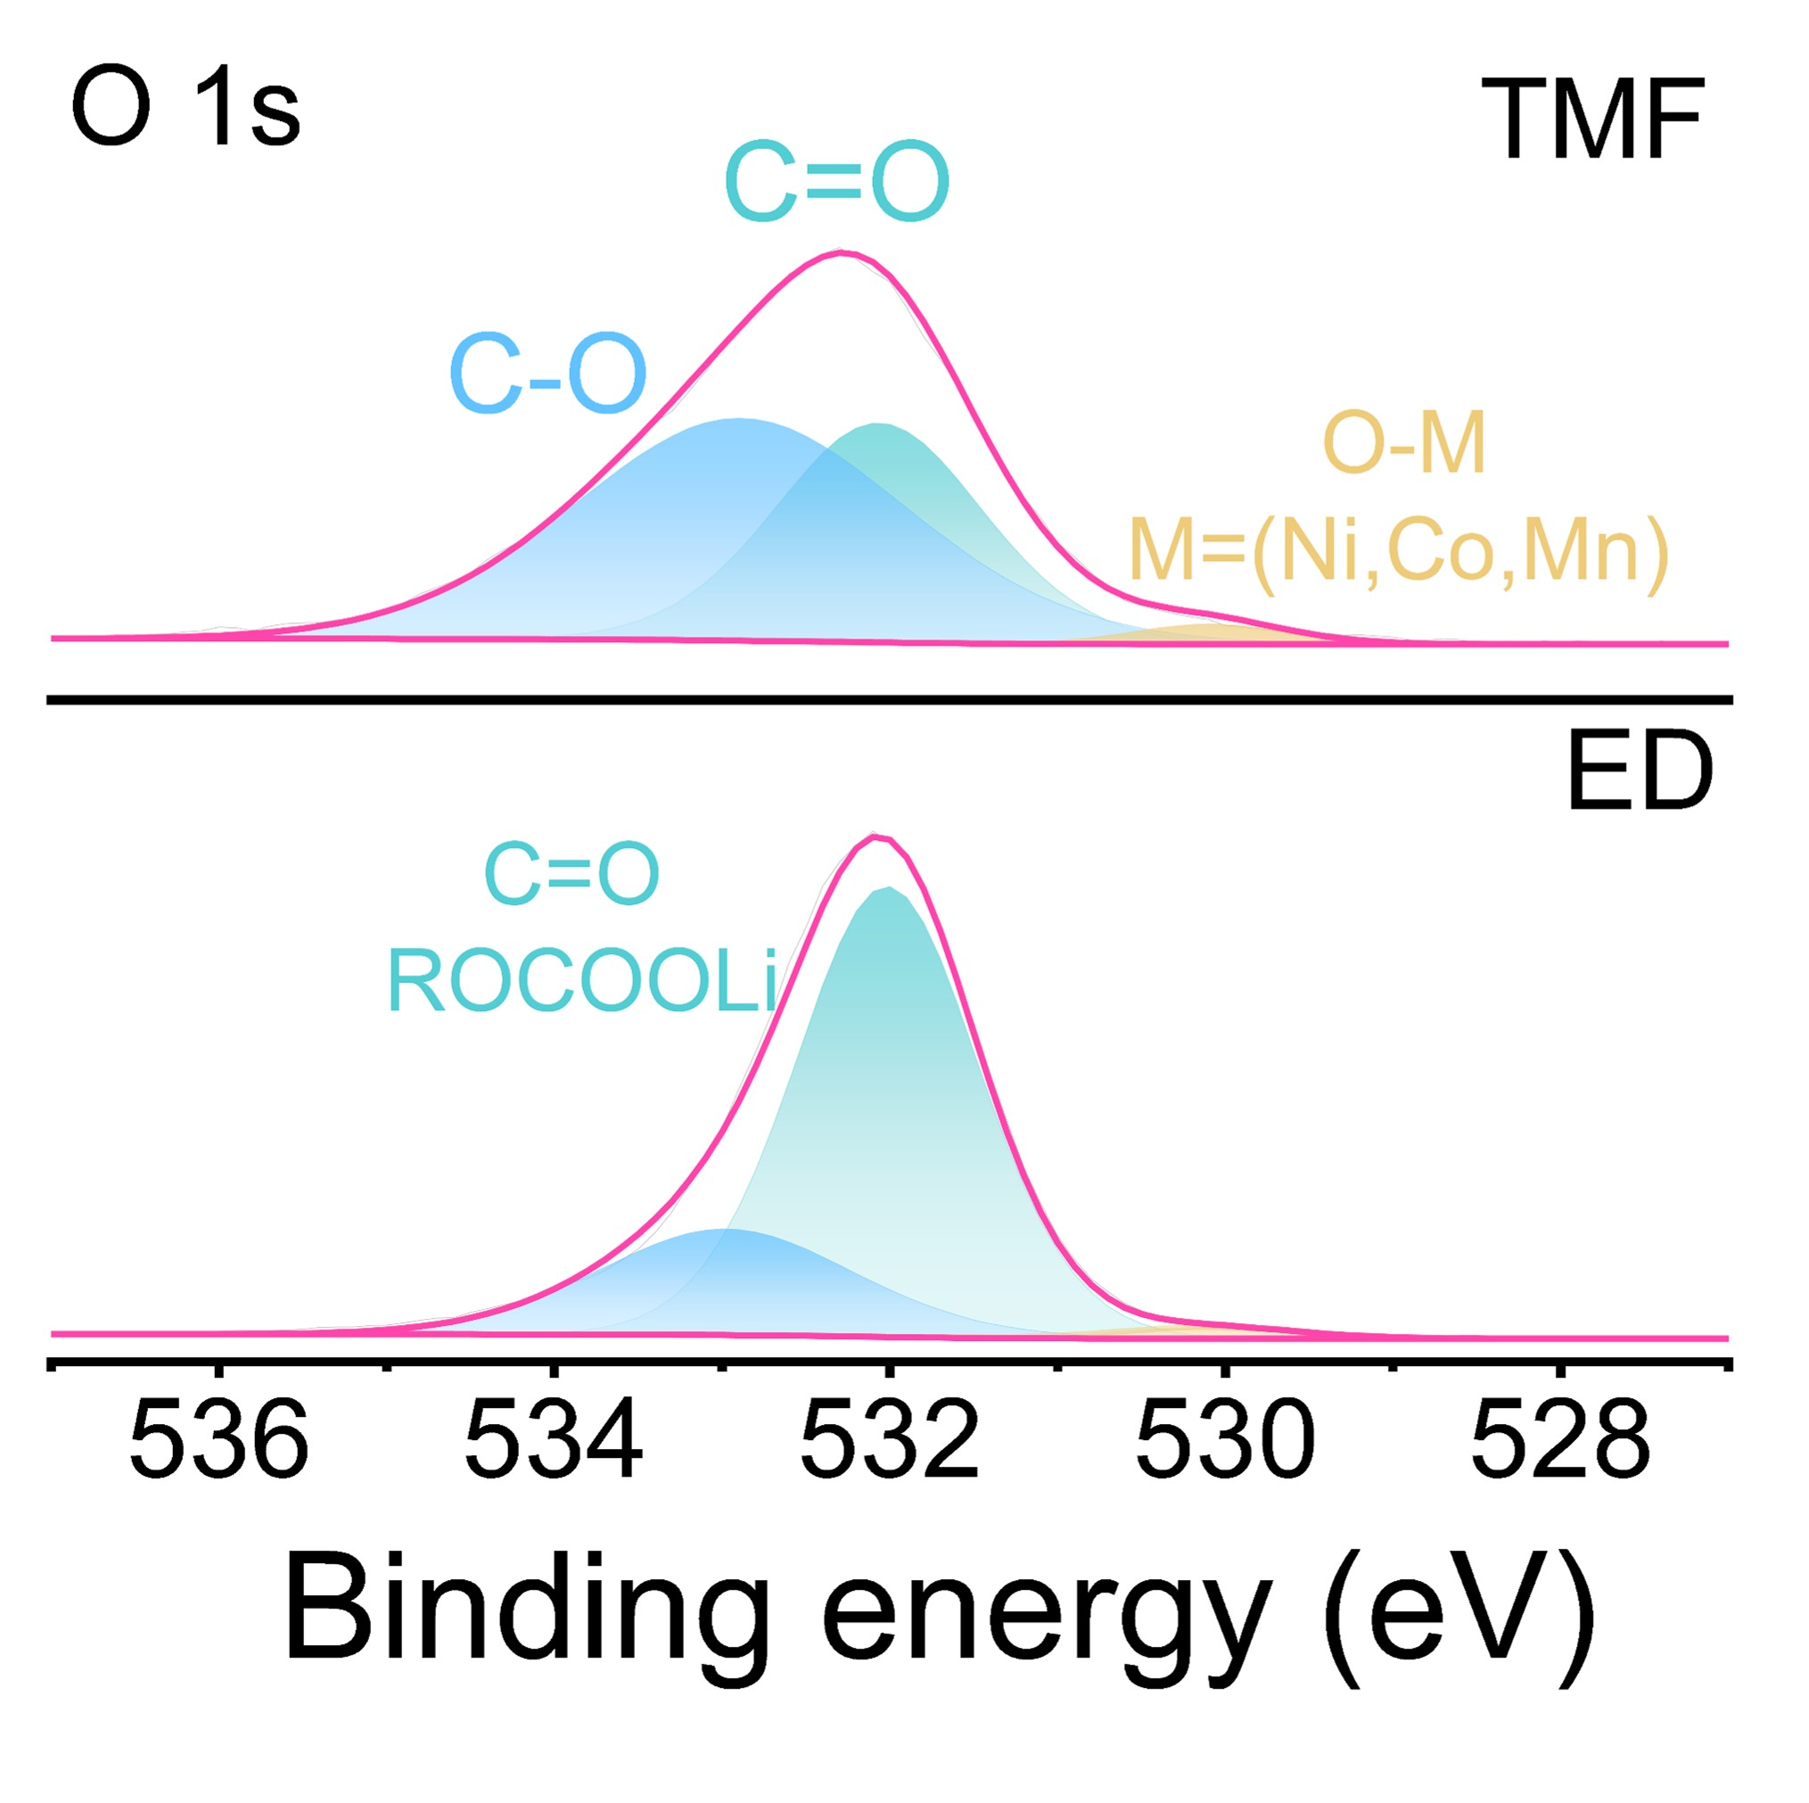
Supplementary Fig. 32. XPS O 1s spectra of the NMC811 cathodes after cycling with TMF and ED electrolytes.

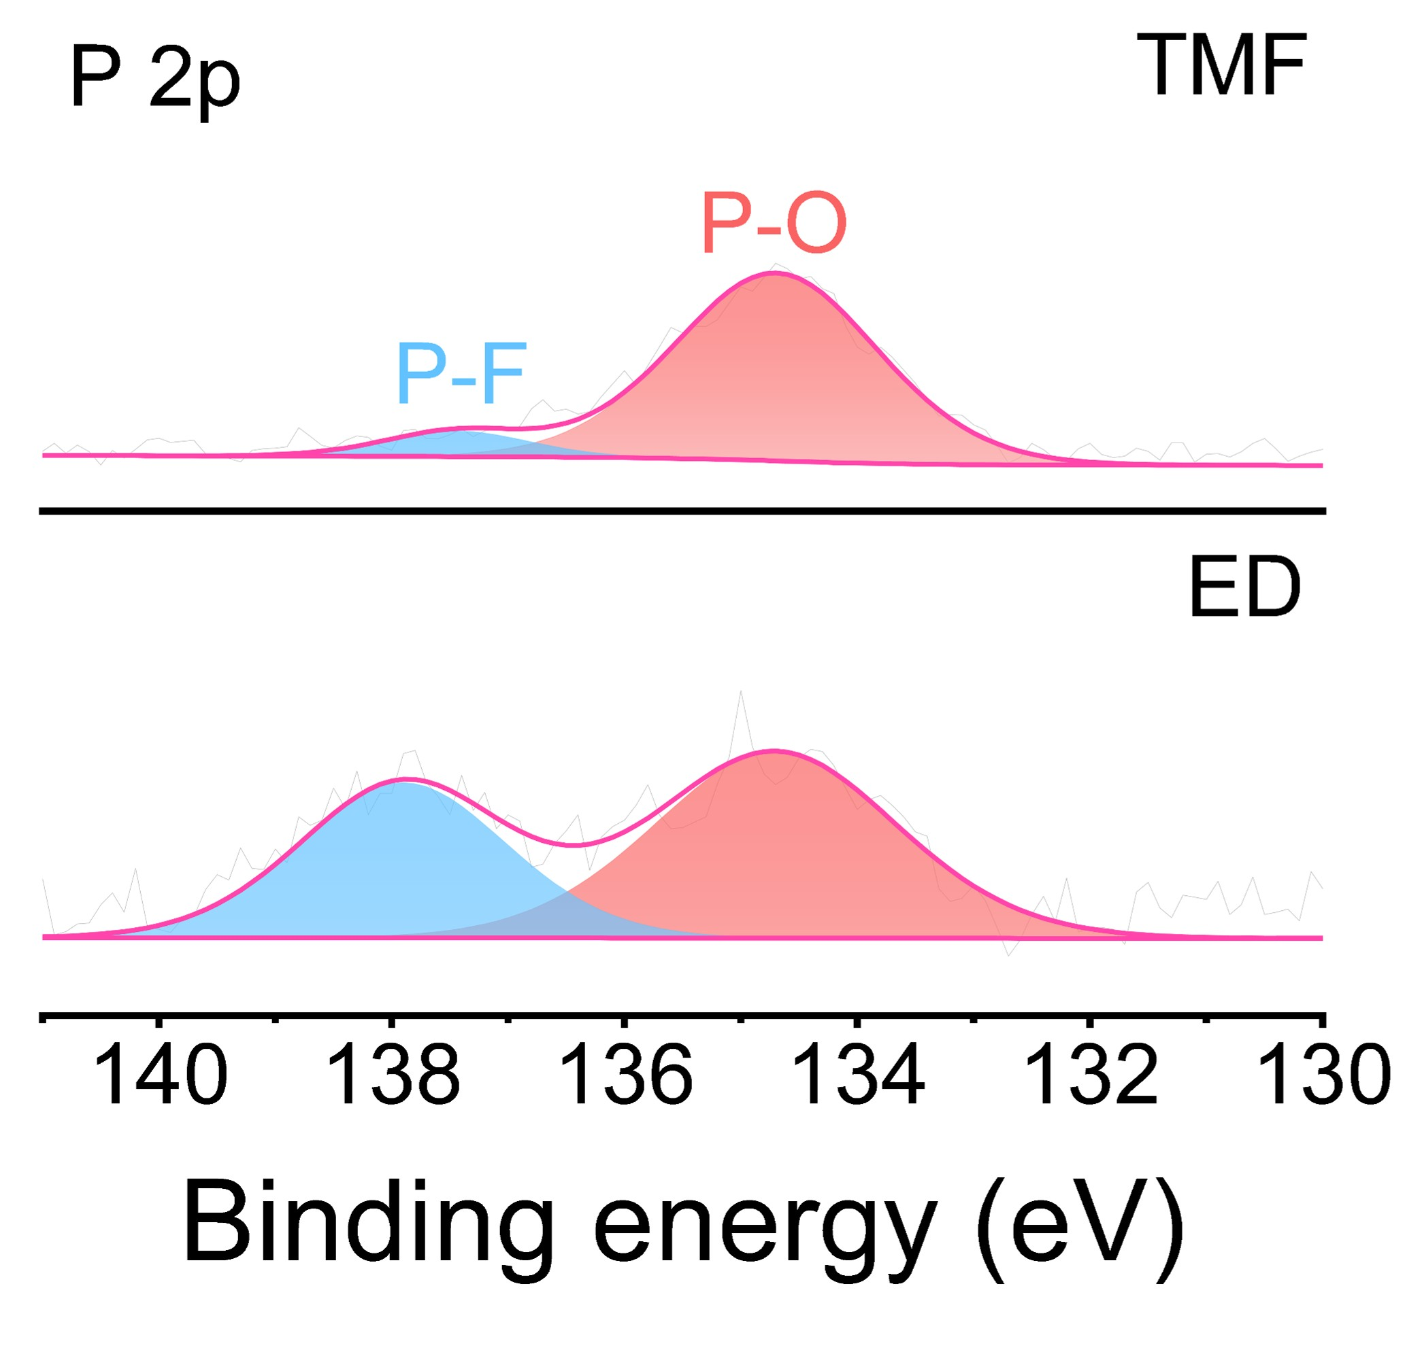
Supplementary Fig. 33. XPS P 2p spectra of the NMC811 cathodes after cycling with TMF and ED electrolytes.

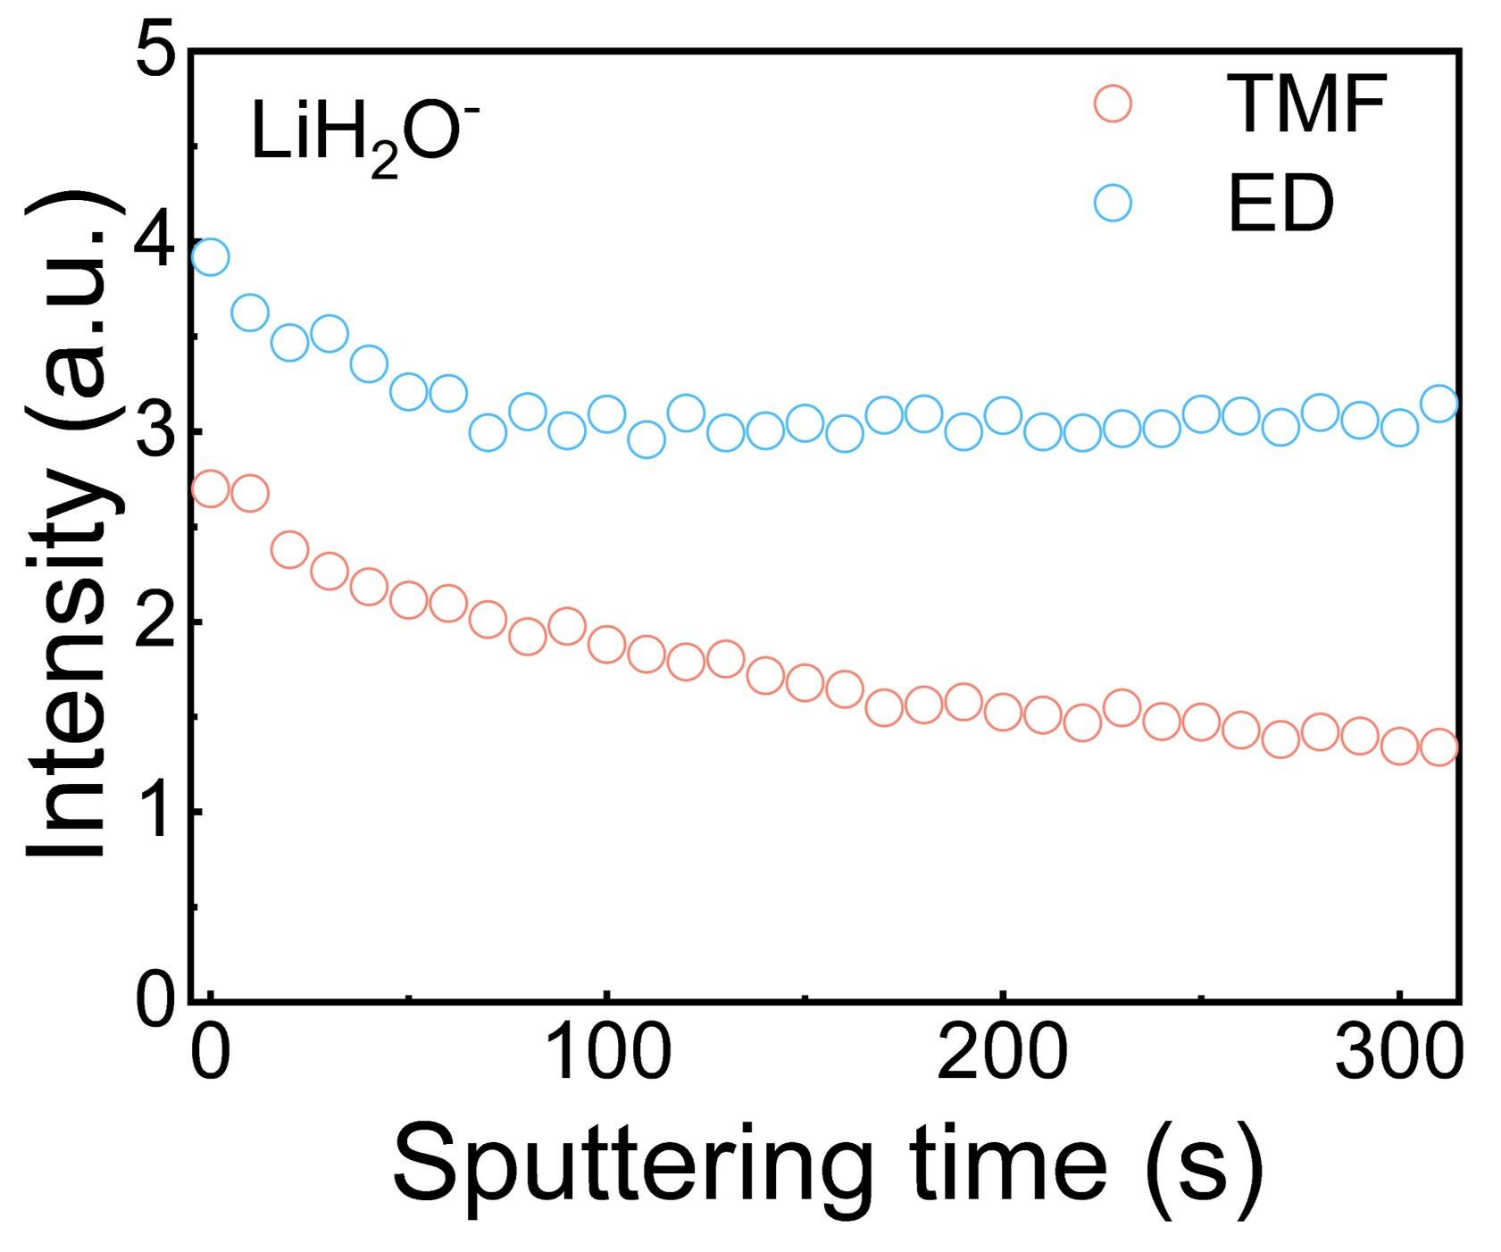
Supplementary Fig. 34. ToF-SIMS depth profiles of LiH₂O⁻ species in the CEI formed in different electrolytes.

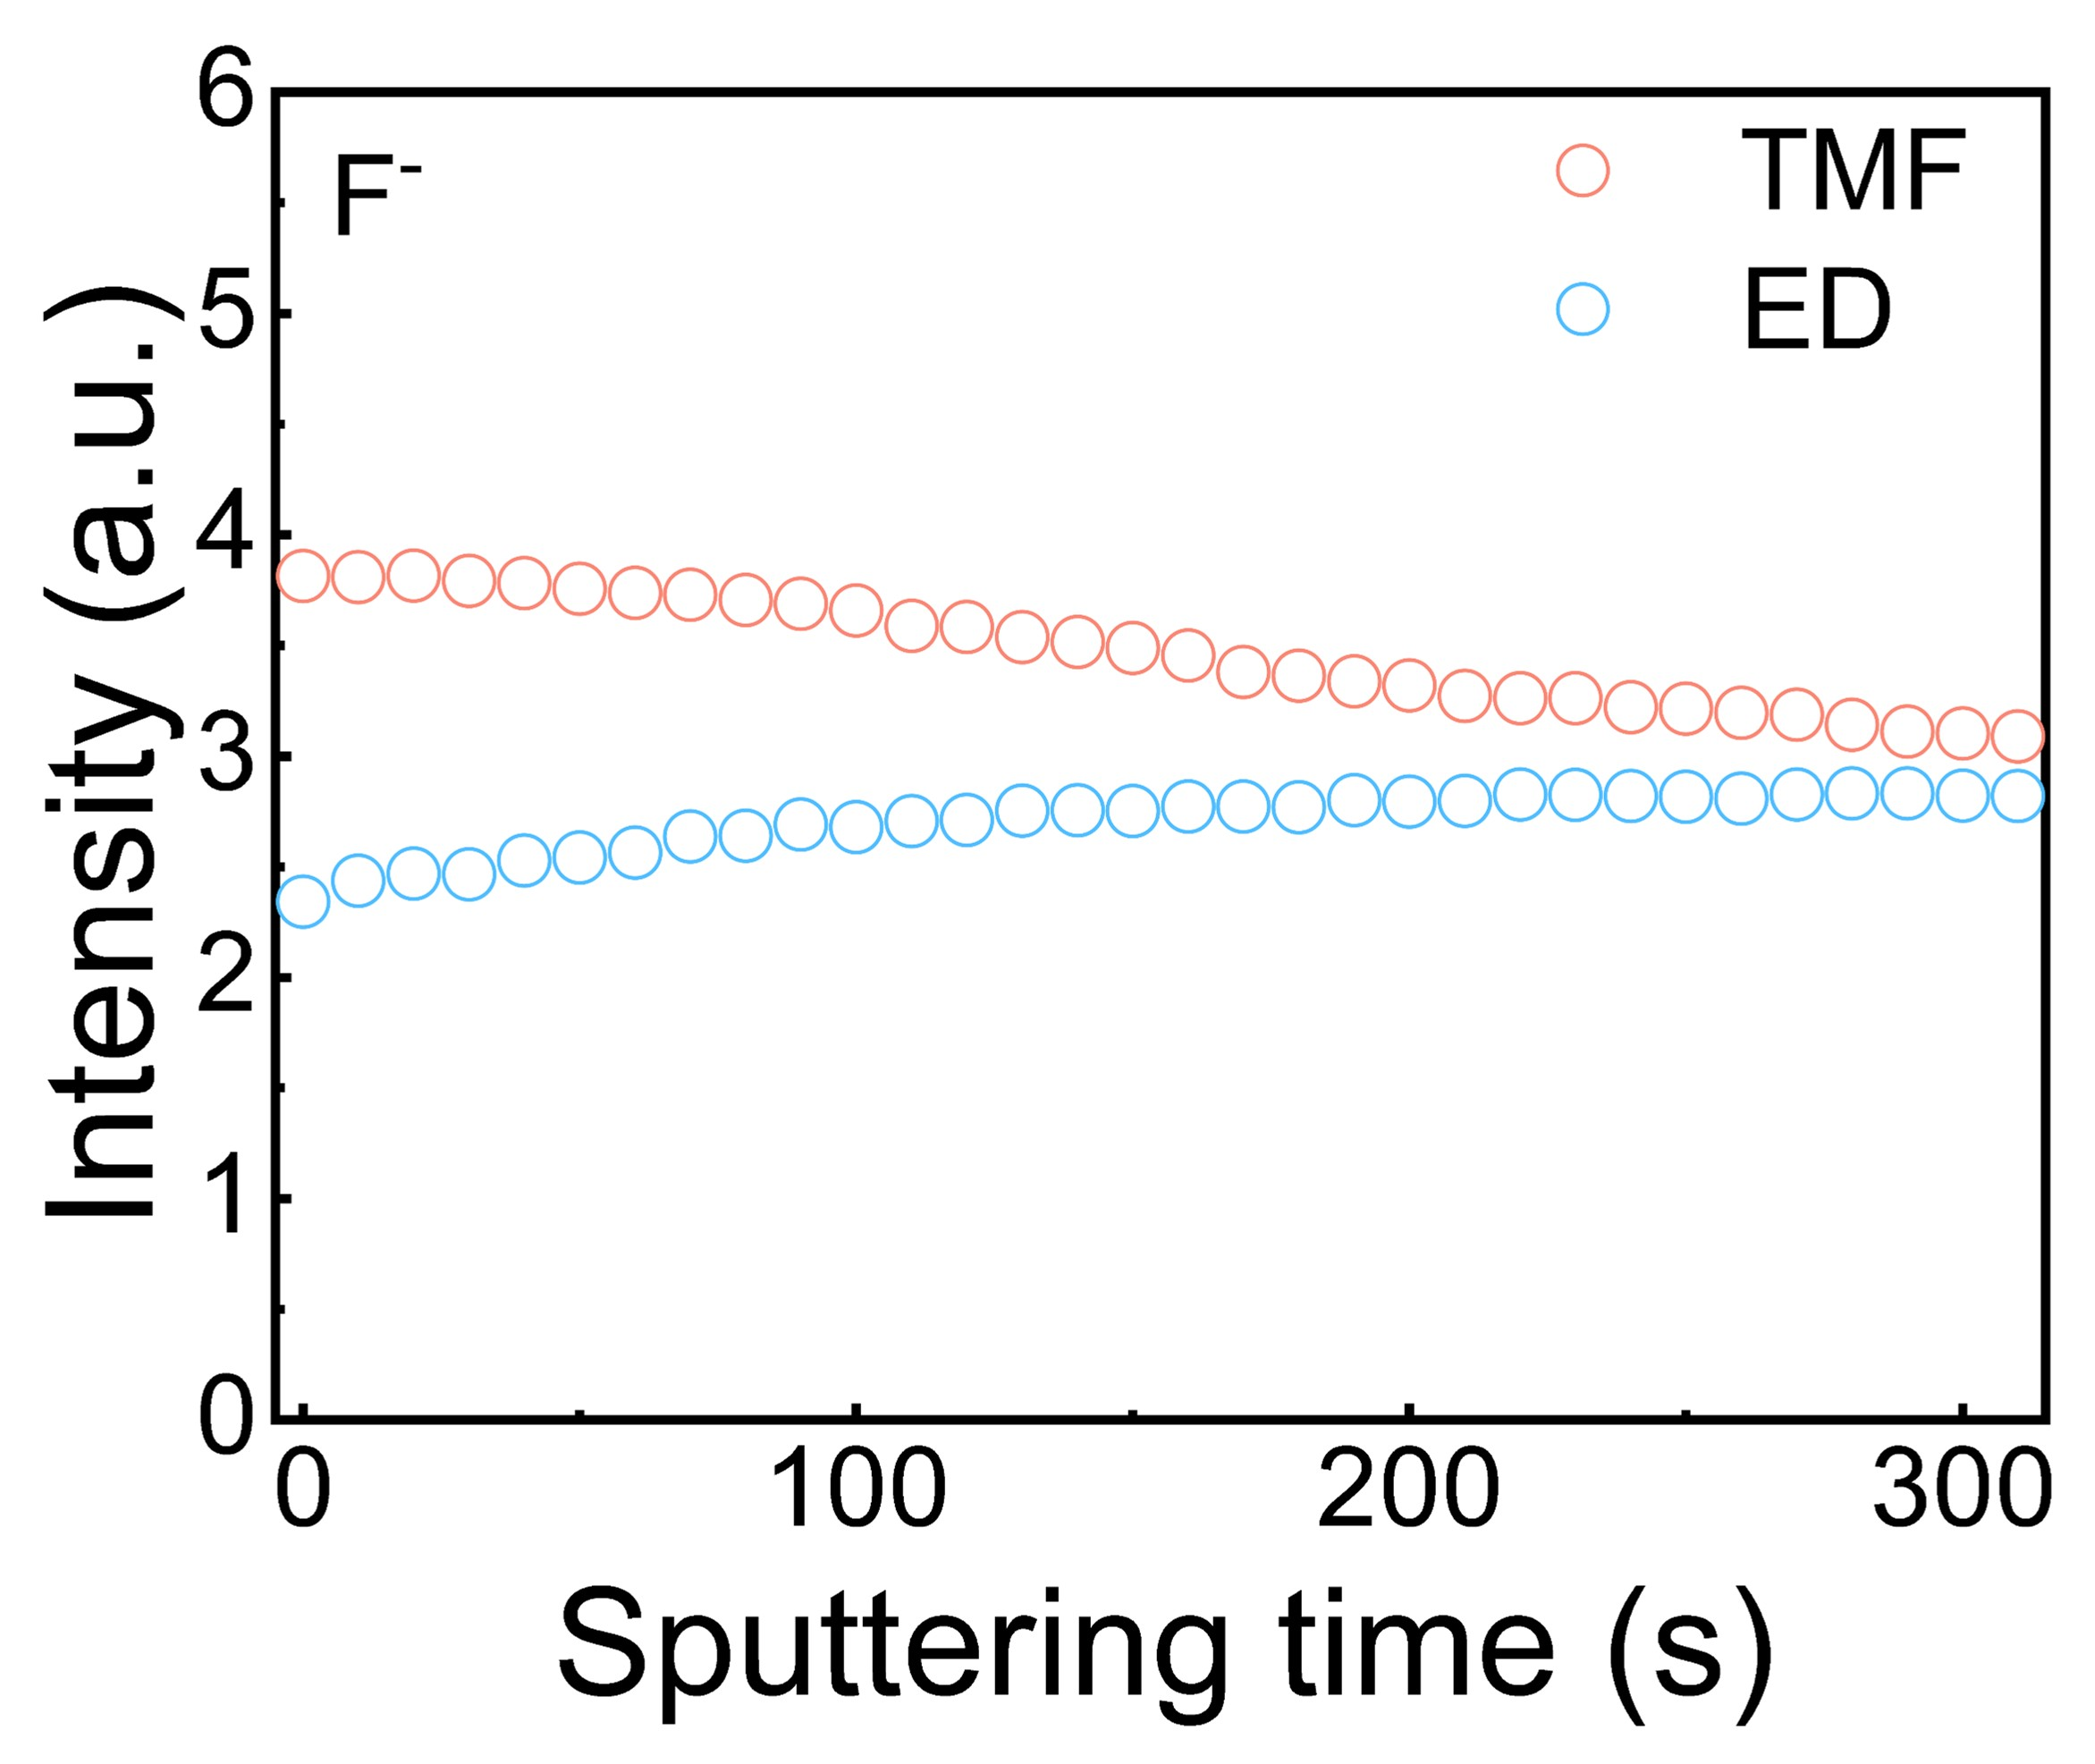
Supplementary Fig. 35. ToF-SIMS depth profiles of F⁻ species in the CEI formed in different electrolytes.

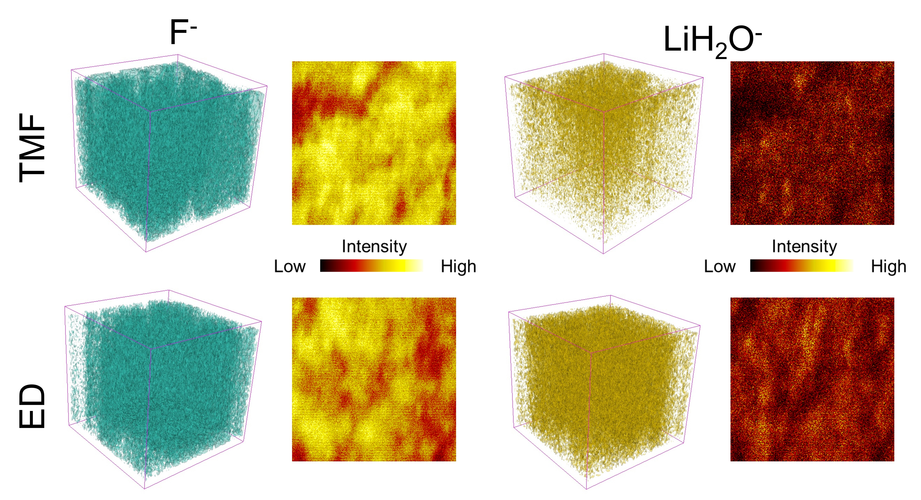
Supplementary Fig. 36. 2D images and 3D of various substances within the CEI, based on ToF-SIMS intensity depth profiles, during cycling in different electrolytes.

Supplementary Table S1. Comparison of low-temperature NMC||Li cell performance between this work and reported works.
No. | Cathode | Electrolyte | Temperature | Cut-off voltage | Discharge rate | Capacity retention | Reference
1 | NMC811 | LiFTFSI in BFPE | -40 °C | 4.3 V | 0.1 C | 100 cycles, 92% | [S1]
2 | NMC532 | LiTFSI in DOL | -40 °C | 4.3 V | 0.1 C | 50 cycles, 78% | [S2]
3 | NMC811 | LiPF₆ in EMC/FEC/2FB | -30 °C | 4.3 V | 0.2 C | 100 cycles, 76% | [S3]
4 | NMC811 | LiTFSI-LiTFPFB in PC/EC/EMC+LiPO₂F₂ | -20 °C | 4.3 V | 0.1 C | 50 cycles, 93.7% | [S4]
5 | NMC811 | LiFSI in TFMP/DME | -40 °C | 4.3 V | 0.2 C | 100 cycles, 70% | [S5]
6 | NMC811 | LiClO₄ in ES/FEC | -33 °C | 4.3 V | 0.1 C | 100 cycles, 80% | [S6]
7 | NMC811 | LiPF₆-LiTFSI-LiNO₃ in THF/FEC | -30 °C | 4.3 V | 0.05 C | 200 cycles, 100%  50 cycles,73% | [S7]
8 | NMC811 | LiFSI in BTFE/DME | -40 °C | 4.4V | 0.2C | 2005 cycles,73% | [S8]
9 | NMC811 | LIFSI-LiNO₃ in THF | -40 °C | 4.3V | 0.3C | 80 cycles, 68% | [S9]
This work | NMC811 | LiPF₆ in TEP/MP/FEC+ LiODFB | -20 °C  -40 °C | 4.6 V  4.6 V | 0.5 C  0.1 C | 200 cycles, 93%  200 cycles, 87% | /

References
S1. Xu, J. et al. Revealing the Anion-Solvent Interaction for Ultralow Temperature Lithium Metal Batteries. Adv. Mater. 36, 2306462 (2023).
S2. Jin, C. B. et al. Taming Solvent-Solute Interaction Accelerates Interfacial Kinetics in Low-Temperature Lithium-Metal Batteries. Adv. Mater. 35, 2208340 (2023).
S3. Huang, A. et al. Low-Temperature and Fast-Charging Lithium Metal Batteries Enabled by Solvent−Solvent Interaction Mediated Electrolyte. Nano Lett. 24, 7499 (2024).
S4. Shangguan, X. et al. Additive-Assisted Novel Dual-Salt Electrolyte Addresses Wide Temperature Operation of Lithium-Metal Batteries. Small 15, 1900269 (2019).
S5. Shi, J. et al. An Amphiphilic Molecule-Regulated Core-Shell-Solvation Electrolyte for Li-Metal Batteries at Ultra-Low Temperature. Angew. Chem. Int. Ed. 62, e202218151 (2023).
S6. Wang, Y. et al. Asymmetric Solvents Regulated Crystallization-Limited Electrolytes for All-Climate Lithium Metal Batteries Angew. Chem. Int. Ed. 63, e202310905 (2024).
S7. Liang, P. et al. Competitive Coordination of Ternary Anions Enabling Fast Li-Ion Desolvation for Low-Temperature Lithium Metal Batteries. Adv. Funct. Mater. 34, 2309858 (2024).
S8. Holoubek, J. et al. Electrolyte design implications of ion-pairing in low-temperature Li metal batteries. Energy Environ. Sci. 15, 1647 (2022).
S9. Zhang, W. et al. Engineering a passivating electric double layer for high performance lithium metal batteries. Nat. Commun. 2022, 13, 2029.

