Supplemental Tables, Figures, and Methods

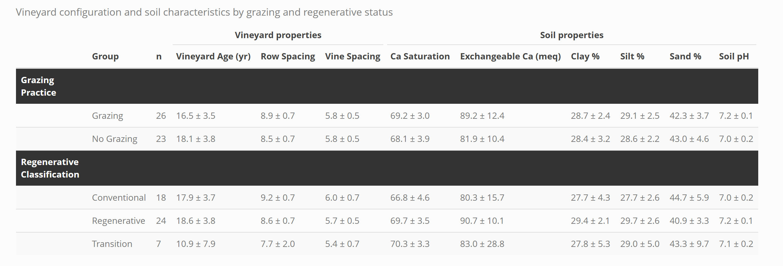
Supplemental Table 1. Summary of vineyard attributes and soil characteristics for vineyards grouped by grazing practice and management classification. All continuous variables are reported as mean ± 95% CI. Vineyards classified as grazed at the time of sampling were established grazing systems with ≥3 years of livestock integration, whereas non-grazed vineyards had no grazing history at the time of sampling. Vineyards with scores ≥4 were classified as regenerative and those with scores <4 as conventional. Vineyards with less than 3 years of continuous regenerative management at time of sampling were designated transition sites. Vineyards received a score of 1 for each regenerative practice adopted or conventional practice avoided, yielding a maximum possible regenerative score of 8 (Fenster, LaCanne et al., 2021). Practices earning a score of 1 included the use of organic amendments, no-till, winter cover crops, and the integration of sheep grazers. Use of synthetic fertilizers, herbicides, insecticides, and fungicides received a score of 0, whereas avoiding these inputs received a score of 1.

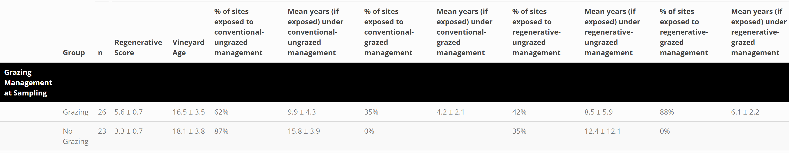
Supplemental Table 2. Summary of vineyard history under conventional and regenerative management regimes stratified by grazing status at the time of soil sampling. Values shown are the percentage of sites with any history (>0 years) under each management regime and the mean number of years among those sites (mean ± 95% CI). Regenerative score and vineyard age are also reported as means ± 95% CI. Vineyards classified as grazed at the time of sampling were established grazing systems with ≥3 years of livestock integration, whereas non-grazed vineyards had no grazing history at the time of sampling. Vineyards with scores ≥4 were classified as regenerative and those with scores <4 as conventional. Vineyards received a score of 1 for each regenerative practice adopted or conventional practice avoided, yielding a maximum possible regenerative score of 8 (Fenster, LaCanne et al., 2021). Practices earning a score of 1 included the use of organic amendments, no-till, winter cover crops, and the integration of sheep grazers. Use of synthetic fertilizers, herbicides, insecticides, and fungicides received a score of 0, whereas avoiding these inputs received a score of. Management histories were reconstructed back to vineyard planting; consequently, grazed and/or regenerative sites may include prior years under ungrazed and/or conventional management before entering their current management regime. See Supplemental Figure 1 for frequency plots documenting the duration each vineyard spent under each management regime (conventional–ungrazed, conventional–grazed, regenerative–ungrazed, and regenerative–grazed).

Supplemental Table 3. Generalized additive model (GAM) results for baseline, stock, and root-zone enrichment (RZA) metrics of soil organic matter (SOM) pools (SOC, MAOC, POC, TSN, MAN, PN) at the farm level (see Excel spreadsheet to view the table). Models were fit separately for SOM pools at 0–15, 15–30, 0–30, and 30–60 cm depth increments. Each SOM pool–depth combination was modeled as a function of grazing status (Y/N) and conventional–regenerative management classification, with smooth terms for clay (%), silt (%), Ca saturation (0–15 cm), and spatial location (longitude × latitude). The table reports adjusted R², estimated parametric and smooth terms (with friendly term labels), standard errors, test statistics, p-values, and effective degrees of freedom for each response × management predictor combination.
Variable | Importance | Normalized Importance | Response | R² | RMSE
Longitude | 0.053816 | 1 | MAN RZA 0-30 cm | 0.928001 | 0.132252
Latitude | 0.038873 | 0.723109 | MAN RZA 0-30 cm | 0.928001 | 0.132252
Clay % | 0.01039 | 0.195318 | MAN RZA 0-30 cm | 0.928001 | 0.132252
Exchangeable Ca (0-15cm) | 0.008986 | 0.169298 | MAN RZA 0-30 cm | 0.928001 | 0.132252
Graze livestock | 0.008801 | 0.165859 | MAN RZA 0-30 cm | 0.928001 | 0.132252
Silt % | 0.00594 | 0.112855 | MAN RZA 0-30 cm | 0.928001 | 0.132252
Ca saturation (0-15cm) | 0.004629 | 0.088548 | MAN RZA 0-30 cm | 0.928001 | 0.132252
No synthetic insecticides | 0.004298 | 0.082429 | MAN RZA 0-30 cm | 0.928001 | 0.132252
Organic amendments and fertilizers | 0.00426 | 0.081723 | MAN RZA 0-30 cm | 0.928001 | 0.132252
No syn/metal fungicides | 0.002095 | 0.041602 | MAN RZA 0-30 cm | 0.928001 | 0.132252
No synthetic fertilizers | 0.001772 | 0.035617 | MAN RZA 0-30 cm | 0.928001 | 0.132252
No-till tractor row | 0.001602 | 0.032472 | MAN RZA 0-30 cm | 0.928001 | 0.132252
Permanent ground cover | 0.001415 | 0.029 | MAN RZA 0-30 cm | 0.928001 | 0.132252
No synthetic herbicides | 0.001335 | 0.027522 | MAN RZA 0-30 cm | 0.928001 | 0.132252
No-till under vine | -0.00015 | 0 | MAN RZA 0-30 cm | 0.928001 | 0.132252
Longitude | 17.08983 | 1 | MAOC RZA 0-30 cm | 0.932513 | 1.546813
Latitude | 9.285852 | 0.542145 | MAOC RZA 0-30 cm | 0.932513 | 1.546813
Silt % | 1.520819 | 0.086574 | MAOC RZA 0-30 cm | 0.932513 | 1.546813
Organic amendments and fertilizers | 1.258832 | 0.071203 | MAOC RZA 0-30 cm | 0.932513 | 1.546813
No synthetic fertilizers | 0.843947 | 0.046862 | MAOC RZA 0-30 cm | 0.932513 | 1.546813
Exchangeable Ca (0-15cm) | 0.55248 | 0.029762 | MAOC RZA 0-30 cm | 0.932513 | 1.546813
No synthetic insecticides | 0.50593 | 0.027031 | MAOC RZA 0-30 cm | 0.932513 | 1.546813
Variable | Importance | Normalized Importance | Response | R² | RMSE
Ca saturation (0-15cm) | 0.461959 | 0.024451 | MAOC RZA 0-30 cm | 0.932513 | 1.546813
No syn/metal fungicides | 0.429927 | 0.022572 | MAOC RZA 0-30 cm | 0.932513 | 1.546813
No-till tractor row | 0.303632 | 0.015162 | MAOC RZA 0-30 cm | 0.932513 | 1.546813
Clay % | 0.295507 | 0.014685 | MAOC RZA 0-30 cm | 0.932513 | 1.546813
Graze livestock | 0.216602 | 0.010056 | MAOC RZA 0-30 cm | 0.932513 | 1.546813
No synthetic herbicides | 0.171771 | 0.007426 | MAOC RZA 0-30 cm | 0.932513 | 1.546813
No-till under vine | 0.110197 | 0.003813 | MAOC RZA 0-30 cm | 0.932513 | 1.546813
Permanent ground cover | 0.045199 | 0 | MAOC RZA 0-30 cm | 0.932513 | 1.546813
Latitude | 0.049613 | 1 | PN RZA 0-30 cm | 0.910195 | 0.230076
Longitude | 0.014675 | 0.385746 | PN RZA 0-30 cm | 0.910195 | 0.230076
No synthetic insecticides | 0.009295 | 0.291161 | PN RZA 0-30 cm | 0.910195 | 0.230076
Graze livestock | 0.007962 | 0.267717 | PN RZA 0-30 cm | 0.910195 | 0.230076
Silt % | 0.006411 | 0.240452 | PN RZA 0-30 cm | 0.910195 | 0.230076
No synthetic fertilizers | 0.006155 | 0.235943 | PN RZA 0-30 cm | 0.910195 | 0.230076
No-till under vine | 0.003325 | 0.186192 | PN RZA 0-30 cm | 0.910195 | 0.230076
Clay % | 0.003008 | 0.180631 | PN RZA 0-30 cm | 0.910195 | 0.230076
Organic amendments and fertilizers | 0.002363 | 0.169285 | PN RZA 0-30 cm | 0.910195 | 0.230076
No synthetic herbicides | 0.001997 | 0.162856 | PN RZA 0-30 cm | 0.910195 | 0.230076
No syn/metal fungicides | 0.000765 | 0.141179 | PN RZA 0-30 cm | 0.910195 | 0.230076
No-till tractor row | 0.000419 | 0.135099 | PN RZA 0-30 cm | 0.910195 | 0.230076
Permanent ground cover | -0.00024 | 0.123519 | PN RZA 0-30 cm | 0.910195 | 0.230076
Exchangeable Ca (0-15cm) | -0.00224 | 0.08835 | PN RZA 0-30 cm | 0.910195 | 0.230076
Ca saturation (0-15cm) | -0.00727 | 0 | PN RZA 0-30 cm | 0.910195 | 0.230076
Variable | Importance | Normalized Importance | Response | R² | RMSE
Latitude | 5.800332 | 1 | POC RZA 0-30 cm | 0.903323 | 1.588568
Longitude | 3.518019 | 0.611489 | POC RZA 0-30 cm | 0.903323 | 1.588568
Clay % | 1.117035 | 0.202776 | POC RZA 0-30 cm | 0.903323 | 1.588568
No synthetic herbicides | 0.669377 | 0.126573 | POC RZA 0-30 cm | 0.903323 | 1.588568
Graze livestock | 0.611245 | 0.116677 | POC RZA 0-30 cm | 0.903323 | 1.588568
Silt % | 0.356737 | 0.073353 | POC RZA 0-30 cm | 0.903323 | 1.588568
No synthetic insecticides | 0.315811 | 0.066386 | POC RZA 0-30 cm | 0.903323 | 1.588568
Permanent ground cover | 0.20276 | 0.047142 | POC RZA 0-30 cm | 0.903323 | 1.588568
No synthetic fertilizers | 0.176975 | 0.042753 | POC RZA 0-30 cm | 0.903323 | 1.588568
No syn/metal fungicides | 0.045159 | 0.020314 | POC RZA 0-30 cm | 0.903323 | 1.588568
No-till tractor row | 0.019366 | 0.015923 | POC RZA 0-30 cm | 0.903323 | 1.588568
Organic amendments and fertilizers | 0.003022 | 0.013141 | POC RZA 0-30 cm | 0.903323 | 1.588568
No-till under vine | -0.00189 | 0.012305 | POC RZA 0-30 cm | 0.903323 | 1.588568
Exchangeable Ca (0-15cm) | -0.01715 | 0.009708 | POC RZA 0-30 cm | 0.903323 | 1.588568
Ca saturation (0-15cm) | -0.07418 | 0 | POC RZA 0-30 cm | 0.903323 | 1.588568
Latitude | 30.75734 | 1 | SOC RZA 0-30 cm | 0.956417 | 1.933153
Longitude | 27.96365 | 0.908006 | SOC RZA 0-30 cm | 0.956417 | 1.933153
Silt % | 3.996054 | 0.118771 | SOC RZA 0-30 cm | 0.956417 | 1.933153
Ca saturation (0-15cm) | 2.210561 | 0.059976 | SOC RZA 0-30 cm | 0.956417 | 1.933153
Clay % | 1.716124 | 0.043694 | SOC RZA 0-30 cm | 0.956417 | 1.933153
Variable | Importance | Normalized Importance | Response | R² | RMSE
No synthetic fertilizers | 1.61521 | 0.040371 | SOC RZA 0-30 cm | 0.956417 | 1.933153
Organic amendments and fertilizers | 1.595677 | 0.039728 | SOC RZA 0-30 cm | 0.956417 | 1.933153
No-till tractor row | 1.569656 | 0.038871 | SOC RZA 0-30 cm | 0.956417 | 1.933153
Exchangeable Ca (0-15cm) | 1.510881 | 0.036936 | SOC RZA 0-30 cm | 0.956417 | 1.933153
No synthetic insecticides | 1.33519 | 0.031151 | SOC RZA 0-30 cm | 0.956417 | 1.933153
Graze livestock | 0.895943 | 0.016686 | SOC RZA 0-30 cm | 0.956417 | 1.933153
No syn/metal fungicides | 0.781612 | 0.012922 | SOC RZA 0-30 cm | 0.956417 | 1.933153
No synthetic herbicides | 0.672724 | 0.009336 | SOC RZA 0-30 cm | 0.956417 | 1.933153
Permanent ground cover | 0.44196 | 0.001737 | SOC RZA 0-30 cm | 0.956417 | 1.933153
No-till under vine | 0.389207 | 0 | SOC RZA 0-30 cm | 0.956417 | 1.933153
Longitude | 0.127142 | 1 | TSN RZA 0-30 cm | 0.953327 | 0.154742
Latitude | 0.096503 | 0.756099 | TSN RZA 0-30 cm | 0.953327 | 0.154742
Exchangeable Ca (0-15cm) | 0.016052 | 0.115662 | TSN RZA 0-30 cm | 0.953327 | 0.154742
Ca saturation (0-15cm) | 0.015516 | 0.111396 | TSN RZA 0-30 cm | 0.953327 | 0.154742
Silt % | 0.014397 | 0.102492 | TSN RZA 0-30 cm | 0.953327 | 0.154742
Graze livestock | 0.013773 | 0.097524 | TSN RZA 0-30 cm | 0.953327 | 0.154742
No synthetic insecticides | 0.010837 | 0.074148 | TSN RZA 0-30 cm | 0.953327 | 0.154742
Clay % | 0.010468 | 0.071216 | TSN RZA 0-30 cm | 0.953327 | 0.154742
Permanent ground cover | 0.007569 | 0.048133 | TSN RZA 0-30 cm | 0.953327 | 0.154742
No synthetic herbicides | 0.005808 | 0.034117 | TSN RZA 0-30 cm | 0.953327 | 0.154742
No synthetic fertilizers | 0.005235 | 0.029555 | TSN RZA 0-30 cm | 0.953327 | 0.154742
Organic amendments and fertilizers | 0.004498 | 0.02369 | TSN RZA 0-30 cm | 0.953327 | 0.154742
Variable | Importance | Normalized Importance | Response | R² | RMSE
No-till tractor row | 0.004321 | 0.022277 | TSN RZA 0-30 cm | 0.953327 | 0.154742
No syn/metal fungicides | 0.002353 | 0.006616 | TSN RZA 0-30 cm | 0.953327 | 0.154742
No-till under vine | 0.001522 | 0 | TSN RZA 0-30 cm | 0.953327 | 0.154742

Supplemental Table 4. Random forest model results summarizing model performance and the relative importance of spatial, edaphic, and management predictors for each soil organic matter pool (SOC, MAOC, POC, TSN, MAN, and PN). Soil organic matter pools are expressed in Mg ha⁻¹. For each predictor, the table reports its variable importance and normalized importance within each SOM pool, along with model performance metrics (R² and RMSE).

Supplemental Table 5. Environmental interactions with management-driven accrual trajectories (see Excel spreadsheet to view the table). Results of exploratory generalized additive model (GAM) interaction tests evaluating whether management-driven accrual slopes varied across spatial and edaphic gradients for root-zone enrichment (RZA) soil organic carbon (SOC; 0–30 cm), total soil nitrogen (TSN; 0–30 cm), and plant-available nitrogen (PAN; 0–15 cm). Starting from the baseline GAM structure used in the main analyses, additional tensor-product smooth interactions were introduced to allow the slopes associated with the conventional–ungrazed trajectory (cT) and deviation terms for conventional–grazed (d_Cg), regenerative–ungrazed (d_Ru), and regenerative–grazed (d_Rg) management to vary across geographic space (longitude–latitude) and soil properties (Ca²⁺ saturation, silt, and clay). Models were fitted using maximum likelihood (ML) to allow comparison with the baseline model. For each interaction model (M1), the table reports model fit statistics relative to the baseline model (M0), including likelihood ratio tests (LRT), ΔAIC, and changes in adjusted R². Smooth-term statistics (effective degrees of freedom, reference degrees of freedom, test statistic, and p-value) are also reported for the interaction term.

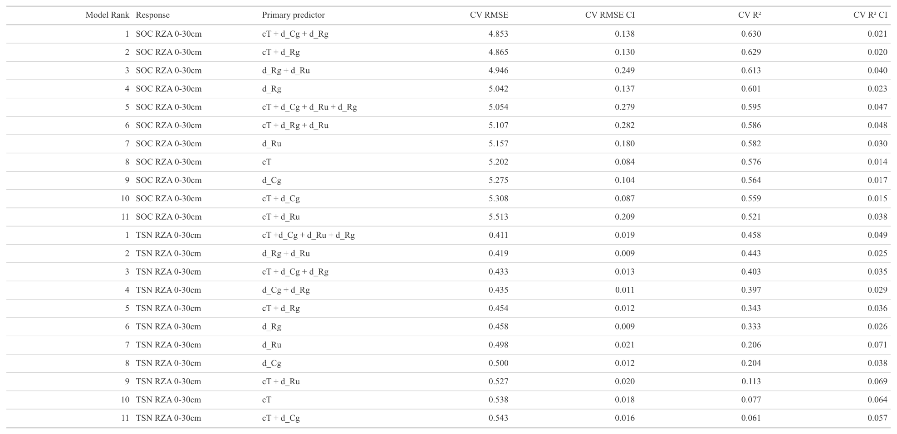
Supplemental Table 6. Predictive performance of generalized additive models (GAMs) using different combinations of management-duration predictors. Models evaluate the contribution of the centered conventional–ungrazed baseline term (cT) and three deviation terms representing years under conventional grazed (d_Cg), regenerative ungrazed (d_Ru), and regenerative grazed (d_Rg) management to root zone accrued (RZA) soil organic carbon (SOC) and total soil nitrogen (TSN). In this parameterization, cT represents the reference time-under-management trajectory for conventional ungrazed vineyards, while the deviation terms estimate how the other management trajectories differ from this baseline. The table lists the top-performing SOC models (ranked by cross-validated R²), followed by the top-performing TSN models. Predictive performance was assessed using five-fold spatial cross-validation repeated 20 times. For each repetition, vineyard sites were reassigned to new spatial blocks, models were trained on four folds and validated on the fifth, and results were pooled across repetitions to estimate RMSE with confidence intervals and cross-validated R² with confidence intervals.

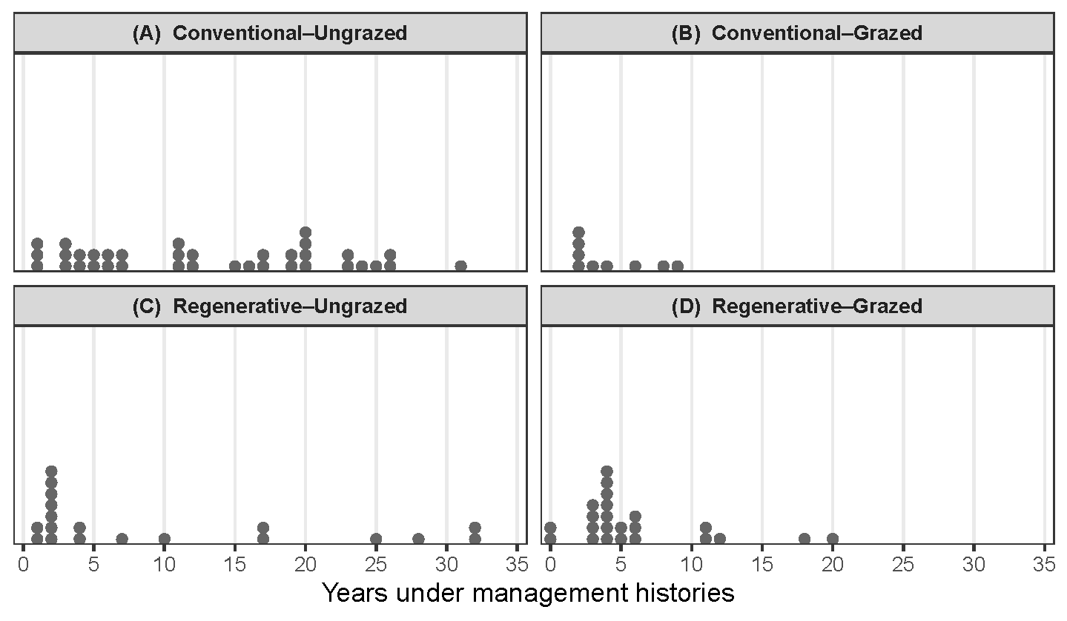
Supplemental Figure 1. Distribution of years that each vineyard spent within the four management histories: Conventional–Ungrazed (A), Conventional–Grazed (B), Regenerative–Ungrazed (C), and Regenerative–Grazed (D). Each point represents one vineyard. Please note that some sites classified within a grazed and/or regenerative trajectory had previously experienced conventional and/or non-grazing management. See supplemental table 2 for percentage of vineyards exposed to each management trajectory and mean number of years exposed vineyards spent under each management trajectory.

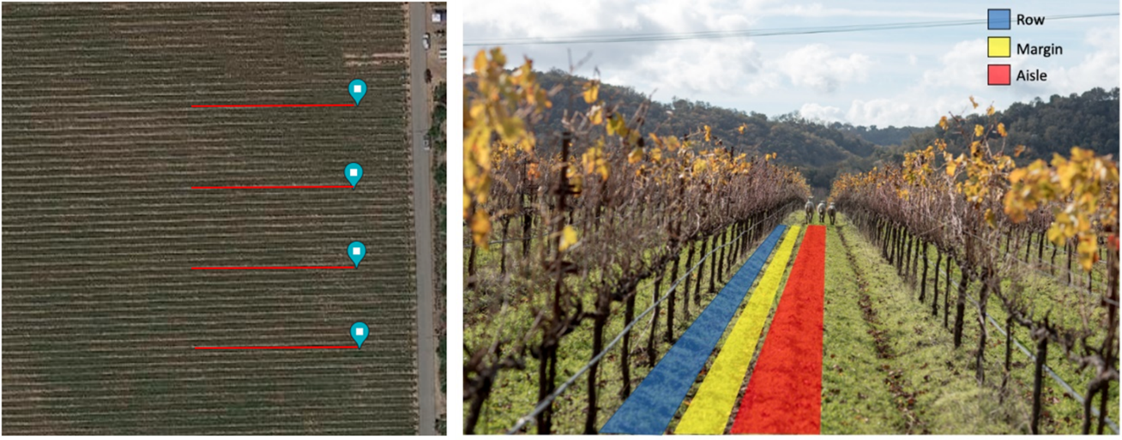
Supplemental Figure 2. Transect layout and sampling pattern. From each transect, four soil cores to 60 cm depth were collected at 0 m (aisle), 15 m (margin), 30 m (row), and 45 m (aisle). Cores were sectioned into 0–5, 5–10, 10–15, 15–30, and 30–60 cm increments, then composited at the transect level. For plant-available nitrogen, twelve separate 0–15 cm cores were taken at 4 m intervals along each transect in a aisle–margin–row pattern.

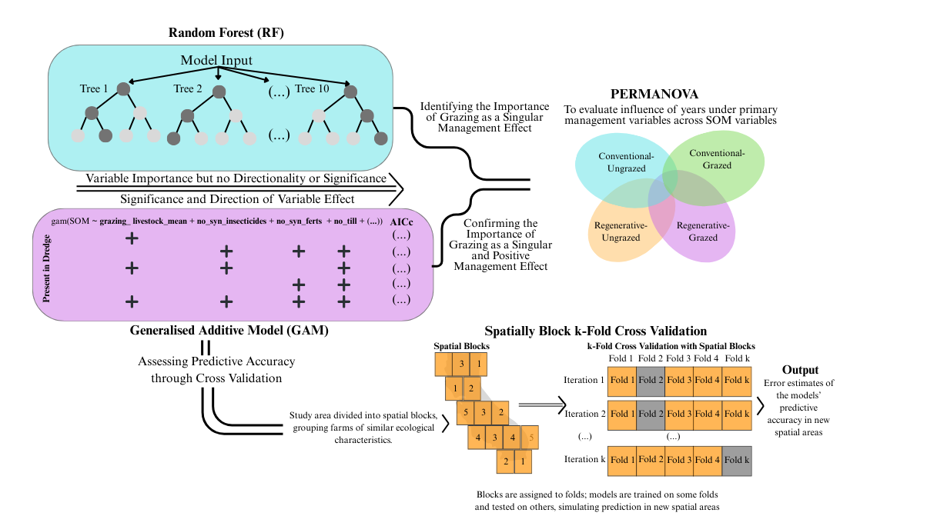

Supplemental Figure 3. Workflow summarizing the integrated modeling approach. Random Forest (RF) identified the relative importance of grazing and other management variables but does not provide coefficient directionality or statistical significance. Generalized additive models (GAMs), fit across a dredged AICc-ranked model set, provided inference on effect direction, consistency, and significance. PERMANOVA assessed whether years spent under each management trajectory (Conventional–Ungrazed, Conventional–Grazed, Regenerative–Ungrazed, Regenerative–Grazed) explained multivariate SOM variation. Spatially blocked k-fold cross-validation estimated predictive accuracy of each management trajectory on SOC and TSN by repeatedly training and testing models across geographically distinct spatial blocks.

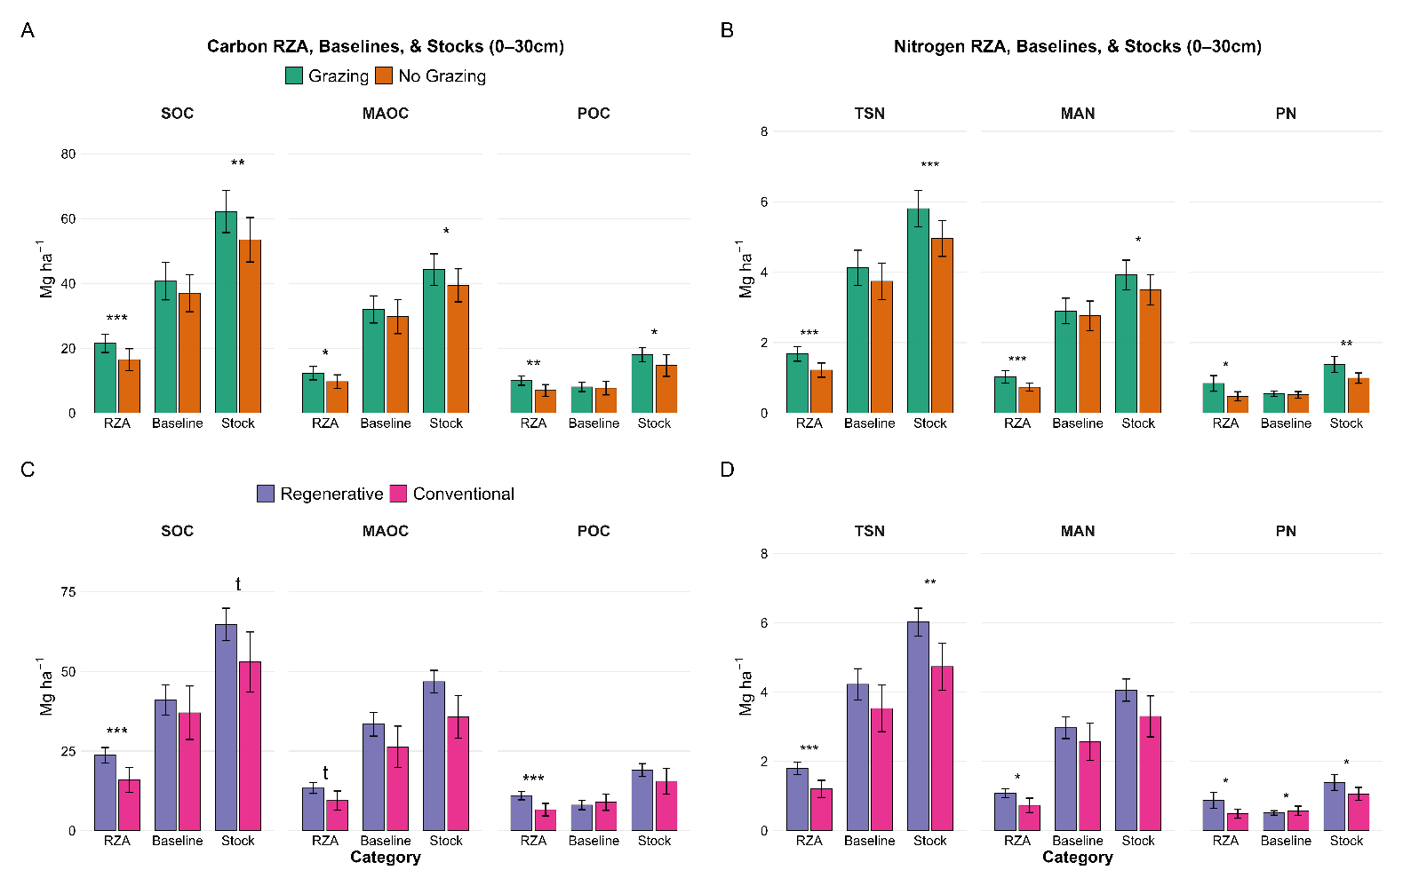
Supplemental Figure 4. Carbon (SOC, MAOC, POC) and nitrogen (TSN, MAN, PN) fractions at 0–30 cm shown as root-zone accrual (RZA, 0-30cm), baseline stocks, and measured stocks, grouped by grazing system (A–B) and regenerative designation (C–D). RZA represents accrual above baseline, calculated as measured stock minus the depth-standardized baseline. Baseline profiles for each SOM pool were estimated using the Franzluebbers exponential depth-distribution model (Franzluebbers 2021), with nonlinear fits retained when R² ≥ 0.90 and GAM-refitted profiles when GAM R² ≥ 0.90. Baseline stocks were obtained by integrating the baseline component to 30 cm, whereas RZA expresses the 0–30 cm surface accrual relative to this modeled baseline.

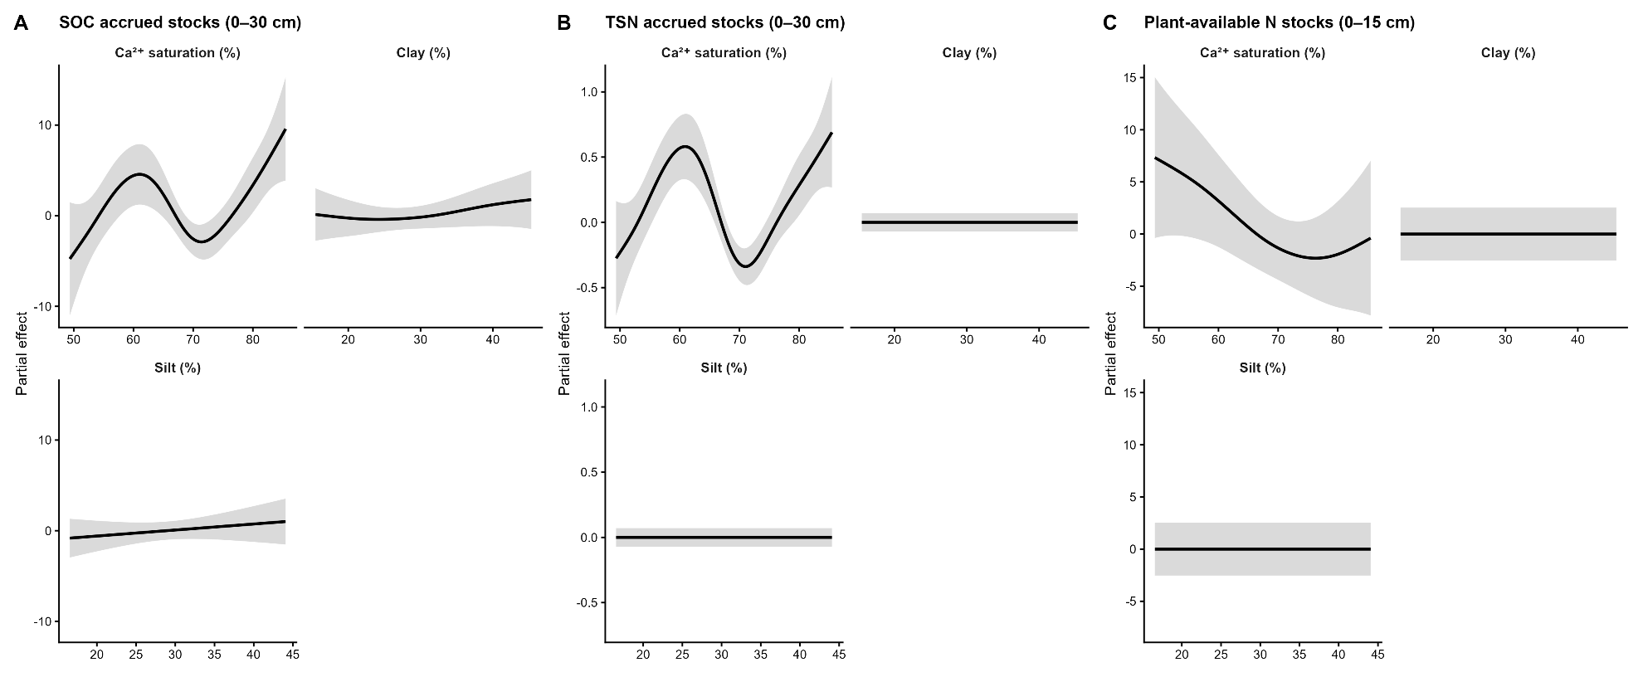
Supplemental Figure 5. Edaphic relationships with model-predicted soil C and N accrual. Partial response curves from generalized additive models (GAMs) showing modeled relationships between Ca²⁺ saturation, silt, and clay content and accrued soil organic carbon (SOC; 0–30 cm), total soil nitrogen (TSN; 0–30 cm), and plant-available nitrogen (PAN; 0–15 cm). Curves represent model predictions with other covariates held constant, and shaded ribbons indicate 95% confidence intervals.

Supplemental Methods
2.6.1. Relative importance of management and co-edaphic factors
To evaluate the relative influence and directional effects of vineyard management practices on each soil C and N pool, we integrated random forest (RF) variable importance with unconditional generalized additive model (GAM) inference across the full candidate model set. RF models yielded normalized importance scores, while GAMs provided unweighted meta-analytic effect estimates and p-values derived from a random-effects combination of model coefficients (β̄) and both within- and between-model variance. Direction was assigned using sign-dominance thresholds (≥ 0.75 agreement in sign) applied separately for strict significance (p < 0.05), marginal significance (0.05–0.10), and a direction-only tier in which predictors with p > 0.10 were retained when directional dominance was ≥ 0.75 across at least two models. These metrics were integrated into six-panel RF×GAM summaries for each SOM pool (SOC, MAOC, POC, TSN, MAN, and PN).
To generate a cross-pool assessment, we combined RF-derived ordinal importance ranks with GAM-based Weighted Scores across the six SOM fractions. RF ranks were averaged across models for each response, while GAM Weighted Scores were summed across pools and normalized by the number of fractions to yield a 0–1 importance scale (the dot sizes in Figure 3). Directional markers (“+” or “–”) identify predictors that exhibited consistent effects across pools. Cross-pool direction was determined using the per-pool unweighted meta-analytic p-values and sign-dominance rules: a predictor contributed directional evidence to a pool only when it met strict or marginal significance with ≥ 0.75 agreement in sign. A predictor was assigned a cross-pool “+” or “–” when it satisfied these criteria in at least three SOM fractions and accounted for ≥ 50% of total weighted directional support across pools, where directional support was defined as the sum of per-pool Weighted Scores multiplied by the strict/marginal sign strength. This combined framework captured both the magnitude of predictor importance and the direction of its influence across SOM pools.

