Year | Overall | Female | Male
1999 | 70.79 | 60.2 | 80.88
2000 | 67.56 | 55.8 | 78.76
2001 | 56.52 | 47.38 | 65.28
2002 | 59.42 | 49.56 | 68.86
2003 | 55.54 | 46.17 | 64.48
2004 | 56.82 | 47.34 | 65.89
2005 | 56.76 | 44.26 | 68.71
2006 | 58.64 | 49.75 | 67.14
2007 | 59.91 | 51.4 | 68.04
2008 | 58.19 | 49.34 | 66.69
2009 | 56.67 | 48.18 | 64.81
2010 | 53.6 | 45.08 | 61.76
2011 | 48.84 | 41.68 | 55.68
2012 | 43.27 | 38.05 | 48.25
2013 | 40.24 | 34.13 | 46.06
2014 | 39.76 | 32.69 | 46.53
2015 | 39.99 | 33.87 | 45.84
2016 | 38.69 | 33.05 | 44.08
2017 | 35.62 | 30.46 | 40.54
2018 | 35.29 | 31.92 | 38.51
2019 | 33.76 | 29.82 | 37.52
2020 | 37.97 | 33.55 | 42.19
2021 | 42.03 | 38.04 | 45.84
2022 | 42.93 | 35.5 | 50.03
2023 | 40.81 | 35.37 | 46.02
Number of Joinpoints (Years of Joinpoint) | 4 | 3 | 3
APC Segment 1 (95% CI) | -10.76* (-14.27 to -3.68) | -11.92* (-16.03 to -4.44) | -10.00* (-14.10 to -3.12)
APC Segment 2 (95% CI) | 0.09 (-1.05 to 4.44) | 0.45 (-0.66 to 3.70) | -0.09 (-1.64 to 4.03)
APC Segment 3 (95% CI) | -8.57* (-11.93 to -0.77) | -8.43* (-13.47 to -5.75) | -5.59* (-7.31 to -4.50)
APC Segment 4 (95% CI) | -2.28 (-7.23 to 1.40) | 1.21 (-0.12 to 3.14) | 5.64* (2.57 to 10.54)
APC Segment 5 (95% CI) | 5.45* (1.37 to 13.11) | - - | - -
Average APC (AAPC) (95% CI) | -2.08* (-2.55 to -1.62) | -2.27* (-2.66 to -1.77) | -2.14* (-2.56 to -1.65)
Supplemental Table 1. SIDS Related Mortality rate per 100,000 people; Overall and Stratified by Sex, 1999-2023.
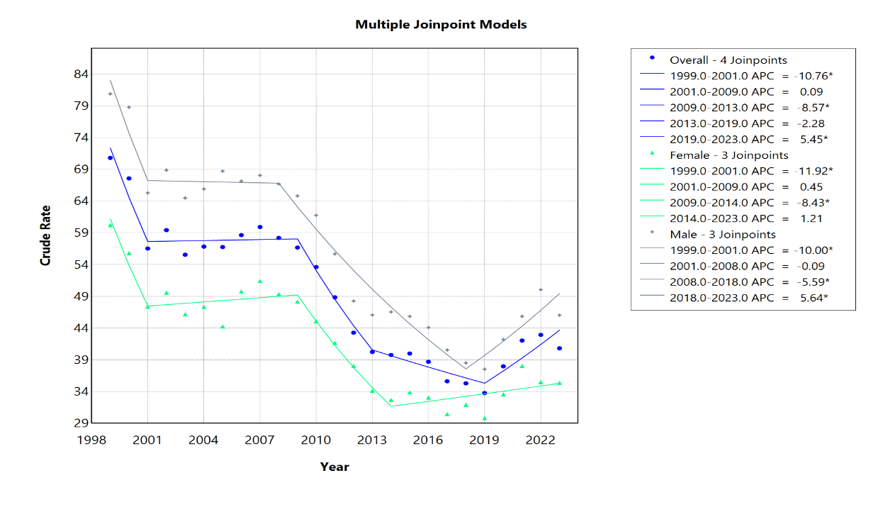Supplemental Figure 1. Joinpoint Model of SIDS Related AAMR per 100,000 People Overall and Stratified by Sex, 1999-2023 (*indicates the APC is statistically significant).

Year | NH White | NH Black or African American | NH Asian or Pacific Islander | NH American Indian or Alaska Native | Hispanic
1999 | 62.41 | 147 | 32.66 | 124.14 | 41.81
2000 | 59.99 | 141.46 | 25.39 | 105.75 | 39.95
2001 | 51.35 | 123.1 | 16.63 | 114.04 | 29.14
2002 | 55.63 | 119.12 | 22.78 | 117.73 | 33.6
2003 | 50.17 | 119.48 | 19.54 | 120.61 | 32.39
2004 | 53.04 | 124.31 | 18.13 | 96.49 | 30.3
2005 | 55.63 | 113.22 | 18.9 | 87.77 | 31.07
2006 | 58.17 | 118.92 | 16.27 | 113.48 | 28.9
2007 | 59.71 | 114.83 | 20.9 | 119.09 | 32.44
2008 | 56.33 | 118.06 | 19.6 | 104.7 | 31.83
2009 | 54.17 | 110.19 | 17.44 | 124.38 | 32.36
2010 | 51.23 | 107.26 | 19.18 | 70.12 | 31.61
2011 | 49.23 | 93.05 | 17.6 | 90.43 | 25.73
2012 | 42.54 | 85.94 | 14.77 | 92.86 | 22.55
2013 | 38.69 | 78.43 | 17.74 | 80.98 | 22.76
2014 | 39.05 | 74.49 | 14.69 | 85.96 | 23.59
2015 | 37.87 | 84.23 | 11.36 | 119.66 | 19.92
2016 | 37.49 | 81.45 | 15.84 | 97.5 | 18.04
2017 | 32.92 | 79.71 | 11.26 | 66.27 | 18.63
2018 | 31.04 | 77.23 | 16.65 | 57.5 | 21.74
2019 | 26.97 | 79.24 | 12.48 | 81.41 | 22.88
2020 | 29.06 | 94.6 | 10.12 | 89.75 | 25.25
2021 | 34.78 | 106.92 | 13.03 | 118.58 | 24.51
2022 | 33.43 | 107.4 | 17.45 | 103.19 | 27.55
2023 | 32.53 | 101.76 | 14.42 | 103.95 | 25.8
Number of Joinpoints (Years of Joinpoint) | 3 | 2 | 1 | 0 | 3
APC Segment 1 (95% CI) | -4.89* (-9.24 to -2.57) | -2.37 (-3.57 to 1.33) | -20.82* (-30.07 to -2.28) | -1.15* (-2.37 to -0.06) | -14.86* (-21.01 to -2.17)
APC Segment 2 (95% CI) | 4.56* (1.48 to 8.36) | -8.88 (-14.57 to 0.48) | -1.96 (-6.91 to 4.14) | - - | 0.03 (-6.32 to 8.66)
APC Segment 3 (95% CI) | -5.93* (-6.96 to -5.23) | 4.22* (1.75 to 8.86) | - - | - - | -7.24* (-15.42 to -2.86)
APC Segment 4 (95% CI) | 4.27 (-0.03 to 11.97) | - - | - - | - - | 5.97* (2.57 to 12.44)
Average APC (AAPC) (95% CI) | -2.42* (-2.91 to -2.02) | -1.09* (-1.64 to -0.45) | -3.69* (-4.70 to -1.88) | -1.15* (-2.37 to -0.06) | -1.81* (-2.42 to -0.92)
Supplemental Table 2. SIDS Related Mortality rate per 100,000 people; Stratified by Race/Ethnicity, 1999-2023.

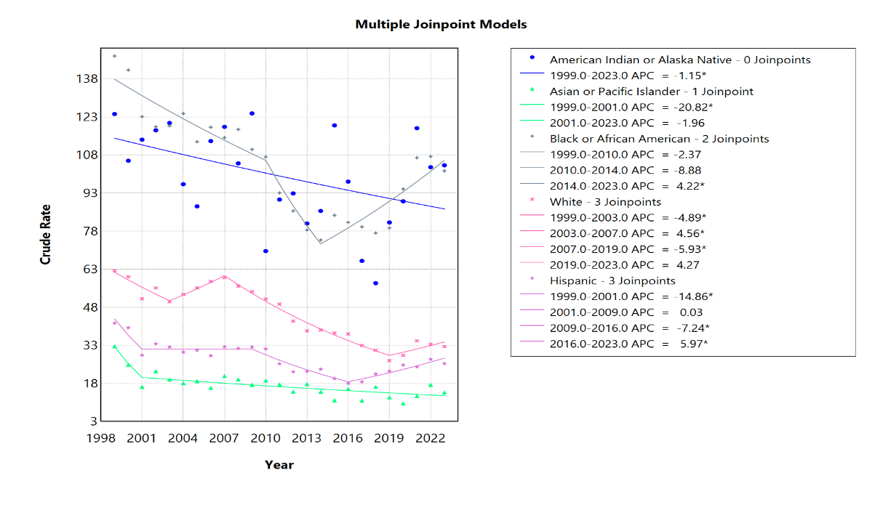 Supplemental Figure 2. Joinpoint Model of SIDS Related AAMR per 100,000 People Stratified by Race and Ethnicity, 1999-2023 (*indicates the APC is statistically significant).

Year | Northeast | Midwest | South | West
1999 | 45.42 | 82.34 | 81.73 | 61.76
2000 | 44.23 | 77.48 | 82.02 | 53.17
2001 | 40.56 | 69.78 | 69.75 | 35.52
2002 | 33.07 | 66.77 | 74.13 | 48.81
2003 | 31.15 | 54.56 | 75.72 | 42.88
2004 | 30.18 | 59.41 | 76.55 | 42.8
2005 | 29.36 | 61.03 | 77.66 | 39.37
2006 | 34.69 | 62.71 | 78.96 | 39.74
2007 | 42.05 | 53.83 | 78.85 | 47.59
2008 | 41.36 | 57.13 | 73.82 | 45.83
2009 | 36.29 | 55.03 | 72.37 | 47.05
2010 | 37.4 | 52.87 | 67.9 | 42.65
2011 | 33.43 | 49.87 | 60.6 | 39.72
2012 | 26.6 | 44.24 | 55.18 | 34.86
2013 | 23.27 | 41.68 | 50.19 | 34.75
2014 | 20.69 | 35.67 | 55.67 | 31.09
2015 | 25.93 | 35.57 | 55.47 | 28.66
2016 | 20.11 | 40.98 | 51.87 | 27.92
2017 | 26.63 | 34.53 | 46.12 | 25.63
2018 | 23.92 | 34.32 | 46.23 | 26.12
2019 | 27.99 | 28.89 | 43.38 | 26.23
2020 | 30.5 | 34.06 | 50.52 | 25.71
2021 | 32.61 | 33.62 | 58.42 | 28.45
2022 | 34.04 | 37.39 | 56.26 | 31.11
2023 | 31.66 | 37.01 | 50.95 | 32.63
Number of Joinpoints (Years of Joinpoint) | 3 | 1 | 2 | 3
APC Segment 1 (95% CI) | -9.50* (-20.56 to -5.04) | -4.33* (-6.20 to -3.79) | -0.16 (-1.69 to 2.79) | -19.10* (-24.77 to -9.93)
APC Segment 2 (95% CI) | 11.08* (3.83 to 22.14) | 3.57 (-3.38 to 18.06) | -4.70* (-9.46 to -3.60) | 1.38 (-0.16 to 6.05)
APC Segment 3 (95% CI) | -10.93* (-21.56 to -6.85) | - - | 4.66* (0.37 to 13.78) | -7.39* (-12.41 to -5.50)
APC Segment 4 (95% CI) | 5.14* (2.37 to 10.60) | - - | - - | 4.04* (0.61 to 10.19)
Average APC (AAPC) (95% CI) | -1.33* (-2.11 to -0.56) | -3.05* (-4.01 to -2.45) | -1.30* (-1.89 to -0.71) | -2.84* (-3.48 to -2.17)
Supplemental Table 3. SIDS Related Mortality rate per 100,000 people; Stratified by Region, 1999-2023.
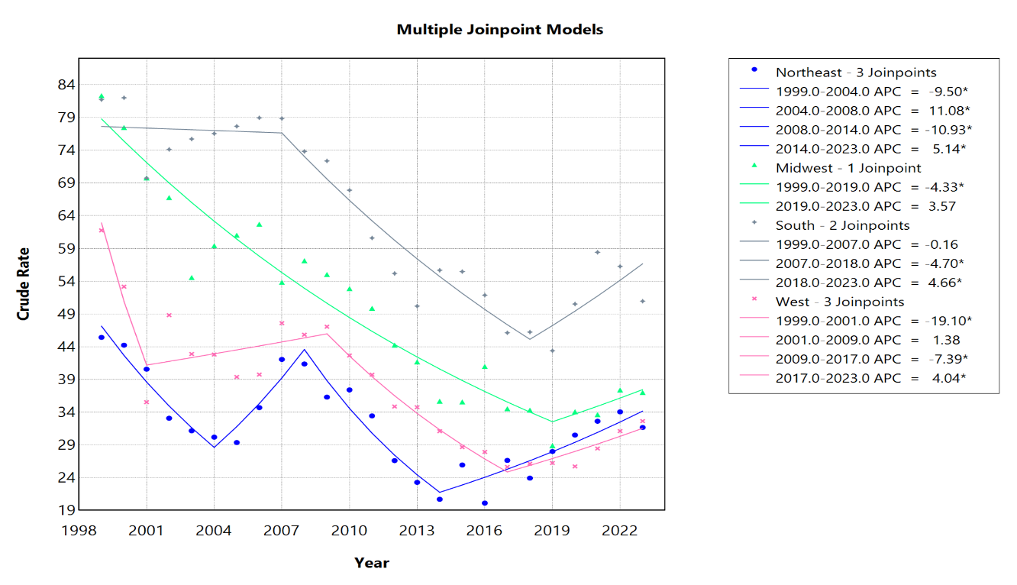 Supplemental Figure 3. Joinpoint Model of SIDS Related AAMR per 100,000 People Stratified Region, 1999-2023 (*indicates the APC is statistically significant).

Year | Urban | Rural
1999 | 66.86 | 94.01
2000 | 61.23 | 104.67
2001 | 51.76 | 85.54
2002 | 54.36 | 90.32
2003 | 50.69 | 85.12
2004 | 52.73 | 81.66
2005 | 51.56 | 88.05
2006 | 52.34 | 96.28
2007 | 54.86 | 89.79
2008 | 54.41 | 80.43
2009 | 51.72 | 86.17
2010 | 48.45 | 84.89
2011 | 45.15 | 72.06
2012 | 39.62 | 66.37
2013 | 36.61 | 63.47
2014 | 36.16 | 62.81
2015 | 36.26 | 63.91
2016 | 34.53 | 65.7
2017 | 33.98 | 46.23
2018 | 33.39 | 47.7
2019 | 31.48 | 48.57
2020 | 35.82 | 51.89
Number of Joinpoints (Years of Joinpoint) | 3 | 1
APC Segment 1 (95% CI) | -12.00* (-14.94 to -6.80) | -1.22 (-2.73 to 6.99)
APC Segment 2 (95% CI) | 0.21 (-0.58 to 1.67) | -5.22* (12.24 to -3.70)
APC Segment 3 (95% CI) | -9.07* (-12.16 to -6.40) | - -
APC Segment 4 (95% CI) | -1.32 (-2.58 to 0.87) | - -
Average APC (AAPC) (95% CI) | -3.33* (-3.67 to -2.94) | -3.34* (-4.61 to -2.29)
Supplemental Table 4. SIDS Related Mortality rate per 100,000 people; Urban vs Rural, 1999-2023.
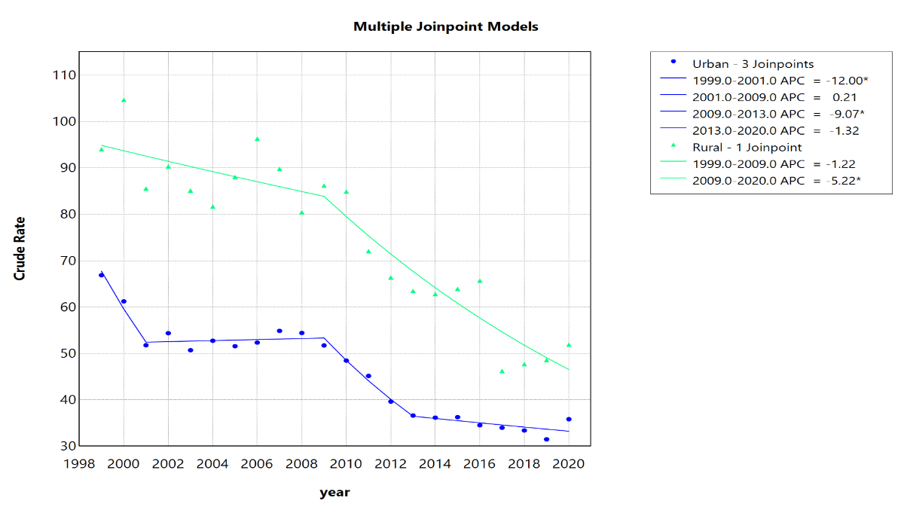 Supplemental Figure 4. Joinpoint Model of SIDS Related AAMR per 100,000 People Urban vs Rural, 1999-2023 (*indicates the APC is statistically significant).

