Fig. S1. Effects of Different Concentrations of GABA on the Morphological Characteristics, Biomass, and Photosynthetic Traits of Common Bean Seedlings. Note: (A) Representative seedling morphological charact eristics under different treatments. (B) Plant height . (C) Root length . (D) Leaf area. (E) Steam diameter. (F) Fresh weight of the upper part. (G) Dry weight of the upper part. (H) Fresh weight of the lower part. (I) Dry weight of the lower part. (J) Net photosynthetic rate. (K) Transpiration rate. (L) Stomatal conductance. (M) Intercellular CO2 concentration.

Table S1 Sequencing Data Statistics
Samples | Clean reads | Clean bases number | GC content（%） | Q30（%）
CK121 | 34312030 | 5.15Gb | 44 | 98.72
CK122 | 38056256 | 5.71Gb | 44 | 98.68
CK123 | 38830738 | 5.82Gb | 44 | 98.76
CK241 | 33025092 | 4.95Gb | 44 | 98.75
CK242 | 37539224 | 5.63Gb | 44.50 | 98.64
CK243 | 34861336 | 5.23Gb | 44.50 | 98.68
N121 | 35145320 | 5.27Gb | 44 | 98.65
N122 | 33878514 | 5.08Gb | 44 | 98.70
N123 | 33823662 | 5.07Gb | 44 | 98.66
N241 | 41319422 | 6.20Gb | 44.50 | 98.62
N242 | 34392014 | 5.16Gb | 44.50 | 98.68
N243 | 39529872 | 5.93Gb | 44.50 | 98.68
NG121 | 37199336 | 5.58Gb | 44 | 98.67
NG122 | 35948476 | 5.39Gb | 44 | 98.71
NG123 | 35117268 | 5.27Gb | 44 | 98.75
NG241 | 35512528 | 5.33Gb | 44.50 | 98.74
NG242 | 33740156 | 5.06Gb | 44 | 98.67
NG243 | 34982850 | 5.25Gb | 45 | 98.68

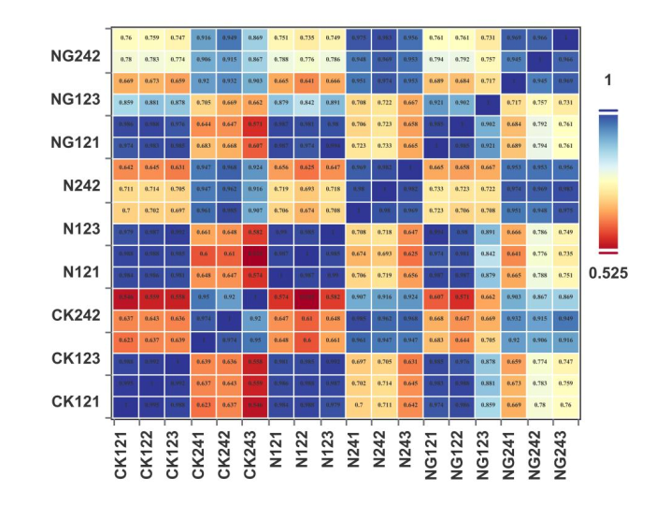
Fig. S2. Correlation matrix of gene expression

Table S2 Upregulated genes by GABA treatment under salt stress
gene_id | N12 | NG12 | N24 | NG24
Phvul.006G075700.v2.1 | no | up | up | down
Phvul.010G112600.v2.1 | no | up | down | up
Phvul.005G071400.v2.1 | no | up | down | down
Phvul.011G154100.v2.1 | no | up | no | no
Phvul.001G169700.v2.1 | no | up | down | up
Phvul.005G117833.v2.1 | no | up | down | down

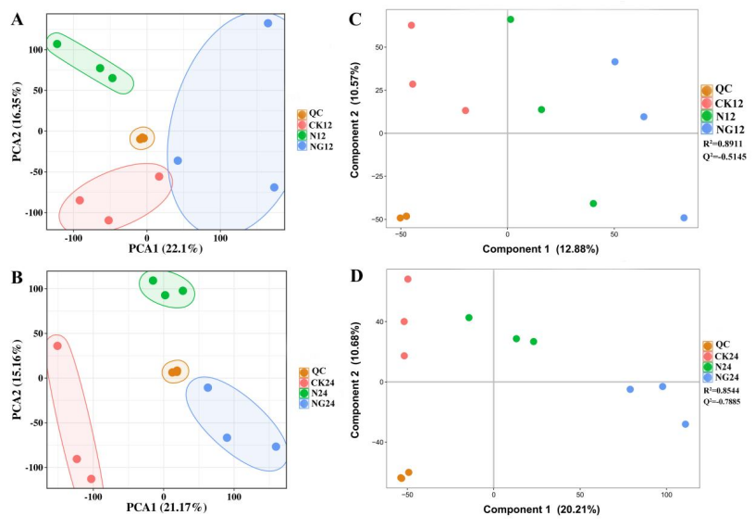
Fig. S3 Multivariate statistical analysis of gene expression profiles under different treatments. Note:(A) Principal component analysis (PCA) of samples at 12 h after treatment. (B) Principal component analysis (PCA) of samples at 24 h after treatment. (C) Partial least squares-discriminant analysis (PLS-DA) of samples at 12 h after treatment, with model performance metrics (R²=0.8911, Q²=-0.5145). (D) Partial least squares-discriminant analysis (PLS-DA) of samples at 24 h after treatment, with model performance metrics (R²=0.8544, Q²=0.7885).

