Supplementary Information

An electrochemically stable defect-free glassy electrolyte formed at room temperature for all-solid-state sodium batteries
Xiaowei Chi^{1,2‡}, Ye Zhang^{1‡}, Fang Hao^{1‡}, Steven Kmiec^{3‡}, Hui Dong¹, Rong Xu,⁴ Kejie Zhao⁴, Liang Wang^{5,} †, Lihong Zhao¹, Liqun Guo¹, Huolin Xin⁶, Steve W. Martin^{3*}, Yan Yao^{1*}
¹Department of Electrical and Computer Engineering and Texas Center for Superconductivity at the University of Houston, University of Houston, Houston, TX, 77204, USA
²Shanghai Institute of Ceramics, Chinese Academy of Sciences, Shanghai 200050, China ³Department of Materials Science & Engineering, Iowa State University, Ames, IA 50011, USA
⁴School of Mechanical Engineering, Purdue University, West Lafayette, IN 47907, USA
⁵Department of Physics, Northern Illinois University, Dekalb, IL 60115, USA
⁶Department of Physics and Astronomy, University of California, Irvine, Irvine, CA, USA
‡ X. C., Y. Z., F. H., S.K. contribute equally to this work.
† Current address: Institute of Advanced Structure Technology and School of Materials Science and Engineering, Beijing Institute of Technology, Beijing 100081, China
* Email: yyao4@uh.edu (Y.Y.), swmartin@iastate.edu (S.M.)

Supplementary Table S1 | Assignments of the peaks in the Fourier-transform infrared spectroscopy (FTIR) spectra of Na₃PS_{4–x}O_{x} SEs

Position (cm⁻¹) | Assignment
445 | P–S linkage
560 | Asymmetric stretching of P–S
590 | Stretching of P–O–P
634 | Bending vibration of O–P–O
685 | Symmetric stretching of P–O–P
720 | Symmetric stretching of P–O–P
895 | Asymmetric stretching of P–O–P
996 | Symmetric stretching of –O–P–O– non-bridging oxygen
1030 | Motion of the P=O or P–O– non-bridging oxygen
1090 | Symmetric stretching of –O–P–O– non-bridging oxygen
1150 | Symmetric stretching of –O–P–O– non-bridging oxygen

Note: P–O connections are also observed in x=0 sample, which may result from the oxygen contamination during synthesis.

Supplementary Table S2 | Fitting results of EIS spectra of Na₃PS_{4−x}O_{x} (x=0, 0.15, 0.30, and 0.60) SEs for symmetric cells before and after contact Na metals for 5 h.
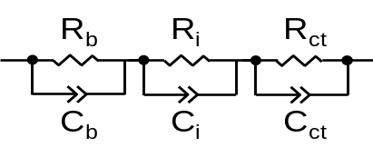

x value | ASR  [Ω∙cm²] | R_{b} [Ω∙cm²] | C_{b} [pF] | R_{i} [Ω∙cm²] | C_{i} [μF] | R_{ct} [Ω∙cm²] | C_{ct} [mF]
0.00 before | 1596.7 | 1240 | 1.20 | 272 | 0.16 | 84.7 | 9.90
0.00 after | 1753.0 | 1350 | 2.90 | 304 | 0.19 | 99.0 | 6.30
0.15 before | 253.1 | 216 | 0.24 | 6 | 4.50 | 31.1 | 53.0
0.15 after | 341.7 | 254 | 0.58 | 16 | 0.32 | 71.2 | 1.53
0.30 before | 367.2 | 334 | 0.24 | 24 | 0.45 | 8.9 | 0.45
0.30 after | 376.7 | 332 | 0.13 | 28 | 1.20 | 16.4 | 3.30
0.60 before | 664.9 | 644 | 0.79 | - | - | 20.9 | 1.30
0.60 after | 662.2 | 640 | 0.89 | - | - | 21.4 | 1.60

Note: The obtained EIS spectra from high frequency to middle frequency to low frequency can be fitted into bulk resistance and capacitance (R_{b} + R_{gb}, C_{b} + C_{gb}) of the SEs, interfacial resistance and capacitance (R_{i}, C_{i}) between Na and SEs with characteristic capacitance of 10^{–6}~10^{–7} F, and the charge-transfer resistance and capacitance (R_{ct}, C_{ct}).

Supplementary Table S3 | Comparison of reported solid-state Na–S batteries with this work

Electrolyte | Cathode | Anode | Voltage (V) | Cathode capacity  (C_{c}, mAh g⁻¹) |  | Full cell capacity  (C, mAh g⁻¹) |  | Specific energy (Wh/kg) |  | Cycling  life |  | Ref.
Na_{3.1}Zr_{1.95}Mg_{0.05}Si₂PO₁₂ (RT) | S | Na | 1.75 | 527 | 363 |  | 635 |  | 10 |  | 1
PEO-NaCF₃SO₃ (90 °C) | S | Na | 1.75 | 505 | 352 |  | 617 |  | 10 |  | 2
PEO−NaN(SO₂F)₂−1% TiO₂ (60 °C) | S | Na | 1.40 | 713 | 442 |  | 619 |  | 100 |  | 3
Na₃PS₄ (RT) | S | Na₁₅Sn₄ | 1.10 | 1522 | 544 |  | 599 |  | 2 |  | 4
Na₃PS₄ (RT) | S | Na₁₅Sn₄ | 1.30 | 1112 | 481 |  | 625 |  | 25 |  | 5
Na₃PS₄ (60 °C) | Na₂S | Na₁₅Sn₄ | 1.25 | 869 | 429 |  | 536 |  | 50 |  | 6
Na₃PS₄ (60 °C) | Na₂S | Na₁₅Sn₄ | 1.25 | 800 | 411 |  | 514 |  | 50 |  | 7
Na₃SbS₄ (RT) | S | Na₃Sb | 0.5 | 1560 | 464 |  | 232 |  | 55 |  | 8
Na₃PS_{4-x}O_{x} (60 °C) | S | Na | 1.42 | 1281 | 610 |  | 866 |  | 150 |  | This work
Note: The cell specific energy (E_{s}) is calculated by E_{s} = E × (C_{c}⁻¹ + C_{a}⁻¹)⁻¹, where E is the average discharge voltage, C_{c} is cathode specific capacity. The anode specific capacity (C_{a}) for Na, Na₁₅Sn₄ and Na₃Sb are 1165, 847 and 660 mAh g⁻¹, respectively. The full cell capacity (C) is calculated by C = (C_{c}⁻¹ + C_{a}⁻¹)⁻¹.
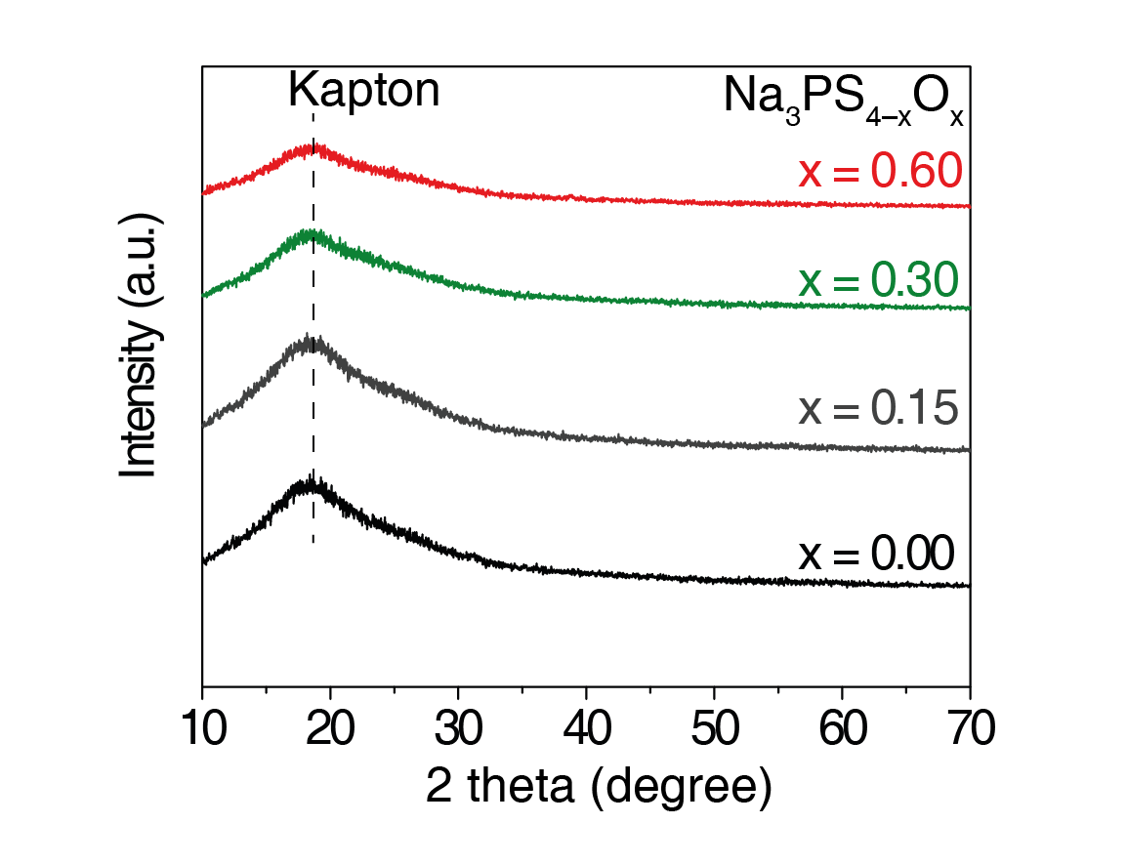
Supplementary Figure 1 | Lab-based X-ray diffraction patterns of Na₃PS_{4–x}O_{x} SEs.

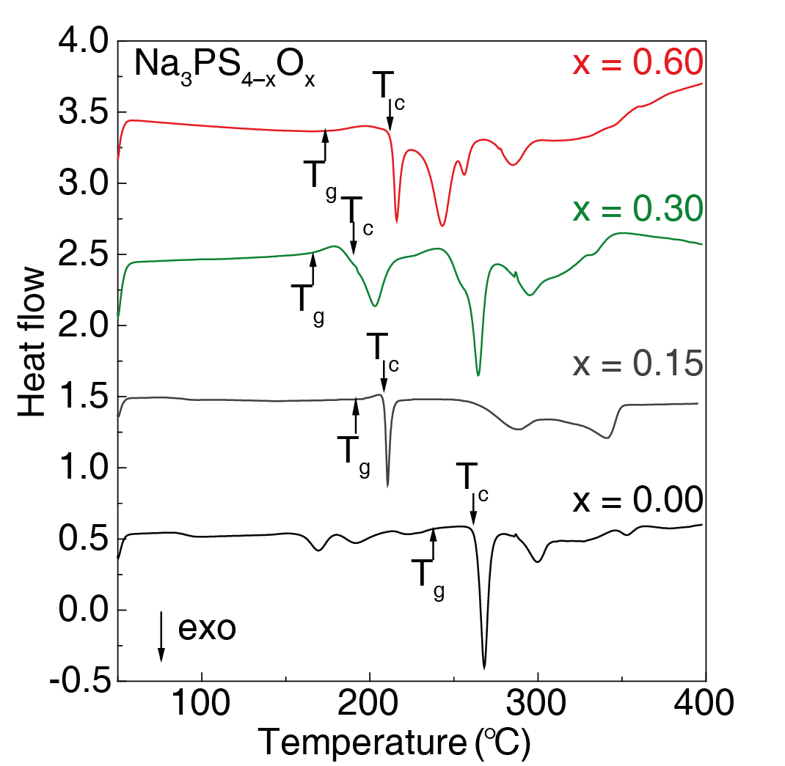
Supplementary Figure 2 | Differential scanning calorimeter (DSC) curves of Na₃PS_{4–x}O_{x} SEs. T_{g} and T_{c} represent the glass transition temperature and crystallization temperature, respectively.
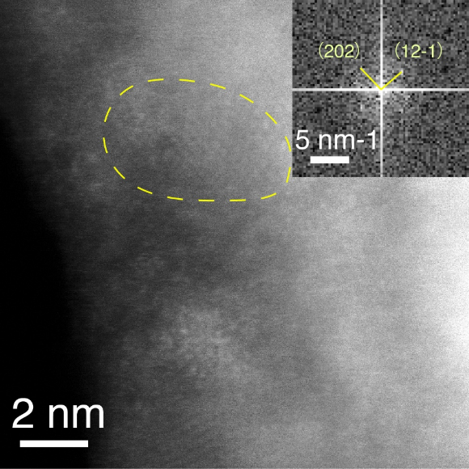
Supplementary Figure 3 | Transmission electron microscope (TEM) image and selected area electron diffraction (SAED) patterns of Na₃PS_{3.85}O_{0.15} SE.

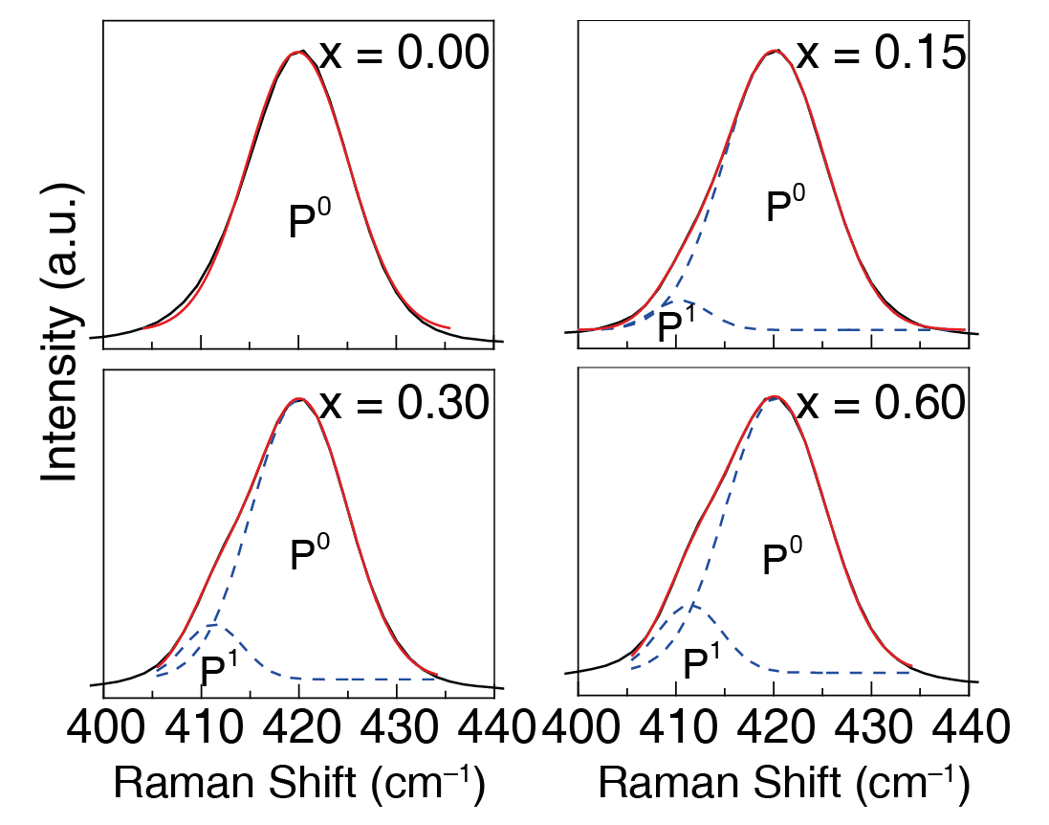
Supplementary Figure 4 | Gaussian fitting results of PS₄ mode in Raman spectra of Na₃PS_{4–x}O_{x} SEs.

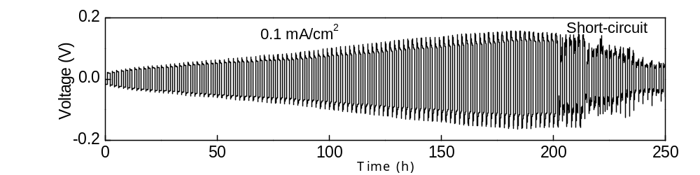
Supplementary Figure 5 | Galvanostatic cycling of Na|HT-Na₃PS₄|Na symmetric cells at 60 °C under current density of 0.1 mA cm⁻² with a stripping/plating capacity of 0.1 mAh cm⁻².


Supplementary Figure 6 | SEM images of cross-sectional Na₃PS₄ SE pressed at (a) 150 MPa and (b) at 375 MPa, in comparison with Na₃PS_{3.4}O_{0.6} SE pressed at (c) 150 MPa and (d) at 375 MPa (scale bar: 20 μm).

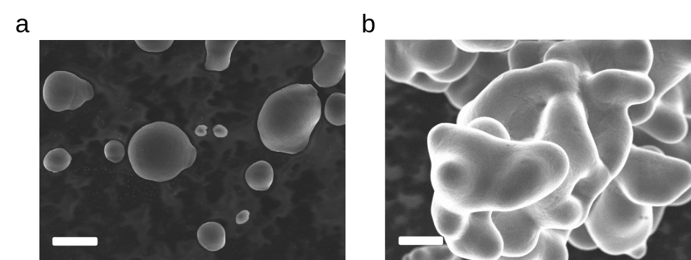
Supplementary Figure 7 | SEM images of (a) Na₃PS₄ glass and (b) Na₃PS_{3.4}O_{0.6} glass powders (scale bar: 5 μm).
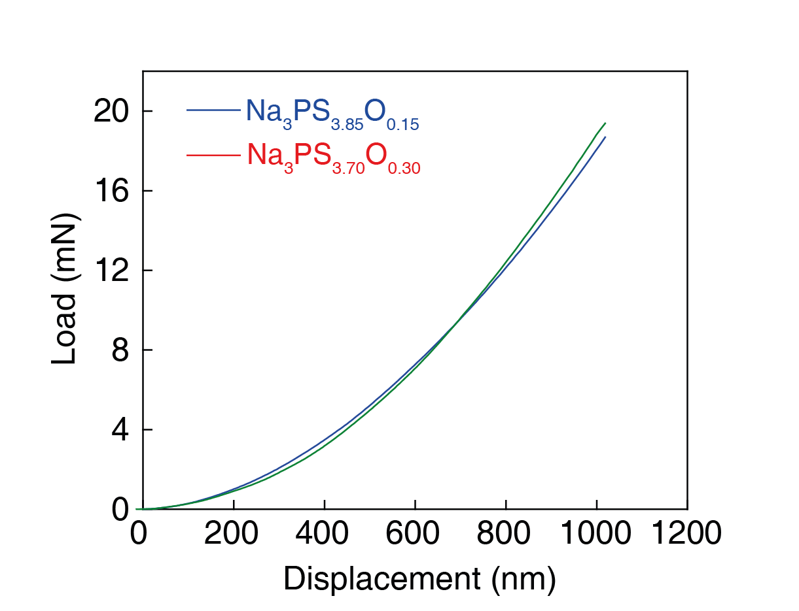
Supplementary Figure 8 | Nano-indentation loading curves of Na₃PS_{3.85}O_{0.15} and Na₃PS_{3.7}O_{0.3} glass SEs;

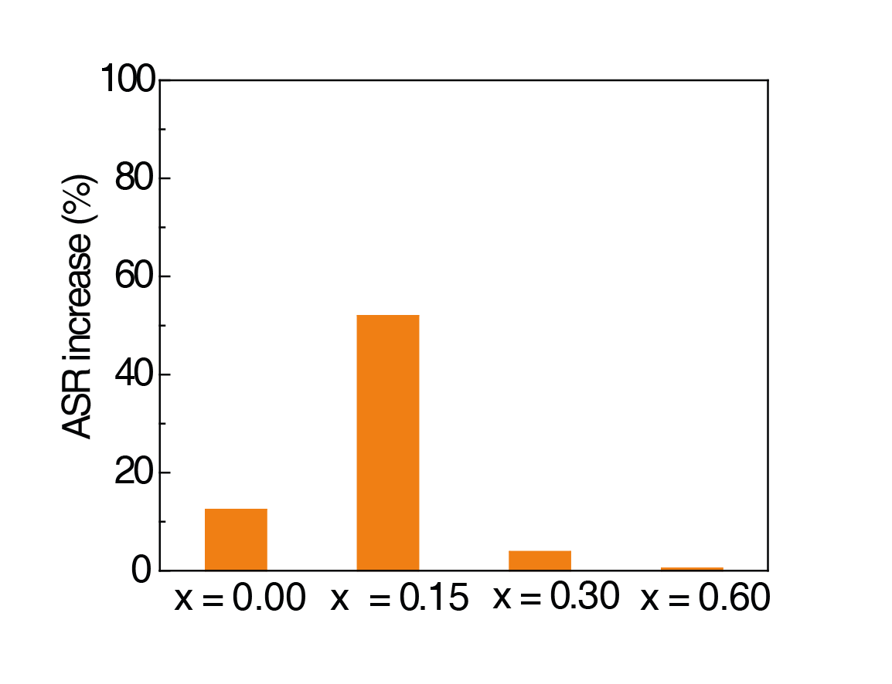
Supplementary Figure 9 | Areal Specific Resistance (ASR) change of Na₃PS_{4–x}O_{x} SEs before and after in contact with Na metal for 5 hours.

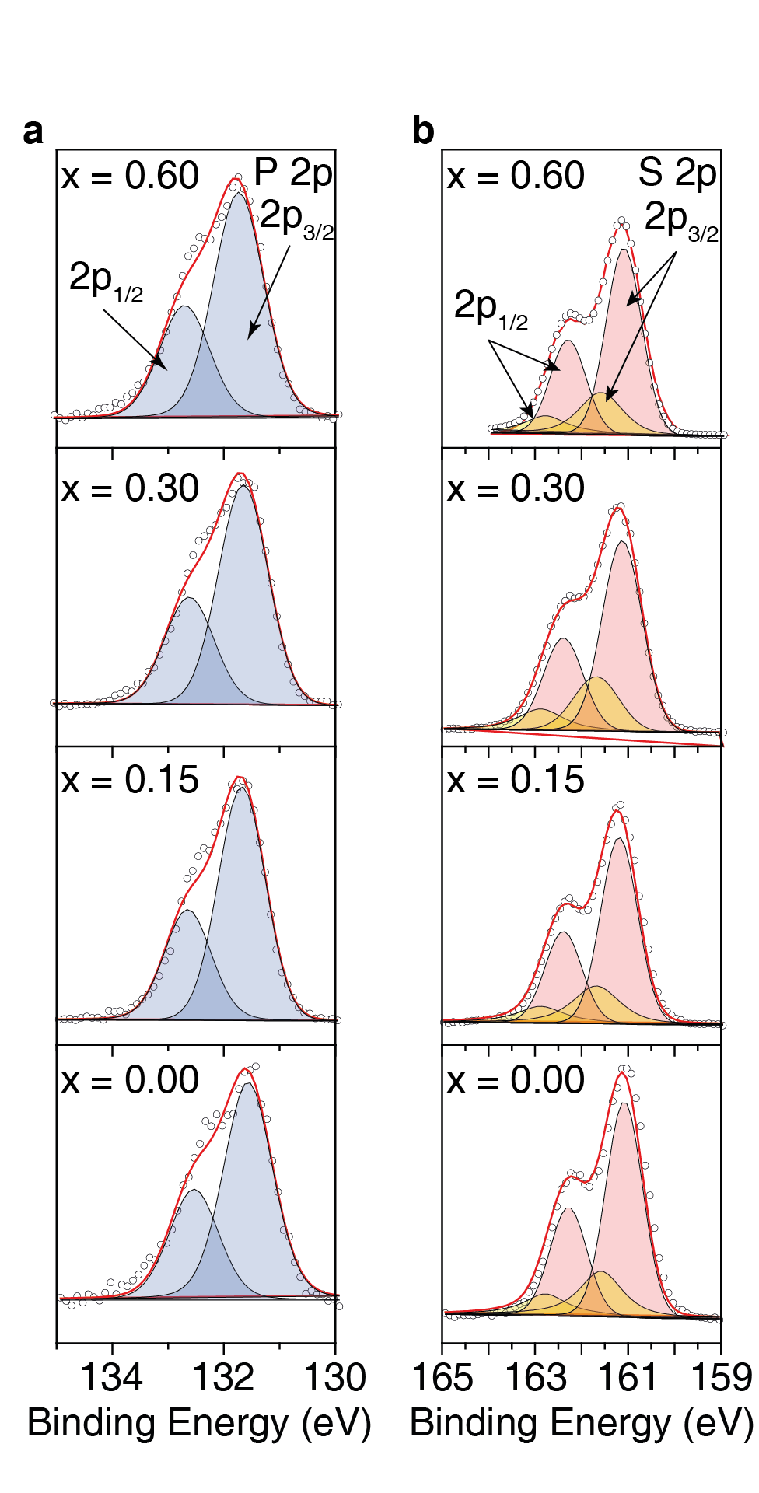
Supplementary Figure 10 | P 2p and S 2p orbitals in XPS spectra of pristine Na₃PS_{4–x}O_{x} SEs.

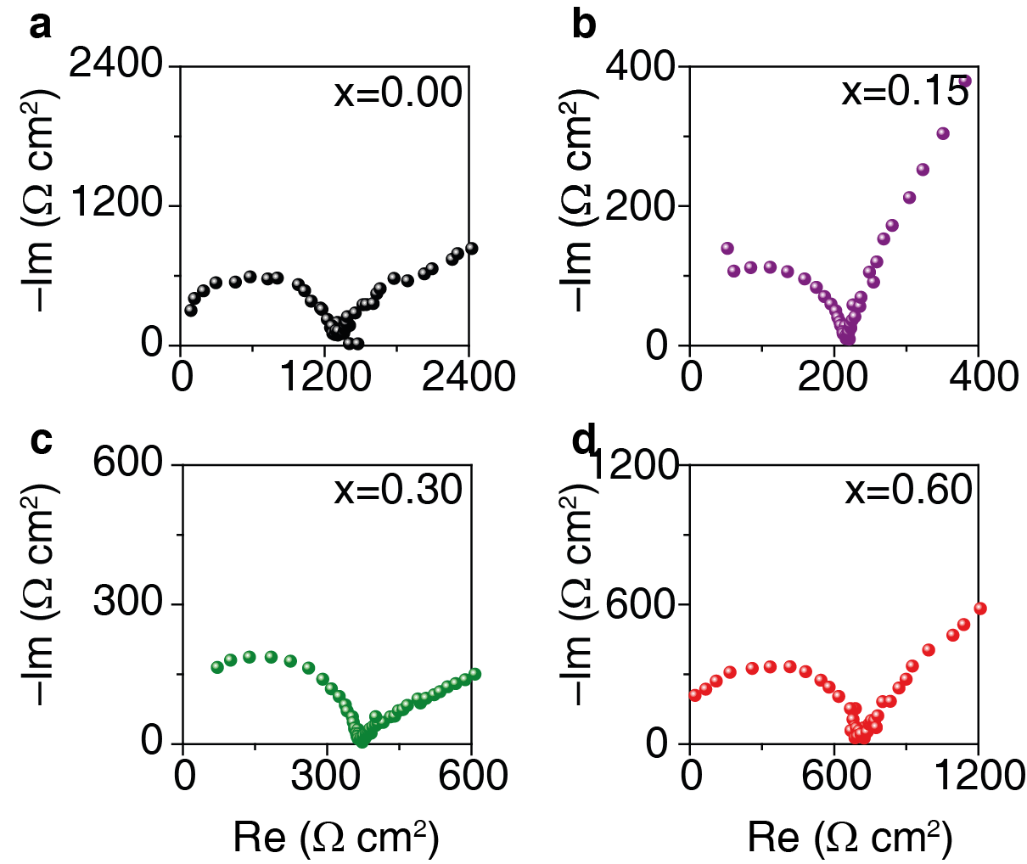

Supplementary Figure 11 | Electrochemical impedance spectra (EIS) of Na₃PS_{4–x}O_{x} SEs in a Cu|SE|Cu cell at 60 °C.
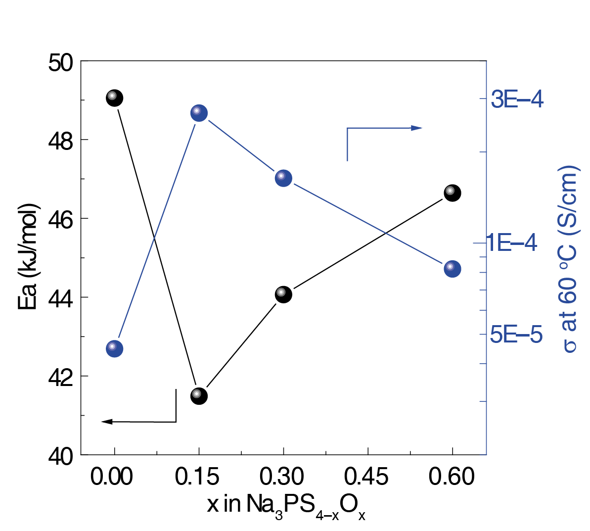
Supplementary Figure 12 | Plots of activation energies (E_{a}) and conductivity at 60 °C in Na₃PS_{4–x}O_{x} SEs.

Supplementary Figure 13 | Cross-sectional SEM images of the tri-layer electrolyte.

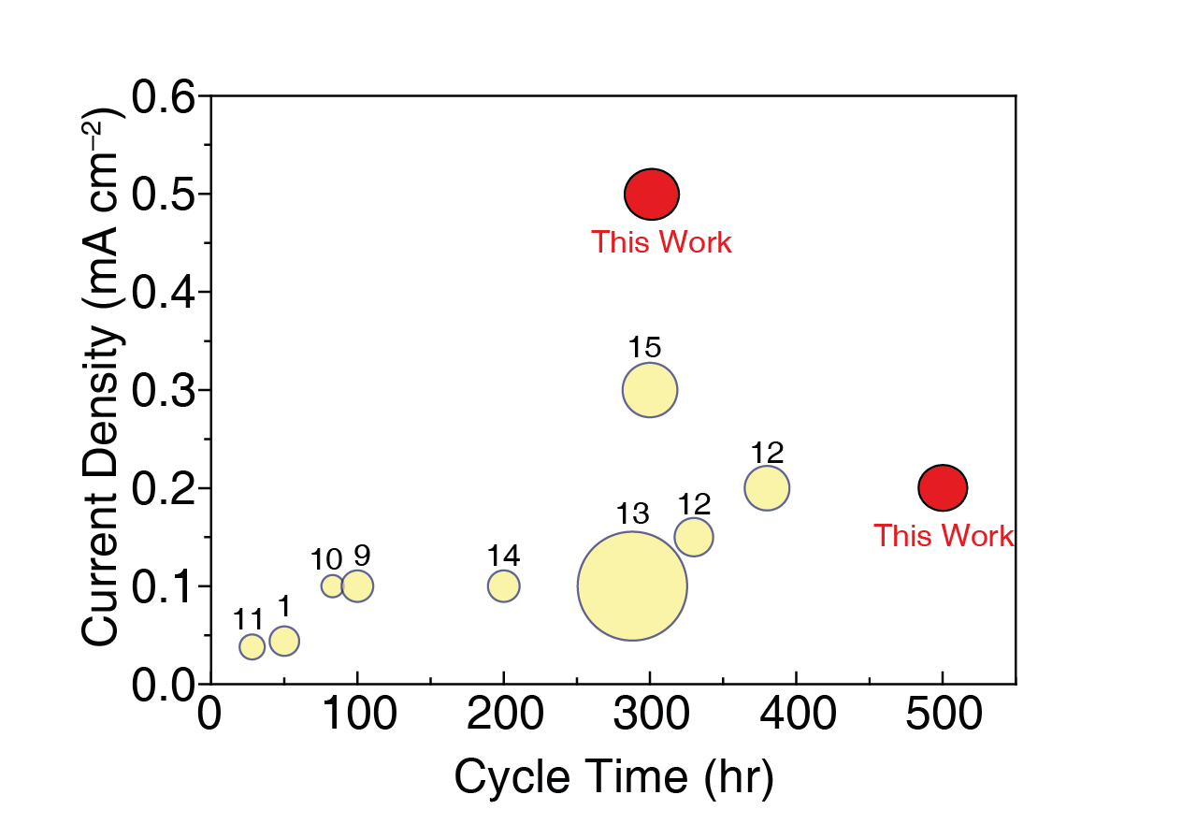

Supplementary Fig. S14 | Comparison of reported Na|SE|Na symmetric cell performance with this work in terms of the capacity of Na metal plated per cycle (circle area), current density, cycling time. SEs include sulfide-based (Na₃PS₄, Na₃SbS₄, Na_{2.9375}PS_{3.9375}Cl_{0.0625})⁹⁻¹¹, oxide-based (Na_{3.1}Zr_{1.95}Mg_{0.05}Si₂PO₁₂, heat-treated Na₃Zr₂(PO₄)(SiO₄)₂)^{1,12}, boride-based (Na₂(B₁₂H₁₂)_{0.5}(B₁₀H₁₀)_{0.5})¹³, polymer-based (poly(ethylene oxide) (PEO), hollow mesoporous organic polymer-PEO composite)^{14,15}, and polymer-oxide composite (cross-linked poly(ethylene glycol) methyl ether acrylate (CPMEA)–Na₃Zr₂(PO₄)(SiO₄)₂)¹².
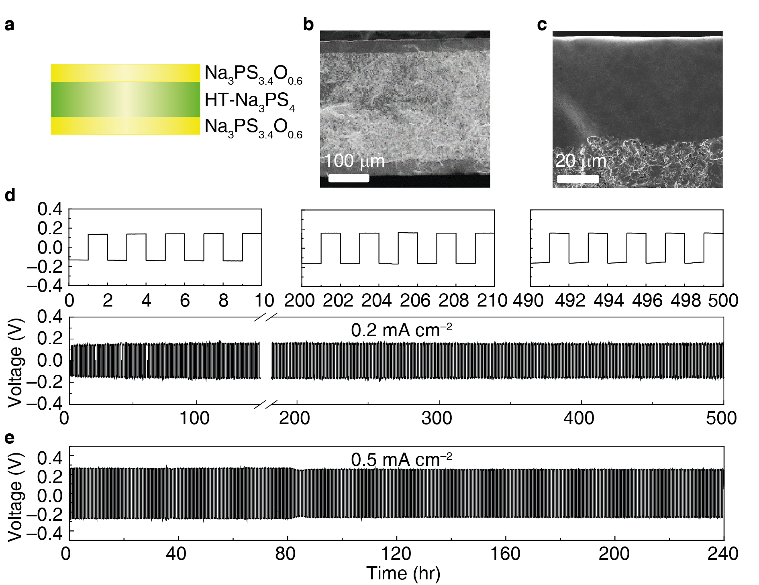
Supplementary Fig. S15 | Symmetric cell performances: (a) Scheme of tri-layer electrolyte composed of Na₃PS_{3.4}O_{0.6}|HT-Na₃PS₄|Na₃PS_{3.4}O_{0.6}; (b) SEM image of the tri-layer electrolyte; (c) SEM image of enlarged interface between Na₃PS_{3.4}O_{0.6} (top layer) and HT-Na₃PS₄ (bottom layer); (d) and (e) galvanostatic cycling of Na|Na₃PS_{3.4}O_{0.6}|HT-Na₃PS₄|Na₃PS_{3.4}O_{0.6}|Na symmetric cells at 60 °C under current densities of 0.2 mA cm⁻² and 0.5 mA cm⁻², respectively.

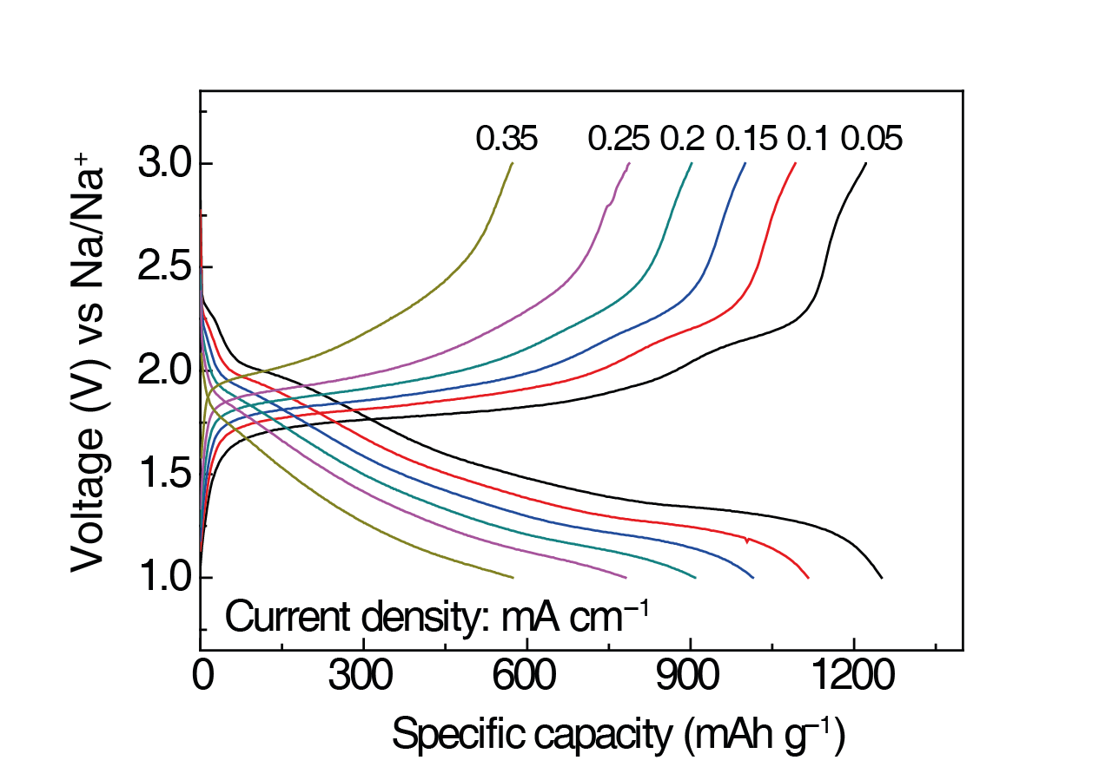
Supplementary Figure 16 | Voltage profiles of Na-S full cells at 60 °C under current densities from 0.05 mA cm⁻² to 0.35 mA cm⁻².
References
1 Song, S., Duong, H. M., Korsunsky, A. M., Hu, N. & Lu, L. A Na⁺ Superionic Conductor for Room-Temperature Sodium Batteries. Sci. Rep. 6, 32330, doi:10.1038/srep32330 (2016).
2 Park, C.-W. et al. Discharge properties of all-solid sodium-sulfur battery using poly(ethylene oxide) electrolyte. J. Power Sources 165, 450-454, doi:https://doi.org/10.1016/j.jpowsour.2006.11.083 (2007).
3 Zhu, T. et al. An All-Solid-State Sodium–Sulfur Battery Using a Sulfur/Carbonized Polyacrylonitrile Composite Cathode. ACS Applied Energy Materials 2, 5263-5271, doi:10.1021/acsaem.9b00953 (2019).
4 Nagata, H. & Chikusa, Y. An All-solid-state Sodium-Sulfur Battery Operating at Room Temperature Using a High-sulfur-content Positive Composite Electrode. Chem. Lett. 43, 1333-1334, doi:10.1246/cl.140353 (2014).
5 Tanibata, N., Deguchi, M., Hayashi, A. & Tatsumisago, M. All-Solid-State Na/S Batteries with a Na₃PS₄ Electrolyte Operating at Room Temperature. Chem. Mater. 29, 5232-5238, doi:10.1021/acs.chemmater.7b01116 (2017).
6 Yue, J. et al. High-Performance All-Inorganic Solid-State Sodium–Sulfur Battery. ACS Nano 11, 4885-4891, doi:10.1021/acsnano.7b01445 (2017).
7 Fan, X. et al. High-Performance All-Solid-State Na–S Battery Enabled by Casting–Annealing Technology. ACS Nano 12, 3360-3368, doi:10.1021/acsnano.7b08856 (2018).
8 Ando, T., Sakuda, A., Tatsumisago, M. & Hayashi, A. All-solid-state sodium-sulfur battery showing full capacity with activated carbon MSP20-sulfur-Na₃SbS₄ composite. Electrochem. Commun. 116, 106741, doi:https://doi.org/10.1016/j.elecom.2020.106741 (2020).
9 Wan, H. et al. Nanoscaled Na₃PS₄ Solid Electrolyte for All-Solid-State FeS₂/Na Batteries with Ultrahigh Initial Coulombic Efficiency of 95% and Excellent Cyclic Performances. ACS Appl. Mater. Interfaces 10, 12300-12304, doi:10.1021/acsami.8b01805 (2018).
10 Wang, H. et al. An Air-Stable Na₃SbS₄ Superionic Conductor Prepared by a Rapid and Economic Synthetic Procedure. Angew. Chem. Int. Ed. 55, 8551-8555, doi:10.1002/anie.201601546 (2016).
11 Wu, E. A. et al. New Insights into the Interphase between the Na Metal Anode and Sulfide Solid-State Electrolytes: A Joint Experimental and Computational Study. ACS Appl. Mater. Interfaces 10, 10076-10086, doi:10.1021/acsami.7b19037 (2018).
12 Zhou, W., Li, Y., Xin, S. & Goodenough, J. B. Rechargeable Sodium All-Solid-State Battery. ACS Cent. Sci. 3, 52-57, doi:10.1021/acscentsci.6b00321 (2017).
13 Duchêne, L. et al. A highly stable sodium solid-state electrolyte based on a dodeca/deca-borate equimolar mixture. Chem. Commun. 53, 4195-4198, doi:10.1039/c7cc00794a (2017).
14 Ma, Q. et al. A new Na[(FSO₂)(n-C₄F₉SO₂)N]-based polymer electrolyte for solid-state sodium batteries. J. Mater. Chem. A 5, 7738-7743, doi:10.1039/c7ta01820g (2017).
15 Zhou, W., Gao, H. & Goodenough, J. B. Low-Cost Hollow Mesoporous Polymer Spheres and All-Solid-State Lithium, Sodium Batteries. Adv. Energy Mater. 6, 1501802, doi:doi:10.1002/aenm.201501802 (2016).

