Supplementary Information
for
CropCast: Context-aware AI framework for in-season crop growth forecasting
Ramana Heggadal Math^{1,2}, Ashutosh Tiwari¹, Lei Zhao¹, Juan Landivar¹, Yuri Calil^{3,4}, Sayantan Sarkar¹, Jose Landivar Scott¹, Benjamin Ghansah^{1,5}, Mahendra Bhandari^{1,6}

¹Texas A&M AgriLife Research, Corpus Christi, Texas, USA
²Texas A&M Institute of Data Science (TAMIDS), Texas A&M University, College Station, Texas
³Texas A&M AgriLife Extension, Corpus Christi, Texas, USA
⁴Department of Agriculture Economics, Texas A&M University, College Station, Texas
⁵Texas A&M University-Corpus Christi, Corpus Christi, Texas, USA
⁶Department of Soil and Crop Sciences, Texas A&M University, College Station, Texas

Contents of this file
Supplementary Figures S1, S2 and S3.

Introduction
We provide supporting information to the main text related to the datasets used in this study and their preprocessing, and performance of the baseline machine learning models on the datasets and compared with the proposed CropCast framework.

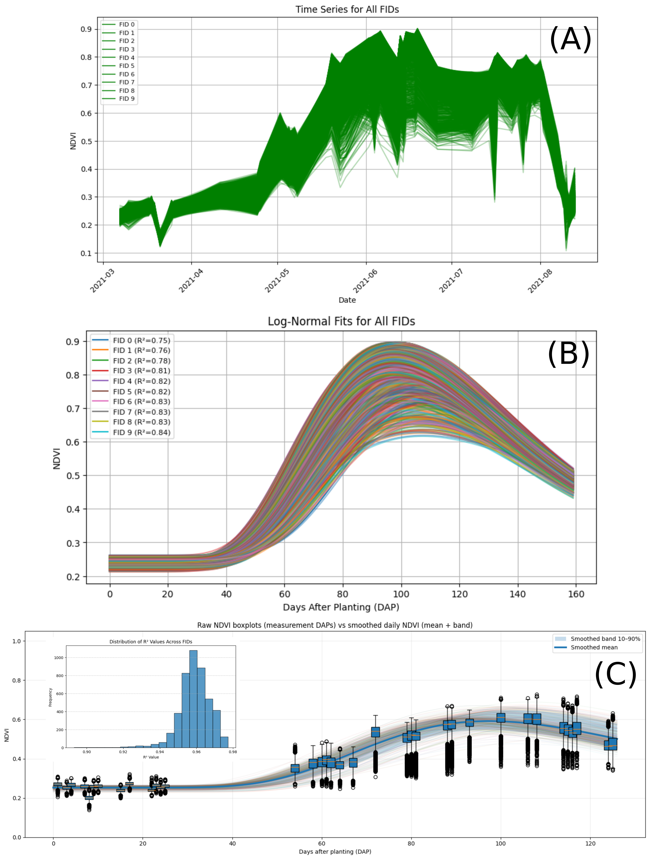
Figure S1. NDVI data interpolation. (A) and (B) show the raw and log-normal interpolated data respectively. (C) shows the difference between the raw and interpolated data.
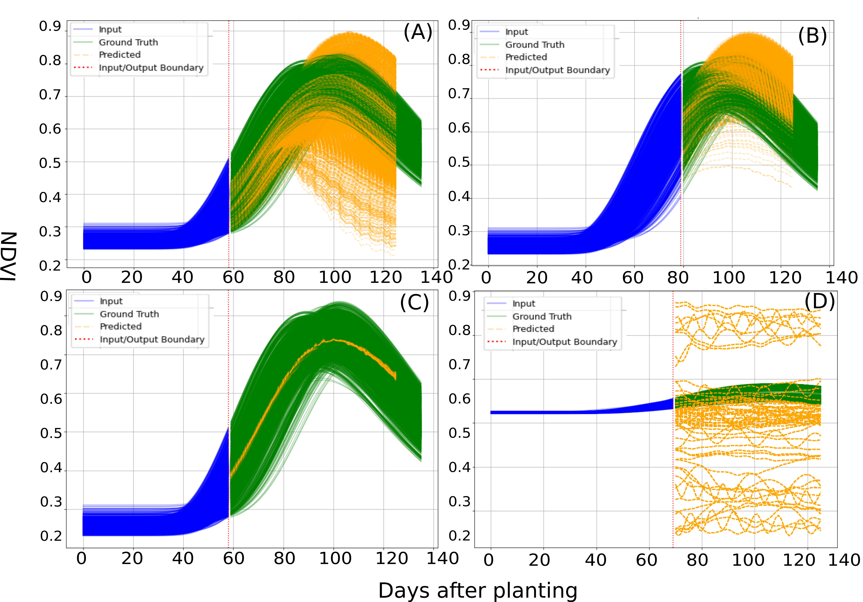
Figure S2. Performance of base models for NDVI forecasting. All the models are trained with 2020-, 2021-and 2022-year datasets, divided into training and validation data in the ratio 80:20. (A), (B) and (C) show results with a feed-forward neural network implemented with small, medium, and large dropout ratios. (D) shows the results with a pretrained Transformer model.

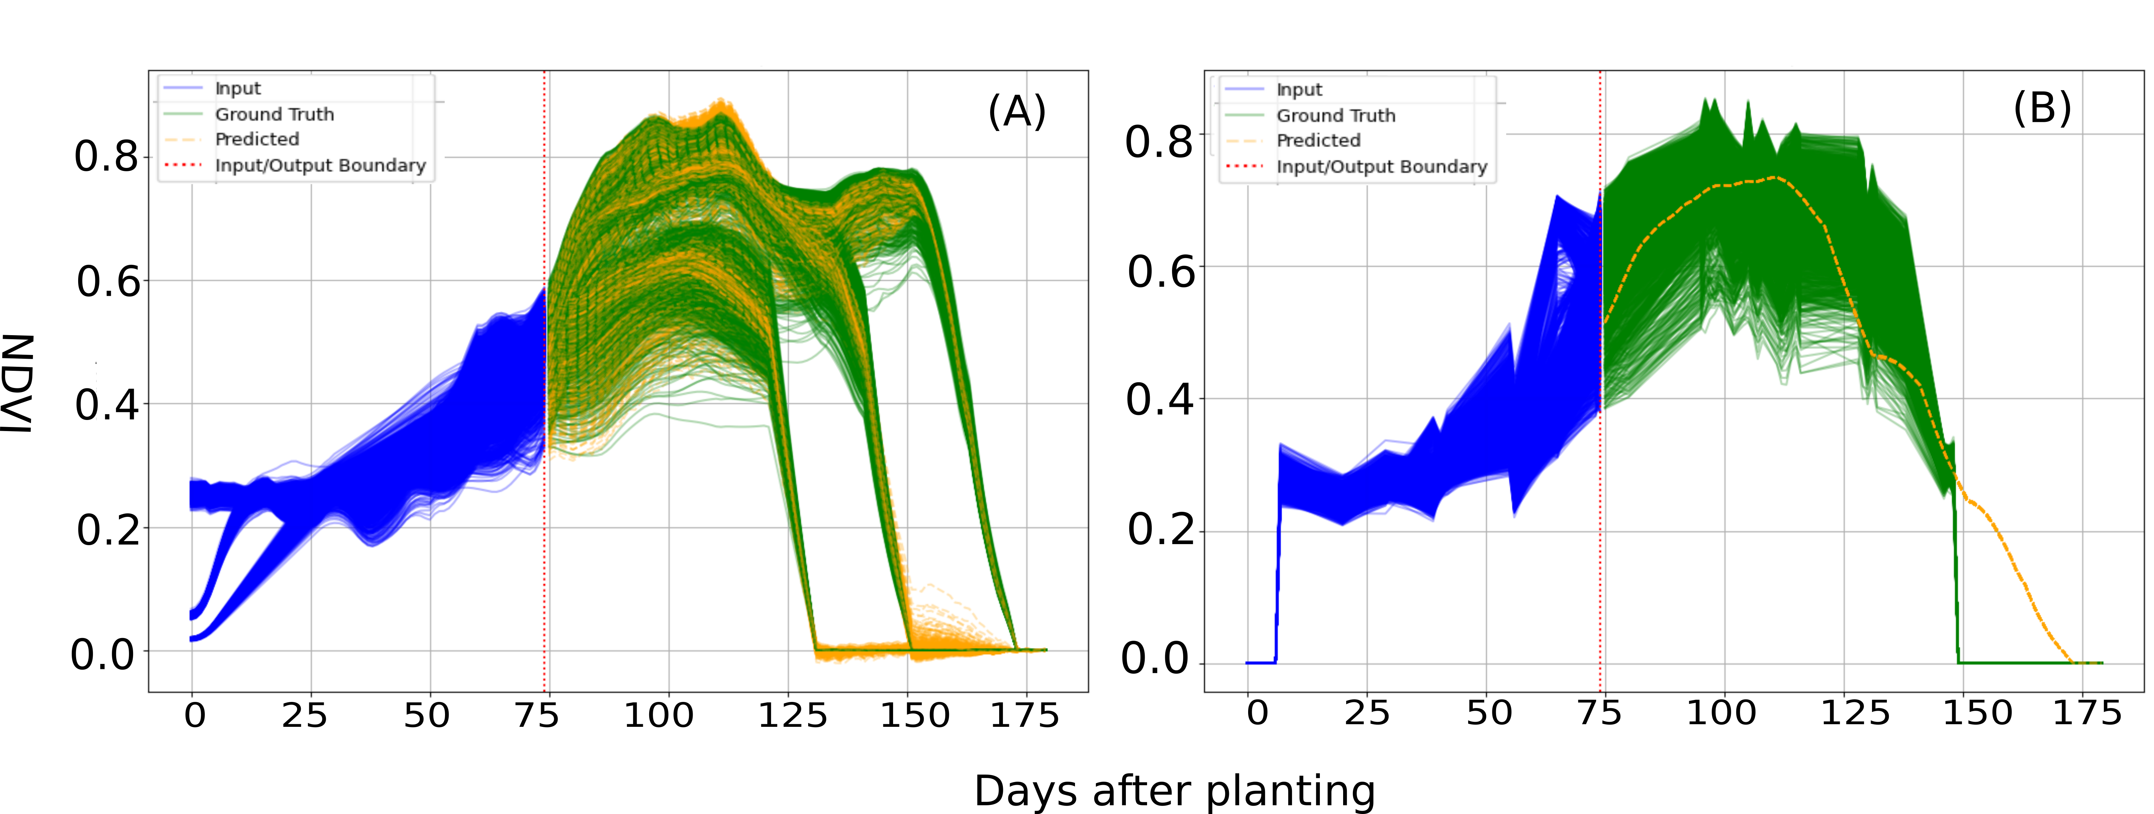
Figure S3. Performance of baseline LSTM model for NDVI forecasting. The model is trained with 2020-, 2021-and 2022-year datasets, divided into training and validation data in the ratio 80:20. (A) shows results with validation data while (B) shows the results with the test data (year 2023)

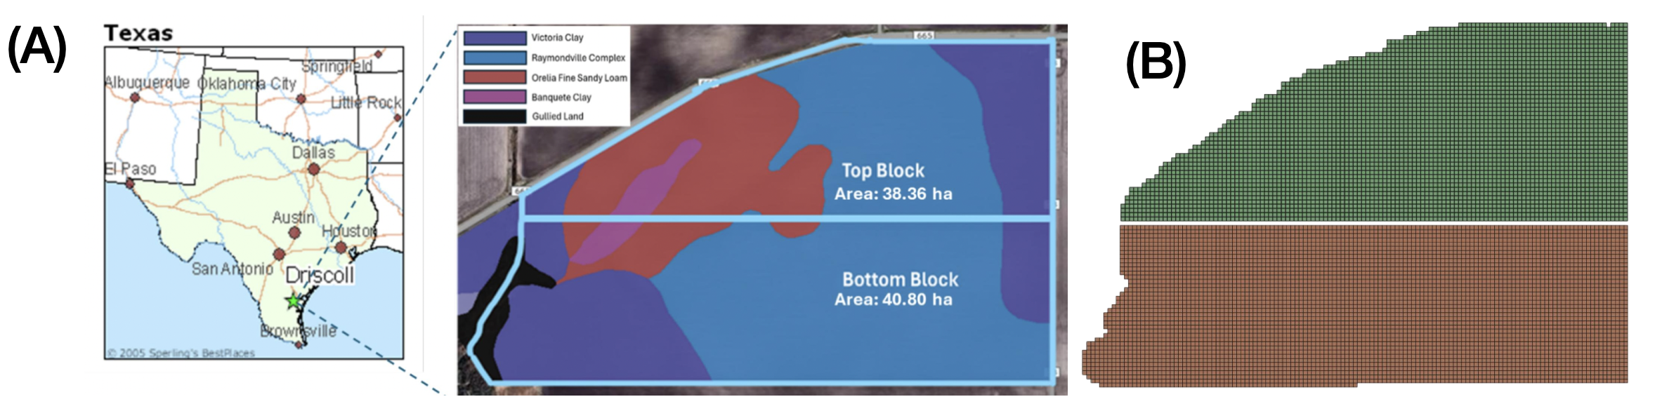
Figure S4. Driscoll cotton field used for training .(A) Location of Driscoll field and its soil properties and acreage. (B) 9m by 9m grids created by aggregating 9 NDVI pixels.

