Future scenarios for the cost of capital for energy technologies linked to the Shared Socioeconomic Pathways

Supplementary Material

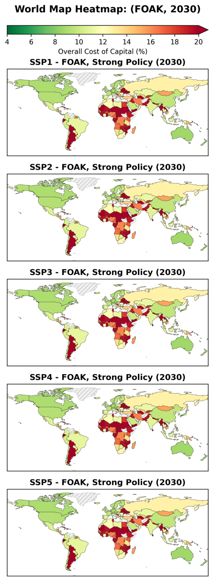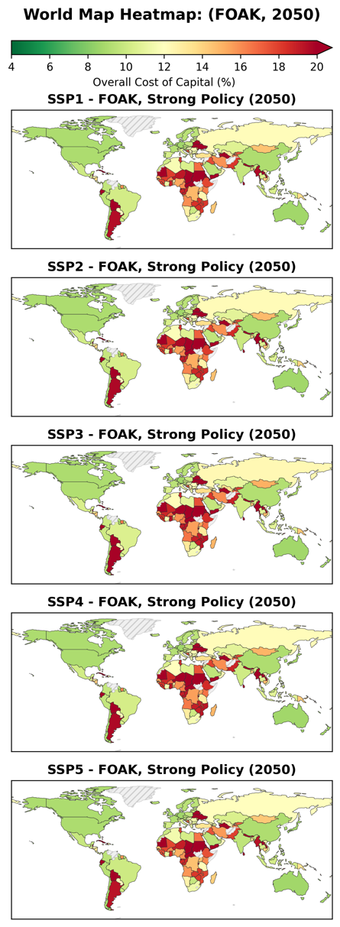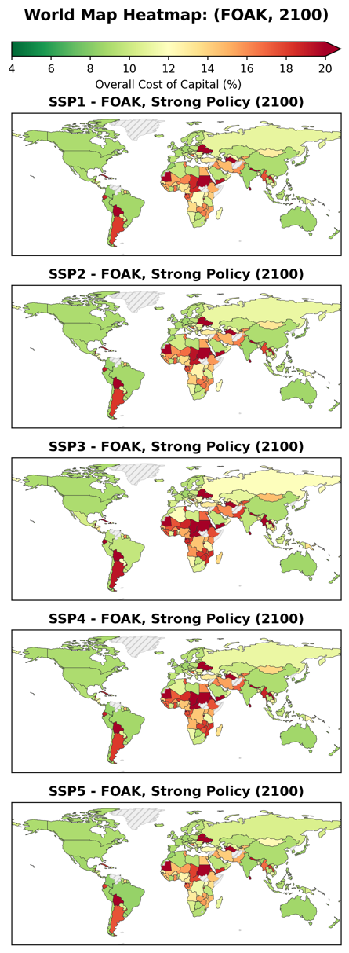
Figure 1: Geographic distribution of the cost of capital for First Of A Kind (FOAK, TRL8) energy technologies with Strong policy support by Shared Socioeconomic Pathway, for 2030, 2050 and 2100. Data gaps correspond to countries that either do not have GDP per capita projections under the SSP scenarios (e.g., Venezuela, Syria) and/or are not rated due to non-sovereignty. Countries without a rating and corresponding country risk premium in the Damodaran database were set to Ca in Moody’s rating (one notch above default). Weak policy support increases the cost of capital between 2 – 3 % depending on the debt share and corporate tax rating.

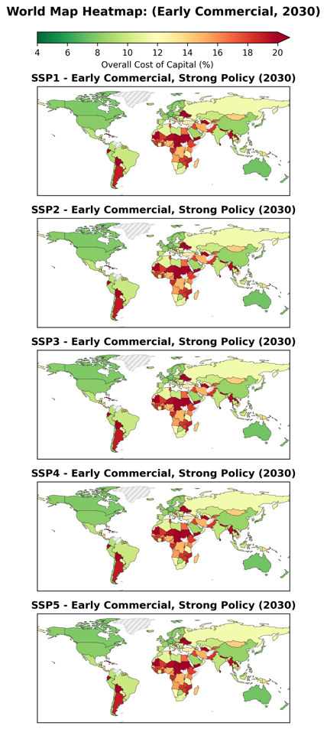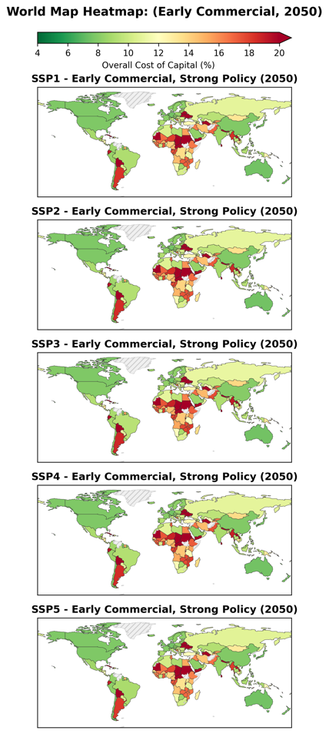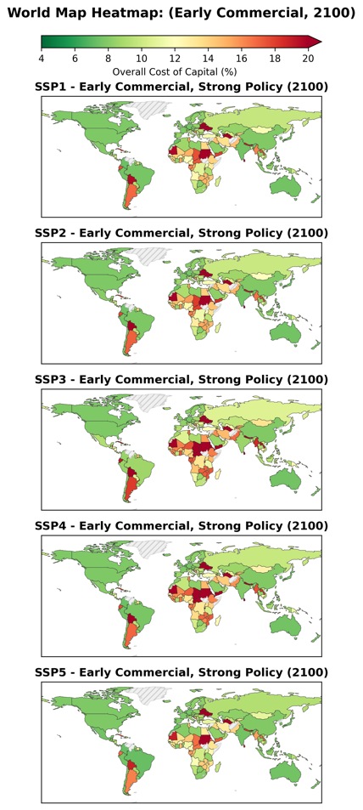
Figure 2: Geographic distribution of the cost of capital for Early Commercial energy technologies (TRL 9) with Strong policy support by Shared Socioeconomic Pathway, for 2030, 2050 and 2100. Data gaps correspond to countries that either do not have GDP per capita projections under the SSP scenarios (e.g., Venezuela, Syria) and/or are not rated due to non-sovereignty. Countries without a rating and corresponding country risk premium in the Damodaran database were set to Ca in Moody’s rating (one notch above default). Weak policy support increases the cost of capital between 2 – 3 % depending on the debt share and corporate tax rating.

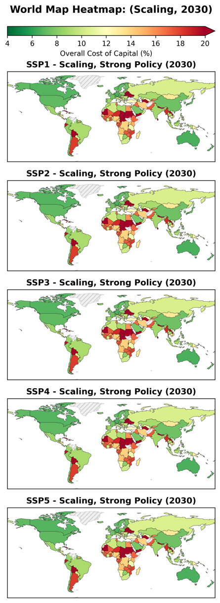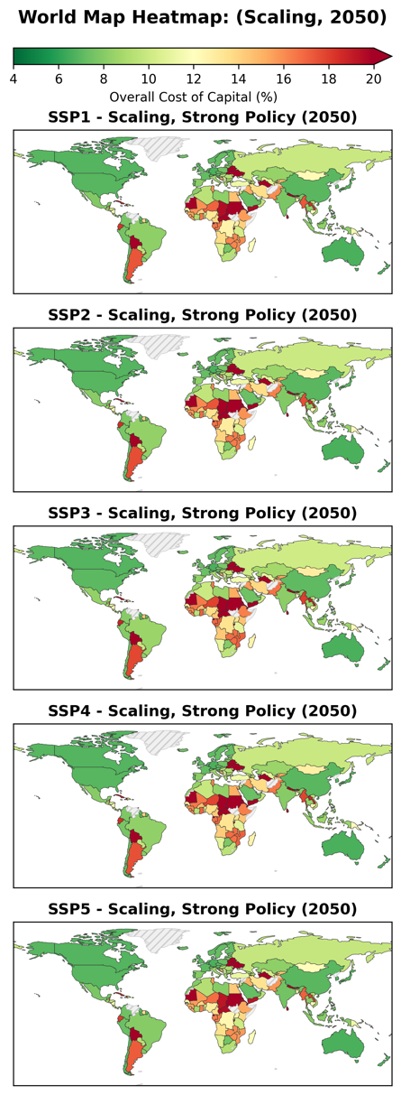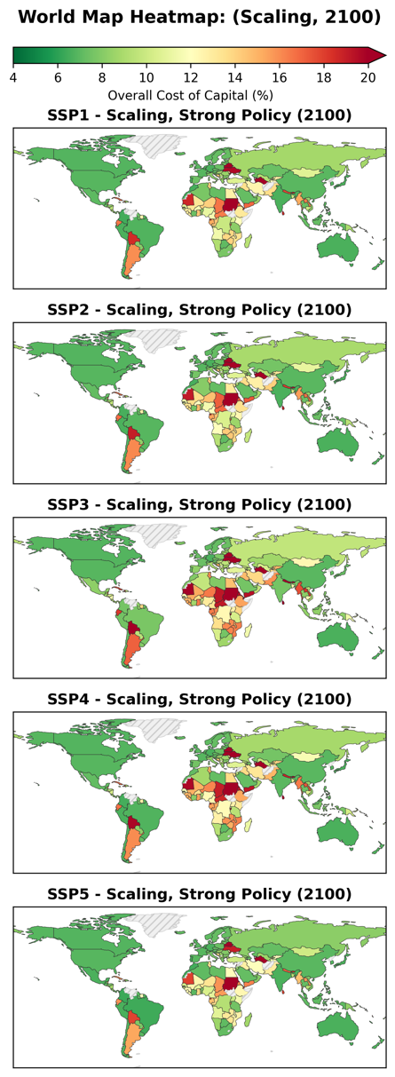
Figure 3: Geographic distribution of the cost of capital for Scaling energy technologies (TRL 9-10) with Strong policy support by Shared Socioeconomic Pathway, for 2030, 2050 and 2100. Data gaps correspond to countries that either do not have GDP per capita projections under the SSP scenarios (e.g., Venezuela, Syria) and/or are not rated due to non-sovereignty. Countries without a rating and corresponding country risk premium in the Damodaran database were set to Ca in Moody’s rating (one notch above default). Weak policy support increases the cost of capital between 2 – 3 % depending on the debt share and corporate tax rating.

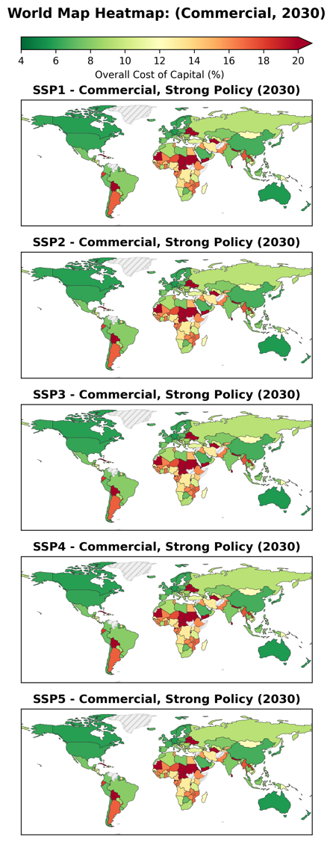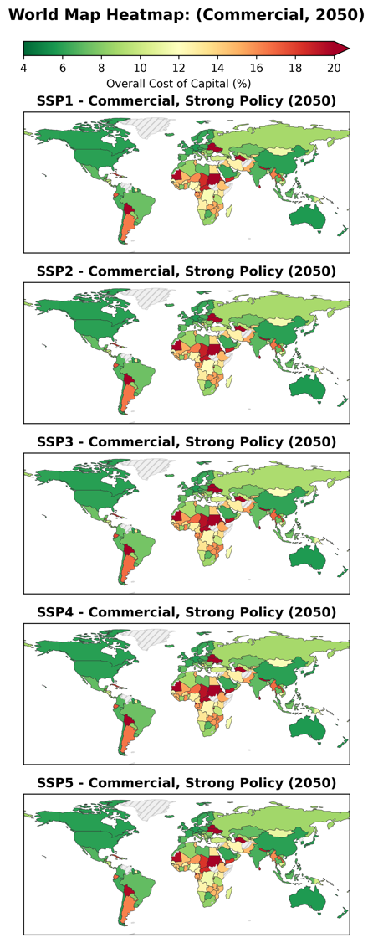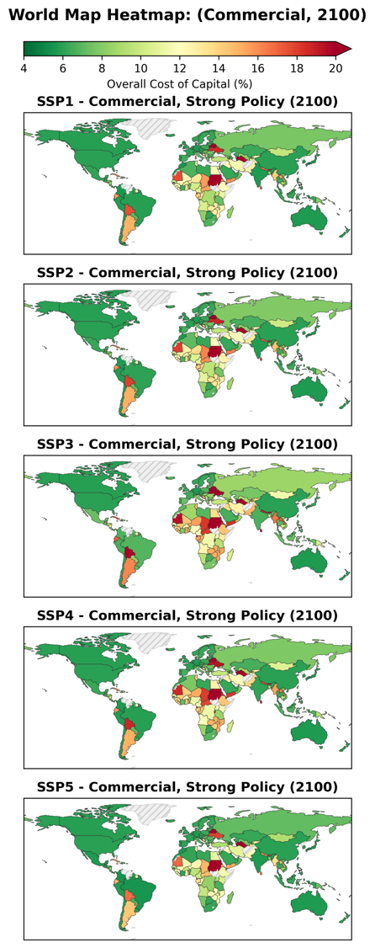
Figure 4: Geographic distribution of the cost of capital for Commercial energy technologies (TRL 10) with Strong policy support by Shared Socioeconomic Pathway, for 2030, 2050 and 2100. Data gaps correspond to countries that either do not have GDP per capita projections under the SSP scenarios (e.g., Venezuela, Syria) and/or are not rated due to non-sovereignty. Countries without a rating and corresponding country risk premium in the Damodaran database were set to Ca in Moody’s rating (one notch above default). Weak policy support increases the cost of capital between 2 – 3 % depending on the debt share and corporate tax rating.

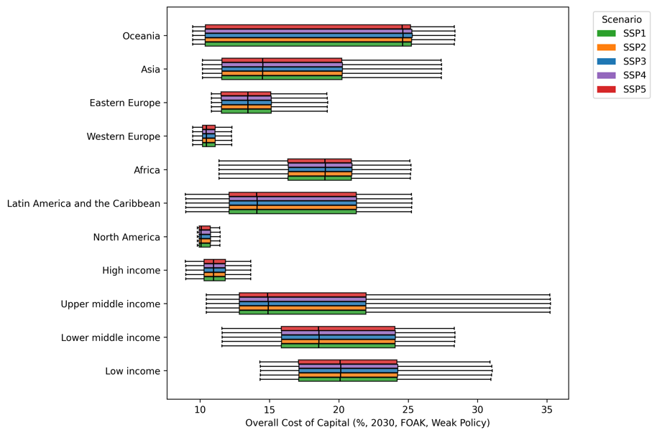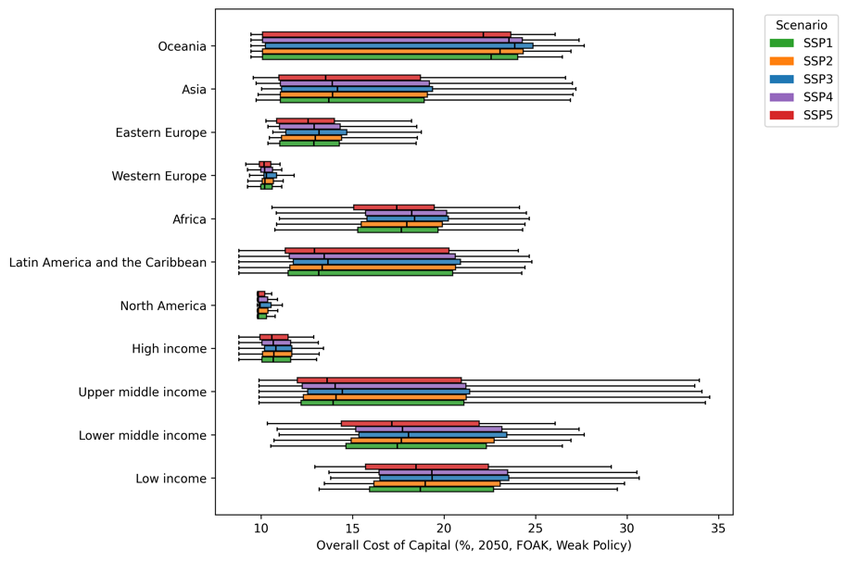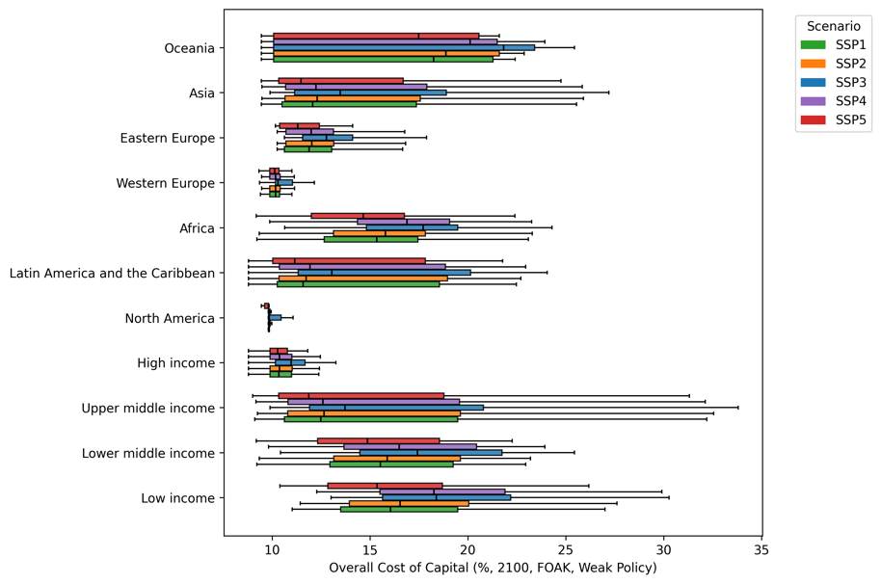
Figure 5: Ranges of the cost of capital for FOAK energy technologies (TRL8) under strong policy support schemes, with comparisons across country groupings by income and region, for 2050 and 2100 and the five modelled SSP scenarios. Boxplots include the range of values falling between the 1st and 3rd quantile, with the median highlighted in black. Values that fall outside of the 1.5 times interquartile range are deemed outliers and are not shown in the figure. Full plots for all technology maturity and policy coherence combinations are included in the Supplementary Material alongside the country groupings used. Weak policy support increases the cost of capital between 2 – 3 % depending on the debt share and corporate tax rating.

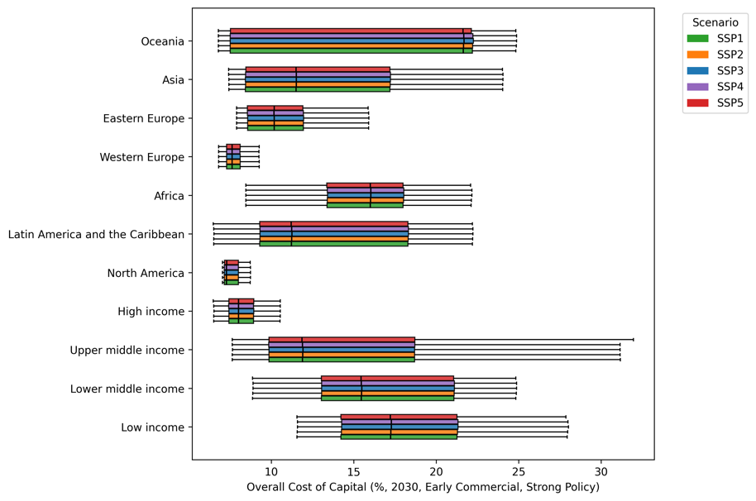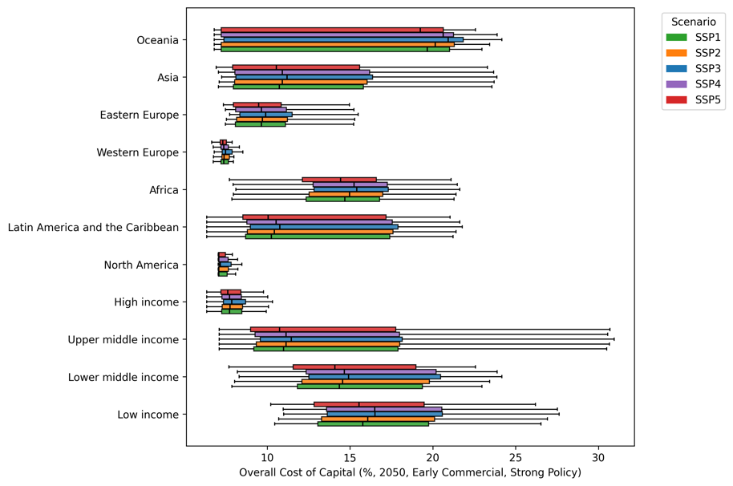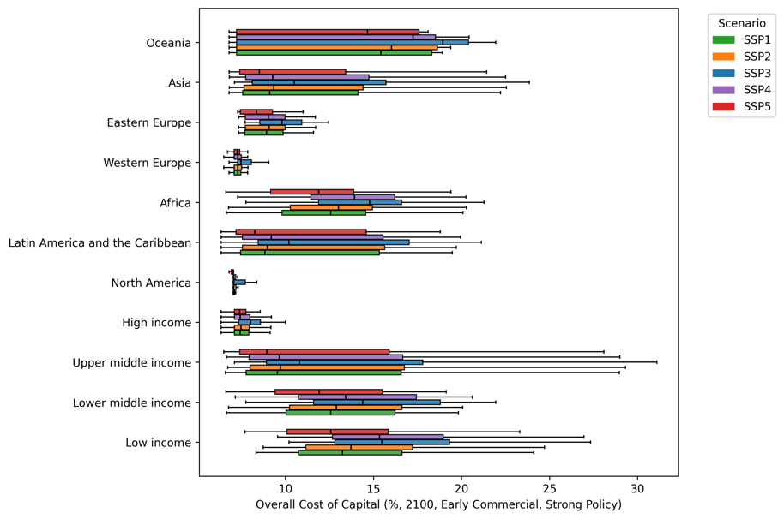
Figure 6: Ranges of the cost of capital for Early Commercial energy technologies (TRL9) under Strong policy support schemes, with comparisons across country groupings by income and region, for 2050 and 2100 and the five modelled SSP scenarios. Boxplots include the range of values falling between the 1st and 3rd quantile, with the median highlighted in black. Values that fall outside of the 1.5 times interquartile range are deemed outliers and are not shown in the figure. Full plots for all technology maturity and policy coherence combinations are included in the Supplementary Material alongside the country groupings used. Weak policy support increases the cost of capital between 2 – 3 % depending on the debt share and corporate tax rating.

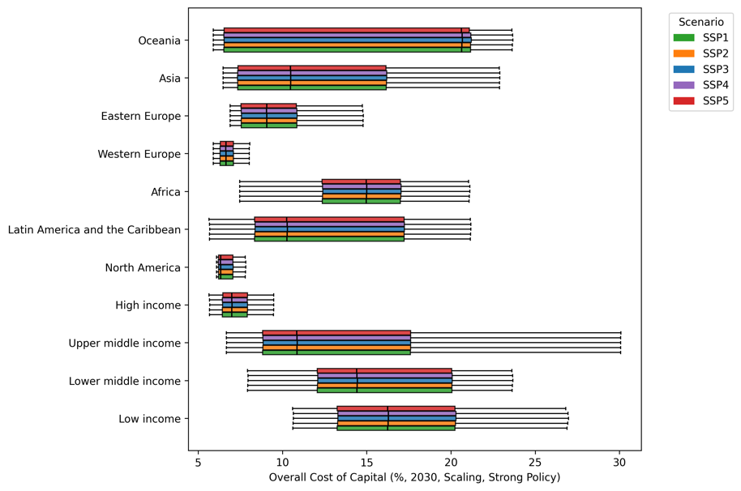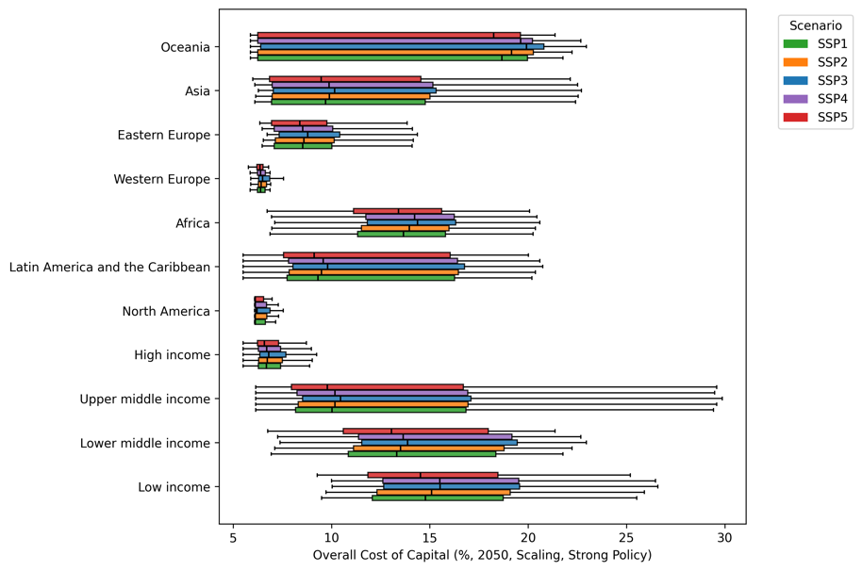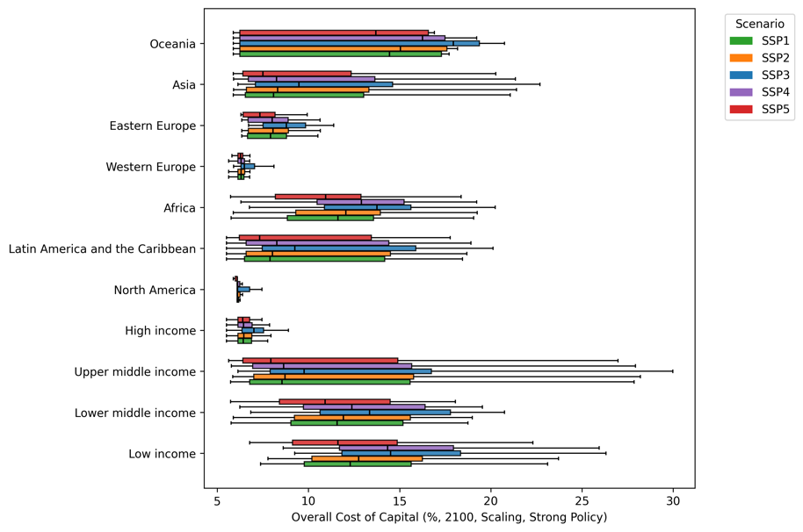
Figure 7: Ranges of the cost of capital for Scaling energy technologies (TRL9-10) under Strong policy support schemes, with comparisons across country groupings by income and region, for 2050 and 2100 and the five modelled SSP scenarios. Boxplots include the range of values falling between the 1st and 3rd quantile, with the median highlighted in black. Values that fall outside of the 1.5 times interquartile range are deemed outliers and are not shown in the figure. Full plots for all technology maturity and policy coherence combinations are included in the Supplementary Material alongside the country groupings used. Weak policy support increases the cost of capital between 2 – 3 % depending on the debt share and corporate tax rating.
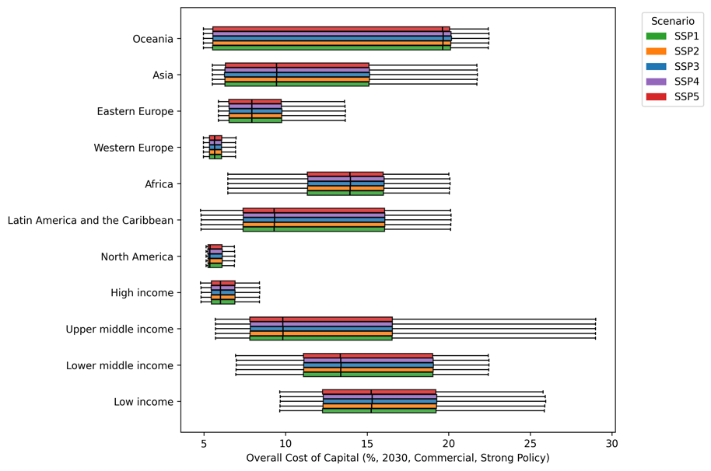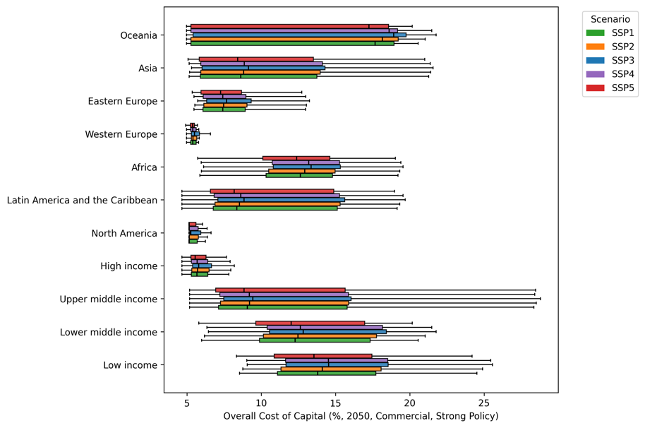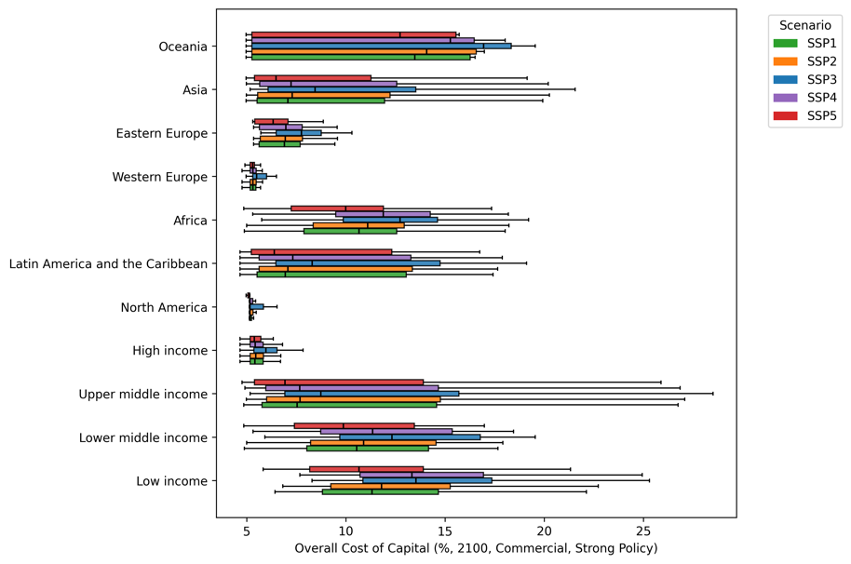
Figure 8: Ranges of the cost of capital for Commercial energy technologies (TRL10) under Strong policy support schemes, with comparisons across country groupings by income and region, for 2050 and 2100 and the five modelled SSP scenarios. Boxplots include the range of values falling between the 1st and 3rd quantile, with the median highlighted in black. Values that fall outside of the 1.5 times interquartile range are deemed outliers and are not shown in the figure. Full plots for all technology maturity and policy coherence combinations are included in the Supplementary Material alongside the country groupings used. Weak policy support increases the cost of capital between 2 – 3 % depending on the debt share and corporate tax rating.

