Electronic Supplementary materials

A Zn(II)-organic framework as a fluorescent probe for the aqueous phase detection of nitroaromatic explosive and Cr(III) ion

Samrah Kamal,ª M. Shahnawaz Khan,ª Mohd Khalid,^{a*} M. Shahid^{a,} Musheer Ahmad^{b}
ªFunctional Inorganic Materials Lab (FIML), Department of Chemistry, Aligarh Muslim University, Aligarh, 202002, India
^{b}ZHCET Aligarh Muslim University, Aligarh, 202002, India
*Corresponding author, Email: khalid215@gmail.com

Formula for calculating the percentage of Trinitrophenol (TNP) fluorescence intensity quenching:

(Io-I)/Io x 100%

Where, Io = initial fluorescence intensity,
I = intensity of Zn-MOF-1 containing Trinitrophenol (TNP) solution.

Stern-Volmer equation:

Io/I = Ksv[A] + 1

Where, Io = fluorescent intensity of Zn-MOF-1 before the addition of the analyte
I = fluorescent intensity after the addition of the respective analyte
Ksv = Stern-Volmer constant
[A] = molar concentration of the analyte (M⁻¹).

Reference: (a) S. Pramanik, C. Zheng, X. Zhang, T. J. Emge and J. Li, J. Am. Chem. Soc., 2011, 133, 4153; (b) D. Banerjee, Z. Hu and J. Li, Dalton Trans., 2014, 43, 10668.

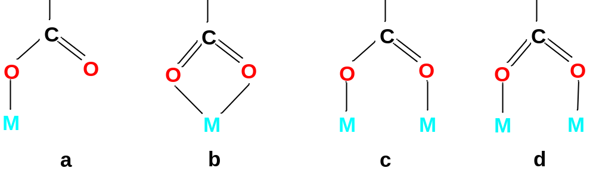

Scheme 1. Different coordination modes of carboxylate (COO‒ ) group [i.e., asymmetric monodentate (a), symmetric bidentate (b) and asymmetric bidentate (c & d)].

Table S1. Selected bond lengths (Å) and bond angles (degree) for Zn-MOF-1

Zn1- O1 | 2.0486(14)
Zn1- O4 | 2.1405(15)
Zn1- O5 | 2.1799(16)
Zn1- O8 | 2.1387(16)
Zn1- O9 | 2.0699(15)
Zn1 -N1 | 2.1154(17)
Zn2 -O2 | 1.9734(16)
Zn2- O4 | 2.0079(15)
Zn2 -O6 | 2.0765(16)
Zn2- O7 | 2.0738(15)
Zn2- N2 | 2.1043(19)
Zn2- O4- Zn1 | 112.88(7)
O4- Zn1- O8 | 87.47(6)
O9- Zn1- O8 | 93.11(6)
O9- Zn1- O4 | 166.81(6)
O5 -Zn1- O8 | 177.78(6)
O5- Zn1- O4 | 90.34(6)
O5- Zn1- O9 | 89.11(6)
O1- Zn1- O8 | 93.56(6)
O1- Zn1- O4 | 97.07(6)
O1- Zn1- O9 | 96.05(6)
O1- Zn1- O5 | 86.30(6)
N1- Zn1- O8 | 94.04(6)
N1- Zn1- O4 | 77.00(6)
N1- Zn1- O9 | 89.81(6)
N1- Zn1- O5 | 85.86(6)
N1- Zn1- O1 | 170.13(7)
O7- Zn2- O4 | 100.38(6)
O2- Zn2- O4 | 101.55(6)
O2 -Zn2- O7 | 96.34(6)
O6- Zn2- O4 | 87.40(6)
O6- Zn2- O7 | 159.25(7)
O6- Zn2- O2 | 100.93(7)
N2- Zn2- O4 | 147.84(7)
N2- Zn2- O7 | 77.48(7)
N2- Zn2- O2 | 110.59(7)
N2- Zn2- O6 | 85.69(7)

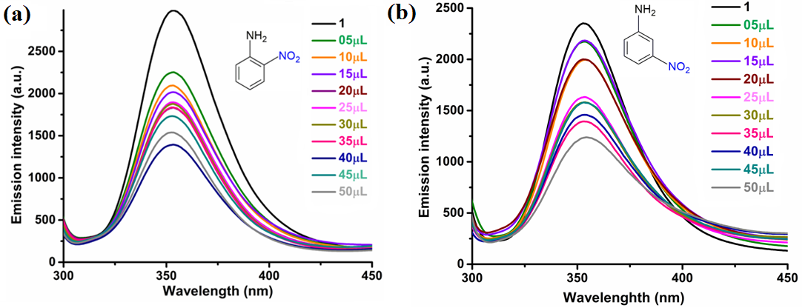

Figure S1: The change in fluorescence intensity of Zn-MOF-1 upon incremental addition of (a) ONA (b) MNA solution.

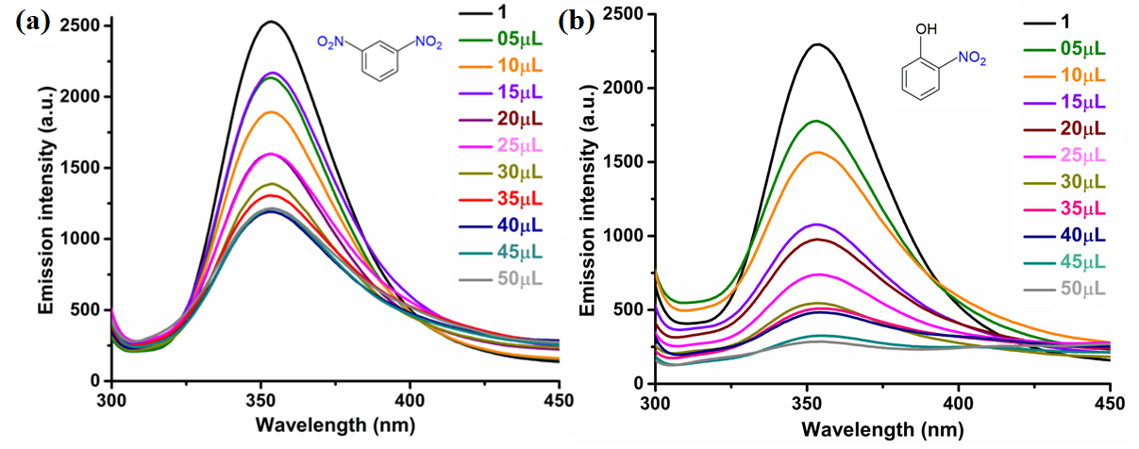

Figure S2: The change in fluorescence intensity of Zn-MOF-1 upon incremental addition of (a) MDNB (b) ONP solution.

Figure S3: Linear region of fluorescence intensity of Zn-MOF-1 upon addition of TNP in water (05 ‒ 50 μL, 1 mM stock solution) (upon λex= 272nm) (R²= 0.97).

Figure S4: Linear region of fluorescence intensity of Zn-MOF-1 upon addition of Cr³⁺ in water (50 ‒ 500 μL, 1 mM stock solution) (upon λex= 272nm) (R²= 0.93).

Calculation of Standard deviation (σ):
Table S2: Standard deviation of Zn-MOF-1
Blank readings (only Zn-MOF-1) | Intensity of Zn-MOF-1
Reading 1 | 2411.04
Reading 2 | 2400.27
Reading 3 | 2409.49
Reading 4 | 2414.03
Reading 5 | 2410.500
Standard deviation (σ) | 4.65

Calculation of detection limit:

Table S3: Detection limit calculation of Zn-MOF-1 for TNP

Compound | Slope from graph  (m) | Detection limit  (3σ)/m
Zn-MOF-1 | 25600 | (µM) | ppb
Zn-MOF-1 | 25600 | 5.4×10⁻⁴ | 0.12

Table S4: Detection limit calculation of Zn-MOF-1 for Cr³⁺

Compound | Slope from graph  (m) | Detection limit  (3σ)/m
Zn-MOF-1 | 5920 | (µM) | ppb
Zn-MOF-1 | 5920 | 2.3×10⁻³ | 0.62

