In vivo and in vitro evaluation of the anti-inflammatory effect of Thymoquinone toward Ischemic brain injury alleviation via Nrf2/HO-1 pathway.
Nashwa Amin^{1,2}, Xiaoxue Du³, Shijia Chen¹, Qiannan Ren¹, Azhar B. Hussien¹, Benson O.A. Botchway¹, Zhiying Hu^{4, a}, Marong Fang^{1, b}
¹Institute of Neuroscience, School of Medicine, Zhejiang University, Hangzhou, China.
²Department of Zoology, Faculty of Science, Aswan University, Egypt.
³Translational Medicine Center, Affiliated Hangzhou First People’s Hospital, Zhejiang, China.
⁴Obstetrics & Gynecology Department, Zhejiang Integrated Traditional and Western Medicine Hospital, Hangzhou, China.
ª Correspondence: Z. Hu, Department of Obstetrics & Gynecology, Zhejiang Integrated Traditional and Western Medicine Hospital, Hangzhou 310003, China.
^{b} Correspondence: M. Fang, Institute of Neuroscience, School of Medicine, Zhejiang University, 866 Yuhangtang Road, Hangzhou 310058, China.
E-mail addresses: huzhiying@zcmu.edu.cn (Z. Hu), fangmaro@zju.edu.cn (M. Fang).

Supplementary Data

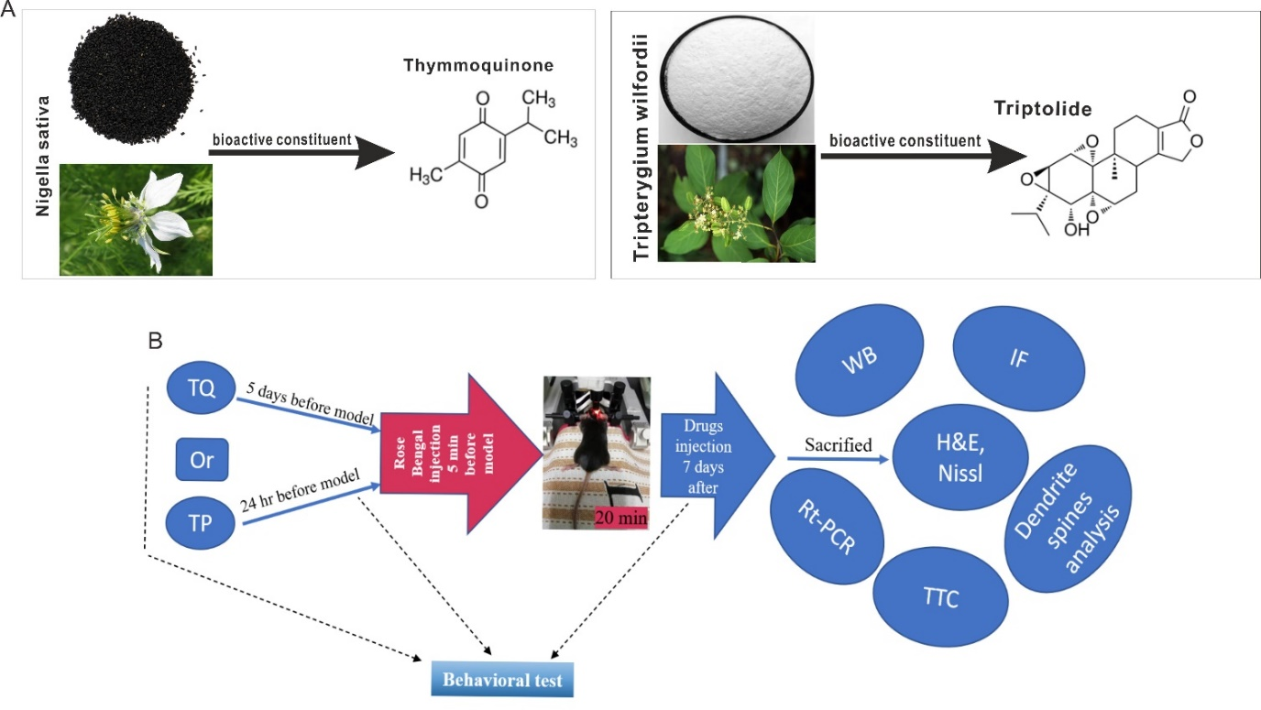
Fig. I (A) chemical structure of TQ and TP, (B) experiment design; TQ injected 5 days before model and continued for 7 days after while TP has been injected 24 h prior establishing the model and continued for 7 days after, behavioral tests were conducted at before treatment, before and after stroke.

Materials and methods

Section 1: Successful establishment of the YFP mice
Sixty adult male C57BL/6J mice (average weight of 25 ± 2 g) obtained from the animal center of Zhejiang University Medical College and sixty adult male C57BL/6 transgenic mice (H-line) expressing YFP in a subset of layer 5 cortical neurons [1] were used after gene identification. The mice allowed to eat and drink freely at room temperature (24 ± 1 °C) under a relative humidity of 55% for 12 h light/12 h dark cycle. This study was performed following the Guide of Care and Use of Laboratory Animal Center of Zhejiang University. All animal treatments were approved by the Ethics Committee for Use of Experimental Animals at Zhejiang University.
For exploring the changes in dendrite spines shape and density after stroke, five adult male YFP mice expressed YFP in 5 cortical neuron subsets were purchased from Jackson Laboratory (Bar Harbor, ME). For measuring the density of the neuronal dendritic spine, we allowed to mate with ten female C57BL/6J mice. Ten-weeks of old offspring were identified by PCR as shown in Fig. I.
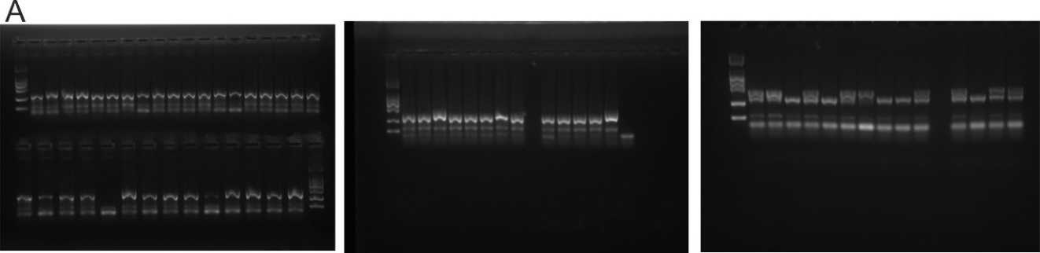
Figure II. Gene identification of YFP gene. YFP double-positive offspring evaluated by using PCR and gel electrophoresis machine.
Section 2: Behavioral tests
Rotarod test
The speed of the rotarod machine was accelerated from 8 rpm to 40 rpm and the total program time was set to be 300 s. Each mouse was trained three times a day, resting for 10 min after each cycle. The mice that stayed on the rotating rod instrument for more than 150 s were used to build the stroke model. The time of each group of mice on the rotating rod was recorded two days before building the model and three days after stroke.
Cylinder test (spontaneous forelimb use asymmetry test)
In this test, the animal was placed inside a glass cylinder with a diameter of 9 to 10 cm and a height of 20 cm. The forelimb use was evaluated by recording the forelimb contact during the vertical exploration of the cylinder wall [2]. A total of 20 vertical movements were recorded and subsequently analyzed by an observer under a slow motion. The asymmetry score was calculated as previously described [3] as follow:
$$\frac{nonimpaired forelimb contact-impaired forelimb contact}{nonimpaired forelimb contact+ impaired forelimb contact+both contacts}$$
Sunflower test
Mice were given sunflower seeds in their home cage to familiarize them with shelling and consuming seeds throughout the week before establishing a stroke model. Food was obscured for 18–24 h before training and testing while maintaining free access to water. Mice were placed in a paper-lined box with 10 sunflower seeds. After 30 min, the number of wholes (uneaten) seeds and pieces of shells were recorded.
Section 3: Western blotting
The protein (20 μg) from each sample was subjected to electrophoresis on 15% SDS PAGE gel using a constant voltage (200 V) for 60 min. The proteins were transferred to a polyvinylidene difluoride (PVDF) membrane with the Bio-Rad Trans-Blot apparatus. Thereafter, membranes were blocked with TBST containing 5% non-fat milk for 2 h at room temperature. Membranes were incubated with primary antibody overnight at 4 °C. The primary antibodies used were: rabbit polyclonal antibody against GAPDH (CST, 1:1000), ATG5/ATG12 (Abcam, 1:1000), TrkB (Abcam,1:1000), Beclin-1 (CST, 1:1000), LC-3II (CST, 1:1000), mTOR (Abcam, 1:1000), AKT (CST, 1:1000), P44/42-MAPK (ERK1/2) antibody (CST,1:1000), (iNOS) (Boster, 1:100), and nuclear factor kappa B (NF-κB) (CST,1:1000), Bcl-2 (Abcam,1:1000), Bax (Abcam,1:1000), HO-1 (Abcam,1:1000), Nrf2 (OMNI:1:1000), IL-10 (Abcam,1:500),c-myc (CST,1:1000), PSD-95 (Abcam,1:1000). On the following day, the membrane was washed with TBS containing 0.05% Tween 20 (TBST). After washing 3 times, with each wash lasting 5 min, membranes were incubated with goat anti-rabbit and anti-mouse IgG antibody (BOSTER, 1:5000) at room temperature for 2 h, and then washed with TBST 3 times (each wash lasting 5 min). Membranes were then exposed to hyper-film detection after incubating with the ECL system. The grayscale value of each band was analyzed using the Image Lab software. Each experiment was performed three times.
Section 4: Immunofluorescence
Brain tissues were obtained after perfusion and fixed with 4% paraformaldehyde. On the next day, tissues were transferred into a 30% sucrose solution. Embedding in OCT and frozen tissue sections were performed using a freezing microtome (Leica, Wetzlar, Germany).Frozen sections of 18 um thickness were dried at 37 °C and then blocked with 5% normal goat serum at room temperature for 1 h. After, primary antibodies were added in the following concentrations at 4 °C overnight: NeuN (Abcam, 1:1000), LC-3II (CST, 1:200) and GFAP (CST, 1:200), HO-1(Abcam,1:200), Nrf2(OMNI,1:200) . Regarding the negative control sections, 0.01 M PBS was used to replace the primary antibody. On the following day, the sections were washed with 0.01 M PBST for 5 min three times, and then incubated with a secondary antibody containing FITC goat anti-rabbit IgG (1:100, Boster, BA1105), Alexa Fluor anti-mouse 594, and Alexa Fluor® anti-rabbit 488 for 3 h at room temperature. The sections were then washed with 0.01 M PBS three times. A mounting medium containing DAPI (VECTASHIELD, USA) was added to the slides and covered with coverslips for observation. Slides were observed under a fluorescence microscope (Olympus BX51, NIKON, Japan) at excitation/emission wavelengths of 547/570 nm (Cy3, red), 494/520 nm (FITC, green), and 360/460 nm (DAPI, blue). Images were taken at 200× magnification.
Section 5: Imaging and Dendritic spine analysis
The laser wavelength was set to 514 nm excitation. Images were collected at a resolution of 1024×1024 pixels and averaged over two lines. Where stacks of z sections were collected for gross cortex morphology, the final magnification was 63× and the scanning step size was 1.14 m. [4]. Spine densities were calculated by quantifying the number of spines per 10 μm of dendritic length. The spine numbers were counted manually in 3 dimensions using Z stacks and the dendritic length was estimated by NIH Image J software. Spine type analyses were performed using the Neurolucida 360 software (http://research.mssm.edu/cnic/tools-ns.html) [4]. This method agrees with well-accepted methods for spine type classification [4-6].
Section 6: TTC staining and Calculation of infarct volume
The animals were anesthetized with isoflurane and the brains were removed rapidly and frozen at −20 °C for 5 min. 1–2 mm coronal slices were cut, then slices were immersed in 2% TTC (Sigma-Aldrich, MO) at 37 °C for 20 min. Afterward, the sections were fixed by 10% paraformaldehyde overnight. The occurrence of infarction was estimated by the area stained negatively with TTC. The volume of damage was calculated based on four slices approximately 2 mm apart, ranging from 3.7 to -6.3 mm relative to bregma. Volumes were calculated for each hemisphere, total brain size, ventricles, damaged tissue, and healthy tissue (remaining ipsilateral tissue). To evaluate the difference in hemisphere size resulting from edema and atrophy, the total ischemic damage was calculated according to the proportion of contralateral hemisphere using this formula [7].
$$\frac{contralateral area- remaining ipsilateral area.}{contralateral area}$$
Section 7: Hematoxylin-eosin (HE) and Nissl staining
In a typical procedure, after de-paraffinization and re-hydration, transverse sections of 7 μm thick were stained with hematoxylin solution for 6 min and then dipped into acidic ethanol (1% HCl in 70% ethanol) for several seconds and rinsed in distilled water for 10 min. After that, the sections were stained with eosin solution for 5 min and followed by dehydration with a graded alcohol series and clearing in xylene. The slides were sealed with neutral balsam and inspected by a microscope. Nissl staining was also conducted as the following de-paraffinization and re-hydration, transverse sections of 7 μm thick were stained in 0.1% cresyl violet solution at 37°C for 5 min. The sections were washed with distilled water, immersed in 95% ethanol for the 30s, and soaked in anhydrous ethanol as well as xylene for 5 min each. The sections were sealed with neutral balsam and observed with a microscope.
Section 8: Cell cultures:
Previous results indicated the advantageous role of PC12 cells in exocytosis and neurite outgrowth studies because of their large capacity for unlimited proliferation with a minimized effort [8-10]. Briefly, PC12 cells (ATCC Mouse Cell) were cultured in RPMI 1640 medium (Gibco) containing 10% fetal bovine serum (FBS) (Vistech) and penicillin-streptomycin mixture (1:1000 dilution, Gibco) at 37°C/5% CO2. The medium was changed daily; Cells were washed twice in 0.01 M phosphate buffer saline (PBS) (HyClone) and passaged by using 0.25% trypsin (Gibco) when the cell density was more than 80%.
Section 9: Cell groups and Establishment of OGD/R model
Cells at a density of 3 × 104 cells per well were cultured in a pre-heated RPMI-1640 glucose-free medium (Gibco). The plate was put into an anaerobic culture bag (MGC) which included an anaerobic gas-producing bag (MGC) and anaerobic indicator (MGC). With no change in the indicator, the anaerobic culture bags containing 6-well plates were put into a CO2 incubator for 4 hours. After deprivation of glucose and hypoxia, the anaerobic devices were removed, and the cells were cultured in a full culture medium at 37°C/5% CO2 for 24 hours.
Normal group (without any treatment), OGD group (cells exposed to the OGD model).TQ and TQ+OGD groups (cells treated with TQ 10 μg/ml for 24 hr.), TP and TP+OGD groups (cells treated with TP 50 nM/ml for 24 hr.), A stock solution of TQ or TP were prepared in DMSO solvent and then suitable working solutions achieved by using a complete medium. The concentrations were chosen according to the literature [11-12]. Further information about establishment of OGD/R model
Section 10: In vitro immunofluorescence staining
Cells were incubated with rabbit anti-HO-1 primary antibody (1:100 dilution, Abcam), rabbit anti-Nrf2 primary antibody (1:200 dilution, OMNI) and rabbit anti-NF-kB primary antibody (1:100, CST) in PBST at 4°C overnight. The next day the cells were washed 5 min 3 times with PBST and incubated with antirabbit Alexa Fluor488 and Alexa Fluor 594 secondary antibody (1:500, EARTHOX, USA) in 0.01 M PBST at room temperature for 1.5 hours. Finally, a mounting medium containing DAPI (VECTASHIELD, USA) was added to the slides and then covered with coverslips for observation. Slides were observed under fluorescence microscopy (Olympus BX53, Japan). Images were taken at 400x and 800x magnification. For negative controls, cells on the coverslips were incubated with secondary antibody only.
Results:
1. Effect of TQ drug on mice weight and Survival rate:
The mice's weight before establishing the stroke model was approximately equal in all groups (25±2 g) (Fig. III(A)). After the model, Stroke and TP+ Stroke groups show a significant decrease in their body weight (P<0.001) (P<0.05), respectively. While TQ+ Stroke mice display a non-significant change in their weight compared with pre-stroke mice. Besides, the observation of the survival rate of all groups for 7 days shows a noticeable increase with TQ administration for 5 days before stroke as shown in (Fig. III(B)).

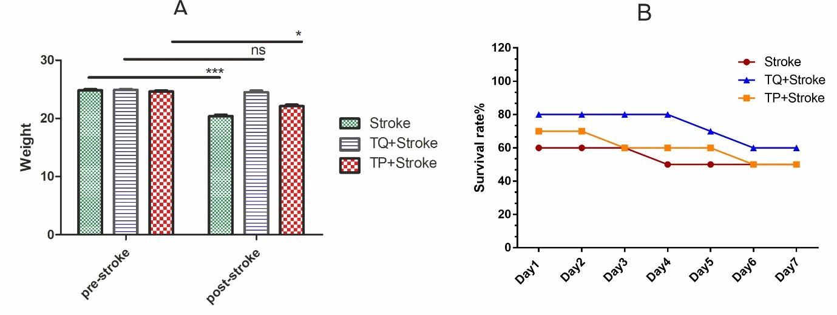

Fig. III TQ increases the survival rate after stroke without loss in body weight. A, Weight, Stroke Vs. pre-stroke ***P<0.001, TP+ stroke Vs. pre-stroke *P<0.05, TQ+ stroke Vs. pre-stroke P=ns. B, Survival rate. TQ survival rate on the last day before sacrificed = 70%. All values are expressed as mean ± SEM, n=10.
3.TQ administration have no toxicity on liver tissue
TQ shows an insignificant change in liver morphology, meanwhile, TP administration exhibits fibrosis, focal necrosis, and congestion of hepatoportal blood vessel, which is covered by inflammatory cell infiltration (black arrows) as shown in Fig. IV.
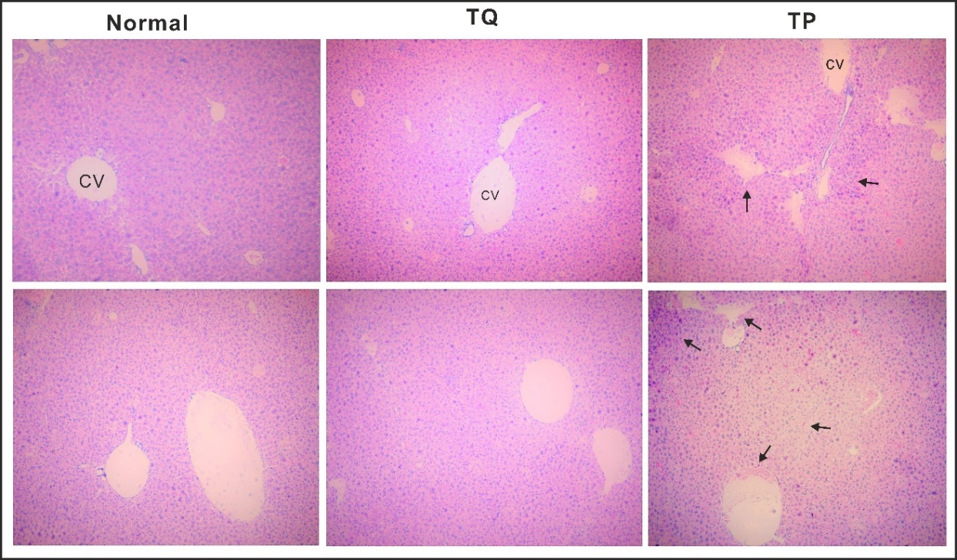
Fig. IV. TQ has no side effects on liver tissues compared to TP. (CV) central vein, TP administration exhibits fibrosis, focal necrosis, and congestion of hepatoportal blood vessel, which is covered by inflammatory cell infiltration (black arrows).
4. The effect of TQ on the expression of proliferation and apoptosis-related proteins
The TrkB/AKT/mTOR and MAP2 after stroke are significantly decreased (P<0.01, P<0.05, P<0.01, and P<0.01), respectively (Fig. V B, C, F, G). Besides, Erk1/2, p-Erk1/2, c-MYC, and PSD-95 proteins are significantly increased following stroke (P< 0.01, P<0.001, P<0.001 and P<0.001), respectively (Fig. V D, E) & (Fig. VI B, C). The levels of these proteins are extremely reversed after TQ therapy as shown in Fig.9 & Fig.10. Moreover, levels of c-FOS and 5HT gene expression upregulate after stroke and downregulate in TQ+Stroke mice (P<0.01, Fig. VI E& F). Additionally, analysis of c-MYC gene expression matches well with the western blot results (Fig.VI D)

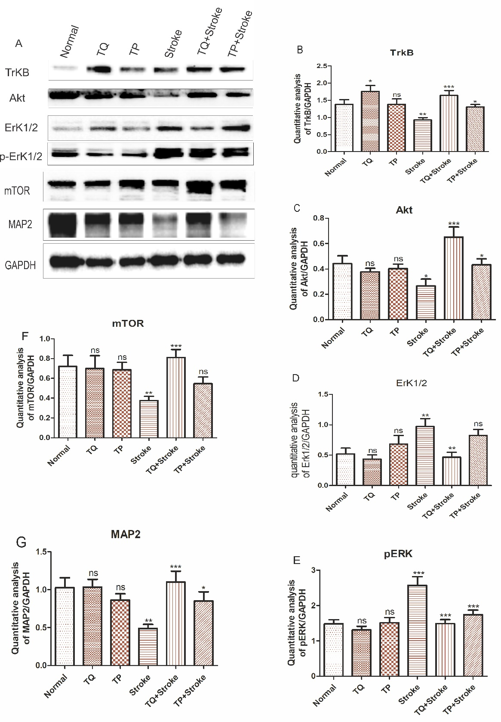
Fig. V. TQ drug possesses a modulating effect on proliferating proteins. (A) Western blot results. Quantification analysis of (B) TrkB (C) AKT (D) Erk1/2 (E) p-ErK1/2 (F) mTOR (G) MAP2. All values are expressed as mean ± SEM, n=5. Stroke Vs. Normal: AKT *P<0.05, p-Erk1/2 ***P<0.001, TrkB, mTOR, Erk1/2, MAP2.TQ+ Stroke Vs. Stroke: AKT, p-Erk1/2, TrkB, mTOR and MAP2***P<0.001, Erk1/2. TP+ Stroke Vs. Stroke: AKT, TrkB, and MAP2*P<0.05, mTOR and Erk1/2 P=ns, p-Erk1/2 ***P<0.001.
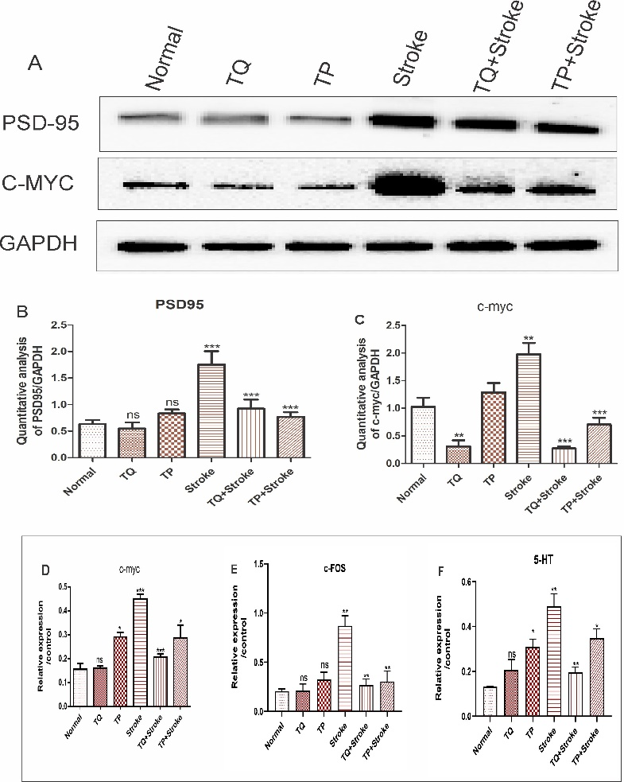

Fig.VI. TQ drug possesses a modulating effect on proliferating proteins. (A) Western blot results. Quantification analysis of (B) PSD-95 (C)C-myc (D) c-MYC gene analysis, (E) c-FOS gene analysis, (F) 5 -HT gene analysis. All values are expressed as mean ± SEM, n=5. Stroke Vs. Normal: PSD-95; ***P<0.001, c-MYC, c-FOS and 5HT **P<0.01.TQ+ Stroke Vs. Stroke: PSD-95; ***P<0.001, c-FOS and 5HT **P<0.01. TP+ Stroke Vs. Stroke: c-MYC, 5HT and *P<0.05, PSD-95& p-Erk1/2 ***P<0.001.

5. Pre-treatment by TQ assisted cells number and shape recovery after OGD/R
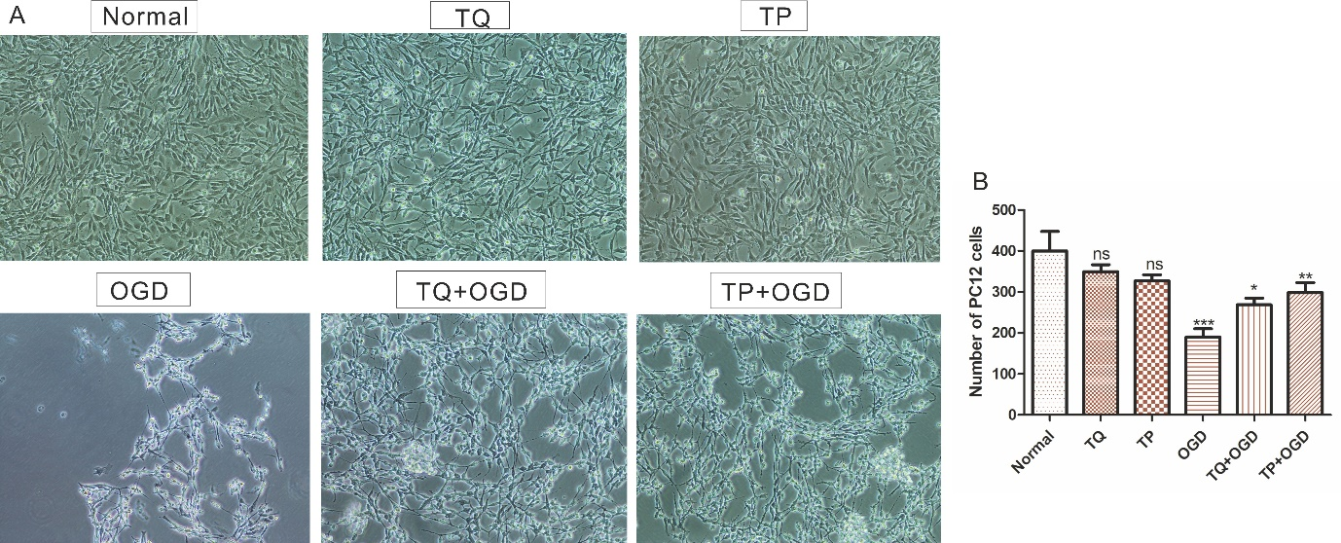
Fig. VII. pre-treatment of cells by TQ improves cell numbers after OGD/R. A, Phase-contrast microscope. B, Number of PC12 cells; OGD Vs. Normal ***P<0.001, TQ+ OGD Vs. OGD *P<0.05 and TP+ OGD Vs. OGD **P<0.01. The spindle shape of PC12 cells and their interfacial connection after the OGD model are lost and can be recovered under TQ or TP treatment. All values are expressed as mean ± SEM, n=3.

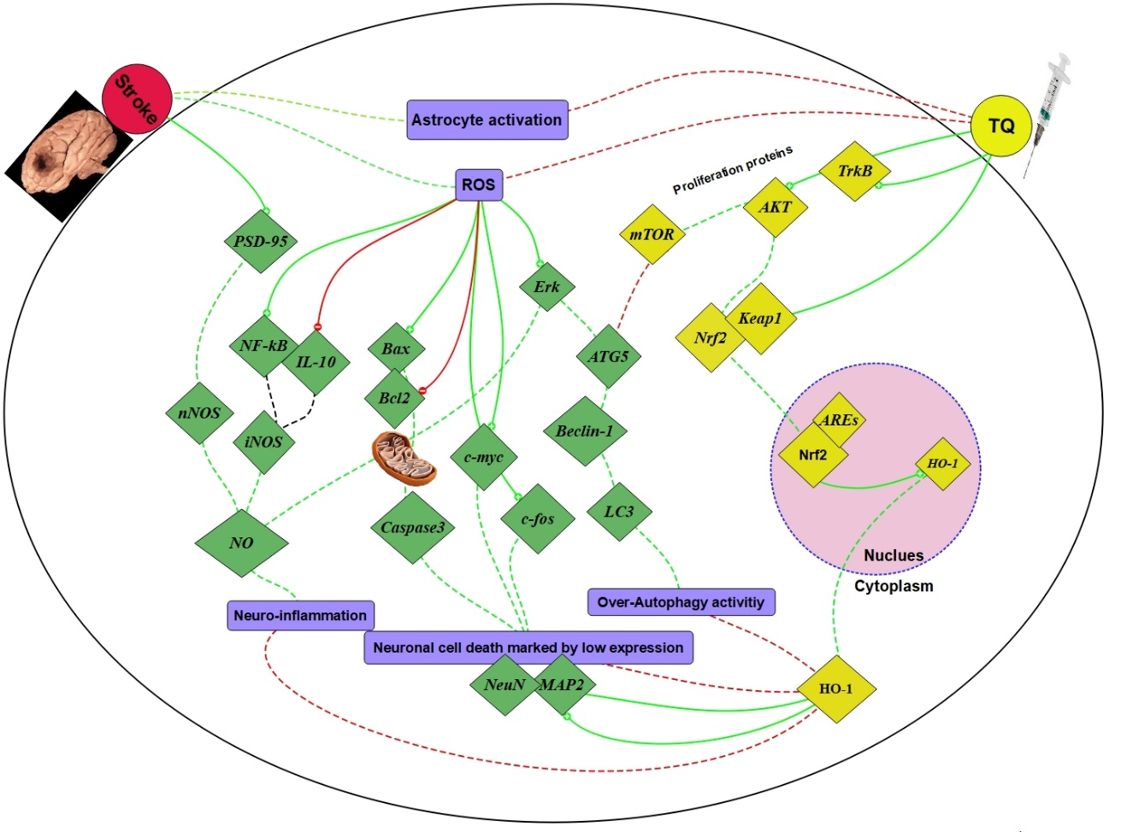
Fig. VIII Suggested pathway of TQ therapy on ischemic brain damage: TQ therapy can alleviate the ischemia brain damage through activating Nrf2, which in turn activates HO-1 to be released into the cytoplasm. Thus, apoptosis, inflammation, and autophagy processes are suppressed. Additionally, TQ administration exhibits a pivotal role in mTOR activity and subsequently impacts the autophagy process. Results confirm that neuronal cell death can be diminished after TQ treatment by controlling the apoptosis-related proteins such as Bax, Caspase-3, Bcl2, c-myc, and c-fos. Besides, TQ can modulate the activity of the astrocytes by decreasing GFAP expression.
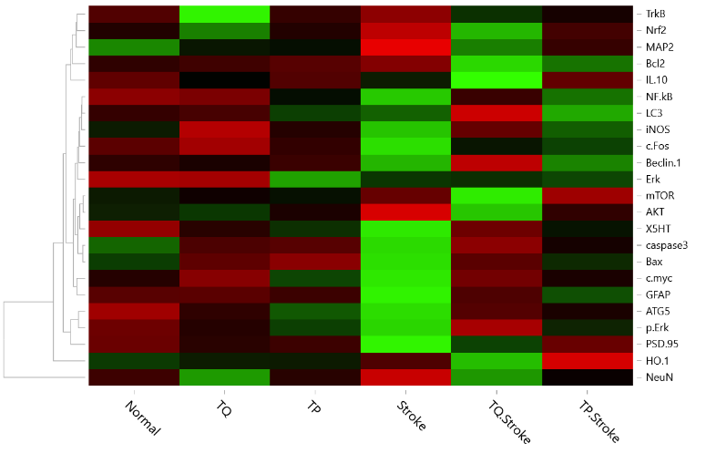
Fig. IX. Heat map of proteins expression in the experimental groups. (Green) high expression. (Red) low expression.

References:
- Gordon, J. W., Chesa, P. G., Nishimura, H., Rettig, W. J., Maccari, J. E., Endo, T., Seravalli, E., Seki, T., & Silver, J. (1987). Regulation of Thy-1 gene expression in transgenic mice. Cell, 50(3), 445–452.
- Freret T, Chazalviel L, Roussel S, Bernaudin M, Schumann-Bard P, Boulouard M. Long-term functional outcome following transient middle cerebral artery occlusion in the rat: correlation between brain damage and behavioral impairment. Behav Neurosci. 2006; 120(6):1285-98.
- Bouët, V., Freret, T., Toutain, J., Divoux, D., Boulouard, M., & Schumann-Bard, P. (2007). Sensorimotor and cognitive deficits after transient middle cerebral artery occlusion in the mouse. Experimental neurology, 203(2), 555–567.
- Abramoff MD, Magelhaes PJ, Ram SJ. Image processing with ImageJ. Biophotonics International. 2004; 11:36.
- Simon J. Bulley, Cheney J.G. Drew, and A. Jennifer Morton Direct Visualization of Abnormal Dendritic Spine Morphology in the Hippocampus of the R6/2 Transgenic Mouse Model of Huntington’s Disease. Journal of Huntington’s Disease 1 (2012) 267–273.
- Hering H, Sheng M. Dendritic spines: Structure, dynamics, and regulation. Nat Rev. Neurosci. 2001; 2:880.

- Spires TL, Grote HE, Garry S, Cordery PM, Van Dellen A, Blakemore C, Hannan AJ. Dendritic spine pathology and deficits in experience-dependent dendritic plasticity in R6/1 Huntington’s disease transgenic mice. Eur J Neurosci. 2004; 19:2799.
- Rendong H, Qiaoyu C, Zhongqing S, Jinying C, Qing Z, and Fei X (2018) A novel method of neural differentiation of PC12 cells by using Opti-MEM as a basic induction medium. Int J Mol Med 41(1): 195–201.
- Rena Q, Hu Z, Jiang Y, Tan X, Benson O A B, Amin N, Lin G, Yu G , Fang M (2019) SIRT1 Protects Against Apoptosis by Promoting Autophagy in the Oxygen Glucose Deprivation/Reperfusion-Induced Injury. Front. Neurol. 10:1289.
- Malagelada C, Greene LA (2008) PC12 Cells as a model for parkinson’s disease research. Parkinson’s Disease 375–387.
- Alhebshi AH, Gotoh M, Suzuki I (2013) Thymoquinone protects cultured rat primary neurons against amyloid induced neurotoxicity, Biochem. Biophys. Res.Commun. 433: 362–367.
- Fei Z, Weiwei H, Zhe Z, Lin M, Yangyang H, Jun Y, Ming L (2016) Triptolide induces protective autophagy through activation of the CaMKKβ-AMPK signaling pathway in prostate cancer cells. Oncotarget 7(5): 5366–5382.

