Optoelectronic and Thermoelectric Properties of High-Performance AlSb Semiconductors

Dilshod Nematov ^{a,b*}, Amondulloi Burkhonzoda^{a**}, Iskandar Raufov ª, Sherali Murodzoda ª, Saidjafar Murodzoda ª, Sakhidod Sattorzoda ª, Anushervon Ashurov ª, Makhsud Barot Islomzoda ^{c}, Kholmirzo Kholmurodov ª

ª S.U. Umarov Physical-Technical Institute of NAST, Dushanbe 734063, Tajikistan
^{b} School of Optoelectronic Engineering & CQUPT-BUL Innovation Institute, Chongqing University of Posts and Telecommunications, Chongqing 400065, China
^{c} Tajik National University, Dushanbe 734025, Tajikistan
Corresponding author’s E-mail: *dilnem@mail.ru (D. Nematov), ** amondullo.burkhonzoda@mail.ru (A. Burkhonzoda)

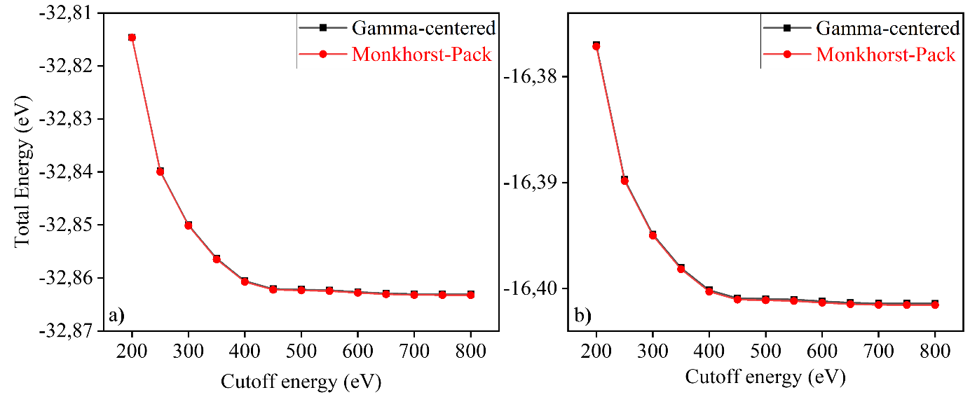
Figure S1. Convergence of total energy for (a) the cubic and (b) the hexagonal phases of AlSb as a function of plane-wave cutoff energy (ENCUT), calculated using Monkhorst-Pack (red) and Γ-centered (black) k-point sampling schemes.

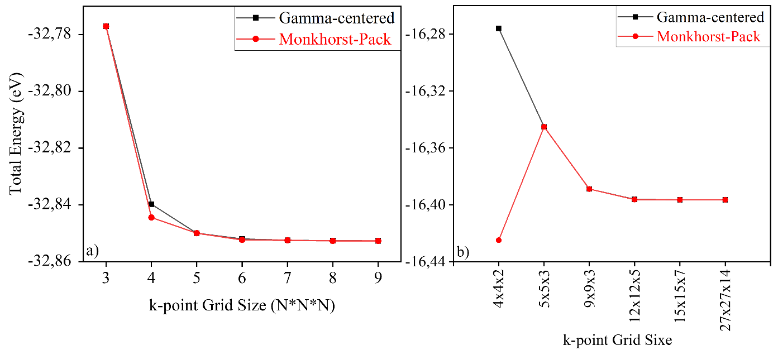
Figure S2. Convergence of the total energy for (a) the cubic and (b) the hexagonal phases of AlSb as a function of k-point mesh density, calculated using the Monkhorst-Pack (red) and Γ-centered (black) sampling schemes.

Table S1. Comparison of SCAN-calculated crystal lattice parameters of cubic and hexagonal phases of AlSb with experimental data.
AlSb | Lattice constants | SCAN | Experimental
F43m | a (Å) | 6.17 | 6.14 [37, 38]
F43m | α=β=γ , º | 90.00
F43m | V (Å³) | 235.11
P6₃mc | a (Å) | 4.35
P6₃mc | b (Å) | 3.76
P6₃mc | c (Å) | 7.17
P6₃mc | α= β≠γ, º | 90, 12
P6₃mc | V (Å³) | 117.55

