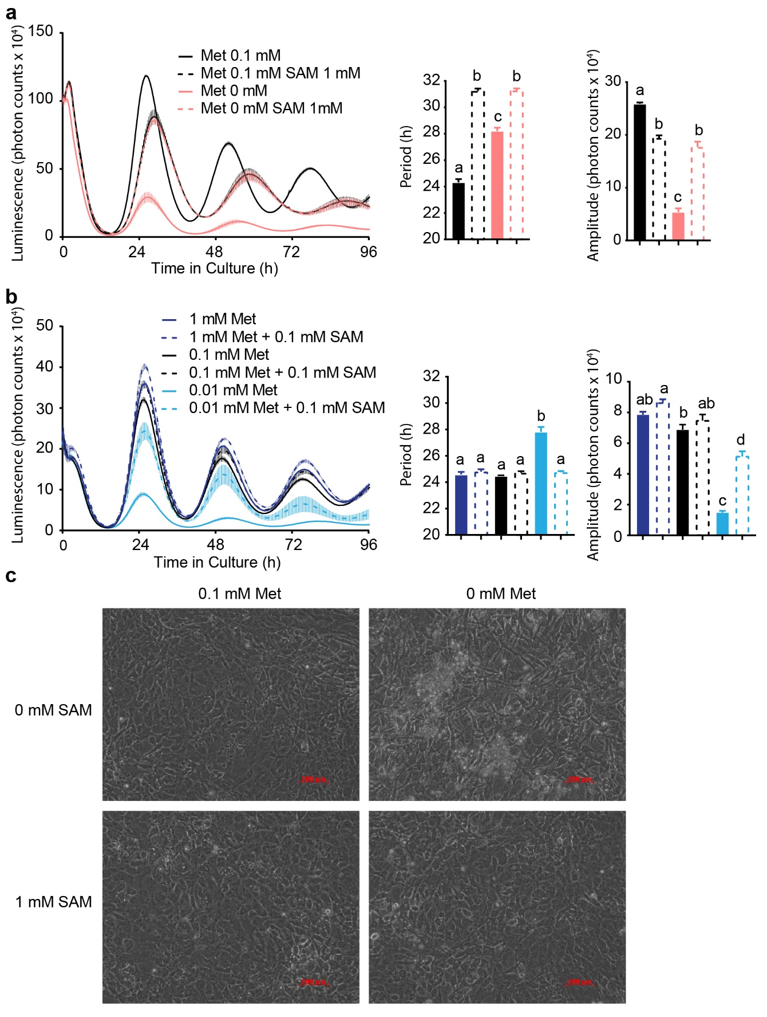
Figure S1: Exogenous SAM partially rescue cells from the lack of methionine.
a, 0.1 mM SAM rescues PER2::LUC mouse embryonic fibroblasts from the effects of 0.01 mM methionine on the period and amplitude of PER2::LUC oscillations. b, 1mM SAM overrides the effects of methionine deprivation on PER2::LUC mouse embryonic fibroblasts, clamping oscillations at a fixed period length and amplitude. C, 1mM SAM rescue cells from the lack of methionine. Notice the confluent cell population with 1 mM SAM/0 mM methionine but the less crowded cells without SAM or methionine, with clumps of dead cells. All data shown are mean +/- SEM of 4 biological replicates (culture wells). Data shown as bar graphs analysed by One-Way ANOVA followed by Bonferroni multiple comparison test, a vs. b vs. c vs. d at least p<0.01.
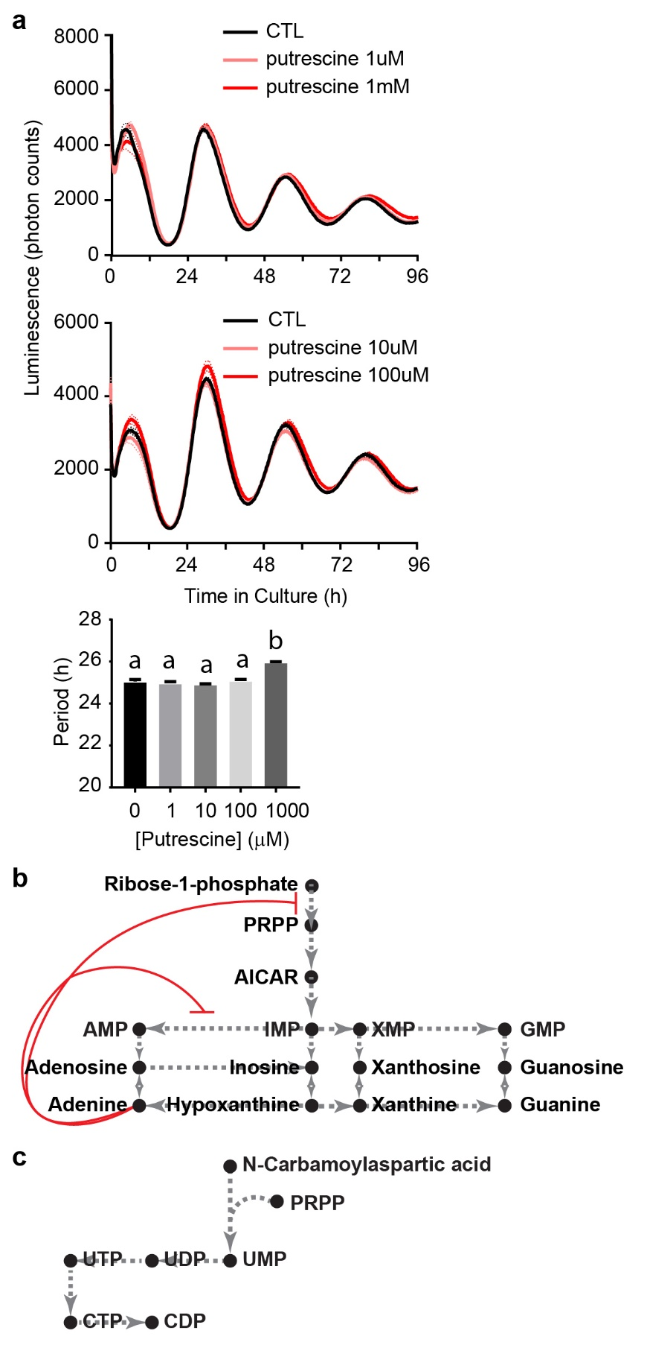
Figure S2: Putrescine does not contribute to the effects of SAM on the circadian clock, but increased adenine explains changes in other nucleotides.
a, Putrescine only causes a mild period lengthening at 1 mM. Data shown are mean +/- SEM of 3 biological replicates (culture wells). Data shown as bar graphs analysed by One-Way ANOVA followed by Bonferroni multiple comparison test, a vs. b p<0.0001. b, Simplified purine nucleotides synthesis pathway, in which excess adenine inhibits the committing step of de novo purine synthesis to phosphoribosyl pyrophosphate (PRPP) and its own branch of the pathway to AMP. c, Simplified pyrimidine nucleotides synthesis pathway, requiring PRPP.

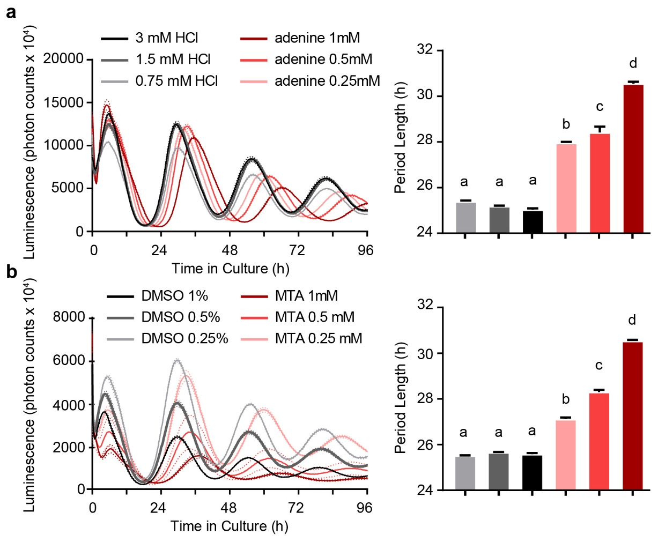
Figure S3: MTA and adenine lengthen the circadian period.
a, PER2::LUC oscillations in mouse embryonic fibroblasts treated with increasing concentration of adenine or its vehicle HCl. Period length of the oscillations is shown on the right. b, PER2::LUC oscillations in mouse embryonic fibroblasts treated with increasing concentration of MTA or its vehicle DMSO. Period length of the oscillations is shown on the right. All data show mean +/- SEM of n = 4 cell culture wells. Data shown as bar graphs analyzed by One-Way ANOVA followed by Bonferroni multiple comparison test, a vs. b vs. c vs. d at least p<0.05.
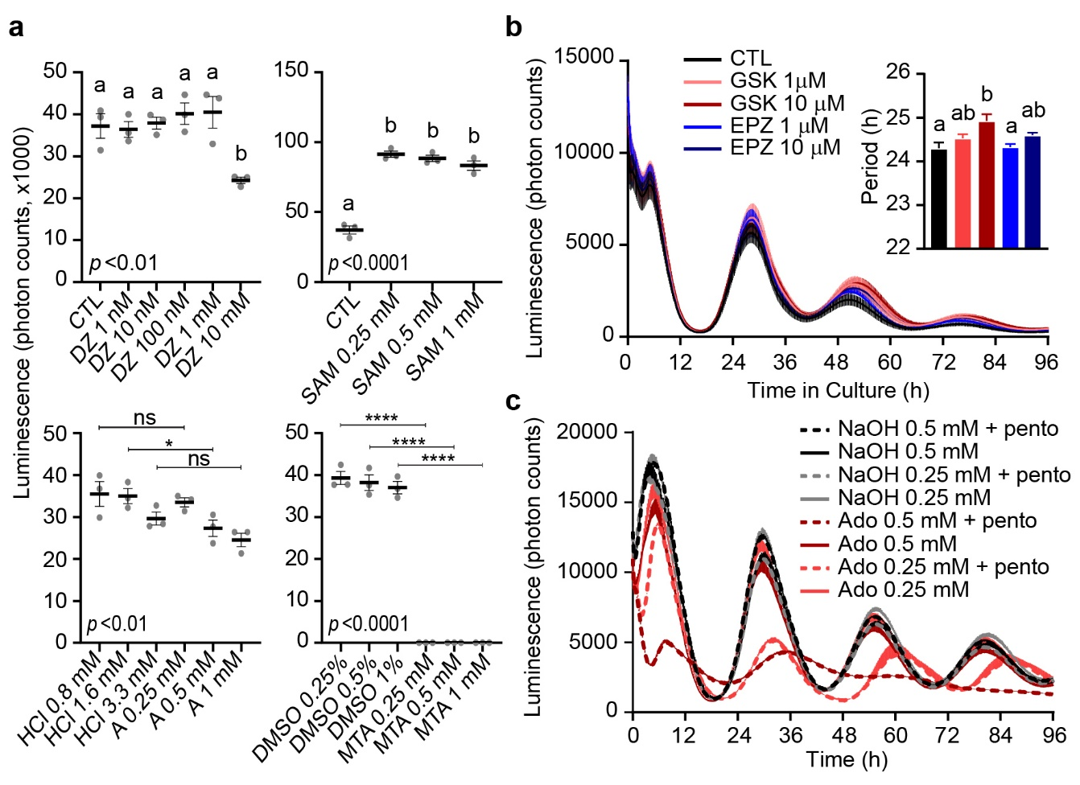
Figure S4: Effects of direct inhibition of PRMT5 and adenosine + pentostatin on the circadian period.
a, In vitro PRMT5 enzymatic assays shows that MTA is a direct PRMT5 inhibitor. Adenine and DZ did not have clear effects. SAM in contrast stimulated PRMT5 activity on the H4R3 substrate. Data show mean luminescence +/- SEM of n = 4 immunoassay wells. HCl was used as a vehicle for adenine (A), DMSO for MTA, and water for DZ and SAM. DZ and SAM treatments analyzed by One-Way ANOVA followed by Bonferroni multiple comparison test, a vs. b at least p<0.05; for adenine and MTA, only the indicated comparisons were made in Bonferroni multiple comparison test. b, Known PRMT5 specific inhibitors GSK591 and EPZ015666 only have mild effects on the circadian period in PER2::LUC mouse embryonic fibroblasts. Data show mean luminescence +/- SEM of n = 4 cell culture wells. Insert shows analysis of mean period +/- SEM by One-Way ANOVA followed by Bonferroni multiple comparison test, a vs. b at least p<0.05. c, While adenosine (Ado) and 10 μM pentostatin (Nipent®) (pento) alone have no effect on the circadian period in PER2::LUC mouse embryonic fibroblasts (mean +/- SEM: Ado 0.25 mM, 25.26 +/-0.025h; Ado 0.5 mM, 25.21 +/-0.027h; NaOH 0.25 mM, 25.30 +/-0.052h; NaOH 0.5 mM, 25.16 +/-0.03h; NaOH 0.25 mM + pento, 25.14 +/-0.025h; NaOH 0.5 mM + pento, 25.14 +/-0.015h), together they dramatically and significantly lengthen the period (Ado 0.25 mM + pento, 28.83 +/- 1.29h; Ado 0.5 mM + pento, 28.81 +/-0.081h; all comparison between other groups p<0.01 by One-Way ANOVA followed by Bonferroni multiple comparison test). Period graph is not shown. Data show mean luminescence +/- SEM of n = 3 cell culture wells. NaOH was used as a vehicle for Ado.

