Supporting Information 1
PlasticFADE: A predictive model for plastic fragmentation and degradation in the environment
Yibo Tang ª, Nadim Saadi ª, Jérôme Lavoie ^{b}, Anne-Marie Boulay *ª
Authors affiliations:
ª CIRAIG, Department of Chemical Engineering, Polytechnique Montréal, 3333 Queen Mary Road, suite 310, Montréal, Québec, H3V 1A2, Canada
^{b} CIRAIG, Department of Strategy and Corporate Social Responsibility, ESG UQAM, 3333 Queen Mary Road suite, 310, Montréal, Québec, H3V 1A2, Canada
Corresponding author: Anne-Marie Boulay (anne-marie.boulay@polymtl.ca)
Table of Contents
S1. Compiling experimental data from the literature 2
S2. Quantifying environmental stresses in experimental studies 2
S2.1. UV intensity 2
S2.2. Mechanical power 5
S2.3. Microbial concentration 7
S3. Determining environmental stresses in real-world conditions 9
S4. Selecting the more appropriate set of model equations 12
S5. Presenting supplementary results beyond the main article 17
S6. Implication for life cycle assessment 20
References 22

Compiling experimental data from the literature
Relevant articles providing experimental data on plastic fragmentation and degradation were identified in the Web of Science database using the following keywords:
TS=(rate* OR “speed” OR “mass” OR “weight” OR “mass loss” OR “weight loss” OR “number”)
AND TS=(“polypropylene” OR “polystyrene” OR “expanded polystyrene” OR “polyethylene terephthalate” OR “PET” OR “low-density polyethylene” OR “LDPE” OR “high-density polyethylene” OR “HDPE” OR “polyethylene” OR “polyvinyl chloride” OR “PVC” OR “polylactic acid” OR “PLA” OR “polyester” OR “polyamide” OR “nylon”)
AND TI=(fragment* OR degradat* OR “weathering” OR “aging” OR “breakdown” OR “break down” OR decompos* OR “abrasion” OR photooxidat* OR photodegradat* OR biodegradat* OR disintegrat* OR dissolut* OR dissociat* OR mineraliz* OR mineralis*)
Data were extracted from published studies that provided information on the polymer type, size and shape, environmental conditions, exposure time, and mass loss (or sufficient data for its calculation). To ensure the inclusion of relevant studies, the identified articles were screened with the assistance of ChatGPT. The extracted data were systematically compiled into a database and categorized according to their relevance to fragmentation or degradation (Table S1). Data classified in this way were used for model calibration, while reported values for overall, inseparable mass loss were retained for subsequent analysis.
Table S1. Classification of the collected data
Category | Data extracted from published studies
Fragmentation data | Mass loss reported separately for fragmentation (distinct from degradation)
Fragmentation data | Mass of generated micro- and nanoplastics
Fragmentation data | Quantity and average size of generated micro- and nanoplastics
Degradation data | Mass loss reported separately for degradation (distinct from fragmentation)
Degradation data | Mass loss reported in studies where the plastic sample is classified as microplastics and is not subjected to mechanical stress
Degradation data | Mass loss reported in studies where microbial activity is the sole environmental stressor, with occasional mild rotation to ensure proper mixing of the plastic sample with the inoculum

Quantifying environmental stresses in experimental studies
This section outlines the approach for quantifying the environmental stresses applied to plastic samples in the experimental studies from which data were collected. PlasticFADE considers ultraviolet (UV) radiation, mechanical abrasion, and microbial activity, quantified by UV intensity (W/m²), mechanical power (mW), and microbial concentration (CFU/mL), respectively. This approach ensures a consistent evaluation of the magnitude of each environmental stress.

UV intensity
UV radiation is a type of electromagnetic radiation with wavelengths between 100 and 400 nm. UV is further classified by wavelength into UVA (315–400 nm), UVB (280–315 nm), and UVC (100–280 nm) (Svedin, 2020). Approximately 5% of solar radiation that reaches the Earth’s surface is UV radiation, comprising approximately 95% UVA and 5% UVB. UVC and most of UVB are removed from extraterrestrial radiation by stratospheric ozone (IARC, 2012). Since UV exposure in different studies varies greatly, we propose the following approach to calculate the overall UV intensity—UVe (UV equivalent, in W/m²)—using details provided in each study. First, we define UV_{S} as the UV that reaches the Earth’s surface, so that
$${UV}_{S}=95\% UVA+5\% UVB\#\left(1\right)$$
The energy of a photon $E$ (in J), which is calculated using Planck’s equation (Eq. 2), differs between UVA and UVB. In Eq. 2, h is Planck’s constant (in J∙s), c is the speed of light (in m/s), and λ is the wavelength (in m). UVB photons possess higher energy than UVA photons due to shorter wavelengths.
$$E=\frac{hc}{λ}\#\left(2\right)$$
The percentages given in Eq. 1 are based on measurements of the intensity of UV radiation at the Earth’s surface. Intensity (in W/m²), defined as power per unit area, is identical regardless of the type of UV. Thus, we assume that UV types with the same intensity have equivalent effects on fragmentation and degradation, despite differences in energy density (Eq. 3). Thus, UVe can be determined by summing the intensities of UVA, UVB, and UVC for studies employing artificial UV.
$$1W/m^{2} UVA= 1W/m^{2} UVB =1W/m^{2} UVC=1W/m^{2} UVe\#\left(3\right)$$
In some studies, plastic samples were exposed to natural sunlight. In this case, UVe can be calculated using Eq. 4. Due to longer wavelengths, visible light (400–700 nm) and infrared (700 nm – 1 mm) have less energy than UV (i.e., < 71.5 kcal/mol), which is not sufficient to break the chemical bonds in the polymer chains (normally 80–160 kcal/mol) (Rabek, 2012). Therefore, we assume that exposure to visible light and infrared, which together account for about 95% of solar radiation, does not lead to fragmentation or degradation.
$$UVe=5\% of solar irradiance\#\left(4\right)$$
Furthermore, some studies reported UV exposure using the UV index (UVI). To derive a conversion factor (ConvF) between UVe and UVI, we compare the UV irradiance map for 2015 (BASF, n.d.) with the annual average UVI map (KNMI, 2008) (Fig. S1). In general, a UVI of 1 corresponds to an annual UV irradiance of approximately 50 MJ/m² (Fig. S2). Based on this relationship, we derive a ConvF of 1.6 W/m² (Eqs. 5 and 6). The UV exposure and UVe value for each data point are detailed in Supporting Information 2.
$$ConvF=\frac{50 MJ/m^{2}/year}{1}=\frac{50×{10}^{6}}{365×24×3600}\frac{J/m^{2}}{s}=1.585 W/m^{2}≈1.6 W/m^{2}\#\left(5\right)$$
$$UVe=UVI×ConvF=UVI×1.6 W/m^{2}\#\left(6\right)$$
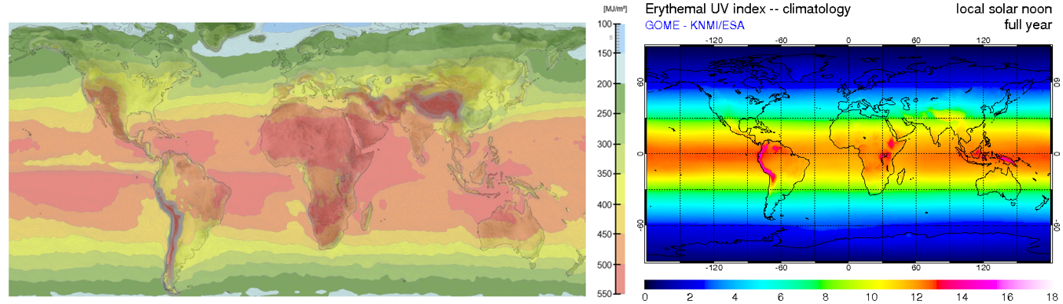
Figure S1. UV irradiance map (left; BASF, n.d.) and UV index map (right; KNMI, 2008) used to derive the ConvF between UVe and UVI
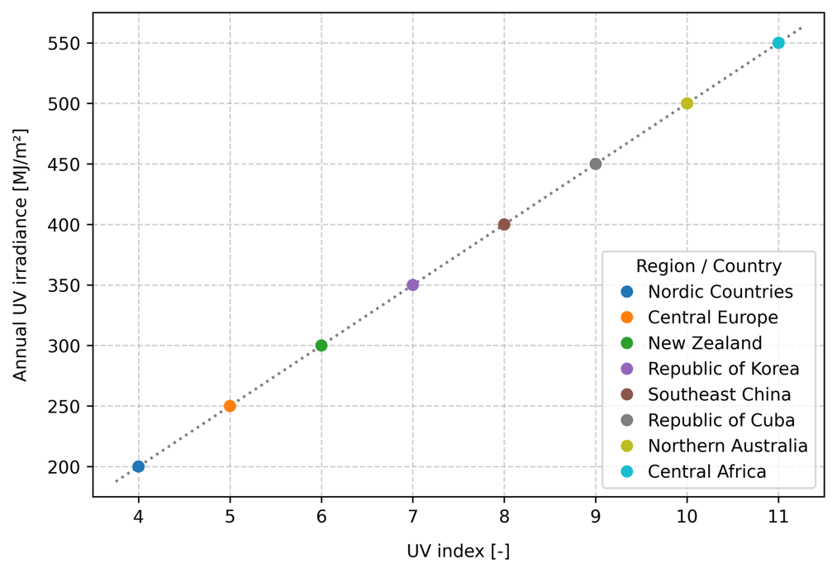
Figure S2. Empirical relationship between annual UV irradiance and UVI (based on approximate values read from Figure S1)

Mechanical power
Mechanical stress is quantified as the power acting on one plastic item, consistent with the model outputs—fragmentation and degradation rate constants—expressed as the fraction of mass loss per item per day. In experimental studies, mechanical abrasion is typically simulated by rotating containers that hold the plastic sample together with sand, water, or both (Reineccius et al., 2023; Song et al., 2023). Because of the limited availability of details on the mechanical stress applied in the experiments, several assumptions were made during the estimation of mechanical power, including parameters such as density of the sand and radius of the container. Three distinct exposure scenarios were considered, each dominated by a specific force that contributes to plastic fragmentation (Table S2).
Table S2. Exposure scenarios considered in the model
No. | Exposure scenario | Dominating force | Calculation
Scenario 1 | Plastics in contact with sand | Frictional force | $F_{F}=μF_{N}$
Scenario 2 | Flat surfaces (e.g., films )in contact with water | Shear force | $F_{S}=τA$
Scenario 3 | Microparticles (e.g., pellets) in contact with water | Drag force | $F_{D}=6πηrv$

This section provides detailed calculation examples for each scenario, including the available information, underlying assumptions, and applied equations. The relative velocity between plastics and the surrounding medium—both moving below the maximum container velocity—is a key factor for calculating mechanical power ($P=Fv$). This velocity, often referred to as slip velocity in stirred-tank systems, has been reported to reach 20–30% of the impeller tip speed (Derksen, 2003; Odeleye et al., 2014). By analogy, we assume that a similar scaling holds for rotating systems, with the container’s edge speed as the reference. On this basis, we adopt a conservative estimate of $v_{rel}=0.2{ v}_{edge}$ across all exposure scenarios. Details regarding the calculation of mechanical power for each data point are available in Supporting Information 2.
Example #1
Dominating force: frictional force; data source: (Song et al., 2017)
1) Information given in the article
Sand collected from Heungnam Beach (Korea) was pretreated prior to the experiment to remove organic matter and plastics. Ten PP pellets (volume: 19 ± 0.9 mm³) were placed in a 60 mL amber bottle with 50 g pretreated sand. The bottle was rotated on a roller mixer for 2 months at 37 rpm.
2) Assumptions made
The coefficient of friction between dry sand and PP pellets is 0.4, and the bottle has a radius of 1.5 cm. We further assume that the moving pellets remain along the inner wall of the bottle, while the sand is uniformly distributed in the bottle. The normal force acting on one pellet is governed by the fraction of sand in direct contact with its surface.
3) Calculation of mechanical power
Radius of one PP pellet: $r_{pellet}={\left(3V/4π\right)}^{1/3}×0.001 m/mm=0.00166 m$
Fraction of sand in contact with the pellet: $p_{sand}=r_{pellet}^{2}/r_{bottle}^{2}=0.0122$
Mass of sand in contact with the pellet: $m_{sand}=0.0122×50 g=0.601 g$
Normal force: $F_{N}=0.601 g×0.001 kg/g×9.81 m/s^{2}=0.0060 N$
Frictional force acting on the pellets: $F_{F}=μ×F_{N}=0.4×0.0060 N=0.0024 N$
Angular velocity: $ω=\frac{37 rpm × 2π}{60 s/min}=3.875 rad/s$
Linear velocity at the bottle’s edge: $v_{edge}=ω×r_{bottle}=3.875 rad/s×0.015 m=0.0581 m/s$
Relative velocity of the pellet: $v_{rel}=20\%×0.0581 m/s=0.0116 m/s$
Mechanical power: $P=F_{F}×v_{rel}=0.0024 N×0.0116 m/s×1000 mW/W=0.0278 mW$
Example #2
Dominating force: shear force; data source: (Song et al., 2023)
1) Information given in the article
A PP sheet (5 cm × 1.5 cm × 1 mm) was inserted into a quartz vial filled with 20 mL of pure water. After simulated sunlight exposure, 10 mL of water in the vial was removed for the analysis of fragmentation by photooxidation. Then, the PP sheet in the remaining water was exposed to vortexing for 30 seconds.
2) Assumptions made
The mixer operates at 3000 rpm; the quartz vial has a volume of 25 mL and a radius of 1 cm; the dynamic viscosity of water is 0.001 Pa·s; the effective thickness of the water layer shearing against the PP sheet is 1 mm (h = 0.001 m).
3) Calculation of mechanical power
Angular velocity: $ω=\frac{3000 rpm × 2π}{60 s/min}=314.2 rad/s$
Linear velocity at the vial’s edge: $v_{edge}=ω×r_{vial}=314.2 rad/s×0.01 m=3.142 m/s$
Relative velocity of the sheet: $v_{rel}=20\%×3.142 m/s=0.628 m/s$
Shear rate: $\dot{γ}=v/h=0.628 m/s÷0.001 m=628 s^{-1}$
Shear stress: $τ=μ×\dot{γ}=0.001 Pa∙s×628 s^{-1}=0.628 Pa$
Contact area*: $A=5 cm×1.5 cm×0.0001 {cm}^{2}/m^{2}=0.00075 m^{2}$
* Since PP is less dense than water, we consider only one side of the sheet.
Sheer force: $F_{S}=τ×A=0.628 Pa×0.00075 m^{2}=0.00047 N$
Mechanical power: $P=F_{S}×v_{rel}=0.00047 N×0.628 m/s×1000 mW/W=0.296 mW$
Example #3
Dominating force: drag force; data source: (Reineccius et al., 2023)
1) Information given in the article
55.2 PS pellets (diameter: 3.5 mm; density:1.05 g/cm³) were added to a 100 mL flask containing 20 g sand and 15 mL water. The flask was placed on a shaking plate operating at 130 rpm in circular motion to exert continuous mechanical stress to the plastic pellets, which remained at the water-sand interface throughout the experiment.
Notes: Initially, 100 pellets were added to the flask. Subsets of five pellets were retrieved for analysis after exposure durations of 1, 2, 3, 4, and 6 weeks, as well as 2, 3, 4, 6, 9, 12, and 15 months. Consequently, 40 pellets remained in the flask for the entire 18-month period. This corresponds to 55.2 pellets experiencing mechanical stress throughout the entire exposure duration (see below; all exposure periods were converted into days).
$$\frac{5×\left(7+14+21+28+42+60+90+120+180+270+360+450\right)+40×540}{540}=55.20$$
2) Assumptions made
The flask has a radius of 3 cm; the dynamic viscosity of water is 0.001 Pa·s; Stokes’ law can be applied to calculate the drag force exerted on on a small spherical particle moving slowly through a fluid.
3) Calculation of mechanical power
Angular velocity: $ω=\frac{130 rpm × 2π}{60 s/min}=13.61 rad/s$
Linear velocity at the flask’s edge: $v_{edge}=ω×r_{flask}=13.61 rad/s×0.03 m=0.408 m/s$
Relative velocity of the pellet: $v_{rel}=20\%×0.408 m/s=0.082 m/s$
Drag force: $F_{D}=6π{μr}_{pellet}v_{rel}=6π×0.001 Pa∙s×0.00175 m×0.082 m/s=2.69×{10}^{-6} N$
Mechanical power: $P=F_{D}×v_{rel}=2.69×{10}^{-6} N×0.082 m/s×1000 mW/W=0.00022 W$

Microbial concentration
The final environmental stressor addressed by the model is microbial activity. Owing to the limited number of available data points, the model does not differentiate between microbial species at this stage. Instead, it assumes that a given microbial concentration exerts a uniform effect on biodegradation. Such concentrations are typically given as colony-forming units per milliliter (CFU/mL), cell counts (e.g., cells/mL), or optical density at 600 nm (OD600). When data are available over the entire exposure period, an average value was used to more accurately represent the microbial activity throughout the exposure duration. CFU/mL is used as the standard unit for microbial concentration. Conversion factors from alternative indicators to CFU/mL are provided below. Details on microbial exposure and the corresponding CFU/mL for each data point are available in Supporting Information 2. Similar to UV intensity, the quantified microbial concentration does not depend on the number of plastic items tested in each experimental group.
1) Cells/mL to CFU/mL: 1 cell/mL = 0.8 CFU/mL
Cell count measurements typically do not differentiate between viable, senescent, and dead cells, and thus may overestimate the number of cells capable of forming colonies. Piccinini et al. (2017) reported 77.2%– 91.5% cell viabilities under minimally perturbing conditions, e.g., the transfer of cultures from an incubator to a sterile laminar flow hood at room temperature. Based on these figures, we assume that approximately 80% of cells in a healthy culture are viable, with each having the capacity to give rise to a single colony.
2) OD600 to CFU/mL: 1 OD600 = 1.77×10⁹ CFU/mL
OD600 is a common method in microbiology to estimate cell or bacterial concentrations in liquid cultures. Mira et al. (2022) calibrated polynomial equations to establish the relationship between OD600 and cell density (cells/mL) for four bacterial genera. The reported values at an OD600 of 1 are 5.04×10⁸ cells/mL for P. putida, 8.64×10⁸ for B. megaterium, 1.60×10⁹ for E. coli, and 3.42×10¹⁰ for S. epidermidis on 96-well microtiter plates. Using the geometric mean of these values, we estimate that an OD600 of 1 corresponds to approximately 2.21×10⁹ cells/mL. Assuming a cell viability of 80%, as discussed above, this equates to an estimated concentration of 1.77×10⁹ CFU/mL.

Determining environmental stresses in real-world conditions
This section introduces the determination of environmental stresses considered in the model under natural conditions. It provides default values for UV intensity and microbial concentration for the compartments considered in the model: air, topsoil, subsoil, beach, water surface, water column, and sediment. In addition, it describes the method used to estimate the mechanical power acting on a plastic object, considering its size, shape, and the compartment in which it is located. The values and equations introduced in this section are summarized in Table S3.
Table S3. Summary of real-world environmental stresses
Compartment | UV intensity | Microbial concentration | Mechanical power
Air | 10 W/m² | 0.5 CFU/mL | $P=500ρ_{air}C_{d}A{\left(f_{C}v_{wind}\right)}^{3}$ (mW)
Topsoil | 0.1 W/m² | 6.70×10⁸ CFU/mL | $P=1000μ_{topsoil}mgf_{C}v_{topsoil}$ (mW)
Subsoil | 0 W/m² | 1.21×10⁸ CFU/mL | $P=0$ (mW)
Beach | 12.5 W/m² | 1.25×10⁷ CFU/mL | $P=1000μ_{beach}mgf_{C}v_{beach}$ (mW)
Water surface | 10 W/m² | 2.5 × 10⁵ CFU/mL | $P=500ρ_{water}C_{d}A{\left(f_{C}v_{wave}\right)}^{3}$ (mW)
Water column | 0 W/m² | 3.85 × 10⁴ CFU/mL | $P=500ρ_{water}C_{d}A{\left(f_{C}v_{current}\right)}^{3}$ (mW)
Sediment | 0 W/m² | 4.82 × 10⁵ CFU/mL | $P=0$ (mW)

- UV intensity
UV intensity varies significantly by latitude, altitude, season, and atmospheric conditions. According to the UV radiation map (Fig. S1), annual UV irradiance ranges from approximately 200 MJ/m² in high-latitude regions to over 500 MJ/m² in areas such as the Middle East, Central Africa, and the Himalayas. We adopt a global average annual irradiance of 300 MJ/m², corresponding to an intensity of 9.51 W/m². Accordingly, we set the UV intensity in the air at 10 W/m², which reflects direct exposure of plastics to the atmosphere. Given that UV penetrates only several microns into the soil with substantial attenuation (Paul & Gwynn-Jones, 2003), we assume a 1% transmission rate into the topsoil, resulting in an estimated UV intensity of 0.1 W/m². Assuming a sand albedo of 25% (Chadyšienė & Girgždys, 2008), beached plastics are exposed to a total UV intensity of 12.5 W/m², comprising 10 W/m² of direct irradiance and an additional 25% from reflected radiation. For the water surface, we assume that upward-scattered UV radiation from subsurface layers offsets the absorption at the surface, resulting in a net UV intensity of 10 W/m². For the remaining compartments—soil, water column, and sediment—we assume negligible UV penetration and exclude UV exposure from the analysis.
- Microbial concentration
Microbial attachment to the plastic surface facilitates biofilm formation, which plays a crucial role in the biodegradation of plastics. Bacterial concentrations vary significantly across different environments. In the atmosphere, microbial abundances have been estimated to range from 10⁵ to 10⁶ bacteria cells per cubic meter of air (Bowers et al., 2011), with the upper bound corresponding to 1 cell/mL. Raynaud and Nunan (2014) measured and reported bacterial concentrations in samples collected from an arable soil in Scotland. For topsoil, we adopt the reported cell density for 0–30 cm depth soil samples (1.03×10⁹ cells∙g⁻¹), and for subsoil, we use the value for depths >60 cm (1.86×10⁸ cells∙g⁻¹). Assuming a soil density of 1.3 g/cm³, these values correspond to 1.34×10⁹ cells/mL for topsoil and 2.42×10⁸ cells/mL for subsoil. Among the microbial communities present on the beach, bacteria and fungi play a predominant role in plastic biodegradation. Previous studies have reported microscopic counts of bacteria greater than 1×10⁷ per gram of beach sand, while densities of culturable fungi range from 1.5×10⁶ to 7.6×10⁶ CFU/g (R. L. Whitman et al., 2014). Based on these figures, we adopt a microbial concentration of 2.5×10⁷ cells/mL for the beach. In the continental shelf and the upper 200 m of the open ocean, microbial concentrations average about 5×10⁵ cells/mL (W. B. Whitman et al., 1998). In deep waters of the North Atlantic, these concentrations were measured between 3.3×10⁴ and 1.8×10⁵ cells/mL across different sampling sites (Sogin et al., 2006); we adopt the geometric mean of 7.71×10⁴ cells/mL for the water column. The total microbial abundance in marine sediments has been estimated at 2.9×10²⁹ cells (Kallmeyer et al., 2012), with a total sediment volume of 3.01×10⁸ km³ (LaRowe et al., 2017). Based on these values, the calculated microbial concentration is 9.63×10⁵ cells/mL for the sediment. Finally, we assume a cell viability of 50% for microbes in the environment, as opposed to 80% in experimental studies. This adjustment accounts for factors that can profoundly impact cell survival, including nutrient availability, predation, and temperature fluctuations, which reduce cell viability in real-world conditions compared to controlled laboratory settings.
- Mechanical power
The mechanical power acting on a plastic object is estimated independently for each compartment using the general equation $P=Fv$, where $F$ denotes the dominant force exerted on the object and $v$ the movement speed of the object. A size-dependent correction factor, $f_{C}$, is used to estimate $v$ as a fraction of the velocity of the surrounding medium (see Supporting Information 2 for details). Due to extremely limited mobility of plastic objects in subsoil and sediment, the mechanical power in these compartments is assumed to be zero. Mechanical stress in air, water surface, and water column compartments is primarily driven by drag forces arising from wind, waves, and deep-sea currents, respectively. These forces are estimated using the drag equation from fluid dynamics (Eq. 7). In contrast, mechanical stress on the beach and in topsoil is largely attributed to friction with sand particles and is quantified using the equation of friction (Eq. 8).
$$F_{d}=\frac{1}{2}ρC_{d}Av^{2}\#\left(7\right)$$
$$F_{f}=μmg\#\left(8\right)$$
In Eq. 7, $ρ$ is the density of fluid (i.e., air or water), $C_{d}$ is the drag coefficient, which primarily depends on the shape of the plastic object, A is the reference area (i.e., the projected frontal area of the object), and $v$ is the velocity of the object. In Eq. 8, $μ$ is the coefficient of friction, $m$ is the mass of the object, and $g$ is the gravitational acceleration. The parameter values applied in Eqs. 7 and 8 within the PlasticFADE model are detailed in Table S4.

Table S4. Parameters used for mechanical power estimation
Parameter | Value | Condition/reference | Parameter | Value | Condition/reference
ρ_{air} | 1.225 kg/m³ | 15 °C, 1 atm | μ_{beach} | 0.4 | (Layfield, n.d.)
ρ_{water} | 1000 kg/m³ | ~4 °C, 1 atm | μ_{topsoil} | 0.35 | (Layfield, n.d.)
g | 9.81 m/s² | 45° latitude, sea level | v_{wind} | 5 m/s | (Archer et al., 2005)
C_{d, sphere} | 0.47 | (Hoerner, 1965) | v_{surface water} | 0.5 m/s | (Grue et al., 2012)
C_{d, cube} | 1.05 | (Hoerner, 1965) | v_{deep-sea current} | 0.04 m/s | (Purkiani et al., 2020)
C_{d, film/fiber, ⊥ flow} | 1.2 | (Filippone, n.d.) | v_{beach} | 0.02 m/s | (Cheng et al., 2015)
C_{d, film/fiber, ∥ flow} | 0.005 | (Filippone, n.d.) | v_{topsoil} | 0.001 m/s | (Hardy et al., 2017)
C_{d, irregular} | 1.5 | (Filippone, n.d.)

Selecting the more appropriate set of model equations
- Model equations
In this study, two sets of empirical equations were developed to estimate fragmentation and degradation rate constants (Set 1: Eqs. 9 and 10; Set 2: Eqs. 11 and 12). Set 1 assumes that environmental stressors contribute additively, with their effects independently scaled and subsequently summed. Set 2 employs a multiplicative formulation, in which the stressors are modeled as interacting factors, implying potential synergistic effects. To identify the more suitable set of equations for PlasticFADE, both were evaluated in terms of the goodness of fit to experimental data, the plausibility of parameter estimates, and the credibility of model outputs.
$$k_{frag,i,j}=a_{i}∙s^{δ_{i}}∙\left(b_{i}∙{I_{j}}^{α_{i}}+c_{i}∙{P_{j}}^{β_{i}}\right)\#\left(9\right)$$
$$k_{degr,i,j}=x_{i}∙s^{τ_{i}}∙\left(y_{i}∙{I_{j}}^{θ_{i}}+z_{i}∙{C_{j}}^{η_{i}}\right)\#\left(10\right)$$
$$k_{frag,i,j}=x_{i}∙s^{δ_{i}}∙{\left(I_{j}+ϵ_{I,i}\right)}^{α_{i}}∙{\left(P_{j}+ϵ_{P,i}\right)}^{β_{i}}\#\left(11\right)$$
$$k_{degr,i,j}=y_{i}∙s^{τ_{i}}∙{\left(I_{j}+ξ_{I,i}\right)}^{θ_{i}}∙{\left(C_{j}+ξ_{C,i}\right)}^{η_{i}}\#\left(12\right)$$
- Quality of the fit
To assess the goodness of fit, modeled and experimental rate constants were plotted and grouped by polymer for which fragmentation and degradation equations were calibrated (Figs. S3 and S4; UV = ultraviolet, MS = mechanical stress, MC = microbes). In addition, coefficients of determination in log-transformed space ($R_{log}^{2}$) were computed, which are shown in the panels of Figs. S3 and S4. $R_{log}^{2}$ quantifies the model’s ability to capture relative differences between observed and predicted values, which is particularly relevant when data span orders of magnitude, as is the case for rate constants ($0.9≤R_{log}^{2}≤1$: excellent fit; $0.75≤R_{log}^{2}<1$: good fit, $0.5≤R_{log}^{2}<0.75$; moderate fit). Equation Set 2 yields better fit for fragmentation than Equation Set 1, as evidenced by higher $R_{log}^{2}$ values for all three polymers. In contrast, Equation Set 1 yields a fit comparable to or better than that of Equation Set 2 for the degradation of all six polymers. These results indicate that goodness-of-fit metrics alone are insufficient for selecting the most appropriate equation set.
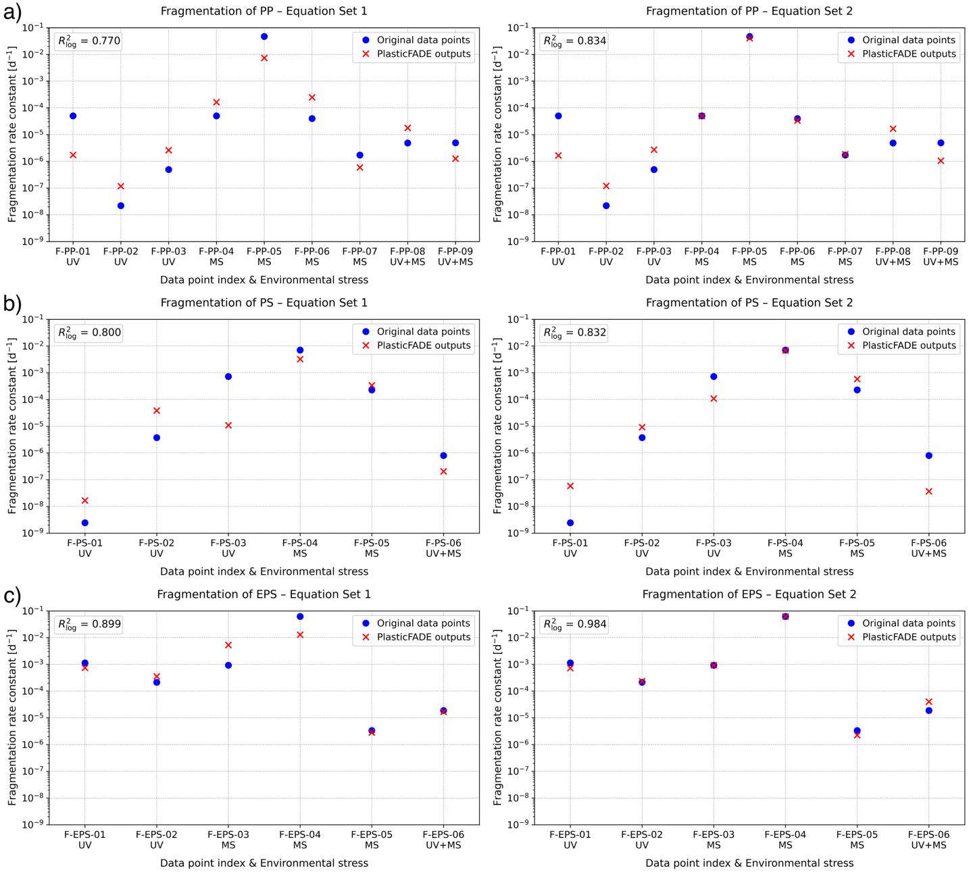
Figure S3. Comparison of experimental and modeled rate constants using different equation sets for a) PP fragmentation, b) PS fragmentation, and c) EPS fragmentation
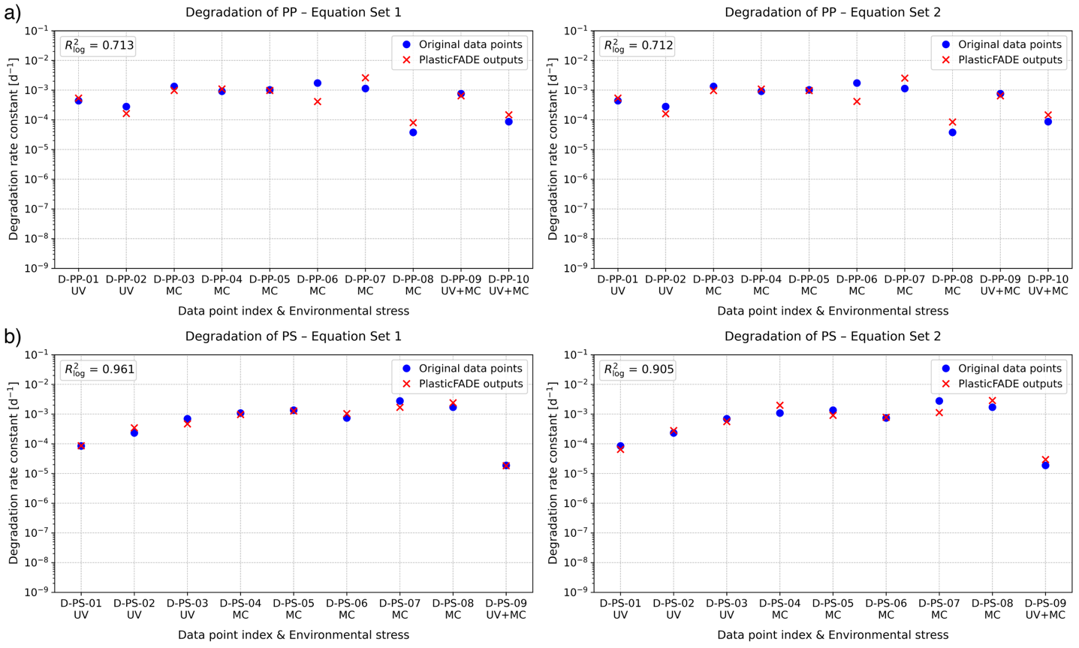
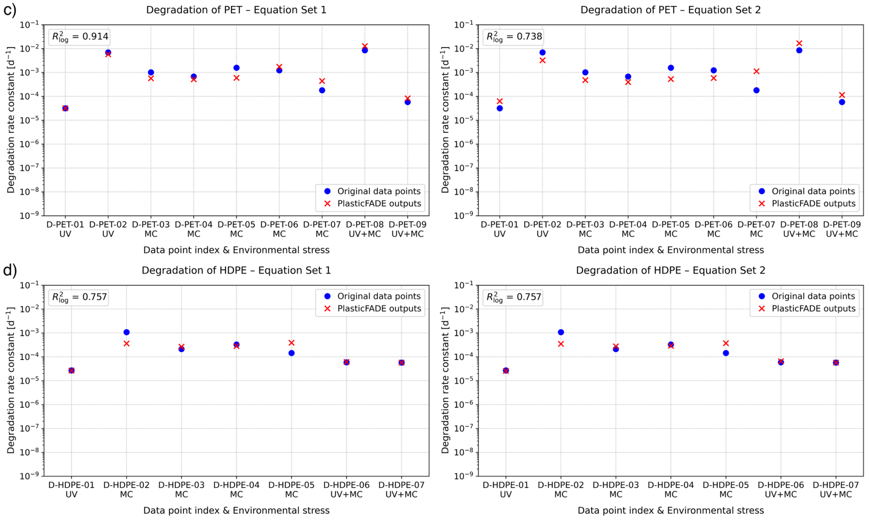
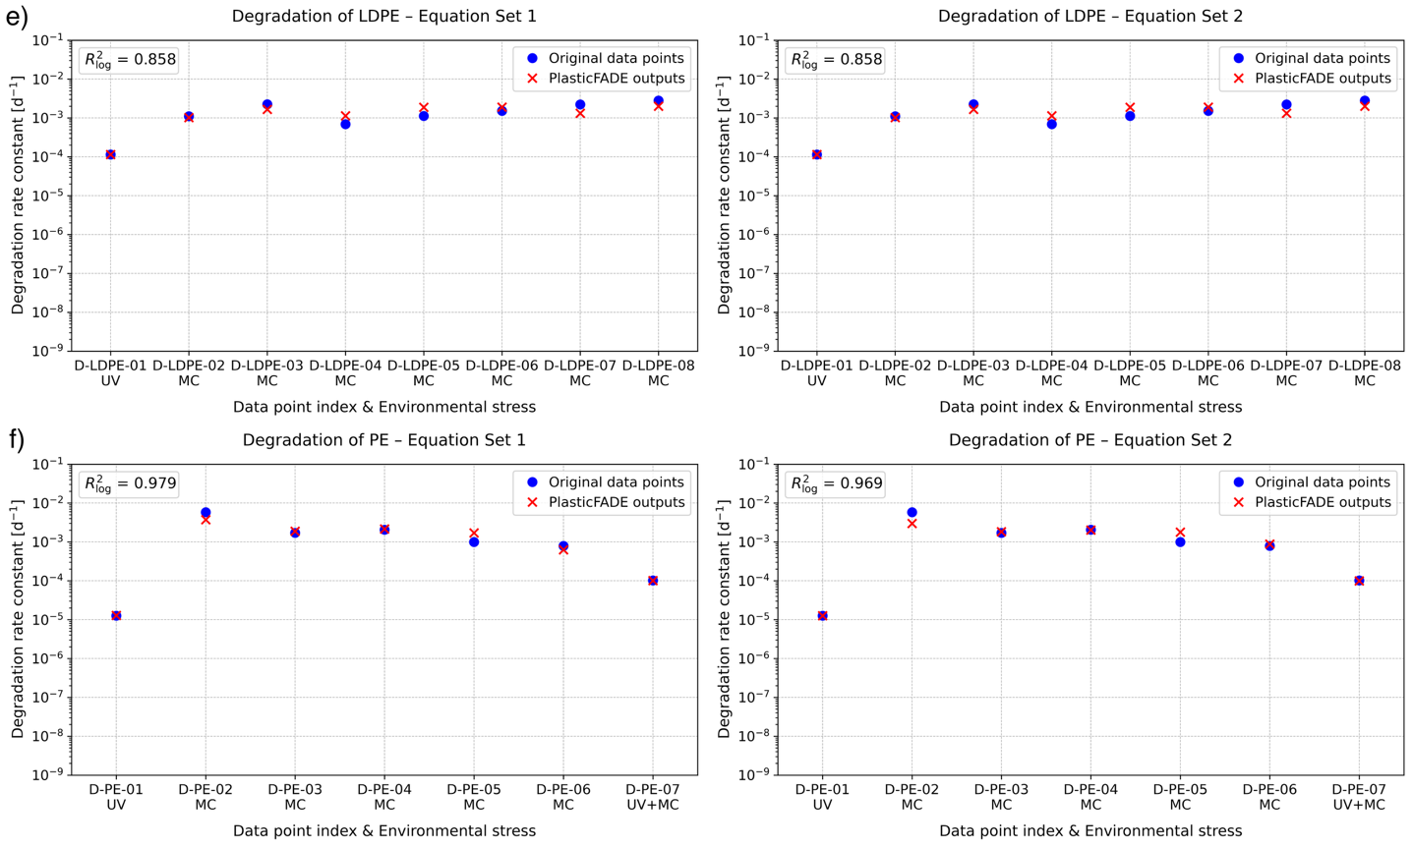
Figure S4. Comparison of experimental and modeled rate constants using different equation sets for a) PP degradation, b) PS degradation, c) PET degradation, 4) HDPE degradation, 5) LDPE degradation, and 6) PE degradation
- Plausibility of parameter estimates
The empirical constants obtained through curve fitting for the two model formulations are listed in Tables S5 and S6 (F: fragmentation, D: degradation). Parameters with estimated values ≤ 1×10-10 (highlighted in red) likely had their effects absorbed or compensated by other parameters during curve fitting. As a result, four parameter estimates in Table S5 and two in Table S6 were identified as having negligible influence on model predictions. As parameter scaling shows no substantial differences between the two equation sets, a more detailed evaluation of the model outputs is necessary to determine the preferred formulation.
Table S5. Parameter estimates obtained by curve fitting with Equation Set 1
Process & Polymer | a_i /  x_i | delta_i /  tau_i | b_i /  y_i | alpha_i /  theta_i | c_i /  z_i | beta_i /  eta_i
F–PP | 4.66E-06 | 2.26E+00 | 5.34E-04 | 5.00E-13 | 8.68E+00 | 1.44E+00
F–PS | 7.23E-03 | 3.90E+00 | 3.27E-10 | 5.50E-01 | 5.57E+01 | 4.95E+00
F–EPS | 2.90E-02 | 9.30E-12 | 1.70E-07 | 4.94E+00 | 1.99E+01 | 1.34E+00
D–PP | 5.50E-03 | 1.37E-02 | 1.72E-02 | 7.05E-01 | 1.62E-05 | 4.42E-01
D–PS | 2.73E-04 | 2.43E-01 | 1.44E-02 | 1.01E+00 | 6.23E-05 | 4.96E-01
D–PET | 2.43E-04 | 7.91E-01 | 1.33E-05 | 1.88E+00 | 1.52E-02 | 7.85E-02
D–HDPE | 1.03E-02 | 3.36E-11 | 2.18E-03 | 2.99E-01 | 3.78E-04 | 2.16E-01
D–LDPE | 1.11E-02 | 5.00E-13 | 1.03E-02 | 4.36E-03 | 1.05E-04 | 3.24E-01
D–PE | 4.72E-09 | 1.35E+00 | 3.68E-04 | 4.99E+00 | 5.33E-05 | 6.51E-01

Table S6. Parameter estimates obtained by curve fitting with Equation Set 2
Process & Polymer | x_i /  y_i | delta_i /  tau_i | eps_I_i /  xi_I_i | alpha_i /  theta_i | eps_P_i /  xi_C_i | beta_i /  eta_i
F–PP | 8.34E-03 | 2.28E+00 | 4.22E-10 | 9.49E-02 | 4.26E-03 | 2.81E+00
F–PS | 5.66E-09 | 2.52E+00 | 2.51E+02 | 3.29E+01 | 2.58E-01 | 1.38E+02
F–EPS | 6.95E-09 | 2.00E-01 | 2.77E+01 | 1.75E+01 | 9.94E-02 | 2.29E+01
D–PP | 3.91E-07 | 1.21E-02 | 1.62E-01 | 7.35E-01 | 2.52E+05 | 4.35E-01
D–PS | 3.00E-09 | 5.59E-01 | 3.03E+00 | 2.50E+00 | 2.26E+00 | 3.70E-01
D–PET | 4.39E-09 | 9.20E-02 | 1.75E+01 | 2.84E+00 | 4.66E+00 | 1.51E-01
D–HDPE | 5.12E-09 | 1.00E-10 | 2.92E+01 | 2.26E+00 | 8.42E+01 | 1.67E-01
D–LDPE | 7.09E-03 | 1.00E-10 | 3.10E-02 | 2.51E+00 | 3.00E-08 | 3.24E-01
D–PE | 2.75E-09 | 7.49E-01 | 5.47E-01 | 2.20E+00 | 2.64E-01 | 4.64E-01

- Credibility of model outputs
Despite a good quality of fit and well-scaled parameters, Equation Set 2 can lead to implausible results, as highlighted in red in Table S7. For instance, $k_{frag}$ for PS food containers on the beach is excessively high, corresponding to a $t_{macro}$ of 28 d. Moreover, nonzero fragmentation rate constants are estimated for PS in subsoil and sediment, despite the absence of UV radiation and mechanical abrasion in these compartments. In contrast, the additive structure of Equation Set 1 allows environmental stresses that are absent in a given compartment to be excluded while retaining the contributions of those that are present. This property avoids generating unrealistic predictions, as evidenced in Table S8. For these reasons, Equation Set 1 is considered more suitable for implementation in PlasticFADE.
Table S7. Rate constants and predicted lifespans calculated using Equation Set 2 (excerpt; complete results provided in the Excel sheet “EQS 2” in Supporting Information 2). The values presented here are not model results generated by PlasticFADE.
Polymer | Compartment | $k_{frag}$ [d⁻¹] | $k_{degr}$ [d⁻¹] | $t_{macro}$ [yr] | $t_{total}$ [yr]
PS | Subsoil | 6.81E-08 | 2.84E-04 | 67 – ∞ | 67 – ∞
PS | Beach | 2.35E-01 | 7.29E-03 | 0.1 | 3
PS | Sediment | 6.81E-08 | 3.68E-05 | 514 – ∞ | 515 – ∞

Presenting supplementary results beyond the main article
This section presents the complete model results for food containers generated by PlasticFADE (Table S8).
Table S8. Rate constants and predicted lifespans of food containers (height: 4 cm, diameter: 11 cm, thickness: 0.8 mm) derived using Equation Set 1. Rate constants are color-coded to indicate the level of confidence (green=high, orange=moderate, red=low). This table complements Table 3 in the main article.
Polymer | Compartment | $k_{frag}$ [d⁻¹] | 95% CI_$k_{frag}$ [d⁻¹] | $k_{degr}$ [d⁻¹] | 95% CI_$k_{degr}$ [d⁻¹] | $t_{macro}$ [yr] | $t_{total}$ [yr] | 95% CI_$t_{total}$ [yr]
PP | Air | 2.48E-05 | 1.13E-08~3.09E+00 | 5.03E-04 | 2.13E-04~3.07E-03 | 36 | 38 | 6~89
PP | Topsoil | 7.08E-06 | 7.51E-09~1.04E+00 | 7.61E-04 | 1.44E-04~6.91E-03 | 25 | 25 | 3~131
PP | Subsoil | 0 | 0 | 3.48E-04 | 6.83E-05~2.54E-03 | 54 | 54 – ∞ | 7~277 – ∞
PP | Beach | 3.17E-04 | 5.75E-08~1.55E+01 | 7.16E-04 | 3.29E-04~4.29E-03 | 18 | 26 | 4~58
PP | Water surface | 1.94E-05 | 9.59E-09~2.70E+00 | 5.26E-04 | 2.39E-04~3.21E-03 | 35 | 36 | 6~79
PP | Water column | 2.98E-10 | 7.34E-20~3.35E-03 | 9.89E-06 | 4.02E-06~3.18E-05 | 1914 | 1914 – ∞ | 595~4706 – ∞
PP | Sediment | 0 | 0 | 3.02E-05 | 9.61E-06~1.19E-04 | 626 | 626 – ∞ | 159~1969 – ∞
PS | Air | 2.57E-06 | 2.50E-06~2.64E-06 | 8.82E-05 | 4.67E-05~2.11E-04 | 208 | 214 | 90~405
PS | Topsoil | 1.91E-07 | 1.86E-07~1.97E-07 | 8.91E-04 | 1.05E-04~1.42E-02 | 21 | 21 | 1~180
PS | Subsoil | 0 | 0 | 3.81E-04 | 5.23E-05~4.54E-03 | 50 | 50 – ∞ | 4~362 – ∞
PS | Beach | 1.79E-03 | 1.73E-03~1.84E-03 | 2.34E-04 | 1.07E-04~1.19E-03 | 9 | 81 | 16~177
PS | Water surface | 2.46E-06 | 2.40E-06~2.53E-06 | 1.06E-04 | 6.10E-05~2.59E-04 | 175 | 179 | 73~310
PS | Water column | 3.22E-24 | 3.01E-24~3.44E-24 | 7.01E-06 | 2.34E-06~2.99E-05 | 2698 | 2698 – ∞ | 632~8081 – ∞
PS | Sediment | 0 | 0 | 2.46E-05 | 6.07E-06~1.36E-04 | 770 | 770 – ∞ | 139~3120 – ∞
EPS | Air | 7.80E-04 | 7.37E-06~7.81E-03 | N/A | N/A | N/A | N/A | N/A
EPS | Topsoil | 6.47E-05 | 1.04E-07~2.75E-03 | N/A | N/A | N/A | N/A | N/A
EPS | Subsoil | 0 | 0 | N/A | N/A | N/A | N/A | N/A
EPS | Beach | 5.65E-03 | 3.17E-04~3.25E-02 | N/A | N/A | N/A | N/A | N/A
EPS | Water surface | 6.97E-04 | 5.74E-06~6.80E-03 | N/A | N/A | N/A | N/A | N/A
EPS | Water column | 1.00E-08 | 2.93E-14~1.33E-05 | N/A | N/A | N/A | N/A | N/A
EPS | Sediment | 0 | 0 | N/A | N/A | N/A | N/A | N/A
PET | Air | N/A | N/A | 4.78E-05 | 2.17E-05~1.77E-04 | N/A | 396 | 107~873
PET | Topsoil | N/A | N/A | 2.33E-04 | 1.03E-04~7.74E-04 | N/A | 81 | 24~184
PET | Subsoil | N/A | N/A | 2.03E-04 | 9.02E-05~6.84E-04 | N/A | 93 – ∞ | 28~210 – ∞
PET | Beach | N/A | N/A | 1.75E-04 | 7.88E-05~6.00E-04 | N/A | 108 | 32~240
PET | Water surface | N/A | N/A | 1.28E-04 | 5.80E-05~4.26E-04 | N/A | 147 | 44~326
PET | Water column | N/A | N/A | 1.08E-04 | 4.77E-05~3.33E-04 | N/A | 175 – ∞ | 57~397 – ∞
PET | Sediment | N/A | N/A | 1.32E-04 | 5.95E-05~4.35E-04 | N/A | 144 – ∞ | 44~318 – ∞
HDPE | Air | N/A | N/A | 4.79E-05 | 3.14E-05~1.85E-04 | N/A | 395 | 102~602
HDPE | Topsoil | N/A | N/A | 3.27E-04 | 9.81E-05~1.96E-03 | N/A | 58 | 10~193
HDPE | Subsoil | N/A | N/A | 2.18E-04 | 6.73E-05~1.11E-03 | N/A | 87 – ∞ | 17~281 – ∞
HDPE | Beach | N/A | N/A | 1.81E-04 | 9.19E-05~6.57E-04 | N/A | 105 | 29~206
HDPE | Water surface | N/A | N/A | 1.02E-04 | 6.40E-05~2.99E-04 | N/A | 186 | 63~296
HDPE | Water column | N/A | N/A | 3.81E-05 | 1.99E-05~9.91E-05 | N/A | 496 – ∞ | 191~951 – ∞
HDPE | Sediment | N/A | N/A | 6.59E-05 | 2.88E-05~2.01E-04 | N/A | 287 – ∞ | 94~657 – ∞
LDPE | Air | N/A | N/A | 1.16E-04 | 1.14E-04~1.18E-04 | N/A | 163 | 160~166
LDPE | Topsoil | N/A | N/A | 9.52E-04 | 2.17E-04~1.82E-02 | N/A | 20 | 1~87
LDPE | Subsoil | N/A | N/A | 4.82E-04 | 7.14E-05~7.44E-03 | N/A | 39 – ∞ | 3~265 – ∞
LDPE | Beach | N/A | N/A | 3.46E-04 | 1.59E-04~2.58E-03 | N/A | 55 | 7~119
LDPE | Water surface | N/A | N/A | 1.80E-04 | 1.33E-04~5.18E-04 | N/A | 105 | 37~142
LDPE | Water column | N/A | N/A | 3.54E-05 | 1.24E-05~1.77E-04 | N/A | 534 – ∞ | 107~1532 – ∞
LDPE | Sediment | N/A | N/A | 8.04E-05 | 2.10E-05~5.27E-04 | N/A | 235 – ∞ | 36~901 – ∞
PE | Air | N/A | N/A | 1.30E-05 | 1.30E-05~1.30E-05 | N/A | 1457 | 1457~1457
PE | Topsoil | N/A | N/A | 1.07E-05 | 1.07E-05~1.07E-05 | N/A | 1769 | 1769~1769
PE | Subsoil | N/A | N/A | 3.51E-06 | 3.51E-06~3.51E-06 | N/A | 5389 – ∞ | 5388~5389 – ∞
PE | Beach | N/A | N/A | 4.03E-05 | 4.03E-05~4.03E-05 | N/A | 469 | 469~469
PE | Water surface | N/A | N/A | 1.30E-05 | 1.30E-05~1.30E-05 | N/A | 1450 | 1450~1450
PE | Water column | N/A | N/A | 1.86E-08 | 1.86E-08~1.86E-08 | N/A | 1.0×10⁶ – ∞ | 1.0×10⁶~1.0×10⁶ – ∞
PE | Sediment | N/A | N/A | 9.63E-08 | 9.63E-08~9.63E-08 | N/A | 2.0×10⁵ – ∞ | 2.0×10⁵~2.0×10⁵ – ∞

Implication for life cycle assessment
Degradation and fragmentation occur simultaneously on macroplastics. To determine the amount of microplastics generated due to the fragmentation of macroplastics (while accounting for the mass loss of macroplastics via degradation occurring simultaneously), the mass balances presented in table 2 of the main text were solved for microplastics generated (ignoring their degradation, as it is considered in the characterization factors of microplastics). Table S9 presents the equations used and derived.
Table S9. Mathematical representation of mass balance to estimate microplastics generation.
Model components | Macroplastic emission
Mass balance (Differential) | $$\frac{dm_{A}}{dt}=-(k_{frag}+k_{degr})m_{A}$$  $\frac{dm_{B}}{dt}=+k_{frag}m_{A}$ (degradation neglected, only generation considered)
$$m_{A}$$ | $$m_{0}e^{-\left(k_{frag}+k_{degr}\right)t}$$
$$m_{B}$$ | $$m_{0}k_{frag}(\frac{1}{k_{frag}+k_{deg}}-\frac{e^{-(k_{frag}+k_{deg})t}}{k_{frag}+k_{deg}})$$
$m_{B}$(t=inf) | $$m_{0}(\frac{k_{frag}}{k_{frag}+k_{deg}})$$
Here, $m_{B}$ represents the total mass of microplastics generated via fragmentation of macroplastics, after time t. The equation was applied to PP and PS, for which both degradation and fragmentation empirical constants are available, using compartment-specific degradation and fragmentation rates, for two different SA:V ratios: 25 cm⁻¹ (assumed as representative of a rigid plastic, thickness: 0.8 mm) and 500 cm⁻¹ (assumed as representative of a flexible plastic, thickness: 0.04 mm). The mass of microplastics generated after a specific time horizon can be used as an input for inventory of microplastics emission in LCA. The characterization factors (CFs) of microplastics used in LCA account for their fate, which includes their degradation rates. In Table S10, microplastics (MiP) generation over different time horizons are shown, which can be used as a preliminary estimate in LCA studies quantifying an inventory of secondary microplastics emissions and their impacts. The results suggest that flexible (i.e., thin) plastics tend to reach high fragmentation percentages: 80 to 100% of the initial macroplastic mass fragments (the rest being degraded directly from the macroplastic). For rigid (i.e., thicker) plastics, high fragmentation percentages of 30% (PP) and 80% (PS) are reached only on the beach, where UV intensity is the highest, and in other compartments, only 0 to 5% fragmentation is achieved. For both rigid and flexible plastics, values are highly uncertain in sediments and subsoil, where neither UV radiation nor mechanical stress is present. As a result, fragmentation is not expected to occur, and PS and PP, which lack known degrading enzymes in the environment, also exhibit negligible degradation. Thus, both fragmentation and degradation rates are null, making it impossible to estimate a fragmentation percentage other than 0 in these compartments. Yet, it is expected that plastics reach these compartments after redistributing from other compartments where fragmentation would have started (e.g. in water surface, before reaching water column and sediments). To obtain a better understanding of microplastics generation from macroplastics, a complete fate model for macroplastics would be necessary to estimate the fate of macroplastics in the different environmental compartments where fragmentation occurs at different rates.
Table S10. Fragmentation percentages for “flexible” and “rigid” macroplastics, PS and PP, in all environmental compartments, after 100, 500, 1000 yrs and infinity. Rate constants are color-coded to indicate the level of confidence (green=high, orange=moderate, red=low). Fragmentation percentages with low confidence are shown in red
Rigid | Polymer | Compartment | SA:V [cm⁻¹] | $k_{frag}$ [d⁻¹] | $k_{degr}$ [d⁻¹] | MiP generated ( 100 yrs) | MiP generated (500 yrs) | MiP generated (1000 yrs) | MiP generated (inf)
Rigid | PP | Air | 25 | 2.48E-05 | 5.03E-04 | 4.70% | 4.70% | 4.70% | 4.70%
Rigid | PP | Topsoil | 25 | 7.08E-06 | 7.61E-04 | 0.92% | 0.92% | 0.92% | 0.92%
Rigid | PP | Subsoil | 25 | 0 | 3.48E-04 | 0.00% | 0.00% | 0.00% | 0.00%
Rigid | PP | Beach | 25 | 3.17E-04 | 7.16E-04 | 30.70% | 30.70% | 30.70% | 30.70%
Rigid | PP | Water surface | 25 | 1.94E-05 | 5.26E-04 | 3.57% | 3.57% | 3.57% | 3.57%
Rigid | PP | Water column | 25 | 2.98E-10 | 9.89E-06 | 0.00% | 0.01% | 0.01% | 0.00%
Rigid | PP | Sediment | 25 | 0 | 3.02E-05 | 0.00% | 0.00% | 0.00% | 0.00%
Rigid | PS | Air | 25 | 2.57E-06 | 8.82E-05 | 2.73% | 2.83% | 2.83% | 2.83%
Rigid | PS | Topsoil | 25 | 1.91E-07 | 8.91E-04 | 0.02% | 0.02% | 0.02% | 0.02%
Rigid | PS | Subsoil | 25 | 0 | 3.81E-04 | 0.00% | 0.00% | 0.00% | 0.00%
Rigid | PS | Beach | 25 | 1.79E-03 | 2.34E-04 | 88.42% | 88.42% | 88.42% | 88.42%
Rigid | PS | Water surface | 25 | 2.46E-06 | 1.06E-04 | 2.23% | 2.27% | 2.27% | 2.27%
Rigid | PS | Water column | 25 | 3.22E-24 | 7.01E-06 | 0.00% | 0.00% | 0.00% | 0.00%
Rigid | PS | Sediment | 25 | 0 | 2.46E-05 | 0.00% | 0.00% | 0.00% | 0.00%
Flexible | PP | Air | 500 | 2.16E-02 | 5.24E-04 | 97.63% | 97.63% | 97.63% | 97.63%
Flexible | PP | Topsoil | 500 | 3.71E-03 | 7.93E-04 | 82.40% | 82.40% | 82.40% | 82.40%
Flexible | PP | Subsoil | 500 | 0 | 3.62E-04 | 0.00% | 0.00% | 0.00% | 0.00%
Flexible | PP | Beach | 500 | 5.66E-02 | 7.46E-04 | 98.70% | 98.70% | 98.70% | 98.70%
Flexible | PP | Water surface | 500 | 1.69E-02 | 5.48E-04 | 96.86% | 96.86% | 96.86% | 96.86%
Flexible | PP | Water column | 500 | 2.59E-07 | 1.03E-05 | 0.78% | 2.09% | 2.40% | 2.45%
Flexible | PP | Sediment | 500 | 0 | 3.15E-05 | 0.00% | 0.00% | 0.00% | 0.00%
Flexible | PS | Air | 500 | 3.08E-01 | 1.83E-04 | 99.94% | 99.94% | 99.94% | 99.94%
Flexible | PS | Topsoil | 500 | 2.29E-02 | 1.85E-03 | 92.54% | 92.54% | 92.54% | 92.54%
Flexible | PS | Subsoil | 500 | 0 | 7.89E-04 | 0.00% | 0.00% | 0.00% | 0.00%
Flexible | PS | Beach | 500 | 1.11E+00 | 4.85E-04 | 99.96% | 99.96% | 99.96% | 99.96%
Flexible | PS | Water surface | 500 | 2.96E-01 | 2.20E-04 | 99.93% | 99.93% | 99.93% | 99.93%
Flexible | PS | Water column | 500 | 3.87E-19 | 1.45E-05 | 0.00% | 0.00% | 0.00% | 0.00%
Flexible | PS | Sediment | 500 | 0 | 5.09E-05 | 0.00% | 0.00% | 0.00% | 0.00%

References
Archer, C. L., & Jacobson, M. Z. (2005). Evaluation of global wind power. Journal of Geophysical Research: Atmospheres, 110(D12), 2004JD005462. https://doi.org/10.1029/2004JD005462
BASF. (n.d.). Solar UV radiation as a major factor in the premature degradation of plastics in outdoor applications. BASF SE, Ludwigshafen, Germany.
Bowers, R. M., McLetchie, S., Knight, R., & Fierer, N. (2011). Spatial variability in airborne bacterial communities across land-use types and their relationship to the bacterial communities of potential source environments. The ISME Journal, 5(4), 601–612. https://doi.org/10.1038/ismej.2010.167
Chadyšienė, R., & Girgždys, A. (2008). Ultraviolet radiation albedo of natural surfaces. Journal of Environmental Engineering and Landscape Management, 16(2), 83–88. https://doi.org/10.3846/1648-6897.2008.16.83-88
Cheng, H., Liu, C., Zou, X., Li, J., He, J., Liu, B., Wu, Y., Kang, L., & Fang, Y. (2015). Aeolian creeping mass of different grain sizes over sand beds of varying length. Journal of Geophysical Research: Earth Surface, 120(7), 1404–1417. https://doi.org/10.1002/2014JF003367
Derksen, J. J. (2003). Numerical simulation of solids suspension in a stirred tank. AIChE Journal, 49(11), 2700–2714. https://doi.org/10.1002/aic.690491104
Filippone, A. (n.d.). Aerodynamic Database: Drag Coefficients. Retrieved September 16, 2025, from https://web.archive.org/web/20070715171817/http://aerodyn.org/Drag/tables.html
Grue, J., & Jensen, A. (2012). Orbital velocity and breaking in steep random gravity waves. Journal of Geophysical Research: Oceans, 117(C7), 2012JC008024. https://doi.org/10.1029/2012JC008024
Hardy, R. A., James, M. R., Pates, J. M., & Quinton, J. N. (2017). Using real time particle tracking to understand soil particle movements during rainfall events. CATENA, 150, 32–38. https://doi.org/10.1016/j.catena.2016.11.005
Hoerner, S. F. (1965). Fluid-Dynamic Drag. Hoerner Fluid Dynamics, Bakersfield, USA.
IARC. (2012). Solar and ultraviolet radiation. In A review of human carcinogens. Part D: Radiation.
Kallmeyer, J., Pockalny, R., Adhikari, R. R., Smith, D. C., & D’Hondt, S. (2012). Global distribution of microbial abundance and biomass in subseafloor sediment. Proceedings of the National Academy of Sciences, 109(40), 16213–16216. https://doi.org/10.1073/pnas.1203849109
KNMI. (2008). Solar noon UV Index average for 1996-2002, based on GOME spectrometer data from ESA’s ERS-2 satellite [Map]. Royal Netherlands Meteorological Institute.
LaRowe, D. E., Burwicz, E., Arndt, S., Dale, A. W., & Amend, J. P. (2017). Temperature and volume of global marine sediments. Geology, 45(3), 275–278. https://doi.org/10.1130/G38601.1
Layfield. (n.d.). Geomembrane Interface Friction: Technical paper. Layfield Geosynthetics. https://www.layfieldgroup.com/wp-content/uploads/2023/06/Geomembrane-Interface-Friction.pdf
Mira, P., Yeh, P., & Hall, B. G. (2022). Estimating microbial population data from optical density. PLOS ONE, 17(10), e0276040. https://doi.org/10.1371/journal.pone.0276040
Odeleye, A. O. O., Marsh, D. T. J., Osborne, M. D., Lye, G. J., & Micheletti, M. (2014). On the fluid dynamics of a laboratory scale single-use stirred bioreactor. Chemical Engineering Science, 111, 299–312. https://doi.org/10.1016/j.ces.2014.02.032
Paul, N. D., & Gwynn-Jones, D. (2003). Ecological roles of solar UV radiation: Towards an integrated approach. Trends in Ecology & Evolution, 18(1), 48–55. https://doi.org/10.1016/S0169-5347(02)00014-9
Piccinini, F., Tesei, A., Arienti, C., & Bevilacqua, A. (2017). Cell Counting and Viability Assessment of 2D and 3D Cell Cultures: Expected Reliability of the Trypan Blue Assay. Biological Procedures Online, 19(1), 8. https://doi.org/10.1186/s12575-017-0056-3
Purkiani, K., Paul, A., Vink, A., Walter, M., Schulz, M., & Haeckel, M. (2020). Evidence of eddy-related deep-ocean current variability in the northeast tropical Pacific Ocean induced by remote gap winds. Biogeosciences, 17(24), 6527–6544. https://doi.org/10.5194/bg-17-6527-2020
Rabek, J. F. (2012). Photodegradation of polymers: Physical characteristics and applications. Springer Berlin, Heidelberg. https://doi.org/10.1007/978-3-642-80090-0
Raynaud, X., & Nunan, N. (2014). Spatial Ecology of Bacteria at the Microscale in Soil. PLoS ONE, 9(1), e87217. https://doi.org/10.1371/journal.pone.0087217
Reineccius, J., Schönke, M., & Waniek, J. J. (2023). Abiotic Long-Term Simulation of Microplastic Weathering Pathways under Different Aqueous Conditions. Environmental Science & Technology, 57(2), 963–975. https://doi.org/10.1021/acs.est.2c05746
Sogin, M. L., Morrison, H. G., Huber, J. A., Welch, D. M., Huse, S. M., Neal, P. R., Arrieta, J. M., & Herndl, G. J. (2006). Microbial diversity in the deep sea and the underexplored “rare biosphere.” Proceedings of the National Academy of Sciences, 103(32), 12115–12120. https://doi.org/10.1073/pnas.0605127103
Song, Y. K., Hong, S. H., Eo, S., & Shim, W. J. (2023). Fragmentation of nano- and microplastics from virgin- and additive-containing polypropylene by accelerated photooxidation. Environmental Pollution, 327, 121590. https://doi.org/10.1016/j.envpol.2023.121590
Song, Y. K., Hong, S. H., Jang, M., Han, G. M., Jung, S. W., & Shim, W. J. (2017). Combined Effects of UV Exposure Duration and Mechanical Abrasion on Microplastic Fragmentation by Polymer Type. Environmental Science & Technology, 51(8), 4368–4376. https://doi.org/10.1021/acs.est.6b06155
Svedin, J. (2020). Photodegradation of macroplastics to microplastics: A laboratory study on common litter found in urban areas [Master’s Thesis]. Luleå University of Technology.
Whitman, R. L., Harwood, V. J., Edge, T. A., Nevers, M. B., Byappanahalli, M., Vijayavel, K., Brandão, J., Sadowsky, M. J., Alm, E. W., Crowe, A., Ferguson, D., Ge, Z., Halliday, E., Kinzelman, J., Kleinheinz, G., Przybyla-Kelly, K., Staley, C., Staley, Z., & Solo-Gabriele, H. M. (2014). Microbes in beach sands: Integrating environment, ecology and public health. Reviews in Environmental Science and Bio/Technology, 13(3), 329–368. https://doi.org/10.1007/s11157-014-9340-8
Whitman, W. B., Coleman, D. C., & Wiebe, W. J. (1998). Prokaryotes: The unseen majority. Proceedings of the National Academy of Sciences, 95(12), 6578–6583. https://doi.org/10.1073/pnas.95.12.6578

