Supplementary Raw Gels
This file contains original, uncropped gel images corresponding to Figures 2A, 2B, 2C, and 2D in the main manuscript ID: 4338757c-aaa5-4edf-a22e-9e6c894279b2.

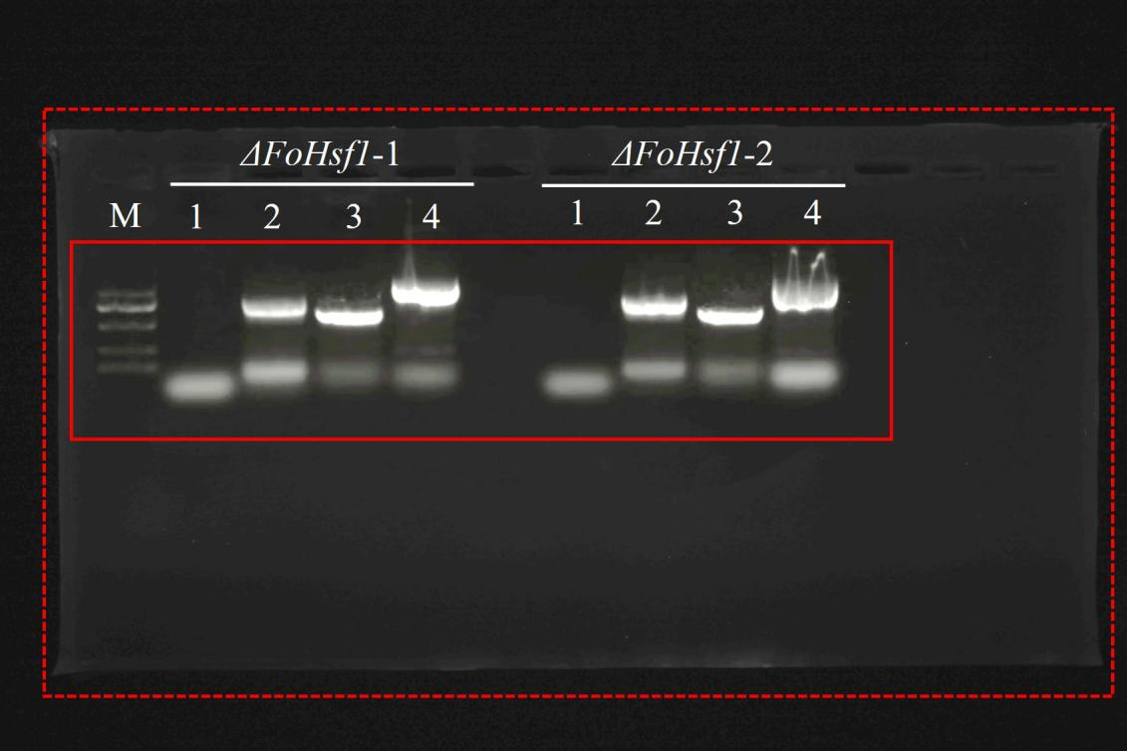
Original, uncropped gel images corresponding to Fig. 2A. Membrane boundary is outlined by a red dashed box, and the cropped region used in Fig. 2A is indicated by a red solid box. PCR validation of two independent ΔFoHsf1 knockout mutants (ΔFoHsf1-1 and ΔFoHsf1-2). M, DNA Marker DL2000. Four primer pairs were used to confirm correct gene replacement: (1) target gene primers (I-F/I-R), confirming loss of the wild‑type allele; (2) hygromycin resistance cassette primers (Hy‑F/Yg‑R), confirming integration of the hph marker; (3) upstream junction primers (UH‑F/UH‑R), verifying fusion of the 5′ flank with hph; and (4) downstream junction primers (DY‑F/DY‑R), verifying fusion of the 3′ flank with hph.

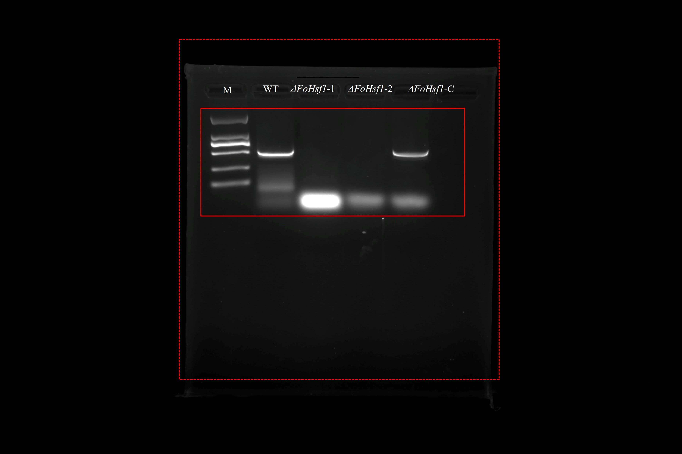
Original, uncropped gel images corresponding to Fig. 2B. Membrane boundary is outlined by a red dashed box, and the cropped region used in Fig. 2B is indicated by a red solid box. PCR analysis of WT, ΔFoHsf1, and ΔFoHsf1‑C isolates using target gene primers (I-F/I-R). M, DNA Marker DL2000.

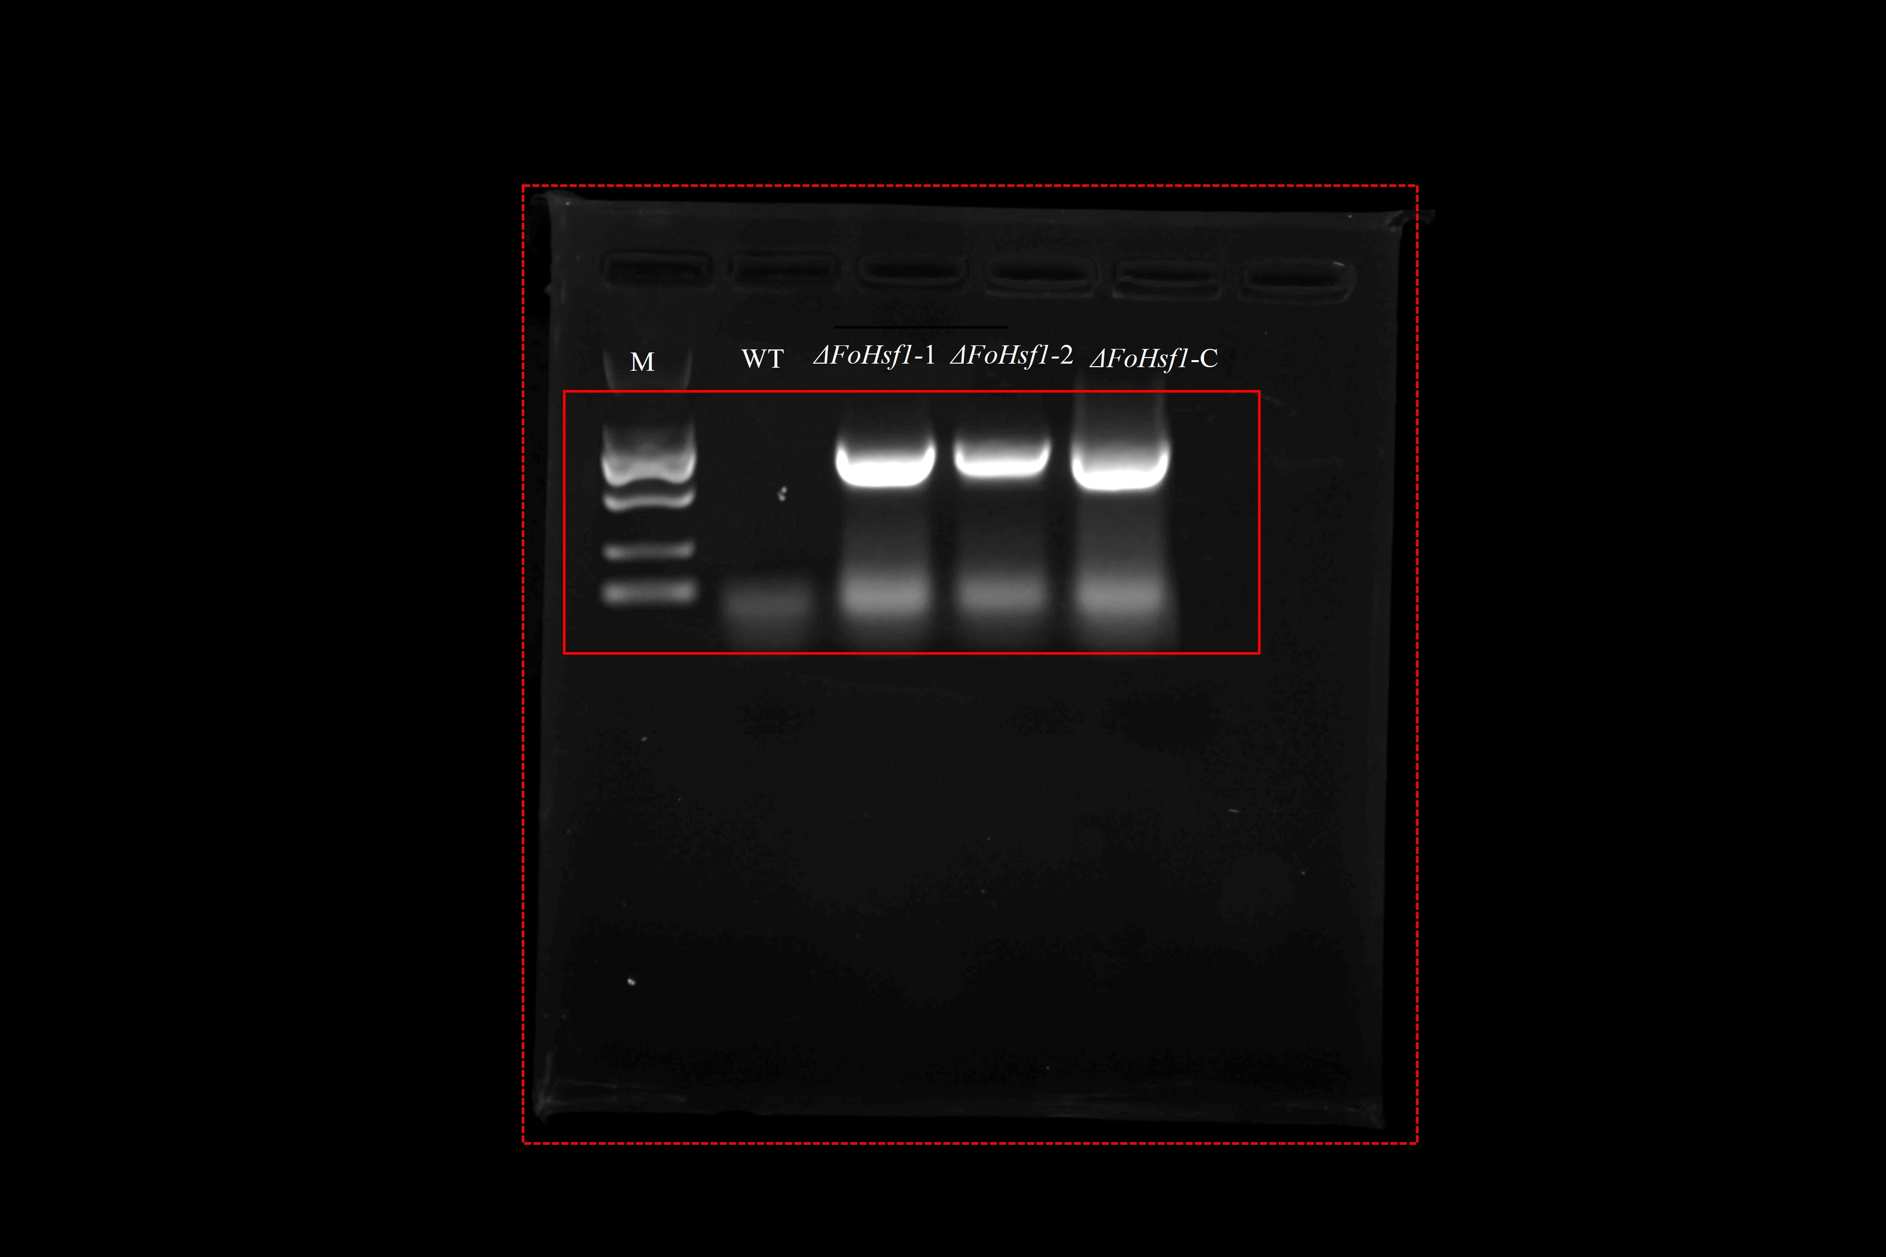
Original, uncropped gel images corresponding to Fig. 2C. Membrane boundary is indicated by red arrows, and the cropped region used in Fig. 2C is outlined by a red box. PCR analysis of the same isolates using hygromycin primers (Hy‑F/Yg‑R). M, DNA Marker DL2000.

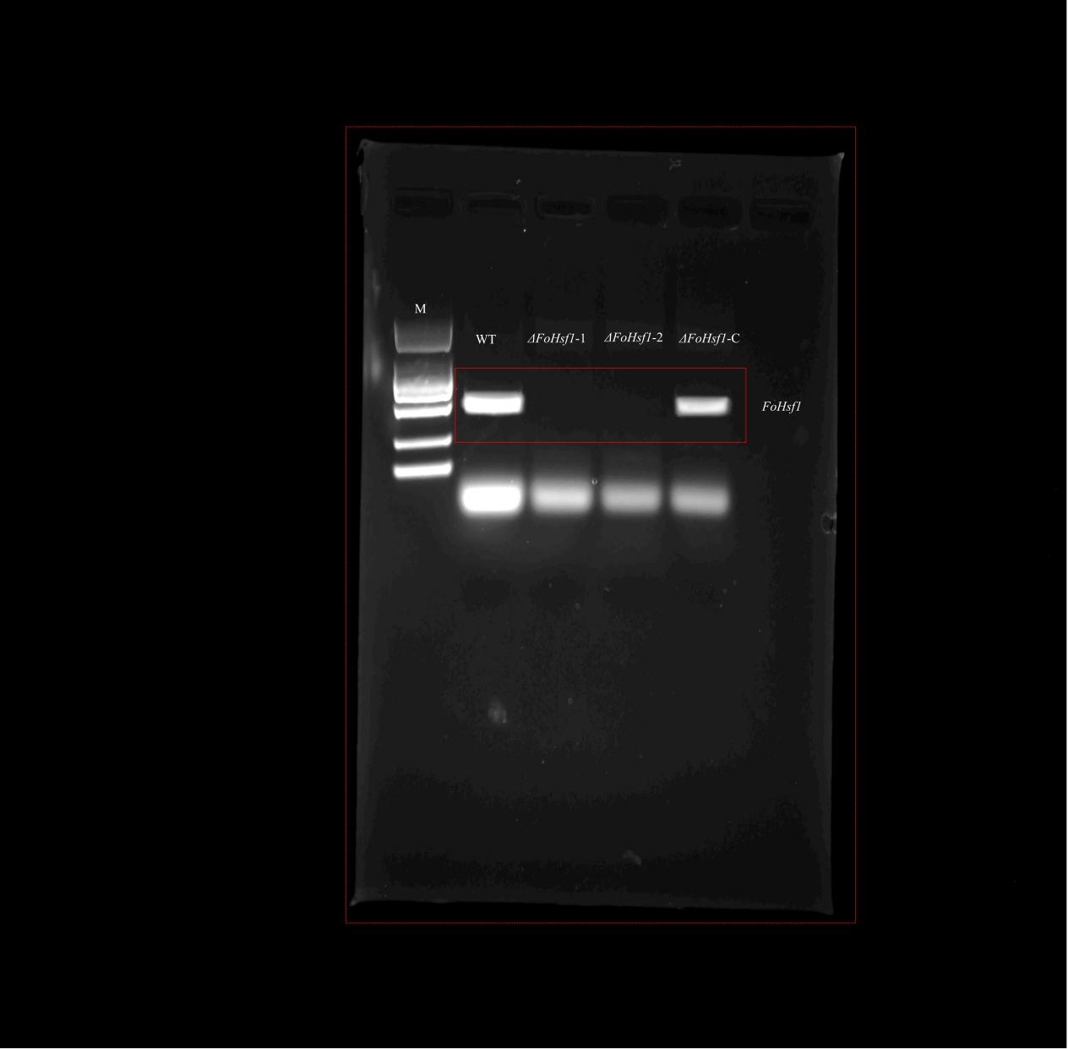
Original, uncropped gel images corresponding to Fig. 2D (FoHsf1). Membrane boundary is indicated by red arrows, and the cropped region used in Fig. 2D is outlined by a red box. Semi‑quantitative RT‑PCR detection of FoHsf1 expression levels in WT, ΔFoHsf1, and ΔFoHsf1‑C isolates. M, DNA Marker DL2000.

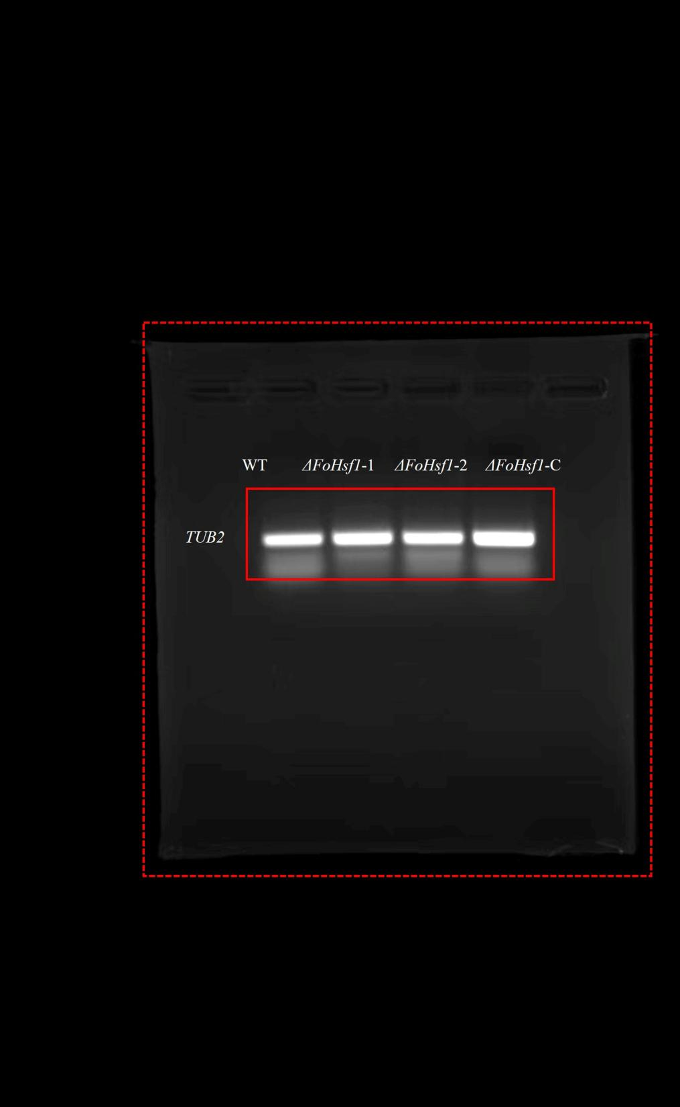
Original, uncropped gel images corresponding to Fig. 2D (TUB2). Membrane boundary is indicated by red arrows, and the cropped region used in Fig. 2D is outlined by a red box. Semi‑quantitative RT‑PCR detection of TUB2 expression levels in WT, ΔFoHsf1, and ΔFoHsf1‑C isolates.

