Supplementary Information
Table S1 List of primers used in this study.
Fig. S1 Location of primers used in this study.
Fig. S2 RT-qPCR validation of RNA-seq data.

Table S1 List of primers used in this study
Name | Sequence (5’-3’) | Product size (bp)
U-F | GAGCATCAGCAGCGACATC | 706
U-R | TAGCCACGATTCGAAGCCGCCGACGGATAGCGGATGGAA | 706
D-F | CGCATTGAATTGAAAAAGGAAGAGTATGCGTTCGGAGCGAGACTGTA | 729
D-R | TGCCACACCTACACAACCTT | 729
Hy-F | GCGGCTTCGAATCGTGGCTA | 800
Hy-R | GTATTGACCGATTCCTTGCGGTCCGAA | 800
Yg-F | GATGTAGGAGGGCGTGGATATGTCCT | 1112
Yg-R | CATACTCTTCCTTTTTCAATTCAATGCG | 1112
I-F | GCCACAGAGGACTTCACAAC | 971
I-R | CACGACTCCTGCTACGACTA | 971
UH-F | GCTCAGGCTATTCCGTTCCA | 1203
UH-R | CCGCTCGTCTGGCTAAGAT | 1203
DY-F | GGCTCCAACAATGTCCTGAC | 1356
DY-R | TTCCGTGCTTCTCCATCCAT | 1356
C-F | cccgggATGGGCTGCTGTGAAGGACCA | 3881
C-R | cccgggTTAAGTCACCAACCCTCAAGA | 3881
Q-F | CCACCTGACTGACCATTG | 248
Q-R | CGACTCCTGCTACGACTA | 248
TUB2-F | TTCTGCTGTCATGTCCGGTGT | 134
TUB2-R | TCAGAGGAGCAAAGCCAACCA | 134
SalI-F | ATGTCTGGTGACGGAACCTC | 750
SalI-R | AACGTAGGTGCGCTGGCGCT | 750
FOXG_15151F | TTGGTGGTCAGAAGAGTTG | 276
FOXG_15151R | CGTCCTTGTCAGATTCCTT | 276
FOXG_03930F | TGTCACTTGGAGGCAGAA | 118
FOXG_03930R | TGTGGTAGAGGAATATCATCAG | 118
FOXG_03933F | TGCGACTGGATACTTGAAC | 180
FOXG_03933R | ATATGCGGCTGGATTGTG | 180
FOXG_02756F | GCACTGATGGCTCTGAAT | 242
FOXG_02756R | CATATCCTTCCTCGTCCTC | 242
FOXG_02993F | CGACAACTACGACTATGACT | 132
FOXG_02993R | AGAGCGACAGAACCAGAA | 132
FOXG_03803F | GCGACTACGACACGATAA | 139
FOXG_03803R | TACCTGCTCACCAACTCT | 139
FOXG_05748F | GTTGAGGTAAGAAGCAGAGT | 229
FOXG_05748R | AGCGATAATAGGCAGATTGG | 229
FOXG_02501F | CCGAGACTGCCAAGATTC | 127
FOXG_02501R | GACATACCAATACCGCTGAT | 127
FOXG_01089F | CCACCGAGTTACCAAGAC | 246
FOXG_01089R | ATGAAGAGACCAGCAAGAC | 246
FOXG_01081F | CGACCGCTTAACTGAACT | 292
FOXG_01081R | GCTGTGAAGACCATCCAA | 292
FOXG_02209F | ATTGAGGACGATGTGAATGA | 190
FOXG_02209R | GGACCAACAAGTGCTTAGT | 190
FOXG_06198F | CGTCTATGGAGGTCAAGTG | 155
FOXG_06198R | GGTAAGTGTCGGTCATCTC | 155

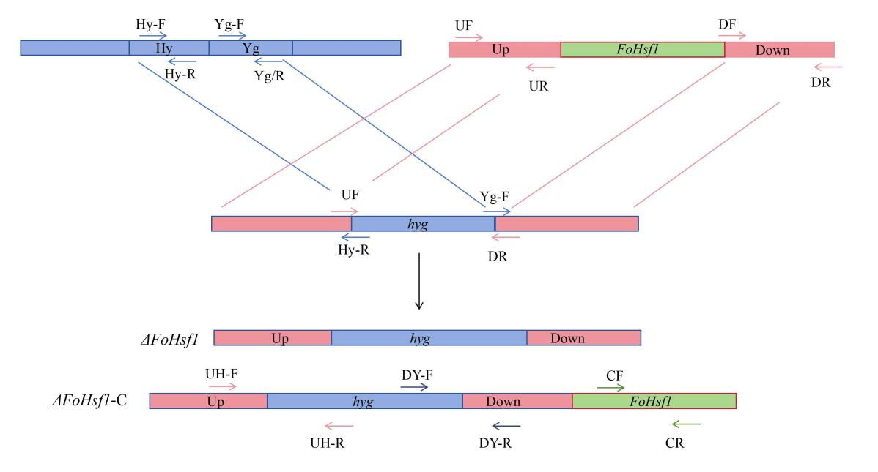
Fig. S1 Location of primers used in this study.

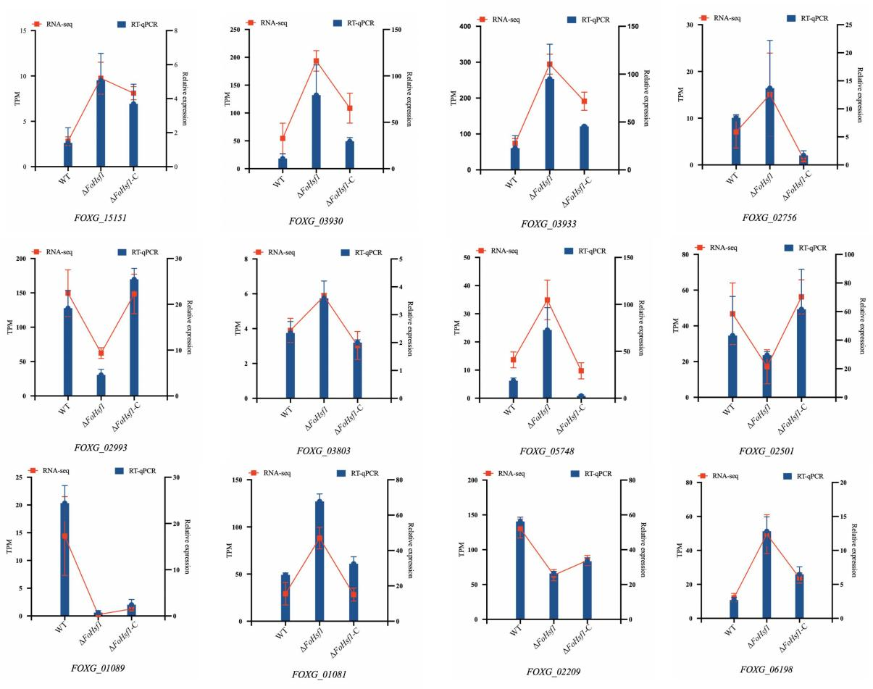
Fig. S2 RT-qPCR validation of RNA-seq data. Data are presented as mean ± SD from three independent biological replicates.

