Table S1. Univariate and multivariate analysis for bleeding complications
Characteristics | Univariate analysis |  |  | Multivariate analysis
Characteristics | RR | 95% CI | P value | RR | 95% CI | P value
Age (≥ 60 years) | 0.62 | 0.25–1.52 | 0.291
Gender (female) | 1.50 | 0.72–3.11 | 0.275
Body weight (≥ 65 kg) | 0.42 | 0.20–0.88 | 0.022 | 0.39 | 0.13–1.15 | 0.087
Height (≥ 165 cm) | 0.77 | 0.36–1.63 | 0.500
Time from symptoms to kidney biopsy (≥ 30 days) | 1.52 | 0.48–4.76 | 0.477
Underlying disease | 0.83 | 0.33–2.13 | 0.705
Cardiovascular disease | 0.84 | 0.40–1.74 | 0.636
Hematologic disease | 1.14 | 0.34–3.82 | 0.833
Liver disease | 0.80 | 0.11–5.85 | 0.823
Systolic blood pressure (≥ 140 mmHg) | 1.06 | 0.41–2.78 | 0.902
Hemoglobin (≥ 10 g/dL) | 0.53 | 0.25–1.16 | 0.113
Hematocrit (≥ 30%) | 0.69 | 0.32–1.52 | 0.353
Platelet (≥ 150,000 cells/µL) | 0.79 | 0.32–1.92 | 0.608
White blood cell (≥ 10,000 cells/µL) | 1.27 | 0.61–2.86 | 0.479
Neutrophil to lymphocyte ratio (≥ 15) | 0.28 | 0.09–0.85 | 0.025 | 0.05 | 0.01–0.28 | < 0.001
aPTT (≥ 25 s) | 1.01 | 0.49–2.08 | 0.983
PT (≥ 1.00 s) | 0.91 | 0.44–1.89 | 0.801
Fibrin (≥ 500 mg/dL) | 0.40 | 0.18–0.87 | 0.021 | 0.25 | 0.07–0.82 | 0.022
Blood urea nitrogen (≥ 60 mg/dL) | 1.25 | 0.47–3.33 | 0.655
Creatinine (≥ 3.0 mg/dL) | 2.50 | 1.12–5.56 | 0.025 | 1.19 | 0.38–3.70 | 0.759
Platelet aggregation test
Adenosine diphosphate
Primary slope (≥ 150%/min) | 1.92 | 0.68–5.56 | 0.220
Secondary slope (≥ 20%/min) | 0.66 | 0.21–2.08 | 0.482
Maximum aggregation (≥ 80%) | 0.86 | 0.35–2.13 | 0.752
Time to maximum aggregation (≥ 480 s) | 0.31 | 0.11–0.88 | 0.027 | 0.42 | 0.09–2.04 | 0.283
Collagen
Primary slope (≥ 30%/min) | 0.82 | 0.35–1.89 | 0.642
Secondary slope (≥ 170%/min) | 2.27 | 0.58–9.09 | 0.237
Maximum aggregation (≥ 90%) | 0.83 | 0.38–1.79 | 0.625
Time to maximum aggregation (≥ 550 s) | 0.36 | 0.13–0.99 | 0.049 | 0.48 | 0.12–1.85 | 0.286
Epinephrine
Primary slope (≥ 80%/min) | 2.44 | 1.09–5.26 | 0.029
Secondary slope (≥ 40%/min) | 0.11 | 0.02–0.50 | 0.005
Maximum aggregation (≥ 90%) | 0.55 | 0.26–1.15 | 0.112
Time to maximum aggregation (≥ 450 s) | 0.26 | 0.09–0.75 | 0.012 | 0.09 | 0.01–0.63 | 0.015
Ristocetin
Primary slope (≥ 60%/min) | 0.82 | 0.34–1.96 | 0.652
Maximum aggregation (≥ 90%) | 0.83 | 0.40–1.69 | 0.605
Time to maximum aggregation (≥ 420 s) | 0.25 | 0.09–0.71 | 0.009 | 0.06 | 0.01–0.32 | <0.001
Thromboelastography
EXTEM
Coagulation time (≥ 40 s) | 3.70 | 1.29–10.00 | 0.014 | 3.13 | 0.78–12.50 | 0.110
Clot formation time (≥ 50 s) | 1.82 | 0.85–3.85 | 0.120
α angle (≥ 80 degree) | 1.03 | 0.50–2.13 | 0.940
Amplitude 10 min after CT (≥ 60 mm) | 0.88 | 0.42–1.89 | 0.751
Amplitude 20 min after CT (≥ 70 mm) | 0.54 | 0.26–1.14 | 0.106
Maximum clot firmness (≥ 70 mm) | 0.78 | 0.38–1.61 | 0.513
Maximum lysis within 60 min (≥ 5%) | 2.50 | 1.12–5.56 | 0.025 | 3.70 | 1.11–12.50 | 0.039
INTEM
Coagulation times (≥ 200 s) | 0.64 | 0.30–1.35 | 0.241
Clot formation times (≥ 50 s) | 1.41 | 0.60–3.33 | 0.434
α angle (≥ 80 degree) | 0.60 | 0.27–1.33 | 0.208
Amplitude 10 min after CT (≥ 60 mm) | 0.55 | 0.26–1.16 | 0.117
Amplitude 20 min after CT (≥ 60 mm) | 0.84 | 0.35–2.00 | 0.692
Maximum clot firmness (≥ 60 mm) | 1.20 | 0.49–3.03 | 0.686
Maximum lysis within 60 min (≥ 5%) | 1.03 | 0.50–2.13 | 0.930
APTEM
Maximum clot firmness (≥ 60 mm) | 0.61 | 0.26–1.43 | 0.248
FIBTEM
Amplitude 10 min after CT (≥ 30 mm) | 2.00 | 0.21–1.18 | 0.114
Amplitude 20 min after CT (≥ 20 mm) | 0.76 | 0.35–1.67 | 0.489
Maximum clot firmness (≥ 20 mm) | 0.56 | 0.25–1.27 | 0.167
aPTT, activated partial thromboplastin time; CI, confidence interval; cm, centimeters; CT, coagulation time; kg, kilograms; mm, millimeters; PT, prothrombin time; s, seconds.

Table S2. Multivariate analysis of the BENREEF model for bleeding complications in renal biopsy
Characteristic | Relative risk | 95% CI | P value
Body weight | 0.37 | 0.13–1.04 | 0.060
Neutrophil-to-lymphocyte | 0.07 | 0.01–0.33 | 0.001
Fibrinogen | 0.23 | 0.07–0.73 | 0.013
Epinephrine: Time to maximum aggregation | 0.09 | 0.01–0.58 | 0.011
Ristocetin: Time to maximum aggregation | 0.05 | 0.01–0.26 | <0.001
EXTEM: Coagulation time | 5.00 | 1.39–16.67 | 0.014
EXTEM: Maximum lysis within 60 min | 3.33 | 1.05–10.0 | 0.040

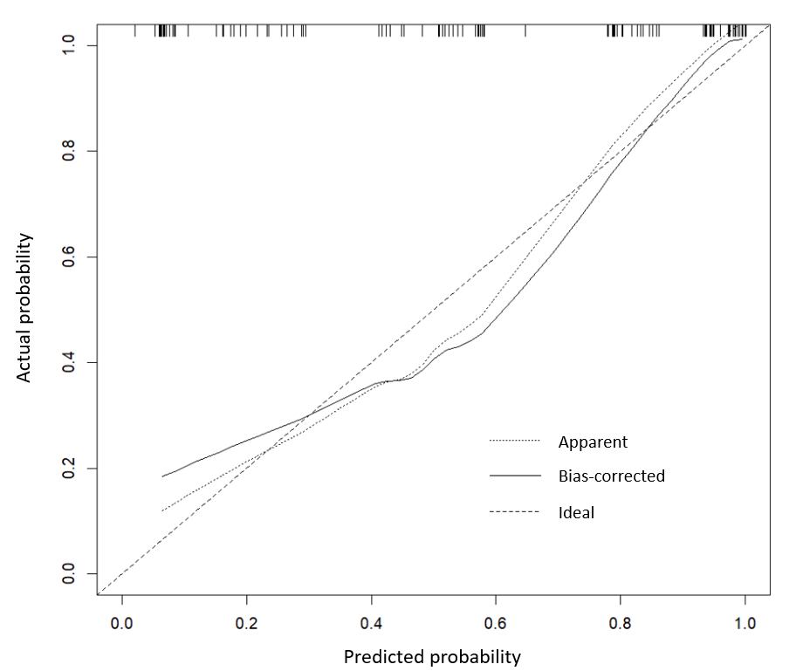
Fig. S1. Calibration plot of the BENREEF model in the internal validation study.

