Supplementary material
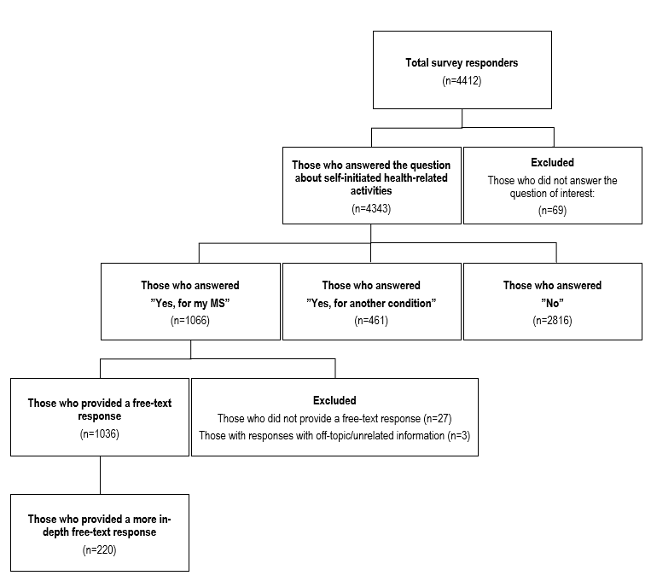
Figure S1. Flowchart of the total study participants’ responses to the question: “In the past 12 months, have you performed any health activity or are you using any other form of treatment that was not prescribed or recommended to you by a doctor (e.g., exercise, dietary supplements, or CBD oil)?”

Table S1. Sociodemographic and clinical characteristics of the subset of free-text responders who provided more in-depth responses to the survey question of interest
“In the past 12 months, have you performed any health activity or are you using any other form of treatment that was not prescribed or recommended to you by a doctor (e.g., exercise, dietary supplements, or CBD oil)?”

TOTAL
(n=220; 100%)
Sex
Women | 161 (73.2%)
Men | (59 (26.8%)
Age (years)
20-39 years | 93 (42.3%)
40-50+ years | 127 (57.7%)
University-level education
Non-university | 64 (29.1%)
University | 156 (70.9%)
Born in Sweden
Yes | 195 (88.6%)
No | 25 (11.4)
Type of living area
Cities | 119 (54.1%)
Towns and suburbs | 78 (35.5%)
Rural areas | 23 (10.5%)
Type of MS
Relapsing-remitting MS | 199 (90.5%)
MS severity
Mild (EDSS=0-2.5) | 135 (61.4%)
Moderate-Severe (EDSS=3-9.5) | 44 (20.0%)
Ongoing MS treatment
Yes | 200 (90.9%)
No | 20 (9.1%)
Treatment satisfaction
Yes | 162 (73.6%)
Partly/not satisfied | 55 (25.0%)
Abbreviations: EDSS, Expanded Disability Status Scale score; MS, multiple sclerosis. Missing values are not included in the table.

