SUPPLEMENTAL MATERIAL
A Mobile Phone-Based Communication Strategy to Maximize Retention in a Post-Intensive Care Follow-up Study of Acute Respiratory Distress Syndrome Survivors
Charity O. Ogunlusi, MBBS, MPH;¹ Ansley Jones, MHS;¹ Margarita Mira-Sanchez, MD;¹ Arooj Fatima, MD, MPH;² Victor D Dinglas, MPH;² Dale M. Needham, MD, PhD;² Peter Scala, PT;³ Richard Ellsworth, PT, DPT;³ Matthew R. Baldwin, MD, MS¹*
1. Division of Pulmonary, Allergy, and Critical Care, Columbia University, Vagelos College of Physicians and Surgeons, NY, NY, USA
2. Outcomes After Critical Illness and Surgery Group (OACIS) Johns Hopkins University, and Division of Pulmonary and Critical Care Medicine, and Department of Physical Medicine and Rehabilitation, School of Medicine, Johns Hopkins University, Baltimore, MD, USA
3. Department of Rehabilitation Medicine-Physical Therapy, New York Presbyterian Hospital, NY, NY, USA

E-Table 1. Inclusion-Exclusion Criteria for ARDS Survivors
E-Table 2. List of specific surveys completed at study timepoints
E-Figure 1. Study flow diagram of eligible patients at each follow-up
E-References

E-Table 1. Inclusion and exclusion criteria for the ARDS Survivor cohort.​
Inclusion Criteria​ | Rationale​
1. Age ≥18 years​ | Adults of all ages are susceptible to ARDS morbidity and mortality.​
2. ARF requiring >24 hours of invasive ​  mechanical ventilation or high flow ​  nasal cannula oxygen​ | High flow nasal cannula is used as a first line therapy for ARDS. Allowable inclusion for NHBLI ARDS NEXIS trial. Proposed expansion criterion of Berlin criteria (Ref 98)​
Exclusion Criteria​ | Rationale​
1. Enrollment in a double-blinded clinical trial​ | Unknown whether intervention may affect immunophenotyping and biomarker measures or functional recovery outcome.​
2. ARDS due to trauma​  3. ARDS during hospitalization with surgery​ | Trauma or surgery can confound recovery to pre-hospitalization baseline​  activity level.​
4. Prior severe COVID requiring high flow nasal cannula oxygen therapy or critical COVID.​ | Prior COVID ALI/ARDS may confound recovery and biomarker measurements.​
5. ICU admission within prior 3 months​  6. Cardiac surgery within prior 3 months​ | Pre-hospitalization physical activity level may reflect debilitation from prior critical illness and not baseline activity level.​
7. Admission from long-term care​ | Usually does not ambulate independently, chronic multiple ADL disability.​
8. Planned discharge to hospice or ​  long-term care​ | Functional recovery unlikely to be within goals of care.​
9. Systemic connective tissue disorders​  10. Solid organ transplant​  11. WHO group I pulmonary hypertension​  12. Active solid tumor or blood malignancy​  13. Pregnancy​ | Immunophenotyping, biomarker measurements, and functional recovery may be affected uniquely by the condition​
14. ARDS with new stroke or Guillain-Barré.​  15. Pre-existing neurological or muscular ​  disease with motor deficits​ | Recovery and frailty assessments affect by a single, chronic deficit or disease​
16. Suspected anoxic brain injury ​  (e.g., post-cardiac arrest)​ | Often leads to withdrawal of life support, hospice care, or long-term care.​
17. Moribund status​
18. Dementia (IQCODE >3.31) ​  19. Uncontrolled psychiatric disorder ​  involving delusions​ | Potentially unreliable responses; dementia modifies physical recovery trajectory; difficult follow-up.​
20. Homelessness or Prisoner ​ | Difficult follow-up.

E-Table 2 – List of surveys administered at specific study timepoints.
Study Assessments | Baseline Visit | 3-Month Telephone Follow-up | 3- Month In- Person Visit | 6-Month Telephone Follow-up | 12-Month Telephone Follow-up
Language | ü | ü | ü | ü | ü
4AT^{1,2} | ü
IQCODE³ | ü
Participant Information | ü
Personal History | ü
Katz ADL^{4,5} | ü | ü |  | ü | ü
Lawton IADL⁶ | ü | ü |  | ü | ü
PEP⁷ | ü | ü |  | ü | ü
DASI^{8,9} | ü | ü |  | ü | ü
Clinical Frailty Scale¹⁰ | ü
Frailty Phenotype Exhaustion¹¹ | ü |  | ü
Physical Exam Form | ü |  | ü
SPPB¹² | ü |  | ü
Phlebotomy | ü |  | ü
MOCA Blind¹³ | ü | ü |  | ü | ü
Initial ARDS SOFA Score¹⁴ | ü
Charlson Comorbidity Index¹⁵ | ü
Discharge Location | ü
Hospital and Follow-up Dates | ü
Changes to Information |  | ü |  | ü | ü
Modified Medical Research Council scale for dyspnea¹⁶ |  | ü |  | ü | ü
IES-6¹⁷ |  | ü |  | ü | ü
HADS^{18,19} |  | ü |  | ü | ü
EQ5D-5L²⁰ |  | ü |  | ü | ü
MOS Social Support Survey²¹ |  | ü |  | ü | ü
Custom-made Scale on Recovery* |  | ü |  | ü | ü
Medications |  |  | ü
FACIT- Fatigue Scale²² |  |  | ü
4AT – Abbreviated Mental Test-4, IQCODE -Informant Questionnaire on Cognitive Decline in the Elderly, ADL – Activities of Daily Living, IADL – Instrumental Activities of Daily Living, PEP – Precipitating Events Project, DASI – Duke Activity Status Index, SPPB – Short Physical Performance Battery, MOCA- Montreal Cognitive Assessment, SOFA – Sequential Organ Failure Assessment, IES-6 – Impact Event Scale-6, HADS – Hospital Anxiety and Depression Scale, EQ5D-5L – EuroQol 5- Dimension Questionnaire, MOS – Medical Outcome Study, FACIT– Functional Assessment of Chronic Illness Therapy.

* “How recovered from your illness are you? Complete recovery means you no longer have symptoms related to your illness, you can do your usual daily activities, and you have returned to your previous state of health and mind before your illness.” Not recovered at all; somewhat recovered; about half recovered; mostly recovered; and, completely recovered.
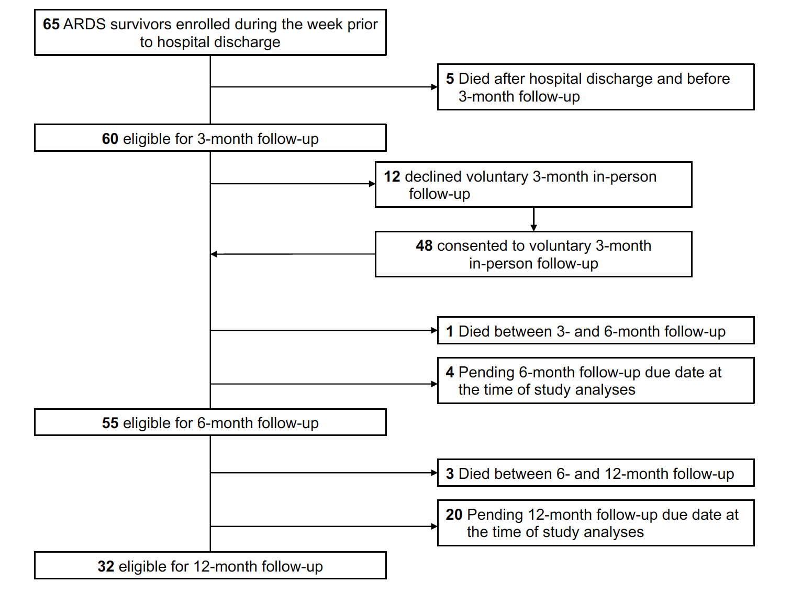
E-Figure 1. Study flow diagram of eligible patients at each follow-up.

E-References

1. Bellelli G, Morandi A, Davis DH, et al. Validation of the 4AT, a new instrument for rapid delirium screening: a study in 234 hospitalised older people. Age and ageing. Jul 2014;43(4):496–502. doi:10.1093/ageing/afu021
2. Hendry K, Quinn TJ, Evans J, et al. Evaluation of delirium screening tools in geriatric medical inpatients: a diagnostic test accuracy study. Age and ageing. Nov 2016;45(6):832–837. doi:10.1093/ageing/afw130
3. Jorm AF. A short form of the Informant Questionnaire on Cognitive Decline in the Elderly (IQCODE): development and cross-validation. Psychological medicine. Feb 1994;24(1):145–53.
4. Katz S, Ford AB, Moskowitz RW, Jackson BA, Jaffe MW. STUDIES OF ILLNESS IN THE AGED. THE INDEX OF ADL: A STANDARDIZED MEASURE OF BIOLOGICAL AND PSYCHOSOCIAL FUNCTION. Jama. Sep 21 1963;185:914–9. doi:10.1001/jama.1963.03060120024016
5. Ciesla JR, Shi L, Stoskopf CH, Samuels ME. Reliability of Katz's Activities of Daily Living Scale when used in telephone interviews. Eval Health Prof. Jun 1993;16(2):190–203. doi:10.1177/016327879301600204
6. Lawton MP, Brody EM. Assessment of older people: self-maintaining and instrumental activities of daily living. Gerontologist. Autumn 1969;9(3):179–86.
7. Hardy SE, Gill TM. Recovery from disability among community-dwelling older persons. Jama. Apr 7 2004;291(13):1596–602. doi:10.1001/jama.291.13.1596
8. Hlatky MA, Boineau RE, Higginbotham MB, et al. A brief self-administered questionnaire to determine functional capacity (the Duke Activity Status Index). Am J Cardiol. Sep 15 1989;64(10):651–4. doi:10.1016/0002-9149(89)90496-7
9. Baldwin MR, Singer JP, Huang D, et al. Refining Low Physical Activity Measurement Improves Frailty Assessment in Advanced Lung Disease and Survivors of Critical Illness. Ann Am Thorac Soc. Aug 2017;14(8):1270–1279. doi:10.1513/AnnalsATS.201612-1008OC
10. Rockwood K, Song X, MacKnight C, et al. A global clinical measure of fitness and frailty in elderly people. Cmaj. Aug 30 2005;173(5):489–95. doi:10.1503/cmaj.050051
11. Fried LP, Tangen CM, Walston J, et al. Frailty in older adults: evidence for a phenotype. J Gerontol A Biol Sci Med Sci. Mar 2001;56(3):M146–56. doi:10.1093/gerona/56.3.m146
12. Guralnik JM, Simonsick EM, Ferrucci L, et al. A short physical performance battery assessing lower extremity function: association with self-reported disability and prediction of mortality and nursing home admission. J Gerontol. Mar 1994;49(2):M85–94. doi:10.1093/geronj/49.2.m85
13. Wittich W, Phillips N, Nasreddine ZS, Chertkow H. Sensitivity and Specificity of the Montreal Cognitive Assessemnt Modified for Individuals Who are Visually Impaired. Journal of Visual Impairment and Blindness. 2010;104(6):360–368.
14. Vincent JL, de Mendonca A, Cantraine F, et al. Use of the SOFA score to assess the incidence of organ dysfunction/failure in intensive care units: results of a multicenter, prospective study. Working group on "sepsis-related problems" of the European Society of Intensive Care Medicine. Crit Care Med. Nov 1998;26(11):1793–800. doi:10.1097/00003246-199811000-00016
15. Charlson ME, Pompei P, Ales KL, MacKenzie CR. A new method of classifying prognostic comorbidity in longitudinal studies: development and validation. J Chronic Dis. 1987;40(5):373–83. doi:10.1016/0021-9681(87)90171-8
16. Mahler DA, Wells CK. Evaluation of clinical methods for rating dyspnea. Chest. Mar 1988;93(3):580–6. doi:10.1378/chest.93.3.580
17. Thoresen S, Tambs K, Hussain A, Heir T, Johansen VA, Bisson JI. Brief measure of posttraumatic stress reactions: impact of Event Scale-6. Soc Psychiatry Psychiatr Epidemiol. Mar 2010;45(3):405–12. doi:10.1007/s00127-009-0073-x
18. Sukantarat KT, Williamson RC, Brett SJ. Psychological assessment of ICU survivors: a comparison between the Hospital Anxiety and Depression scale and the Depression, Anxiety and Stress scale. Anaesthesia. Mar 2007;62(3):239–43. doi:10.1111/j.1365-2044.2006.04948.x
19. Jutte JE, Needham DM, Pfoh ER, Bienvenu OJ. Psychometric evaluation of the Hospital Anxiety and Depression Scale 3 months after acute lung injury. J Crit Care. Aug 2015;30(4):793–8. doi:10.1016/j.jcrc.2015.04.006
20. EuroQol--a new facility for the measurement of health-related quality of life. The EuroQol Group. Health Policy. Dec 1990;16(3):199–208.
21. Moser A, Stuck AE, Silliman RA, Ganz PA, Clough-Gorr KM. The eight-item modified Medical Outcomes Study Social Support Survey: psychometric evaluation showed excellent performance. J Clin Epidemiol. Oct 2012;65(10):1107–16. doi:10.1016/j.jclinepi.2012.04.007
22. Cella D, Lai JS, Chang CH, Peterman A, Slavin M. Fatigue in cancer patients compared with fatigue in the general United States population. Cancer. Jan 15 2002;94(2):528–38. doi:10.1002/cncr.10245

