Name | Host species | Vendor | Catalog Number | Dilution
CD11b/c (OX42) | Mouse | Invitrogen (eBioscience) | 12-0110-82 | ---
CD45 (OX1) | Mouse | Proteintech | CL594-65228 | ---
IFN-γ | Mouse | Biolegend | 507804 | ---
FOXP3 (FJK-16s) | Mouse | Invitrogen (eBioscience) | 17-5773-82 | ---
IL-17A (eBio17B7) | Mouse | Invitrogen (eBioscience) | 48-7177-82 | ---
IL-4 (OX-81) | Mouse | Biolegend | 511905 | ---
Ly-6G/Ly-6C | Mouse | Invitrogen (eBioscience) | 11-5931-82 | ---
Occludin | Rabbit | Abways | CY5997 | 1:5000
Claudin-1 | Rabbit | Abways | CY6872 | 1:500
IL-4 (OX-81) | Rabbit | ABclonal | A14660 | 1:500
IFN-γ | Rabbit | ABclonal | A12450 | 1:2000
IL-17F | Rabbit | Beyotime | AF7263 | 1:500
ZO-1 | Rabbit | Proteintech | 21773-1-AP | 1:5000
GAPDH | Rabbit | ZEN BIO | 380626 | 1:5000
IL-17A (eBio17B7) | Rabbit | Affinity Biosciences | DF6127 | 1:200
Goat anti-Rabbit IgG (H+L) | Goat | Proteintech | RGAR001 | 1:3000
Goat anti-MOUSE IgG (H+L), HRP | Goat | GenScript | A00160 | 1:1000
Lyzozyme | Rabbit | Proteintech | 15013-1-AP | 1:500
YAP1 | Rabbit | Proteintech | 13584-1-AP | 1:2000
ALDOB | Rabbit | Proteintech | 18065-1-AP | 1:2000
SOX9 | Rabbit | Nature Biosciences | A12852 | 1:1000
Supplementary Table 1. Antibodies list.

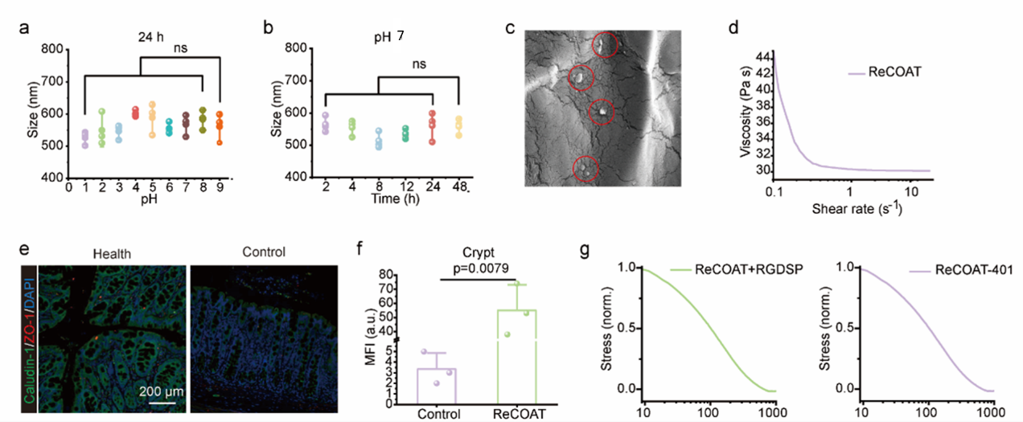
Supplementary Fig. 1. I Characterization of ReCOAT-401 components and intestinal tissue architecture. a) Hydrodynamic diameter of Ti-MOF particles at different pH levels (n=3). b) Time-dependent stability of Ti-MOF particle size under simulated intestinal conditions (pH≈7) (n= 3). c) TEM images of ReCOAT-401 synthesized via a facile mixing method. (d) Rheological analysis demonstrating the shear-thinning behavior of ReCOAT-401 with viscosity decreasing as a function of shear rate (0.1 to 10.0 s⁻¹). (e) Immunofluorescence staining of tight junction proteins (ZO-1 and Occludin) in healthy versus inflamed colonic tissues. (f) In vivo retention of FITC-labeled conventional stiff hydrogels and ReCOAT-401 in intestinal crypts following oral administration (n=3). (g) Stress relaxation profiles of ReCOAT-401 alone or incorporated with RGDSP. Data are presented as mean ± SD. P values derived from one-way ANOVA analysis followed by Tukey’s multiple comparisons test.

Supplementary Fig. 2. I Computational simulation of intermolecular interactions within ReCOAT and its variants. (a) DFT-optimized geometries and calculated binding energies of the parent coacervate, ReCOAZ, ReCOAF and ReCOAT. (b) Representative snapshots from MD simulations showing the equilibrium structures of the parent coacervate, ReCOAZ, ReCOAF and ReCOAT. (c) Time-dependent evolution of the number of hydrogen bonds in the parent coacervate and MOF-incorporated systems (ReCOAZ, ReCOAF, and ReCOAT) over a 5000 ps simulation period.

Supplementary Fig. 3. I Restoration of epithelial barrier integrity and modulation of the colonic microenvironment in chronic colitis. a) Trans-epithelial permeability of FD-4 across Caco-2 monolayers following various treatments (n = 3). b, c) Quantitative Western blot analysis of (b) IL-4 and (c) IFN-γ protein expression in CD4+ T cells isolated from rat colons (n=3). (d) Disease Activity Index (DAI) scores of rats over the 28-day treatment period (n=5). e, f) Representative macroscopic images (e) and average colon lengths (f) of rats from each treatment group (n = 5). g, h) Alpha diversity of the gut microbiota assessed by (g) Chao1 richness and (h) Shannon diversity indices (n = 3). i) Principal component analysis (PCA) of gut microbiota composition (n=3). j–l) Relative abundance of specific bacterial taxa: (j) Lactobacillus, (k) Limosilactobacillus reuteri, and (l) Romboutsia in the gut microbiome (n=3). m) Abundances of the gut microbiota at family. Data are presented as mean ± SD. P values derived from one-way ANOVA analysis followed by Tukey’s multiple comparisons test.
Supplementary Fig. 4. I Evaluation of intestinal retention and in vivo biosafety of ReCOAT-401. (a) In vivo fluorescence imaging of chronic colitis rats and ex vivo fluorescence images of major organs and colons harvested from different treatment groups. (b) Representative H&E staining images of major organs (heart, liver, spleen, lung and kidney) indicating no pathological abnormalities. c-e) Biodistribution analysis quantifying Ti content in (c) colon tissues, (d) feces, and (e) blood (n=3). f) Serum biochemical analysis of liver and kidney function markers in healthy rats versus those receiving different treatments. Data are presented as mean ± SD. P values derived from one-way ANOVA analysis followed by Tukey’s multiple comparisons test.

