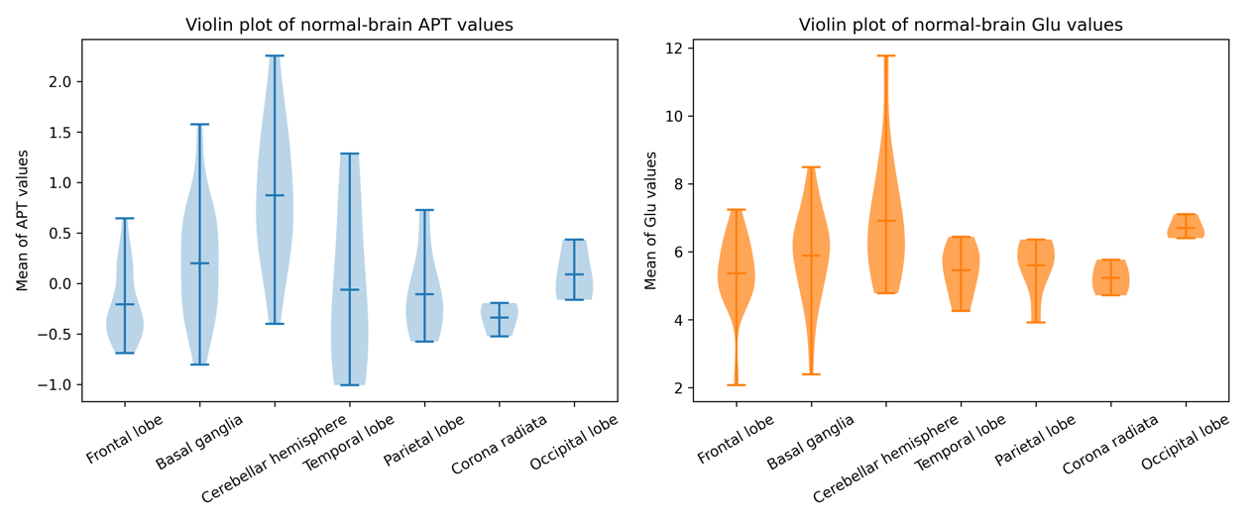
Supplementary Figure 1: Violin plots of APT and Glu measurement in normal brain tissues across various anatomical regions (The three black short horizontal lines represent the mean, minimum, and maximum values).

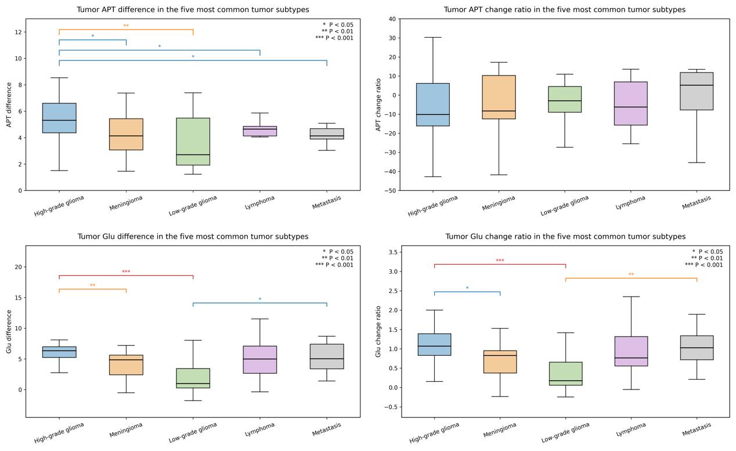
Supplementary Figure 2: Uncorrected box plots of APT/Glu differences and change ratios across five tumor subtypes.

Supplementary Table 1: Mean APT and Glu values in different normal tissue regions

Brain region | n | APT (mean ± SD) | Glu (mean ± SD)
Frontal lobe | 32 | −0.21 ± 0.36 | 5.37 ± 1.13
Basal ganglia | 31 | 0.20 ± 0.57 | 5.89 ± 1.35
Cerebellar hemisphere | 13 | 0.87 ± 0.72 | 6.91 ± 1.88
Parietal lobe | 6 | −0.11 ± 0.46 | 5.60 ± 0.89
Temporal lobe | 6 | −0.06 ± 0.89 | 5.46 ± 0.79
Corona radiata | 3 | −0.34 ± 0.17 | 5.23 ± 0.53
Occipital lobe | 3 | 0.09 ± 0.31 | 6.70 ± 0.36
Pons | 2 | 0.49 ± 0.45 | 7.00 ± 0.24
All brain | 96 | 0.10 ± 0.62 | 5.83 ± 1.36

