Supplementary Figure 1: Phylogenetic tree comparing outbreak isolates (light blue) with global sequences belonging to all reported STs in PubMLST database with known ST in the outer circle (labeled the nearest related lineages).
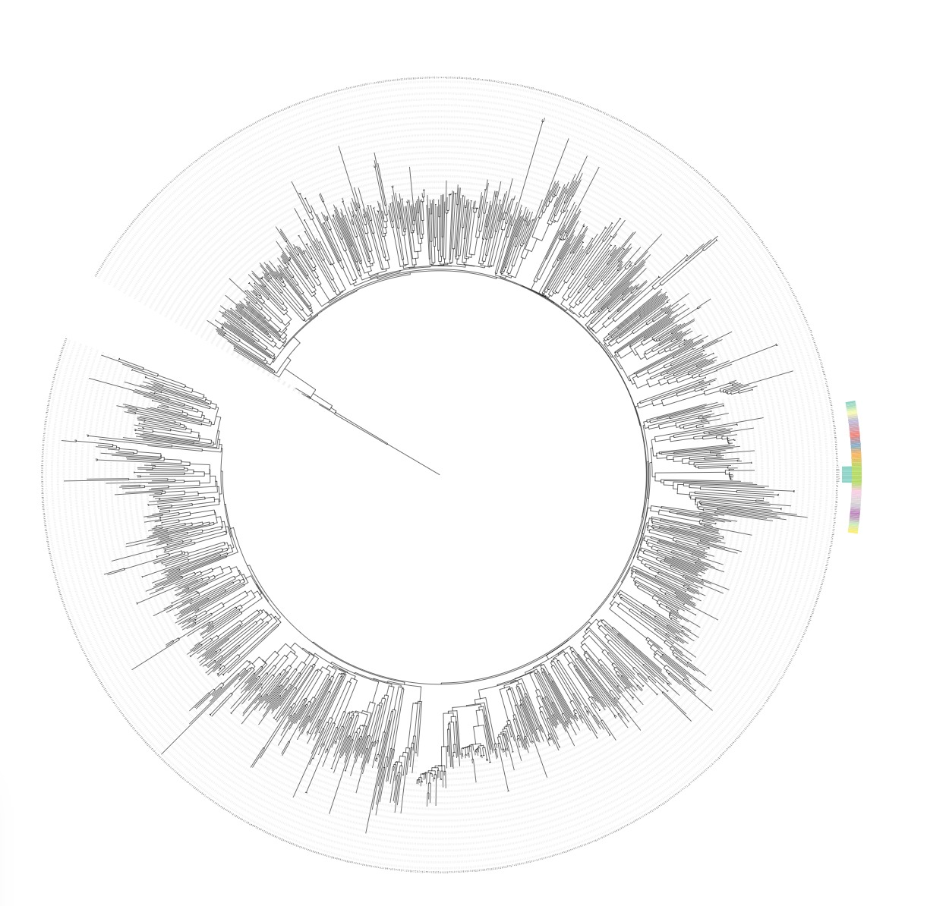
Supplementary Table 1: Clinical and epidemiological characteristics of patients involved in the Pseudomonas aeruginosa outbreak.
Patient number | Age | Sex (M/F) | Date of admission | Date of discharge | Length of stay (days) | Discharge diagnosis | Surgery performed | Device present | Outcome | Pseudomona aeruginosa date of isolation | Epidemiological link (yes/no) | Identified contact | Targeted antimicrobial therapy for Pseudomonas aeruginosa
PA61-24 | 48 | M | 11/09/2024 | 28/09/2024 | 17 | Thoraco-abdominal aortic aneurysm — post-endovascular repair endoleak | Thoracoabdominal aortic aneurysm repair (type II) with aorto-aortic bypass | Central venous catheter, urinary catheter, intubated | Dischargerd | 19/09/24 | NO | NA | Meropenem
PA36-24 | 81 | M | 20/06/2024 | 28/08/2024 | 69 | Prosthetic valve infective endocarditis (MRSA) with pneumonia and hypoxic brain injury | No surgery | Central venous catheter, urinary catheter, intubated | Transferred to rehabilitation | 20/06/24 | NO | NA | Ceftolozane/tazobactam
PA40-24 | 41 | F | 29/06/2024 | 09/07/2024 | 10 | Toxic epidermal necrolysis (suspected lamotrigine-induced) | No surgery | Central venous catheter, urinary catheter, intubated | Dischargerd | 03/07/24 | SI | PA 39-24 | Not treated (colonisation); therapy ongoing for other MDROs
PA47-24 | 54 | F | 27/07/2024 | 30/08/2024 | 34 | Septic shock in breast cancer with pyelonephritis | Nephrostomy | Central venous catheter, urinary catheter, intubated, port-a-cath | Dischargerd | 28/07/24 | NO | NA | Piperacillin/tazobactam
PA26-24 | 79 | M | 16/04/2024 | 16/07/2024 | 91 | Oesophagogastric junction adenocarcinoma with ARDS and tracheo-oesophageal fistula | Minimally invasive Ivor-Lewis oesophagectomy with bronchial fistula repair and feeding jejunostomy | Central venous catheter, urinary catheter, intubated | Dischargerd | 13/05/24 | NO | NA | Meropenem
PA55-24 | 67 | M | 26/08/2024 | 07/09/2024 | 12 | Ruptured abdominal aortic aneurysm | Repair of ruptured infrarenal abdominal aortic aneurysm with aorto-bifemoral bypass and endovascular revision | Central venous catheter, urinary catheter, intubated | Dischargerd | 27/08/24 | NO | NA | Piperacillin/tazobactam
PA64-24 | 76 | M | 17/09/2024 | 06/11/2024 | 50 | Gastric cardia adenocarcinoma with anastomotic leak and intra-abdominal fistulas | Transhiatal oesophagogastrectomy with oesophagojejunostomy, liver resection, cholecystectomy and jejunostomy (reoperation for anastomotic failure) | Central venous catheter, urinary catheter | Dischargerd | 26/09/24 | NO | NA | Piperacillin/tazobactam
PA54-24 | 79 | M | 13/06/2024 | 31/01/2025 | 232 | Pacemaker-related tricuspid infective endocarditis with septic pulmonary emboli | Tricuspid valve replacement with pacemaker implantation and sternal wound revision | Central venous catheter, urinary catheter, intubated | Dischargerd | 21/08/24 | SI | PA 26-24 | Ceftazidime/avibactam
PA39-24 | 66 | M | 06/06/2024 | 05/07/2024 | 29 | Post-gastrectomy syndrome | Intrathoracic colon interposition (oesophageal reconstruction) | Central venous catheter, urinary catheter, intubated | Deceased | 02/07/24 | SI | PA 36-24 | Switched from meropenem to imipenem for prior P. aeruginosa; after BAL isolation treated with tigecycline and ceftazidime/avibactam

Supplementary Table 2: Phenotypic and genotypic characteristics of Pseudomonas aeruginosa isolates (phenotypic tests have been interpreted based on EUCAST Clinical Breakpoint Tables v. 15.0, valid from 2025-01-01).
 | Amikacin |  |  | Ceftazidime |  |  | Ciprofloxacin |  | Imipenem |  | Meropenem |  | Piperacillin–Tazobactam |  | Beta-lactam
Isolates | Phenotypic interpretation | MIC | Resistance determinants | Phenotypic interpretation | MIC | Resistance determinats | Phenotypic interpretation | MIC | Phenotypic interpretation | MIC | Phenotypic interpretation | MIC | Phenotypic interpretation | MIC | Resistance determinats
PA26-24 | S | 8 | aph(3')-IIb | I | 2 | _{bla}PDC-3 (AmpC) | I | 0.5 | R | >8 | R | >8 |  |  | _{bla}OXA-486
PA36-24 | S | 4 | aph(3')-IIb | I | 8 | _{bla}PDC-3 (AmpC) | I | 0.25 | R | >8 | R | >8 | R | 32 | _{bla}OXA-486
PA39-24 | S | 4 | aph(3')-IIb | R | >32 | _{bla}PDC-3 (AmpC) | I | 0.5 | R | >8 | R | >8 | R | 64 | _{bla}OXA-486
PA40-24 | S | 4 | aph(3')-IIb | I | 8 | _{bla}PDC-3 (AmpC) | I | 0.25 | R | >8 | R | >8 | R | >256 | _{bla}OXA-486
PA47-24 | S | 4 | aph(3')-IIb | I | 2 | _{bla}PDC-3 (AmpC) | I | 0.12 | R | >8 | I | 8 | R | <=4 | _{bla}OXA-486
PA54-24 | R | >32 | aph(3')-IIb | R | >32 | _{bla}PDC-3 (AmpC) | R | >2 | R | >8 | R | >8 | R | >64 | _{bla}OXA-486
PA55-24 | S | 4 | aph(3')-IIb | I | 2 | _{bla}PDC-3 (AmpC) | I | <=0.06 | R | >8 | R | >8 | R | <=4 | _{bla}OXA-486
PA61-24 | S | 4 | aph(3')-IIb | I | 1 | _{bla}PDC-3 (AmpC) | I | <=0.06 | R | >8 | I | 6 | R | <=4 | _{bla}OXA-486
PA64-24 | S | 4 | aph(3')-IIb | I | 1 | _{bla}PDC-3 (AmpC) | I | <=0.06 | R | 12 | R | 8 | R | <=4 | _{bla}OXA-486

