A Closed-Loop Machine Learning and Digital Twin Framework for the Discovery of High-Performance Solid-State Electrolytes
Sahil Bhardwaj
Department of Electronics and Communication Engineering, MDU Rohtak, Haryana, India
Supplementary Figures
Fig. S1. Distribution of log₁₀(ionic conductivity) in the curated dataset after cleaning and deduplication (497 unique compositions). The histogram shows a wide spread of conductivity values, from very low (<10⁻¹⁶ S cm⁻¹) to high (>10⁻² S cm⁻¹), reflecting the diversity of solid-state electrolyte families included.
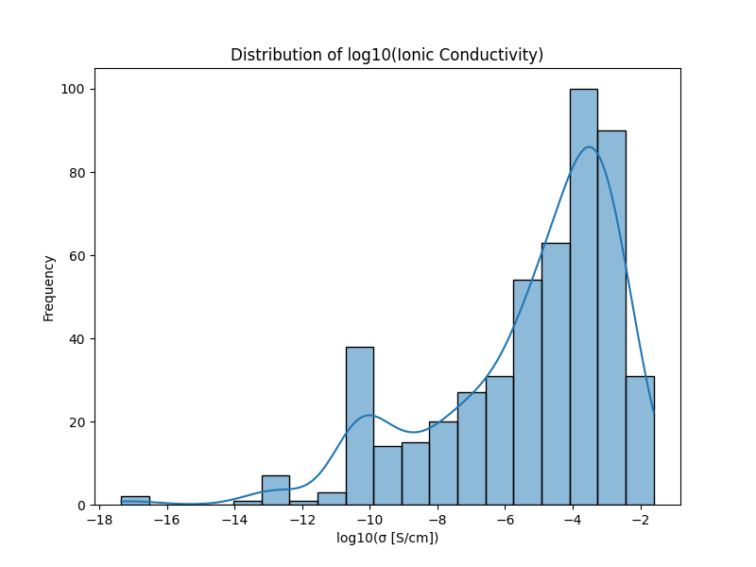
Fig. S2. Learning curve of the Random Forest model: test mean absolute error (MAE) as a function of training set size (percentage of the full dataset). Performance improves rapidly up to ~60% of the data and then plateaus, indicating that adding more samples beyond the current 497 entries would yield diminishing returns for a composition-only model.
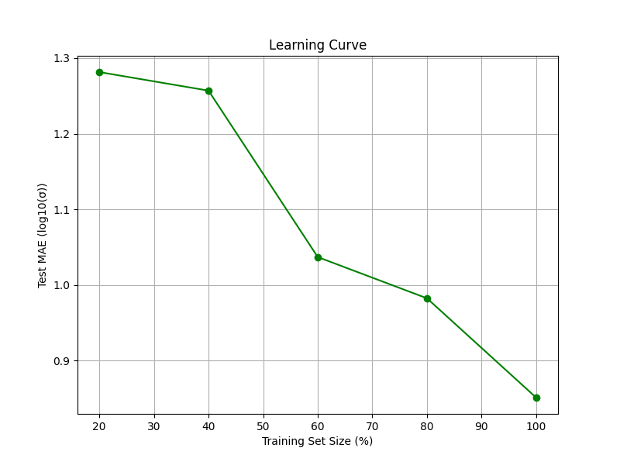
Fig. S3. Digital twin discharge curve (0.5 C) for the reference high-conductivity material Li₁₀GeP₂S₁₂ (LGPS). The predicted ionic conductivity from the Random Forest model is 1.10 × 10⁻² S cm⁻¹, which agrees well with the literature value (~1.2 × 10⁻² S cm⁻¹). The smooth voltage profile confirms that the digital twin simulation behaves as expected.
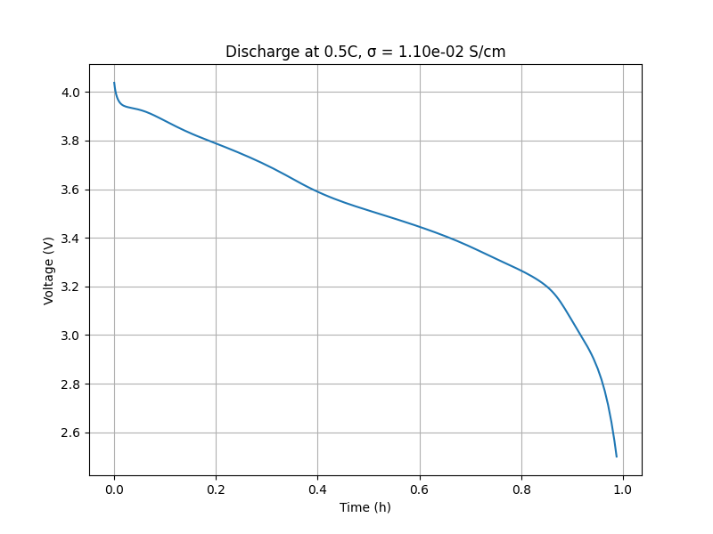
Fig. S4. Residual plot for the best Random Forest model on the test set. Residuals are distributed around zero with no strong systematic trend, indicating that the model does not exhibit significant bias. Slightly larger spread at low conductivity values reflects the greater difficulty in predicting poorly conducting materials.
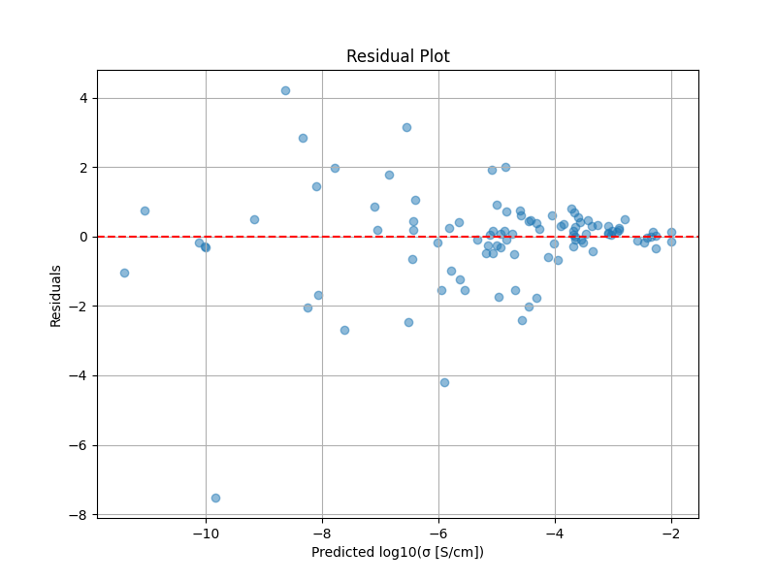
Fig. S5. Correlation heatmap of the top 15 Magpie features. Several features show strong positive or negative correlations, indicating redundancy in the descriptor set. However, the Random Forest model handles correlated features robustly without performance degradation.
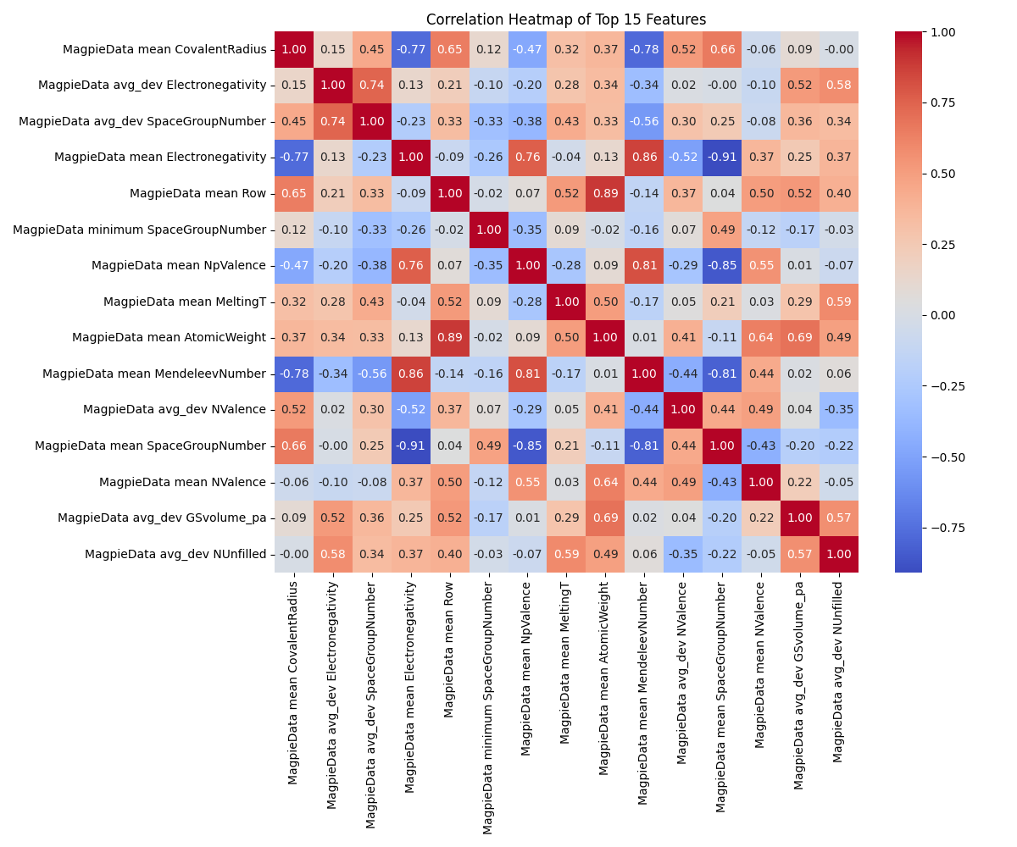
Supplementary Table
Table S1. All 20 compositions evaluated during Bayesian optimisation (Li₇₋₃ₓ₋₃ᵧGaₓTaᵧLa₃Zr₂O₁₂). Columns: composition, Ga doping fraction (x), Ta doping fraction (y), predicted log₁₀(σ) (log₁₀(S cm⁻¹)), uncertainty (standard deviation of tree predictions), and predicted σ (S cm⁻¹). The best composition (lowest log₁₀σ) is highlighted in bold.
Composition | Ga (x) | Ta (y) | predicted log₁₀σ | uncertainty (std) | predicted σ (S cm⁻¹)
Li5.68Ga0.41Ta0.03La3Zr2O12 | 0.412 | 0.028 | -3.559 | 0.511 | 2.76×10⁻⁴
Li4.91Ga0.22Ta0.48La3Zr2O12 | 0.219 | 0.477 | -4.367 | 1.572 | 4.29×10⁻⁵
Li5.19Ga0.37Ta0.24La3Zr2O12 | 0.369 | 0.236 | -4.222 | 1.515 | 6.00×10⁻⁵
Li5.77Ga0.20Ta0.21La3Zr2O12 | 0.204 | 0.206 | -3.518 | 0.613 | 3.04×10⁻⁴
Li5.05Ga0.31Ta0.34La3Zr2O12 | 0.311 | 0.340 | -4.383 | 1.609 | 4.14×10⁻⁵
Li4.68Ga0.49Ta0.28La3Zr2O12 | 0.493 | 0.280 | -4.392 | 1.405 | 4.06×10⁻⁵
Li4.15Ga0.48Ta0.47La3Zr2O12 | 0.484 | 0.467 | -4.551 | 1.568 | 2.81×10⁻⁵
Li5.83Ga0.16Ta0.23La3Zr2O12 | 0.163 | 0.229 | -3.496 | 0.597 | 3.19×10⁻⁴
Li5.17Ga0.45Ta0.16La3Zr2O12 | 0.447 | 0.162 | -4.284 | 1.539 | 5.20×10⁻⁵
Li4.60Ga0.34Ta0.46La3Zr2O12 | 0.344 | 0.457 | -4.294 | 1.314 | 5.09×10⁻⁵
Li6.19Ga0.11Ta0.16La3Zr2O12 | 0.114 | 0.157 | -3.414 | 1.025 | 3.85×10⁻⁴
Li6.26Ga0.25Ta0.00La3Zr2O12 | 0.247 | 0.000 | -3.375 | 0.189 | 4.22×10⁻⁴
Li6.20Ga0.20Ta0.07La3Zr2O12 | 0.197 | 0.068 | -3.232 | 0.225 | 5.86×10⁻⁴
Li6.81Ga0.06Ta0.00La3Zr2O12 | 0.063 | 0.000 | -3.431 | 0.349 | 3.71×10⁻⁴
Li6.33Ga0.16Ta0.06La3Zr2O12 | 0.161 | 0.063 | -3.296 | 0.206 | 5.06×10⁻⁴
Li6.06Ga0.23Ta0.09La3Zr2O12 | 0.227 | 0.087 | -3.350 | 0.760 | 4.46×10⁻⁴
Li6.29Ga0.00Ta0.24La3Zr2O12 | 0.000 | 0.238 | -3.336 | 0.745 | 4.61×10⁻⁴
Li6.61Ga0.00Ta0.13La3Zr2O12 | 0.000 | 0.131 | -3.335 | 0.239 | 4.62×10⁻⁴
Li6.44Ga0.19Ta0.00La3Zr2O12 | 0.188 | 0.000 | -3.428 | 0.261 | 3.73×10⁻⁴
Li6.38Ga0.11Ta0.10La3Zr2O12 | 0.109 | 0.097 | -3.267 | 0.216 | 5.41×10⁻⁴
Note: The best composition (bold) corresponds to the lowest predicted log₁₀σ (highest conductivity).

Supplementary Methods (optional, if needed)
Hyperparameters of the Random Forest model
- Number of trees: n_estimators = 100
- Maximum depth: max_depth = 12
- Random seeds used for train/test splits: [42, 123, 7, 101, 2024]
- Test size: 20% (80/20 split)
- Feature scaling: StandardScaler (zero mean, unit variance)
PyBaMM digital twin parameters
- Model: Doyle-Fuller-Newman (DFN)
- Parameter set: Chen2020
- Solid electrolyte conductivity: set to ML-predicted value (converted to S m⁻¹)
- Discharge rate: 0.5 C
- Simulation time: 1 hour (3600 s)
Bayesian optimisation settings
- Surrogate model: Gaussian process
- Acquisition function: Expected improvement (EI)
- Initial points: 10 random
- Total iterations: 20
- Search space: Ga (0–0.5), Ta (0–0.5)

