Supplementary Material

Article Title: Motor Cortex Excitability in Early Adult Females with Adolescent Idiopathic Scoliosis during Spine Shape-Judgment: A TMS Motor Evoked Potential Study

Supplementary Material 1: Trunk Appearance Perception Scale (TAPS) (Bago et al., 2010).
Scoring Instructions: Each drawing is scored on a 5-point scale, ranging from 1 (greatest perceived deformity) to 5 (least perceived deformity). In the provided sets, the far-right image represents a score of 1, while the far-left image represents a score of 5. The final TAPS score represents the mean of the three included items.
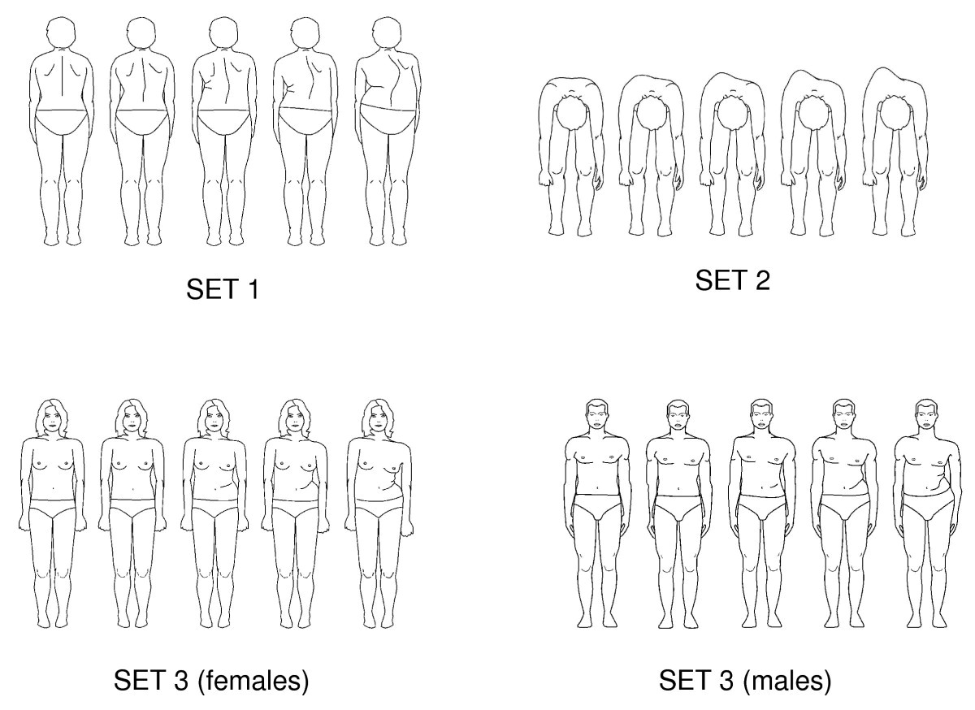
Methodological Note: To maintain the demographic relevance of the stimuli, the male-specific drawing sets were omitted from the presentation as all participants in the current study were female.

