Supplementary Information

Plasmonic Nano-Candle Platform for Phase-Resolved Optical Tracking of Pd Hydrogenation with Structure-Sensitive Readout

Min-Joong Kim^{1,†}, Nu-Ri Park^{1,2,†}, Jongsu Lee^{3,†}, Jaeho Lee¹, Minah Seo^{4,}*, Myung-Ki Kim^{1,}*, and Yong-Sang Ryu^{5-8,}*

¹KU-KIST Graduate School of Converging Science and Technology, Korea University, Seoul, 02481, Republic of Korea
²Quantum Information, Korea Institute of Science and Technology (KIST), Seoul, 02792, Republic of Korea
³Department of Chemical Engineering, Kumoh National Institute of Technology (KIT), Gumi, 39177 Republic of Korea
⁴Department of Physics, Sogang University, Seoul, 04107 Republic of Korea
⁵School of Biomedical Engineering, Korea University, Seoul, 02841, Republic of Korea
⁶Department of Micro/Nano Systems, Korea University, Seoul, 02841, Republic of Korea
⁷Department of Bio Micro Systems, Korea University, Seoul, 02841, Republic of Korea
⁸BK21 Four Institute of Precision Public Health, Korea University, Seoul, 02841, Republic of Korea

†These authors contributed equally
*Correspondence and requests for materials should be addressed to M. Seo (mseo@sogang.ac.kr), M.-K. Kim (rokmk@korea.ac.kr), and Y.-S.R. (rongxiang82@korea.ac.kr)
Supporting Information

S1. Comparison between planar films and Λ-shaped NC structures under hydrogenation
S2. Fabrication process of Λ-shaped NC structures through template stripping
S3. Clean surface achieved through template stripping
S4. COMSOL thermal expansion simulations of the Λ-shaped NC structures
S5. Structural deformation of Λ-shaped Pd only NC arrays
S6. Negative control experiment with Au/Pd V-shaped NC structures
S7. Optical permittivity of Pd and PdH
S8. Phase diagram of PdH
S9. Long-term stability of the Λ-shaped Pd/Au NC sensor
S10. Effective medium modeling of the Au–Pd thin-film of the Λ-shaped NC structures
S11. Signal noise smoothing and filtering in the experiments
S12. Transmittance measurement setup
S1. Comparison between planar films and Λ-shaped NC structures under hydrogenation

All the spectra correspond to PdH_{0.65}​ with a Pd (10 nm)/Au (90 nm) bilayer. Figure S1a shows an increase in transmission at approximately 500 nm, whereas Fig. S1b exhibits a slight increase at approximately 500 nm. Additionally, a distinct structural resonance peak appears near 750 nm, which originates from the NC geometry. For this resonance (Mode 1), the transmittance increased when Pd was converted to PdH​ in the absence of gap narrowing, whereas progressive gap narrowing (from 15 nm to 10 nm) decreased the transmittance. This indicates that Mode 1 is highly sensitive to both material expansion and structural deformation. In contrast, Mode 2 was primarily material-driven, reflecting the intrinsic index change from Pd to PdH, thereby serving as a reliable indicator of hydrogen uptake.

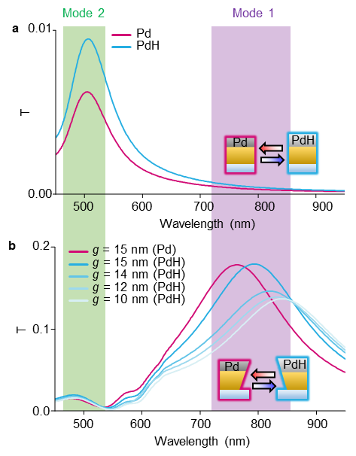
Figure S1. a, b Simulated transmittance spectra of (a) the planar film and (b) the NC structure (g = 15 nm, L = 150 nm).
S2. Fabrication process of Λ-shaped NC structures through template stripping

First, Pd and Au metal bilayers were sequentially deposited onto a silicon substrate. Subsequently, focused ion beam milling was used to create the nano-slit arrays. A UV-curable polymer (Norland Optical Adhesive, NOA) was drop-cast onto the patterned V-shaped Au/Pd nanostructures, and a glass substrate was placed on top to ensure conformal contact. After UV curing, the NOA film was peeled away, producing an inverted Λ-shaped NC structure. The final structure comprised a Pd (10 nm)/Au (60 nm) bilayer on NOA.

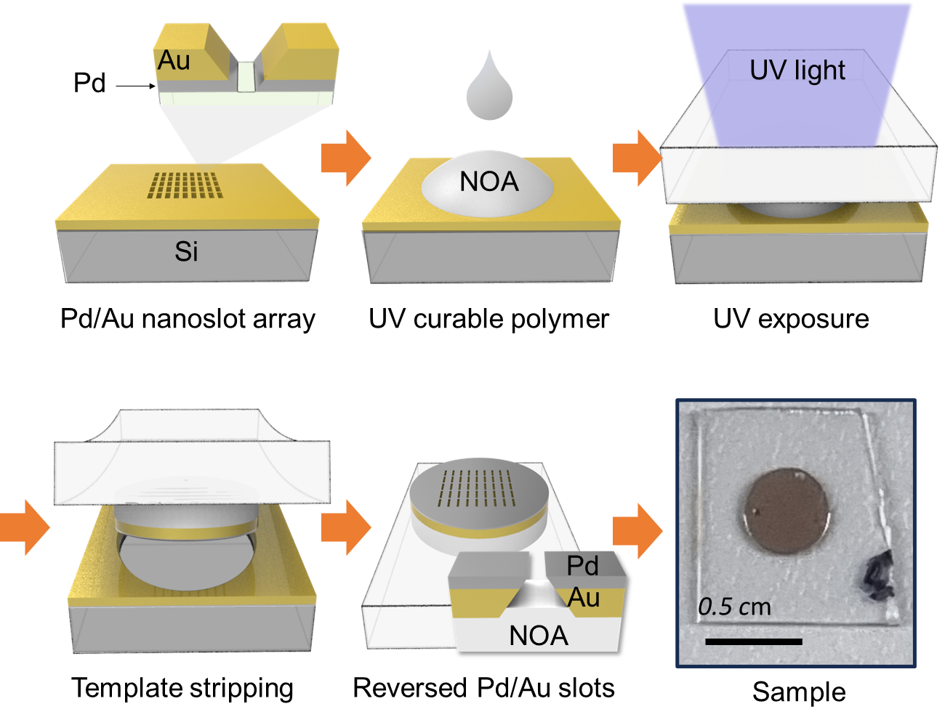
Figure S2. Schematic of the transfer process of converting V-shaped NC arrays into Λ-shaped structures; the photograph at the bottom right shows the final transferred sample.
S3. Clean surface achieved through template stripping

This transfer method utilizes the clean and smooth surface of the Si substrate, free from dust and residual fabrication artifacts, which is critical for achieving high-quality optical sensors with minimal scattering and enhanced optical signal fidelity.

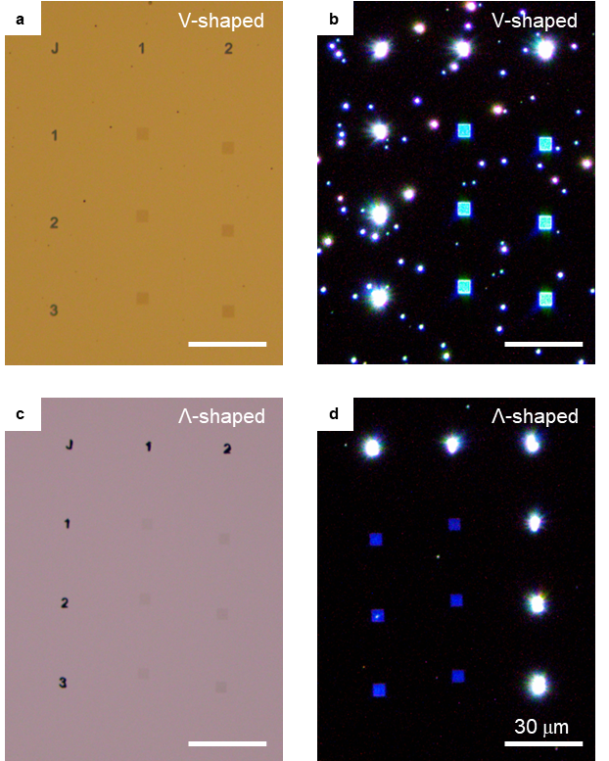

Figure S3. a, b Bright-field (a) and dark-field (b) optical microscopy (OM) images of V-shaped NC arrays (Au 50 nm/Pd 10 nm) on a Si substrate. c, d Corresponding bright-field (c) and dark-field (d) images of Λ-shaped NC arrays fabricated through template stripping.
S4. COMSOL thermal expansion simulations of the Λ-shaped NC structure

Because COMSOL lacks a module to directly model the lattice expansion from atomic-scale hydrogen incorporation, a thermal expansion model was employed as an alternative framework. In this approximation, nanogap expansion of the heterogeneous Pd/Au NC nanoantenna was simulated based on the volumetric expansion ratio. As shown in Fig. S4.1, g′ indicates the effective gap width, which progressively narrows owing to lateral bulging of the Pd layer. At higher expansion levels (7%), the gap was significantly constricted and tapered. These results highlight the critical role of hydrogen-induced volumetric changes in modulating the nanogap geometry and plasmonic confinement.
Moreover, lattice simulation expansion affects the Pd 10​ nm/Au 60​ nm Λ-shaped NC structures with initial gap sizes of 10 nm and 15 nm (Fig. S4.2). Under a theoretical Pd lattice expansion of 3%, both the gap configurations retained their designed geometries without structural damage. However, at 4% expansion, the 10 nm gap closed owing to sidewall contact, resulting in structural collapse. In contrast, the 15 nm gap maintained its geometry even at 4% expansion. These results demonstrate that although ultra-narrow gaps (of the order of a few nanometers) can enhance the local field confinement and sensor sensitivity, the gap dimension must be carefully optimized by accounting for both the Pd film thickness and the expected degree of hydrogen-induced lattice expansion.

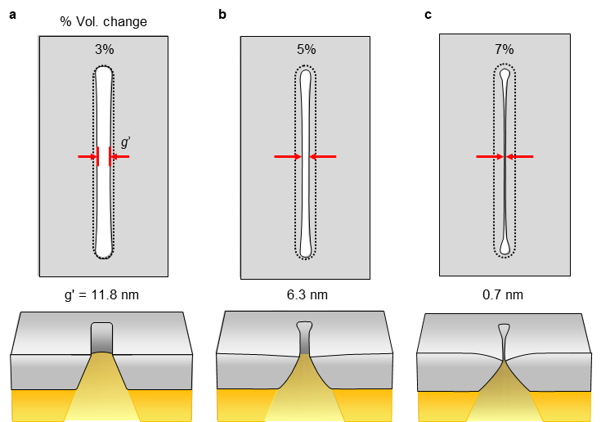

Figure S4.1. a–c, Top and cross-sectional view of the COMSOL simulation results for Pd volumetric expansion of 3% (a), 5% (b), and 7% (c).
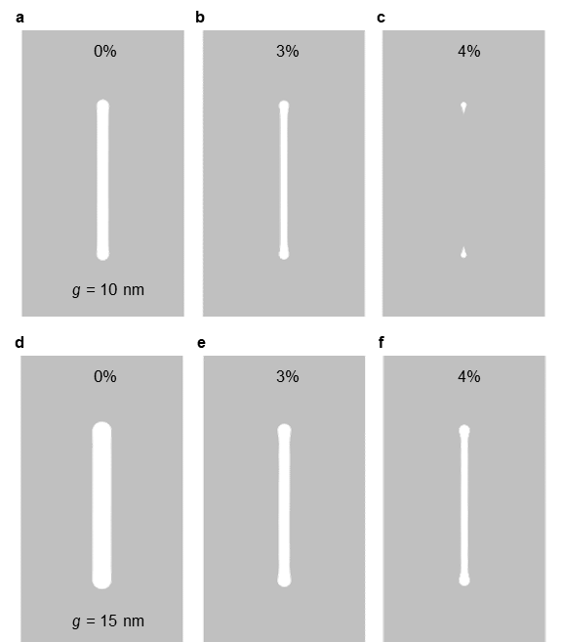

Figure S4.2. a–c, Top-view of the COMSOL simulation results for an initial gap of 10 nm under 0% (a), 3% (b), and 4% (c) Pd volumetric expansion. d–f, Results for an initial gap of 15 nm under 0% (d), 3% (e), and 4% (f) Pd volumetric expansion.
S5. Structural deformation of Λ-shaped Pd only NC arrays

Despite UV curing, the NOA substrate remained soft and flexible, preventing it from withstanding Pd volume expansion during hydrogen absorption. This causes surface buckling and limits the stability of the sensor, thereby restricting its ability to perform repeatable H₂ detection. Both the microscopic (OM) images and photographs of the Λ-shaped Pd only NC array sample clearly show deformation of the Pd film after H₂ exposure.

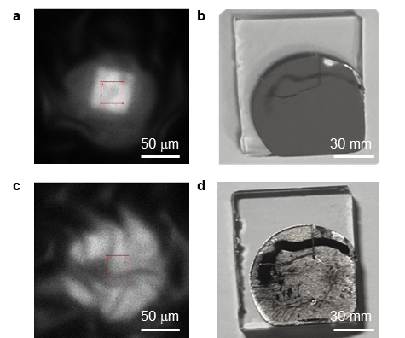

Figure S5. a, OM image of the Λ-shaped Pd NCs under N₂ environment, showing a relatively smooth surface morphology. b, Photograph of the same Λ-shaped Pd NC sample on a flexible NOA substrate before gas exposure. c, OM image of the Λ-shaped Pd NCs after exposure to 4% H₂, exhibiting surface wrinkling because of Pd expansion. d, Photograph of the sample after H₂ exposure, showing macroscopic deformation.
S6. Negative control experiment with Au/Pd V-shaped NC structures

The optical hydrogen-sensing performance of the Pd/Au V-shaped NC structures was examined as a negative control. When the control sample was exposed to H₂ concentrations ranging from 0.5% to 10%, only minimal spectral shifts were observed with increasing hydrogen concentration (Fig. S6).

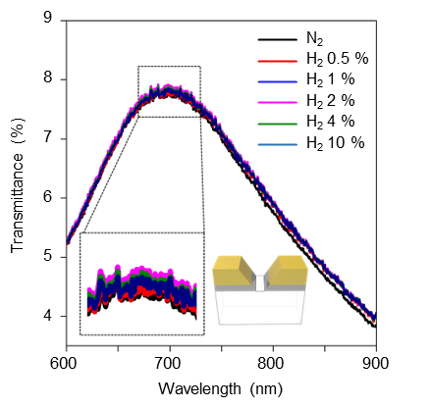
Figure S6. Transmittance spectra of the V-shaped NC sensors (Pd 10 nm/Au 60 nm, gap = 20 nm, length = 80 nm) under hydrogen concentrations ranging from 0 to 10%. Inset: Cross-sectional schematic of the V-shaped NC structure, showing the asymmetric metal configuration and tapered gap region.
S7. Optical permittivity of Pd and PdH

To accurately simulate the step-by-step gap narrowing and optical property variations of the Λ-shaped Pd NC sample reacting in response to H₂, the optical permittivities of Pd and PdH_{x}, x ranging from 0 to 0.65, were taken from a published study¹.

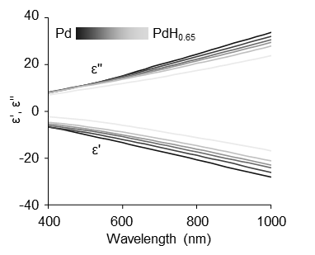
Figure S7. Real (ε') and imaginary (ε'') permittivity of Pd and PdH as a function of the wavelength and the H-to-Pd stoichiometry x.
S8. Phase diagram of PdH

To accurately simulate the step-by-step gap narrowing and optical property variations of the Λ-shaped Pd NC sample reacting in response to H₂, the relationship between the PdHₓ composition (x = 0–0.65) and H₂ pressure was taken from a published study².

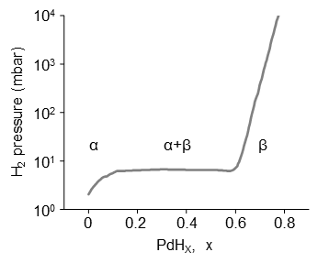
Figure S8. H₂ partial pressure versus H-to-Pd atomic ratio at 20 ℃.

S9. Long-term stability of the Λ-shaped Pd/Au NC sensor

Palladium-based hydrogen sensors, when stored under ambient conditions without specific surface treatment, are susceptible to material degradation induced by oxygen and other environmental factors, which may ultimately lead to degraded sensing performance³. As shown in Fig. S9.1, a delayed response was observed in a 1-year-old sample under identical conditions (t₉₀ = 41 s), relative to the fresh device (t₉₀ = 4.3 s), indicating kinetic degradation after long-term storage. Nevertheless, the device retained a measurable and reversible response within 1 min, suggesting functional persistence despite aging.
In a separate experiment, a Λ-shaped structure with a thicker Pd layer (30 nm) on top of 50 nm Au, with a 30 nm gap and a length of 145 nm, was fabricated and stored under ambient conditions for 6 months. As shown in Fig. S9.2, the resonance spectra exhibited negligible spectral degradation over this period. Furthermore, SEM images of a single nanogap structure taken before and after 6 months of storage showed no obvious structural collapse or deformation, supporting preservation of the nanogap architecture under these conditions.
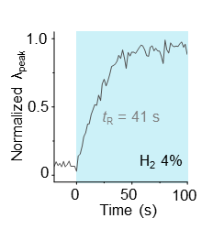
Figure S9.1. Response time of a 1-year-old Λ-shaped Pd/Au NC sensor platform under 4% H₂ (t₉₀ = 41 s).

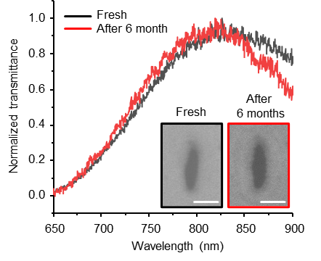
Figure S9. Normalized transmittance spectra of the same Λ-shaped NC sensor measured immediately after fabrication (black line) and again after 6 months of ambient storage (red line). Scale bar: 50 nm.

S10. Effective medium modeling of the Au–Pd thin-film of the Λ-shaped NC structure

Bruggeman’s effective medium theory was employed to estimate the optical response at the intermixed Au–Pd interface of the Λ-shaped NC structure. In this configuration, the interfacial region formed by the Pd deposition on the Au layer can be regarded as a subwavelength composite medium in which the two metals are partially interdiffused. The effective permittivity (ε_{eff}) was determined by solving the Bruggeman’s relation:
$$f_{Au}\frac{{(ε}_{Au}-ε_{eff})}{(ε_{Au}+{kε}_{eff})}+(1-f_{Au})\frac{{(ε}_{Pd}-ε_{eff})}{(ε_{Pd}+{kε}_{eff})}$$
where, f denotes the volume fraction of each constituent, and κ = 1 is the screening parameter appropriate for quasi-two-dimensional interfaces. This effective medium approximation provides a more realistic description of the Au–Pd hybrid region, where gradual compositional and electronic transitions occur, and was used to reproduce the experimentally observed spectral characteristics of the Λ-shaped nano-slit metasurface.

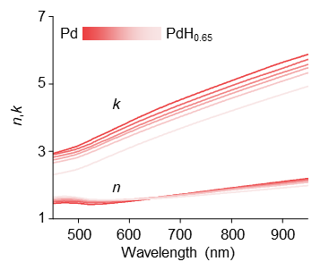
Figure S10. Refractive index (n) and extinction coefficient (k) of Pd–Au and PdHₓ–Au as functions of wavelength and H-to-Pd stoichiometry (x), calculated using Bruggeman’s effective medium approximation with a Pd-to-Au volume ratio of 8:2.
S11. Signal noise smoothing and filtering in experiments

The original data were obtained from experimental measurements, and smoothed data were generated using Savitzky–Golay filtering. The Gaussian fit was applied to the smoothed data within a ±50 nm range around the peak wavelength for curve approximation. The fitting process was performed using nonlinear least-squares optimization, in which the Gaussian model was fitted to the peak region representing the characteristic spectral response.

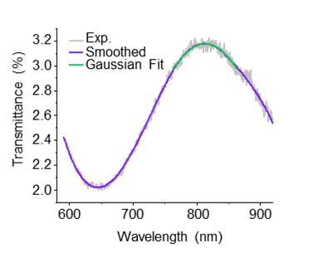
Figure S11. Transmittance spectrum showing the original data (gray line), smoothed data (purple line), and Gaussian fit (green line).
S12. Transmittance measurement setup

A gas-controlled chamber was positioned at the beam focus to enable real-time optical transmittance measurements at varying H₂ concentrations. The composition of the carrier gas was controlled by mixing N₂ and O₂ to simulate atmospheric conditions. The H₂ concentration was measured at the chamber outlet.

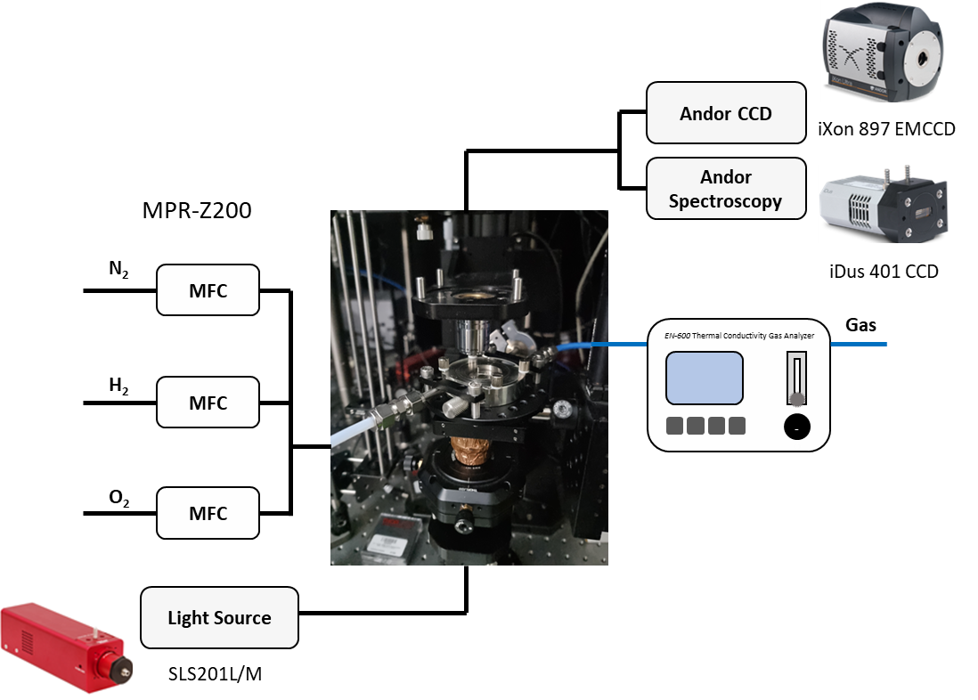

Figure S12. Schematic of the optical setup for the hydrogen sensing experiments.

References

1 Palm, K. J., Murray, J. B., Narayan, T. C. & Munday, J. N. Dynamic Optical Properties of Metal Hydrides. ACS Photonics 5, 4677-4686 (2018).
2 Manchester, F. D., San-Martin, A. & Pitre, J. M. The H-Pd (hydrogen-palladium) System. J. Phase Equilib. 15, 62-83 (1994).
3 Kim, K.-H. et al. Long-term reliable wireless H2 gas sensor via repeatable thermal refreshing of palladium nanowire. Nat. Commun. 15, 8761 (2024).

