Online supplementary material 1
Cost-utility and cost-effectiveness results per country

Bulgaria
In Bulgaria, the CMHT group demonstrated lower incremental costs and higher incremental effects (both in terms of responder rate as well as QALYs) from both a societal and a healthcare perspective. This resulted in dominant ICERs for both cost per responders and cost per QALY gained (see table S1). A large portion of the bootstrap-simulated ICERs were lying in the South-East quadrant, leading to a high probability of the intervention being cost-effective (see figures S1 & S2).

Table S1 Results of the main analyses for Bulgaria, based on 2500 bootstrap replications from the imputed sample data
 |  |  |  | Distribution of ICERs over the ICER quadrants, %
 | Incremental costs, € | Incremental effects | Mean bootstrapped ICER/ICUR | NE | NW | SW | SE
CUA, QALY
Main analysis | -€2,641  (-€6,857; €1,383) | 0.055  (0.008; 0.101) | Dominant | 10% | 0% | 1% | 89%
Healthcare perspective | -€1,298  (-€4,731; 2010) | 0.055  (0.008; 0.101) | Dominant | 22% | 0% | 1% | 77%
CEA, WHODAS responder
Main analysis | -€2,641  (-€6,857; €1,383) | 0.416  (0.280; 0.550) | Dominant | 23% | 0% | 0% | 77%
Healthcare perspective | -€1,298  (-€4,731; 2010) | 0.416  (0.280; 0.550) | Dominant | 10% | 0% | 0% | 90%

Figure S1 Cost-utility analysis - Societal (“A”; top) & healthcare perspective (“B”; bottom) for Bulgaria
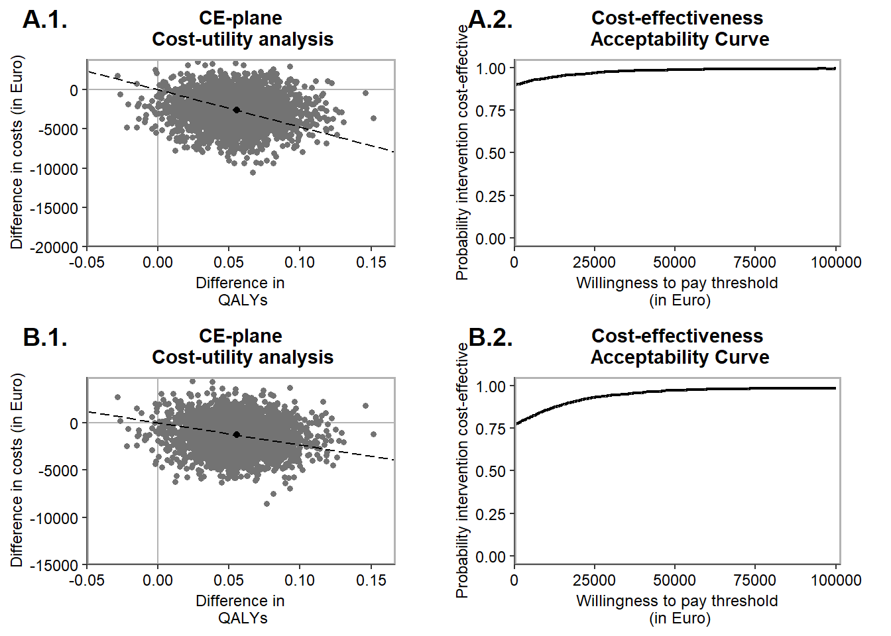

Figure S2 Cost-effectiveness analysis - Societal (“A”; top) & healthcare perspective (“B”; bottom) for Bulgaria
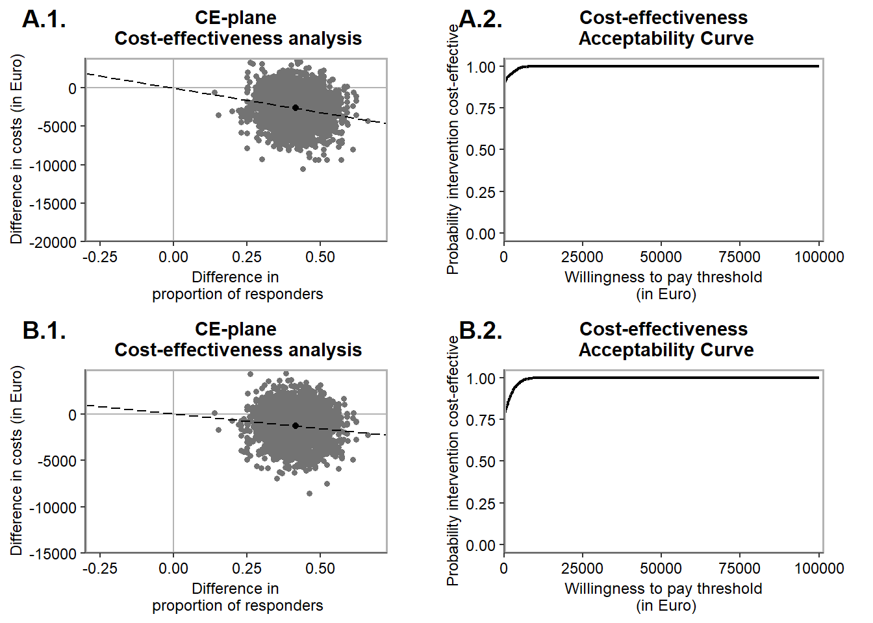

Croatia
In Croatia, the CMHT group demonstrated higher incremental costs and marginally lower incremental QALYs but higher response rates from both a societal and a healthcare perspective. This resulted in CMHT being inferior in terms of costs per QALY and an ICER of €1,920 per responder (see table S2). A large portion of the bootstrap-simulated ICERs were lying in the North-West, South-West, and South-East quadrant of the CE-plane, indicating that the intervention performs relatively similar in terms of costs and effects when compared to the CAU group (see figures S3 & S4).

Table S2 Results of the main analyses for Croatia, based on 2500 bootstrap replications from the imputed sample data
 |  |  |  | Distribution of ICERs over the ICER quadrants, %
 | Incremental costs, € | Incremental effects | Mean bootstrapped ICER/ICUR | NE | NW | SW | SE
CUA, QALY
Main analysis | €144 (-€4,089; €4,327) | -0.004 (-0.077; 0.075) | Inferior | 18 | 35 | 21 | 26
Healthcare perspective | €111 (-€188; €420) | -0.004 (-0.077; 0.075) | Inferior | 33 | 45 | 11 | 11
CEA, WHODAS responder
Main analysis | €144 (-€4,089; €4,327) | 0.075 (-0.088; 0.234) | €1,920 per responder | 42 | 11 | 8 | 39
Healthcare perspective | €111 (-€188; €420) | 0.075 (-0.088; 0.234) | €1,480 per responder | 64 | 14 | 5 | 16

Figure S3 Cost-utility analysis - Societal (“A”; top) & healthcare perspective (“B”; bottom) for Croatia
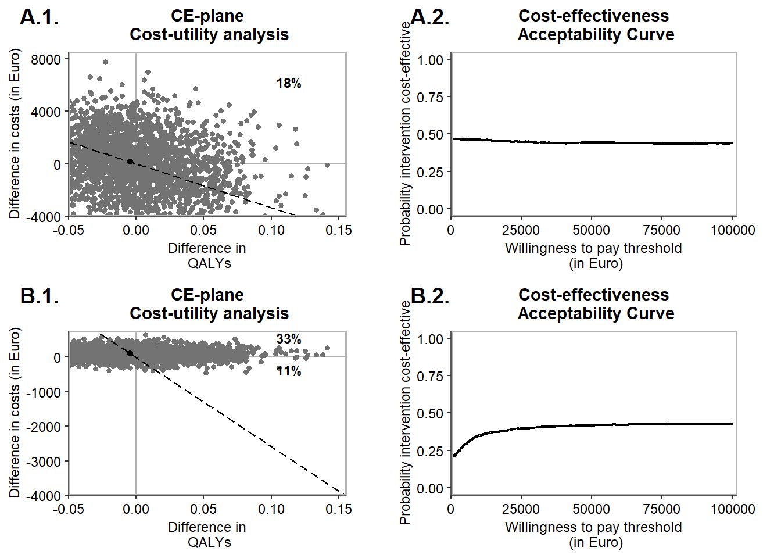

Figure S4 Cost-effectiveness analysis - Societal (“A”; top) & healthcare perspective (“B”; bottom) for Croatia
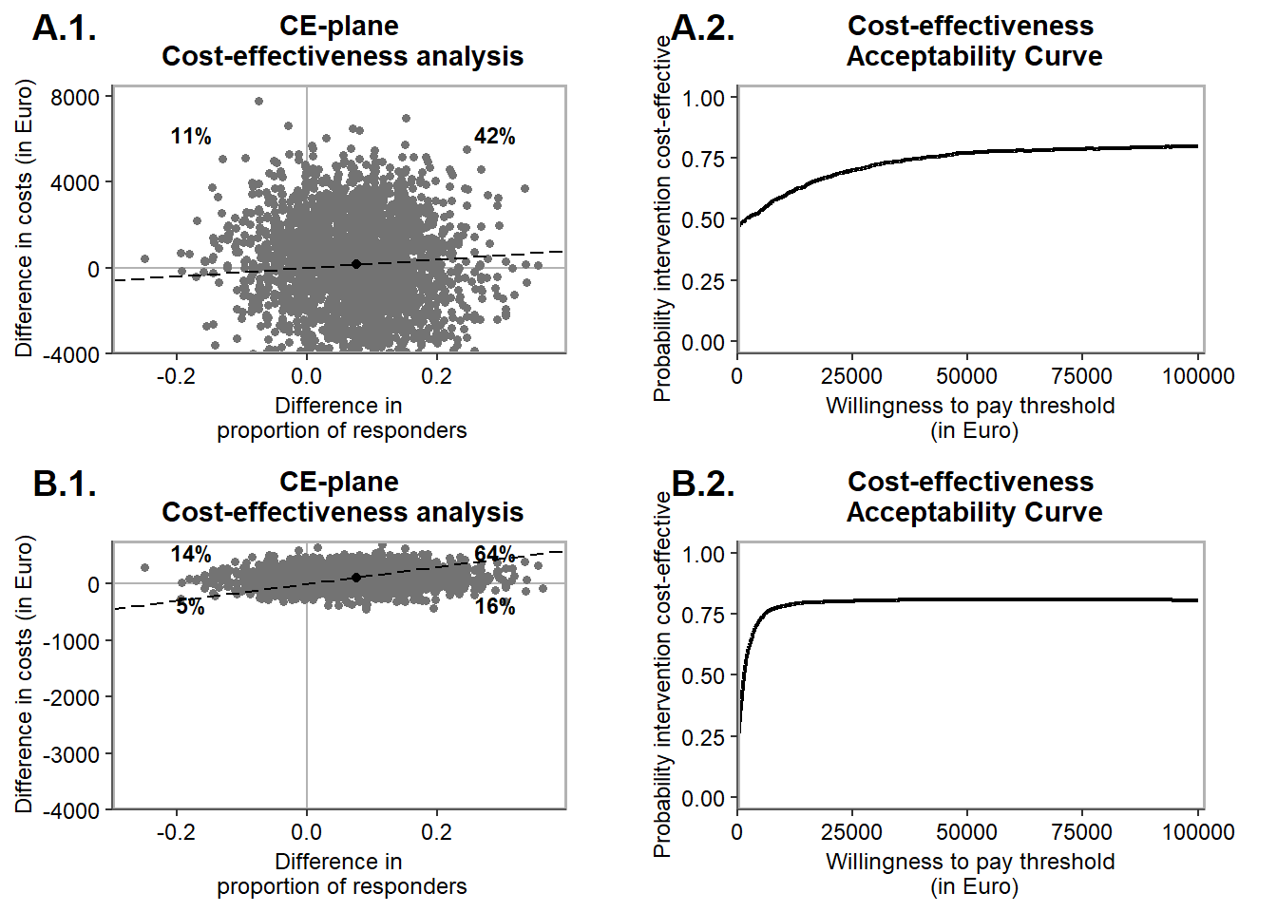

Montenegro
In Montenegro, the CMHT group demonstrated higher incremental costs and marginally higher incremental effects (both in terms of responder rate as well as QALYs) from both a societal and a healthcare perspective. The small difference in effects resulted in relatively high ICERs for both cost costs per QALY gained and costs per responder (see table S3). A large portion of the bootstrap-simulated ICERs were lying in the North-West and North-East quadrant of the CE-plane, indicating that the intervention performs relatively similar in terms of effects when compared to the CAU group but likely results in increased costs (see figures S5 & S6).

Table S3 Results of the main analyses for Montenegro, based on 2500 bootstrap replications from the imputed sample data
 |  |  |  | Distribution of ICERs over the ICER quadrants, %
 | Incremental costs, € | Incremental effects | Mean bootstrapped ICER/ICUR | NE | NW | SW | SE
CUA, QALY
Main analysis | €1,338  (-€1,348; €4,097) | 0.00034  (-0.04138; 0.04357) | €3,935,294 per QALY gained | 41% | 43% | 7% | 10%
Healthcare perspective | 1,028  (-€1,002; €3,059) | 0.00034  (-0.04138; 0.04357) | €3,023,529 per QALY gained | 42% | 43% | 7% | 8%
CEA, WHODAS responder
Main analysis | €1,338  (-€1,348; €4,097) | 0.051  (-0.115; 0.216) | €26,235 per responder | 60% | 23% | 4% | 12%
Healthcare perspective | 1,028  (-€1,002; €3,059) | 0.051  (-0.115; 0.216) | €20,157 per responder | 61% | 23% | 4% | 11%

Figure S5 Cost-utility analysis - Societal (“A”; top) & healthcare perspective (“B”; bottom) for Montenegro

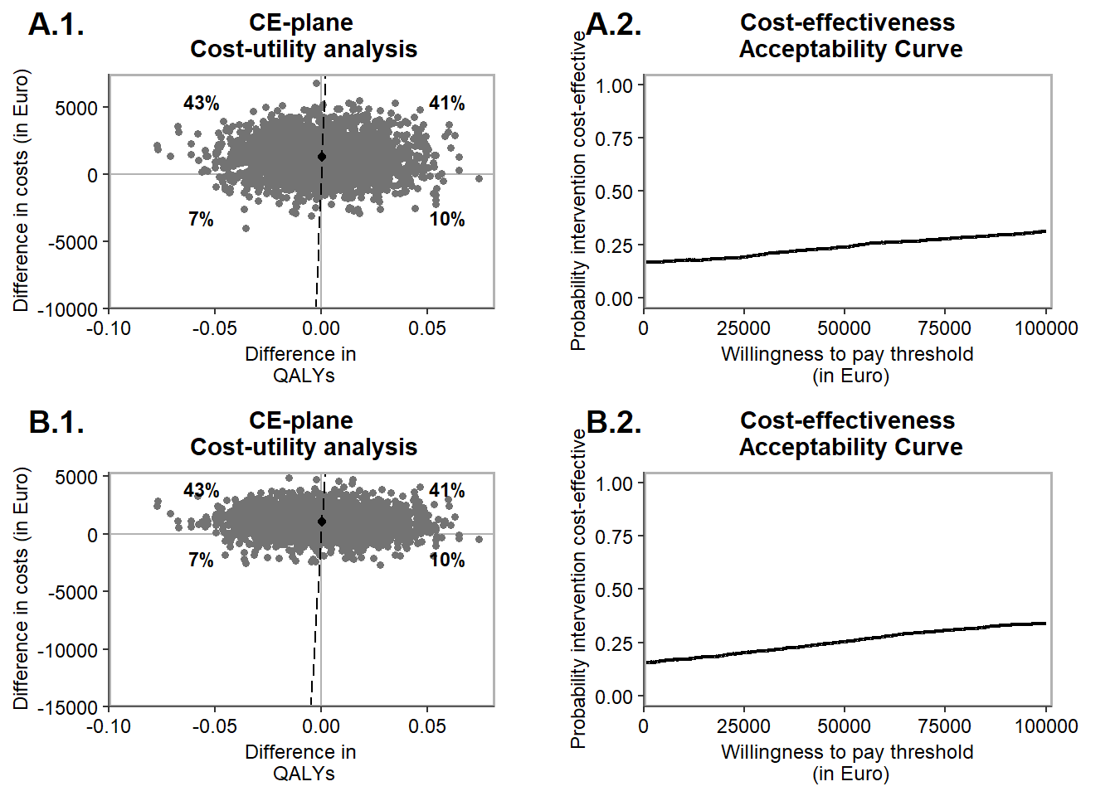

Figure S6 Cost-effectiveness analysis - Societal (“A”; top) & healthcare perspective (“B”; bottom) for Montenegro
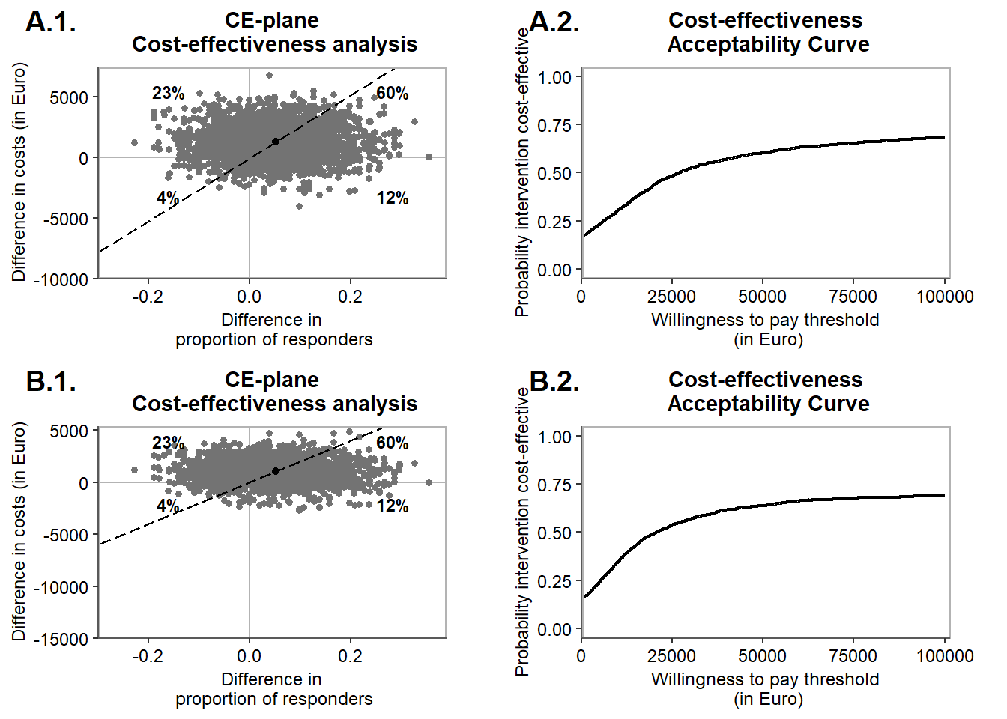

Romania
In Romania, the CMHT group demonstrated higher incremental costs and marginally higher incremental QALYs with marginally lower response rates from both a societal and a healthcare perspective. The small difference in effects resulted in inferior ICERs for cost per responders and relatively high ICERs for the cost per QALY gained (see table 4). A large portion of the bootstrap-simulated ICERs were lying in the North-West quadrant and North-East quadrant of the CE-plane, indicating that the intervention performs relatively similar in terms of effects when compared to the CAU group but likely results in increased costs (see figures S7 & S8).

Table S4 Results of the main analyses for Romania, based on 2500 bootstrap replications from the imputed sample data
 |  |  |  | Distribution of ICERs over the ICER quadrants, %
 | Incremental costs, € | Incremental effects | Mean bootstrapped ICER/ICUR | NE | NW | SW | SE
CUA, QALY
Main analysis | €1,100  (-€2,265; €4,579) | 0.0004  (-0.0462; 0.0487) | €2,750,000 per QALY gained | 36% | 38% | 11% | 14%
Healthcare perspective | €1,354  (-€2,179; €4,733) | 0.0004  (-0.0462; 0.0487) | €3,385,000 per QALY gained | 39% | 41% | 8% | 12%
CEA, WHODAS responder
Main analysis | €1,100  (-€2,265; €4,579) | -0.031  (-0.167; 0.111) | Inferior | 21% | 54% | 16% | 9%
Healthcare perspective | €1,354  (-€2,179; €4,733) | -0.031  (-0.167; 0.111) | Inferior | 22% | 58% | 12% | 8%

Figure S7 Cost-utility analysis - Societal (“A”; top) & healthcare perspective (“B”; bottom) for Romania
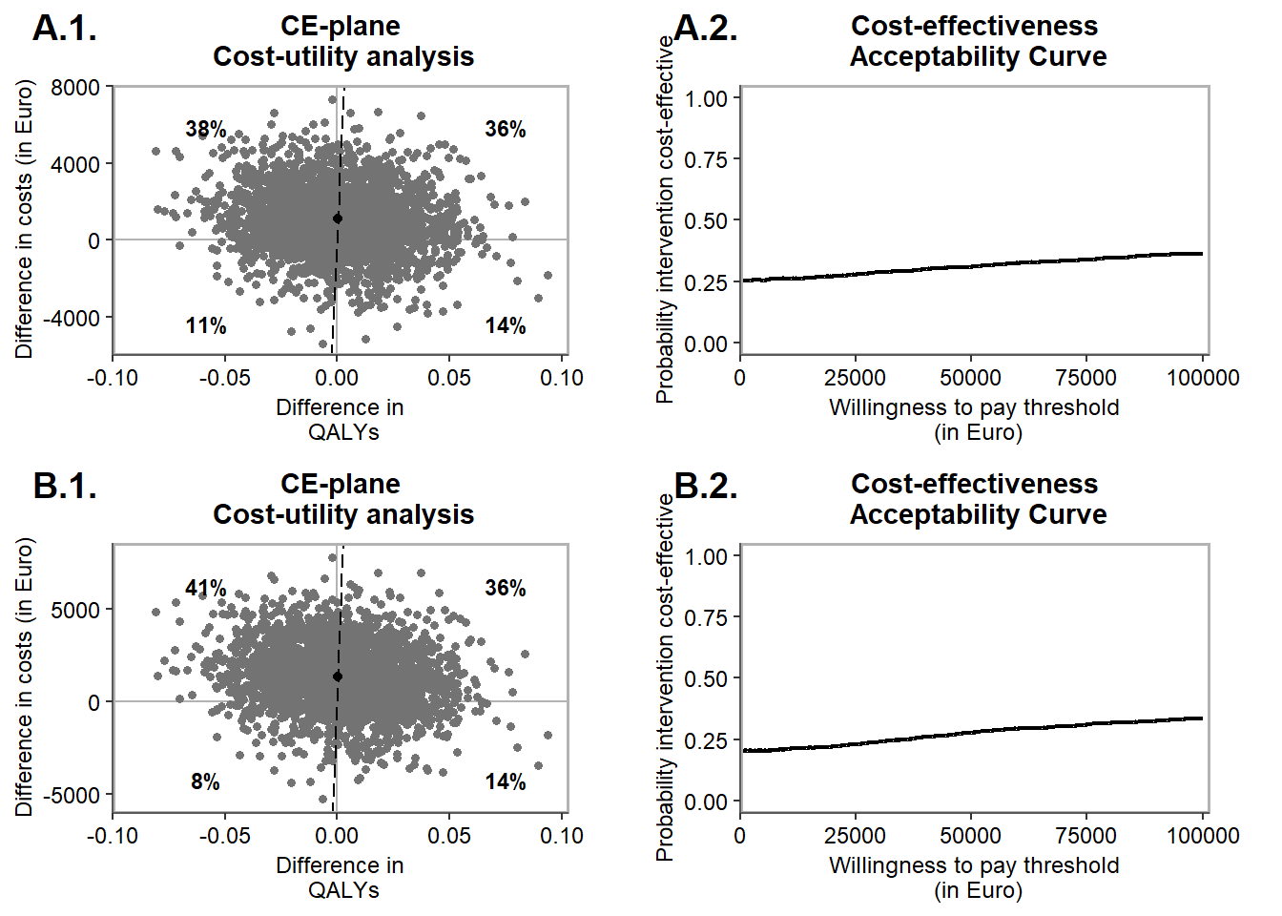

Figure S8 Cost-effectiveness analysis - Societal (“A”; top) & healthcare perspective (“B”; bottom) for Romania
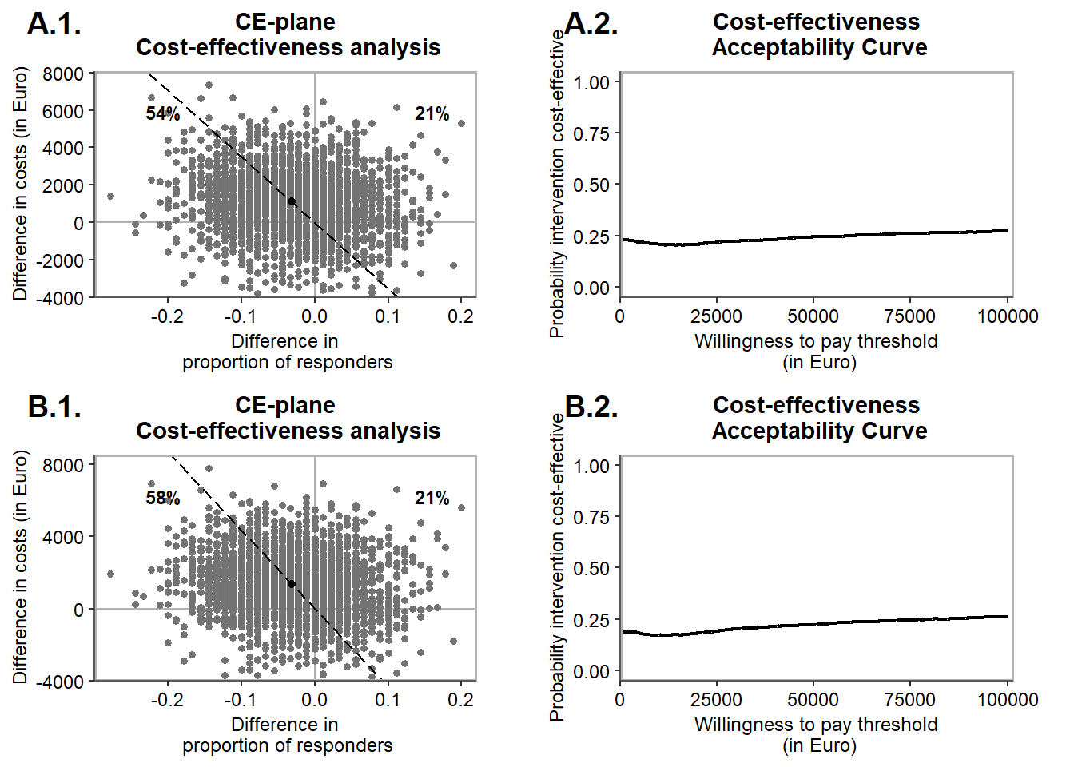

North-Macedonia
In North-Macedonia, the CMHT group demonstrated higher incremental costs and marginally higher incremental QALYs from both a societal and a healthcare perspective. Looking at the responder rate, the CMHT group demonstrated a marginally lower rate. The small difference in effects resulted in inferior ICERs for cost per responders (see table S5). Looking at the cost per QALY gained, ICERs rose above any acceptable willingness to pay threshold. A large portion of the bootstrap-simulated ICERs were lying in the North-West quadrant of the CE-plane, indicating that the intervention performs relatively similar in terms of effects when compared to the CAU group but likely results in increased costs (see figures S9 & S10).

Table S5 Results of the main analyses for North-Macedonia, based on 2500 bootstrap replications from the imputed sample data
 |  |  |  | Distribution of ICERs over the ICER quadrants, %
 | Incremental costs, € | Incremental effects | Mean bootstrapped ICER/ICUR | NE | NW | SW | SE
CUA, QALY
Main analysis | €12,435 (€6,509; €18,389) | 0.043 (-0.032; 0.119) | €289,186 per QALY gained | 86% | 14% | 0% | 0%
Healthcare perspective | €3,368 (€610; €6,945) | 0.043 (-0.032; 0.119) | €78,326 per QALY gained | 85% | 14% | 0% | 1%
CEA, WHODAS responder
Main analysis | €12,435 (€6,509; €18,389) | -0.087 (-0.244; 0.078) | Inferior | 12% | 88% | 0% | 0%
Healthcare perspective | €3,368 (€610; €6,945) | -0.087 (-0.244; 0.078) | Inferior | 12% | 87% | 1% | 0%

Figure S9 Cost-utility analysis - Societal (“A”; top) & healthcare perspective (“B”; bottom) for North-Macedonia
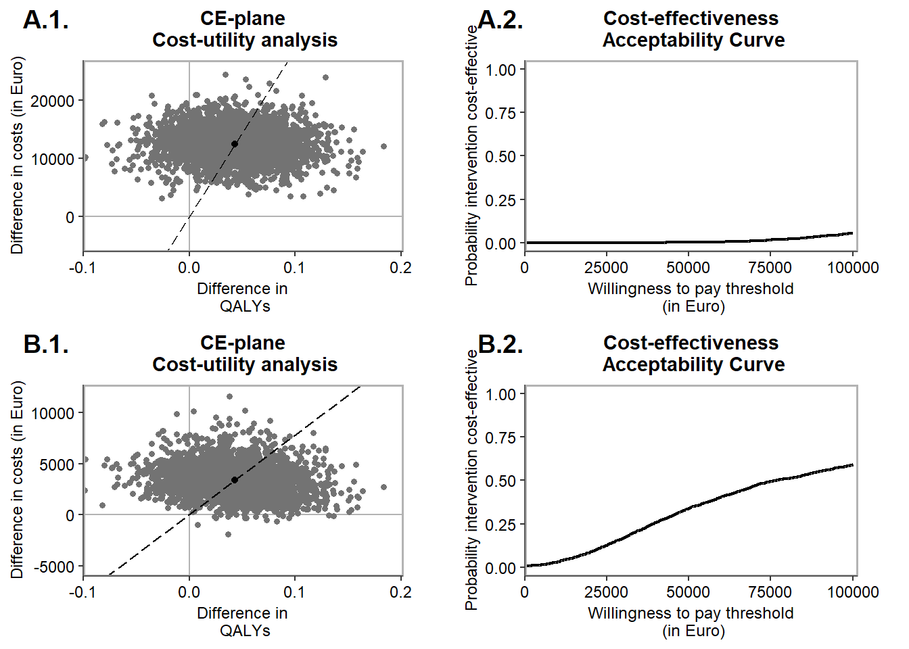

Figure S10 Cost-effectiveness analysis - Societal (“A”; top) & healthcare perspective (“B”; bottom) for North-Macedonia
