Supplemental figures
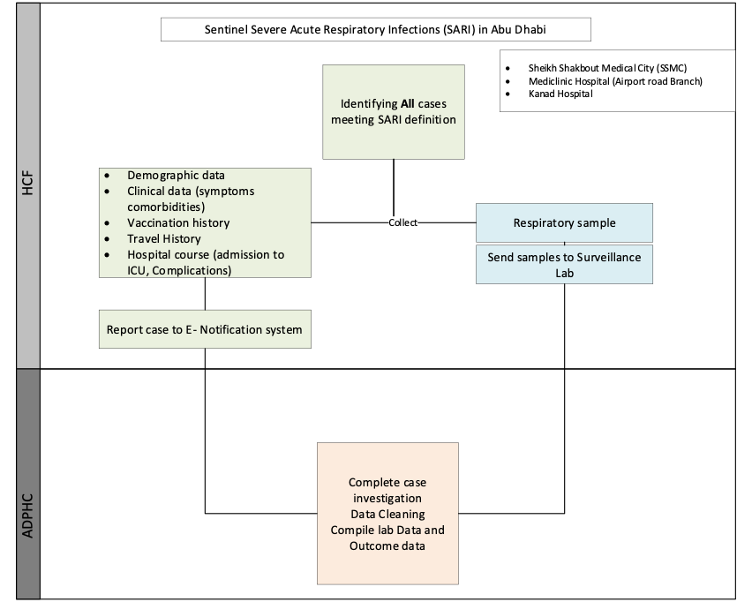
Figure S1. Workflow for SARI and ILI surveillance in the UAE. Schematic diagram representing sentinel surveillance workflow: 1A: Overall workflow from medical network, laboratory, data sharing and reporting of sentinel surveillance; 1B: SARI Laboratory work flow; 1C: ARI Laboratory workflow. The UAE’s Ministry of Health and Prevention (MOHAP) and the Department of Health (DOH) in Abu Dhabi launched sentinel surveillance for SARI and Influenza-like Illnesses (ILI) in 2017 to monitor national influenza trends. In 2022, ILI was reclassified as Acute Respiratory Illness (ARI). Since then, additional respiratory surveillance systems have expanded to track emerging pathogens and enhance capacity. This effort is part of the WHO’s Global Influenza Surveillance and Response System (GISRS), which monitors influenza and other respiratory viruses worldwide, informing vaccine strain selection. The primary goals of the UAE's surveillance are to enhance its preparedness for respiratory pathogens and response measures by providing timely epidemiological data on viral etiology to determine flu season timing, support vaccine development, and track viral evolution. It also identifies high-risk groups, assesses disease severity, estimates the disease burden, monitors antiviral resistance, and detects unusual outbreaks.

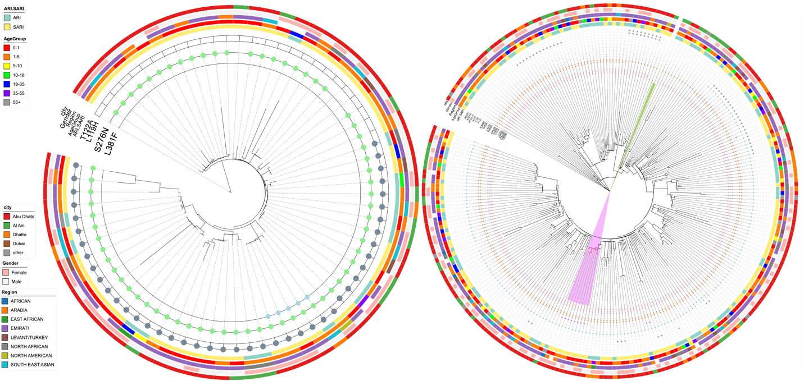
Figure S2. Phylogenetic structure and genomic diversity of local RSV-A and RSV-B strains from the UAE. Maximum-likelihood phylogenetic trees of RSV-A (left) and RSV-B (right) F-gene coding sequences from UAE clinical isolates are shown, annotated with key genomic, demographic, and epidemiological features. Outer colored rings denote infection syndrome (ARI/SARI), age group, genotype/clade assignment, sampling city, patient gender, and regional background. Distinct clusters highlight circulating sub-lineages and corresponding amino-acid substitutions in the F protein, including T122A, S276N, and L381F in RSV-A, and representative mutations in RSV-B. The trees demonstrate that both RSV-A and RSV-B lineages circulating in the UAE during 2021–2024 are genetically diverse yet phylogenetically interspersed with global strains, consistent with repeated viral introductions and sustained local transmission.

Figure S3. RSV-B escape enrichment resolves into two fine-clade backbone ladders within GB5.0.5a. Exact recurrent RSV-B F backbones observed in the UAE cohort are shown separately for B.D.E.1 (top) and B.D.4.1.1 (bottom). The y-axis shows the median matched-public percentile from the primary variant-level analysis, and point size indicates the number of UAE variants carrying each exact backbone. In B.D.E.1, the recurrent core backbone is followed by higher-scoring derived backgrounds carrying S173L, N466S, N116S, and V220I; in B.D.4.1.1, the recurrent core backbone is followed by higher-scoring derived backgrounds carrying A103I, V127I, and G329E. Exploratory within-clade support tests were concordant with the visual ladder structure (B.D.E.1: Kruskal-Wallis p = 6.4 × 10⁻¹⁷; B.D.4.1.1: p = 7.9 × 10⁻⁸). Because the ladder groups were selected from the same dataset, these p-values should be interpreted as internal support for the recurrent ladder structure rather than independent confirmatory inference.

Figure S4. Exploratory analyses of clinical severity and age in relation to RSV-B F-protein substitutions S211N and N466S. (A,C) Distribution of mild acute respiratory infection (ARI) and severe acute respiratory infection (SARI) cases by mutation status for S211N and N466S, respectively. (B,D) Age distributions by mutation status for S211N and N466S, respectively. Univariate P values are from Fisher’s exact tests for severity comparisons and Mann-Whitney U tests for age comparisons. Multivariable P values were obtained from logistic regression models adjusted for clinical covariates as described in Methods. Percentages and sample counts are shown on the bars.
Figure S5. Global frequency of RSV-A F-protein substitutions and clinical associations (2021–2024). Association of two substitutions with clinical phenotype. Bar plots compare the proportion of acute respiratory infection (ARI, mild) versus severe acute respiratory infection (SARI) when the substitution is absent versus present.

