Supporting information
Synthesis and biological evaluation of spirofused pyrazole and pyrrolidine hybrids from tryptanthrin
Devika Krishnan,ª Sruthi S. L.,ª Ashkar Ali B., ^{b} E. G. Jayasree,^{b} Aparna Sahoo^{c,d}, Ankita Lama^{c,d}, Sidharth Chopra,^{c,d} and Ani Deepthi^{a,}*
ªDepartment of Chemistry, University of Kerala, Kariavattom campus, Thiruvananthapuram-695581, Kerala, India
^{b}Department of Applied Chemistry, Cochin University of Science and Technology, Kochi, 682022, Kerala, India
^{c}Division of Molecular Microbiology and Immunology, CSIR-Central Drug Research Institute, Sector 10, Janakipuram Extension, Sitapur Road, Lucknow 226031, Uttar Pradesh, India
^{d}AcSIR: Academy of Scientific and Innovative Research (AcSIR), Ghaziabad 201002, India

Email: anideepthi@gmail.com

Table of Contents
SL. No | Contents | Page No.
1 | Chemicals and Techniques | 1
2 | General Procedure | 2
3 | Spectral Data | 2-10
4 | Spectra | 10-32

1. Chemicals and Techniques
All the derivatives were prepared using tryptanthrins (synthesized using isatins, isatoic anhydrides and triethylamine), benzoic hydrazide and isoniazid under reflux conditions in toluene at 110 ⁰C. All the starting materials, chemical reagents and solvents were purchased from commercial sellers and are used as such without any further purification. The reaction progress was monitored by thin-layer chromatography (TLC) performed on silica gel 60 F254 pre-coated aluminium sheets. TLC was visualized by a 254 nm UV lamp and iodine staining. NMR spectra were recorded on a 400MHz Bruker Avance FTNMR spectrometer using CDCl₃ and DMSO as solvents. Tetramethylsilane (TMS) was used as internal standard (signal at 0 ppm) for ¹H chemical shifts measurements, and coupling constants (J) are reported in hertz (Hz). FTIR spectra were recorded on an Agilent Cary 630 FTIR spectrometer. CHN data was recorded using Perkin Elmer 2400 Series II CHNS/O analyser and melting points were recorded using Optics Technology digital melting/ boiling point apparatus.

2. General procedure
2.1. General procedure for the synthesis of tryptanthrins (1a-h)
Tryptanthrin derivatives were synthesized from the corresponding isatins and isatoic anhydrides according to a previously reported procedure [7]. Isatin (1 mmol) was taken in a round bottom flask, followed by the addition of isatoic anhydride (1 mmol) and triethylamine (5 mmol). A minimal amount of dry toluene was added as solvent and the reaction mixture was refluxed at 110 ℃ for three hours. The precipitated product was filtered, washed using methanol and dried. The product was recrystallized from ethanol.
2.2 General procedure for the synthesis of Spiropyrazole compounds (3a-k)
Hydrazonyl chloride (0.25 mmol) was stirred in acetonitrile in a 50 ml round-bottom flask at room temperature followed by the addition of triethylamine (0.25 mmol) as base for the in-situ generation of nitrile imine. It is then added with tryptanthrin ylidene (0.25 mmol and allowed to stir for 3-4 hours. The completion of reaction was observed from TLC, and the product was isolated by silica gel column chromatography using 80:20 hexane-ethyl acetate in 78- 92% yield.
2.3 General procedure for the synthesis of dispiropyrrolidine compounds (6a-k)
The dispiropyrrolidine compounds were synthesized by a three-component reaction of isatin (1 mmol), sarcosine (2 mmol) and tryptanthrin ylidene (1 mmol) by refluxing in ethanol- toluene mixture for 85℃ until complete consumption of isatin was observed from TLC. The product was isolated by silica gel column chromatography using 70:30 hexane-ethyl acetate in 70- 91% yield.
3. Spectral data
3.1 Ethyl-12-oxo-2',5'-diphenyl-2',4'-dihydro-12H-spiro[indolo[2,1-b]quinazoline-6,3'-pyrazole]-4'-carboxylate, C₃₂H₂₄N₄O_{3,} (3a): Light yellow powder; Yield: 92%; mp: 278-280 ℃; FTIR (cm⁻¹): 3030, 2917, 1713, 1672, 1639, 1590, 1337, 1315. ¹H NMR (δ ppm, 400 MHz, CDCl₃): 8.66 (d, J=8 Hz, 1H), 8.48 (d, J=8 Hz, 1H), 7.78-7.74 (m, 4H), 7.61-7.55 (m, 2H), 7.47-7.42 (m, 4H), 7.28-7.24 (m, 1H), 7.02 (t, J=8 Hz, 2H), 6.77-6.74 (m, 3H), 5.24 (s, 1H), 3.78 (q, J=10.1 Hz, 2H), 0.81 (t, J=7.2 Hz, 3H). ¹³C NMR (δ ppm, 100 MHz, CDCl₃): 166.5, 163.8, 159.7, 159.0, 147.1, 144.1, 142.6, 139.3, 134.7, 131.6, 131.2, 129.0, 128.9, 128.6, 128.4, 128.3, 127.8, 127.5, 126.9, 126.8, 126.7, 126.1, 125.9, 121.7, 121.3, 117.2, 115.5, 115.3, 65.5, 61.7, 29.7, 13.5. Elemental Analysis: Analytically calculated (%): C, 74.99; H, 4.72; N, 10.93; O, 9.36 Found %: C, 7.98; H, 4.73; N, 10.94
3.2 Ethyl-8-chloro-12-oxo-2',5'-diphenyl-2',4'-dihydro-12H-spiro[indolo[2,1-b]quinazoline-6,3'-pyrazole]-4'-carboxylate; C₃₂H₂₃ClN₄O₃, (3b): Light yellow powder; Yield: 88%; mp: 273-275 ℃; FTIR (cm⁻¹): 3032, 2919, 1717, 1679, 1632, 1593,1339, 1317. ¹H NMR (δ ppm, 400 MHz, CDCl₃): 8.52 (d, J=8.4 Hz, 1H), 8.37-8.35 (dd, J=8 Hz, J=0.8 Hz, 1H), 7.69-7.64 (m, 4H), 7.52-7.47 (m, 1H), 7.43-7.40 (m, 1H), 7.37-7.31 (m, 4H), 7.02 (t, J=8 Hz, 2H), 6.95 (t, J=8 Hz, 2H), 6.72-6.66 (m, 3H), 5.1 (s, 1H), 3.78 (q, J=7.2 Hz, 2H), 0.81 (t, J=7.2 Hz, 3H). ¹³C NMR (δ ppm, 100 MHz, CDCl₃): 166.4, 163.4, 160.8, 159.5, 147.0, 144.3, 142.4, 140.2, 134.8, 132.5, 131.3, 130.4, 129.7, 129.2, 129.1, 128.6, 128.5, 128.3, 128.0, 127.5, 127.0, 126.1, 125.74, 123.5, 122.7, 121.6, 118.2, 115.3, 65.7, 62.0, 29.5, 13.5. Elemental Analysis: Analytically calculated %: C,70.26; H, 4.24; Cl, 6.48; N, 10.24; O, 8.77 Found %: C, 70.27; H, 4.25; N, 10.25.
3.3 Ethyl-8-bromo-12-oxo-2',5'-diphenyl-2',4'-dihydro-12H-spiro[indolo[2,1-b]quinazoline-6,3'-pyrazole]-4'-carboxylate; C₃₂H₂₃BrN₄O₃, (3c): Light yellow powder; Yield: 85%; mp: 276-278 ℃; FTIR (cm⁻¹): 3034, 2919, 1715, 1675, 1636, 1598, 1335, 1318. ¹H NMR (δ ppm, 400 MHz, CDCl₃): 8.56 (d, J=8.4 Hz, 1H) 8.45 (d, J=8 Hz, 1H), 7.79-7.74 (m, 4H), 7.69-7.66 (dd, J=8.8 Hz, J=2 Hz, 1H) 7.61-7.57 (dt, J=7.3 Hz, J=4.3 Hz, 2H), 7.47-7.41 (m, 3H), 7.05 (t, J=8 Hz, 2H), 6.82-6.75 (m, 3H), 5.22 (s, 1H), 3.88 (q, J=9.2 Hz, 2H), 0.92 (t, J=7.2 Hz, 3H).¹³C NMR (δ ppm, 100 MHz, CDCl₃): 170.6, 166.4, 159.5, 159.4, 146.5, 145.6, 142.9, 140.3, 140.2, 138.2, 134.8, 134.2, 133.9, 131.4, 129.8, 129.3, 129.1, 128.6, 128.5, 126.4, 126.1, 125.7, 123.5, 122.0, 121.6, 118.4, 115.8, 115.3, 65.8, 62.0, 29.7, 13.6. Elemental Analysis: Analytically calculated %: C, 64.50; H, 3.29; N, 10.75. Found %: C, 64.52; H, 3.31; N, 10.77.
3.4 Ethyl-8-fluoro-12-oxo-2',5'-diphenyl-2',4'-dihydro-12H-spiro[indolo[2,1-b]quinazoline-6,3'-pyrazole]-4'-carboxylate; C₃₂H₂₃FN₄O₃ (3d): Yellow powder; Yield: 87%; mp: 280-282 ℃; FTIR (cm⁻¹): 3171, 3051, 1680, 1628, 1546, 1456, 1337, 1248, 1156, 1061. ¹H NMR (δ ppm, 400 MHz, CDCl₃): 8.53 (q, J=4.4 Hz, 1H), 8.31 (d, J=1.6 Hz, 2H), 7.66 - 7.60 (m, 4H), 7.36-7.32 (m, 3H), 7.14-7.08 (m, 3H), 6.95 (t, J=8 Hz, 2H), 6.72-6.63 (m, 2H), 5.12 (s, 1H), 3.78 (q, J=4.6 Hz, 2H), 0.80 (t, J=7 Hz, 3H). ¹³C NMR (δ ppm, 100 MHz, CDCl₃): 165.3, 158.7, 158.0, 157.2, 144.4, 143.4, 141.4, 134.2, 134.1, 133.0, 130.3, 128.7, 128.2, 128.0, 127.6, 125.3, 125.1, 121.7, 120.8, 117.7, 117.6, 117.2, 116.9, 114.4, 112.8, 112.5, 64.5, 61.0, 28.6, 12.6. Elemental Analysis: Analytical calculated (%): C, 72.44; H, 4.37; N, 10.56. Found (%): 72.40; H, 4.35; N, 10.52.
3.5 Ethyl-8-methoxy-12-oxo-2',5'-diphenyl-2',4'-dihydro-12H-spiro[indolo[2,1-b]quinazoline-6,3'-pyrazole]-4'-carboxylate; C₃₃H₂₆N₄O₄ (3e): Yellow powder; Yield: 78%; mp: 286-288 ℃; FTIR (cm⁻¹): 3170, 3059, 1672, 1630, 1540, 1450, 1330, 1250, 1158, 1065. ¹H NMR (δ ppm, 400 MHz, CDCl₃): 8.61 (d, J=8.8 Hz, 1H) 8.45 (t, J=6.2 Hz, 1H), 7.84 (d, J=8 Hz, 1H), 7.81-7.74 (m, 2H) 7.69-7.58 (m, 2H), 7.53-7.41 (m, 3H), 7.07-6.96 (m, 2H), 6.94-6.85 (m, 3H), 6.78 (q, J=8.4 Hz, 2H), 5.22 (s, 1H), 3.87 (q, J=7.2 Hz, 2H), 3.76 (s, 3H), 0.80 (t, J=7.28 Hz, 3H). ¹³C NMR (δ ppm, 100 MHz, CDCl₃): 166.3, 166.1, 158.5, 158.3, 145.5, 145.1, 144.4, 142.4, 137.9, 136.8, 135.2, 134.3, 134.1, 131.3, 129.8, 129.7, 129.3, 129.1, 129.0, 128.7, 126.4, 126.2, 126.1, 122.7, 121.8, 120.3, 118.7, 115.4, 65.7, 62.1, 57.1, 29.3, 13.6. Elemental Analysis: Analytical calculated (%): C, 73.05; H, 4.83; N, 10.33. Found (%): C, 73.01; H, 4.85; N, 10.30.
3.6 Ethyl 8-bromo-2-chloro-12-oxo-2',5'-diphenyl-2',4'-dihydro-12H-spiro[indolo[2,1-b]quinazoline-6,3'-pyrazole]-4'-carboxylate; C₃₂H₂₂BrClN₄O₃, (3f): Yellow powder; Yield: 83%; mp: 288-290 ℃; FTIR (cm⁻¹): 3032, 2914, 1717, 1677, 1637, 1599, 1334, 1312. ¹H NMR (δ ppm, 400 MHz, CDCl₃): 8.44 (d, J=8.8 Hz, 1H), 8.30 (d, J=2.4 Hz, 1H), 7.66-7.51 (m, 5H), 7.51 (d, J=2.4 Hz, 1H), 7.38-7.32 (m, 3H), 6.95 (2H, t, J= 8Hz), 6.73-6.64 (3H, m), 5.09 (s, 1H), 3.80 (q, J=2.9 Hz, 2H), 0.83 (t, J=7.2 Hz, 3H).¹³C NMR (δ ppm, 100 MHz, CDCl₃): 168.6, 166.3, 158.5, 158.3, 145.5, 144.4, 142.4, 137.9, 135.2, 134.3, 134.1, 131.3, 129.8, 129.3, 129.1, 129.0, 128.7, 126.4, 126.1, 122.7, 121.8, 120.3, 119.0, 118.6, 115.4, 115.4, 65.7, 62.1, 29.7, 13.6. Elemental Analysis: Analytical calculated (%): C, 61.41; H, 3.54; N, 8.95. Found (%): C, 61.40; H, 3.55; N, 8.92.
3.7 Ethyl-8-bromo-2'-(4-fluorophenyl)-12-oxo-5'-phenyl-2',4'-dihydro-12H-spiro[indolo[2,1-b]quinazoline-6,3'-pyrazole]-4'-carboxylate; C₃₂H₂₂BrFN₄O₃ (3g): Yellow powder; Yield: 82%; mp: 290-292 ℃; FTIR (cm⁻¹): 3178, 3045, 1685, 1630, 1545, 1450, 1335, 1240, 1160, 1070. ¹H NMR (δ ppm, 400 MHz, CDCl₃): 8.62 (d, J=2 Hz, 1H), 8.38 (d, J=7.6 Hz, 1H), 7.82-7.77 (m, 1H), 7.72-7.69 (m, 1H), 7.67-7.60 (m, 2H), 7.52 (t, J=7.4 Hz, 1H), 7.05 (t, J=8.6 Hz, 3H), 6.95 (t, J=8Hz, 3H), 6.71 (q, J=7.2 Hz, 2H), 6.64 (d, J=7.6 Hz, 1H), 5.11 (s, 1H), 3.73 (q, J=3.3 Hz, 2H), 0.78 (t, J=8.6 Hz, 3H). ¹³C NMR (δ ppm, 100 MHz, CDCl₃): 166.3, 162.8, 159.8, 159.4, 146.8, 142.4, 140.0, 137.1, 135.2, 135.0, 130.2, 129.9, 129.0, 128.3, 128.1, 128.0, 127.9, 127.1, 126.9, 126.7, 125.0, 121.8, 117.7, 115.9, 115.7, 115.5, 65.4, 62.0, 29.7, 14.1. Elemental Analysis: Analytical calculated (%): C, 63.06; H, 3.64; N, 9.19; Found (%): C, 63.05; H, 3.66; N, 9.18.
3.8 Ethyl-8-bromo-2-chloro-2'-(4-fluorophenyl)-12-oxo-5'-phenyl-2',4'-dihydro-12H-spiro[indolo[2,1-b]quinazoline-6,3'-pyrazole]-4'-carboxylate; C₃₂H₂₁BrClFN₄O₃ (3h): Yellow powder; Yield: 80%; mp: 296-298 ℃; FTIR (cm⁻¹): 3172, 3051, 1682, 1630, 1552, 1455, 1335, 1250, 1158, 1065. ¹H NMR (δ ppm, 400 MHz, CDCl₃): 8.44 (d, J=8.4 Hz, 1H), 8.31 (d, J=2.4 Hz, 1H), 7.65-7.58 (m, 5H), 7.49 (d, J=2 Hz, 1H), 7.05 (t, J=8.6 Hz, 2H), 6.98-6.92 (m, 2H), 6.72 (t, J=7.2 Hz, 1H), 6.63 (d, J=7.6 Hz, 2H), 5.07 (s, 1H), 3.79 (q, J=2.6 Hz, 2H), 0.83 (t, J=7.2 Hz, 3H). ¹³C NMR (δ ppm, 100 MHz, CDCl₃): 166.2, 160.3, 158.4, 158.3, 145.4, 143.4, 142.4, 137.9, 135.2, 134.3, 134.2, 129.8, 129.1, 128.9, 128.8, 128.0, 127.9, 126.4, 122.7, 121.9, 120.3, 118.7, 115.9, 115.7, 115.4, 65.6, 62.2, 29.7, 13.6. Elemental Analysis: Analytical calculated (%): C, 59.69; H, 3.29; N, 8.70; Found (%): C, 59.66; H, 3.28; N, 8.69
3.9 Ethyl (4'S,6S)-8-bromo-12-oxo-5'-phenyl-2'-(4-(trifluoromethyl)phenyl)-2',4'-dihydro-12H-spiro[indolo[2,1-b]quinazoline-6,3'-pyrazole]-4'-carboxylate; C₃₃H₂₂BrF₃N₄O₃ (3i): Yellow powder; Yield: 87%; mp: 300-302 ℃; FTIR (cm⁻¹): 3175, 3051, 1680, 1630, 1544, 1450, 1335, 1240, 1150, 1060. ¹H NMR (δ ppm, 400 MHz, CDCl₃): 8.38 (d, J=1.6 Hz, 1H), 8.36 (d, J=1.2 Hz, 1H), 7.99-7.91 (m, 1H), 7.75-7.67 (m, 3H), 7.62-7.58 (m, 4H), 7.54-7.51 (m, 1H), 7.47-7.45 (m, 1H), 6.98 (t, J=8 Hz, 2H), 6.75-6.67 (m, 2H), 5.13 (s, 1H), 3.79 (q, J=7.2 Hz, 2H), 0.82 (t, J=6 Hz, 3H). ¹³C NMR (δ ppm, 100 MHz, CDCl₃): 167.2, 166.1, 159.5, 158.4, 146.3, 142.0, 140.8, 138.2, 134.9, 134.4, 130.9, 129.5, 129.2, 128.8, 128.3, 128.2, 127.0, 126.4, 126.2, 125.6, 124.6, 123.7, 123.2, 122.2, 120.1, 118.6, 115.8, 115.5, 65.3, 62.3, 29.7, 14.1. Elemental Analysis: Analytical calculated (%): C, 60.10; H, 3.36; N, 8.50; Found (%): C, 60.12; H, 3.34; N, 8.51.
3.10 Ethyl(4'S,6S)-8-bromo-2-chloro-12-oxo-5'-phenyl-2'-(4-(trifluoromethyl)phenyl)-2',4'-dihydro-12H-spiro[indolo[2,1-b]quinazoline-6,3'-pyrazole]-4'-carboxylate; C₃₃H₂₁BrClF₃N₄O₃ (3j): Yellow powder; Yield: 85%; mp: 295-297 ℃; FTIR (cm⁻¹): 3168, 3050, 1685, 1636, 1550, 1459, 1340, 1250, 1158, 1065. ¹H NMR (δ ppm, 400 MHz, CDCl₃): 8.44 (d, J=8.8 Hz, 1H), 8.31 (d, J=2.4 Hz, 1H), 7.74 (d, J=8.4 Hz, 2H), 7.65-7.56 (m, 5H), 7.48 (d, J=1.6 Hz, 1H), 6.98 (t, J=8 Hz, 2H), 6.75 (t, J=7.6 Hz, 1H), 6.70-6.64 (m, 2H), 5.10 (s, 1H), 3.80 (q, J=7 Hz, 2H), 0.83 (t, J=7 Hz, 3H). ¹³C NMR (δ ppm, 100 MHz, CDCl₃): 166.0, 160.0, 158.2, 158.2, 145.4, 142.8, 141.9, 137.9, 135.3, 134.7, 134.5, 134.3, 129.8, 129.2, 128.8, 128.6, 126.5, 126.3, 126.1, 125.6, 122.7, 122.6, 122.3, 120.4, 119.1, 118.7, 115.6, 65.2, 62.3, 29.7, 13.6. Elemental Analysis: Analytical calculated (%): C, 57.12; H, 3.05; N, 8.07; Found (%): C, 57.13; H, 3.02; N, 8.05.
3.11 (R)-12-oxo-2',5'-diphenyl-12H-spiro[indolo[2,1-b]quinazoline-6,3'-pyrazole]-4',4'(2'H)-dicarbonitrile; C₃₁H₁₈N₆O (3k): Yellow powder; Yield: 93%; mp: 298-300 ℃; FTIR (cm⁻¹): 2105, 1676, 1594, 1486, 1456, 1352, 1229, 1095. ¹H NMR (δ ppm, 400 MHz, CDCl₃): 8.80 (d, J=7.6 Hz, 1H), 8.71 (d, J=8 Hz, 1H), 8.51 (d, J=7.6 Hz, 1H), 8.41-8.39 (dd, J=0.8 Hz, J=8 Hz, 1H), 8.10-8.06 (m, 2H), 8.02-8.00 (dd, J=0.6 Hz, J=8.4 Hz, 1H), 7.86-7.83 (m, 1H), 7.79-7.74 (m, 3H), 7.69-7.65 (m, 1H), 7.59-7.55 (m, 2H), 7.08 (t, J=8 Hz, 2H), 6.95-6.85 (m, 2H). ¹³C NMR (δ ppm, 100 MHz, CDCl₃): 162.9, 159.3, 158.9, 146.2, 145.8, 142.0, 141.4, 134.9, 133.5, 133.0, 129.8, 129.1, 128.5, 128.4, 127.1, 126.6, 126.4, 126.1, 124.5, 122.0, 119.8, 118.6, 118.0, 116.8, 116.5, 116.2, 109.9, 109.4, 68.9, 53.2. Elemental Analysis: Analytical calculated (%): C, 75.91; H, 3.70; N, 17.13; Found (%): C, 75.93; H, 3.71; N, 17.10
3.12 Ethyl-1'-methyl-2,12''-dioxo-12''H-dispiro[indoline-3,2'-pyrrolidine-3',6''- indolo[2,1-b]quinazoline]-4'-carboxylate; C₂₉H₂₄N₄O₄ (6a): Yellow solid; Yield: 85%; mp: 250-252 ℃; FTIR (cm⁻¹): 1722, 1705, 1695, 1514, 750. ¹H NMR (δ ppm, 400 MHz, CDCl₃): 10.46 (s, 1H), 8.32-8.27 (m, 2H), 8.19 (q, J=7.8, 1H), 8.00 (s, 1H), 7.58-7.49 (m, 3H), 7.36 (t, J=7.4 Hz, 1H), 6.95 (t, J=7.7 Hz, 1H), 6.53 (t, J=7.6 Hz, 2H), 6.12 (d, J=7.5 Hz, 1H), 4.95 (q, J=5.8 Hz, 2H), 3.78 (t, J=10 Hz, 1H), 3.69-3.61 (m, 1H), 3.50-3.44 (m, 1H), 2.22 (s, 3H), 0.50 (t, J=7.1 Hz, 3H). ¹³C NMR (δ ppm, 100 MHz, CDCl₃): 176.4, 169.8, 159.5, 155.6, 146.9, 141.7, 139.2, 134.3, 132.7, 132.2, 130.1, 129.7, 127.9, 127.3, 126.7, 125.8, 122.6, 122.3, 121.1, 119.1, 117.8, 109.8, 78.6, 60.6, 51.6, 49.1, 35.0, 29.7, 13.3. Elemental Analysis: Analytical calculated (%): C, 60.96; H, 4.06; N, 9.80; Found (%): C, 60.94; H, 4.06; N, 9.81.
3.12 Ethyl-8''-chloro-1'-methyl-2,12''-dioxo-12''H-dispiro[indoline-3,2'-pyrrolidine- 3',6''-indolo[2,1-b]quinazoline]-4'-carboxylate; C₂₉H₂₃ClN₄O₄ (6b): Yellow solid; Yield: 91%; mp: 214-216 ℃; FTIR (cm⁻¹): 1721, 1718,1685, 1575, 690. ¹H NMR (δ ppm, 400 MHz, CDCl₃): 10.89 (s, 1H). 8.32 (d, J=8.8 Hz, 1H), 8.23-8.21 (m, 1H), 8.13-8.12 (m, 1H), 7.66-7.65 (m, 1H), 7.59-7.57 (m, 1H), 7.44-7.40 (m, 2H), 7.32-7.30 (m, 1H), 6.57-6.53 (m, 1H), 6.45 (d, J=8 Hz, 1H), 6.34 (d, J=7.2 Hz, 1H), 4.06 (q, J=8.8 Hz, 2H), 2.56-2.54 (m, 1H), 2.30 (t, J=7.6 Hz, 2H), 1.96 (s, 3H), 0.68 (t, J=6.8 Hz, 3H). ¹³C NMR (δ ppm, 100 MHz, CDCl₃): 175.6, 165.1, 157.2, 140.7, 139.0, 137.2, 135.5, 134.7, 131.7, 130.0, 129.1, 128.4, 128.1, 127.3, 125.0, 121.0, 119.9, 119.7, 118.1, 116.4, 113.2, 110.2, 86.2, 61.5, 52.7, 46.7, 29.7, 22.7, 14.1. Elemental Analysis: Analytical calculated (%): C, 70.72; H, 4.91; N, 11.38; Found (%): C, 70.70; H, 4.92; N, 11.36.
3.13 Ethyl-8''-bromo-1'-methyl-2,12''-dioxo-12''H-dispiro[indoline-3,2'-pyrrolidine- 3',6''-indolo[2,1-b]quinazoline]-4'-carboxylate; C₂₉H₂₃BrN₄O₄ (6c): Yellow solid; Yield: 88%; mp: 225-227 ℃; FTIR (cm⁻¹): 1724, 1719, 1691, 1595, 1450. ). ¹H NMR (δ ppm, 400 MHz, DMSO-d6): 10.71 (s, 1H), 8.10 (d, J=7.7, 1H), 8.02 (q, J=5, 1H), 7.84 (d, J=7.8, 1H), 7.79-7.71 (m, 1H), 7.59 (d, J=8.2 Hz, 1H), 7.48-7.41 (m, 1H), 7.26-7.19 (m, 1H), 7.14 (d, J=8.2 Hz, 1H), 6.96 (dd, J=10.4 J=2.4 Hz, 1H), 6.45 (d, J=2.4Hz, 1H), 6.04- 5.99 (m, 1H), 4.67 (d, J=11 Hz, 2H), 4.25 (d, J=11.7 Hz, 1H), 4.20- 4.16 (m, 1H), 4.01- 3.94 (m, 1H), 2.99 (s, 3H), 0.85 (t, J=6.3 Hz, 3H). ¹³C NMR (δ ppm, 100 MHz, DMSO-d6): 182.0, 171.2, 159.4, 144.0, 141.0, 139.4, 137.6, 135.8, 135.6, 132.9, 129.3, 128.3, 127.9, 125.9, 124.3, 121.2, 120.0, 117.3, 116.2, 116.0, 112.1, 83.0, 67.6, 60.1, 46.2, 33.3, 23.2, 15.1, 9.1. Elemental Analysis: Analytical calculated (%): C, 66.10; H, 4.40; N, 10.63; Found (%): C, 66.10; H, 4.42; N, 10.62.
3.14 Ethyl-8''-fluoro-1'-methyl-2,12''-dioxo-12''H-dispiro[indoline-3,2'-pyrrolidine- 3',6''-indolo[2,1-b]quinazoline]-4'-carboxylate; C₂₉H₂₃FN₄O₄ (6d): Yellow solid; Yield: 80%; mp: 252-254 ℃; FTIR (cm⁻¹): 1723, 1714, 1683, 1584, 720. ¹H NMR (δ ppm, 400 MHz, DMSO-d6): 10.2 (s, 1H), 8.02 (q, J=5.1 Hz, 1H), 7.84 (d, J=7.8 Hz, 1H), 7.78-7.71 (m, 3H), 7.59 (d, J=8.2 Hz, 1H), 7.48-7.41 (m, 2H), 6.96 (d, J=11 Hz, 1H), 6.48-6.42 (m, 1H), 6.04- 5.99 (m, 1H), 4.67 (d, J=11.6 Hz, 2H), 4.20- 4.16 (m, 1H), 4.01- 3.94 (m, 2H), 2.92 (s, 3H), 1.13 (t, J=7 Hz, 3H). ¹³C NMR (δ ppm, 100 MHz, DMSO-d6): 174.4, 165.3, 156.5, 137.4, 137.2, 136.6, 130.6, 128.8, 128.0, 127.7, 127.2, 124.6, 124.4, 123.3, 121.4, 120.8, 120.2, 120.0, 118.9, 114.2, 112.3, 107.6, 73.3, 62.4, 55.3, 42.5, 29.4, 22.5, 14.4. Elemental Analysis: Analytical calculated (%): C, 68.23; H, 4.54; N, 10.97; Found (%): C, 68.24; H, 4.55; N, 10.96.
3.15 Ethyl-8''-methoxy-1'-methyl-2,12''-dioxo-12''H-dispiro[indoline-3,2'- pyrrolidine-3',6''-indolo[2,1-b]quinazoline]-4'-carboxylate; C₃₀H₂₆N₄O₅ (6e): Yellow solid; Yield: 74%; mp: 260-262 ℃; FTIR (cm⁻¹): 1725, 1718, 1690, 1591, 735. ¹H NMR (δ ppm, 400 MHz, DMSO-d6): 11.67 (s, 1H), 8.49 (d, J=7.6 Hz, 2H), 8.33 (d, J=8 Hz, 2H), 7.96 (d, J=3.6 Hz, 2H), 7.90-7.86 (m, 2H), 7.73-7.77 (m, 1H), 7.49 (t, J=7.6 Hz, 2H), 4.34 (q, J=3.6 Hz, 2H), 3.73 (s. 3H), 2.68-2.66 (m, 1H), 2.33-2.32 (m, 2H), 1.97 (s, 3H), 0.69 (t, J=9.2 Hz, 3H). ¹³C NMR (δ ppm, 100 MHz, DMSO-d6): 181.8, 170.8, 158.1, 146.8, 145.4, 144.9, 137.3, 135.9, 135.8, 131.6, 130.5, 130.4, 127.4, 124.7, 124.4, 123.6, 121.4, 119.6, 119.0, 114.6, 110.7, 82.7, 60.8, 56.4, 46.3, 32.2, 25.7, 21.5, 12.8. Elemental Analysis: Analytical calculated (%): C, 68.95; H, 5.02; N, 10.72; Found (%): C, 68.94; H, 5.01; N, 10.73.
3.16 Ethyl-2''-chloro-1'-methyl-2,12''-dioxo-12''H-dispiro[indoline-3,2'-pyrrolidine- 3',6''-indolo[2,1-b]quinazoline]-4'-carboxylate; C₂₉H₂₃ClN₄O₄ (6f): Yellow solid; Yield: 71%; mp: 243-245 ℃; FTIR (cm⁻¹): 1720, 1715, 1697, 1514, 819. ¹H NMR (δ ppm, 400 MHz, CDCl₃): 10.33 (s, 1H), 8.56 (d, J=8 Hz, 1H), 8.39- 8.36 (m, 1H), 7.97 (d, J=8 Hz, 1H), 7.85 (d, J=7.6 Hz, 1H), 7.81-7.76 (m, 2H), 7.74-7.70 (m, 1H), 7.63-7.59 (m, 1H), 7.47- 7.38 (m, 1H), 7.36 (t, J=7.6 Hz, 1H), 7.07-7.04 (m, 1H), 3.91 (q, J=3.6 Hz, 2H), 2.90 (t, J=10.4 Hz, 1H), 2.72 (d, J=7.6 Hz, 1H), 2.27 (t, J=7.6 Hz, 1H), 1.96 (s, 3H), 0.48 (t, J=7.2 Hz, 3H). ¹³C NMR (δ ppm, 100 MHz, CDCl3): 177.0, 169.4, 152.8, 142.5, 134.3, 133.1, 131.8, 130.0, 129.2, 128.2, 127.2, 126.5, 124.9, 123.3, 121.8, 116.7, 114.8, 112.8, 111.2, 110.0, 72.4, 65.3, 52.9, 42.2, 29.7, 20.5, 11.5. Elemental Analysis: Analytical calculated (%): C, 66.10; H, 4.40; N, 10.63; Found (%): C, 66.11; H, 4.40; N, 10.62.
3.17 Ethyl-2''-bromo-1'-methyl-2,12''-dioxo-12''H-dispiro[indoline-3,2'-pyrrolidine- 3',6''-indolo[2,1-b]quinazoline]-4'-carboxylate; C₂₉H₂₃BrN₄O₄ (6g): Yellow solid; Yield: 73%; mp: 236-238 ℃; FTIR (cm⁻¹): 1722, 1714, 1685, 1592, 724. ¹H NMR (δ ppm, 400 MHz, CDCl₃): 9.99 (s, 1H), 8.33-8.27 (m, 2H), 8.19 (d, J=6.6 Hz, 1H), 8.00 (d, J=5.5 Hz, 1H), 7.59- 7.56 (m, 2H), 7.53-7.49 (m, 1H), 7.38-7.34 (m, 1H), 6.97-6.9 (m, 1H), 6.52 (t, J=8.3 Hz, 2H), 4.96 (q, J=12.5 Hz, 2H), 4.01- 3.94 (m, 1H), 3.78 (t, J=10.2 Hz, 1H), 3.69- 3.62 (m, 1H), 2.25 (s, 3H), 0.63 (t, J=7.1 Hz, 3H). ¹³C NMR (δ ppm, 100 MHz, CDCl₃): 182.5, 170.3, 158.1, 146.6, 146.3, 144.3, 138.2, 135.1, 133.0, 131.9, 130.7, 130.3, 130.2, 127.5, 127.2, 125.4, 124.1, 123.7, 121.9, 118.0, 101.9, 72.6, 62.7, 44.1, 31.9, 29.6, 22.6, 14.1. Elemental Analysis: Analytical calculated (%): C, 60.96; H, 4.06; N, 9.80; Found (%): C, 60.96; H, 4.05; N, 9.81.
3.18 Ethyl-2''-bromo-8''-chloro-1'-methyl-2,12''-dioxo-12''H-dispiro[indoline-3,2'- pyrrolidine-3',6''-indolo[2,1-b]quinazoline]-4'-carboxylate; C₂₉H₂₂BrClN₄O₄ (6h): Yellow solid; Yield: 70%; mp: 248-250 ℃; FTIR (cm⁻¹): 1721, 1717, 1682, 1595, 1414. ¹H NMR (δ ppm, 400 MHz, CDCl₃): 10.34 (s, 1H), 8.45 (d, J=8.8 Hz, 1H), 8.32 (d, J=2.4 Hz, 1H), 7.96 (d, J=2.2 Hz, 1H), 7.85-7.82 (m, 1H), 7.75- 7.72 (m, 1H), 7.46 (d, J=9.2 Hz, 2H), 7.28 (t, J=2.4 Hz, 1H), 7.07-7.04 (m, 2H), 3.91 (q, J=2.4 Hz, 2H), 2.75-2.71 (m, 1H), 2.55-2.51 (m, 1H), 2.10 (t, J=4 Hz, 1H), 1.96 (s, 3H), 0.80 (t, J=6.4 Hz, 3H). ¹³C NMR (δ ppm, 100 MHz, CDCl₃): 182.5, 169.4, 158.1, 147.5, 146.6, 146.3, 144.3, 138.3, 135.1, 130.7, 130.2, 127.5, 127.2, 125.4, 123.7, 121.9, 117.9, 107.0, 106.0, 104.1, 101.9, 81.4, 60.5, 46.9, 41.8, 29.7, 22.7, 14.1. Elemental Analysis: Analytical calculated (%): C, 57.49; H, 3.66; N, 9.25; Found (%): C, 57.49; H, 3.65; N, 9.26.
3.19 Ethyl-8''-bromo-2,12''-dioxo-5',6',7',7a'-tetrahydro-1'H,12''H-dispiro[indoline- 3,3'-pyrrolizine-2',6''-indolo[2,1-b]quinazoline]-1'-carboxylate; C₃₁H₂₅BrN₄O₄ (6i): Yellow solid; Yeild: 80%; mp: 225-227 ℃; FTIR (cm⁻¹): 1720, 1713, 1681. 1592. 1418. ¹H NMR (δ ppm, 400 MHz, CDCl₃): 9.08 (s, 1H), 8.60- 8.53 (m, 2H), 8.47 (d, J=8.4 Hz, 1H), 8.41 (d, J=8 Hz, 1H), 8.35 (t, J=5.6 Hz, 2H), 7.74- 7.73 (m, 2H), 7.68-7.45 (m, 1H), 7.39 (t, J=4 Hz, 2H), 3.69 (q, J=7.6 Hz, 2H), 2.75-2.71 (m, 1H), 2.55-2.51 (m, 1H), 2.28 (t, J=7.2 Hz, 3H), 1.37-1.33 (m, 2H), 1.31-1.30 (m, 1H), 0.69 (t, J=8 Hz, 3H). ¹³C NMR (δ ppm, 100 MHz, CDCl3): 177.0, 170.0, 158.3, 145.7, 141.7, 139.9, 137.1, 130.0, 129.8, 129.3, 129.2, 126.9, 126.2, 126.0, 122.8, 122.6, 122.2, 120.8, 116.6, 109.7, 78.8, 61.8, 60.5, 51.7, 49.2, 35.0, 29.7, 22.7, 13.2. Elemental Analysis: Analytical calculated (%): C, 62.32; H, 4.22; N, 9.38; Found (%): C, 62.33; H, 4.23; N, 9.36.
3.20 Ethyl-8''-bromo-2,12''-dioxo-7',7a'-dihydro-1'H,3'H,12''H-dispiro[indoline- 3,5'-pyrrolo[1,2-c]thiazole-6',6''-indolo[2,1-b]quinazoline]-7'-carboxylate; C₃₀H₂₃BrN₄O₄S (6j):
Yellow solid; Yield: 89%; mp: 249-251 ℃; FTIR (cm⁻¹): 1721, 1719, 1687, 1538, 1425, 918. ¹H NMR (δ ppm, 400 MHz, CDCl₃): 9.85 (s, 1H), 8.32 (d, J=8.8 Hz, 1H), 8.23-8.21 (m, 1H), 8.13-8.12 (m, 1H), 7.81-7.65 (m, 2H), 7.59-7.57 (m, 2H), 6.96-6.92 (m, 1H), 6.57-6.53 (m, 1H), 6.45 (d, J=7.6 Hz, 1H), 6.34 (d, J=7.6 Hz, 1H), 4.72 (q, J=6 Hz, 2H), 3.89 (d, J=8 Hz, 1H), 3.74-3.67 (m, 1H), 3.62 (d, J=8Hz, 1H), 3.56-3.52 (m, 2H), 3.23 (q, J=4 Hz, 2H), 0.58 (t, J=10.8 Hz, 3H). ¹³C NMR (δ ppm, 100 MHz, CDCl3): 177.3, 168.8, 159.4, 154.1, 146.7, 140.8, 139.2, 134.5, 133.1, 131.2, 130.3, 129.3, 127.9, 127.5, 126.7, 125.9, 123.5, 122.5, 121.1, 119.3, 118.1, 109.9, 79.4, 69.0, 66.4, 60.9, 51.2, 36.3, 29.7, 13.4. Elemental Analysis: Analytical calculated (%): C, 58.54; H, 3.77; N, 9.10; Found (%): C, 58.54; H, 3.76; N, 9.10.
3.21 (3R,3'S)-1'-methyl-2,12''-dioxo-12''H-dispiro[indoline-3,2'-pyrrolidine-3',6''-indolo[2,1-b]quinazoline]-4',4'-dicarbonitrile; C₂₈H₁₈N₆O₂ (6k): Yellow solid: Yield: 90%; mp: 260-262 ℃; FTIR (cm⁻¹): 2149,1680, 1546, 1456, 765. ¹H NMR (δ ppm, 400 MHz, DMSO-d6): 11.05 (s, 1H), 8.43 (d, J=7.6 Hz, 1H), 8.30-8.28 (dd, J=1.2 Hz, J=8 Hz, 1H), 7.91-7.86 (m, 1H), 7.82 (d, J=7.2 Hz, 1H), 7.62-7.58 (m, 2H), 7.52-7.48 (m, 1H), 7.45-7.41 (m, 1H), 7.28-7.23 (m, 1H), 7.18-7.13 (m, 1H), 6.86 (s, 2H), 3.89 (d, J=10 Hz, 1H). 3.64 (d, J=10 Hz, 1H). 2.86 (s, 3H). ¹³C NMR (δ ppm, 100 MHz, DMSO-d6): 164.4, 163.8, 159.5, 147.8, 138.6, 137.8, 136.2, 135.1, 129.3, 128.6, 127.8, 127.5, 126.8, 125.7, 124.6, 121.4, 121.3, 116.4, 64.2, 56.0, 55.5, 33.5, 21.5. Elemental Analysis: Analytical calculated (%): C, 71.48; H, 3.86; N, 17.86; Found (%): C, 71.44; H, 3.83; N, 17.85.

4. Spectra
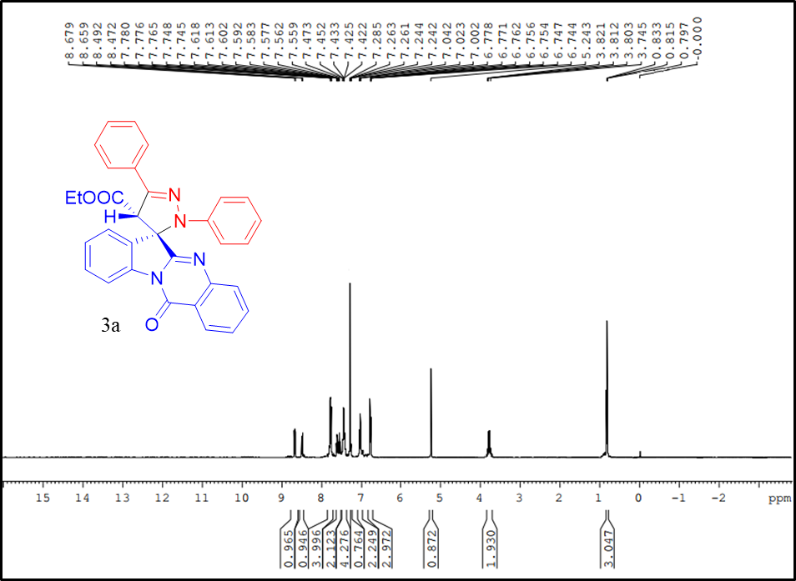
Figure S1: ¹H NMR of compound 3a (400MHz, CDCl₃)

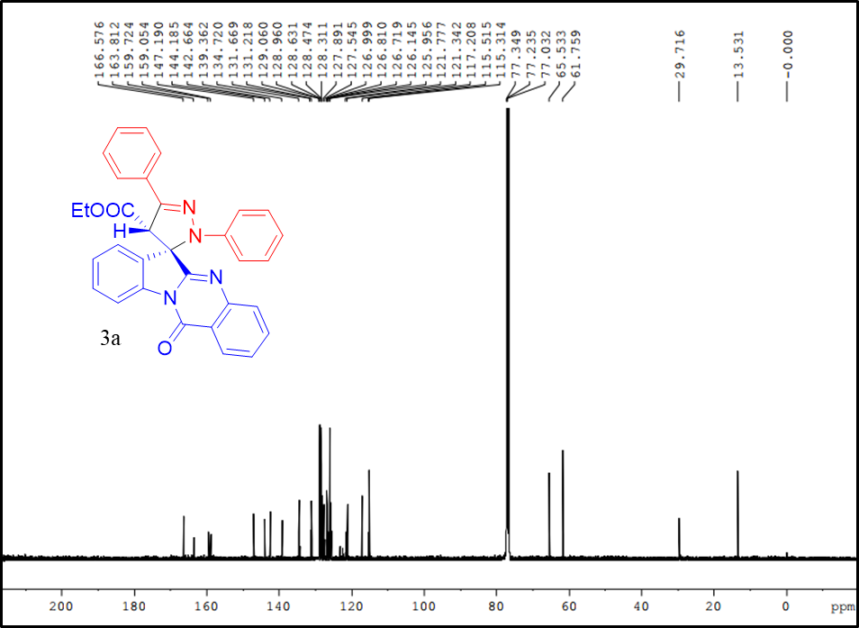
Figure S2: ¹³C NMR of compound 3a (100 MHz, CDCl₃)
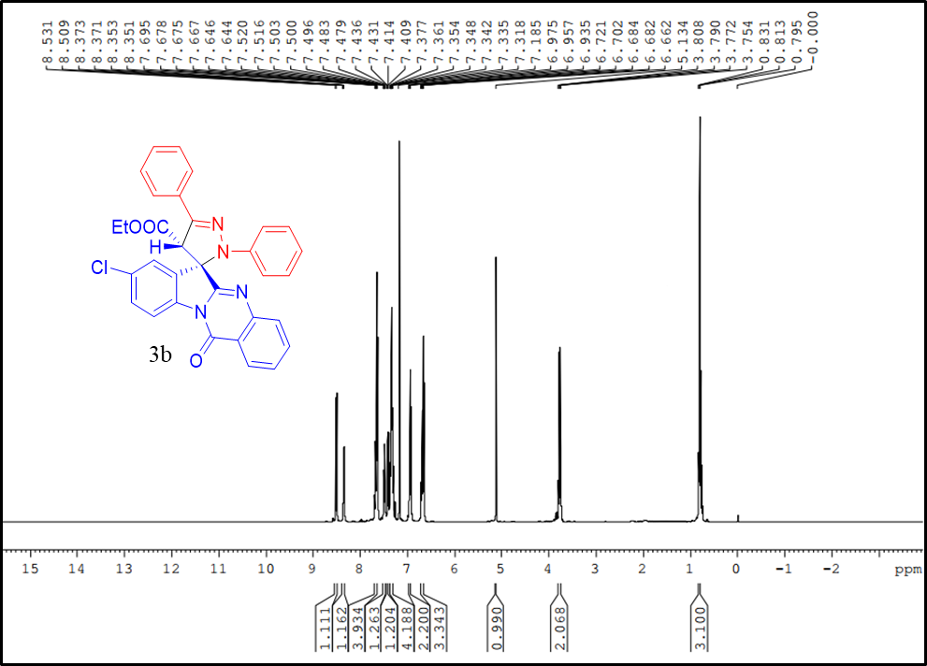
Figure S3: ¹H NMR of compound 3b (400 MHz, CDCl₃)

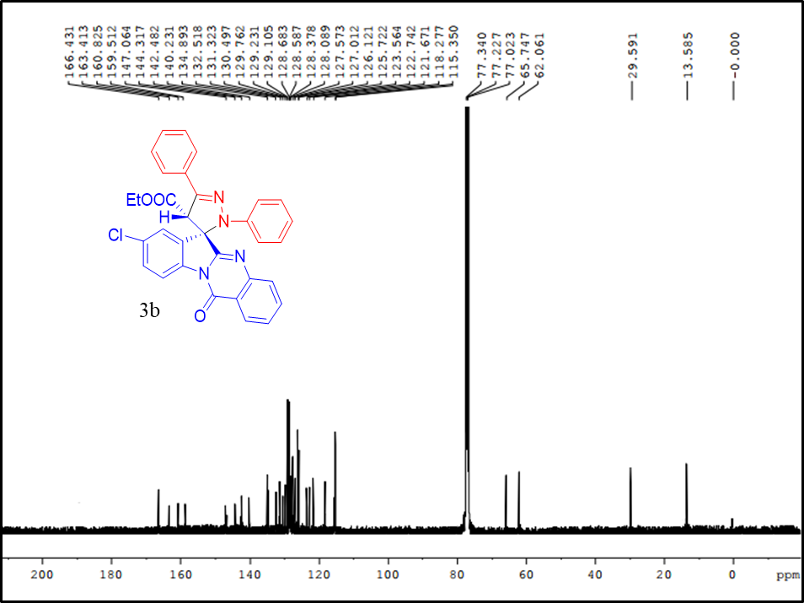
Figure S4: ¹³C NMR of compound 3b (100 MHz, CDCl₃)
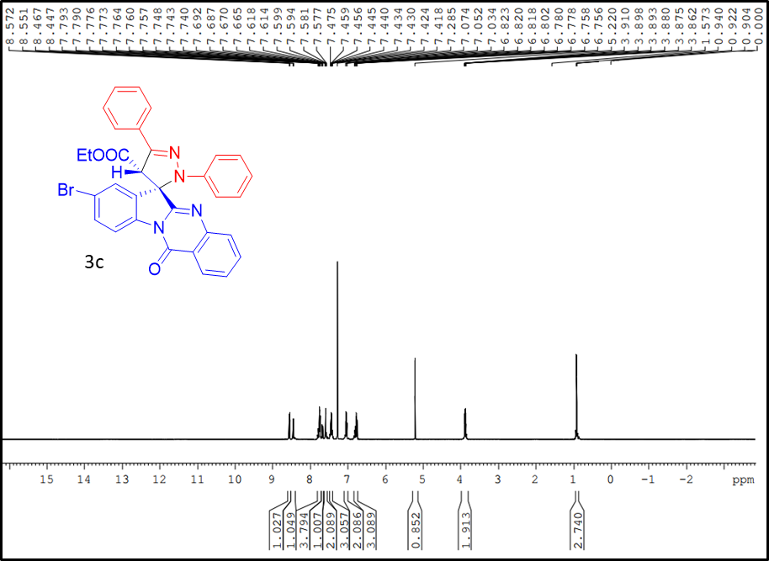
Figure S5: ¹H NMR of compound 3c (400 MHz, CDCl₃)

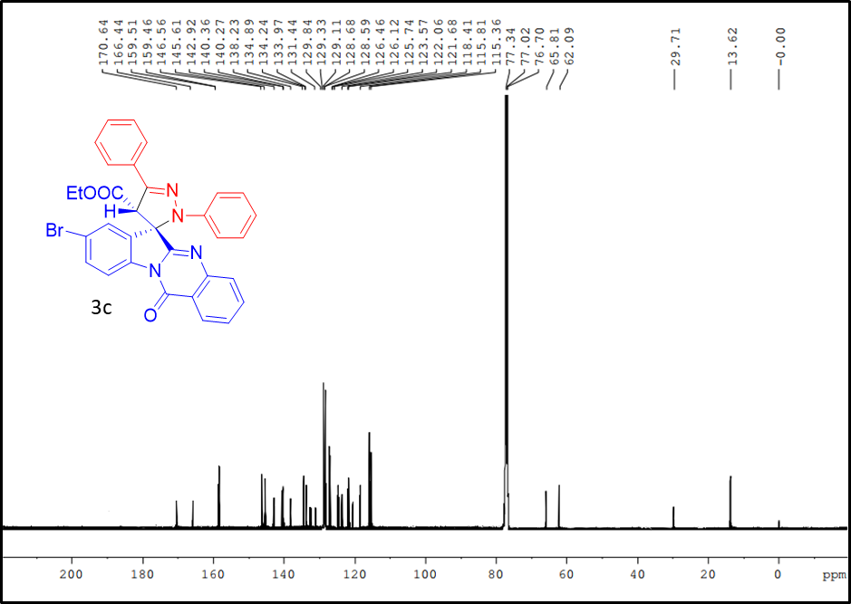
Figure S6: ¹³C NMR of compound 3c (100 MHz, CDCl₃)
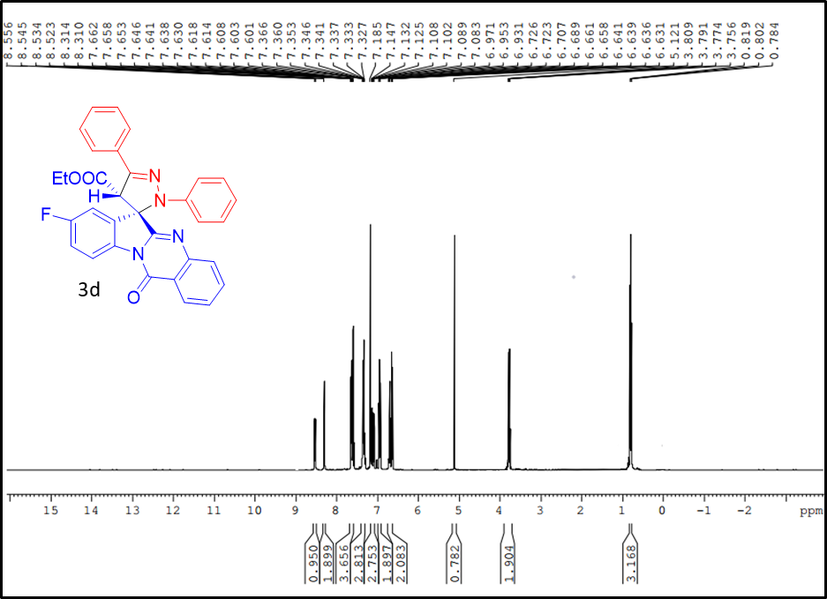
Figure S7: ¹H NMR of compound 3d (400 MHz, CDCl₃)
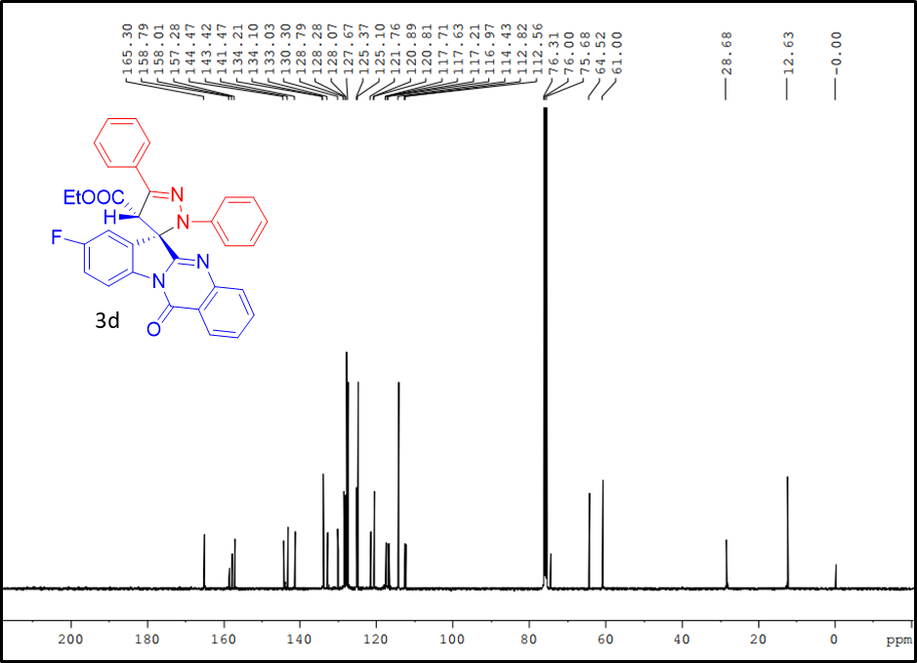
Figure S8: ¹³C NMR of compound 3d (100 MHz, CDCl₃)
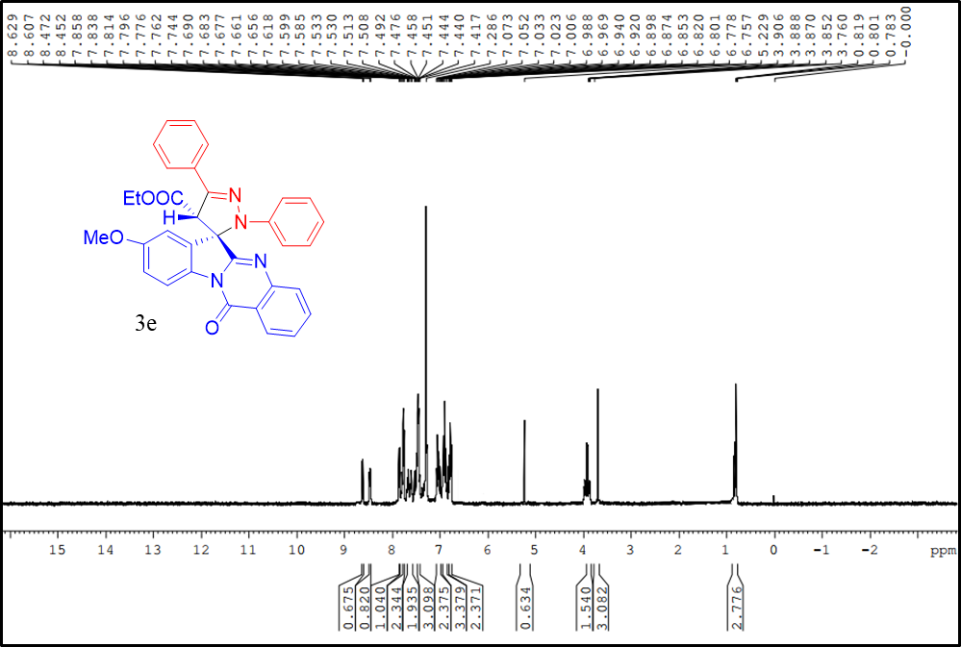
Figure S9: ¹H NMR of compound 3e (400 MHz, CDCl₃)
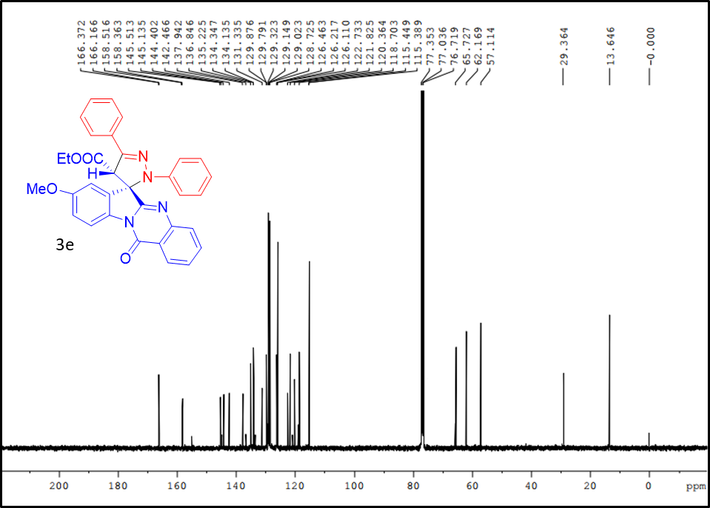
Figure S10: ¹³C NMR of compound 3e (100 MHz, CDCl₃)
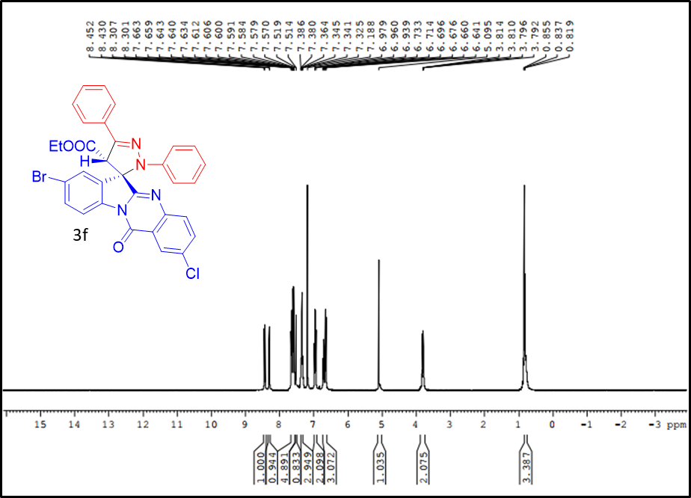
Figure S11: ¹H NMR of compound 3f (400 MHz, CDCl₃)
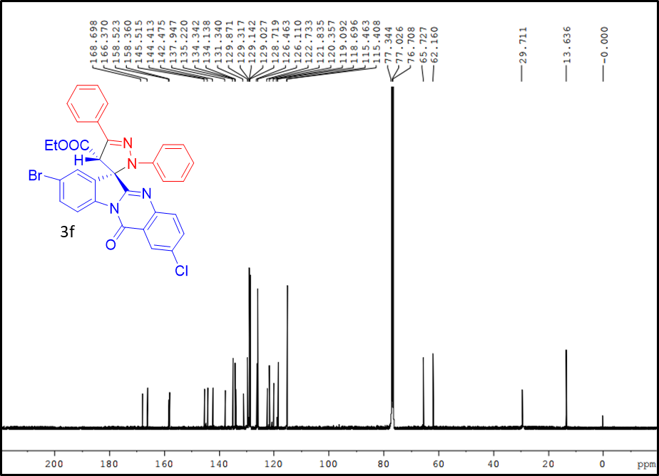
Figure S12: ¹³C NMR of compound 3f (100 MHz, CDCl₃)
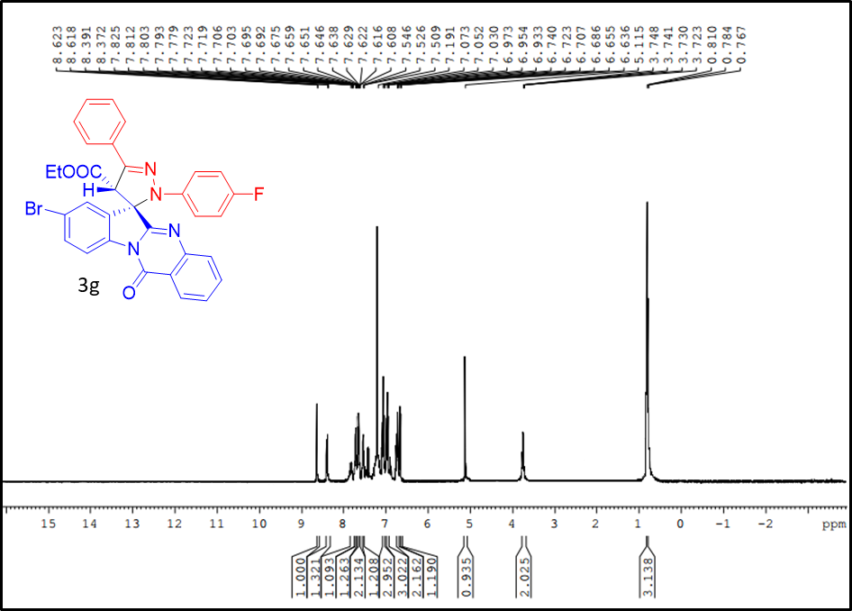
Figure S13: ¹H NMR of compound 3g (400 MHz, CDCl₃)
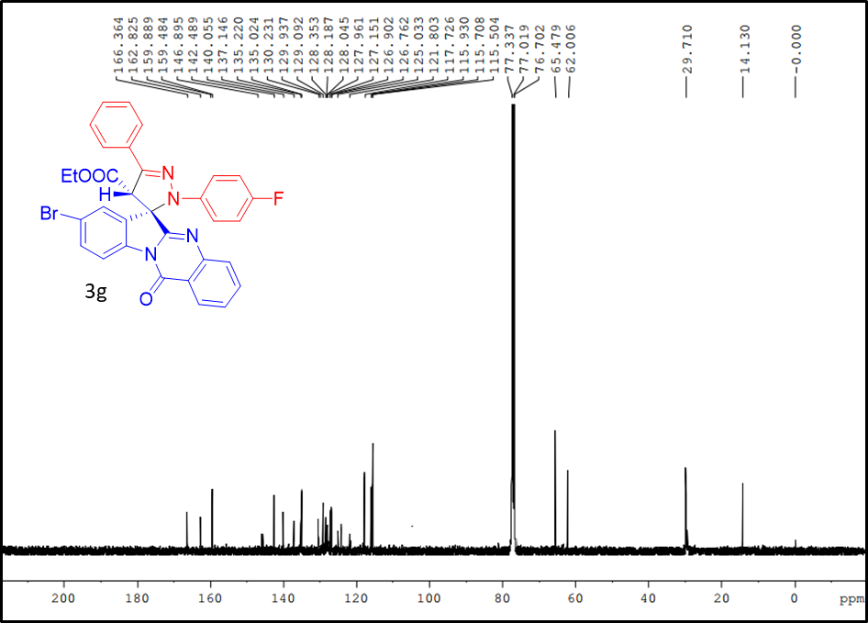
Figure S14: ¹³C NMR of compound 3g (100 MHz, CDCl₃)
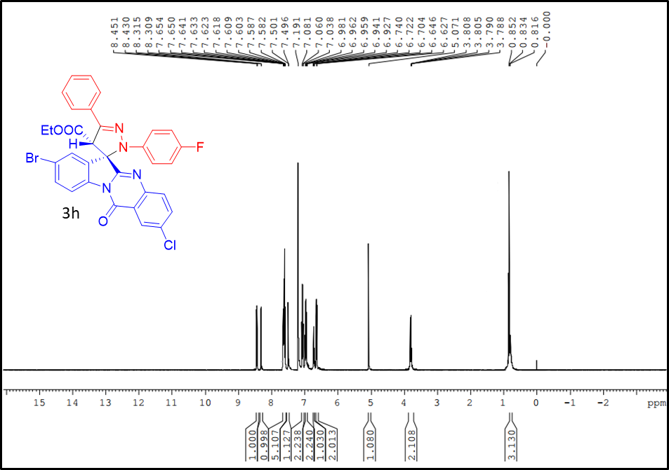
Figure S15: ¹H NMR of compound 3h (400 MHz, CDCl₃)
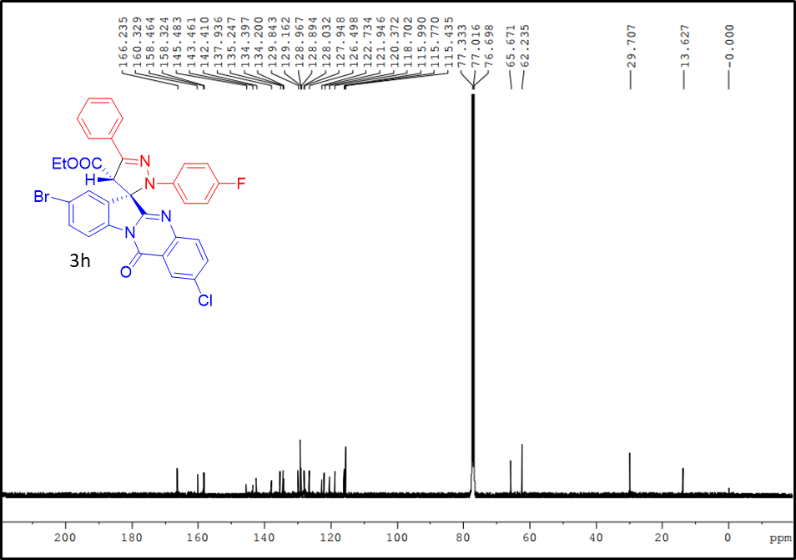
Figure S16: ¹³C NMR of compound 3h (100 MHz, CDCl₃)
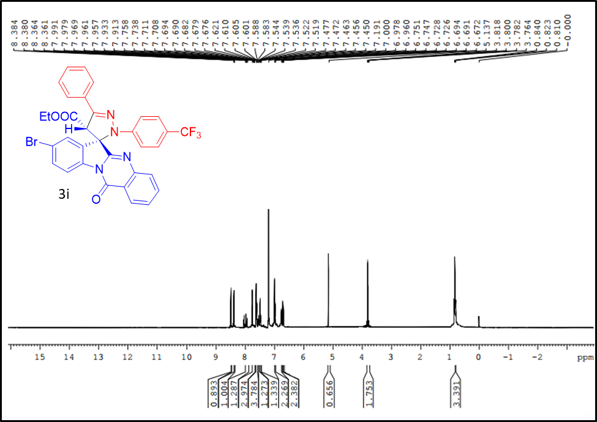
Figure S17: ¹H NMR of compound 3i (400 MHz, CDCl₃)
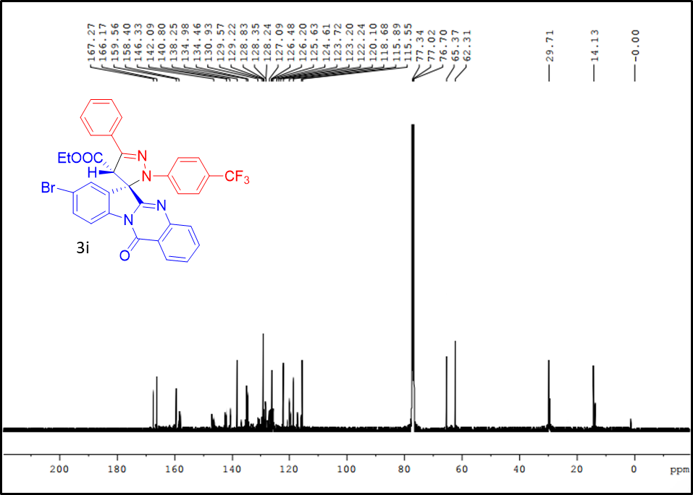
Figure S18: ¹³C NMR of compound 3i (100 MHz, CDCl₃)
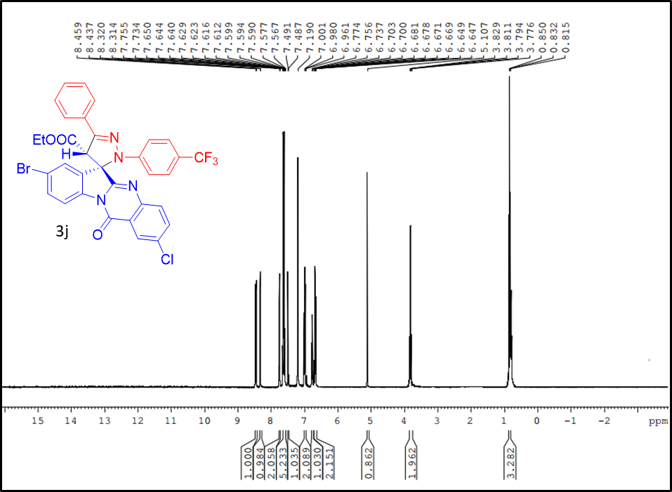
Figure S19: ¹H NMR of compound 3j (400 MHz, CDCl₃)
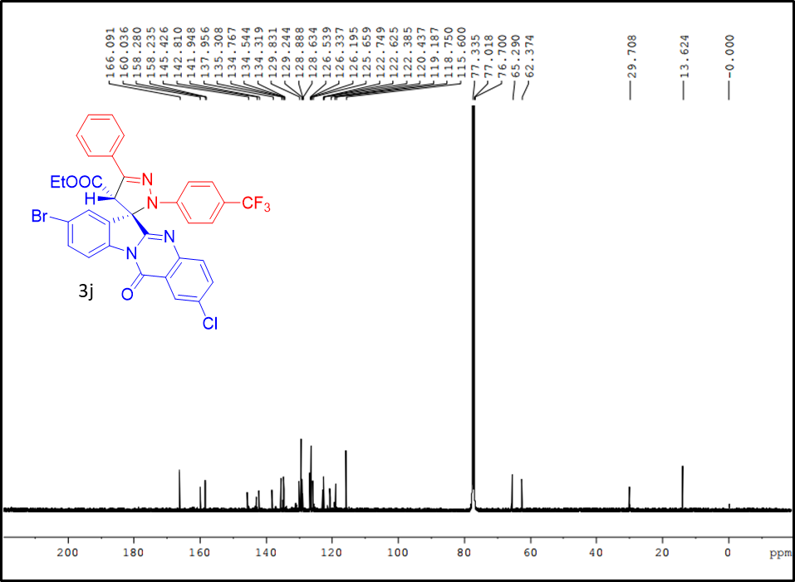
Figure S20: ¹³C NMR of compound 3j (100 MHz, CDCl₃)
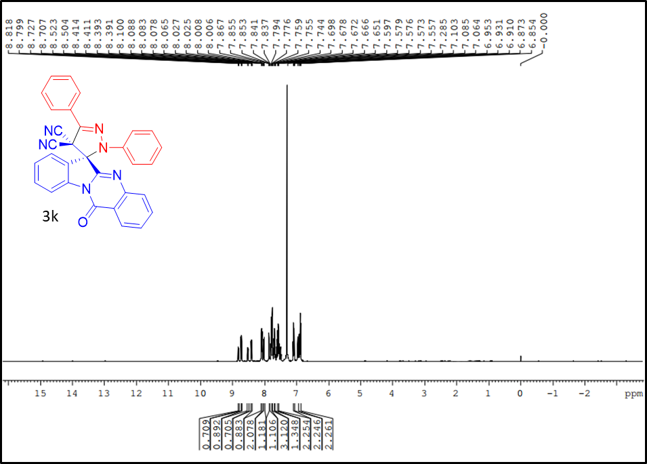
Figure S21: ¹H NMR of compound 3k (400 MHz, CDCl₃)
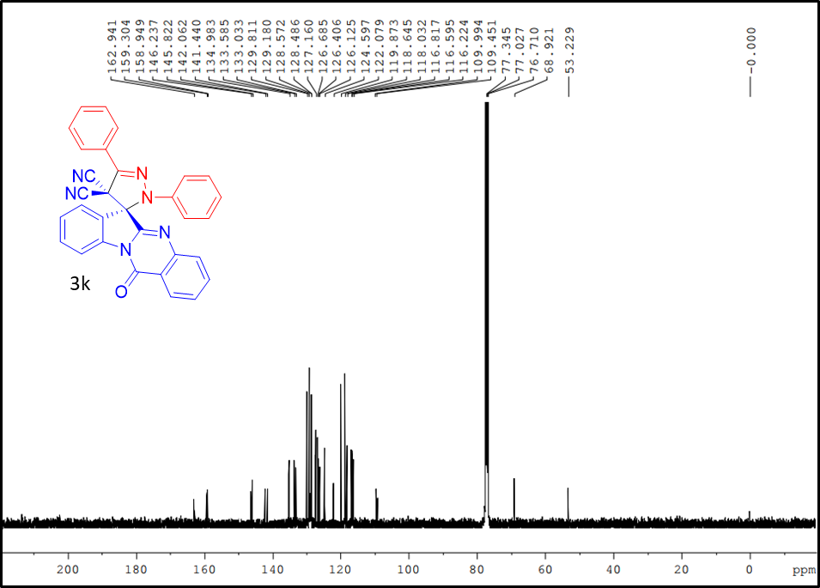
Figure S22: ¹³C NMR of compound 3k (100 MHz, CDCl₃)
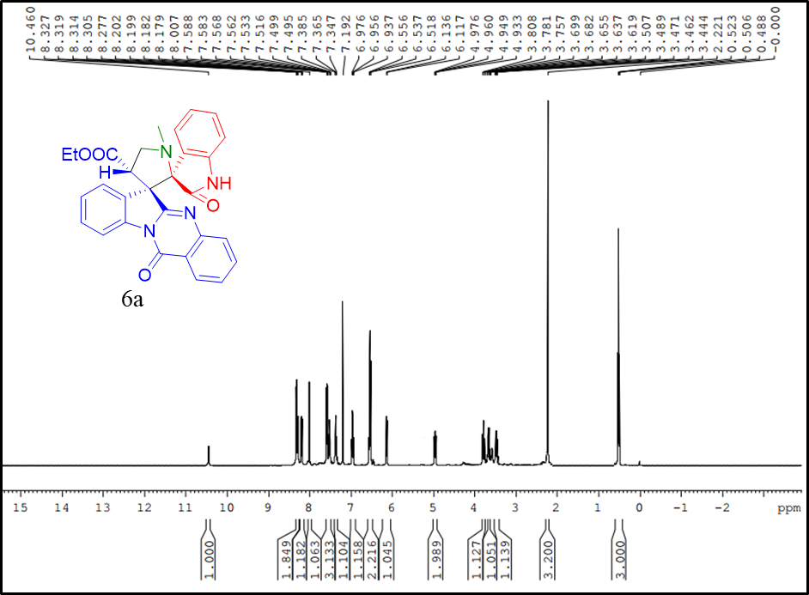
Figure S23: ¹H NMR of compound 6a (400 MHz, CDCl₃)
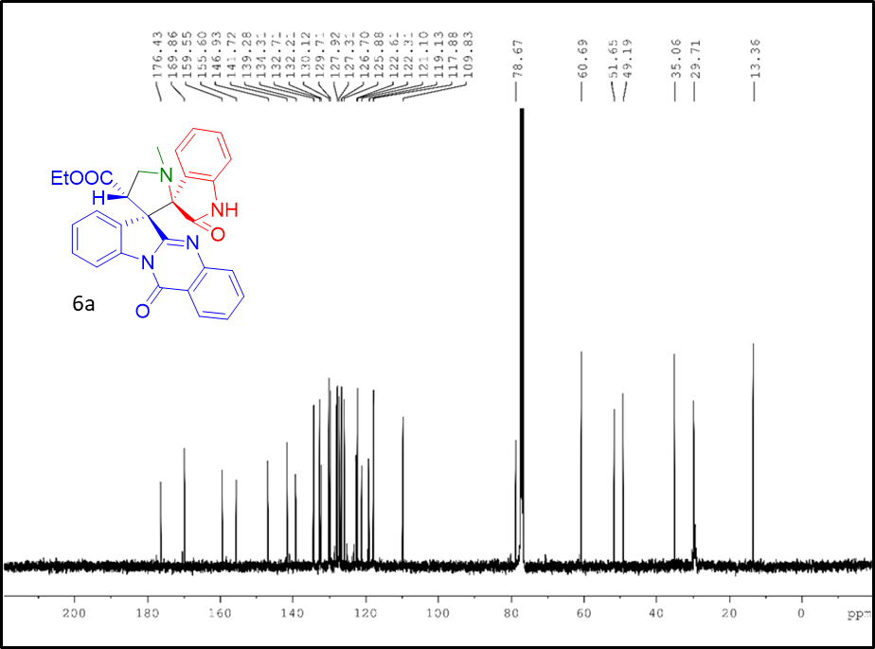
Figure S24: ¹³C NMR of compound 6a (100 MHz, CDCl₃)
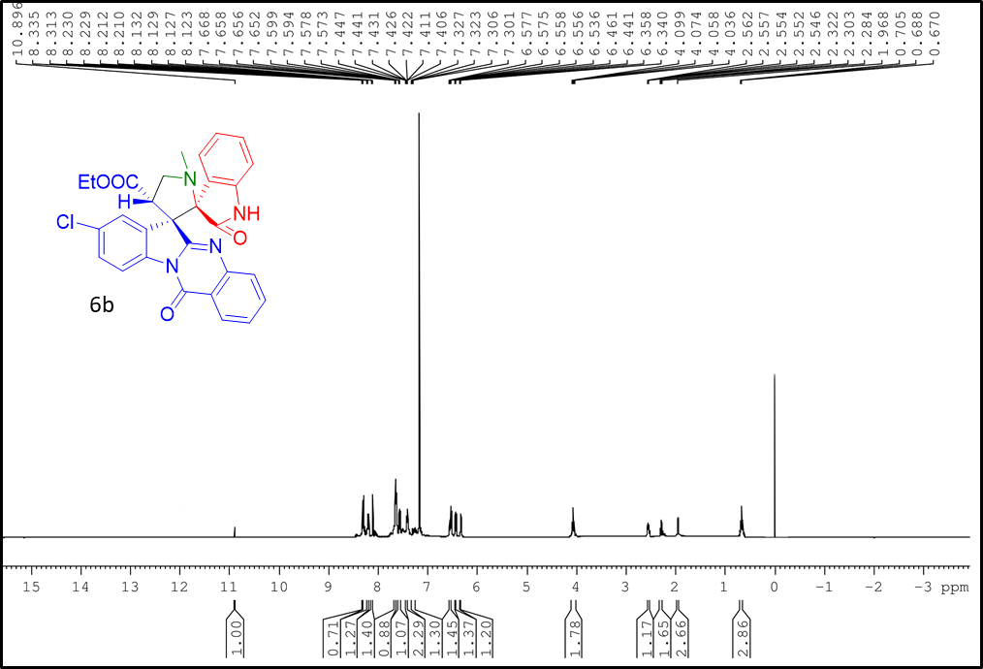
Figure S25: ¹H NMR of compound 6b (400 MHz, CDCl₃)
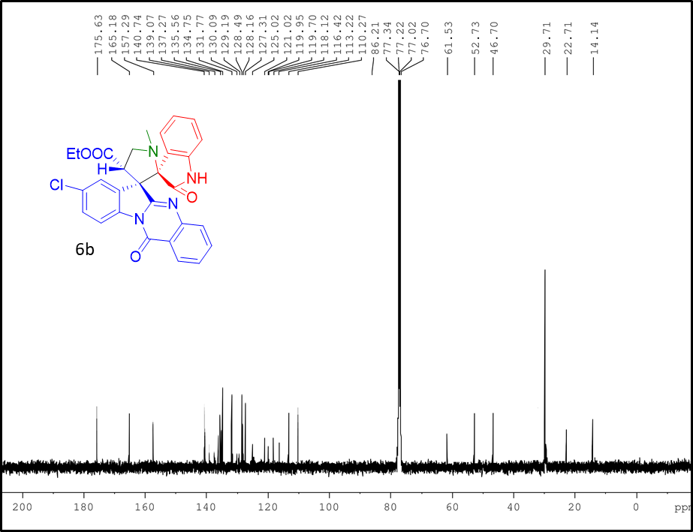
Figure S26: ¹³C NMR of compound 6b (100 MHz, CDCl₃)
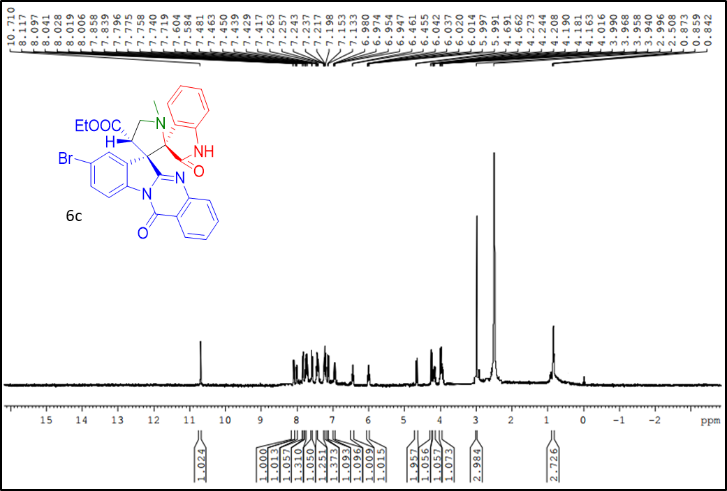
Figure S27: ¹H NMR of compound 6c (400 MHz, DMSO-d6)
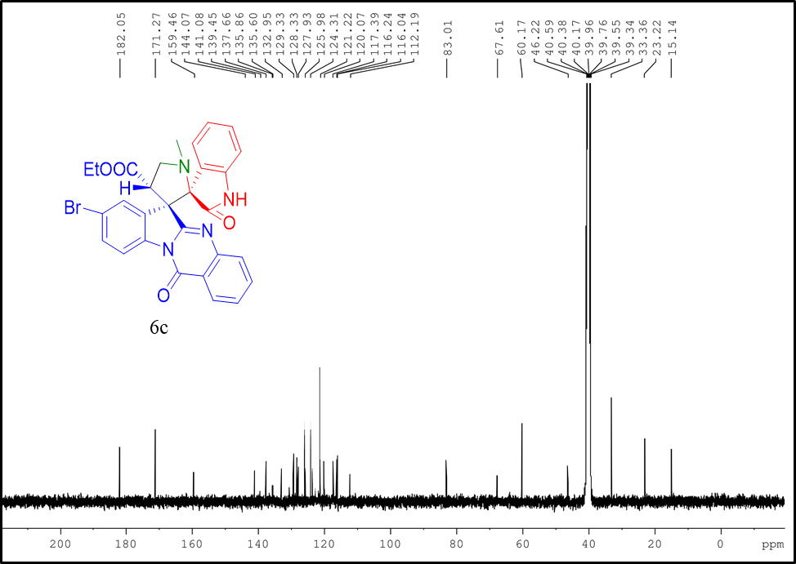
Figure S28: ¹³C NMR of compound 6c (100 MHz, DMSO-d6)
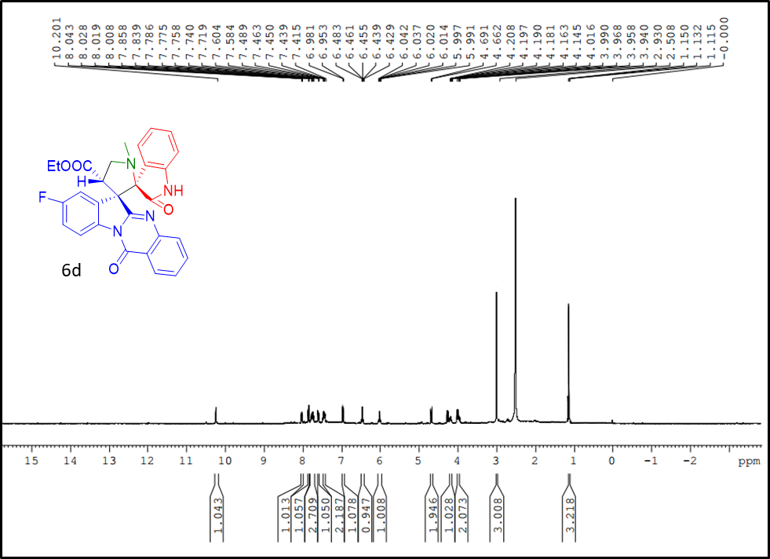
Figure S29: ¹H NMR of compound 6d (400 MHz, DMSO-d6)
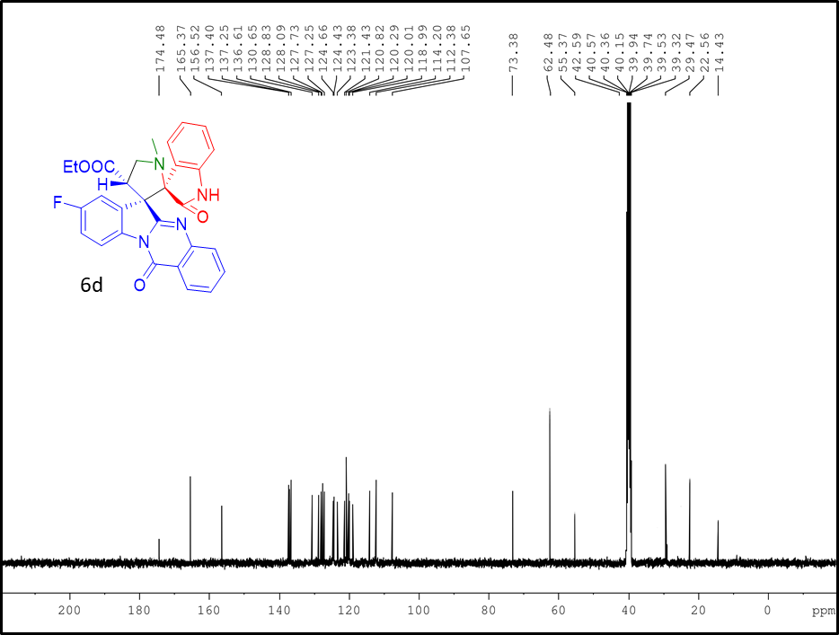
Figure S30: ¹³C NMR of compound 6d (100 MHz, DMSO-d6)
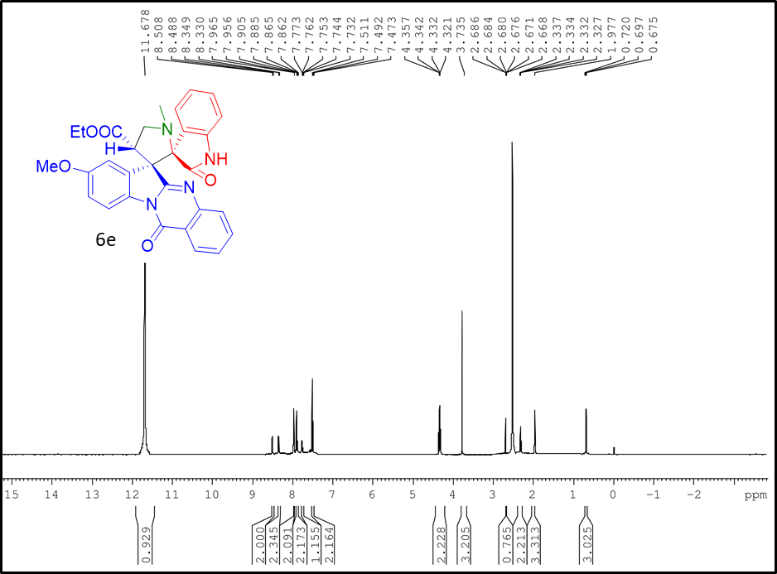
Figure S31: ¹H NMR of compound 6e (400 MHz, DMSO-d6)
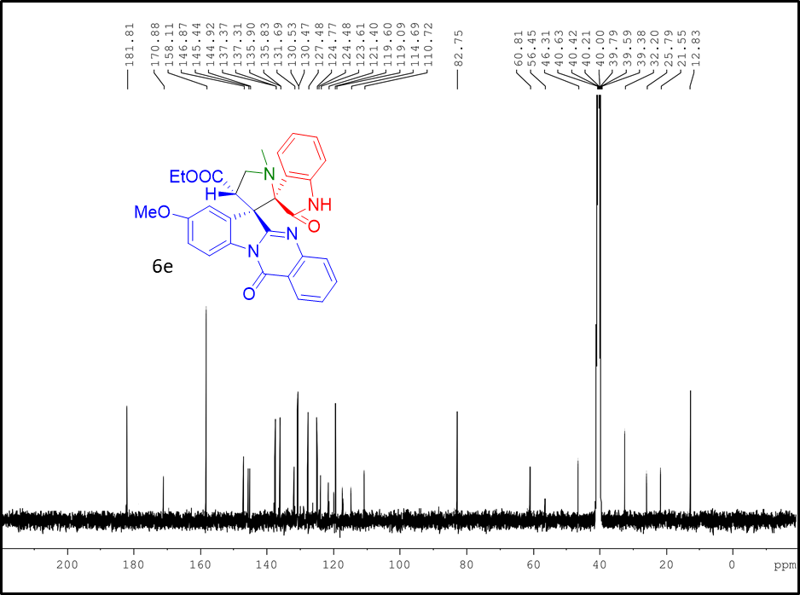
Figure S32: ¹³C NMR of compound 6e (100 MHz, DMSO-d6)
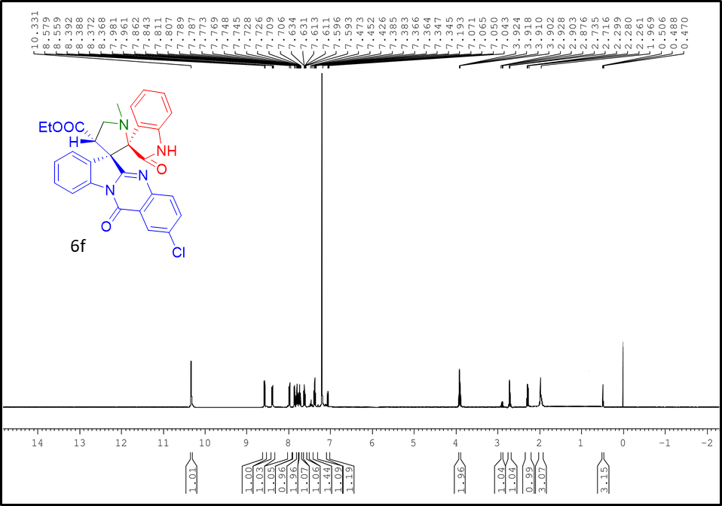
Figure S33: ¹H NMR of compound 6f (400 MHz, CDCl₃)
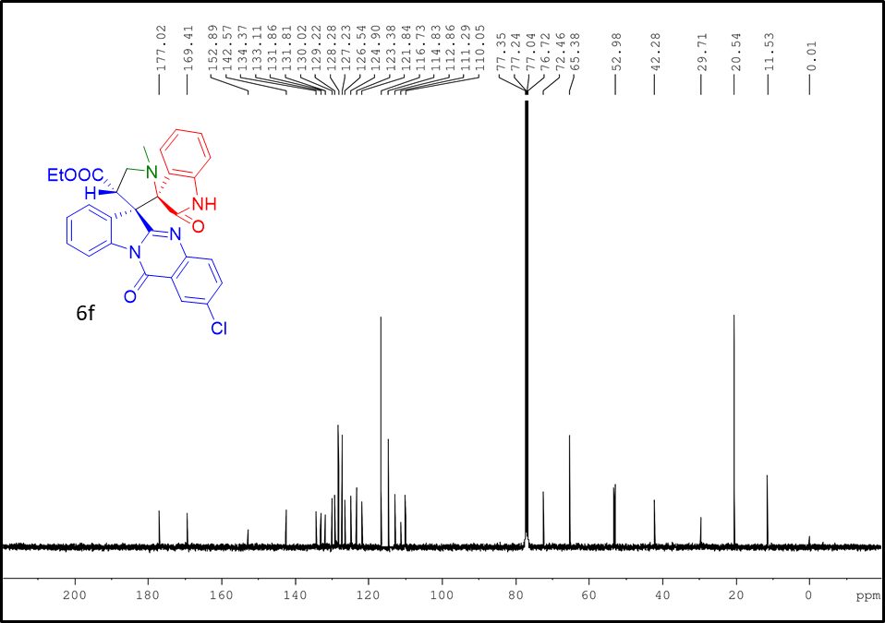
Figure S34: ¹³C NMR of compound 6f (100 MHz, CDCl₃)
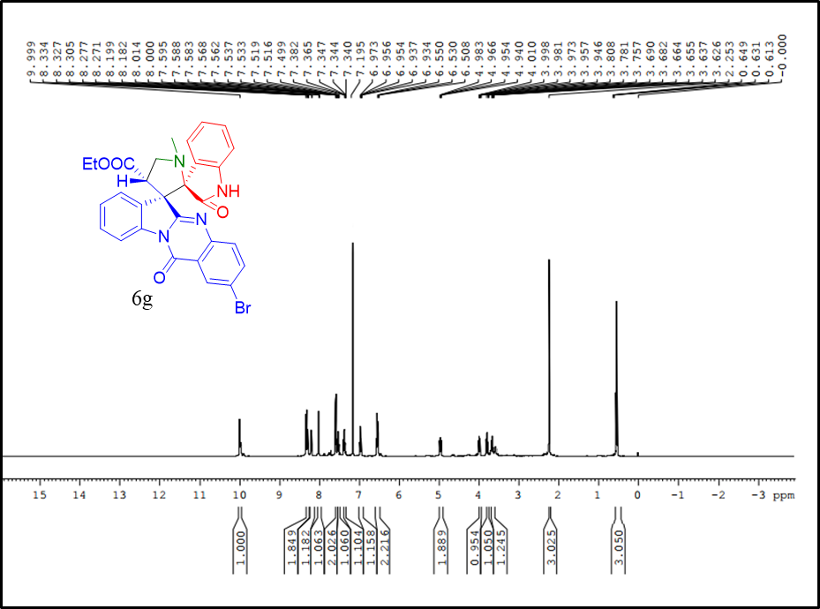
Figure S35: ¹H NMR of compound 6g (400 MHz, CDCl₃)
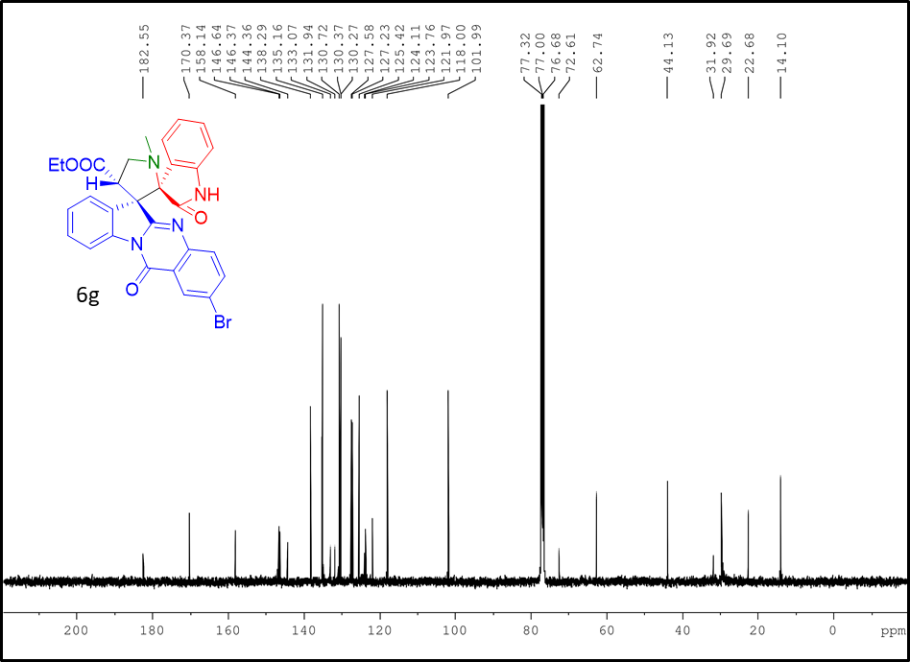
Figure S36: ¹³C NMR of compound 6g (100 MHz, CDCl₃)
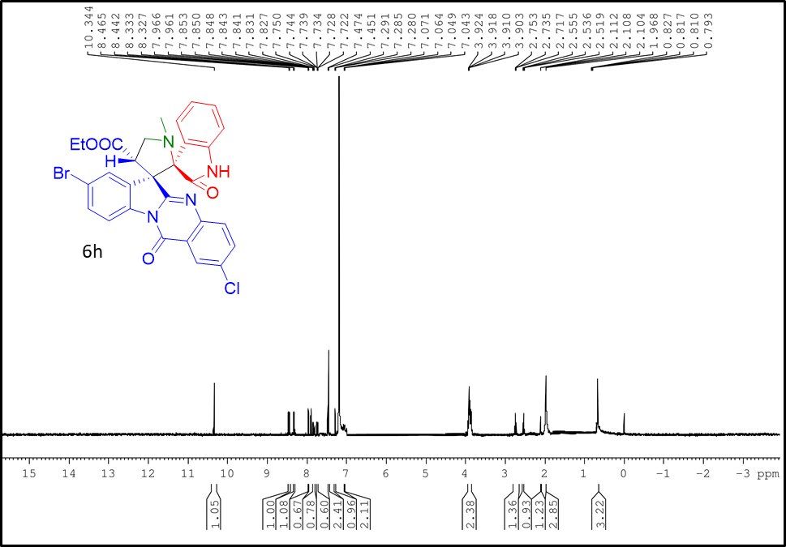
Figure S37: ¹H NMR of compound 6h (400 MHz, CDCl₃)
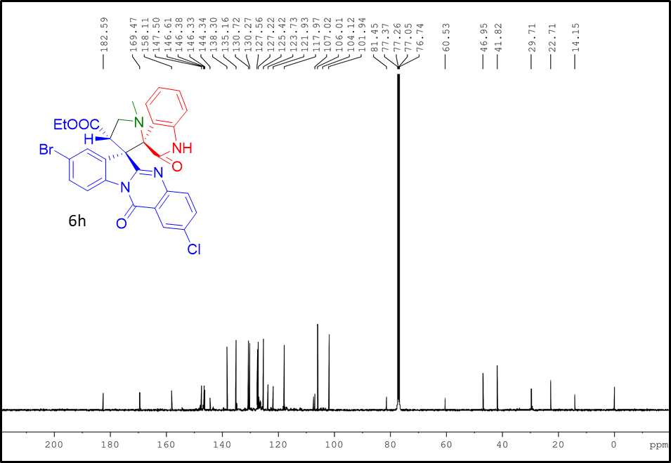
Figure S38: ¹³C NMR of compound 6h (100 MHz, CDCl₃)
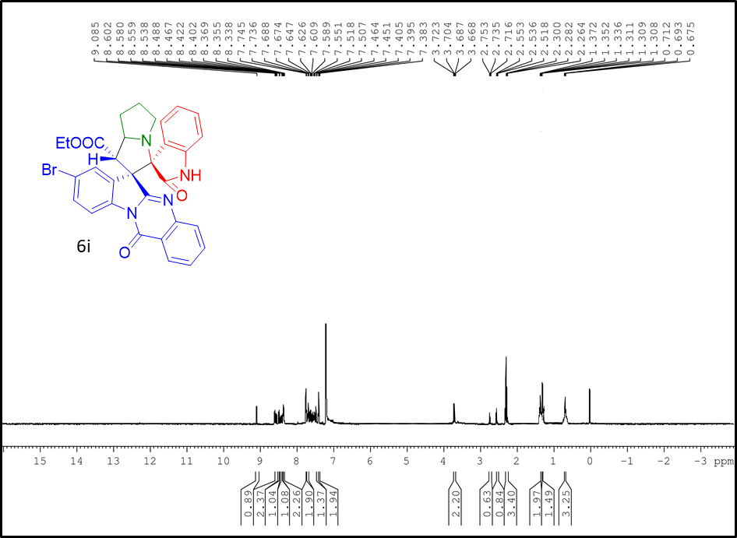
Figure S39: ¹H NMR of compound 6i (400 MHz, CDCl₃)
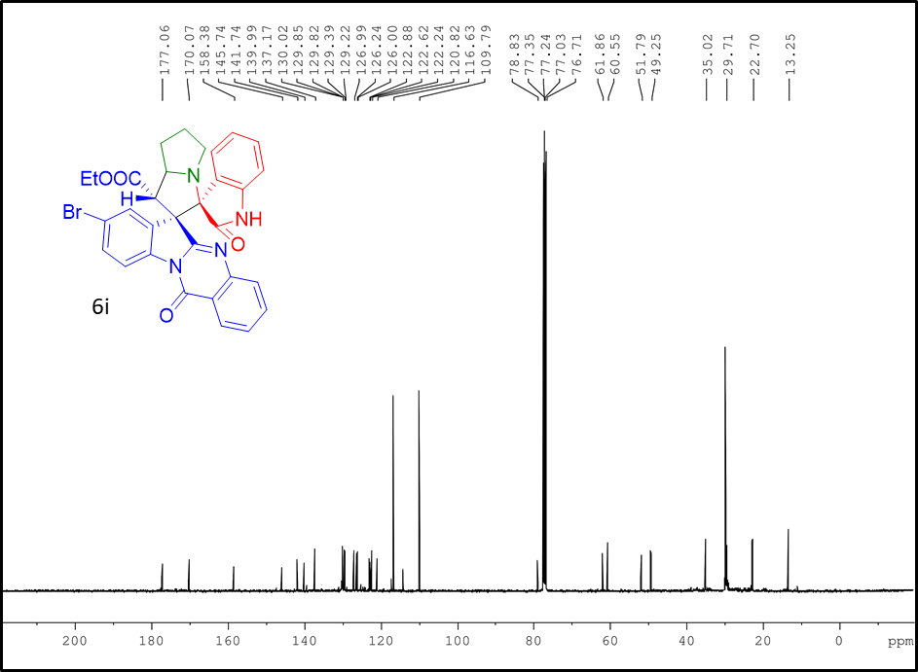
Figure S40: ¹³C NMR of compound 6i (100 MHz, CDCl₃)
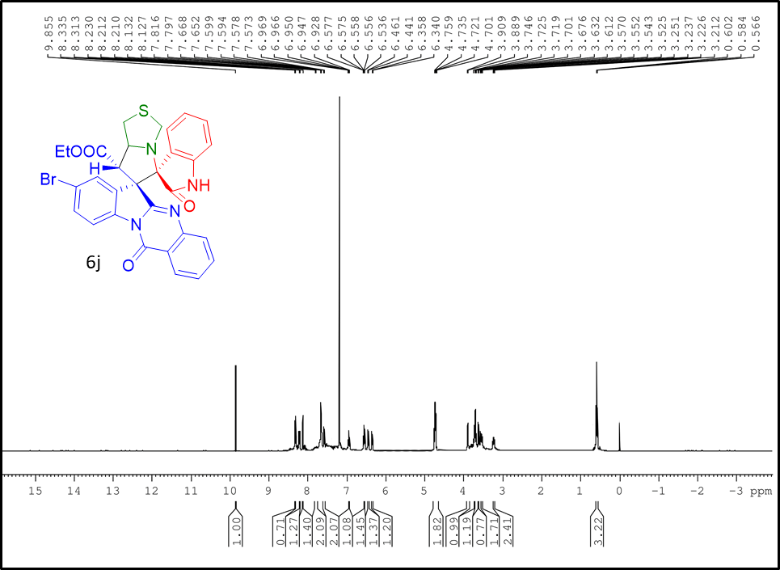
Figure S41: ¹H NMR of compound 6j (400 MHz, CDCl₃)
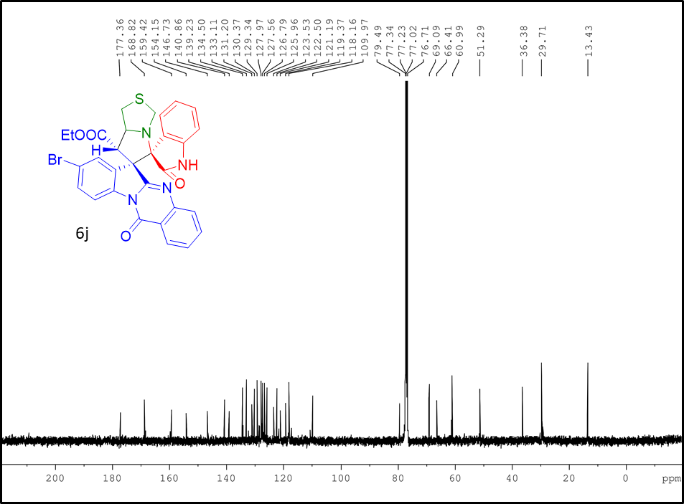
Figure S42: ¹³C NMR of compound 6j (100 MHz, CDCl₃)
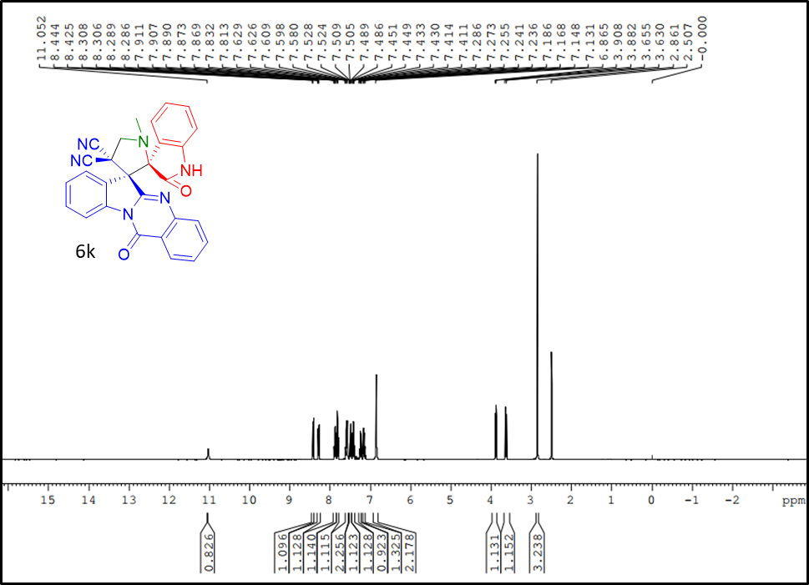
Figure S43: ¹H NMR of compound 6k (400 MHz, DMSO-d6)
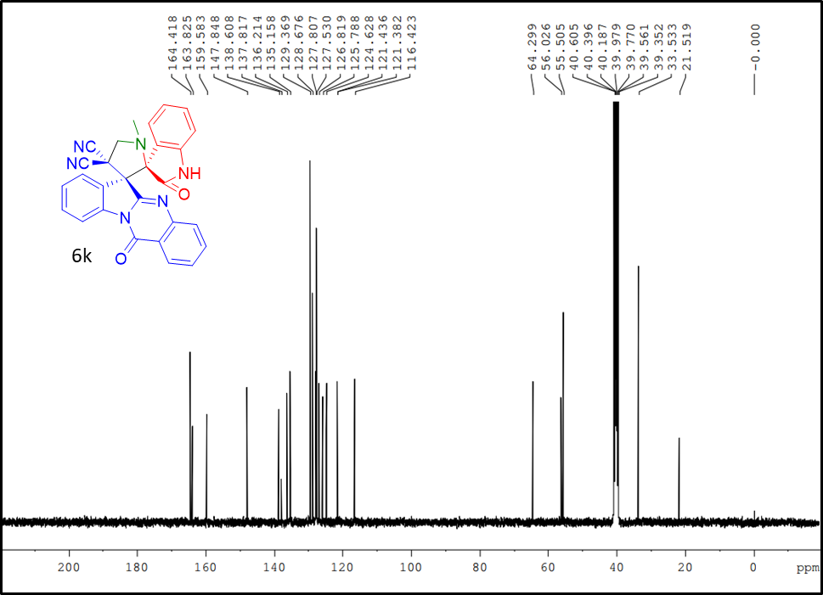
Figure S44: ¹³C NMR of compound 6k (100 MHz, DMSO-d6)

