Title
Bioprocessing method is a critical factor for IgM oligomerization
Authors
Öykü Üzülmez¹, Vanessa Hawlin¹, Maria Magdalena John¹, Katharina Stadlbauer², Julia Hennicke¹, Monika Hunjadi¹, Gordana Wozniak-Knopp², Renate Kunert^{1*}
¹ Department of Biotechnology and Food Sciences, Institute of Animal Cell Technology and Systems Biology, BOKU University, Vienna, Austria
² Department of Biotechnology and Food Sciences, Institute of Molecular Biotechnology, BOKU University, Vienna, Austria

*Corresponding author: renate.kunert@boku.ac.at

Supplementary Materials
Figure S1. Raw NativePAGE images for Figure 1.
Fig.1 Marker lane
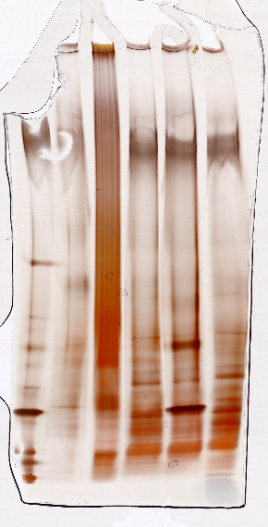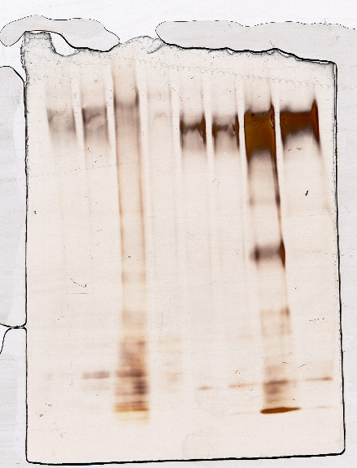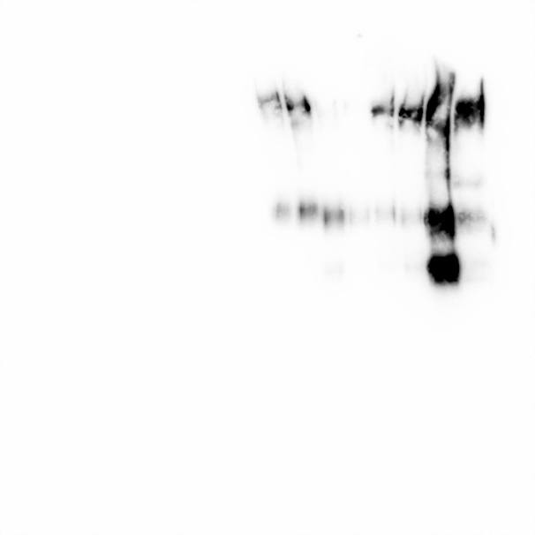
Anti-µ HRP staining (Fig.1 right)
Silver staining (Fig.1 left)

Figure S2. Raw NativePAGE image for Figure 4D.
