Supplementary Information

Species turnover dominates rhizosphere bacterial and fungal β-diversity of broad-leaved trees in a temperate natural secondary forest, independent of host mycorrhizal type

Liu Yang^{a+}, Li Pan^{a+}, Tingting Liª, Gang Liuª, Xiuwei Wang^{a,b *}

+ Liu Yang and Li Pan contributed equally to this work.
* Corresponding author: Xiuwei Wang, E-mail: wxgreat@nefu.edu.cn

ª School of Forestry, Northeast Forestry University, Harbin 150040, China
^{b} Key Laboratory of Sustainable Forest Ecosystem Management-Ministry of Education, Northeast Forestry University, Harbin 150040, China

This supplementary file includes:
Supplementary Methods S1 to S3
Tables S1 to S4
Figures S1 to S4

Supplementary Methods
Methods S1Additional details on the root exudation collection
Based on segmented sequence classification, the first three-order roots were selected as the fine roots. An in situ collection system was used to collect root exudates (Phillips et al. 2008). First, after clearing litter and weeds from the soil surface, the fine roots of each target plant were carefully excavated from the topsoil layer (from surface to 5-15 cm), and all roots were washed by deionized water until there was no soil left. Then the fine roots were incubated in a syringe filled with 25 ml C-free nutrient solution (0.1 mM KH₂PO₄, 0.2 mM K₂SO₄, 0.3 mM CaCl₂, and 0.15 mM MgSO₄). The syringe was pre-filled with acid-washed (2 M HCl) glass beads to provide mechanical support for the fine roots. The syringe and external roots were wrapped in moist, air laid paper and sealed with parafilm. A control consisting of syringes without roots (only glass beads and nutrient solution) was also included for each species. Finally, the entire collection system was wrapped in aluminum foil, returned to the soil, and covered with soil and litter to prevent sunlight. After 24 h, rinse the interior of the collection system with fresh carbon-free nutrient solution, then add 25 mL of nutrient solution. After 24 h, the solution was recovered from syringe. The recovered solution was filtered by 0.22 μm disposable needle filter immediately and then stored at -80℃ until analysis. The roots were then washed until there were no glass beads and then cut down from mother plant for measuring root morphological traits. Total organic carbon of the exudation was analyzed using a TOC analyzer (Multi N/C 2100s, Analytikjena, Jena, Germany). The root exudation rate was calculated by dividing the net total organic carbon by the incubation time and root dry weight.
Methods S2 Rhizosphere soil DNA extraction and high-throughput DNA sequencing
Genomic DNA was extracted from 0.25 g of soil using the PowerSoil® DNA Isolation Kit (MOBIO Laboratories, Carlsbad, CA, USA) according to the manufacturer's instructions. The concentration and purity of the extracted DNA were assessed using a NanoDrop One spectrophotometer (Thermo Fisher Scientific, Waltham, MA, USA). The V4 region of the bacterial 16S rRNA gene was amplified using the universal primers 515F (5′-GTGCCAGCMGCCGCGGTAA-3′) and 806R (5′-GGACTACHVGGGTWTCTAAT-3′) (Gilbert et al. 2012). The fungal internal transcribed spacer 1 (ITS1) region was amplified using the primers ITS5-1737F (5′-GGAAGTAAAAGTCGTAACAAGG-3′) and ITS2-2043R (5′-GCTGCGTTCTTCATCGATGC-3′) (Zhao et al. 2021).
Polymerase chain reaction (PCR) amplifications were performed in triplicate for each sample using a BioRad S1000 thermal cycler (Bio-Rad Laboratories, Hercules, CA, USA). The 25 μL reaction mixture contained 12.5 μL of 2× Premix Taq (TaKaRa, Japan), 1 μL of each primer (10 μM), and approximately 10-20 ng of template DNA. The thermal cycling conditions were as follows: initial denaturation at 94°C for 5 min; 30 cycles of denaturation at 94°C for 30 s, annealing at 52°C for 30s, and extension at 72°C for 30s; followed by a final extension at 72°C for 10 min. The length and yield of the PCR products were verified by 1% (w/v) agarose gel electrophoresis. Amplicons from the same sample were pooled and purified. Equimolar amounts of purified amplicons from all samples were combined to construct sequencing libraries, which were paired-end sequenced (2 × 250 bp) on an Illumina NovaSeq 6000 platform (Guangdong Magigene Biotechnology Co., Ltd., Guangzhou, China).
Methods S3 Bioinformatic analysis
The raw paired-end reads were processed as follows using a standardized pipeline. First, adapter removal and quality filtering (e.g., trimming low-quality bases, discarding reads containing N bases) were performed using fastp (version 0.14.1). Primer sequences were then trimmed using cutadapt. The paired-end reads were merged based on their overlap using USEARCH (version 10). Chimeric sequences were identified and removed using the UCHIME algorithm. High-quality, non-chimeric sequences were clustered into operational taxonomic units (OTUs) at a 97% similarity threshold using the UPARSE pipeline. Singleton OTUs (appearing only once across all samples) and those classified as chloroplasts, mitochondria (for 16S data), or unassigned at the kingdom level were discarded to obtain the final OTU table.
Taxonomic assignment of bacterial and fungal OTUs was conducted by aligning the representative sequence of each OTU against the SILVA (release 138) and UNITE (version 8.3) databases, respectively, using the USEARCH -sintax algorithm with a confidence threshold of 0.8. To rarefy the effects of uneven sequencing depth among samples, we resampled the sequence numbers per sample to 26,489 and 46,101 for bacteria and fungi, respectively.

References
Gilbert JA, Steele JA, Caporaso JG, Steinbrück L, Reeder J, Temperton B, Huse S, McHardy AC, Knight R, Joint I, Somerfield P, Fuhrman JA, Field D (2012) Defining seasonal marine microbial community dynamics. The ISME Journal 6: 298-308.
Phillips RP, Erlitz Y, Bier R, Bernhardt ES (2008) New approach for capturing soluble root exudates in forest soils. Functional Ecology 22: 990-999.
Zhao M, Zhao J, Yuan J, Hale L, Wen T, Huang Q, Vivanco JM, Zhou J, Kowalchuk GA, Shen Q (2021) Root exudates drive soil-microbe-nutrient feedbacks in response to plant growth. Plant, Cell & Environment 44: 613-628.

Supplementary Tables

Table S1 Kruskal-Wallis test results for the effects of mycorrhizal type and tree species on plant traits and soil physicochemical factors. Notes to the trait parameters: diameter at breast height (DBH), RER (root exudation rate), SRL (specific root length), SRA (specific root surface area), RTD (root tissue density), RD (root diameter), SC (soil total carbon), SN (soil total nitrogen), SP (soil total phosphorous)
Variable | Species |  |  | Mycorrhizal type
 | K | P | df | K | P | df
DBH | 82.075 | 0.000 | 19 | 2.8738 | 0.090 | 1
RER | 35.48 | 0.012 | 19 | 0.90 | 0.344 | 1
SRL | 39.07 | 0.004 | 19 | 0.16 | 0.690 | 1
SRA | 25.18 | 0.155 | 19 | 0.21 | 0.645 | 1
RTD | 19.77 | 0.409 | 19 | 1.13 | 0.289 | 1
RD | 49.69 | 0.000 | 19 | 1.34 | 0.246 | 1
SC | 62.60 | 0.000 | 19 | 0.28 | 0.599 | 1
SN | 59.57 | 0.000 | 19 | 0.04 | 0.835 | 1
SP | 56.93 | 0.000 | 19 | 0.37 | 0.544 | 1
pH | 77.31 | 0.000 | 19 | 0.12 | 0.726 | 1

Species | RER mg g⁻¹ h⁻¹ | SRL m g⁻¹ | SRA cm² g⁻¹ | RTD g cm⁻³ | RD mm | SC mg g⁻¹ | SN mg g⁻¹ | SP mg g⁻¹ | pH
AlH | 0.21 ± 0.07 | 4.55 ± 0.33 | 340.89 ± 30.41 | 0.28 ± 0.01 | 0.27 ± 0.01 | 174.4 ± 15.57 | 10.09 ± 1.27 | 1.4 ± 0.03 | 4.41 ± 0.11
BeP | 0.10 ± 0.04 | 3.1 ± 0.65 | 303.66 ± 59.37 | 0.31 ± 0.05 | 0.34 ± 0.02 | 87.8 ± 7.24 | 5.41 ± 0.37 | 1.11 ± 0.03 | 4.51 ± 0.25
BeC | 0.15 ± 0.03 | 3.11 ± 0.04 | 323.91 ± 4.42 | 0.25 ± 0.02 | 0.4 ± 0.02 | 68.48 ± 5.1 | 3.87 ± 0.21 | 1.22 ± 0.09 | 4.58 ± 0.1
AlK | 0.18 ± 0.04 | 3.85 ± 0.61 | 343.68 ± 24.83 | 0.3 ± 0.03 | 0.33 ± 0.03 | 60.18 ± 7.38 | 3.53 ± 0.52 | 0.99 ± 0.08 | 4.45 ± 0.06
JuM | 0.67 ± 0.07 | 5.02 ± 0.95 | 456.39 ± 88.39 | 0.27 ± 0.04 | 0.31 ± 0.01 | 135.5 ± 19.65 | 7.38 ± 0.71 | 1.52 ± 0.07 | 4.82 ± 0.09
FrM | 0.15 ± 0.02 | 4.97 ± 0.9 | 404.05 ± 79.34 | 0.29 ± 0.06 | 0.29 ± 0.02 | 136 ± 9.57 | 6.89 ± 0.31 | 1.46 ± 0.03 | 4.72 ± 0.08
SyA | 0.21 ± 0.04 | 5.11 ± 0.95 | 468.89 ± 62.75 | 0.22 ± 0.03 | 0.35 ± 0.04 | 144 ± 14.74 | 5.95 ± 1.29 | 1.31 ± 0.05 | 5.13 ± 0.23
RhD | 0.29 ± 0.08 | 6.31 ± 1.02 | 434.72 ± 40.95 | 0.32 ± 0.04 | 0.27 ± 0.03 | 181.2 ± 9.79 | 10.29 ± 0.9 | 1.23 ± 0.01 | 5.47 ± 0.11
PrP | 0.13 ± 0.02 | 4.53 ± 1.13 | 444.86 ± 126.22 | 0.27 ± 0.07 | 0.33 ± 0.03 | 131.34 ± 15.49 | 6.79 ± 1.74 | 1.1 ± 0.21 | 4.15 ± 0.04
SoA | 0.14 ± 0.04 | 4.89 ± 0.94 | 425.98 ± 75.07 | 0.27 ± 0.04 | 0.31 ± 0.03 | 70.88 ± 8.81 | 2.75 ± 0.44 | 1.02 ± 0.06 | 3.42 ± 0.06
MaB | 0.12 ± 0.02 | 3.67 ± 0.71 | 280.22 ± 55.22 | 0.51 ± 0.09 | 0.27 ± 0.02 | 160.4 ± 21.63 | 8.86 ± 1.43 | 1.15 ± 0.07 | 5.8 ± 0.25
PrM | 0.08 ± 0.03 | 3.06 ± 0.99 | 383.28 ± 110.96 | 0.22 ± 0.06 | 0.43 ± 0.03 | 76.23 ± 27.81 | 2.6 ± 1.05 | 0.95 ± 0.1 | 5.15 ± 0.65
PyU | 0.09 ± 0.02 | 2.6 ± 0.21 | 289.55 ± 32.96 | 0.27 ± 0.05 | 0.37 ± 0.02 | 144.4 ± 11.74 | 7.47 ± 1.03 | 1.2 ± 0.06 | 5.88 ± 0.06
PhA | 0.28 ± 0.08 | 1.31 ± 0.15 | 237.73 ± 16.38 | 0.23 ± 0.01 | 0.66 ± 0.1 | 161 ± 16.83 | 8.12 ± 0.46 | 1.19 ± 0.05 | 4.52 ± 0.1
PoU | 0.18 ± 0.05 | 2.89 ± 0.33 | 287.39 ± 26.07 | 0.25 ± 0.02 | 0.34 ± 0.01 | 138.14 ± 14.43 | 5.1 ± 0.59 | 0.65 ± 0.12 | 5.99 ± 0.03
PoD | 0.17 ± 0.04 | 4.29 ± 0.59 | 335.73 ± 34.69 | 0.34 ± 0.04 | 0.28 ± 0.02 | 105.94 ± 16.06 | 4.19 ± 0.74 | 1.23 ± 0.05 | 5.39 ± 0.15
AcM | 0.21 ± 0.06 | 4.72 ± 0.76 | 556.87 ± 183.5 | 0.24 ± 0.05 | 0.38 ± 0.05 | 143.4 ± 11.82 | 6.46 ± 0.75 | 1.14 ± 0.08 | 4.89 ± 0.17
AcT | 0.15 ± 0.03 | 3.63 ± 0.63 | 464.93 ± 140.66 | 0.26 ± 0.07 | 0.44 ± 0.06 | 101.82 ± 12.67 | 5.88 ± 0.47 | 1.2 ± 0.06 | 4.74 ± 0.11
UlM | 0.11 ± 0.03 | 2.78 ± 0.35 | 311.07 ± 35.04 | 0.27 ± 0.02 | 0.38 ± 0.01 | 112.42 ± 11 | 7.05 ± 0.48 | 1.34 ± 0.04 | 5.9 ± 0.23
UlD | 0.19 ± 0.08 | 3.89 ± 0.46 | 364.39 ± 57.04 | 0.3 ± 0.05 | 0.32 ± 0.03 | 192.4 ± 23.98 | 9.55 ± 1.03 | 1.18 ± 0.05 | 5.82 ± 0.16
Table S2 Growth, root functional trait, and soil physicochemical factors of different tree species. Values are mean ± SE. Notes to the trait parameters: AlH (Alnus hirsuta), BeC (Betula costata), BeP (Betula platyphylla), AlK (Albizia kalkora), JuM (Juglans mandshurica), FrM (Fraxinus mandshurica), SyA (Syringa reticulata subsp. amurensis), RhD (Rhamnus davurica), MaB (Malus baccata), PrM (Prunus maackii), PrP (Prunus padus), PyU (Pyrus ussuriensis), SoA (Sorbus alnifolia), PhA (Phellodendron amurense), PoU (Populus ussuriensis), PoD (Populus davidiana), AcM (Acer pictum subsp. mono), AcT (Acer tegmentosum), UlM (Ulmus macrocarpa), UlD (Ulmus davidiana var. japonica). For the meanings of other trait abbreviations, see Table S1
Table S3 Average values of plant traits and soil properties in the AM and ECM tree species and effects of mycorrhizal type on the traits indicated by linear mixed models (mycorrhizal type as the fix factor and plant species as the random factor; notes to the trait parameters are in Table S1). Values are mean ± SE
Variables |  | Trait average values |  | F | P
 |  | AM | ECM
Plant | DBH | 23.21 ± 1.62 | 26.09 ± 1.75 | 0.17 | 0.685
Plant | RER | 0.20 ± 0.02 | 0.16 ± 0.02 | 0.24 | 0.630
Plant | SRL | 3.98 ± 0.23 | 3.79 ± 0.23 | 0.09 | 0.771
Plant | SRA | 386.05 ± 22.58 | 333.71 ± 17.72 | 1.54 | 0.230
Plant | RTD | 0.28 ± 0.01 | 0.30 ± 0.02 | 0.26 | 0.620
Plant | RD | 0.36 ± 0.01 | 0.32 ± 0.01 | 0.84 | 0.371
Soil | SC | 127.84 ± 5.16 | 125.80 ± 11.74 | 0.00 | 0.965
 | SN | 6.44 ± 0.32 | 6.62 ± 0.64 | 0.05 | 0.833
 | SP | 1.17 ± 0.03 | 1.23 ± 0.03 | 0.39 | 0.539
 | pH | 5.00 ± 0.09 | 4.94 ± 0.13 | 0.02 | 0.880

Table S4 Relative contribution rates of each trait in the Hierarchical Partitioning analysis results. Phy.dis represent phylogenetic distance. For the meanings of other trait abbreviations, see Table S1
Trait | Bacteria |  |  |  | Fungi
 | Unique | Aver.share | Indivi. | Perc% | Unique | Aver.share | Indivi. | Perc%
DBH | 0.00 | 0.05 | 0.06 | 8.49 | 0.00 | 0.03 | 0.03 | 7.09
RE | 0.00 | 0.00 | 0.00 | -0.53 | 0.00 | 0.00 | 0.00 | 1.10
SRL | 0.02 | 0.00 | 0.01 | 2.10 | 0.01 | 0.00 | 0.01 | 1.35
SRA | 0.01 | -0.01 | 0.01 | 0.91 | 0.01 | -0.01 | 0.00 | 0.90
RTD | 0.01 | 0.00 | 0.00 | 0.43 | 0.00 | 0.00 | 0.00 | -0.52
RD | 0.01 | -0.01 | 0.00 | 0.62 | -0.01 | 0.00 | -0.01 | -1.17
SC | 0.00 | 0.06 | 0.07 | 9.81 | 0.01 | 0.07 | 0.07 | 16.73
SN | 0.00 | 0.04 | 0.04 | 5.59 | 0.00 | 0.05 | 0.05 | 11.32
SP | 0.01 | -0.01 | 0.00 | 0.37 | 0.01 | 0.01 | 0.02 | 3.39
pH | 0.39 | 0.10 | 0.49 | 71.96 | 0.19 | 0.08 | 0.27 | 60.49
Phy.dis | 0.01 | -0.01 | 0.00 | 0.26 | 0.00 | 0.00 | 0.00 | -0.58

Supplementary Figures

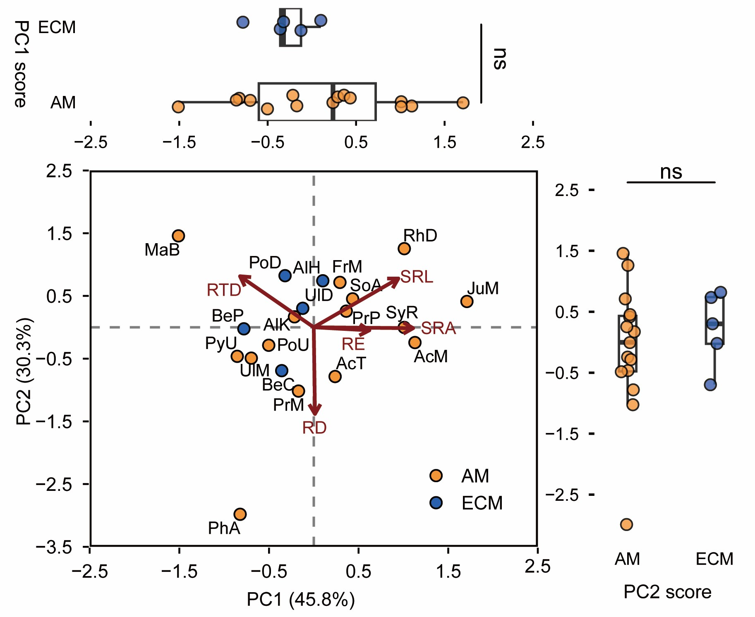
Fig. S1 Principal components analysis (PCA) ordinations of root functional trait variations in the 20 tree species from the AM and ECM types. Different colours denote mycorrhizal types, points denote average score of host plants (see caption of Table S1 for meanings of the abbreviations of host names). SRL, specific root length; SRA, specific root surface area; RTD, root tissue density, root diameter. The ‘ns’ indicates that the score differences between the two mycorrhizal tree species on PC1 and PC2 axes are not significant
Fig. S2 Ternary diagrams of β-diversity components (using Jaccard dissimilarity indexes) for bacterial and fungal communities of AM and ECM tree species among different host species and within the same host species. In the plots, each point represents a pair of samples and the positions of the points are determined by a triplet of percentage values from species turnover (Turnover), nestedness (Nest), and community similarity (Similarity) components

Fig. S3 Phylogenetic tree among host plant species (a), and the influences of host phylogenetic distances on the bacterial and fungal (RAF) community Raup-Crick index (RCI) and β-mean-nearest-taxon-distance index (βNTI) (b)

Fig. S4 Specificity-occupancy plots of (a) bacterial and (b) fungal OTUs of each host plant species (see caption of Table S2 for meanings of the abbreviations of host names). The points represent bacterial and fungal OTUs and the colours denote microbial phylum. When both ‘occupancy’ and “specify” > 0.7, it indicates a “specialist” in a particular microbial community. Notes to the tree species abbreviation are in Table S2

