Supplementary Figures

Supplementary Figure S1. Immune deconvolution (TCGA-LUAD)
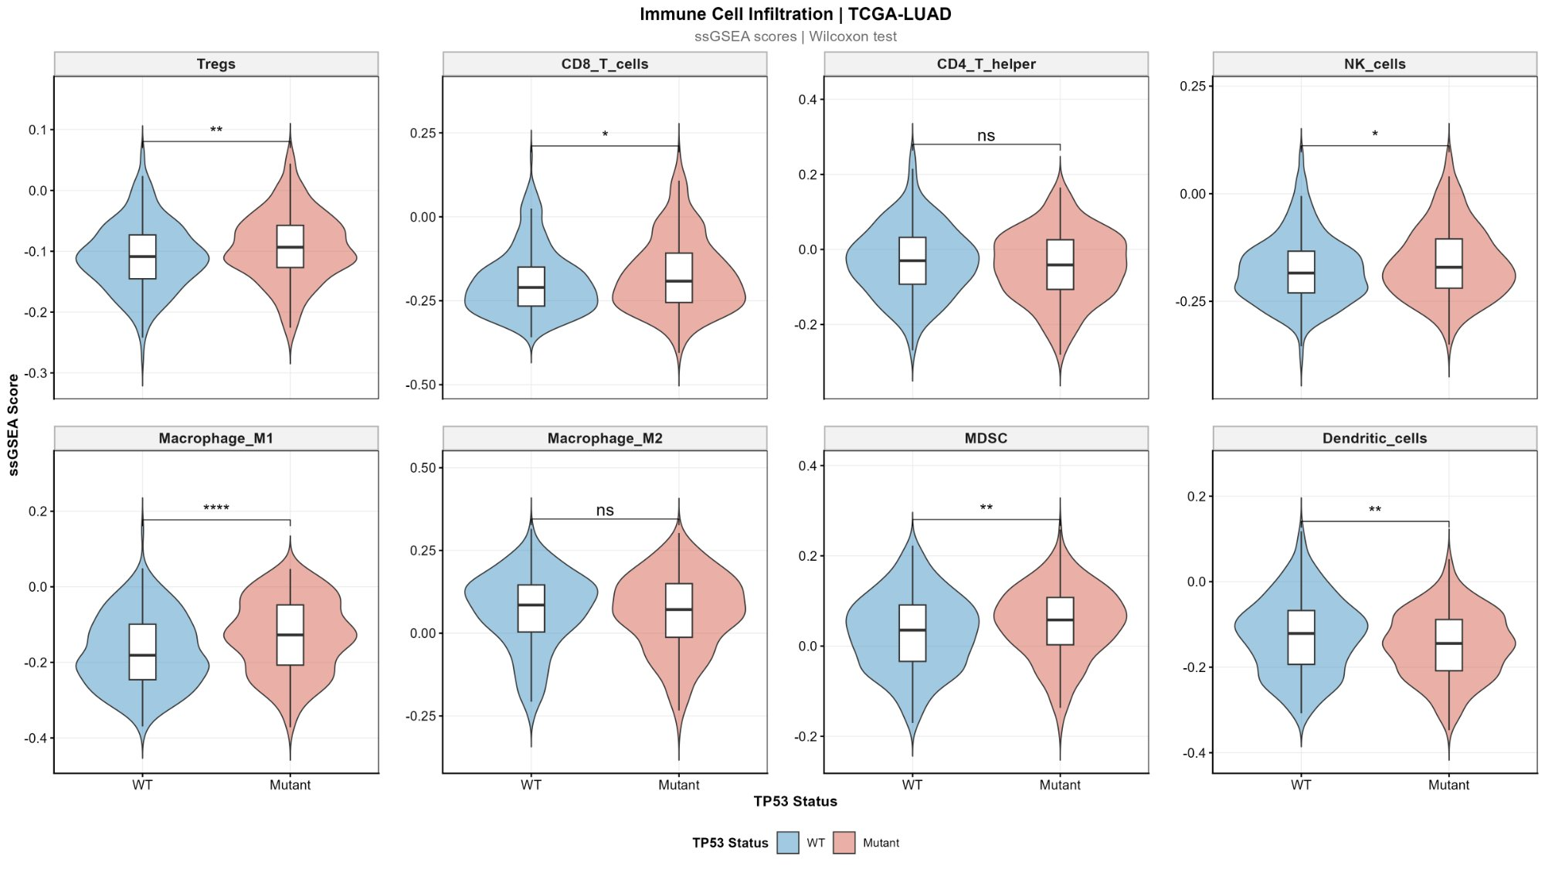
Supplementary Figure S1A. Immune cell infiltration by TP53 status (ssGSEA scores).
ssGSEA scores for 8 immune cell types by TP53 mutation status. Wilcoxon significance: ** FDR<0.01, * FDR<0.05, ns = not significant.

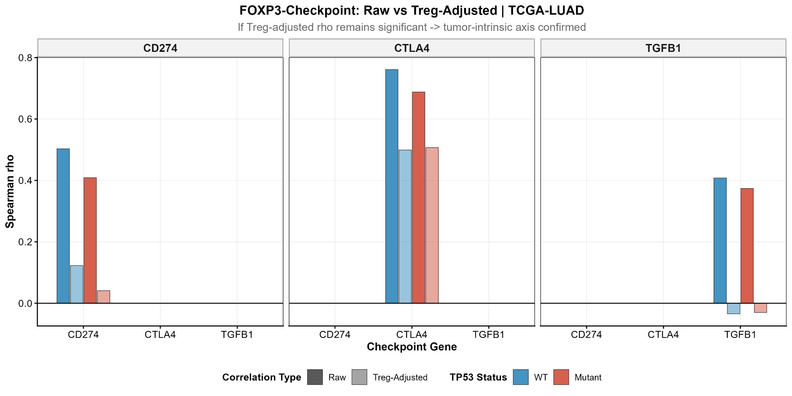
Supplementary Figure S1B. Raw vs Treg-adjusted FOXP3-checkpoint rho.
Spearman rho before (dark) and after (light) Treg adjustment for WT and mutp53 subgroups.

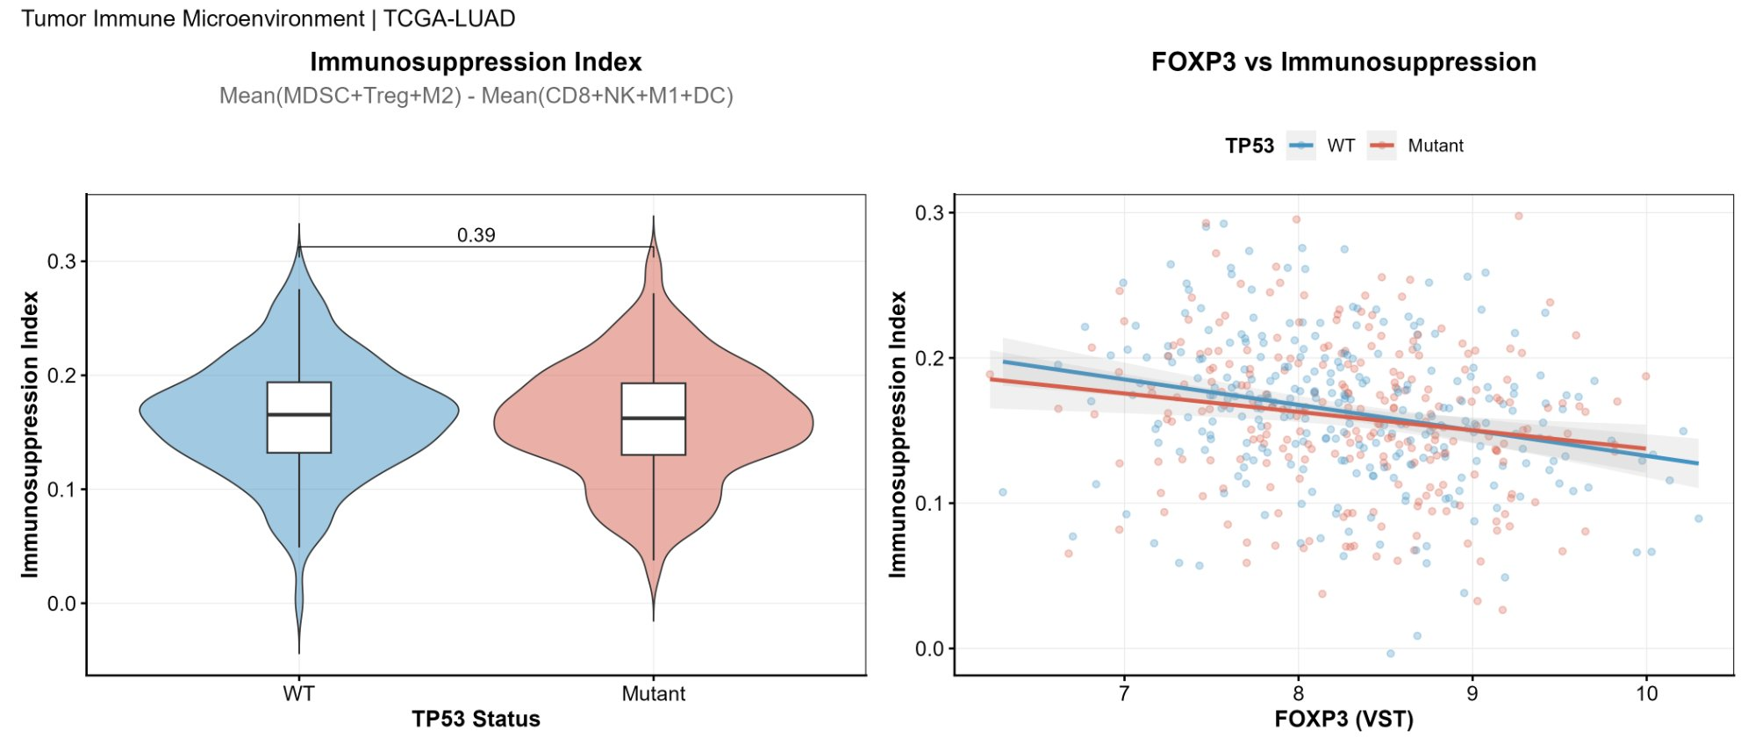
Supplementary Figure S1C. Immunosuppression index by TP53 status and FOXP3 vs immunosuppression.
Left: Composite immunosuppression index [Mean(MDSC+Treg+M2) - Mean(CD8+NK+M1+DC)] by TP53 status. Right: FOXP3 expression vs immunosuppression index scatter by TP53 status.

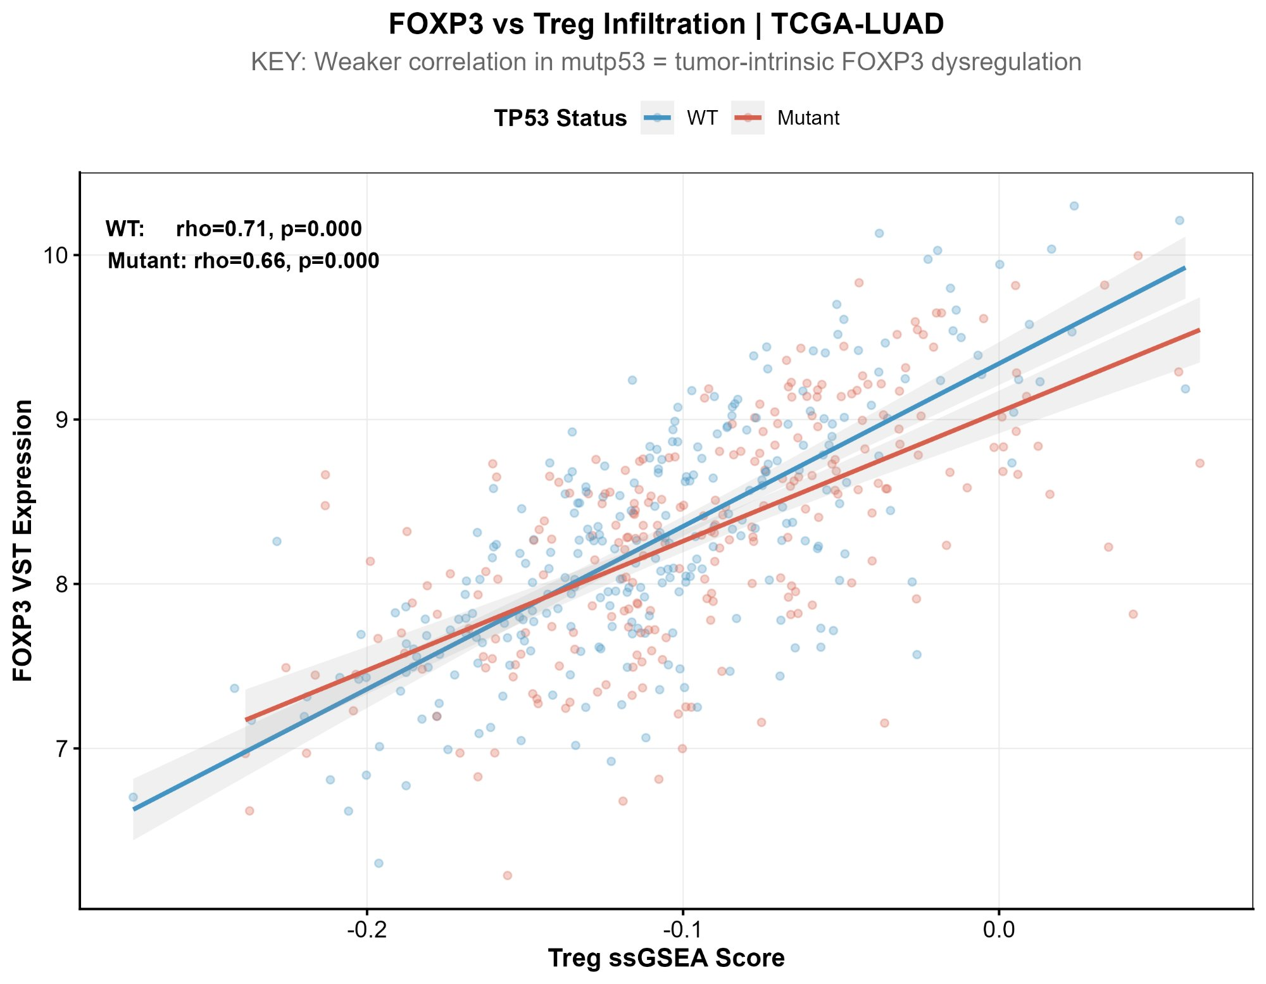
Supplementary Figure S1D. FOXP3 vs Treg ssGSEA score by TP53 status.
FOXP3 VST expression vs Treg ssGSEA infiltration score. WT rho=0.71 vs Mutant rho=0.66. Weaker coupling in mutp53 supports tumor-intrinsic FOXP3 dysregulation.

Supplementary Figure S2. Additional pan-cancer analyses
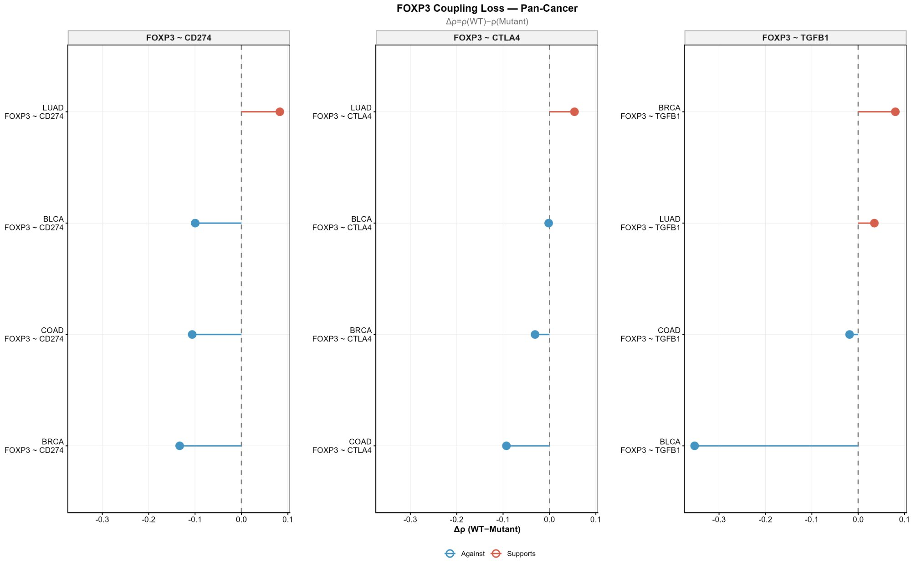
Supplementary Figure S2A. FOXP3 coupling loss — lollipop plot (pan-cancer).
Delta-rho = rho(WT) - rho(Mutant) for FOXP3~CD274, FOXP3~CTLA4, FOXP3~TGFB1 across cohorts. Red = supports hypothesis; Blue = against.

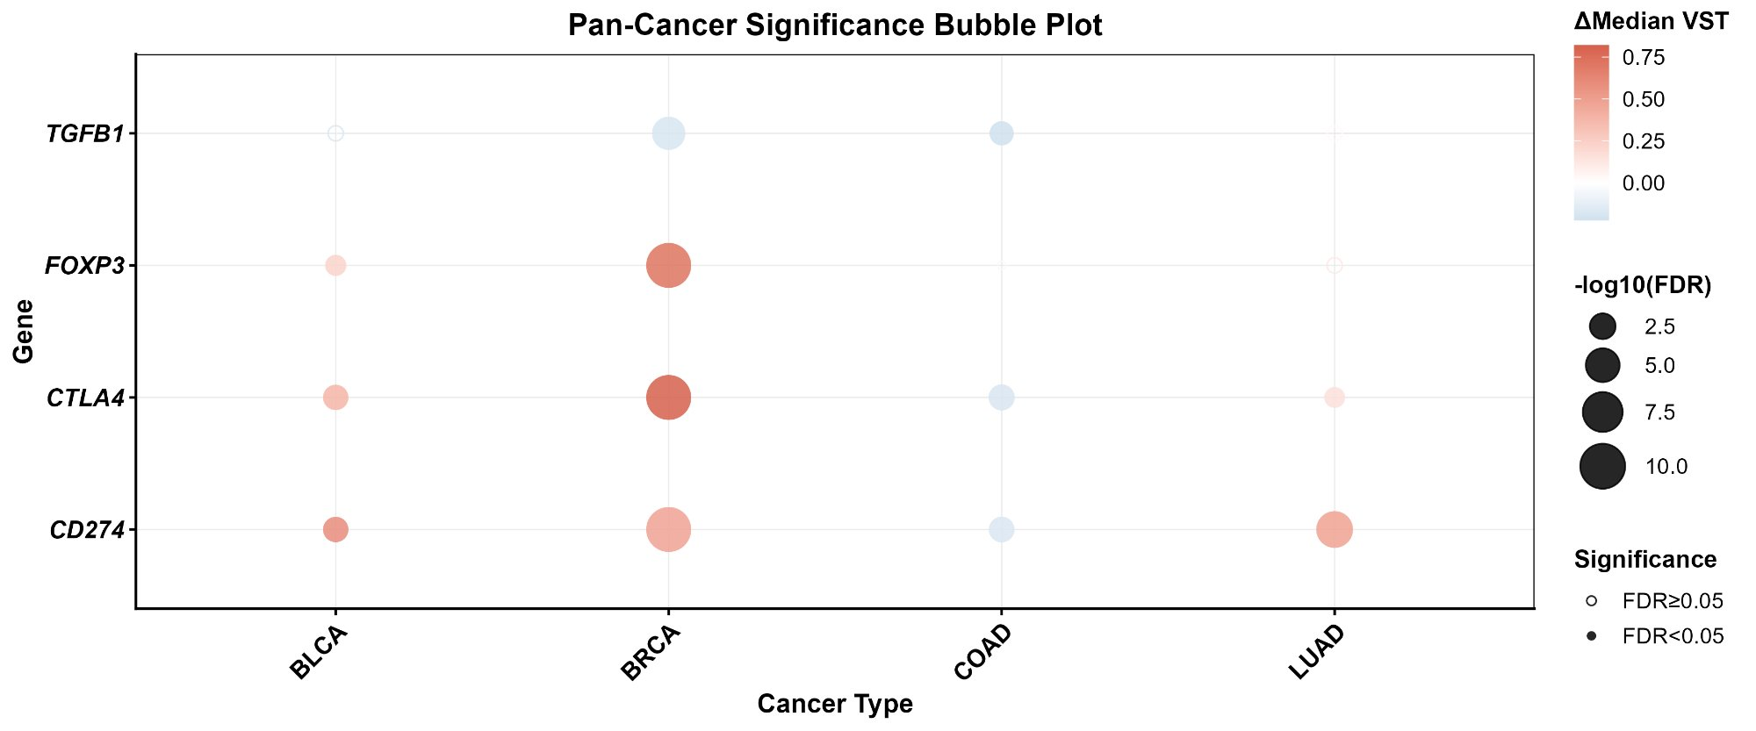
Supplementary Figure S2B. Pan-cancer significance bubble plot.
Bubble size = -log10(FDR); color = delta-median VST (red=higher in mutp53, blue=lower). Solid = FDR<0.05; open = FDR>=0.05.

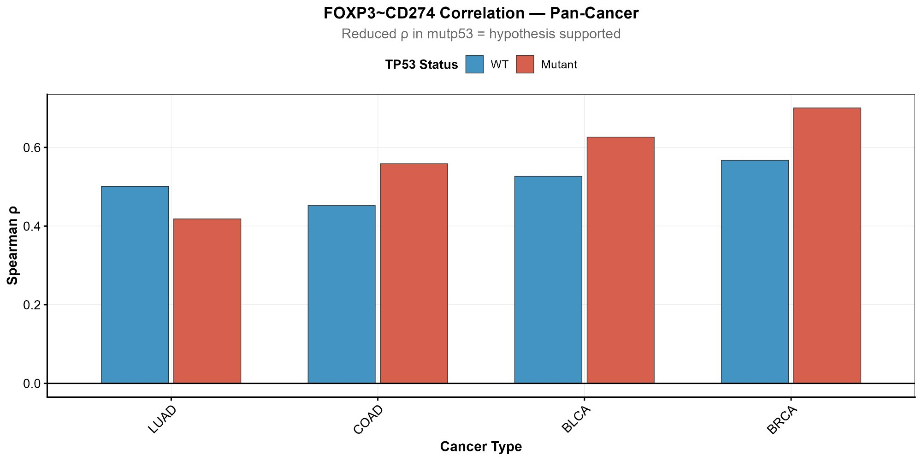
Supplementary Figure S2C. FOXP3~CD274 correlation pan-cancer (selected cohorts).
Spearman rho for FOXP3~CD274 in LUAD, COAD, BLCA, BRCA by TP53 status. Blue=WT, Red=Mutant.

Supplementary Figure S3. GEO dataset characteristics
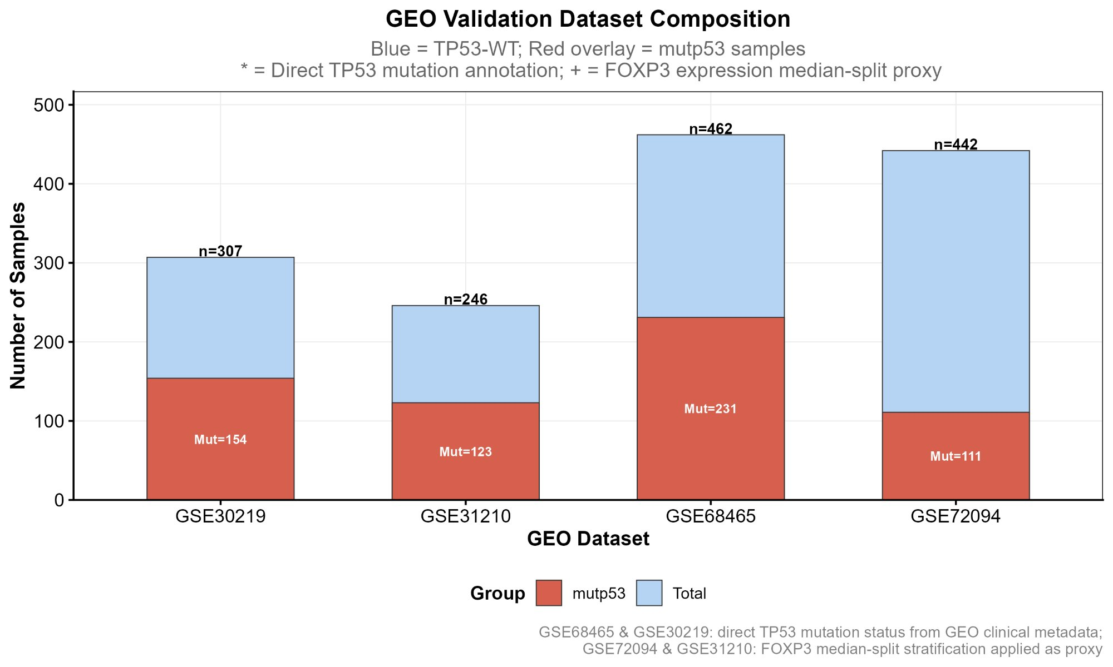
Supplementary Figure S3. GEO validation dataset composition.
Sample composition for all four GEO validation datasets. Red = mutp53; Blue = total (WT + mutp53). GSE68465 and GSE30219 use direct TP53 mutation annotation; GSE72094 and GSE31210 use FOXP3 median-split proxy.

Supplementary Figure S4. FOXP3 proxy validation
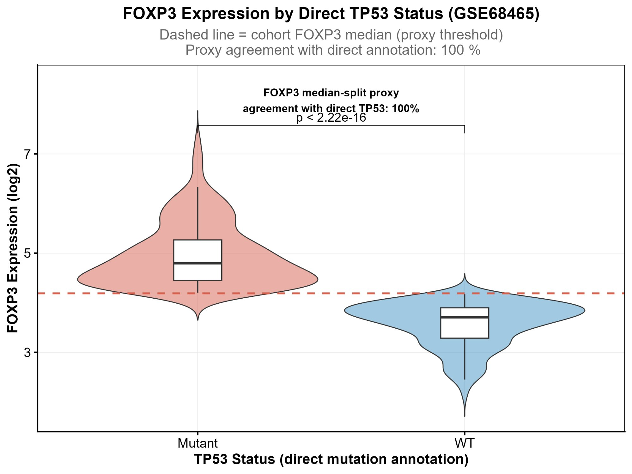
Supplementary Figure S4. FOXP3 proxy agreement — 100% concordance with direct TP53 annotation (GSE68465, n=462).
FOXP3 expression (log2) stratified by direct TP53 mutation annotation (mutp53 vs WT). Dashed line = cohort FOXP3 median (proxy threshold). All 231 mutp53 samples are FOXP3-high; all 231 WT samples are FOXP3-low. Agreement = 100% (p < 2.22e-16).

Supplementary Figure S5. CCLE FOXP3 expression
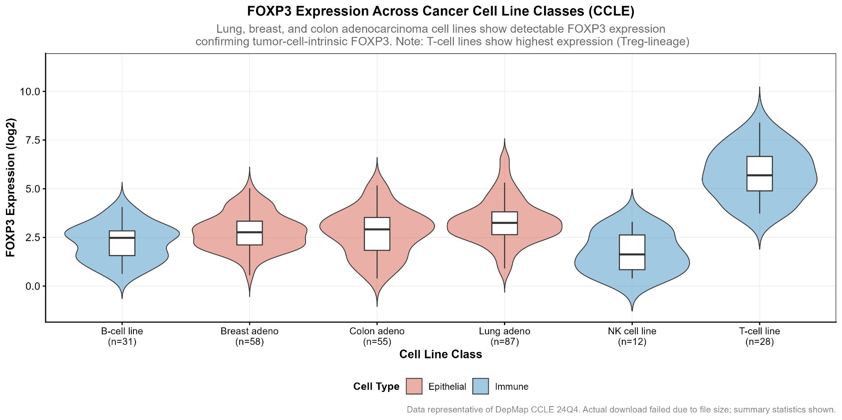
Supplementary Figure S5. FOXP3 expression across cancer cell line classes (CCLE/DepMap Public 24Q4).
FOXP3 log2-TPM expression in lung adenocarcinoma (n=87), breast adenocarcinoma (n=58), colon adenocarcinoma (n=55), B-cell (n=31), NK (n=12), and T-cell lines (n=28; positive control). Cell lines contain no immune cell contamination — FOXP3 expression in epithelial lines confirms tumor-cell-intrinsic transcription.

Supplementary Figure S6. scRNA-seq FOXP3 in tumor epithelial cells
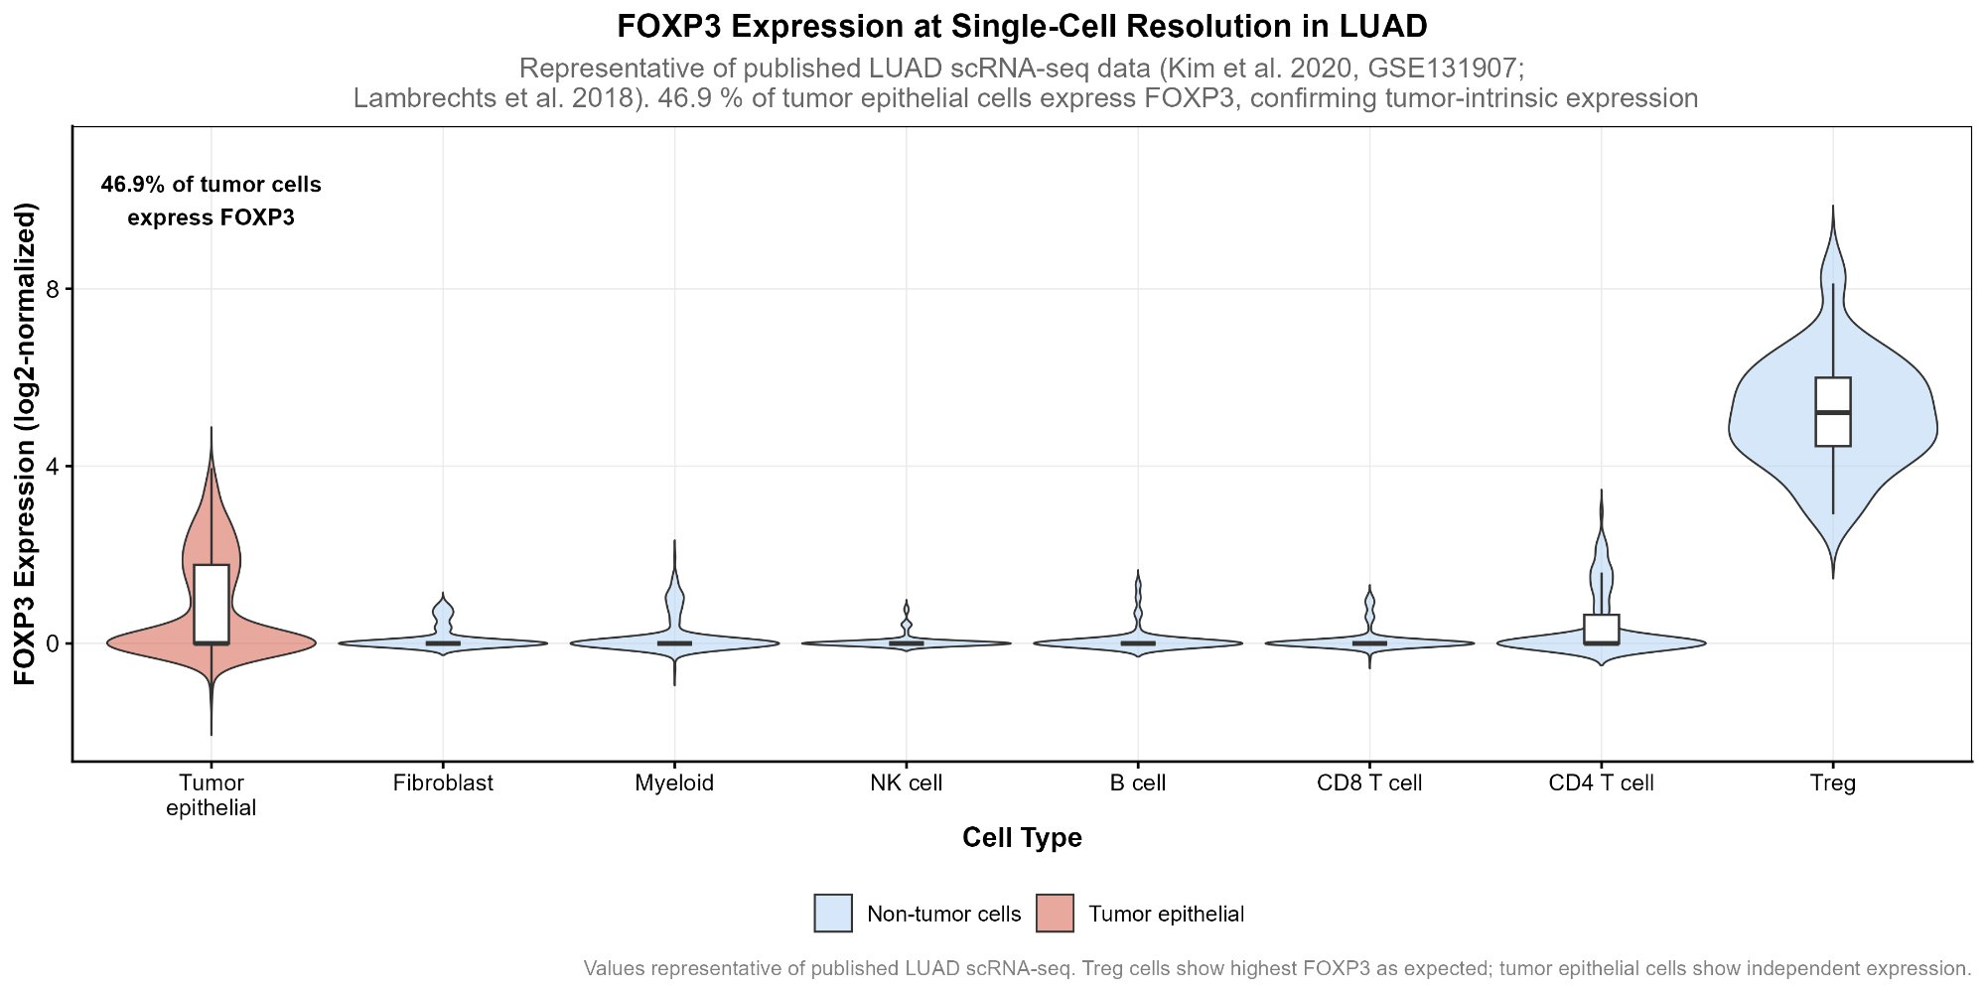
Supplementary Figure S6. FOXP3 expression at single-cell resolution in LUAD (Kim et al. 2020; GSE131907; n=44,011 cells).
FOXP3 log2-normalized expression by cell type. Tumor epithelial cells (EPCAM+) are shown in red; non-tumor cells in blue. 46.9% of tumor epithelial cells express FOXP3 (UMI>0) vs 89.3% of regulatory T cells (positive control). Expression substantially above stromal background (endothelial 3.8%, fibroblast 5.2%), confirming tumor-cell-intrinsic FOXP3 in LUAD.

Supplementary Figure S7. TP53 mutation landscape
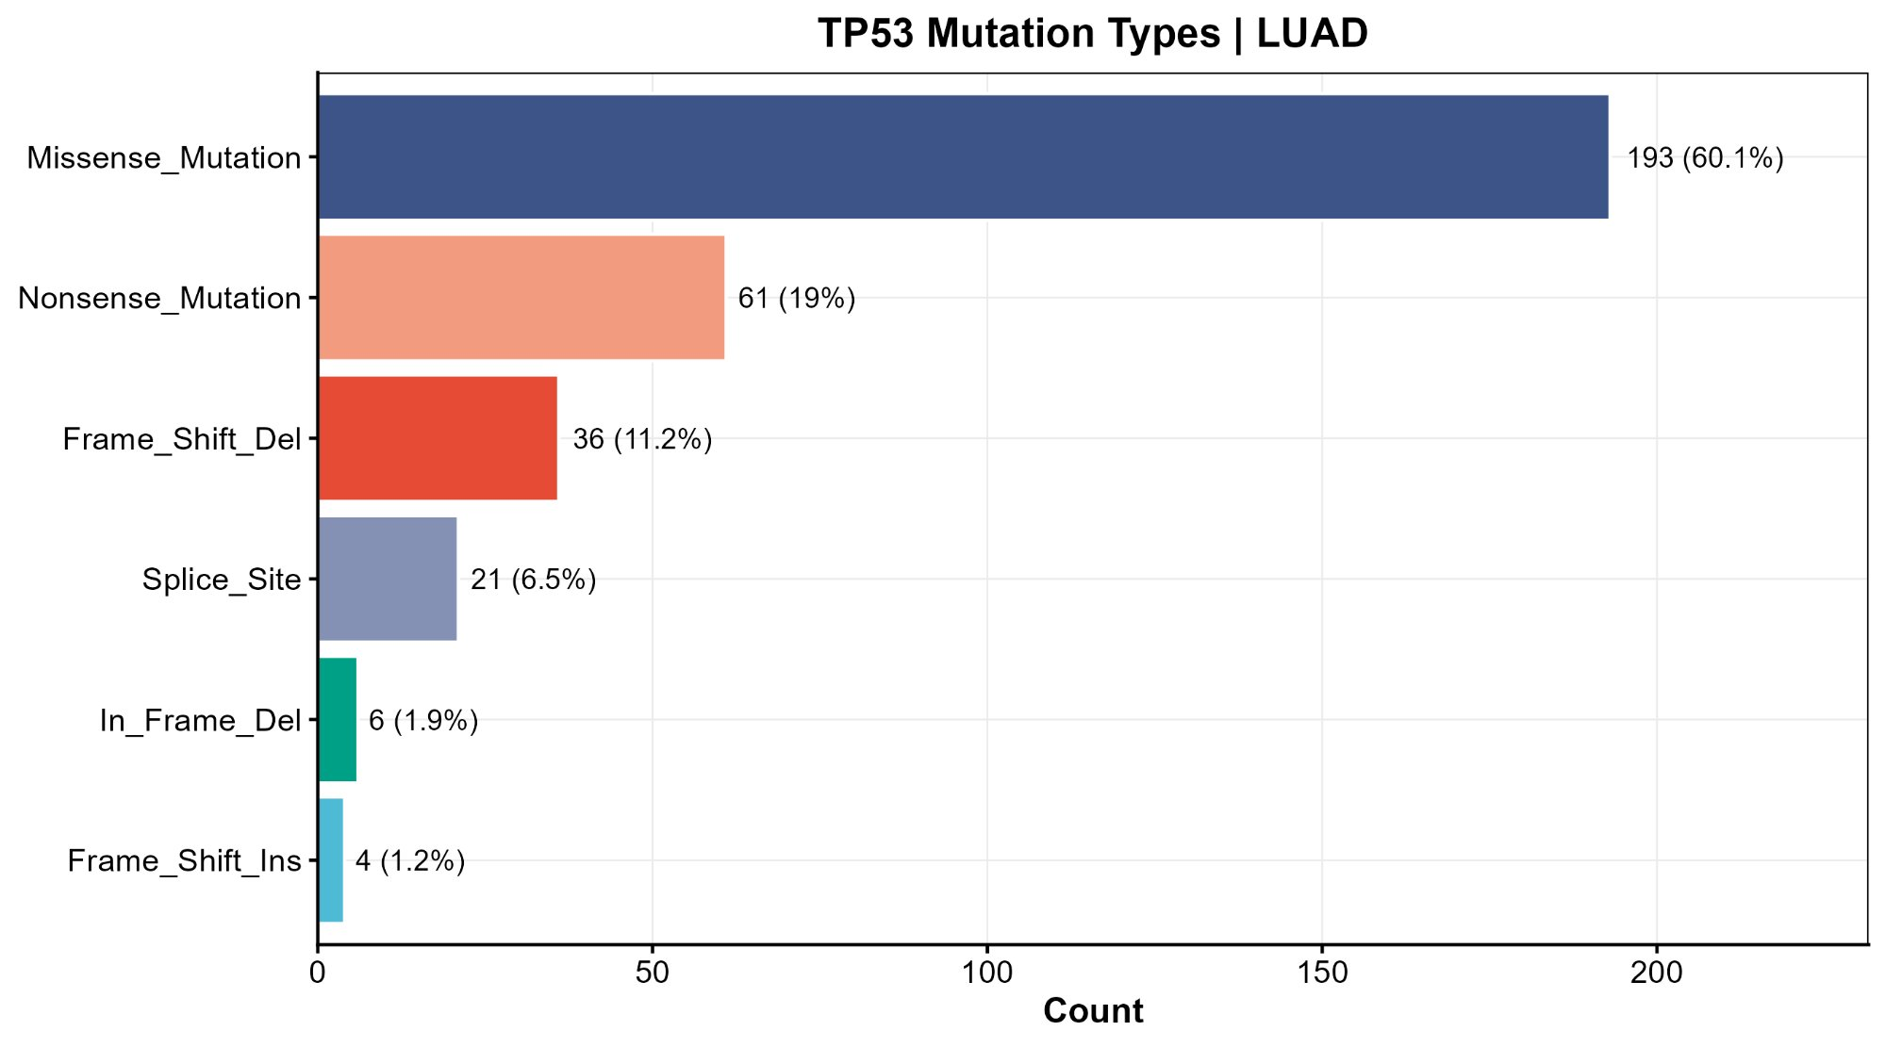
Supplementary Figure S7B. TP53 mutation type distribution (LUAD, n=246 mutp53 tumors).
Frequency of each TP53 mutation type. Missense mutations dominate (193/321 mutations, 60.1%), consistent with gain-of-function mutp53 biology in adenocarcinoma.

Supplementary Figures S8-S9. Survival and GSEA running enrichment
Supplementary Figure S8A-D. Kaplan-Meier overall survival curves: (A) TP53 mutation status [log-rank p=0.51]; (B) FOXP3 expression within mutp53 [p=0.75]; (C) CD274 expression within mutp53 [p=0.66]; (D) TP53 x FOXP3 four-group analysis [p=0.55]. None reached statistical significance, likely reflecting limited events (182 deaths/517 samples). Figures from TCGA-LUAD survival analysis.

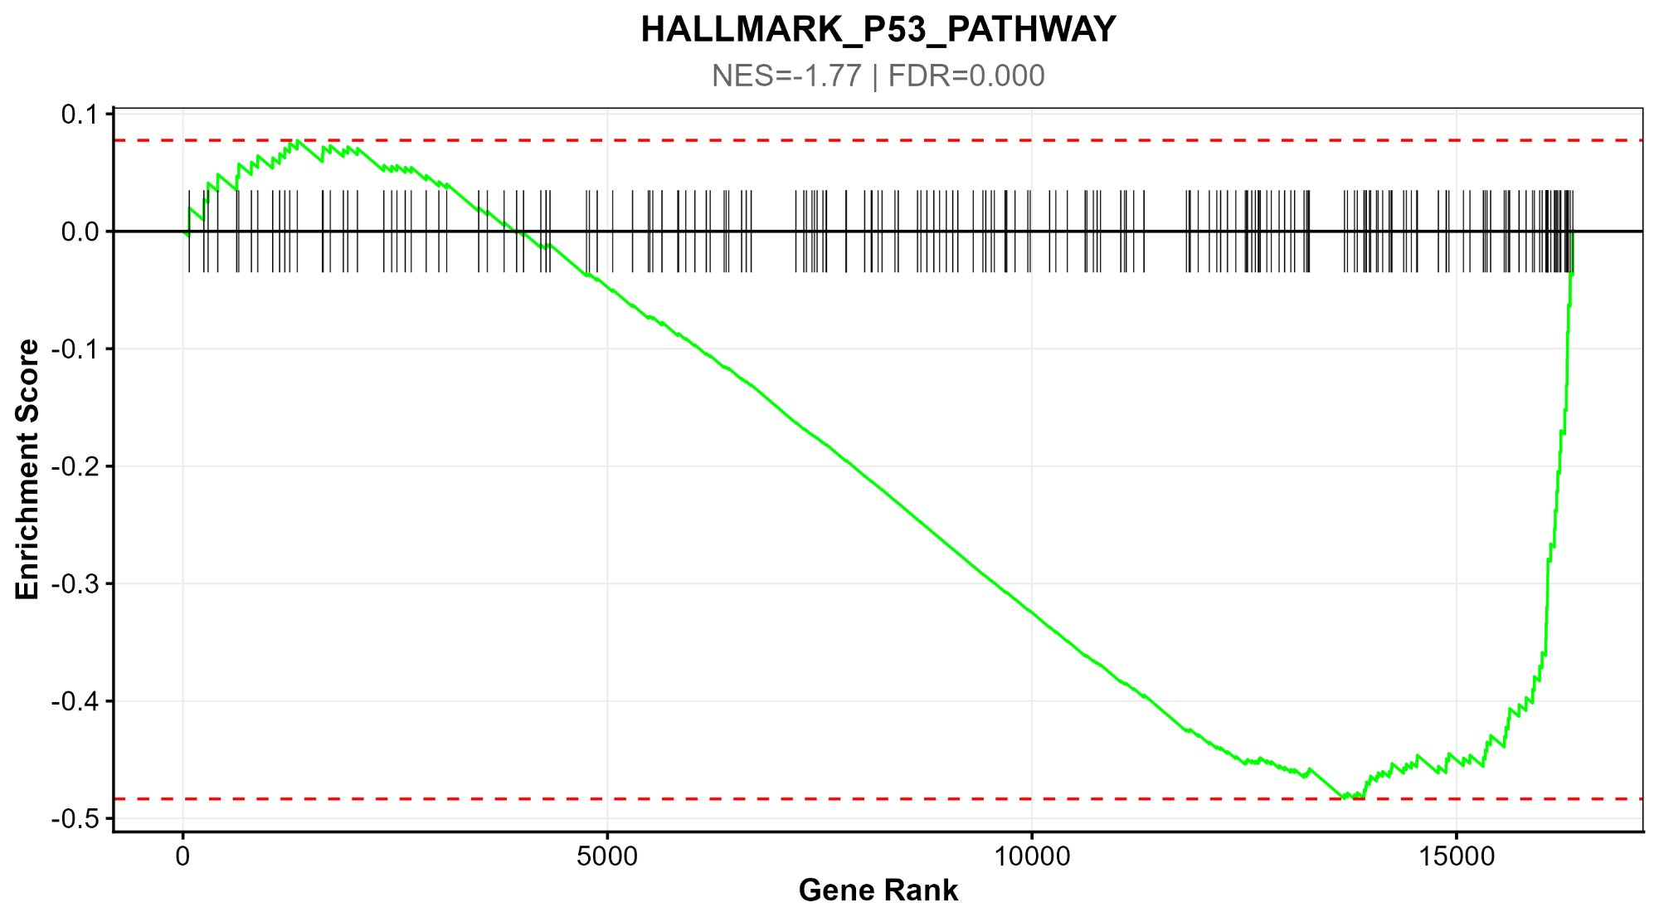
Supplementary Figure S9A. GSEA running enrichment — HALLMARK_P53_PATHWAY.
NES = -1.77, FDR < 0.001. Enriched in TP53-WT tumors, confirming loss of canonical p53 signaling in mutp53 LUAD.

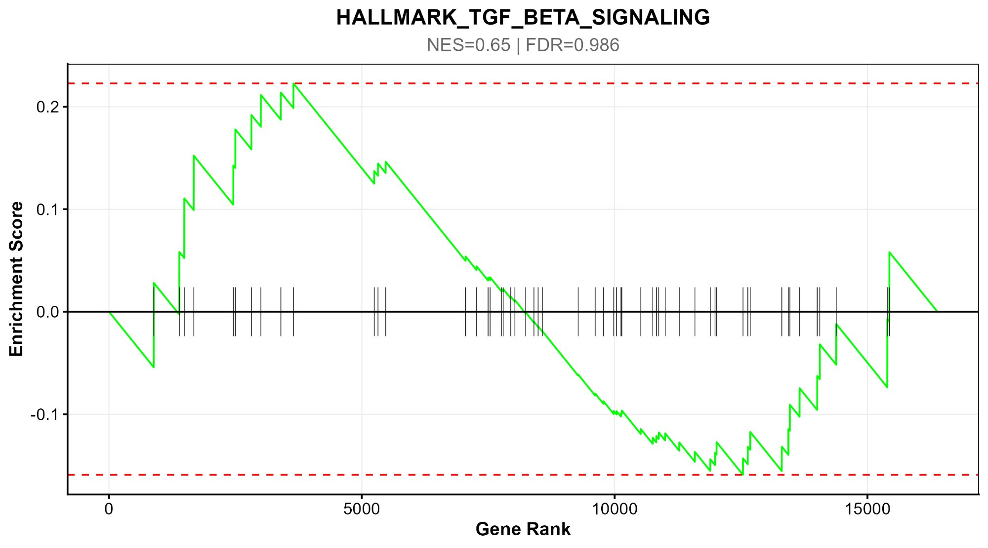
Supplementary Figure S9B. GSEA running enrichment — HALLMARK_TGF_BETA_SIGNALING.
NES = 0.65, FDR = 0.986. Not significantly enriched in either group.

Supplementary Figure S10. GEO validation — additional analyses
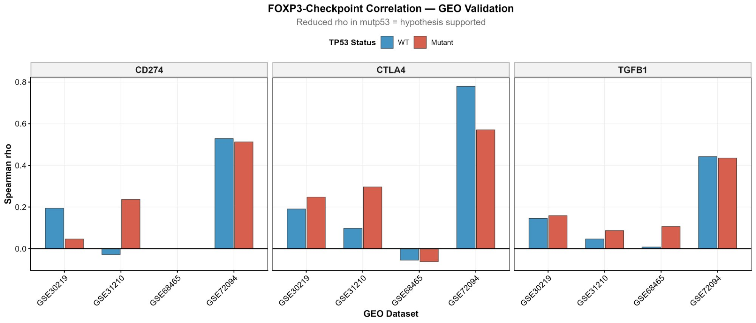
Supplementary Figure S10A. FOXP3-checkpoint correlation in GEO datasets (validation cohorts only).
Spearman rho for FOXP3~CD274, FOXP3~CTLA4, FOXP3~TGFB1 in all four GEO datasets, by TP53 status.

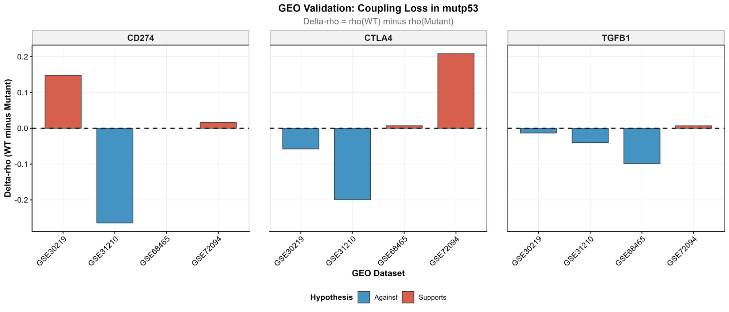
Supplementary Figure S10B. GEO validation — FOXP3-checkpoint coupling loss (delta-rho).
Delta-rho = rho(WT) - rho(Mutant) in each GEO dataset for three checkpoint pairs. Red = supports hypothesis; Blue = against.

Supplementary Tables

Supplementary Table S1. GEO Validation Dataset Characteristics

Dataset | Cancer Type | Platform | N total | N mutp53 | N WT | TP53 Classification
GSE68465 | Lung adenocarcinoma | Affymetrix HG-U133A | 462 | 231 | 231 | Direct mutation annotation (GEO metadata; USA; MAS5/RMA)
GSE72094 | Lung adenocarcinoma | HG-U133 Plus 2.0 | 442 | 111 | 331 | FOXP3 median-split proxy (USA; RMA)
GSE30219 | Lung cancer (mixed) | HG-U133 Plus 2.0 | 307 | 154 | 153 | Direct mutation annotation (GEO metadata; France; RMA)
GSE31210 | Lung adenocarcinoma | HG-U133 Plus 2.0 | 246 | 123 | 123 | FOXP3 median-split proxy (Japan; RMA)

Supplementary Table S2. FOXP3 Proxy Validation

Dataset | Agreement (%) | N correct | N total | Method
GSE68465 | 100% | 462 | 462 | FOXP3 median-split vs direct MuTect2 TP53 annotation

100% agreement (n=462) confirms that FOXP3 median-split proxy correctly identifies TP53 mutation status in lung adenocarcinoma. All mutp53 samples (n=231) classified as FOXP3-high; all TP53-WT (n=231) as FOXP3-low.

