Supplementary material
Figure A1. The frequency distribution of the five-year survival rates for the cancer diagnoses.
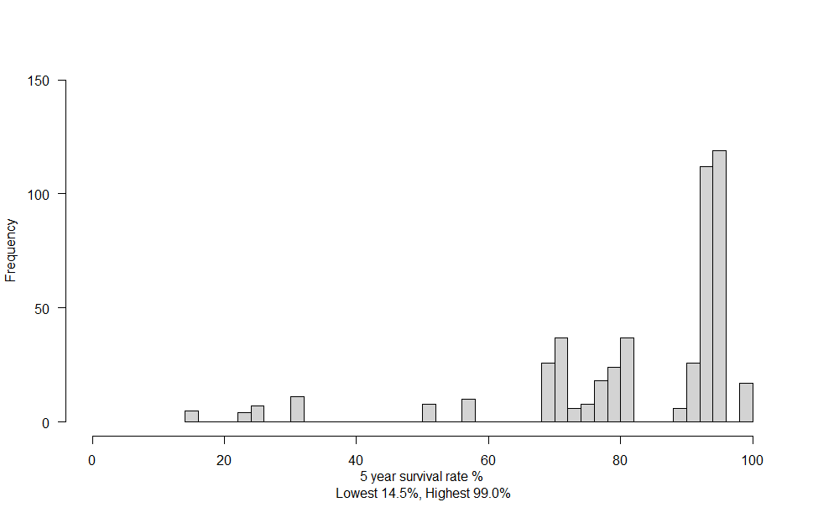

Figure A2. The trajectories in work hours per week and the extrapolated line for both the hospitalized individuals and the control groups with a placebo disease.
Hospitalized individuals | Control groups with a placebo disease
Acute heart attack | Placebo Acute heart attack
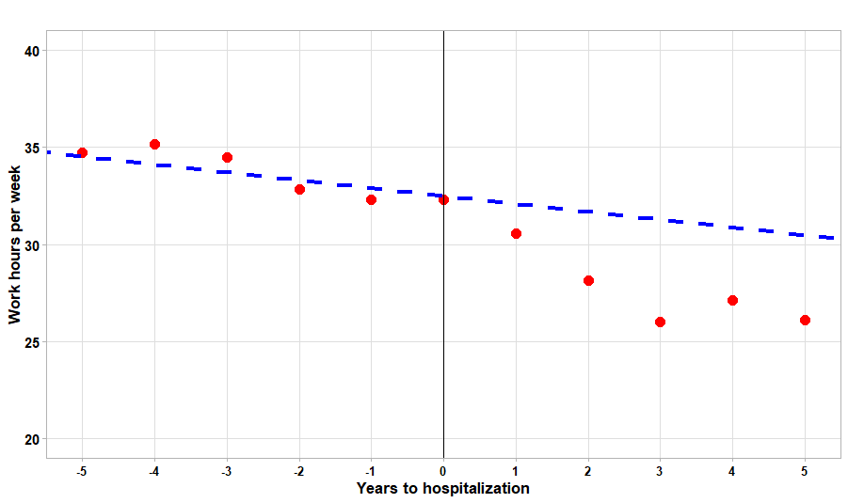 | 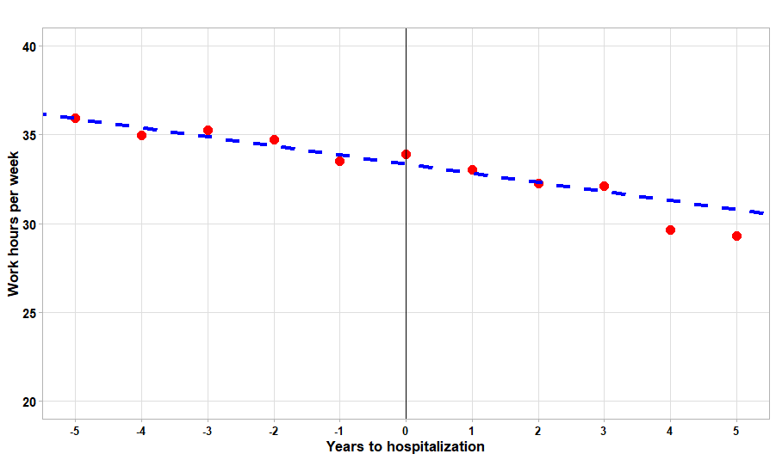
Stroke | Placebo stroke
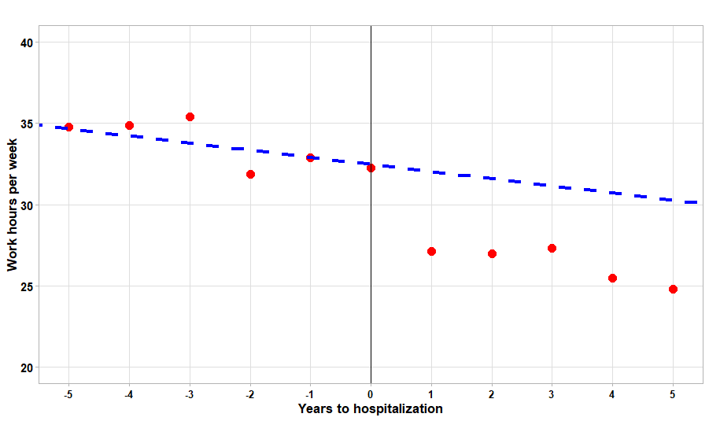 | 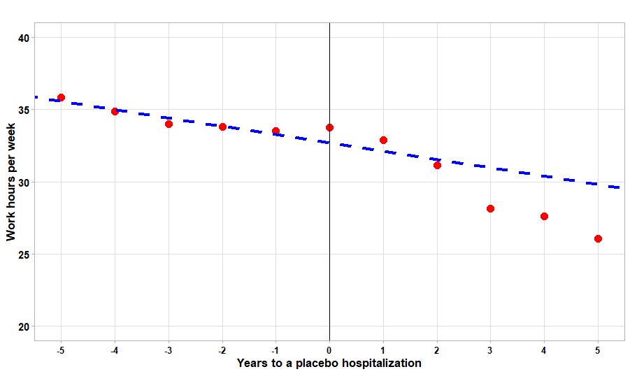
Cancer | Placebo cancer
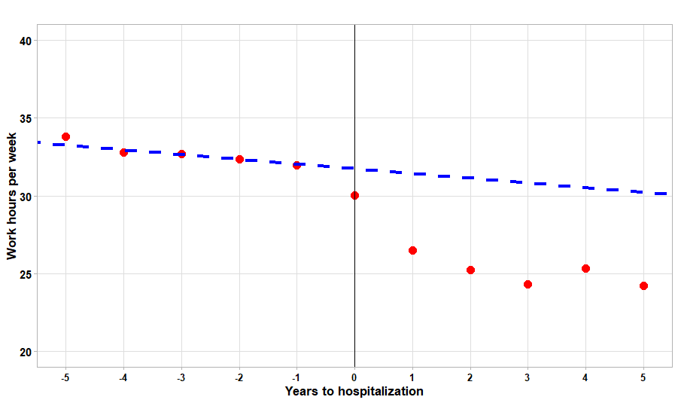 | 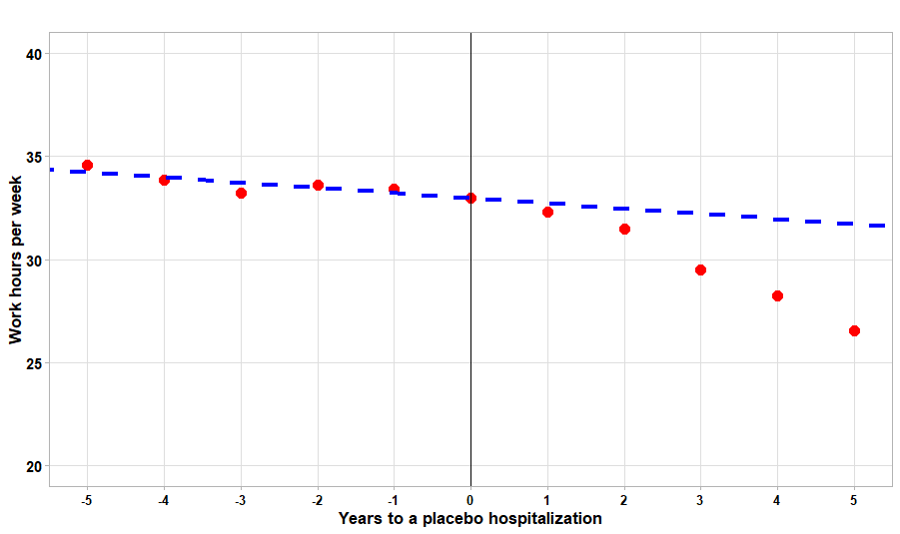

Figure A3. Comparing the trajectories in work hours per week of the hospitalized individuals with the control groups with a placebo disease.
Acute heart attacks
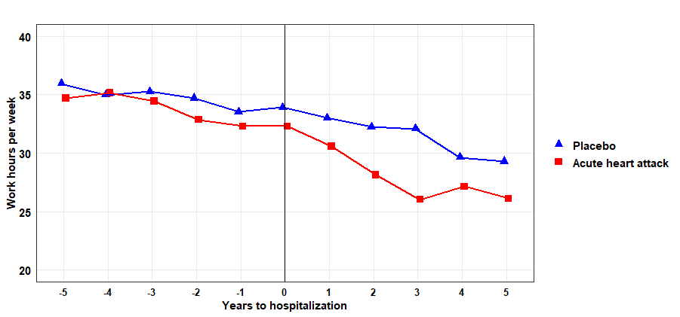
Stroke
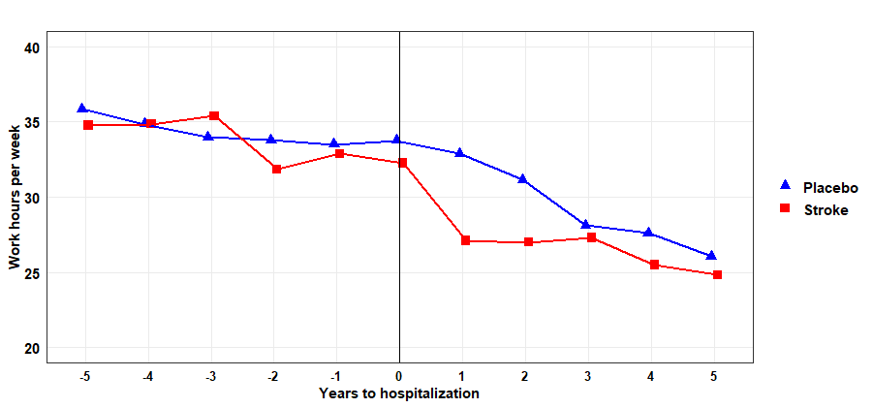

Cancer
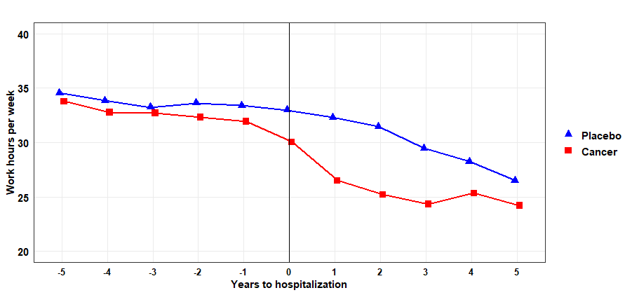

Table A1. Overview of types of cancer, survival rates based on sex, and prognosis category
ICD codes |  | Survival rates |  | Prognosis category
 |  | Women | Men
C01 | Malignant neoplasm of base of tongue | 75.6 | 70.7 | Intermediate
C04 | Malignant neoplasm of floor of mouth | 75.6 | 70.7 | Intermediate
C06 | Malignant neoplasm of other and unspecified parts of mouth | 75.6 | 70.7 | Intermediate
C07 | Malignant neoplasm of parotid gland | 75.6 | 70.7 | Intermediate
C09 | Malignant neoplasm of tonsil | 75.6 | 70.7 | Intermediate
C10 | Malignant neoplasm of oropharynx | 75.6 | 70.7 | Intermediate
C15 | Malignant neoplasm of oesophagus | 30.3 | 22.3 | Poor
C16 | Malignant neoplasm of stomach | 22.3 | 30.3 | Poor
C18 | Malignant neoplasm of colon | 71.3 | 69.4 | Intermediate
C19 | Malignant neoplasm of rectosigmoid junction | 72.4 | 71.4 | Intermediate
C20 | Malignant neoplasm of rectum | 72.4 | 71.4 | Intermediate
C22 | Malignant neoplasm of liver and intrahepatic bile ducts | 24.1 | 23.2 | Poor
C25 | Malignant neoplasm of pancreas | 14.7 | 14.5 | Poor
C34 | Malignant neoplasm of bronchus and lung | 31.0 | 24.7 | Poor
C43 | Malignant melanoma of skin | 94.9 | 90.1 | Good
C50 | Malignant neoplasm of breast | 92.1 |  | Good
C53 | Malignant neoplasm of cervix uteri | 82.0 |  | Intermediate
C54 | Malignant neoplasm of corpus uteri | 82.0 |  | Intermediate
C56 | Malignant neoplasm of ovary | 51.1 |  | Poor
C61 | Malignant neoplasm of prostate |  | 95.7 | Good
C62 | Malignant neoplasm of testis |  | 99.0 | Good
C64 | Malignant neoplasm of kidney, except renal pelvis | 80.7 | 79.6 | Intermediate
C66 | Malignant neoplasm of ureter | 75.4 | 79.3 | Intermediate
C67 | Malignant neoplasm of bladder | 75.4 | 79.3 | Intermediate
C70 | Malignant neoplasm of meninges | 75.3 | 57.9 | Poor
C71 | Malignant neoplasm of brain | 75.3 | 57.9 | Intermediate(women), poor(men)
C72 | Malignant neoplasm of spinal cord, cranial nerves and other parts of central nervous system | 75.3 | 57.9 | Intermediate(women), poor(men)
C73 | Malignant neoplasm of thyroid gland | 95.1 | 88.8 | Intermediate
C81 | Hodgkin lymphoma | 88.7 | 90.2 | Intermediate
C82 | Follicular lymphoma | 79.8 | 77.6 | Intermediate
C83 | Non-follicular lymphoma | 79.8 | 77.6 | Intermediate
C84 | Mature T/NK-cell lymphomas | 79.8 | 77.6 | Intermediate
C85 | Other and unspecified types of non-Hodgkin lymphoma | 77.6 | 77.6 | Intermediate
C91 | Lymphoid leukaemia | 76.2 | 69.9 | Intermediate
C92 | Myeloid leukaemia | 76.2 | 69.9 | Intermediate
Some survival rates are not provided by the Cancer Registry due to few observations. They are the empty cells.

Table A2. Individuals’ characteristics in the year of a hospitalization for acute hearth attack, stroke, or cancer. The cancer diagnoses are categorized into good, intermediate, and poor survival prognosis based on their five-year survival prognosis.
 | Acute heart attack |  | Stroke |  | Cancer: Good |  | Cancer: Intermediate |  | Cancer: Poor
 | N | Mean age (SD) | N | Mean age (SD) | N | Mean age (SD) | N | Mean age (SD) | N | Mean age (SD)
Total | 133 | 53.3 (6.2) | 71 | 51.7 (7.6) | 277 | 52.9 (8.0) | 156 | 52.4 (7.6) | 45 | 53.0 (6.3)
Sex
Women | 26 | 55.0(6.7) | 21 | 49.1(8.5) | 150 | 51.1(7.4) | 78 | 51.6(8.3) | 17 | 52.9(4.6)
Men | 107 | 52.9(6.0) | 50 | 52.8(7.0) | 127 | 55.0(8.3) | 78 | 53.1(6.8) | 28 | 53.4(7.2)
Education¹
No university degree | 79 | 53.2(5.4) | 41 | 53.2(6.7) | 126 | 53.6(7.1) | 74 | 52.7(7.3) | 20 | 55.0(5.5)
University degree | 52 | 53.6(7.0) | 30 | 49.7(8.3) | 151 | 52.3(8.7) | 82 | 52.0(7.9) | 25 | 51.8(6.6)
¹In the educational variable there are two missing values for acute heart attacks and three missing values for cancer with a good survival prognosis.

Summary of the propensity score matching.
This section provides a summary of the propensity score matching results. The sample sizes, control groups, and treated observations reported in Table A4 , Table A6, and Table A8 vary. This variation occurs because individuals already used as controls are removed from the pool of non-hospitalized individuals. Table A4 reports that there are initially 9,627 individuals available as potential controls (10,307 minus 680). We use characteristics from the year 2012 for the control individuals. We match on the original four levels of education to increase the similarity between the numcontrol and treatment groups, while the main analysis uses the rougher granularity of two levels. Propensity scores are applied using nearest-neighbour matching (one-to-one matching without replacement). First, we found matches for acute heart attack, followed by stroke, and finally for cancer-related diseases.

Table A3. Propensity score matching for the acute heart attack disease.
 | Means Treated | Means Control | Std. Mean Diff. | Var. Ratio | eCDF Mean | eCDF Max | Std. Pair Dist.
Summary of balance for All data
Distance | 0.04 | 0.01 | 0.71 | 3.86 | 0.30 | 0.51
Age | 53.36 | 47.26 | 1.01 | 0.72 | 0.18 | 0.36
Women | 0.18 | 0.49 | -0.79 |  | 0.30 | 0.30
Men | 0.82 | 0.51 | 0.79 |  | 0.30 | 0.30
Primary/lower secondary school | 0.12 | 0.14 | -0.05 |  | 0.02 | 0.02
Upper secondary school | 0.48 | 0.29 | 0.39 |  | 0.19 | 0.19
Lower university degree <4 years | 0.18 | 0.21 | -0.07 |  | 0.03 | 0.03
Higher university degree >4 years | 0.21 | 0.36 | -0.37 |  | 0.15 | 0.15
Summary of balance for Matched data
Distance | 0.04 | 0.04 | 0.04 | 1.36 | 0.00 | 0.02 | 0.04
Age | 53.36 | 52.87 | 0.08 | 1.25 | 0.01 | 0.08 | 0.08
Women | 0.18 | 0.17 | 0.04 |  | 0.02 | 0.02 | 0.04
Men | 0.82 | 0.83 | -0.04 |  | 0.02 | 0.02 | 0.04
Primary/lower secondary school | 0.12 | 0.11 | 0.02 |  | 0.01 | 0.01 | 0.02
Upper secondary school | 0.48 | 0.53 | -0.09 |  | 0.05 | 0.05 | 0.12
Lower university degree <4 years | 0.18 | 0.15 | 0.08 |  | 0.03 | 0.03 | 0.08
Higher university degree >4 years | 0.21 | 0.21 | 0.02 |  | 0.01 | 0.01 | 0.09

Table A4. Propensity score matching for the acute heart attack disease.
Sampe Sizes | Control | Treated
All | 9,627 | 131
Matched | 131 | 131
Unmatched | 9,496 | 0
Discarded | 0 | 0

Table A5. Propensity score matching for the stroke disease
 | Means Treated | Means Control | Std. Mean Diff. | Var. Ratio | eCDF Mean | eCDF Max | Std. Pair Dist.
Summary of balance for All data
Distance | 0.01 | 0.01 | 0.66 | 2.76 | 0.21 | 0.33
Age | 51.69 | 47.18 | 0.59 | 1.13 | 0.15 | 0.30
Women | 0.30 | 0.49 | -0.43 |  | 0.20 | 0.20
Men | 0.70 | 0.51 | 0.43 |  | 0.20 | 0.20
Primary/lower secondary school | 0.23 | 0.14 | 0.21 |  | 0.09 | 0.09
Upper secondary school | 0.35 | 0.28 | 0.14 |  | 0.07 | 0.07
Lower university degree <4 years | 0.20 | 0.21 | -0.04 |  | 0.02 | 0.02
Higher university degree >4 years | 0.23 | 0.37 | -0.34 |  | 0.14 | 0.14
Summary of balance for Matched data
Distance | 0.01 | 0.01 | 0.02 | 1.08 | 0.00 | 0.03 | 0.02
Age | 51.69 | 51.42 | 0.04 | 1.09 | 0.01 | 0.06 | 0.04
Women | 0.30 | 0.28 | 0.03 |  | 0.01 | 0.01 | 0.03
Men | 0.70 | 0.72 | -0.03 |  | 0.01 | 0.01 | 0.03
Primary/lower secondary school | 0.23 | 0.24 | -0.03 |  | 0.01 | 0.01 | 0.03
Upper secondary school | 0.35 | 0.35 | 0.00 |  | 0.00 | 0.00 | 0.03
Lower university degree <4 years | 0.20 | 0.20 | 0.00 |  | 0.00 | 0.00 | 0.00
Higher university degree >4 years | 0.23 | 0.21 | 0.03 |  | 0.01 | 0.01 | 0.03

Table A6. Propensity score matching for the stroke disease
Sampe Sizes | Control | Treated
All | 9,496 | 71
Matched | 71 | 71
Unmatched | 9,425 | 0
Discarded | 0 | 0

Table A7. Propensity score matching for the cancer diseases
 | Means Treated | Means Control | Std. Mean Diff. | Var. Ratio | eCDF Mean | eCDF Max | Std. Pair Dist.
Summary of balance for All data
Distance | 0.08 | 0.05 | 0.66 | 2.35 | 0.18 | 0.33
Age | 52.74 | 47.15 | 0.72 | 1.18 | 0.16 | 0.32
Women | 0.51 | 0.49 | 0.04 |  | 0.02 | 0.02
Men | 0.49 | 0.51 | -0.04 |  | 0.02 | 0.02
Primary/lower secondary school | 0.16 | 0.14 | 0.07 |  | 0.02 | 0.02
Upper secondary school | 0.30 | 0.28 | 0.03 |  | 0.02 | 0.02
Lower university degree <4 years | 0.23 | 0.21 | 0.05 |  | 0.02 | 0.02
Higher university degree >4 years | 0.31 | 0.37 | -0.13 |  | 0.06 | 0.06
Summary of balance for Matched data
Distance | 0.08 | 0.08 | 0.06 | 1.30 | 0.01 | 0.10 | 0.06
Age | 52.74 | 52.44 | 0.04 | 1.13 | 0.01 | 0.13 | 0.04
Women | 0.51 | 0.55 | -0.08 |  | 0.04 | 0.04 | 0.18
Men | 0.49 | 0.45 | 0.08 |  | 0.04 | 0.04 | 0.18
Primary/lower secondary school | 0.16 | 0.14 | 0.06 |  | 0.02 | 0.02 | 0.07
Upper secondary school | 0.30 | 0.33 | -0.07 |  | 0.03 | 0.03 | 0.16
Lower university degree <4 years | 0.23 | 0.26 | -0.06 |  | 0.03 | 0.03 | 0.17
Higher university degree >4 years | 0.31 | 0.27 | 0.08 |  | 0.04 | 0.04 | 0.09

Table A8. Propensity score matching for the cancer disease
Sampe Sizes | Control | Treated
All | 9,425 | 478
Matched | 478 | 478
Unmatched | 8,947 | 0
Discarded | 0 | 0

Table A9. Two-sample t-tests of the mean for the health shocks and placebo health shocks. We compare the means of work hours from the periods prior to a health shock. The null-hypothesis(H0) is that the mean differences is zero.
 | Means for health shocks | Means for  placebo shocks | p-value | t-value | Df | H0
Acute heart attack | 34.2 | 34.9 | 0.13 | 1.50 | 1418 | Keep H0
Stroke | 34.3 | 34.4 | 0.88 | 0.14 | 720 | Keep H0
Cancer, five-year survival prognosis
Good survival prognosis | 33.3 | 33.4 | 0.85 | 0.19 | 2960 | Keep H0
Intermediate survival prognosis | 32.9 | 34.2 | 0.01 | 2.91 | 1653 | Reject H0
Poor survival prognosis | 31.4 | 34.3 | 0.01 | 3.20 | 468 | Reject H0

