Supplementary Information

Structure based design of Benzimidazole derivative inhibitors targeting Streptococcus pneumoniae FtsZ: an integrated computational framework
Anisha Kumari^{1†}, Priyanka Kataria^{2†}, Rajni Khan³, Pradeep Kumar Singh⁴, Basant Narain Singh⁵, Ankit Rai⁶, * Anil Kumar Singh^{7*}, Amresh Prakash^{2*}& Shashikant Ray^{1*}
¹Department of Biotechnology, Mahatma Gandhi Central University, Motihari 845401, India.
²Data Science Lab, Amity Institute of Integrative Sciences and Health, Amity University Haryana, Gurugram-122413, India.
³Department of Pharmacology and Toxicology, National Institute of Pharmaceutical Education and Research, Hajipur 844102, India.
⁴JBS Haldane Center of Molecular Medicine, Silicon University Odisha, Bhuwaneswar 751024
⁵Department of Botany, Pandit Deendayal Upadhyaya Shekhawati University, Sikar, Nawalgarh Road, Katrathal, Rajasthan 332024, India.
⁶Department of Medical Biotechnology, Gujrat Biotechnology University, Gandhinagar 382355, Gujarat, India.
⁷Department of Chemistry, Mahatma Gandhi Central University, Motihari 845401, India.

†Authors contributed equally

*Correspondence authors
E-mail: ankit.rai@gbu.edu.in, apraksh@ggn.amity.edu, anilkumarsingh@mgcub.ac.in, shashikantray@mgcub.ac.in

Figure S1
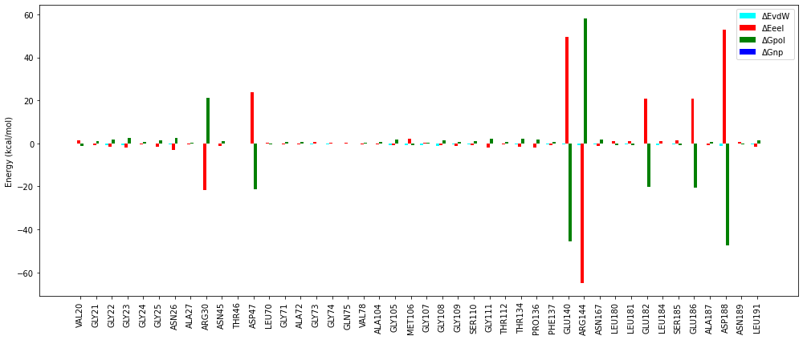Figure S1. Active site residue wise energy decomposition of SpFtsZ-RR26 complex. The total contribution (ΔG_{residue}) is decomposed into van der Waals (ΔE_{vdW}), electrostatic (ΔE_{eel}), polar solvation (ΔG_{pol}), and non-polar solvation (ΔG_{np}) components. Residues with significant energetic contributions (|ΔG_residue| > 1.0 kcal/mol) are highlighted. The negative values indicate favorable contributions to binding, whereas positive values denote unfavorable interactions.

Figure S2

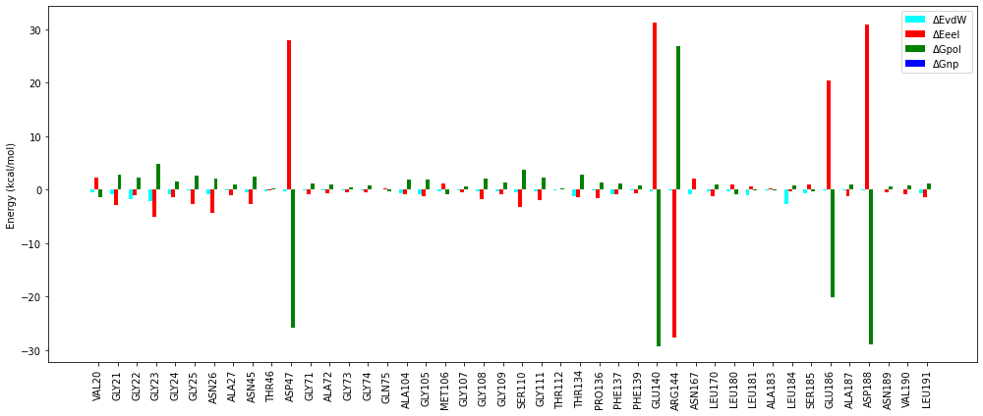
Figure S2. Active site residue wise energy decomposition of SpFtsZ-RR27 complex. The total contribution (ΔG_{residue}) is decomposed into van der Waals (ΔE_{vdW}), electrostatic (ΔE_{eel}), polar solvation (ΔG_{pol}), and non-polar solvation (ΔG_{np}) components. Residues with significant energetic contributions (|ΔG_residue| > 1.0 kcal/mol) are highlighted. The negative values indicate favorable contributions to binding, whereas positive values denote unfavorable interactions.
Figure S3.
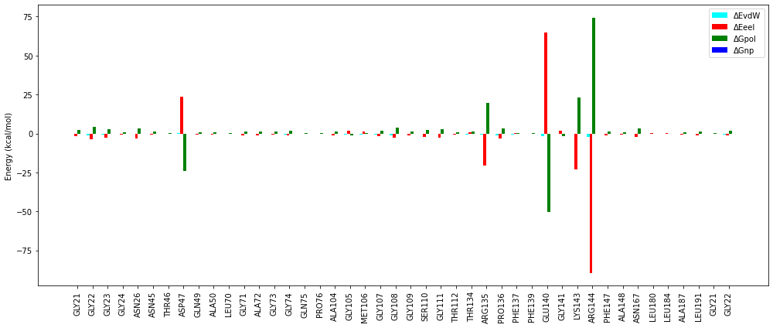Figure S3. Active site residue wise energy decomposition of SpFtsZ-RR33 complex. The total contribution (ΔG_{residue}) is decomposed into van der Waals (ΔE_{vdW}), electrostatic (ΔE_{eel}), polar solvation (ΔG_{pol}), and non-polar solvation (ΔG_{np}) components. Residues with significant energetic contributions (|ΔG_residue| > 1.0 kcal/mol) are highlighted. The negative values indicate favorable contributions to binding, whereas positive values denote unfavorable interactions.

Supplementary table 1:

Entry | Mol. Wt (g/mol) | R¹ | R² | R³ | R⁴ | R⁵ | R⁶
RR01 | 499.57 | Bn | H | H | Ph | H | H
RR02 | 548.04 | Bn | H | CH₃ | Ph | H | Cl
RR03 | 665.62 | 4-hydroxybenzyl | OH | OH | naphthyl | H | CH₃
RR04 | 499.57 | Bn | H | H | Ph | H | H
RR05 | 578.06 | 4-methoxy-benzyl | Cl | H | p-toluene | H | H
RR06 | 592.09 | 4-methoxy-benzyl | CH₃ | CH₃ | 4-chlorophenyl | H | H
RR07 | 523.59 | 4-methoxy-benzyl | CH₃ | CH₃ | acetyl | H | H
RR08 | 499.57 | 4-methoxy-benzyl | CH₃ | CH₃ | methyl | H | H
RR09 | 548.04 | p-chlorobenzyl | carboxamidyl | H | Ph | H | H
RR10 | 665.62 | 2-carboxamide-ethyl | Cl | H | p-nitrophenyl | H | H
RR11 | 561.61 | 4-methoxy-benzyl | fluoro | CH₃ | Ph | H | H
RR12 | 557.6 | 4-hydroxybenzyl | H | H | Ph | H | COCH₃
RR13 | 527.62 | Benzyl | H | H | Ph | CH₃ | CH₃
RR14 | 582.48 | 4-(diClMe)-Bn | H | H | Ph | H | H
RR15 | 582.48 | 3-(diClMe)-Bn | H | H | Ph | H | H
RR16 | 543.58 | Bn | COOH | H | Ph | H | H
RR17 | 529.6 | Bn | NH₂ | NH₂ | Ph | H | H
RR18 | 514.58 | Bn | NH₂ | H | Ph | H | H
RR19 | 544.56 | Bn | NO₂ | H | Ph | H | H
RR20 | 538.6 | Bn | H | CH₃ | Ph | H | CN
RR21 | 576.62 | m-fluorobenzyl | CH₃ | CH₃ | m-hydroxyphenyl | H | NH₂
RR22 | 608.62 | o-hydroxybenzyl | OCH₃ | OCH₃ | o-fluoro-phenyl | H | NH₂
RR23 | 623.64 | m-hydroxy-benzyl | OCH₃ | OCH₃ | 2-fluoro-3-aminophenyl | H | NH₂
RR24 | 626.61 | m-hydroxy-benzyl | OCH₃ | OCH₃ | 2,6-difluorophenyl | H | NH₂
RR25 | 644.6 | m-hydroxy-benzyl | OCH₃ | OCH₃ | 2,3,6-trifluorophenyl | H | NH₂
RR26 | 576.62 | m-hydroxy-benzyl | CH₃ | CH₃ | o-fluorophenyl | H | NH₂
RR27 | 576.62 | m-fluoro | CH₃ | CH₃ | o-hydroxyphenyl | H | NH₂
RR28 | 562.06 | Bn | CH₃ | CH₃ | Ph | H | Cl
RR29 | 548.04 | Bn | CH₃ | H | Ph | H | Cl
RR30 | 630.95 | 3-(diClMe)-Bn | H | CH₃ | Ph | H | Cl
RR31 | 564.04 | 3-hydroxybenzyl | H | CH₃ | Ph | H | Cl
RR32 | 564.04 | 4-hydroxybenzyl | H | CH₃ | Ph | H | Cl
RR33 | 571.63 | Bn | H | CH₃ | Ph | H | Acetate
RR34 | 528.61 | Bn | H | CH₃ | Ph | H | NH₂
RR35 | 549.03 | Bn | H | NH₂ | Ph | H | Cl
RR36 | 548.04 | Bn | H | CH₃ | Ph | H | Cl
RR37 | 548.04 | Bn | H | CH₃ | Ph | H | Cl
RR38 | 580 | 3-hydroxybenzyl | OH | OH | o-fluorophenyl | H | NH₂
RR39 | 542.63 | Bn | CH₃ | CH₃ | Ph | H | NH₂
RR40 | 558.63 | 3-hydroxybenzyl | CH₃ | CH₃ | o-fluorophenyl | H | NH₂
RR41 | 578.06 | 3-hydroxybenzyl | CH₃ | CH₃ | Ph | H | Cl
RR42 | 606.07 | 3-carboxybenzyl | CH₃ | CH₃ | Ph | H | Cl
RR43 | 587.63 | 3-carboxybenzyl | CH₃ | CH₃ | Ph | H | OH
RR44 | 579.56 | 3-hydroxybenzyl | OH | OH | 4-hydroxyphenyl | H | OH
RR45 | 566.01 | Bn | OH | OH | Ph | H | Cl
RR46 | 652.06 | 3-carboxybenzyl | COOH | CH₃ | 4-hydroxyphenyl | H | Cl
RR47 | 652.06 | 3-carboxybenzyl | COOH | CH₃ | p-chlorophenyl | H | OH
RR48 | 632.63 | 3-carboxybenzyl | COOH | CH₃ | 4-aminophenyl | H | OH
RR49 | 648.62 | 3-carboxybenzyl | COOH | CH₃ | 4-aminophenyl | OH | OH
RR50 | 576.62 | 3-hydroxybenzyl | CH₃ | CH₃ | m-fluorophenyl | H | NH₂

Table S1. The structural details of the designed compounds (RR01-RR50)

Supplementary table 2:
Compound | Structure | IUPAC name
RR01 |  | (S)-N-(2-phenyl-1-(1-((1-phenyl-1H-1,2,3-triazol-4-yl)methyl)-1H-benzo[d]imidazol-2-yl)ethyl)picolinamide
RR02 |  | (R)-5-chloro-N-(1-(6-methyl-1-((1-phenyl-1H-1,2,3-triazol-4-yl)methyl)-1H-benzo[d]imidazol-2-yl)-2-phenylethyl)picolinamide
RR03 |  | (R)-N-(1-(5,6-dihydroxy-1-((1-(naphthalen-2-yl)-1H-1,2,3-triazol-4-yl)methyl)-1H-benzo[d]imidazol-2-yl)-2-(4-hydroxyphenyl)ethyl)-5-(trifluoromethyl)picolinamide
RR04 |  | (R)-N-(2-phenyl-1-(1-((1-phenyl-1H-1,2,3-triazol-4-yl)methyl)-1H-benzo[d]imidazol-2-yl)ethyl)picolinamide
RR05 |  | (S)-N-(1-(5-chloro-1-((1-(p-tolyl)-1H-1,2,3-triazol-4-yl)methyl)-1H-benzo[d]imidazol-2-yl)-2-(4-methoxyphenyl)ethyl)picolinamide
RR06 |  | (S)-N-(1-(1-((1-(4-chlorophenyl)-1H-1,2,3-triazol-4-yl)methyl)-5,6-dimethyl-1H-benzo[d]imidazol-2-yl)-2-(4-methoxyphenyl)ethyl)picolinamide
RR07 |  | (S)-N-(1-(1-((1-acetyl-1H-1,2,3-triazol-4-yl)methyl)-5,6-dimethyl-1H-benzo[d]imidazol-2-yl)-2-(4-methoxyphenyl)ethyl)picolinamide
RR08 |  | (S)-N-(1-(5,6-dimethyl-1-((1-methyl-1H-1,2,3-triazol-4-yl)methyl)-1H-benzo[d]imidazol-2-yl)-2-(4-methoxyphenyl)ethyl)picolinamide
RR09 |  | (S)-2-(2-(4-chlorophenyl)-1-(picolinamido)ethyl)-1-((1-phenyl-1H-1,2,3-triazol-4-yl)methyl)-1H-benzo[d]imidazole-5-carboxamide
RR10 |  | (S)-N-(4-amino-1-(5-chloro-1-((1-(4-nitrophenyl)-1H-1,2,3-triazol-4-yl)methyl)-1H-benzo[d]imidazol-2-yl)-4-oxobutyl)picolinamide
RR11 |  | (S)-N-(1-(5-fluoro-6-methyl-1-((1-phenyl-1H-1,2,3-triazol-4-yl)methyl)-1H-benzo[d]imidazol-2-yl)-2-(4-methoxyphenyl)ethyl)picolinamide
RR12 |  | (S)-5-acetyl-N-(2-(4-hydroxyphenyl)-1-(1-((1-phenyl-1H-1,2,3-triazol-4-yl)methyl)-1H-benzo[d]imidazol-2-yl)ethyl)picolinamide
RR13 |  | (S)-4,5-dimethyl-N-(2-phenyl-1-(1-((1-phenyl-1H-1,2,3-triazol-4-yl)methyl)-1H-benzo[d]imidazol-2-yl)ethyl)picolinamide
RR14 |  | (S)-N-(2-(4-(dichloromethyl)phenyl)-1-(1-((1-phenyl-1H-1,2,3-triazol-4-yl)methyl)-1H-benzo[d]imidazol-2-yl)ethyl)picolinamide
RR15 |  | (S)-N-(2-(3-(dichloromethyl)phenyl)-1-(1-((1-phenyl-1H-1,2,3-triazol-4-yl)methyl)-1H-benzo[d]imidazol-2-yl)ethyl)picolinamide
RR16 |  | (S)-2-(2-phenyl-1-(picolinamido)ethyl)-1-((1-phenyl-1H-1,2,3-triazol-4-yl)methyl)-1H-benzo[d]imidazole-5-carboxylic acid
RR17 |  | (S)-N-(1-(5,6-diamino-1-((1-phenyl-1H-1,2,3-triazol-4-yl)methyl)-1H-benzo[d]imidazol-2-yl)-2-phenylethyl)picolinamide
RR18 |  | (S)-N-(1-(5-amino-1-((1-phenyl-1H-1,2,3-triazol-4-yl)methyl)-1H-benzo[d]imidazol-2-yl)-2-phenylethyl)picolinamide
RR19 |  | (S)-N-(1-(5-nitro-1-((1-phenyl-1H-1,2,3-triazol-4-yl)methyl)-1H-benzo[d]imidazol-2-yl)-2-phenylethyl)picolinamide
RR20 |  | (S)-5-cyano-N-(1-(6-methyl-1-((1-phenyl-1H-1,2,3-triazol-4-yl)methyl)-1H-benzo[d]imidazol-2-yl)-2-phenylethyl)picolinamide
RR21 |  | (S)-5-amino-N-(2-(3-fluorophenyl)-1-(1-((1-(3-hydroxyphenyl)-1H-1,2,3-triazol-4-yl)methyl)-5,6-dimethyl-1H-benzo[d]imidazol-2-yl)ethyl)picolinamide
RR22 |  | (R)-5-amino-N-(1-(1-((1-(2-fluorophenyl)-1H-1,2,3-triazol-4-yl)methyl)-5,6-dimethoxy-1H-benzo[d]imidazol-2-yl)-2-(3-hydroxyphenyl)ethyl)picolinamide
RR23 |  | (R)-5-amino-N-(1-(1-((1-(3-amino-2-fluorophenyl)-1H-1,2,3-triazol-4-yl)methyl)-5,6-dimethoxy-1H-benzo[d]imidazol-2-yl)-2-(3-hydroxyphenyl)ethyl)picolinamide
RR24 |  | (R)-5-amino-N-(1-(1-((1-(2,6-difluorophenyl)-1H-1,2,3-triazol-4-yl)methyl)-5,6-dimethoxy-1H-benzo[d]imidazol-2-yl)-2-(3-hydroxyphenyl)ethyl)picolinamide
RR25 |  | (R)-5-amino-N-(1-(5,6-dimethoxy-1-((1-(2,3,6-trifluorophenyl)-1H-1,2,3-triazol-4-yl)methyl)-1H-benzo[d]imidazol-2-yl)-2-(3-hydroxyphenyl)ethyl)picolinamide
RR26 |  | (R)-5-amino-N-(1-(1-((1-(2-fluorophenyl)-1H-1,2,3-triazol-4-yl)methyl)-5,6-dimethyl-1H-benzo[d]imidazol-2-yl)-2-(3-hydroxyphenyl)ethyl)picolinamide
RR27 |  | (R)-5-amino-N-(2-(3-fluorophenyl)-1-(1-((1-(2-hydroxyphenyl)-1H-1,2,3-triazol-4-yl)methyl)-5,6-dimethyl-1H-benzo[d]imidazol-2-yl)ethyl)picolinamide
RR28 |  | 5-chloro-N-(1-(5,6-dimethyl-1-((1-phenyl-1H-1,2,3-triazol-4-yl)methyl)-1H-benzo[d]imidazol-2-yl)-2-phenylethyl)picolinamide
RR29 |  | 5-chloro-N-(1-(5-methyl-1-((1-phenyl-1H-1,2,3-triazol-4-yl)methyl)-1H-benzo[d]imidazol-2-yl)-2-phenylethyl)picolinamide
RR30 |  | (R)-5-chloro-N-(2-(3-(dichloromethyl)phenyl)-1-(6-methyl-1-((1-phenyl-1H-1,2,3-triazol-4-yl)methyl)-1H-benzo[d]imidazol-2-yl)ethyl)picolinamide
RR31 |  | (R)-5-chloro-N-(2-(3-hydroxyphenyl)-1-(6-methyl-1-((1-phenyl-1H-1,2,3-triazol-4-yl)methyl)-1H-benzo[d]imidazol-2-yl)ethyl)picolinamide
RR32 |  | (R)-5-chloro-N-(2-(4-hydroxyphenyl)-1-(6-methyl-1-((1-phenyl-1H-1,2,3-triazol-4-yl)methyl)-1H-benzo[d]imidazol-2-yl)ethyl)picolinamide
RR33 |  | (R)-6-((1-(6-methyl-1-((1-phenyl-1H-1,2,3-triazol-4-yl)methyl)-1H-benzo[d]imidazol-2-yl)-2-phenylethyl)carbamoyl)pyridin-3-yl acetate
RR34 |  | (R)-5-amino-N-(1-(6-methyl-1-((1-phenyl-1H-1,2,3-triazol-4-yl)methyl)-1H-benzo[d]imidazol-2-yl)-2-phenylethyl)picolinamide
RR35 |  | (R)-N-(1-(6-amino-1-((1-phenyl-1H-1,2,3-triazol-4-yl)methyl)-1H-benzo[d]imidazol-2-yl)-2-phenylethyl)-5-chloropicolinamide
RR36 |  | (R)-5-chloro-N-(1-(6-methyl-1-((1-phenyl-1H-1,2,3-triazol-4-yl)methyl)-1H-benzo[d]imidazol-2-yl)-2-phenylethyl)picolinamide
RR37 |  | (S)-5-chloro-N-(1-(6-methyl-1-((1-phenyl-1H-1,2,3-triazol-4-yl)methyl)-1H-benzo[d]imidazol-2-yl)-2-phenylethyl)picolinamide
RR38 |  | (R)-5-amino-N-(1-(1-((1-(2-fluorophenyl)-1H-1,2,3-triazol-4-yl)methyl)-5,6-dihydroxy-1H-benzo[d]imidazol-2-yl)-2-(3-hydroxyphenyl)ethyl)picolinamide
RR39 |  | (R)-5-amino-N-(1-(5,6-dimethyl-1-((1-phenyl-1H-1,2,3-triazol-4-yl)methyl)-1H-benzo[d]imidazol-2-yl)-2-phenylethyl)picolinamide
RR40 |  | (R)-5-amino-N-(1-(1-((1-(2-fluorophenyl)-1H-1,2,3-triazol-4-yl)methyl)-5,6-dimethyl-1H-benzo[d]imidazol-2-yl)-2-(3-hydroxyphenyl)ethyl)picolinamide
RR41 |  | 5-chloro-N-(1-(5,6-dimethyl-1-((1-phenyl-1H-1,2,3-triazol-4-yl)methyl)-1H-benzo[d]imidazol-2-yl)-2-(3-hydroxyphenyl)ethyl)picolinamide
RR42 |  | 3-(2-(5-chloropicolinamido)-2-(5,6-dimethyl-1-((1-phenyl-1H-1,2,3-triazol-4-yl)methyl)-1H-benzo[d]imidazol-2-yl)ethyl)benzoic acid
RR43 |  | 3-(2-(5,6-dimethyl-1-((1-phenyl-1H-1,2,3-triazol-4-yl)methyl)-1H-benzo[d]imidazol-2-yl)-2-(5-hydroxypicolinamido)ethyl)benzoic acid
RR44 |  | N-(1-(5,6-dihydroxy-1-((1-(4-hydroxyphenyl)-1H-1,2,3-triazol-4-yl)methyl)-1H-benzo[d]imidazol-2-yl)-2-(3-hydroxyphenyl)ethyl)-5-hydroxypicolinamide
RR45 |  | 5-chloro-N-(1-(5,6-dihydroxy-1-((1-phenyl-1H-1,2,3-triazol-4-yl)methyl)-1H-benzo[d]imidazol-2-yl)-2-phenylethyl)picolinamide
RR46 |  | (S)-2-(2-(4-carboxyphenyl)-1-(5-chloropicolinamido)ethyl)-1-((1-(4-hydroxyphenyl)-1H-1,2,3-triazol-4-yl)methyl)-6-methyl-1H-benzo[d]imidazole-5-carboxylic acid
RR47 |  | (S)-2-(2-(4-carboxyphenyl)-1-(5-hydroxypicolinamido)ethyl)-1-((1-(4-chlorophenyl)-1H-1,2,3-triazol-4-yl)methyl)-6-methyl-1H-benzo[d]imidazole-5-carboxylic acid
RR48 |  | (S)-1-((1-(4-aminophenyl)-1H-1,2,3-triazol-4-yl)methyl)-2-(2-(4-carboxyphenyl)-1-(5-hydroxypicolinamido)ethyl)-6-methyl-1H-benzo[d]imidazole-5-carboxylic acid
RR49 |  | (S)-1-((1-(4-aminophenyl)-1H-1,2,3-triazol-4-yl)methyl)-2-(2-(4-carboxyphenyl)-1-(4,5-dihydroxypicolinamido)ethyl)-6-methyl-1H-benzo[d]imidazole-5-carboxylic acid
RR50 |  | (R)-5-amino-N-(1-(1-((1-(2-fluorophenyl)-1H-1,2,3-triazol-4-yl)methyl)-5,6-dimethyl-1H-benzo[d]imidazol-2-yl)-2-(3-hydroxyphenyl)ethyl)picolinamide

Table S2: Structure and IUPAC name of compounds.

