Mesoporous Silica Nanoparticles Confer Broad-Spectrum Disease Resistance in Rice via the OsERF3-OsRBOHE-ROS Pathway
Yaling Zhao^{a,b#}, Shunkang Zhou^{a,d#}, Guotao He^{a#}, Meng Yang^{a,b#}, Ziyi Liª, Simin Liuª, Gufeng Yuanª, Yongqi Huangª, Wei Zhang^{c}, Yuhao Yang^{c}, Yi Xu^{c}, Baoshan Chen^{a,b}, Huihua Tan^{a,b}, Wenwei Tang^{a,b}, Yongqiang He^{a,b}, Wen Li^{a,b}, Yanmei Liuª, Tong Zhang^{d}*, Wenxiu Qiu^{c}*, Ying Zhou^{c,e}*
ªGuangxi Key Laboratory of Agro-environment and Agro-product Safety, College of Agriculture, Guangxi University, Nanning, 530004, China.
^{b}State Key Laboratory for Conservation and Utilization of Subtropical Agro-bioresources, College of Agriculture, Guangxi University, Nanning, 530004, China.
^{c}College of Life Science and Health, Wuhan University of Science and Technology, Wuhan, Hubei, 430081, China.
^{d}Guangdong Province Key Laboratory of Microbial Signals and Disease Control, College of Plant Protection, South China Agricultural University, Guangzhou, 510624, China.
^{e}Wuhan Greenfafa Institute of Novel Genechip R&D Co., Ltd., Wuhan, 430070, China.
#These authors contribute equally to this work.
*Author to whom correspondence should be addressed: Ying Zhou (18062565621@163.com); Wenxiu Qiu (wx_qiu1816@163.com); Tong Zhang (zhangtong@scau.edu.cn).

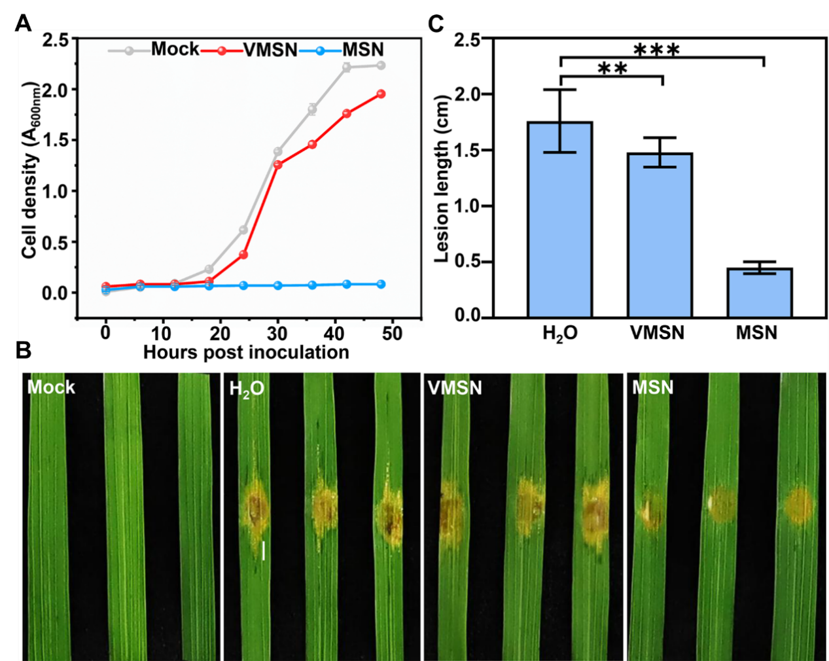
Figure S1. Control effect of the VMSN and MSN on BLS.
(A) The growth curves of Xoc strain in NA medium supplemented with 0.1 mg/mL VMSN and MSN were analyzed. (B) Phenotypes of BLS lesion expansion in rice plants following treatment with 0.1 mg/mL VMSN and MSN. (C) Statistics of lesion length in (B). The values shown are the means ± SD (n = 10). **p ≤ 0.01, ***p ≤ 0.001; one-way ANOVA with post hoc Duncan’s multiple range test.
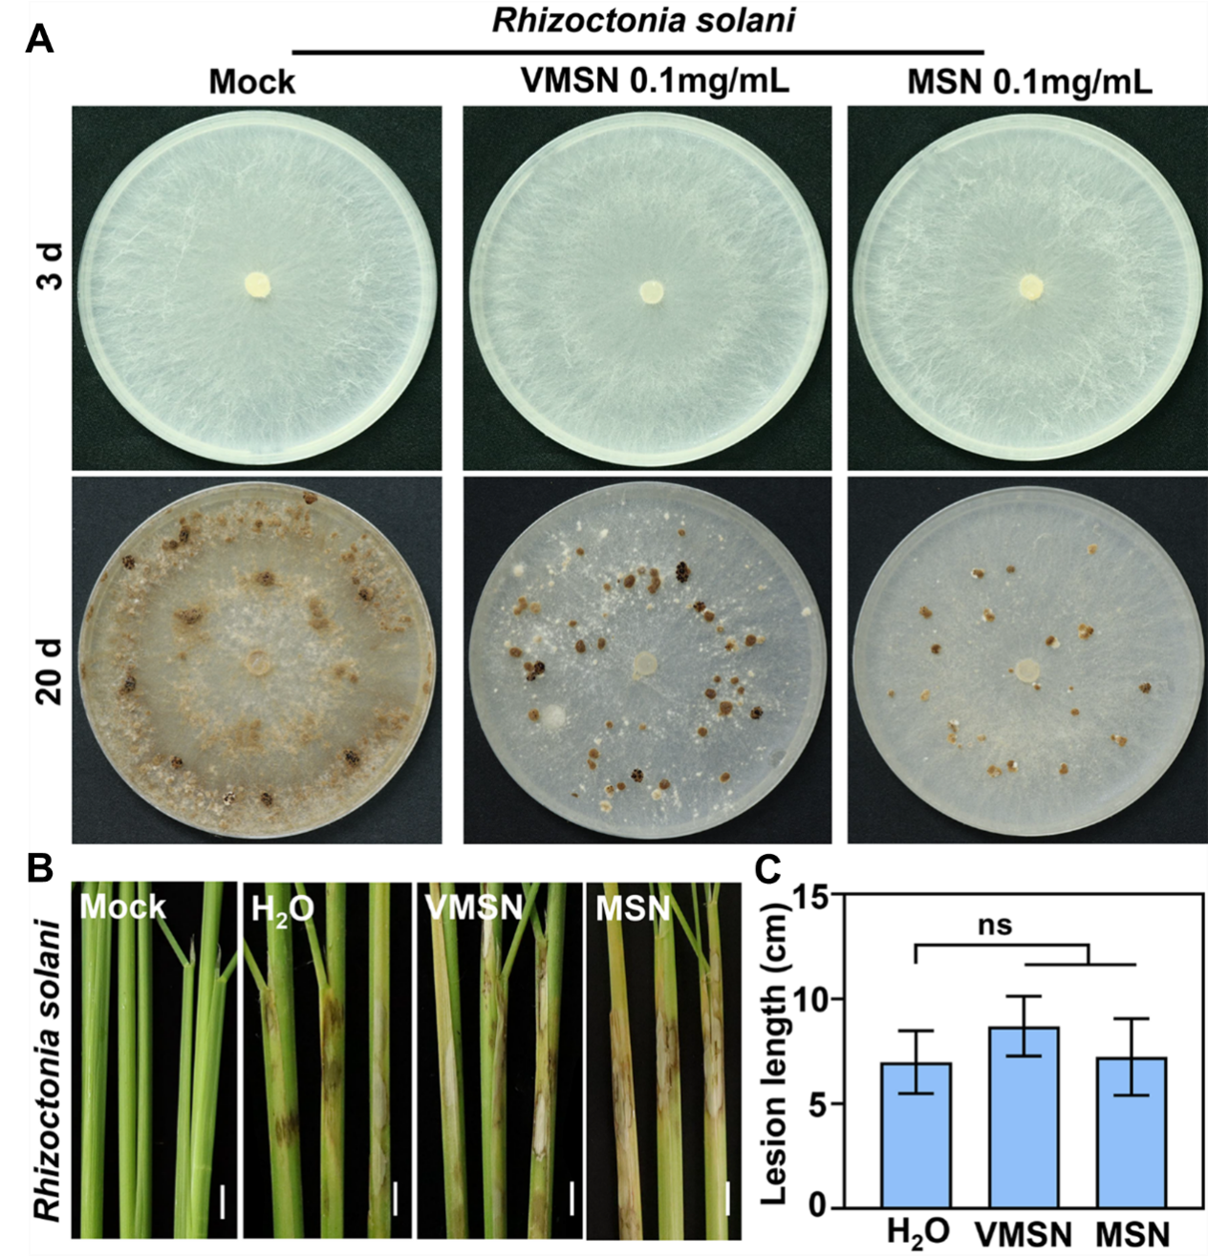
Figure S2. Control effect of the VMSN and MSN on RSB.
(A) The morphological features of R. solani hyphae and sclerotia were characterized on PDA cotained with 0.1 mg/mL of both VMSN and MSN. (B) Phenotypes of SHB lesion expansion in rice plants following treatment with 0.1 mg/mL VMSN and MSN. (C) Statistics of lesion length in (B). The values shown are the means ± SD (n = 10). ns: no significant difference; one-way ANOVA with post hoc Duncan’s multiple range test.
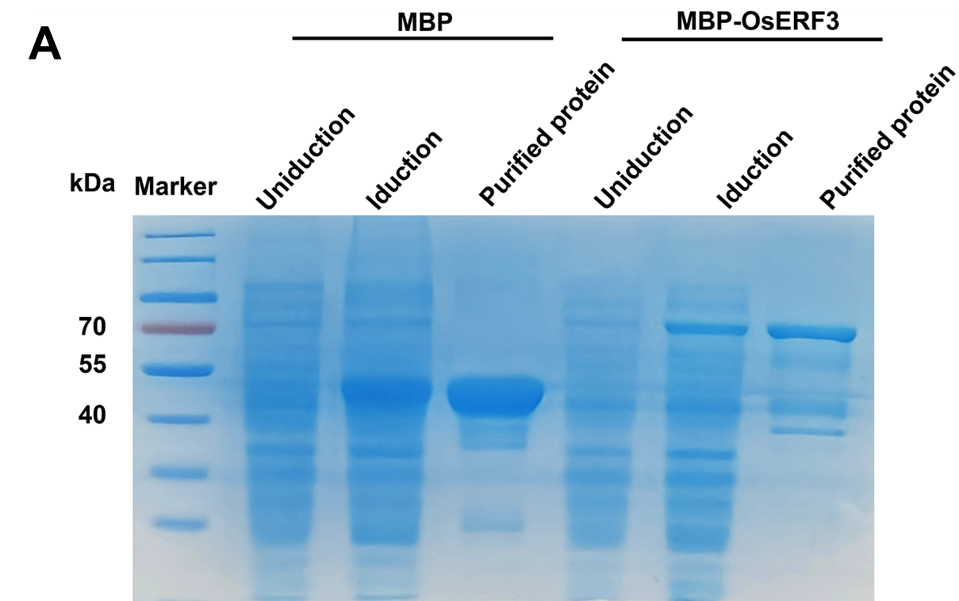
Figure S3. Control effect of the VMSN and MSN on RSB.
SDS-PAGE analysis with Coomassie Brilliant Blue staining was performed to analyze protein expression and purification. Samples included lysates from bacterial strains expressing the MBP and MBP-OsERF3 fusion proteins under uninduced and induced conditions, as well as the final purified protein sample.

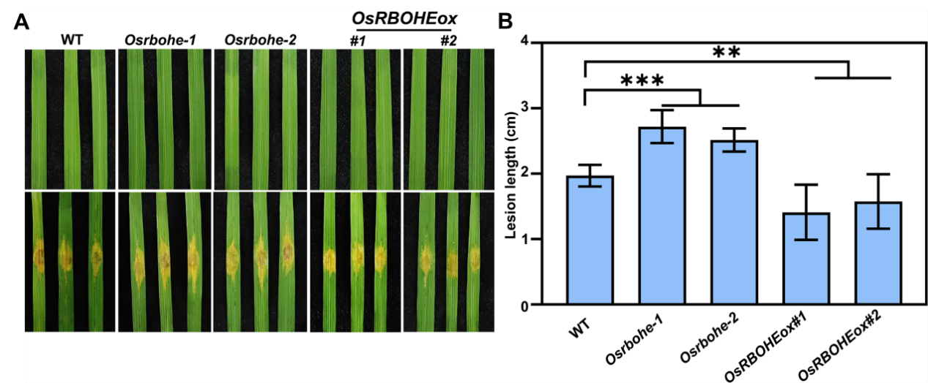
Figure S4. Control effect of the VMSN and MSN on BLS.
(A) The growth curves of Xoc strain in NA medium supplemented with 0.1 mg/mL VMSN and MSN were analyzed. Differences in growth among the treatment groups were compared using repeated-measures ANOVA. (B) Phenotypes of BLS lesion expansion in rice plants following treatment with 0.1 mg/mL VMSN and MSN. (C) Statistics of lesion length in (B). The values shown are the means ± SD (n = 10). **p ≤ 0.01, ***p ≤ 0.001; one-way ANOVA with post hoc Duncan’s multiple range test.

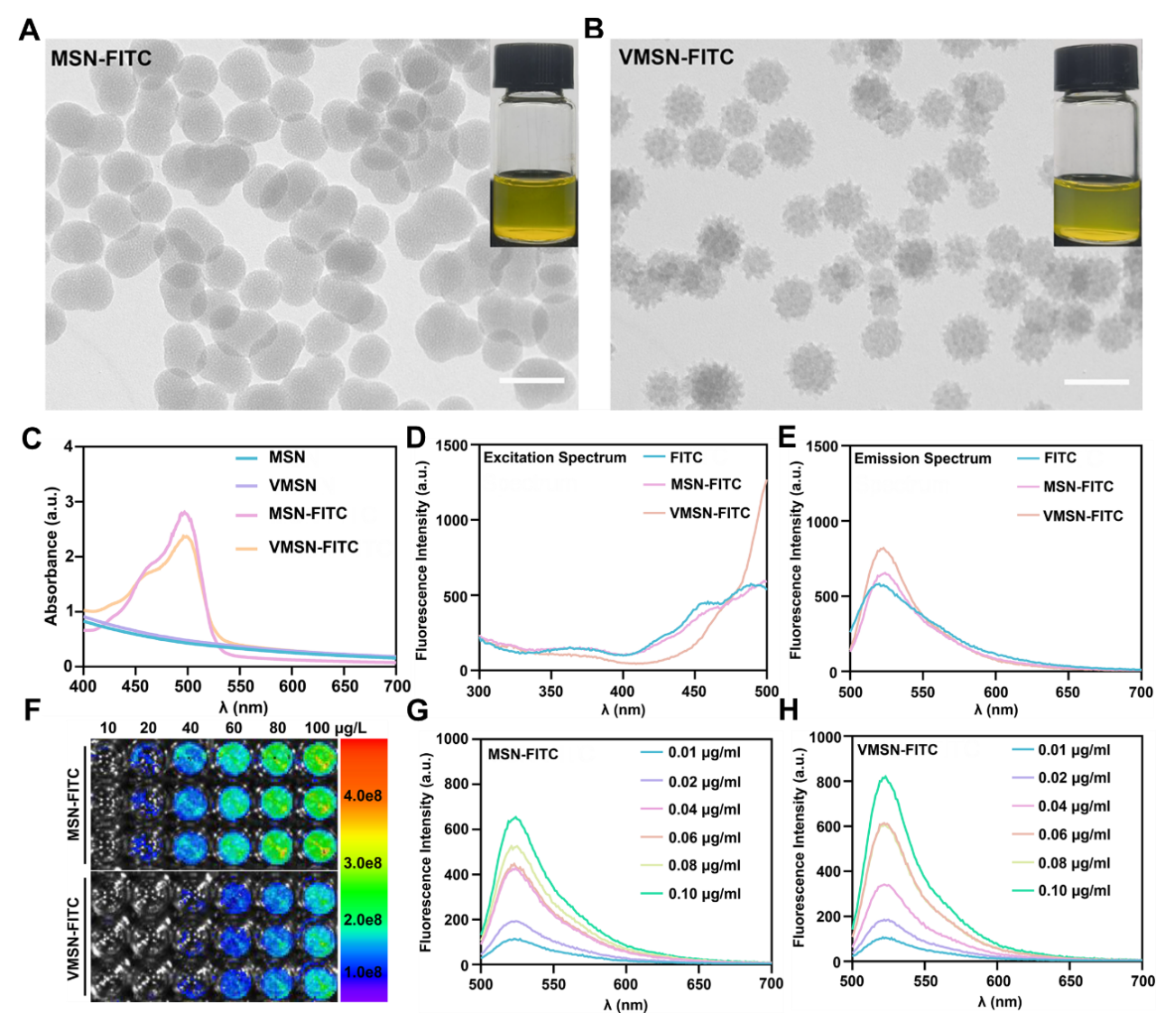
Figure S5. Characteristics of the MSN-FITC and VMSN-FITC.
(A-B) TEM images of MSN-FITC and VMSN-FITC, the insert images showed different nano-silicon in aqueous solution. (C) UV-vis spectrum of MSN, VMSN, MSN-FITC and VMSN-FITC in ethanol. (D-E) Fluorescence excitation spectrum (D) and emission spectrum (E) of FITC, MSN-FITC and VMSN-FITC in ethanol (Em: 520 nm, Ex: 300-500 nm; Ex: 490 nm, Em: 500-700 nm; 0.1 μg/mL FITC). (F) Fluorescence imaging pictures of MSN-FITC and VMSN-FITC. (G-H) Fluorescence intensity of MSN-FITC (G) and VMSN-FITC (H) with different concentrations in ethanal of (Ex: 490 nm, Em: 500-700 nm).

Figure S6. Full uncropped images of the original gel and blot.
Figure 2D, Figure 3F and Figure 4C Original Image

Table S1 The predicted results of the OsRBOHE promoter
Matrix ID | Name | Score | Start | End | Strand | Predicted sequence
MA1001.4 | MA1001.4.ERF076 | 12.903428 | 586 | 595 | ＋ | tagccgccac
MA0992.3 | MA0992.3.ERF4 | 12.609626 | 1884 | 1892 | － | ccgccgtcg
MA1006.1 | MA1006.1.ERF6 | 12.436645 | 2106 | 2115 | － | atgccggctc
MA0992.2 | MA0992.2.ERF4 | 11.950581 | 1882 | 1893 | － | tccgccgtcgga
MA0998.1 | MA0998.1.ERF096 | 11.025113 | 586 | 595 | ＋ | tagccgccac
MA1004.2 | MA1004.2.ERF13 | 10.786069 | 587 | 593 | ＋ | agccgcc
MA1005.1 | MA1005.1.ERF3 | 10.43057 | 587 | 594 | ＋ | agccgcca
MA0994.3 | MA0994.3.ERF8 | 10.178817 | 1884 | 1894 | ＋ | cgacggcggaa
MA1005.1 | MA1005.1.ERF3 | 10.103334 | 1884 | 1891 | － | cgccgtcg

Table S2. Sequences of the primers used in the study.
Oligonucleotides |  | Sequence (5’-3’)
Primers used for q-PCR
OsRBOHA-qPCR-F |  | CTGTTTGCTTGTATGTAGGGGAGAGG
OsRBOHA-qPCR-R |  | AGGGAGACACTGCTGGACATTGAAC
OsRBOHB-qPCR-F |  | GCGAAGAGGGTGAGGAAGAGGC
OsRBOHB-qPCR-R |  | CTTGAACGGAGCAGCACACCATC
OsRBOHC-qPCR-F |  | GCTACTATCTGGAGGACAACTGGAAG
OsRBOHC-qPCR-R |  | GAGTCTCAGCAGCCCCTTTTG
OsRBOHD-qPCR-F |  | TGGAGCAACGCCTTTCATCAGC
OsRBOHD-qPCR-R |  | TCAGCAACATCATTCATCACGCC
OsRBOHE-qPCR-F |  | CCTCCTGGTGCTCGCCTACG
OsRBOHE-qPCR-R |  | TGGGTAAATCGCTGCCTTGACG
OsRBOHF-qPCR-F |  | CGGCGAGCAGCAACAAGAGG
OsRBOHF-qPCR-R |  | CGACCTGGCATCACGCTCTTC
OsRBOHG-qPCR-F |  | CTTCCTCTTCCTCGTCCGTCGC
OsRBOHG-qPCR-R |  | TTGACAGCATAAGCATTTGACCGC
OsRBOHH-qPCR-F |  | GGAGTGGTGGTAGGGGTGGCG
OsRBOHH-qPCR-R |  | CGCACGAACCACCAGTAGTCCG
OsRBOHI-qPCR-F |  | CCCGCTCAACCGCCTCACG
OsRBOHI-qPCR-R |  | CGCCCTCGTCAGCCTCTCGC
OsERF3-qPCR-F |  | CACACCCAAACCCAACCTCCC
OsERF3-qPCR-R |  | CCCGGAACTCTCGAGCGG
OsERF4-qPCR-F |  | GGAAGACGAGGAGGAGGAGGAG
OsERF4-qPCR-R |  | CGTAGTCCATCTGCCTCATCGC
OsERF6-qPCR-F |  | GCCGCATCCAAGAAGAGGTCC
OsERF6-qPCR-R |  | CGAGCCACCACAAGCACTACCC
OsERF8-qPCR-F |  | CTTCTGCTGCTGCTGCTGCG
OsERF8-qPCR-R |  | CACCCACTTGCCCCACTTCC
OsERF13-qPCR-F |  | GCAGACCAAGAATACGGCGGC
OsERF13-qPCR-R |  | CCCAGCCACACCCTCTCGC
OsERF076-qPCR-F |  | AGGGGGGTGAGGAAGCGGC
OsERF076-qPCR-R |  | TGGTTCTGGCGAGCGGGC
OsERF096-qPCR-F |  | GCCATCCTCAACTTCCCCAACG
OsERF096-qPCR-R |  | TCAGCCTCTCCTTCTTCACCTCCC
P10-qPCR-F |  | AAACAACCGACCAACAATCACA
P10-qPCR-R |  | CAGTTTGTAATCTATCATGAAGTCGAG
OsEF1a-F |  | GCACGCTCTTCTTGCTTTCACTCT
OsEF1a-R |  | AAAGGTCACCACCATACCAGGCTT
Primers used for SRBSDV detection
SRBSDV S10-F |  | CGCGTCATCTCAAACTACAG
SRBSDV S10-R |  | TTTGTCAGCATCTAAAGCGC
Primers used for EMSA
OsRBOHE probe 1-F |  | AlexaFlur680-GTGAGAATTTCTAGCCGCCACAACGAAC
OsRBOHE probe 1-R |  | GTTCGTTGTGGCGGCTAGAAATTCTCAC
specific competitor-F |  | GTGAGAATTTCTAGCCGCCACAACGAAC
Non-specific competitor-F |  | ACAAGCTGGAGTACAACTACAACAGCCA
Non-specific competitor-R |  | TGGCTGTTGTAGTTGTACTCCAGCTTGT
Primers used for cloning
pMBP-OsERF3-F | TATCGGAATTAATTCGGATCCGATGGTACAGCCAAAGAAGAAGTTTC
pMBP-OsERF3-R | GTGGTGGTGGTGGTGCTCGAGTCAGATGACAAAGCTACCCTCTCC
pENTR-OsERF3-F | CCGCGGCCGCCCCCTTCACCATGGTACAGCCAAAGAAGAAGTTTC
pENTR-OsERF3-R | GGGTCGGCGCGCCCACCCTTTCAGATGACAAAGCTACCCTCTCC
pGreen-OsRBOHE Promote-F | CTTGATATCGAATTCCTGCAGCTCATATTGGATTGTTATATAGACTCTCC
pGreen-OsRBOHE Promote-R | TGTTTTTGGCGTCTTCCATGGCCCGGAACACGCAATGCC

