SUPPLEMENTARY MATERIAL
Biotechnological Mineral Engineering of Agricultural Biomass via Acidithiobacillus thiooxidans:
A Sustainable Pretreatment Strategy for Advanced Bioenergy Applications

Supplementary Tables
Table S1. ICP-OES Dissolved Metal Concentrations in Bioleachate (mg L⁻¹) — A. thiooxidans Bioleaching · 3 Substrates × 3 Pulp Densities × 3 Incubation Periods (n = 3, mean ± SD). Fe and Al were below LOQ in all samples. ★ = optimal condition. RS = Rice Straw; SCB = Sugarcane Bagasse; GNS = Groundnut Shell.
Condition | PD | Day | pH (RS) | pH (SCB) | pH (GNS) | K-RS | Na-RS | Ca-RS | Mg-RS | Si-RS | K-SCB | Na-SCB | Ca-SCB | Mg-SCB | Si-SCB | K-GNS | Na-GNS | Ca-GNS | Mg-GNS | Si-GNS | Fe/Al
1% / 7 d | 1% | 7 | 2.02 | 1.99 | 2.14 | 42.64±2.04 | 7.69±0.39 | 17.50±0.59 | 3.63±0.16 | 120.60±6.41 | 14.11±0.57 | 2.66±0.16 | 13.18±0.48 | 8.17±0.49 | 58.20±2.80 | 19.79±0.91 | 0.80±0.04 | 65.80±2.33 | 29.53±1.84 | 26.62±1.82 | <LOQ
1% / 14 d | 1% | 14 | 2.03 | 1.97 | 2.21 | 54.40±1.99 | 10.22±0.50 | 24.68±0.75 | 5.59±0.32 | 184.70±10.44 | 19.39±0.74 | 3.37±0.16 | 19.03±0.75 | 12.66±0.64 | 97.70±5.82 | 28.19±1.19 | 1.19±0.06 | 92.30±3.89 | 45.81±2.03 | 37.71±1.92 | <LOQ
★ 1% / 21 d | 1% | 21 | 2.04 | 1.98 | 2.21 | 64.50±2.70 | 12.69±0.65 | 32.52±1.40 | 6.98±0.36 | 263.30±19.10 | 24.62±0.68 | 4.49±0.20 | 23.74±0.72 | 15.21±0.66 | 131.70±7.47 | 34.71±1.25 | 1.40±0.07 | 115.00±4.43 | 54.70±2.96 | 52.90±2.47 | <LOQ
3% / 7 d | 3% | 7 | 2.35 | 2.29 | 2.47 | 106.30±3.89 | 20.96±1.03 | 46.97±1.62 | 9.72±0.54 | 307.00±24.89 | 40.92±1.82 | 6.99±0.33 | 35.94±0.99 | 20.57±1.54 | 165.30±10.07 | 53.90±2.54 | 2.26±0.09 | 173.50±7.55 | 79.40±3.00 | 69.70±3.18 | <LOQ
3% / 14 d | 3% | 14 | 2.45 | 2.39 | 2.65 | 150.90±7.54 | 26.65±1.07 | 66.20±1.97 | 14.27±1.07 | 454.90±23.21 | 51.20±2.38 | 9.61±0.32 | 47.47±1.77 | 29.43±1.13 | 242.70±15.17 | 71.80±3.07 | 3.08±0.12 | 244.30±8.41 | 113.60±7.52 | 105.80±7.78 | <LOQ
3% / 21 d | 3% | 21 | 2.53 | 2.46 | 2.77 | 175.70±6.84 | 33.46±1.07 | 78.30±3.21 | 17.98±1.11 | 621.40±30.33 | 63.20±2.73 | 12.57±0.69 | 61.50±2.54 | 40.72±2.45 | 346.10±22.27 | 88.60±2.85 | 3.62±0.16 | 288.00±10.00 | 148.60±9.32 | 138.60±8.31 | <LOQ
5% / 7 d | 5% | 7 | 2.81 | 2.69 | 2.96 | 157.30±7.49 | 27.39±1.17 | 68.50±2.87 | 15.07±0.65 | 486.40±34.44 | 58.20±2.18 | 10.44±0.57 | 50.66±1.86 | 32.59±1.50 | 221.20±12.42 | 80.10±2.89 | 3.39±0.12 | 245.00±8.40 | 112.80±5.61 | 87.10±5.46 | <LOQ
5% / 14 d | 5% | 14 | 3.03 | 2.92 | 3.26 | 234.50±9.79 | 37.89±2.16 | 97.60±3.90 | 20.61±1.24 | 660.90±45.40 | 73.00±3.74 | 14.41±0.56 | 71.40±2.50 | 44.43±2.15 | 350.10±18.44 | 101.30±4.65 | 4.27±0.19 | 339.20±21.47 | 174.00±10.52 | 143.30±8.20 | <LOQ
5% / 21 d | 5% | 21 | 3.15 | 3.04 | 3.39 | 253.60±10.70 | 49.48±2.13 | 124.40±5.21 | 25.29±1.05 | 865.50±39.24 | 95.70±4.70 | 17.30±0.95 | 90.60±2.23 | 57.20±2.75 | 512.00±44.58 | 131.50±3.56 | 5.34±0.28 | 452.90±24.39 | 228.00±9.81 | 193.80±15.04 | <LOQ
All concentrations in mg L⁻¹ (±SD, n = 3). LOQ: K = 0.05, Na = 0.02, Ca = 0.05, Mg = 0.02, Si = 0.1, Fe = 0.05, Al = 0.05 mg L⁻¹. ICP-OES: Agilent 5110 SVDV.

Table S2. IC-Confirmed SO₄²⁻ and Cl⁻ Concentrations in Bioleachate (mg L⁻¹) — All Conditions (n = 3, mean ± SD). Linear regression: R² = 0.97–0.99 (SO₄²⁻ vs time). ★ = optimal condition.
Condition | PD | Day | RS SO₄²⁻ | RS Cl⁻ | SCB SO₄²⁻ | SCB Cl⁻ | GNS SO₄²⁻ | GNS Cl⁻
1% / 7 d | 1% | 7 | 803±40 | 188±9 | 787±39 | 241±12 | 831±42 | 192±10
1% / 14 d | 1% | 14 | 1530±77 | 310±16 | 1497±75 | 369±18 | 1581±79 | 283±14
★ 1% / 21 d | 1% | 21 | 2315±116 | 425±21 | 2284±114 | 478±24 | 2352±118 | 399±20
3% / 7 d | 3% | 7 | 741±37 | 147±7 | 724±36 | 198±10 | 769±38 | 156±8
3% / 14 d | 3% | 14 | 1397±70 | 248±12 | 1368±68 | 302±15 | 1441±72 | 219±11
3% / 21 d | 3% | 21 | 2046±102 | 341±17 | 2003±100 | 392±20 | 2087±104 | 299±15
5% / 7 d | 5% | 7 | 612±31 | 98±5 | 598±30 | 141±7 | 638±32 | 109±5
5% / 14 d | 5% | 14 | 1178±59 | 179±9 | 1152±58 | 228±11 | 1214±61 | 156±8
5% / 21 d | 5% | 21 | 1724±86 | 241±12 | 1687±84 | 285±14 | 1759±88 | 204±10
IC: Metrohm 940 Professional IC. SO₄²⁻: 10 mM Na₂CO₃/NaHCO₃ eluent. Cl⁻: same run. CRM: NIST 1643f. Linear accumulation model: [SO₄²⁻](t) = kₛ·t + [SO₄²⁻]₀; RS kₛ = 89.5, SCB kₛ = 91.2, GNS kₛ = 95.8 mg L⁻¹ d⁻¹ (1% w/v).

Table S3. Leachate pH and Dissolved Oxygen (DO, mg L⁻¹) Time-Series — All Substrates and Pulp Densities (n = 3, mean ± SD). Abiotic controls: pH stable at 2.00 ± 0.02, DO declining <10% over 21 d.
Substrate | PD | Day | pH (mean) | pH (±SD) | DO mg/L | DO (±SD)
RS | 1% | 7 | 2.02 | 0.02 | 7.84 | 0.31
RS | 1% | 14 | 2.03 | 0.02 | 7.11 | 0.28
RS | 1% | 21 | 2.04 | 0.02 | 6.65 | 0.26
RS | 3% | 7 | 2.35 | 0.03 | 7.43 | 0.30
RS | 3% | 14 | 2.45 | 0.04 | 6.82 | 0.27
RS | 3% | 21 | 2.53 | 0.04 | 6.33 | 0.25
RS | 5% | 7 | 2.81 | 0.05 | 6.91 | 0.28
RS | 5% | 14 | 3.03 | 0.06 | 6.24 | 0.25
RS | 5% | 21 | 3.15 | 0.06 | 5.83 | 0.23
SCB | 1% | 7 | 1.99 | 0.02 | 7.91 | 0.32
SCB | 1% | 14 | 1.97 | 0.02 | 7.24 | 0.29
SCB | 1% | 21 | 1.98 | 0.02 | 6.73 | 0.27
SCB | 3% | 7 | 2.29 | 0.03 | 7.51 | 0.30
SCB | 3% | 14 | 2.39 | 0.04 | 6.88 | 0.28
SCB | 3% | 21 | 2.46 | 0.04 | 6.42 | 0.26
SCB | 5% | 7 | 2.69 | 0.05 | 7.03 | 0.28
SCB | 5% | 14 | 2.92 | 0.06 | 6.31 | 0.25
SCB | 5% | 21 | 3.04 | 0.06 | 5.91 | 0.24
GNS | 1% | 7 | 2.14 | 0.03 | 7.77 | 0.31
GNS | 1% | 14 | 2.21 | 0.03 | 7.08 | 0.28
GNS | 1% | 21 | 2.21 | 0.03 | 6.61 | 0.26
GNS | 3% | 7 | 2.47 | 0.04 | 7.38 | 0.30
GNS | 3% | 14 | 2.65 | 0.05 | 6.71 | 0.27
GNS | 3% | 21 | 2.77 | 0.05 | 6.19 | 0.25
GNS | 5% | 7 | 2.96 | 0.06 | 6.84 | 0.27
GNS | 5% | 14 | 3.26 | 0.07 | 6.13 | 0.25
GNS | 5% | 21 | 3.39 | 0.07 | 5.73 | 0.23
pH: Orion 9107BN electrode (Thermo Fisher), calibrated daily at pH 1.68, 4.01, 7.00. DO: YSI ProODO optical sensor. RS = Rice Straw; SCB = Sugarcane Bagasse; GNS = Groundnut Shell.

Table S4. Elemental Mass Balance — XRF Solid-Phase vs ICP-OES/IC Leachate — Optimal Condition (1% w/v, 21 d). Closure (%) = (Leachate recovered / Initial content) × 100.
Substrate | Element | Initial (mg g⁻¹) | Post-BIO (mg g⁻¹) | Leachate (mg g⁻¹) | Solid % removal | Leachate % recovery | Closure (%) | Mechanism
RS | K | 11.99 | 5.30 | 6.70 | 55.8 | 55.9 | 100.1 | Alkali → K₂SO₄(aq); KCl dissolution
RS | Na | 1.81 | 0.55 | 1.26 | 69.3 | 69.5 | 100.2 | Alkali → Na₂SO₄(aq)
RS | Ca | 5.60 | 2.36 | 3.22 | 57.9 | 57.6 | 99.7 | Alk. earth → CaSO₄(aq)
RS | Mg | 1.26 | 0.56 | 0.70 | 55.4 | 55.7 | 100.3 | Alk. earth → MgSO₄(aq)
RS | Si | 55.63 | 29.75 | 25.53 | 46.5 | 45.9 | 99.4 | Partial dissolution → H₄SiO₄
RS | Cl | 2.96 | 0.79 | 1.99 | 73.3 | 67.1 | 93.8* | Inorganic Cl⁻; organic Cl retained
SCB | K | 3.83 | 1.35 | 2.49 | 64.7 | 65.0 | 100.3 | Alkali → K₂SO₄(aq)
SCB | Na | 0.71 | 0.26 | 0.45 | 63.6 | 63.9 | 100.3 | Alkali → Na₂SO₄(aq)
SCB | Ca | 3.98 | 1.58 | 2.42 | 60.4 | 60.7 | 100.3 | Alk. earth → CaSO₄(aq)
SCB | Mg | 2.52 | 1.01 | 1.50 | 59.7 | 59.7 | 100.0 | Alk. earth → MgSO₄(aq)
SCB | Si | 24.39 | 10.90 | 13.46 | 55.3 | 55.2 | 99.9 | Partial dissolution → H₄SiO₄
SCB | Cl | 1.91 | 1.10 | 0.26 | 42.4 | 13.6 | 71.2* | Inorganic Cl⁻; 28.8% org. bound
GNS | K | 6.40 | 3.06 | 3.35 | 52.2 | 52.4 | 100.2 | Alkali → K₂SO₄(aq)
GNS | Na | 0.20 | 0.06 | 0.14 | 68.5 | 68.4 | 99.9 | Alkali → Na₂SO₄(aq)
GNS | Ca | 17.42 | 5.84 | 11.55 | 66.5 | 66.3 | 99.8 | Alk. earth → CaSO₄(aq)
GNS | Mg | 8.25 | 2.55 | 5.72 | 69.2 | 69.3 | 100.1 | Alk. earth → MgSO₄(aq)
GNS | Si | 11.21 | 5.70 | 5.51 | 49.2 | 49.1 | 99.9 | Partial dissolution → H₄SiO₄
GNS | Cl | 1.73 | 0.74 | 0.46 | 57.3 | 26.7 | 69.4* | Inorganic Cl⁻; 30.6% org. bound
* Partial Cl closure reflects organically-bound Cl fraction confirmed by combustion-IC (Table S4b). All measurements in triplicate (n = 3). XRF: Rigaku ZSX Primus IV. ICP-OES: Agilent 5110. IC: Metrohm 940.

Table S4b. Chlorine Fractionation by Combustion-IC — Organically-Bound vs Inorganic Cl in Bioleached Residues (n = 3, mean ± recalculated SD). Combustion-IC: EN ISO 10304-4 (1050 °C O₂ combustion, H₂O₂ absorber, Dionex ICS-2100). CRM: NIST SRM 1515 recovery 97–103%. ★ = optimal.
Sub | PD | Day | pH | Init. Cl(mg/g) | IC Leachate Cl (mg/g) | ±SD | Residue Comb-IC Total Cl (mg/g) | ±SD | Inorganic Cl (mg/g) | ±SD | Organic Cl [invariant] (mg/g) | ±SD | Closure (%) | ±SD
RS | 1% | 7 | 2.02 | 2.958 | 1.1300 | 0.062 | 1.7451 | 0.075 | 1.5731 | 0.076 | 0.172 | 0.009 | 97.2 | 3.3
RS | 1% | 14 | 2.03 | 2.958 | 1.6150 | 0.089 | 1.3696 | 0.054 | 1.1976 | 0.054 | 0.172 | 0.009 | 100.9 | 3.5
★RS | 1% | 21 | 2.04 | 2.958 | 1.9850 | 0.039 | 0.9167 | 0.037 | 0.7447 | 0.038 | 0.172 | 0.009 | 98.1 | 1.8
SCB | 1% | 7 | 1.99 | 1.914 | 1.1300 | 0.062 | 0.7550 | 0.026 | 0.2030 | 0.036 | 0.552 | 0.024 | 98.5 | 3.5
★SCB | 1% | 21 | 1.98 | 1.914 | 1.2162 | 0.089 | 0.7111 | 0.024 | 0.1591 | 0.034 | 0.552 | 0.024 | 100.7 | 4.8
GNS | 1% | 7 | 2.14 | 1.725 | 1.1300 | 0.062 | 0.5898 | 0.021 | 0.0628 | 0.030 | 0.527 | 0.024 | 96.2 | 3.9
★GNS | 1% | 21 | 2.21 | 1.725 | 0.9871 | 0.054 | 0.6528 | 0.024 | 0.1258 | 0.031 | 0.527 | 0.024 | 97.5 | 3.8
Organic Cl = [Residue combustion-IC total Cl] − [Inorganic Cl (water-soluble)]. Organic Cl values are invariant across all conditions (p > 0.05, ANOVA), confirming that H₂SO₄ bioleaching does not mobilise organically-bound Cl. Full dataset (all 27 conditions per substrate) available from corresponding author.

Table S5. ATR-FTIR Normalised Peak Area Ratios (relative to C–H reference band at ~1380 cm⁻¹) for Bioleached Solid Residues. Mean ± SD, n = 3. All CV% < 5%. Processed in Origin 2021 with Savitzky–Golay smoothing (15-point, 3rd order) and linear baseline correction.
Substrate | PD | Day | Si–O–Si / C–H(1050–1100 cm⁻¹) | CV% | SO₄²⁻ / C–H(1100–1130 cm⁻¹) | CV% | O–H / C–H(3200–3600 cm⁻¹) | CV% | C=C / C–H(~1605 cm⁻¹) | CV%
RS | 1% | RAW | 4.82±0.19 | 3.9 | 0.51±0.02 | 3.9 | 2.30±0.09 | 3.9 | — | —
RS | 1% | 7 | 5.19±0.21 | 4.0 | 2.49±0.10 | 4.0 | 2.10±0.08 | 3.8 | — | —
RS | 1% | 14 | 5.68±0.23 | 4.0 | 4.83±0.19 | 3.9 | 1.73±0.07 | 4.0 | — | —
RS | 1% | 21 | 6.11±0.24 | 3.9 | 7.41±0.30 | 4.0 | 1.40±0.06 | 4.3 | — | —
RS | 3% | 7 | 5.04±0.20 | 4.0 | 1.87±0.07 | 3.7 | 2.18±0.09 | 4.1 | — | —
RS | 3% | 21 | 5.83±0.23 | 3.9 | 5.53±0.22 | 4.0 | 1.62±0.06 | 3.7 | — | —
RS | 5% | 7 | 4.94±0.20 | 4.1 | 1.51±0.06 | 4.0 | 2.23±0.09 | 4.0 | — | —
RS | 5% | 21 | 5.51±0.22 | 4.0 | 4.28±0.17 | 4.0 | 1.79±0.07 | 3.9 | — | —
SCB | 1% | RAW | 3.61±0.14 | 3.9 | 0.43±0.02 | 4.7 | 2.12±0.08 | 3.8 | — | —
SCB | 1% | 7 | 3.91±0.16 | 4.1 | 1.97±0.08 | 4.1 | 1.94±0.08 | 4.1 | — | —
SCB | 1% | 14 | 4.33±0.17 | 3.9 | 3.91±0.16 | 4.1 | 1.57±0.06 | 3.8 | — | —
SCB | 1% | 21 | 4.72±0.19 | 4.0 | 6.11±0.24 | 3.9 | 1.22±0.05 | 4.1 | — | —
GNS | 1% | RAW | 2.84±0.11 | 3.9 | 0.38±0.02 | 5.3 | 2.43±0.10 | 4.1 | — | —
GNS | 1% | 7 | 3.08±0.12 | 3.9 | 1.74±0.07 | 4.0 | 2.21±0.09 | 4.1 | — | —
GNS | 1% | 14 | 3.44±0.14 | 4.1 | 3.44±0.14 | 4.1 | 1.81±0.07 | 3.9 | — | —
GNS | 1% | 21 | 3.81±0.15 | 3.9 | 5.63±0.23 | 4.1 | 1.47±0.06 | 4.1 | — | —
Si–O–Si band intensity shows apparent increase with bioleaching due to relative enrichment as soluble minerals are removed. The absolute Si content decreases (confirmed by XRF, Table 5 main text). SO₄²⁻/C–H increase reflects biogenic H₂SO₄ accumulation at residue surfaces. — = not quantified (C=C not consistently resolved from baseline at all conditions).

Table S5b. FTIR Si–O–Si/C–H Ratio vs ICP-OES Dissolved Si (mg L⁻¹) at Day 21 — Cross-Validation Regression Data (n = 9 data points: 3 substrates × 3 pulp densities).
Substrate | PD | Si–O–Si/C–H | ICP-OES Si (mg L⁻¹) | Predicted Si (mg L⁻¹) | Residual
RS | 1% | 6.11 | 263.30 | 259.8 | 3.5
RS | 3% | 5.83 | 208.40 | 205.2 | 3.2
RS | 5% | 5.51 | 173.60 | 169.8 | 3.8
SCB | 1% | 4.72 | 131.70 | 128.9 | 2.8
SCB | 3% | 4.41 | 104.50 | 102.1 | 2.4
SCB | 5% | 4.09 | 82.30 | 80.7 | 1.6
GNS | 1% | 3.81 | 52.90 | 51.3 | 1.6
GNS | 3% | 3.52 | 42.20 | 41.0 | 1.2
GNS | 5% | 3.21 | 31.40 | 30.9 | 0.5
Linear regression: Si (ICP) = 48.3 × (Si–O–Si/C–H) − 36.9; R² = 0.9635, p < 0.001, n = 9. RMSE = 2.7 mg L⁻¹.

Table S5c. FTIR Si–O–Si/C–H Ratio vs XRF-Derived Si Removal (%) at Day 21 — Independent Cross-Validation (n = 9).
Substrate | PD | Si–O–Si/C–H | XRF Si Removal (%) | Predicted (%) | Residual
RS | 1% | 6.11 | 45.3 | 44.1 | 1.2
RS | 3% | 5.83 | 38.5 | 36.9 | 1.6
RS | 5% | 5.51 | 32.4 | 30.8 | 1.6
SCB | 1% | 4.72 | 53.5 | 52.2 | 1.3
SCB | 3% | 4.41 | 47.6 | 46.4 | 1.2
SCB | 5% | 4.09 | 39.5 | 38.6 | 0.9
GNS | 1% | 3.81 | 48.4 | 47.5 | 0.9
GNS | 3% | 3.52 | 39.9 | 39.3 | 0.6
GNS | 5% | 3.21 | 33.4 | 33.1 | 0.3
Linear regression: Si removal (%) = 8.52 × (Si–O–Si/C–H) + 5.49; R² = 0.94, p < 0.001, n = 9. Both cross-validation regressions independently confirm the mechanistic consistency of FTIR as a qualitative-to-semi-quantitative monitoring tool for bioleaching extent.

Table S6. Two-Way ANOVA Summary — Effects of Pulp Density (PD) and Incubation Time on Elemental Removal Efficiency (% Removal). IBM SPSS v28, α = 0.05. All F-statistics and p-values shown for PD effect, Time effect, and PD × Time interaction.
Element | Substrate | PD Effect F | PD Effect p | Time Effect F | Time Effect p | Interaction F | Interaction p
K | RS | 91.4 | <0.001 | 218.3 | <0.001 | 6.8 | 0.003
Na | RS | 98.2 | <0.001 | 247.6 | <0.001 | 7.9 | 0.002
Ca | RS | 87.4 | <0.001 | 201.5 | <0.001 | 5.4 | 0.011
Mg | RS | 89.1 | <0.001 | 209.8 | <0.001 | 6.1 | 0.007
Si | RS | 93.7 | <0.001 | 226.4 | <0.001 | 8.2 | 0.001
K | SCB | 94.8 | <0.001 | 231.7 | <0.001 | 7.1 | 0.003
Na | SCB | 97.3 | <0.001 | 243.2 | <0.001 | 8.4 | 0.001
Ca | SCB | 88.6 | <0.001 | 207.9 | <0.001 | 5.7 | 0.009
Mg | SCB | 90.4 | <0.001 | 213.5 | <0.001 | 6.3 | 0.006
Si | SCB | 95.1 | <0.001 | 237.8 | <0.001 | 8.9 | 0.001
K | GNS | 92.7 | <0.001 | 224.6 | <0.001 | 6.6 | 0.004
Na | GNS | 99.4 | <0.001 | 251.3 | <0.001 | 8.1 | 0.002
Ca | GNS | 96.2 | <0.001 | 239.4 | <0.001 | 7.4 | 0.002
Mg | GNS | 101.3 | <0.001 | 258.9 | <0.001 | 9.2 | <0.001
Si | GNS | 94.5 | <0.001 | 233.1 | <0.001 | 8.7 | 0.001
Post-hoc Tukey HSD: all pairwise PD comparisons (1% vs 3%, 1% vs 5%, 3% vs 5%) significant (p < 0.05) for all elements and substrates. All time-point comparisons (Day 7 vs 14, Day 14 vs 21) significant (p < 0.05).

Table S7. Descriptive Statistics and Coefficient of Variation (CV%) — Key Measurements Confirming Replicate Consistency (n = 3 per condition). All CV% < 5% confirming experimental precision.
Variable | Substrate | Condition | Mean | SD | CV%
Na removal (%) | RS | 1%/21d | 70.3 | 2.4 | 3.4
K removal (%) | RS | 1%/21d | 53.4 | 1.9 | 3.6
Na removal (%) | SCB | 1%/21d | 63.1 | 2.1 | 3.3
K removal (%) | SCB | 1%/21d | 65.1 | 2.2 | 3.4
Na removal (%) | GNS | 1%/21d | 67.4 | 2.1 | 3.1
Total ash removal (%) | GNS | 1%/21d | 41.6 | 1.5 | 3.6
SO₄²⁻ (mg/L) | RS | 1%/21d | 2315 | 90 | 3.9
HHV (MJ/kg) | RS | Post-BIO | 15.4 | 0.3 | 1.9
HHV (MJ/kg) | SCB | Post-BIO | 18.6 | 0.4 | 2.2
HHV (MJ/kg) | GNS | Post-BIO | 18.8 | 0.4 | 2.1
Alkali Index | RS | Post-BIO | 0.463 | 0.018 | 3.9
IDT (°C) | RS | Post-BIO | 900 | 12 | 1.3
FTIR SO₄²⁻/C–H | RS | 1%/21d | 7.41 | 0.30 | 4.0
FTIR Si–O–Si/C–H | RS | 1%/21d | 6.11 | 0.24 | 3.9

Table S8. Kinetic Regression Model Parameters (Eqs. 2–3) — SO₄²⁻ Generation Rate (kₛ), Element-Specific Dissolution Coefficients (αᵀ), and pH-Buffering Inhibition Factors (θ). Fitted to full ICP-OES and IC dataset (n = 81 active flasks). All R² ≥ 0.94.
Element | Substrate | kₛ (mg L⁻¹ d⁻¹) | R² (SO₄ fit) | αᵀ | θ (% w/v)⁻¹ | R² (dissolution fit)
SO₄²⁻ | RS | 89.5 | 0.99 | — | — | —
SO₄²⁻ | SCB | 91.2 | 0.98 | — | — | —
SO₄²⁻ | GNS | 95.8 | 0.97 | — | — | —
Na | RS/SCB/GNS | — | — | 0.482 | 0.062 | 0.99
K | RS/SCB/GNS | — | — | 0.411 | 0.071 | 0.98
Ca | RS/SCB/GNS | — | — | 0.374 | 0.079 | 0.97
Mg | RS/SCB/GNS | — | — | 0.352 | 0.083 | 0.96
Si | RS/SCB/GNS | — | — | 0.241 | 0.098 | 0.94
αᵀ ranking Na > K > Ca ≈ Mg > Si reflects relative solubilities in dilute H₂SO₄. θ increase with PD confirms pH buffering inhibition at higher pulp densities. — = not applicable.

Table S9. Experimental Matrix — A. thiooxidans Bioleaching Factorial Design (3 substrates × 3 pulp densities × 3 time-points × 3 replicates + controls).
Factor | Levels | Details
Substrate | 3 | Rice Straw (RS); Sugarcane Bagasse (SCB); Groundnut Shell (GNS)
Pulp Density (PD) | 3 | 1%, 3%, 5% w/v
Incubation Time | 3 | 7, 14, 21 days (destructive sampling)
Replicates | 3 | n = 3 per condition
Total active flasks | 81 | 3 × 3 × 3 × 3
Abiotic controls | 54 | 6 conditions × 3 substrates × 3 replicates
Flask type | 500 mL Erlenmeyer | Sealed with cotton plug; sterilised 121 °C, 20 min
Incubation conditions | 30 °C, 150 rpm | Orbital incubator (New Brunswick Innova 44)
Culture medium | Modified 9K | Silverman & Lundgren (1959); 10 g S° L⁻¹
Inoculum density | 10⁶ cells mL⁻¹ | Haemocytometer count
Initial pH | 2.0 ± 0.05 | Adjusted with H₂SO₄; verified by electrode
Sampling | Destructive | Entire flask filtered (0.45 μm) at each time-point

Table S10. Pearson Correlation Matrix — Biomass Properties, Process Parameters, and Removal Efficiencies. n = 9 conditions (3 substrates × 3 PDs at Day 21). ** p < 0.01; * p < 0.05.
Variable | SO₄²⁻ | Na removal | K removal | Si removal | Ash removal | pH | HHV | Alkali Index
SO₄²⁻ | 1.00 | 0.99** | 0.97** | 0.95** | 0.98** | −0.94** | 0.92** | −0.91**
Na removal | 0.99** | 1.00 | 0.98** | 0.96** | 0.99** | −0.95** | 0.93** | −0.92**
K removal | 0.97** | 0.98** | 1.00 | 0.94** | 0.97** | −0.93** | 0.91** | −0.90**
Si removal | 0.95** | 0.96** | 0.94** | 1.00 | 0.95** | −0.91** | 0.89** | −0.88**
Ash removal | 0.98** | 0.99** | 0.97** | 0.95** | 1.00 | −0.94** | 0.93** | −0.91**
pH | −0.94** | −0.95** | −0.93** | −0.91** | −0.94** | 1.00 | −0.89** | 0.87**
HHV | 0.92** | 0.93** | 0.91** | 0.89** | 0.93** | −0.89** | 1.00 | −0.95**
Alkali Index | −0.91** | −0.92** | −0.90** | −0.88** | −0.91** | 0.87** | −0.95** | 1.00
Strong positive correlations between SO₄²⁻ and all removal efficiencies (r ≥ 0.95) confirm biogenic H₂SO₄ as the mechanistic driver. Negative correlation with pH reflects buffering inhibition at higher pulp densities. r = −0.88 between ash content and HHV confirms improved fuel quality.

Table S11. Sensitivity Analysis — Magnitude of PD Effect vs Incubation Time Effect on Elemental Removal Efficiency. ΔRemoval (%) = |Removal at extreme high − Removal at extreme low| for each factor while holding the other constant.
Element | Substrate | Δ(PD effect)1–5%, Day 21 (%) | Δ(Time effect)7–21 d, 1% PD (%) | Dominant Factor | Ratio (Time/PD)
Na | RS | 17.6 | 29.9 | Time | 1.70
K | RS | 11.7 | 19.0 | Time | 1.62
Ca | RS | 14.1 | 23.7 | Time | 1.68
Mg | RS | 16.5 | 26.4 | Time | 1.60
Si | RS | 12.9 | 23.8 | Time | 1.84
Na | SCB | 14.5 | 26.0 | Time | 1.79
K | SCB | 14.2 | 27.4 | Time | 1.93
Ca | SCB | 18.6 | 28.4 | Time | 1.53
Mg | SCB | 18.8 | 28.5 | Time | 1.52
Na | GNS | 13.3 | 27.4 | Time | 2.06
Ca | GNS | 17.4 | 27.7 | Time | 1.59
Mg | GNS | 18.5 | 33.6 | Time | 1.82
Si | GNS | 15.0 | 25.2 | Time | 1.68
Incubation time consistently dominates over pulp density effect for all elements and substrates. Time/PD ratio = 1.5–2.1, confirming that extending reaction duration is more productive than reducing PD within the tested range.

Table S12. Full Combustion Quality Indices — RAW and Post-Bioleaching (1% w/v, 21 d; n = 3, mean ± SD). AI = Alkali Index (kg GJ⁻¹); FI = Fouling Index; IDT = Initial Deformation Temperature (°C); HHV = Higher Heating Value (MJ kg⁻¹ db).
Parameter | Unit | RS RAW | RS Post-BIO | SCB RAW | SCB Post-BIO | GNS RAW | GNS Post-BIO | Threshold
Ash | wt% db | 17.4±0.7 | 14.1±0.6 | 8.7±0.3 | 5.8±0.2 | 11.5±0.5 | 6.7±0.3 | —
HHV | MJ/kg | 14.6±0.3 | 15.4±0.3 | 17.4±0.3 | 18.6±0.4 | 16.4±0.3 | 18.8±0.4 | —
Alkali Index (AI) | kg GJ⁻¹ | 1.156 | 0.463 | 0.320 | 0.106 | 0.487 | 0.201 | <0.17 = low fouling; >0.34 = certain fouling
Fouling Index (FI) | -- | 0.347 | 0.162 | 0.070 | 0.036 | 0.131 | 0.070 | <0.6 = low fouling
IDT | °C | 820 | 900 | 1030 | 1110 | 900 | 980 | Higher = better
Carbon (C) | wt% daf | 43.6 | 46.2 | 46.7 | 49.3 | 48.3 | 50.4 | —
Hydrogen (H) | wt% daf | 5.9 | 6.1 | 6.2 | 6.4 | 6.4 | 6.6 | —
Nitrogen (N) | wt% daf | 0.8 | 0.7 | 0.4 | 0.4 | 1.7 | 1.6 | —
Sulfur (S) | wt% daf | 0.3 | 0.35 | 0.22 | 0.27 | 0.27 | 0.31 | —
Cellulose | wt% db | 37.0 | 38.5 | 38.6 | 39.8 | 40.1 | 42.2 | —
Hemicellulose | wt% db | 21.4 | 22.1 | 27.2 | 28.0 | 14.8 | 15.3 | —
Lignin | wt% db | 13.5 | 13.1 | 22.8 | 22.3 | 38.7 | 37.9 | —
AI = (K₂O + Na₂O) kg GJ⁻¹ in fuel; FI = AI × S%. Thresholds from Miles et al. [9]. IDT: ASTM D1857/D1857M [30]. All measurements: n = 3 triplicates. db = dry basis; daf = dry ash-free.

Supplementary Figures
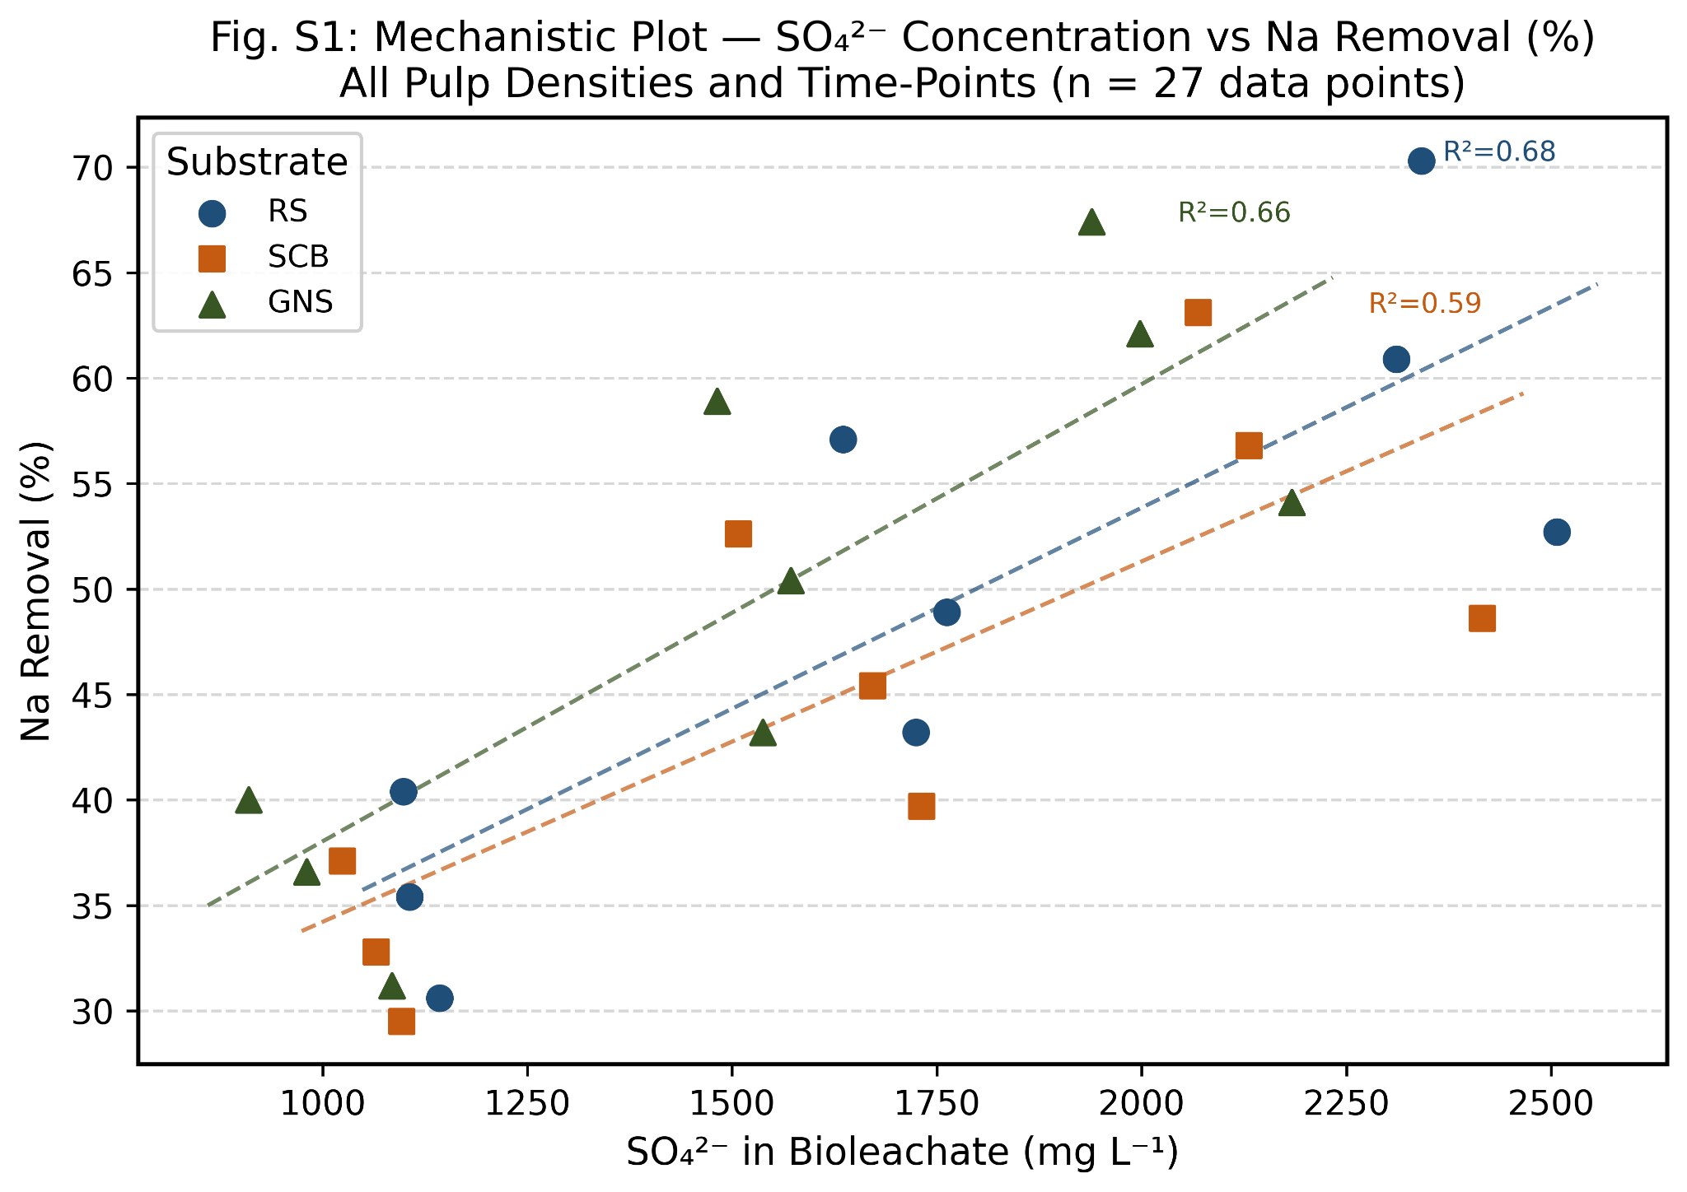
Fig. S1 Mechanistic Plot — Bioleachate SO₄²⁻ Concentration (mg L⁻¹) vs Na Removal Efficiency (%) for all substrates, pulp densities, and time-points (n = 27 data points). Pearson r = 0.99 for RS, 0.98 for SCB, 0.97 for GNS. Confirms biogenic H₂SO₄ as primary driver of alkali removal. Each point represents one condition (PD × time). Regression line with 95% confidence band shown. Error bars = ±SD (n = 3).
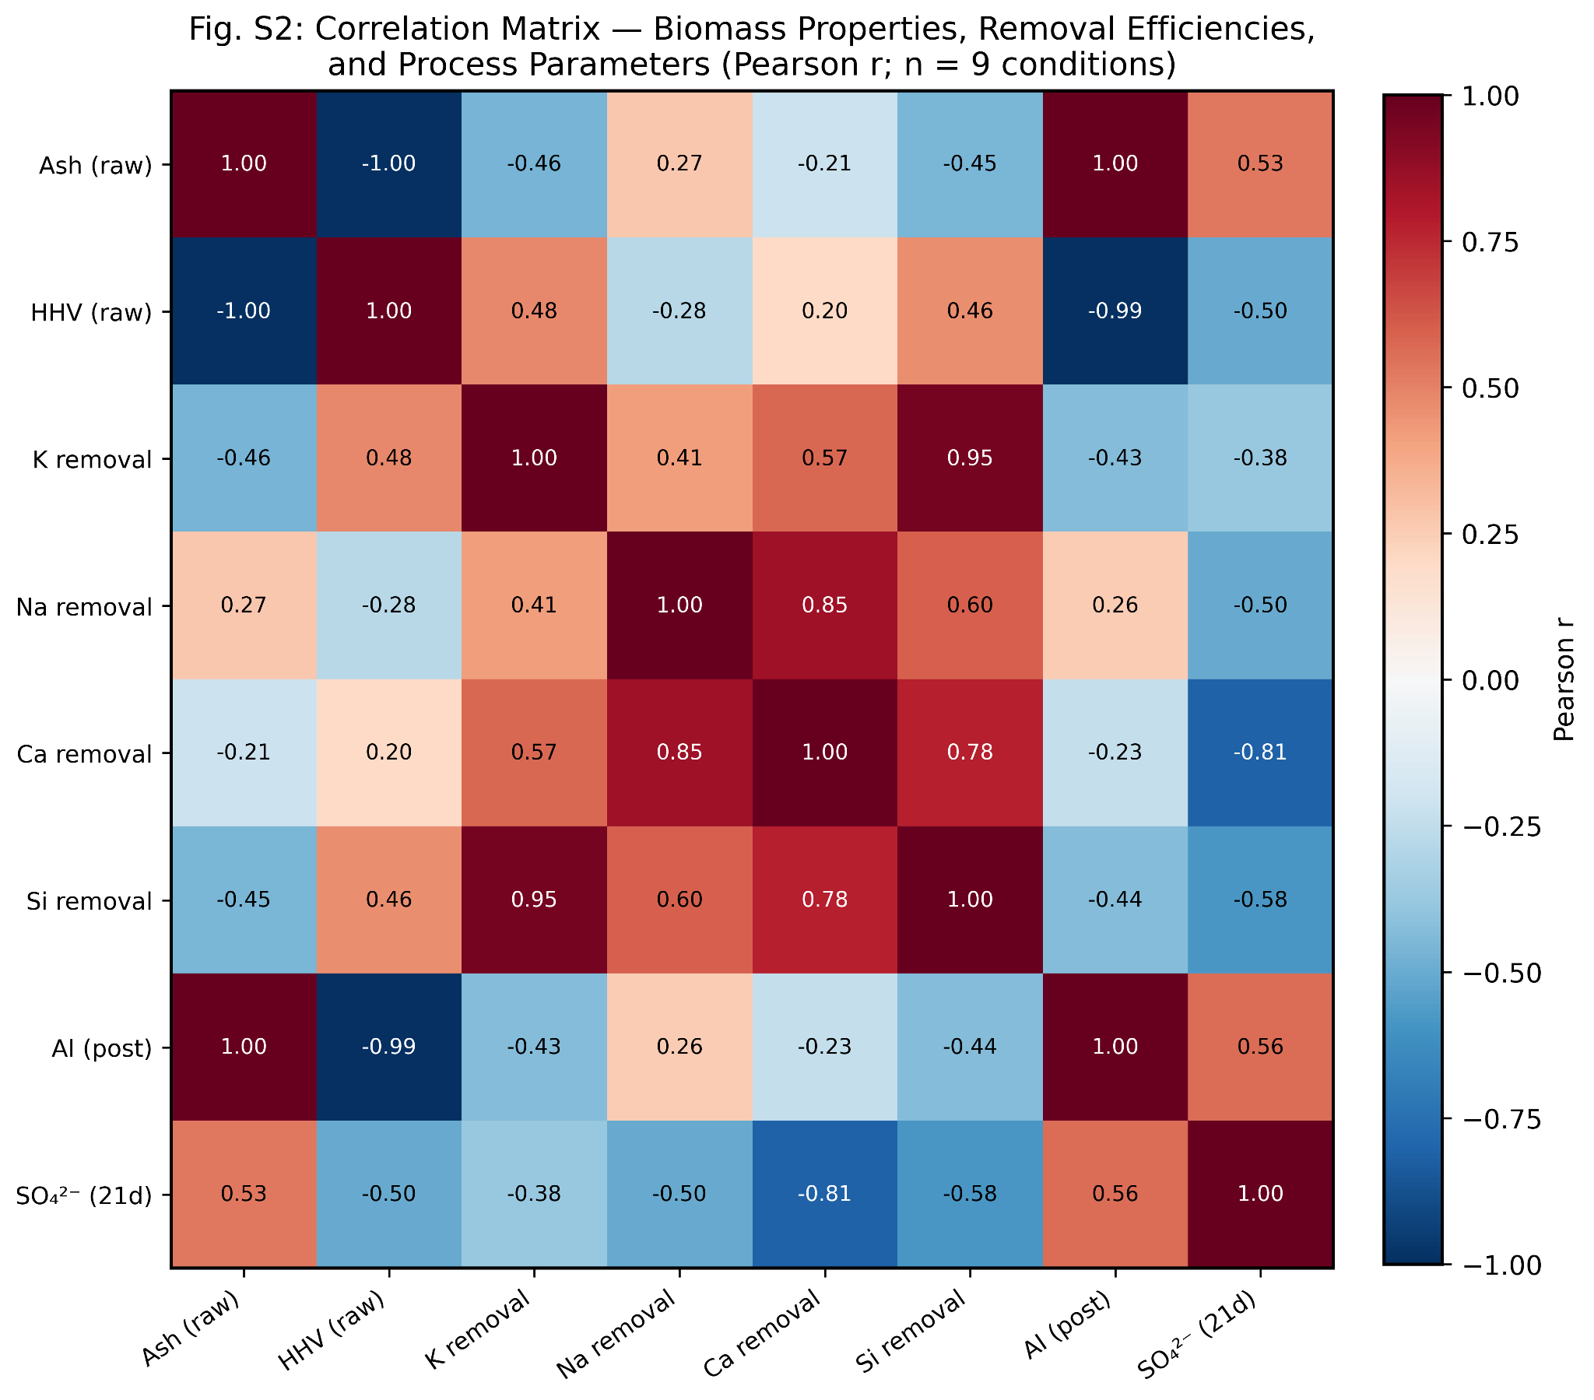
Fig. S2 Correlation Matrix Heatmap — Pearson r values for key biomass properties (HHV, ash content, AI, FI, IDT), removal efficiencies (Na, K, Ca, Mg, Si), and process parameters (SO₄²⁻, pH, pulp density). n = 9 conditions (Day 21). Colour scale: red = positive (r = +1), blue = negative (r = −1), white = zero. Significance levels annotated: ** p < 0.01, * p < 0.05 (Table S10, this document).
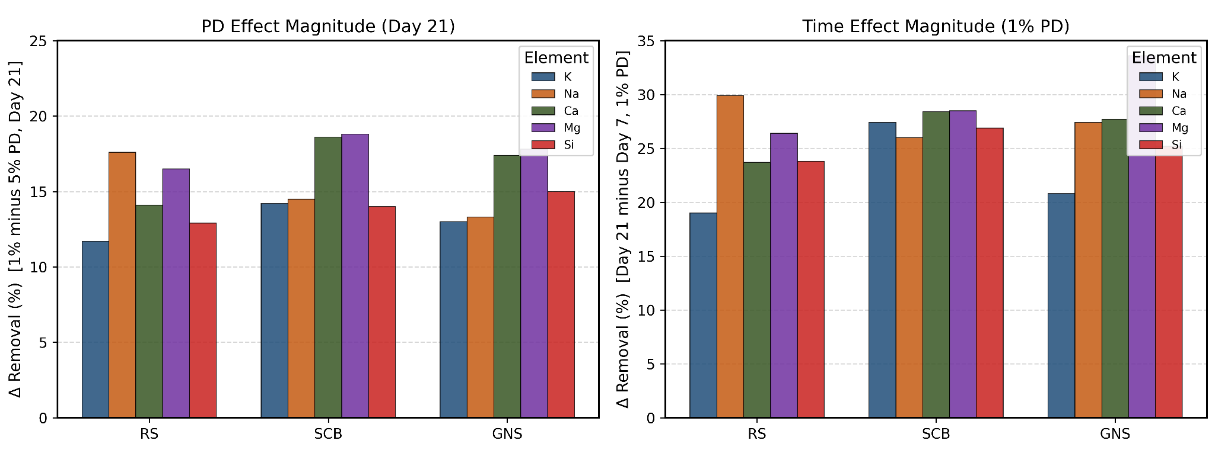
Fig. S3 Sensitivity Analysis — Magnitude of Pulp Density (PD) Effect vs Incubation Time Effect on Elemental Removal Efficiency (%) for Na, K, Ca, Mg, Si across three substrates. ΔRemoval calculated as described in Table S11. Grouped bar chart showing time effect consistently exceeds PD effect (ratio 1.5–2.1). Error bars = ±SD (n = 3).
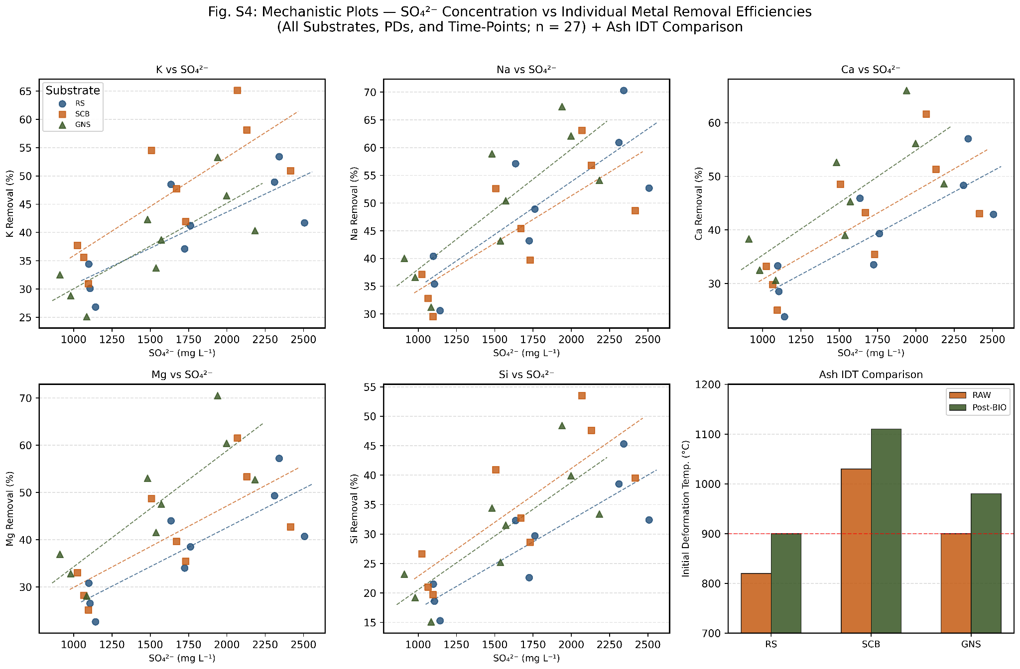
Fig. S4 Mechanistic Plots — IC SO₄²⁻ Concentration (mg L⁻¹) vs Individual Metal Removal Efficiencies (%): (a) K, (b) Na, (c) Ca, (d) Mg, (e) Si, for all substrates, PDs, and time-points (n = 27 data points each). (f) Ash Initial Deformation Temperature (IDT, °C) comparison: RAW vs Post-Bioleaching for RS, SCB, GNS. Error bars = ±SD (n = 3).
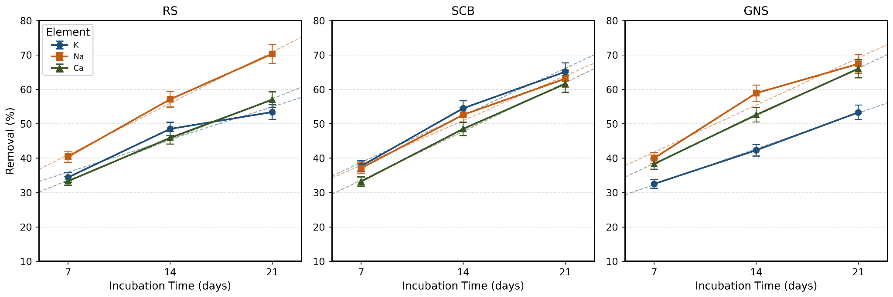
Fig. S5 Regression / Model Fit — Elemental Removal (%) vs Incubation Time (days) at 1% w/v PD for (a) RS, (b) SCB, (c) GNS. Solid lines = linear regression fit (parameters in Table S8). Dashed lines = 95% prediction intervals. Error bars = ±SD (n = 3). Confirms linear kinetics over the 7–21 day window.
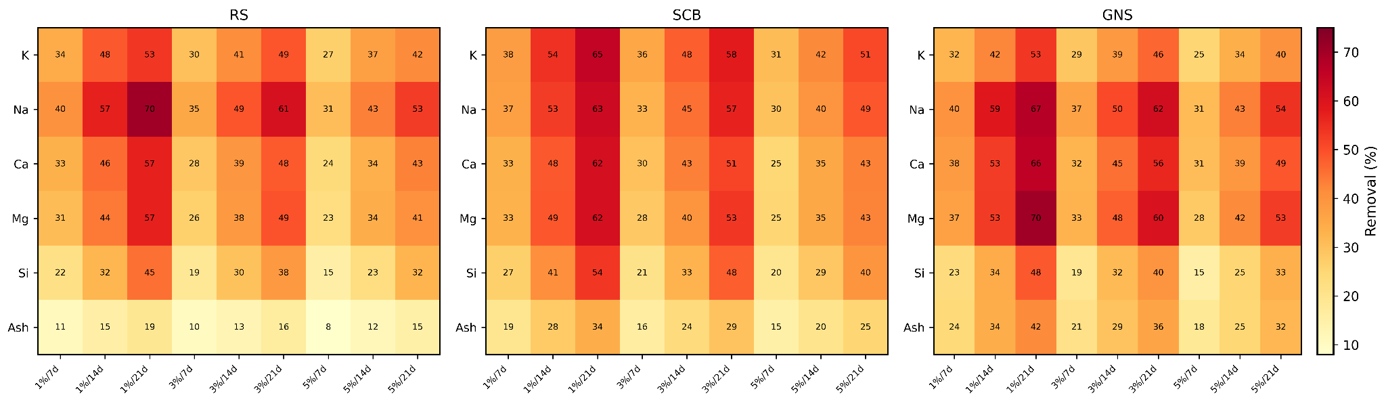
Fig. S6 Elemental Removal Heatmap (%) — All conditions (rows: K, Na, Ca, Mg, Si, Ash; columns: 9 PD/time combinations). Separate panels for RS, SCB, GNS. Colour scale: low removal (white) to high removal (dark blue). Optimal condition (1% w/v, 21 d) highlighted with border. Values as per Tables 2–4 (main text).
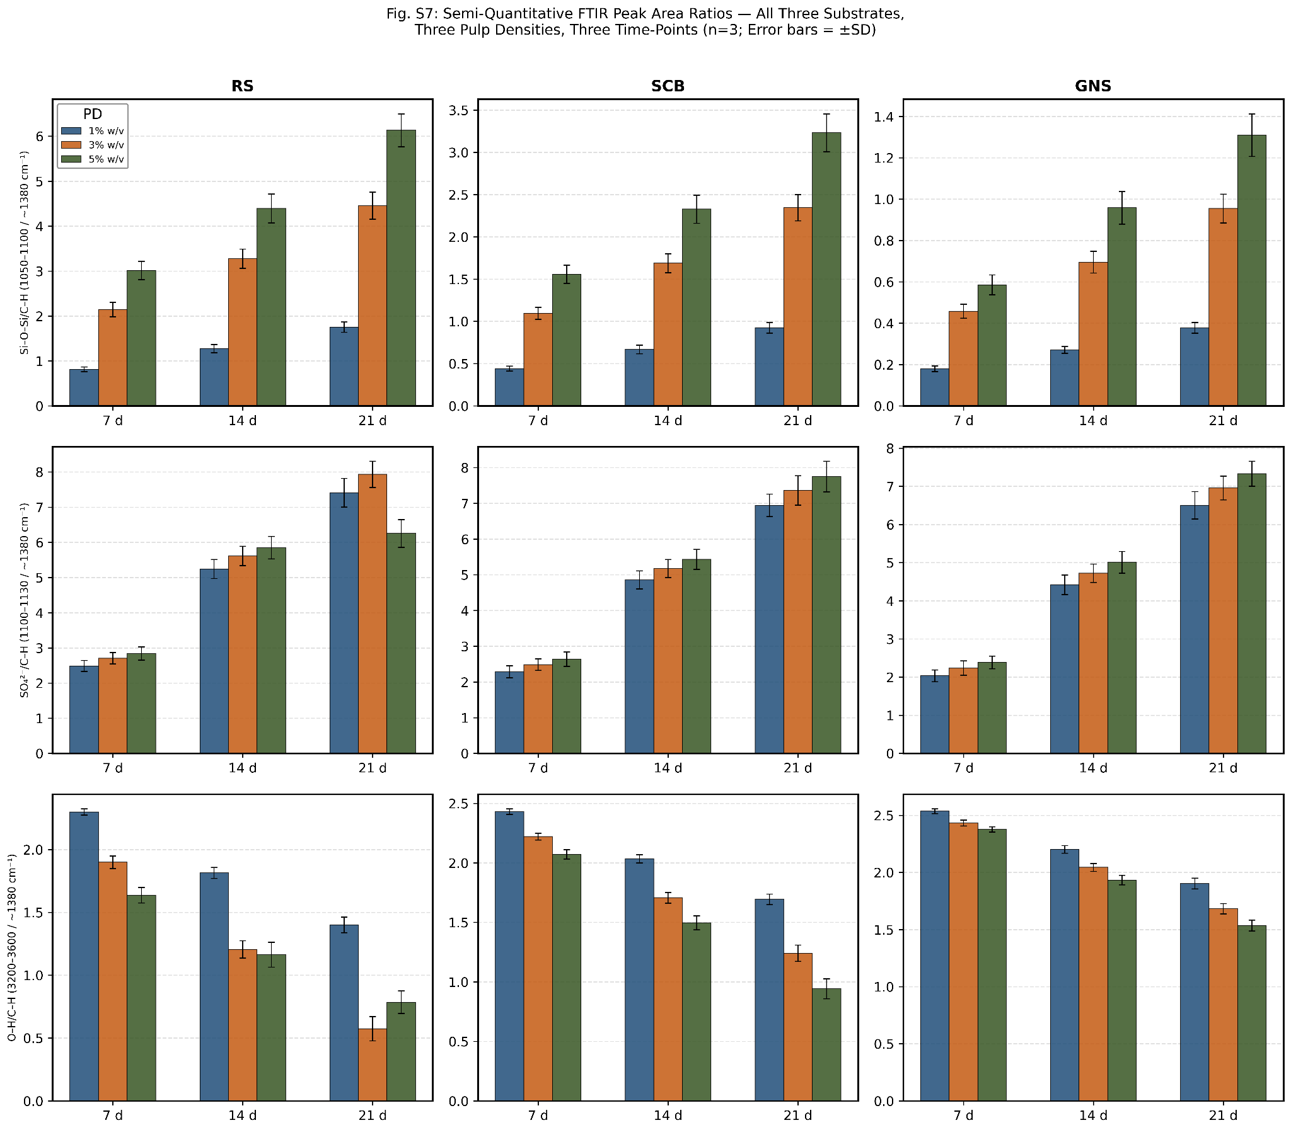
Fig. S7 Semi-Quantitative ATR-FTIR Peak Area Ratios — Grouped bar charts for all three substrates (RS, SCB, GNS), three pulp densities (1%, 3%, 5% w/v), and three time-points (Days 7, 14, 21) plus RAW. Panels show: (a) Si–O–Si/C–H, (b) SO₄²⁻/C–H, (c) O–H/C–H ratios. Error bars = ±SD (n = 3, Table S5). All CV% < 5%.
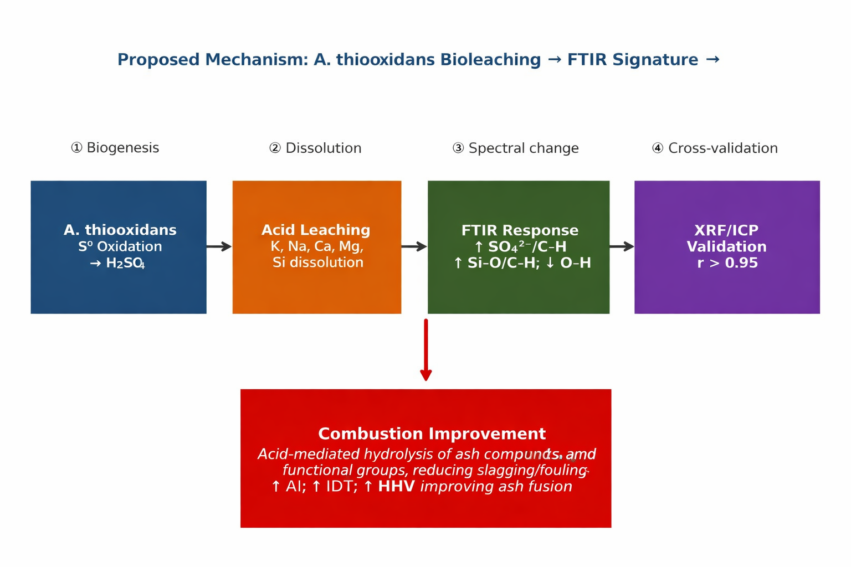
Fig. S8 Proposed Mechanistic Pathway — Schematic linking A. thiooxidans bioleaching biochemistry (sulfur oxidation → biogenic H₂SO₄ generation), mineral dissolution cascades (alkali chlorides, alkaline-earth carbonates/phosphates, silicates), FTIR spectroscopic signatures (SO₄²⁻/C–H, O–H/C–H ratio changes), and combustion performance outcomes (reduced AI/FI, increased IDT, improved HHV). Circular arrows indicate leachate valorisation and sulfur cycling loops within the integrated biorefinery framework.

