Figure S1. Cellular uptake of NVs by M2 macrophages. (a) The fluorescent image of DiR labelled M0 NV, M1 NV or M1 NV-R848 uptaken by M2 macrophages after 4 h incubation. (b) The cellular uptake of DiR labelled M0 NV, M1 NV or M1 NV-R848 by M2 macrophages detected by flow cytometry after 4 h incubation.

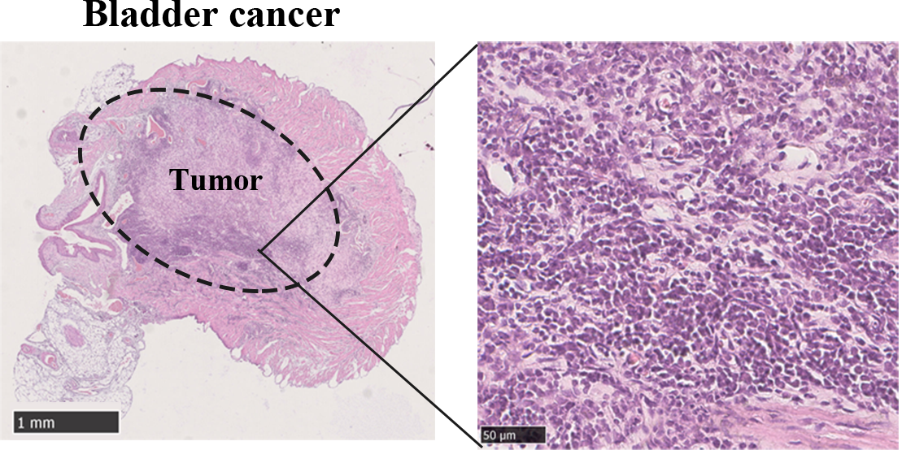
Figure S2. The HE images of orthotopic bladder cancer bearing model. HE images confirmed the tumor (the dotted circle) in the bladder wall.

