Supplementary material

Supplementary document. Detailed hyperparameters of RF and XGboost models in three datasets.
Hyperparameters used for the RF model in all datasets were tuned to the following values: the number of trees in the forest is 1000, the maximum depth of each tree is 90, the minimum number of samples required to split an internal leaf node is 10, and the minimum number of samples required to be at a leaf node is 2.
Hyperparameters used for the XGB model in T1 dataset were tuned to the following values: the maximum number of iterations = 50, maximum depth of the tree = 6, step size of each boosting step =0.3, minimum loss reduction required to make a split = 2, minimum sum of weights of all observations required in a child = 5, fraction of columns to be randomly sampled for each tree =0.9 , and fraction of observations to be randomly sampled for each tree = 0.8.
Hyperparameters used for the XGB model in T1+T2 dataset were tuned to the following values: the maximum number of iterations = 50, maximum depth of the tree = 6, step size of each boosting step =0.3, minimum loss reduction required to make a split = 3, minimum sum of weights of all observations required in a child = 5, fraction of columns to be randomly sampled for each tree =0.9 , and fraction of observations to be randomly sampled for each tree = 0.8.
Hyperparameters used for the XGB model in T1+T2+T3 dataset were tuned to the following values: the maximum number of iterations = 50, maximum depth of the tree = 5, step size of each boosting step =0.3, minimum loss reduction required to make a split = 2, minimum sum of weights of all observations required in a child = 1, fraction of columns to be randomly sampled for each tree =0.9 , and fraction of observations to be randomly sampled for each tree = 0.5.

Figure S1. The prediction of LASSO & Logistic regression model in P2 with T1. Confusion matrix (A) and ROC (B).
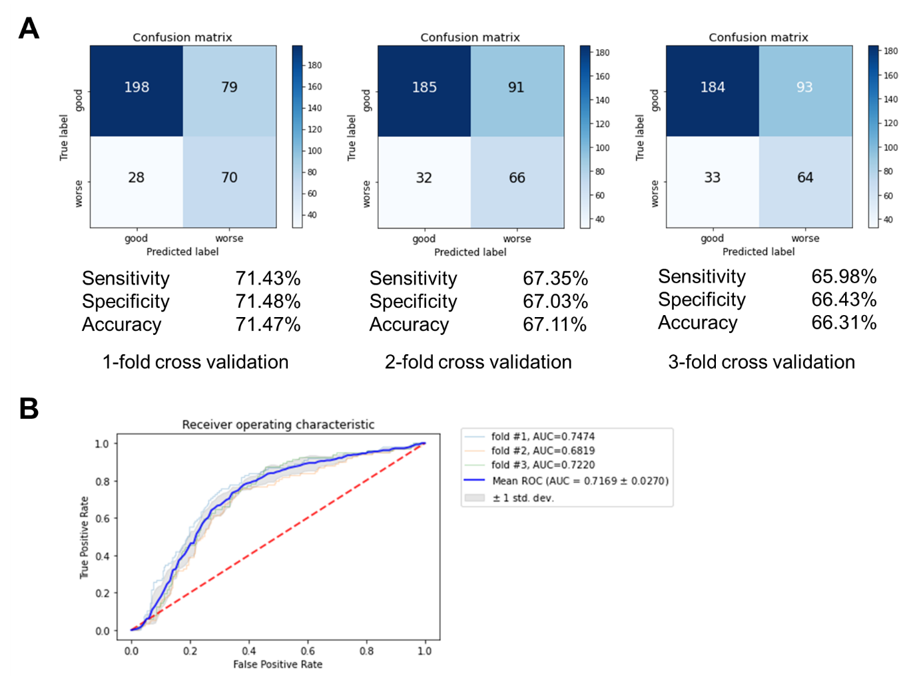

Figure S2. The prediction of XGBoost model in P2 with T1. Confusion matrix (A) and ROC (B).
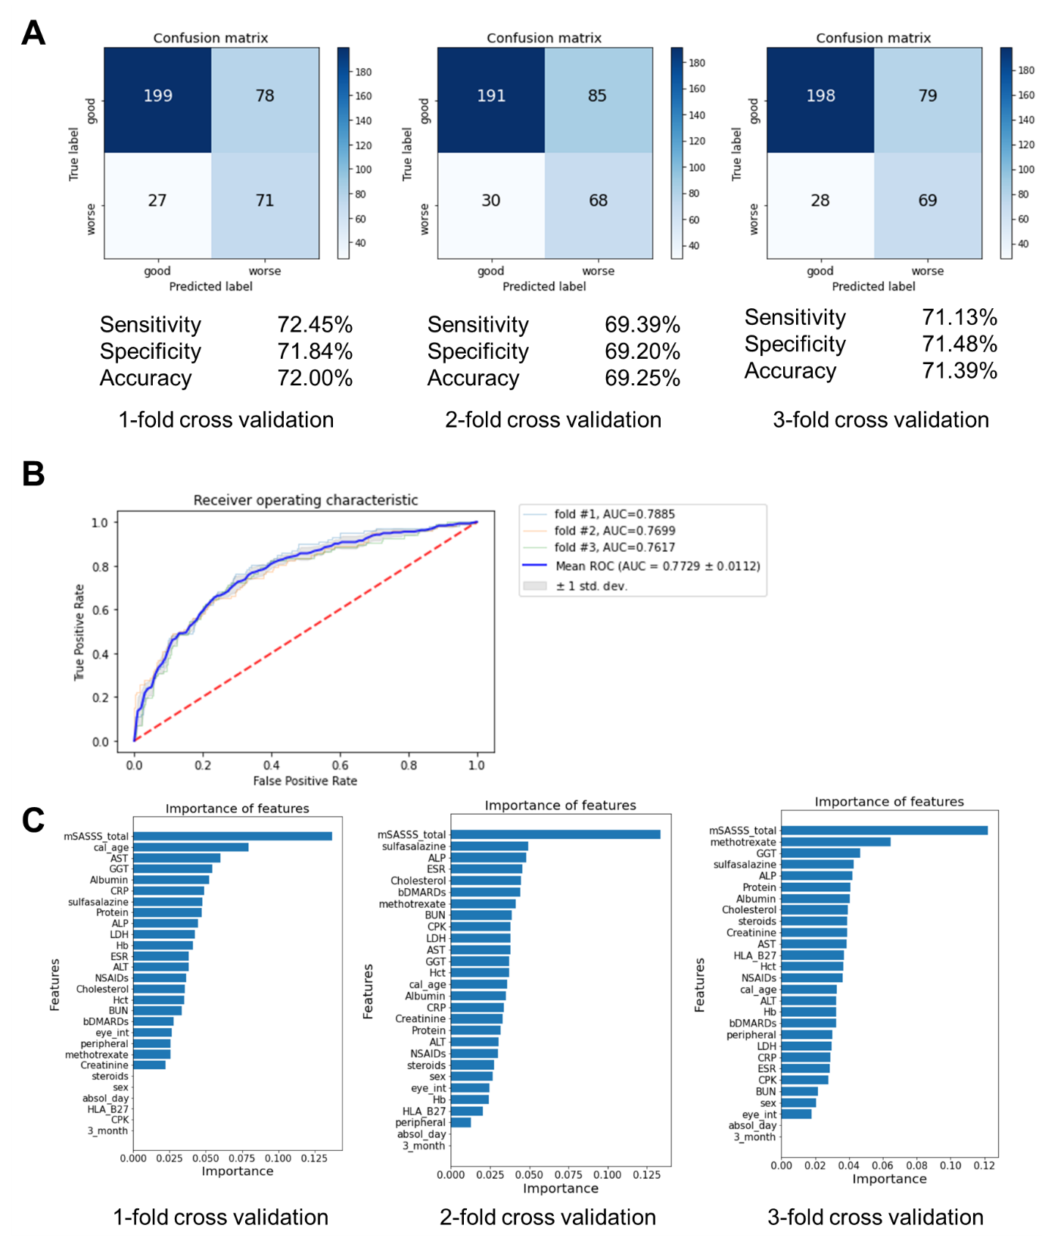

Figure S3. The prediction of LASSO & Logistic regression in P3 with T1+T2. Confusion matrix (A) and ROC (B).
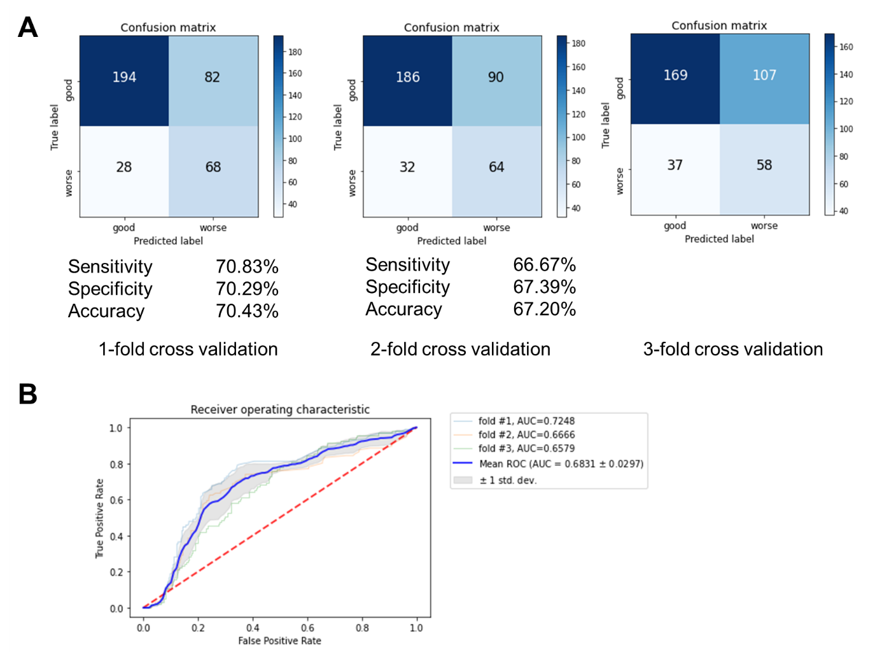

Figure S4. The prediction of random forest in P3 with T1+T2. Confusion matrix (A) and ROC (B).
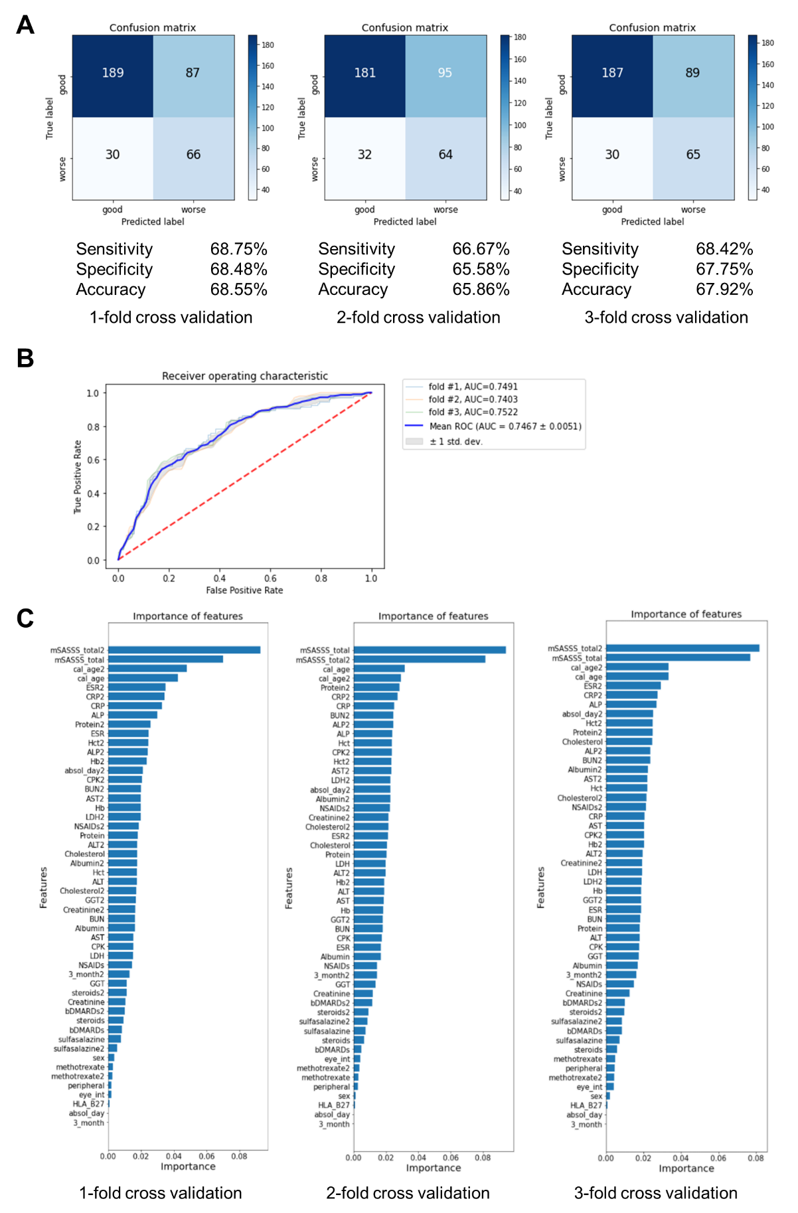

Figure S5. The prediction of XGBoost in P3 with T1+T2. Confusion matrix (A) and ROC (B).
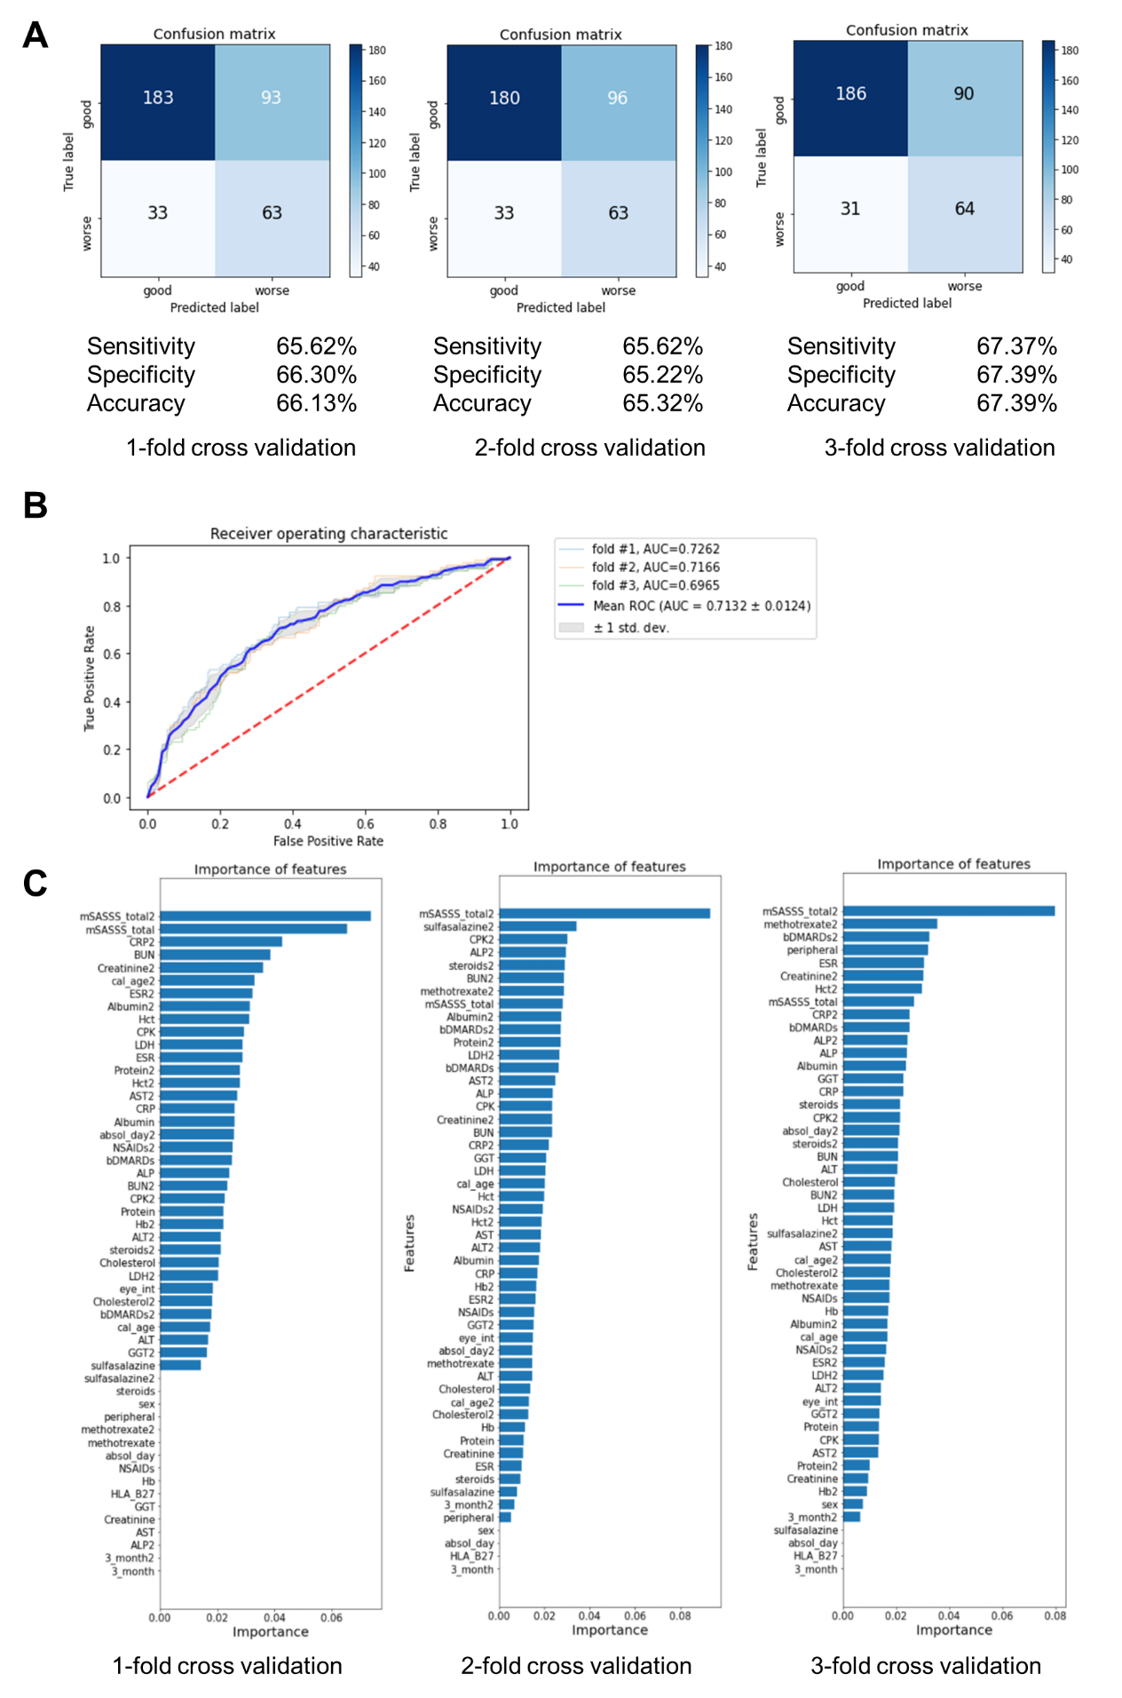

Figure S6. The prediction of LASSO & Logistic regression in P4 with T1+T2+T3. Confusion matrix (A) and ROC (B).
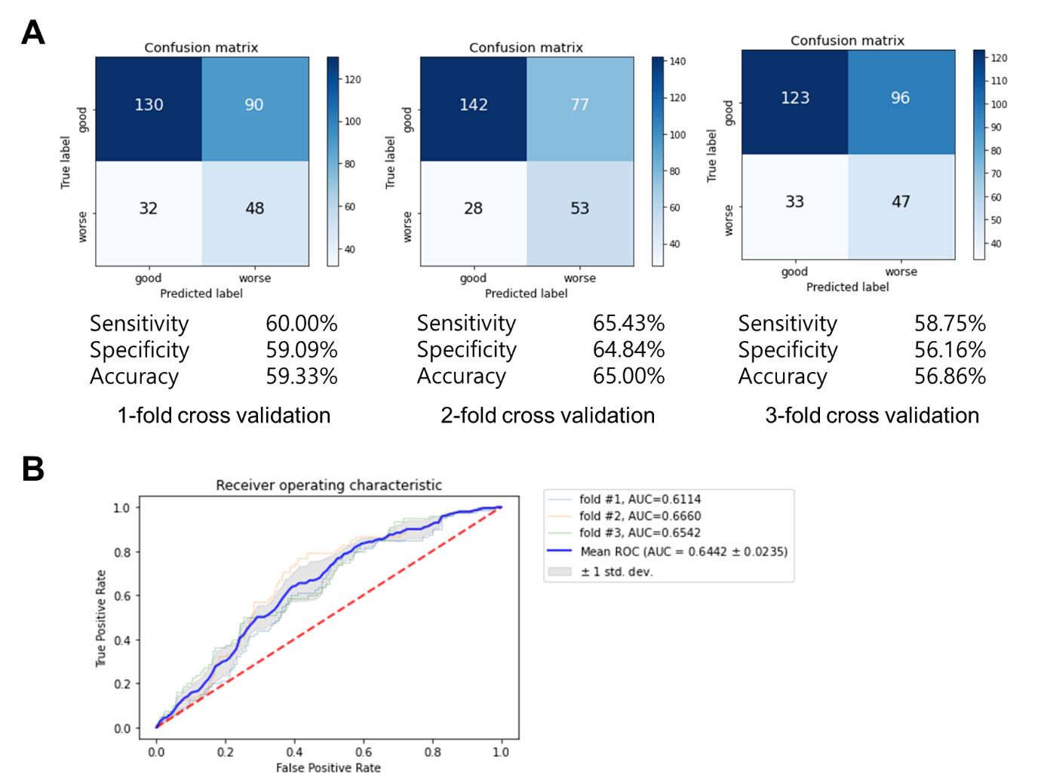

Figure S7. The prediction of random forest in P4 with T1+T2+T3. Confusion matrix (A) and ROC (B).
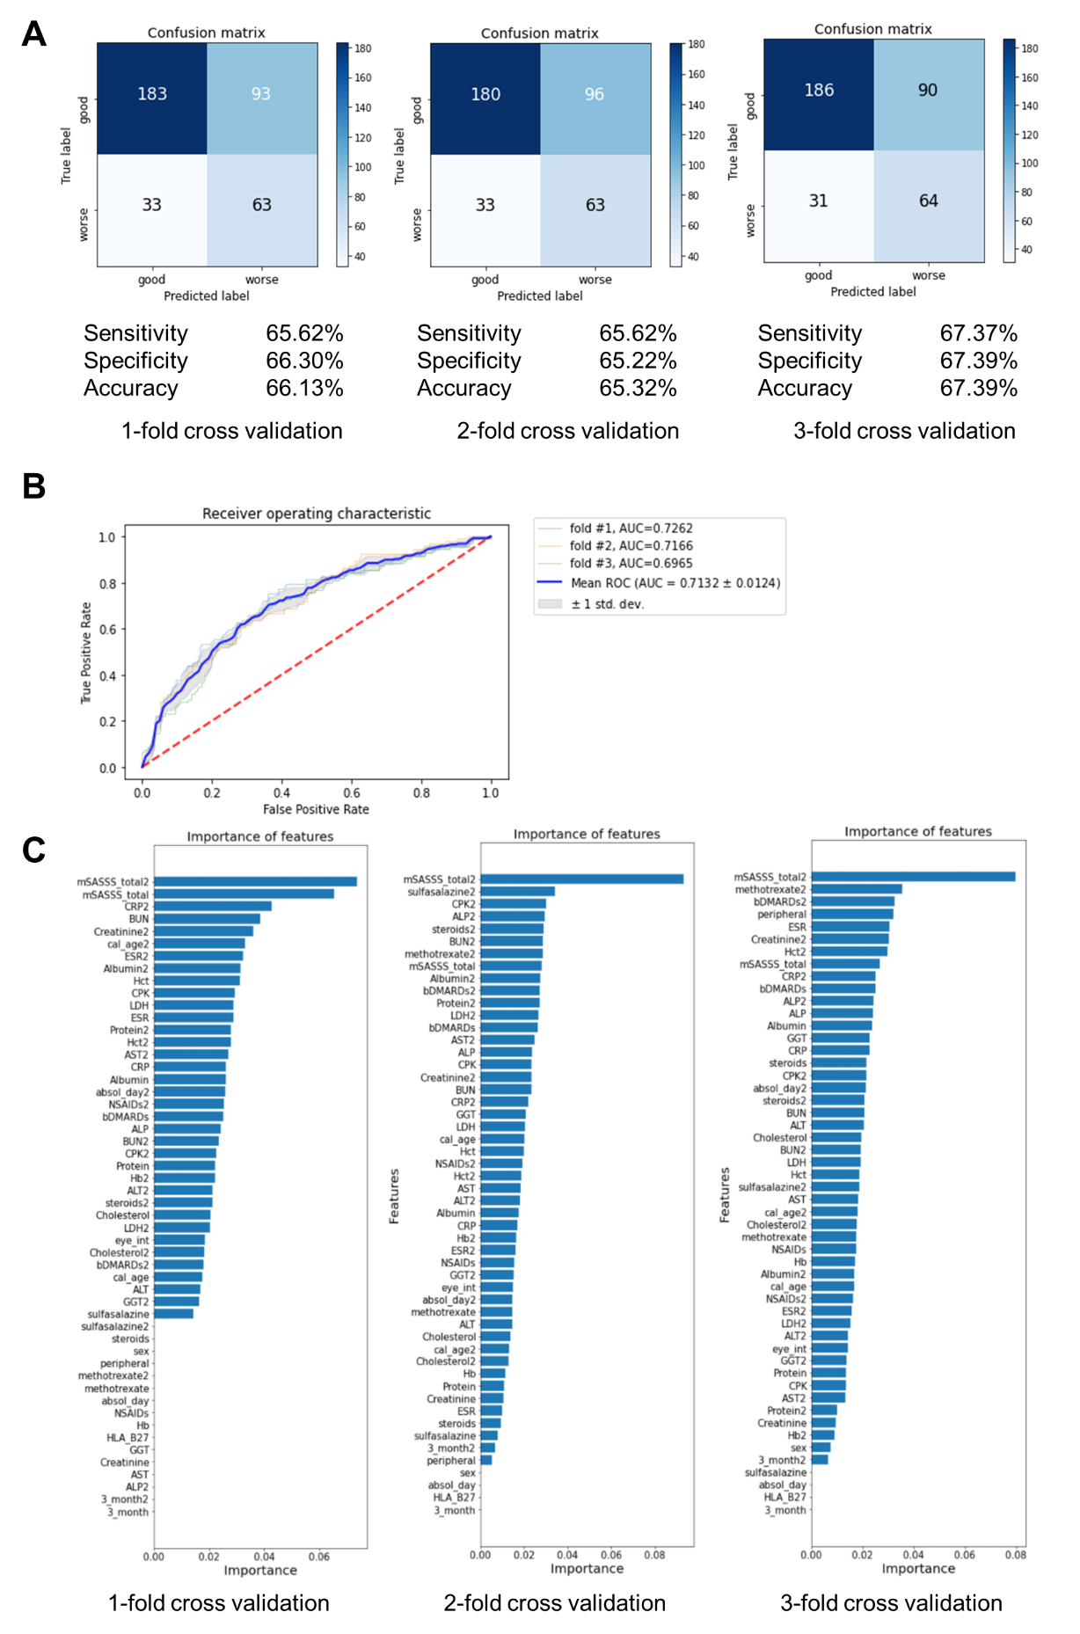

Figure S8. The prediction of XGBoost in P4 with T1+T2+T3. Confusion matrix (A) and ROC (B).
