Supplementary Appendix
Tables
Supplementary Table S1. Baseline characteristics of patients receiving cafelkibart monotherapy by individual study.
 | LM108-01-101 | LM108-01-102 | LM108-01-103 | Pooled
 | (n = 26) | (n = 21) | (n = 38) | (n = 85)
Gender, n (%)
Male | 14 (53.8) | 16 (76.2) | 22 (57.9) | 52 (61.2)
Female | 12 (46.2) | 5 (23.8) | 16 (42.1) | 33 (38.8)
Race, n (%)*
Asian | 2 (7.7) | 0 | 38 (100) | 40 (47.1)
Black or African American | 0 | 1 (4.8) | 0 | 1 (1.2)
White | 22 (84.6) | 20 (95.2) | 0 | 42 (49.4)
Age (years)
Mean (SD) | 64.7 (9.7) | 63.9 (14.6) | 62.5 (10.0) | 63.5 (11.1)
Median | 66 | 66 | 64 | 66
Min, Max | 43, 81 | 20, 82 | 34, 76 | 20, 82
ECOG performance status, n (%)
0 | 11 (42.3) | 8 (38.1) | 0 | 19 (22.4)
1 | 15 (57.7) | 13 (61.9) | 38 (100) | 66 (77.6)
Treatment line, n (%)
≤2 | 18 (69.2) | 12 (57.1) | 19 (50.0) | 49 (57.6)
≥3 | 8 (30.8) | 9 (42.9) | 19 (50.0) | 36 (42.4)
Disease diagnosis, n (%)†
GC | 1 (3.8) | 1 (4.8) | 3 (7.9) | 5 (5.9)
PDAC | 13 (50.0) | 1 (4.8) | 6 (15.8) | 20 (23.5)
Colorectal cancer | 3 (11.5) | 4 (19.0) | 2 (5.3) | 9 (10.6)
Non–small-cell lung cancer (non-squamous) | 1 (3.8) | 3 (14.3) | 5 (13.2) | 9 (10.6)
Non–small-cell lung cancer (squamous) | 0 | 1 (4.8) | 6 (15.8) | 7 (8.2)
Esophageal squamous cell carcinoma | 1 (3.8) | 0 | 5 (13.2) | 6 (7.1)
Ovarian cancer | 0 | 1 (4.8) | 3 (7.9) | 4 (4.7)
Head and neck squamous cell carcinoma | 0 | 3 (14.3) | 0 | 3 (3.5)
Melanoma | 1 (3.8) | 0 | 1 (2.6) | 2 (2.4)
Small-cell lung cancer | 1 (3.8) | 1 (4.8) | 0 | 2 (2.4)
Sarcoma | 0 | 1 (4.8) | 1 (2.6) | 2 (2.4)
Triple-negative breast cancer | 0 | 0 | 2 (5.3) | 2 (2.4)
Number of metastasis sites, n (%)
0–2 | 20 (76.9) | 16 (76.2) | 19 (50.0) | 55 (64.7)
≥3 sites | 5 (19.2) | 5 (23.8) | 15 (39.5) | 25 (29.4)
Missing | 1 (3.8) | 0 | 4 (10.5) | 5 (5.9)
Prior radical resection of tumor, n (%)
Yes | 9 (34.6) | 6 (28.6) | 19 (50.0) | 34 (40.0)
No | 17 (65.4) | 15 (71.4) | 19 (50.0) | 51 (60.0)
Previous systemic therapies, n (%)
Fluorouracil | 17 (65.4) | 8 (38.1) | 13 (34.2) | 38 (44.7)
Taxanes | 2 (7.7) | 5 (23.8) | 28 (73.7) | 35 (41.2)
Platinum | 19 (73.1) | 18 (85.7) | 32 (84.2) | 69 (81.2)
Immunotherapy | 7 (26.9) | 11 (52.4) | 19 (50.0) | 37 (43.5)
Anti-VEGFR | 4 (15.4) | 6 (28.6) | 18 (47.4) | 28 (32.9)
* Two patients (2.4%) identified as having “Other” race.
† One patient had each of the following tumor types: adenoid cystic carcinoma, adrenocortical adenocarcinoma, breast cancer, biliary tract cancer, duodenal adenocarcinoma, extraskeletal myxoid chondrosarcoma, endometrial stromal sarcoma, esophageal neuroendocrine carcinoma, gastrointestinal stromal tumor, mesothelioma, renal cell carcinoma, SETTLE (spindle epithelial tumor with thymus-like differentiation), small intestinal cancer, and urothelial carcinoma.
ECOG, Eastern Cooperative Oncology Group; GC, gastric cancer; PDAC, pancreatic ductal adenocarcinoma; VEGFR, vascular endothelial growth factor receptor therapy.

Supplementary Table S2. Baseline characteristics of patients receiving cafelkibart monotherapy (pooled data).
 | 0.3 mg/kg  Q3W  (n = 4) | 1 mg/kg  Q3W  (n = 5) | 3 mg/kg  Q3W  (n = 18) | 10 mg/kg  Q3W  (n = 34) | 20 mg/kg  Q3W  (n = 7) | 10 mg/kg  Q2W  (n = 14) | 20 mg/kg  Q2W  (n = 3)
Gender, n (%)
Male | 3 (75.0) | 2 (40.0) | 12 (66.7) | 21 (61.8) | 5 (71.4) | 8 (57.1) | 1 (33.3)
Female | 1 (25.0) | 3 (60.0) | 6 (33.3) | 13 (38.2) | 2 (28.6) | 6 (42.9) | 2 (66.7)
Race, n (%)*
Asian | 0 | 0 | 12 (66.7) | 23 (67.6) | 4 (57.1) | 1 (7.1) | 0
Black or African American | 0 | 0 | 0 | 1 (2.9) | 0 | 0 | 0
White | 4 (100) | 5 (100) | 6 (33.3) | 10 (29.4) | 3 (42.9) | 12 (85.7) | 2 (66.7)
Age (years)
Mean (SD) | 67.8 (5.2) | 69.4 (8.5) | 60.2 (9.5) | 62.3 (11.6) | 69.3 (16.1) | 64.7 (9.6) | 61.7 (16.2)
Median | 67 | 72 | 62 | 64 | 75 | 65 | 70
Min, Max | 63, 74 | 59, 78 | 36, 73 | 20, 80 | 34, 82 | 50, 81 | 43, 72
ECOG performance status, n (%)
0 | 0 | 1 (20.0) | 3 (16.7) | 7 (20.6) | 1 (14.3) | 6 (42.9) | 1 (33.3)
1 | 4 (100) | 4 (80.0) | 15 (83.3) | 27 (79.4) | 6 (85.7) | 8 (57.1) | 2 (66.7)
Prior treatment line, n (%)
≤2 | 0 | 3 (60.0) | 10 (55.6) | 21 (61.8) | 3 (42.9) | 10 (71.4) | 2 (66.7)
≥3 | 4 (100) | 2 (40.0) | 8 (44.4) | 13 (38.2) | 4 (57.1) | 4 (28.6) | 1 (33.3)
Disease diagnosis, n (%)†
GC | 0 | 0 | 0 | 4 (11.8) | 0 | 1 (7.1) | 0
PDAC | 0 | 0 | 3 (16.7) | 5 (14.7) | 1 (14.3) | 10 (71.4) | 1 (33.3)
Colorectal cancer | 0 | 0 | 2 (11.1) | 3 (8.8) | 2 (28.6) | 0 | 2 (66.7)
Non–small-cell lung cancer  (non-squamous) | 1 (20.0) | 1 (20.0) | 3 (16.7) | 4 (11.8) | 0 | 0 | 0
Non–small-cell lung cancer (squamous) | 0 | 1 (20.0) | 1 (5.6) | 4 (11.8) | 1 (14.3) | 0 | 0
Esophageal squamous cell carcinoma | 0 | 0 | 2 (11.1) | 3 (8.8) | 0 | 1 (7.1) | 0
Ovarian cancer | 0 | 1 (20.0) | 1 (5.6) | 1 (2.9) | 1 (14.3) | 0 | 0
Head and neck squamous cell carcinoma | 2 (50.0) | 0 | 0 | 1 (2.9) | 0 | 0 | 0
Melanoma | 0 | 0 | 0 | 1 (2.9) | 0 | 1 (7.1) | 0
Small-cell lung cancer | 0 | 0 | 1 (5.6) | 1 (2.9) | 0 | 0 | 0
Sarcoma | 0 | 1 (20.0) | 1 (5.6) | 0 | 0 | 0 | 0
Triple-negative breast cancer | 0 | 0 | 0 | 2 (5.9) | 0 | 0 | 0
Number of metastasis sites, n (%)
0–2 | 3 (75.0) | 5 (100) | 12 (66.7) | 21 (61.8) | 3 (42.9) | 10 (71.4) | 1 (33.3)
≥3 sites | 1 (25.0) | 0 | 5 (27.8) | 11 (32.4) | 3 (42.9) | 3 (21.4) | 2 (66.7)
Missing | 0 | 0 | 1 (5.6) | 2 (5.9) | 1 (14.3) | 1 (7.1) | 0
Prior radical resection of tumor, n (%)
Yes | 1 (25.0) | 4 (80.0) | 6 (33.3) | 15 (44.1) | 3 (42.9) | 4 (28.6) | 1 (33.3)
No | 3 (75.0) | 1 (20.0) | 12 (66.7) | 19 (55.9) | 4 (57.1) | 10 (71.4) | 2 (66.7)
Previous systemic therapies, n (%)
Fluorouracil | 1 (25.0) | 1 (20.0) | 6 (33.3) | 13 (38.2) | 3 (42.9) | 11 (78.6) | 3 (100)
Taxanes | 1 (25.0) | 2 (40.0) | 8 (44.4) | 19 (55.9) | 3 (42.9) | 2 (14.3) | 0
Platinum | 4 (100) | 4 (80.0) | 15 (83.3) | 30 (88.2) | 4 (57.1) | 10 (71.4) | 2 (66.7)
Immunotherapy | 4 (100) | 3 (60.0) | 8 (44.4) | 14 (41.2) | 4 (57.1) | 4 (28.6) | 0
Anti-VEGF | 1 (25.0) | 1 (20.0) | 7 (38.9) | 13 (38.2) | 4 (57.1) | 0 | 2 (66.7)
* One patient each in the 10 mg/kg Q2W and 20 mg/kg Q2W group identified as “Other” race.
† One patient had each of the following: adenoid cystic carcinoma, adrenocortical adenocarcinoma, breast cancer, biliary tract cancer, duodenal adenocarcinoma, endometrial carcinoma, endometrial stromal sarcoma, esophageal neuroendocrine carcinoma, gastrointestinal stromal tumor, mesothelioma, renal cell carcinoma, spindle epithelial tumor with thymus-like differentiation, small intestine cancer, and urothelial carcinoma.
ECOG, Eastern Cooperative Oncology Group; GC, gastric cancer; PDAC, pancreatic ductal adenocarcinoma; Q2W, every 2 weeks; Q3W, every 3 weeks; VEGF, vascular endothelial growth factor therapy.
Supplementary Table S3. Baseline characteristics of patients treated with cafelkibart and a PD-1 inhibitor (pooled data).
 | All patients | GC | PDAC
 | Total  (N = 361) | Total  (n = 89) | Total  (n = 80)
Gender, n (%)
Male | 240 (66.5) | 62 (69.7) | 47 (58.8)
Female | 121 (33.5) | 27 (30.3) | 33 (41.3)
Race, n (%)*
Asian | 330 (91.4) | 87 (97.8) | 74 (92.5)
White | 27 (7.5) | 2 (2.2) | 6 (7.5)
Age (years)
Median (min, max) | 60 (32, 86) | 61 (34, 80) | 63 (33, 80)
ECOG performance status, n (%)
0 | 67 (18.6) | 17 (19.1) | 20 (25.0)
1 | 294 (81.4) | 72 (80.9) | 60 (75.0)
Prior treatment line, n (%)
≤2 | 302 (83.7) | 80 (89.9) | 68 (85.0)
≥3 | 59 (16.3) | 9 (10.1) | 12 (15.0)
Disease diagnosis, n (%)†
GC | 89 (24.7) | 89 (100) | 0
PDAC | 80 (22.2) | 0 | 80 (100)
Other | 192 (53.2) | 0 | 0
Number of metastasis sites, n (%)
0–2 | 242 (67.0) | 69 (77.5) | 52 (65.0)
≥3 sites | 103 (28.5) | 20 (22.5) | 24 (30.0)
Missing | 16 (4.4) | 0 | 4 (5.0)
Prior radical resection of tumor, n (%)
Yes | 176 (48.8) | 52 (58.4) | 34 (42.5)
No | 185 (51.2) | 37 (41.6) | 46 (57.5)
Histopathological type, n (%)
Adenocarcinoma | 183 (50.7) | 66 (74.2) | 72 (90.0)
Squamous cell carcinoma | 23 (6.4) | 0 | 0
Others | 155 (42.9) | 23 (25.8) | 8 (10.0)
MSI/MMR status, n (%)
MSI-H/dMMR | 38 (10.5) | 20 (22.5) | 2 (2.5)
Unknown | 323 (89.5) | 69 (77.5) | 78 (97.5)
Previous systemic therapies, n (%)
Fluorouracil | 199 (55.1) | 85 (95.5) | 55 (68.8)
Taxanes | 203 (56.2) | 38 (42.7) | 61 (76.3)
Platinum | 260 (72.0) | 84 (94.4) | 30 (37.5)
Immunotherapy | 198 (54.8) | 77 (86.5) | 11 (13.8)
* One patient (0.3%) identified as Native Hawaiian or Other Pacific Islander; 3 patients (0.8%) identified as having “Other” race.
dMMR, mismatch repair–deficient; ECOG, Eastern Cooperative Oncology Group; GC, gastric cancer; MMR, mismatch repair; MSI, microsatellite instability; MSI-H, microsatellite instability–high; PD-1, programmed cell death protein-1; PDAC, pancreatic ductal adenocarcinoma.

Supplementary Table S4A. Safety overview of cafelkibart monotherapy (pooled data).
 | 0.3 mg/kg  Q3W  (n = 4) | 1 mg/kg  Q3W  (n = 5) | 3 mg/kg  Q3W  (n = 18) | 10 mg/kg  Q3W  (n = 34) | 20 mg/kg  Q3W  (n = 7) | 10 mg/kg  Q2W  (n = 14) | 20 mg/kg  Q2W  (n = 3) | Total  (N = 85) n (%)
Any TEAEs (total), n (%) | 4 (100) | 5 (100) | 17 (94.4) | 32 (94.1) | 7 (100) | 14 (100) | 3 (100) | 82 (96.5)
Any TRAEs, n (%) | 1 (25.0) | 2 (40.0) | 15 (83.3) | 31 (91.2) | 4 (57.1) | 8 (57.1) | 3 (100) | 64 (75.3)
Any grade 3 or higher TEAEs, n (%) | 4 (100) | 1 (20.0) | 7 (38.9) | 13 (38.2) | 4 (57.1) | 8 (57.1) | 2 (66.7) | 39 (45.9)
Any grade 3 or higher TRAEs, n (%) | 0 | 1 (20.0) | 0 | 9 (26.5) | 0 | 4 (28.6) | 0 | 14 (16.5)
Serious TEAEs, n (%) | 3 (75.0) | 1 (20.0) | 6 (33.3) | 11 (32.4) | 4 (57.1) | 7 (50.0) | 2 (66.7) | 34 (40.0)
Serious TRAEs, n (%) | 0 | 1 (20.0) | 0 | 5 (14.7) | 0 | 2 (14.3) | 0 | 8 (9.4)
TEAEs leading to dose reduction, n (%) | 0 | 0 | 0 | 0 | 0 | 0 | 0 | 0
TEAEs leading to dose interruption, n (%) | 2 (50.0) | 0 | 7 (38.9) | 11 (32.4) | 3 (42.9) | 4 (28.6) | 2 (66.7) | 29 (34.1)
TEAEs leading to treatment discontinuation, n (%) | 2 (50.0) | 0 | 0 | 0 | 2 (28.6) | 3 (21.4) | 0 | 7 (8.2)
TEAEs leading to death, n (%) | 0 | 0 | 0 | 2 (5.9) | 1 (14.3) | 0 | 0 | 3 (3.5)
TRAEs leading to death, n (%) | 0 | 0 | 0 | 1 (2.9) | 0 | 0 | 0 | 1 (1.2)
Infusion related reaction, n (%) | 0 | 0 | 2 (11.1) | 2 (5.9) | 1 (14.3) | 0 | 1 (33.3) | 6 (7.1)
irAE related reaction, n (%) | 1 (25.0) | 1 (20.0) | 2 (11.1) | 10 (29.4) | 0 | 5 (35.7) | 2 (66.7) | 21 (24.7)
Any grade 3 or higher irAEs, n (%) | 0 | 1 (20.0) | 0 | 3 (8.8) | 0 | 2 (14.3) | 0 | 6 (7.1)
irAE, immune-related adverse event; Q2W, every 2 weeks; Q3W, every 3 weeks; TEAE, treatment-emergent adverse event; TRAE, treatment-related adverse event.
Supplementary Table S4B. TEAEs with cafelkibart monotherapy (≥5%) (pooled data).
 | 0.3 mg/kg Q3W  (n = 4) |  | 1 mg/kg Q3W  (n = 5) |  | 3 mg/kg Q3W  (n = 18) |  | 10 mg/kg Q3W  (n = 34) |  | 20 mg/kg Q3W  (n = 7) |  | 10 mg/kg Q2W  (n = 14) |  |  | 20 mg/kg Q2W  (n = 3) |  | Total  (N = 85)
System organ class  preferred term | All G | ≥G3 | All G | ≥G3 | All G | ≥G3 | All G | ≥G3 | All G | ≥G3 |  | All G | ≥G3 | All G | ≥G3 | All G | ≥G3
Patients with any TEAEs  related to cafelkibart | 1 (25.0) | 0 | 2 (40.0) | 1 (20.0) | 15 (83.3) | 0 | 31 (91.2) | 9 (26.5) | 4 (57.1) | 0 |  | 8 (57.1) | 4 (28.6) | 3 (100) | 0 | 64 (75.3) | 14 (16.5)
Investigations | 0 | 0 | 1 (20.0) | 1 (20.0) | 5 (27.8) | 0 | 21 (61.8) | 5 (14.7) | 4 (57.1) | 0 |  | 2 (14.3) | 1 (7.1) | 0 | 0 | 33 (38.8) | 7 (8.2)
Alanine aminotransferase increased | 0 | 0 | 0 | 0 | 1 (5.6) | 0 | 9 (26.5) | 1 (2.9) | 1 (14.3) | 0 |  | 0 | 0 | 0 | 0 | 11 (12.9) | 1 (1.2)
Aspartate aminotransferase increased | 0 | 0 | 0 | 0 | 1 (5.6) | 0 | 9 (26.5) | 1 (2.9) | 1 (14.3) | 0 |  | 0 | 0 | 0 | 0 | 11 (12.9) | 1 (1.2)
Lipase increased | 0 | 0 | 0 | 0 | 3 (16.7) | 0 | 4 (11.8) | 0 | 2 (28.6) | 0 |  | 1 (7.1) | 0 | 0 | 0 | 10 (11.8) | 0
White blood cell count decreased | 0 | 0 | 1 (20.0) | 1 (20.0) | 0 | 0 | 6 (17.6) | 2 (5.9) | 0 | 0 |  | 0 | 0 | 0 | 0 | 7 (8.2) | 3 (3.5)
Neutrophil count decreased | 0 | 0 | 1 (20.0) | 0 | 1 (5.6) | 0 | 4 (11.8) | 0 | 0 | 0 |  | 0 | 0 | 0 | 0 | 6 (7.1) | 0
Activated partial thromboplastin time  prolonged | 0 | 0 | 0 | 0 | 1 (5.6) | 0 | 3 (8.8) | 0 | 1 (14.3) | 0 |  | 0 | 0 | 0 | 0 | 5 (5.9) | 0
Bilirubin conjugated increased | 0 | 0 | 0 | 0 | 1 (5.6) | 0 | 4 (11.8) | 1 (2.9) | 0 | 0 |  | 0 | 0 | 0 | 0 | 5 (5.9) | 1 (1.2)
Skin and subcutaneous tissue disorders | 1 (25.0) | 0 | 1 (20.0) | 0 | 3 (16.7) | 0 | 13 (38.2) | 0 | 0 | 0 |  | 5 (35.7) | 0 | 2 (66.7) | 0 | 25 (29.4) | 0
Rash | 0 | 0 | 0 | 0 | 0 | 0 | 8 (23.5) | 0 | 0 | 0 |  | 3 (21.4) | 0 | 1 (33.3) | 0 | 12 (14.1) | 0
Rash maculo-papular | 1 (25.0) | 0 | 0 | 0 | 1 (5.6) | 0 | 3 (8.8) | 0 | 0 | 0 |  | 1 (7.1) | 0 | 1 (33.3) | 0 | 7 (8.2) | 0
Metabolism and nutrition  disorders | 0 | 0 | 0 | 0 | 5 (27.8) | 0 | 15 (44.1) | 0 | 1 (14.3) | 0 |  | 1 (7.1) | 0 | 0 | 0 | 22 (25.9) | 0
Decreased appetite | 0 | 0 | 0 | 0 | 0 | 0 | 5 (14.7) | 0 | 1 (14.3) | 0 |  | 1 (7.1) | 0 | 0 | 0 | 7 (8.2) | 0
Hypoalbuminemia | 0 | 0 | 0 | 0 | 1 (5.6) | 0 | 5 (14.7) | 0 | 0 | 0 |  | 0 | 0 | 0 | 0 | 6 (7.1) | 0
Hyponatremia | 0 | 0 | 0 | 0 | 1 (5.6) | 0 | 4 (11.8) | 0 | 1 (14.3) | 0 |  | 0 | 0 | 0 | 0 | 6 (7.1) | 0
General disorders and administration  site conditions | 0 | 0 | 1 (20.0) | 0 | 6 (33.3) | 0 | 9 (26.5) | 0 | 2 (28.6) | 0 |  | 3 (21.4) | 1 (7.1) | 0 | 0 | 21 (24.7) | 1 (1.2)
Asthenia | 0 | 0 | 0 | 0 | 4 (22.2) | 0 | 3 (8.8) | 0 | 2 (28.6) | 0 |  | 0 | 0 | 0 | 0 | 9 (10.6) | 0
Fatigue | 0 | 0 | 1 (20.0) | 0 | 1 (5.6) | 0 | 2 (5.9) | 0 | 0 | 0 |  | 3 (21.4) | 1 (7.1) | 0 | 0 | 7 (8.2) | 1 (1.2)
Pyrexia | 0 | 0 | 0 | 0 | 1 (5.6) | 0 | 5 (14.7) | 0 | 1 (14.3) | 0 |  | 0 | 0 | 0 | 0 | 7 (8.2) | 0
Gastrointestinal disorders | 0 | 0 | 0 | 0 | 4 (22.2) | 0 | 11 (32.4) | 1 (2.9) | 0 | 0 |  | 1 (7.1) | 1 (7.1) | 1 (33.3) | 0 | 17 (20.0) | 2 (2.4)
Diarrhea | 0 | 0 | 0 | 0 | 4 (22.2) | 0 | 5 (14.7) | 1 (2.9) | 0 | 0 |  | 1 (7.1) | 0 | 0 | 0 | 10 (11.8) | 1 (1.2)
Blood and lymphatic system disorders | 0 | 0 | 1 (20.0) | 1 (20.0) | 3 (16.7) | 0 | 7 (20.6) | 2 (5.9) | 1 (14.3) | 0 |  | 1 (7.1) | 1 (7.1) | 0 | 0 | 13 (15.3) | 4 (4.7)
Anemia | 0 | 0 | 0 | 0 | 3 (16.7) | 0 | 6 (17.6) | 0 | 1 (14.3) | 0 |  | 0 | 0 | 0 | 0 | 10 (11.8) | 0
Renal and urinary disorders | 0 | 0 | 0 | 0 | 6 (33.3) | 0 | 5 (14.7) | 0 | 1 (14.3) | 0 |  | 0 | 0 | 0 | 0 | 12 (14.1) | 0
Proteinuria | 0 | 0 | 0 | 0 | 6 (33.3) | 0 | 5 (14.7) | 0 | 1 (14.3) | 0 |  | 0 | 0 | 0 | 0 | 12 (14.1) | 0
G, grade; Q2W, every 2 weeks; Q3W, every 3 weeks; TEAE, treatment-emergent adverse event.

Supplementary Table S4C. TEAEs related to cafelkibart monotherapy (≥10%) by study.
 | LM-108-01-101 |  | LM-108-01-102 |  | LM-108-01-103
 | Total  (n = 26) |  | Total  (n = 21) |  | Total  (n = 38)
System organ class preferred term | All Grade | ≥Grade 3 | All Grade | ≥Grade 3 | All Grade | ≥Grade 3
Patients with any TEAEs related to cafelkibart | 16 (61.5) | 4 (15.4) | 11 (52.4) | 3 (14.3) | 37 (97.4) | 7 (18.4)
Investigations | 3 (11.5) | 1 (3.8) | 2 (9.5) | 1 (4.8) | 28 (73.7) | 5 (13.2)
Alanine aminotransferase increased | 1 (3.8) | 0 | 0 | 0 | 10 (26.3) | 1 (2.6)
Aspartate aminotransferase increased | 1 (3.8) | 0 | 0 | 0 | 10 (26.3) | 1 (2.6)
Lipase increased | 1 (3.8) | 0 | 0 | 0 | 9 (23.7) | 0
White blood cell count decreased | 0 | 0 | 1 (4.8) | 1 (4.8) | 6 (15.8) | 2 (5.3)
Neutrophil count decreased | 0 | 0 | 1 (4.8) | 0 | 5 (13.2) | 0
Activated partial thromboplastin time prolonged | 0 | 0 | 0 | 0 | 5 (13.2) | 0
Bilirubin conjugated increased | 0 | 0 | 0 | 0 | 5 (13.2) | 1 (2.6)
Blood bilirubin increased | 0 | 0 | 0 | 0 | 4 (10.5) | 0
C-reactive protein increased | 0 | 0 | 0 | 0 | 4 (10.5) | 0
Weight decreased | 0 | 0 | 0 | 0 | 4 (10.5) | 0
Skin and subcutaneous tissue disorders | 10 (38.5) | 0 | 7 (33.3) | 0 | 8 (21.1) | 0
Rash | 5 (19.2) | 0 | 1 (4.8) | 0 | 6 (15.8) | 0
Rash maculo-papular | 3 (11.5) | 0 | 4 (19.0) | 0 | 0 | 0
Pruritus | 3 (11.5) | 0 | 1 (4.8) | 0 | 0 | 0
Metabolism and nutrition disorders | 1 (3.8) | 0 | 0 | 0 | 21 (55.3) | 0
Decreased appetite | 1 (3.8) | 0 | 0 | 0 | 6 (15.8) | 0
Hypoalbuminemia | 0 | 0 | 0 | 0 | 6 (15.8) | 0
Hyponatraemia | 0 | 0 | 0 | 0 | 6 (15.8) | 0
General disorders and administration site  conditions | 5 (19.2) | 1 (3.8) | 2 (9.5) | 0 | 14 (36.8) | 0
Asthenia | 0 | 0 | 0 | 0 | 9 (23.7) | 0
Fatigue | 5 (19.2) | 1 (3.8) | 2 (9.5) | 0 | 0 | 0
Pyrexia | 0 | 0 | 0 | 0 | 7 (18.4) | 0
Gastrointestinal disorders | 2 (7.7) | 1 (3.8) | 4 (19.0) | 1 (4.8) | 11 (28.9) | 0
Diarrhoea | 1 (3.8) | 0 | 3 (14.3) | 1 (4.8) | 6 (15.8) | 0
Blood and lymphatic system disorders | 1 (3.8) | 1 (3.8) | 1 (4.8) | 1 (4.8) | 11 (28.9) | 2 (5.3)
Anaemia | 0 | 0 | 0 | 0 | 10 (26.3) | 0
Renal and urinary disorders | 0 | 0 | 1 (4.8) | 0 | 11 (28.9) | 0
Proteinuria | 0 | 0 | 1 (4.8) | 0 | 11 (28.9) | 0
Respiratory, thoracic and mediastinal  disorders | 1 (3.8) | 0 | 1 (4.8) | 1 (4.8) | 5 (13.2) | 1 (2.6)
Cardiac disorders | 0 | 0 | 0 | 0 | 4 (10.5) | 1 (2.6)
Musculoskeletal and connective tissue disorders | 3 (11.5) | 0 | 0 | 0 | 0 | 0
TEAE, treatment-emergent adverse event.

Supplementary Table S4D. irAEs with cafelkibart monotherapy (≥2%) (pooled data).
 | 0.3 mg/kg  Q3W  (n = 4) |  |  | 1 mg/kg  Q3W  (n = 5) |  | 3 mg/kg  Q3W  (n = 18) |  |  | 10 mg/kg  Q3W  (n = 34) |  | 20 mg/kg  Q3W  (n = 7) |  |  | 10 mg/kg  Q2W  (n = 14) |  |  | 20 mg/kg  Q2W  (n = 3) |  |  | Total  (N = 85)
System organ class  preferred term | All G | ≥G3 | All G |  | ≥ G3 | All G | ≥ G3 | All G |  | ≥ G3 | All G | ≥ G3 | All G |  | ≥ G3 | All G |  | ≥ G3 | All G |  | ≥ G3
Patients with any irAEs | 1 (25.0) | 0 | 1 (20.0) |  | 1 (20.0) | 2 (11.1) | 0 | 10 (29.4) |  | 3 (8.8) | 0 | 0 | 5 (35.7) |  | 2 (14.3) | 2 (66.7) |  | 0 | 21 (24.7) |  | 6 (7.1)
Skin and subcutaneous tissue disorders | 1 (25.0) | 0 | 0 |  | 0 | 1 (5.6) | 0 | 5 (14.7) |  | 0 | 0 | 0 | 3 (21.4) |  | 0 | 1 (33.3) |  | 0 | 11 (12.9) |  | 0
Rash | 0 | 0 | 0 |  | 0 | 0 | 0 | 4 (11.8) |  | 0 | 0 | 0 | 3 (21.4) |  | 0 | 1 (33.3) |  | 0 | 8 (9.4) |  | 0
Rash maculo-papular | 1 (25.0) | 0 | 0 |  | 0 | 1 (5.6) | 0 | 1 (2.9) |  | 0 | 0 | 0 | 0 |  | 0 | 0 |  | 0 | 3 (3.5) |  | 0
Investigations | 0 | 0 | 0 |  | 0 | 0 | 0 | 3 (8.8) |  | 1 (2.9) | 0 | 0 | 2 (14.3) |  | 1 (7.1) | 0 |  | 0 | 5 (5.9) |  | 2 (2.4)
Alanine aminotransferase  increased | 0 | 0 | 0 |  | 0 | 0 | 0 | 2 (5.9) |  | 1 (2.9) | 0 | 0 | 0 |  | 0 | 0 |  | 0 | 2 (2.4) |  | 1 (1.2)
Gastrointestinal disorders | 0 | 0 | 0 |  | 0 | 1 (5.6) | 0 | 2 (5.9) |  | 0 | 0 | 0 | 1 (7.1) |  | 1 (7.1) | 0 |  | 0 | 4 (4.7) |  | 1 (1.2)
Diarrhea | 0 | 0 | 0 |  | 0 | 1 (5.6) | 0 | 1 (2.9) |  | 0 | 0 | 0 | 1 (7.1) |  | 0 | 0 |  | 0 | 3 (3.5) |  | 0
Endocrine disorders | 0 | 0 | 0 |  | 0 | 1 (5.6) | 0 | 1 (2.9) |  | 0 | 0 | 0 | 1 (7.1) |  | 0 | 0 |  | 0 | 3 (3.5) |  | 0
Hypothyroidism | 0 | 0 | 0 |  | 0 | 1 (5.6) | 0 | 1 (2.9) |  | 0 | 0 | 0 | 1 (7.1) |  | 0 | 0 |  | 0 | 3 (3.5) |  | 0
General disorders and  administration site conditions | 0 | 0 | 0 |  | 0 | 1 (5.6) | 0 | 1 (2.9) |  | 0 | 0 | 0 | 0 |  | 0 | 0 |  | 0 | 2 (2.4) |  | 0
Pyrexia | 0 | 0 | 0 |  | 0 | 1 (5.6) | 0 | 1 (2.9) |  | 0 | 0 | 0 | 0 |  | 0 | 0 |  | 0 | 2 (2.4) |  | 0
G, grade; irAE, immune-related adverse event; Q2W, every 2 weeks; Q3W, every 3 weeks.

Supplementary Table S5A. Safety overview of cafelkibart plus a PD-1 inhibitor (pooled data).
 | 3.0 mg/kg Q3W + P or T Q3W  (n = 17) | 3.0 mg/kg Q2W + P Q6W  (n = 22) | 6.0 mg/kg Q3W + T Q3W  (n = 12) | 10 mg/kg Q3W + P or T Q3W  (n = 298) | 10 mg/kg Q2W + P Q6W  (n = 4) | 10 mg/kg Q6W + T Q3W  (n = 8) | Total  (N = 361) | P total  (n = 32) | T total  (n = 329)
Any TEAEs (total) | 17 (100) | 22 (100) | 12 (100) | 292 (98.0) | 4 (100) | 8 (100) | 355 (98.3) | 32 (100) | 323 (98.2)
Any TRAEs (related to cafelkibart or PD-1 inhibitor) | 17 (100) | 21 (95.5) | 12 (100) | 273 (91.6) | 4 (100) | 7 (87.5) | 334 (92.5) | 30 (93.8) | 304 (92.4)
Any grade 3 or higher  TEAEs | 11 (64.7) | 19 (86.4) | 6 (50.0) | 172 (57.7) | 3 (75.0) | 6 (75.0) | 217 (60.1) | 27 (84.4) | 190 (57.8)
Any grade 3 or higher  TRAEs | 9 (52.9) | 14 (63.6) | 5 (41.7) | 140 (47.0) | 3 (75.0) | 4 (50.0) | 175 (48.5) | 21 (65.6) | 154 (46.8)
Serious TEAEs | 9 (52.9) | 17 (77.3) | 5 (41.7) | 147 (49.3) | 3 (75.0) | 4 (50.0) | 185 (51.2) | 24 (75.0) | 161 (48.9)
Serious TRAEs | 7 (41.2) | 12 (54.5) | 4 (33.3) | 109 (36.6) | 3 (75.0) | 1 (12.5) | 136 (37.7) | 18 (56.3) | 118 (35.9)
TEAEs leading to dose  reduced | 0 | 0 | 2 (16.7) | 17 (5.7) | 0 | 0 | 19 (5.3) | 0 | 19 (5.8)
TEAEs leading to dose  interruption | 8 (47.1) | 14 (63.6) | 6 (50.0) | 157 (52.7) | 2 (50.0) | 5 (62.5) | 192 (53.2) | 20 (62.5) | 172 (52.3)
TEAEs leading to treatment discontinuation | 2 (11.8) | 8 (36.4) | 2 (16.7) | 36 (12.1) | 2 (50.0) | 1 (12.5) | 51 (14.1) | 13 (40.6) | 38 (11.6)
TEAEs leading to death | 0 | 1 (4.5) | 1 (8.3) | 17 (5.7) | 0 | 1 (12.5) | 20 (5.5) | 1 (3.1) | 19 (5.8)
TRAEs leading to death | 0 | 0 | 0 | 7 (2.3) | 0 | 0 | 7 (1.9) | 0 | 7 (2.1)
Infusion related reaction | 1 (5.9) | 6 (27.3) | 0 | 28 (9.4) | 1 (25.0) | 0 | 36 (10.0) | 7 (21.9) | 29 (8.8)
irAE related reaction | 10 (58.8) | 17 (77.3) | 10 (83.3) | 171 (57.4) | 3 (75.0) | 4 (50.0) | 215 (59.6) | 24 (75.0) | 191 (58.1)
Any grade 3 or higher  irAEs | 6 (35.3) | 11 (50.0) | 4 (33.3) | 82 (27.5) | 1 (25.0) | 3 (37.5) | 107 (29.6) | 14 (43.8) | 93 (28.3)
All values presented as n (%).
irAE, immune-related adverse event; P, pembrolizumab; PD-1, programmed cell death protein-1; Q2W, every 2 weeks; Q3W, every 3 weeks; Q6W, every 6 weeks; T, toripalimab; TEAE, treatment-emergent adverse event; TRAE, treatment-related adverse event.
Supplementary Table S5B. irAEs with cafelkibart plus a PD-1 inhibitor (≥2%).
 | 3.0 mg/kg Q3W + P or T Q3W  (n = 17) |  | 3.0 mg/kg Q2W + P Q6W  (n = 22) |  | 6.0 mg/kg Q3W + T Q3W  (n = 12) |  | 10 mg/kg Q3W + P or T Q3W  (n = 298) |  | 10 mg/kg Q2W + P Q6W  (n = 4) |  | 10 mg/kg Q6W + T Q3W  (n = 8) |  | Total  (N = 361) |  | P total  (n = 32) |  | T total  (n = 329)
System organ class  preferred term | All G | ≥G3 | All G | ≥G3 | All G | ≥G3 | All G | ≥G3 | All G | ≥G3 | All G | ≥G3 | All G | ≥G3 | All G | ≥G3 | All G | ≥G3
Patients with any  irAEs | 10 (58.8) | 6 (35.3) | 17 (77.3) | 11 (50.0) | 10 (83.3) | 4 (33.3) | 171 (57.4) | 82 (27.5) | 3 (75.0) | 1 (25.0) | 4 (50.0) | 3 (37.5) | 215 (59.6) | 107 (29.6) | 24 (75.0) | 14 (43.8) | 191 (58.1) | 93 (28.3)
Skin and subcutaneous tissue disorders | 4 (23.5) | 1 (5.9) | 10 (45.5) | 3 (13.6) | 6 (50.0) | 1 (8.3) | 90 (30.2) | 17 (5.7) | 1 (25.0) | 0 | 2 (25.0) | 2 (25.0) | 113 (31.3) | 24 (6.6) | 13 (40.6) | 3 (9.4) | 100 (30.4) | 21 (6.4)
Rash | 4 (23.5) | 1 (5.9) | 5 (22.7) | 1 (4.5) | 3 (25.0) | 0 | 50 (16.8) | 9 (3.0) | 1 (25.0) | 0 | 1 (12.5) | 1 (12.5) | 64 (17.7) | 12 (3.3) | 6 (18.8) | 1 (3.1) | 58 (17.6) | 11 (3.3)
Immune-mediated dermatitis | 0 | 0 | 0 | 0 | 0 | 0 | 19 (6.4) | 5 (1.7) | 0 | 0 | 1 (12.5) | 1 (12.5) | 20 (5.5) | 6 (1.7) | 0 | 0 | 20 (6.1) | 6 (1.8)
Pruritus | 0 | 0 | 1 (4.5) | 0 | 1 (8.3) | 0 | 13 (4.4) | 1 (0.3) | 0 | 0 | 0 | 0 | 15 (4.2) | 1 (0.3) | 1 (3.1) | 0 | 14 (4.3) | 1 (0.3)
Rash maculo-papular | 0 | 0 | 4 (18.2) | 0 | 0 | 0 | 6 (2.0) | 0 | 0 | 0 | 0 | 0 | 10 (2.8) | 0 | 6 (18.8) | 0 | 4 (1.2) | 0
Dermatitis | 0 | 0 | 3 (13.6) | 2 (9.1) | 1 (8.3) | 1 (8.3) | 5 (1.7) | 0 | 0 | 0 | 0 | 0 | 9 (2.5) | 3 (0.8) | 3 (9.4) | 2 (6.3) | 6 (1.8) | 1 (0.3)
Investigations | 7 (41.2) | 4 (23.5) | 5 (22.7) | 2 (9.1) | 5 (41.7) | 0 | 85 (28.5) | 27 (9.1) | 1 (25.0) | 1 (25.0) | 2 (25.0) | 2 (25.0) | 105 (29.1) | 36 (10.0) | 8 (25.0) | 5 (15.6) | 97 (29.5) | 31 (9.4)
Lipase increased | 3 (17.6) | 2 (11.8) | 4 (18.2) | 2 (9.1) | 2 (16.7) | 0 | 30 (10.1) | 17 (5.7) | 0 | 0 | 2 (25.0) | 2 (25.0) | 41 (11.4) | 23 (6.4) | 5 (15.6) | 3 (9.4) | 36 (10.9) | 20 (6.1)
Amylase increased | 4 (23.5) | 2 (11.8) | 3 (13.6) | 1 (4.5) | 1 (8.3) | 0 | 28 (9.4) | 7 (2.3) | 0 | 0 | 1 (12.5) | 1 (12.5) | 37 (10.2) | 11 (3.0) | 5 (15.6) | 3 (9.4) | 32 (9.7) | 8 (2.4)
Aspartate  aminotransferase  increased | 2 (11.8) | 1 (5.9) | 2 (9.1) | 0 | 2 (16.7) | 0 | 21 (7.0) | 5 (1.7) | 1 (25.0) | 1 (25.0) | 0 | 0 | 28 (7.8) | 7 (1.9) | 3 (9.4) | 1 (3.1) | 25 (7.6) | 6 (1.8)
Alanine  aminotransferase  increased | 1 (5.9) | 0 | 2 (9.1) | 1 (4.5) | 2 (16.7) | 0 | 20 (6.7) | 7 (2.3) | 0 | 0 | 0 | 0 | 25 (6.9) | 8 (2.2) | 2 (6.3) | 1 (3.1) | 23 (7.0) | 7 (2.1)
Platelet count  decreased | 1 (5.9) | 0 | 0 | 0 | 0 | 0 | 13 (4.4) | 2 (0.7) | 0 | 0 | 1 (12.5) | 0 | 15 (4.2) | 2 (0.6) | 0 | 0 | 15 (4.6) | 2 (0.6)
Blood thyroid  stimulating hormone  increased | 0 | 0 | 0 | 0 | 0 | 0 | 9 (3.0) | 0 | 0 | 0 | 0 | 0 | 9 (2.5) | 0 | 0 | 0 | 9 (2.7) | 0
Blood bilirubin  increased | 0 | 0 | 0 | 0 | 1 (8.3) | 0 | 8 (2.7) | 2 (0.7) | 0 | 0 | 0 | 0 | 9 (2.5) | 2 (0.6) | 0 | 0 | 9 (2.7) | 2 (0.6)
White blood cells urine positive | 0 | 0 | 0 | 0 | 0 | 0 | 8 (2.7) | 0 | 0 | 0 | 0 | 0 | 8 (2.2) | 0 | 0 | 0 | 8 (2.4) | 0
Gastrointestinal  disorders | 2 (11.8) | 2 (11.8) | 8 (36.4) | 8 (36.4) | 1 (8.3) | 1 (8.3) | 59 (19.8) | 28 (9.4) | 0 | 0 | 1 (12.5) | 1 (12.5) | 71 (19.7) | 40 (11.1) | 9 (28.1) | 9 (28.1) | 62 (18.8) | 31 (9.4)
Diarrhea | 0 | 0 | 4 (18.2) | 4 (18.2) | 0 | 0 | 20 (6.7) | 5 (1.7) | 0 | 0 | 0 | 0 | 24 (6.6) | 9 (2.5) | 4 (12.5) | 4 (12.5) | 20 (6.1) | 5 (1.5)
Immune-mediated enterocolitis | 1 (5.9) | 1 (5.9) | 0 | 0 | 0 | 0 | 15 (5.0) | 13 (4.4) | 0 | 0 | 0 | 0 | 16 (4.4) | 14 (3.9) | 0 | 0 | 16 (4.9) | 14 (4.3)
Stomatitis | 0 | 0 | 0 | 0 | 0 | 0 | 10 (3.4) | 3 (1.0) | 0 | 0 | 0 | 0 | 10 (2.8) | 3 (0.8) | 0 | 0 | 10 (3.0) | 3 (0.9)
Nausea | 1 (5.9) | 0 | 0 | 0 | 1 (8.3) | 1 (8.3) | 6 (2.0) | 0 | 0 | 0 | 0 | 0 | 8 (2.2) | 1 (0.3) | 0 | 0 | 8 (2.4) | 1 (0.3)
Pancreatitis | 0 | 0 | 1 (4.5) | 1 (4.5) | 0 | 0 | 6 (2.0) | 1 (0.3) | 0 | 0 | 1 (12.5) | 1 (12.5) | 8 (2.2) | 3 (0.8) | 1 (3.1) | 1 (3.1) | 7 (2.1) | 2 (0.6)
General disorders and  administration site  conditions | 1 (5.9) | 0 | 0 | 0 | 3 (25.0) | 0 | 45 (15.1) | 5 (1.7) | 2 (50.0) | 0 | 1 (12.5) | 0 | 52 (14.4) | 5 (1.4) | 3 (9.4) | 0 | 49 (14.9) | 5 (1.5)
Pyrexia | 1 (5.9) | 0 | 0 | 0 | 0 | 0 | 22 (7.4) | 0 | 2 (50.0) | 0 | 1 (12.5) | 0 | 26 (7.2) | 0 | 2 (6.3) | 0 | 24 (7.3) | 0
Asthenia | 0 | 0 | 0 | 0 | 3 (25.0) | 0 | 20 (6.7) | 2 (0.7) | 0 | 0 | 0 | 0 | 23 (6.4) | 2 (0.6) | 0 | 0 | 23 (7.0) | 2 (0.6)
Respiratory, thoracic,  and mediastinal  disorders | 2 (11.8) | 2 (11.8) | 1 (4.5) | 0 | 0 | 0 | 32 (10.7) | 8 (2.7) | 0 | 0 | 0 | 0 | 35 (9.7) | 10 (2.8) | 2 (6.3) | 0 | 33 (10.0) | 10 (3.0)
Immune-mediated lung  disease | 1 (5.9) | 1 (5.9) | 0 | 0 | 0 | 0 | 9 (3.0) | 3 (1.0) | 0 | 0 | 0 | 0 | 10 (2.8) | 4 (1.1) | 0 | 0 | 10 (3.0) | 4 (1.2)
Metabolism and  nutrition disorders | 1 (5.9) | 0 | 1 (4.5) | 0 | 1 (8.3) | 0 | 30 (10.1) | 4 (1.3) | 0 | 0 | 1 (12.5) | 0 | 34 (9.4) | 4 (1.1) | 1 (3.1) | 0 | 33 (10.0) | 4 (1.2)
Hypoalbuminemia | 1 (5.9) | 0 | 0 | 0 | 0 | 0 | 9 (3.0) | 0 | 0 | 0 | 0 | 0 | 10 (2.8) | 0 | 0 | 0 | 10 (3.0) | 0
Decreased appetite | 0 | 0 | 0 | 0 | 0 | 0 | 9 (3.0) | 0 | 0 | 0 | 0 | 0 | 9 (2.5) | 0 | 0 | 0 | 9 (2.7) | 0
Hyperglycemia | 0 | 0 | 0 | 0 | 0 | 0 | 9 (3.0) | 1 (0.3) | 0 | 0 | 0 | 0 | 9 (2.5) | 1 (0.3) | 0 | 0 | 9 (2.7) | 1 (0.3)
Hyper-triglyceridemia | 0 | 0 | 0 | 0 | 0 | 0 | 8 (2.7) | 1 (0.3) | 0 | 0 | 0 | 0 | 8 (2.2) | 1 (0.3) | 0 | 0 | 8 (2.4) | 1 (0.3)
Hyponatremia | 0 | 0 | 0 | 0 | 1 (8.3) | 0 | 7 (2.3) | 0 | 0 | 0 | 0 | 0 | 8 (2.2) | 0 | 0 | 0 | 8 (2.4) | 0
Endocrine disorders | 1 (5.9) | 0 | 1 (4.5) | 0 | 2 (16.7) | 0 | 25 (8.4) | 1 (0.3) | 0 | 0 | 0 | 0 | 29 (8.0) | 1 (0.3) | 2 (6.3) | 0 | 27 (8.2) | 1 (0.3)
Hypothyroidism | 1 (5.9) | 0 | 1 (4.5) | 0 | 1 (8.3) | 0 | 18 (6.0) | 0 | 0 | 0 | 0 | 0 | 21 (5.8) | 0 | 1 (3.1) | 0 | 20 (6.1) | 0
Blood and lymphatic  system disorders | 2 (11.8) | 1 (5.9) | 0 | 0 | 2 (16.7) | 2 (16.7) | 18 (6.0) | 7 (2.3) | 0 | 0 | 1 (12.5) | 0 | 23 (6.4) | 10 (2.8) | 0 | 0 | 23 (7.0) | 10 (3.0)
Anemia | 1 (5.9) | 0 | 0 | 0 | 1 (8.3) | 1 (8.3) | 16 (5.4) | 5 (1.7) | 0 | 0 | 1 (12.5) | 0 | 19 (5.3) | 6 (1.7) | 0 | 0 | 19 (5.8) | 6 (1.8)
Hepatobiliary  disorders | 0 | 0 | 3 (13.6) | 2 (9.1) | 1 (8.3) | 0 | 18 (6.0) | 14 (4.7) | 1 (25.0) | 1 (25.0) | 1 (12.5) | 0 | 24 (6.6) | 17 (4.7) | 4 (12.5) | 3 (9.4) | 20 (6.1) | 14 (4.3)
Immune-mediated hepatitis | 0 | 0 | 0 | 0 | 0 | 0 | 8 (2.7) | 8 (2.7) | 1 (25.0) | 1 (25.0) | 1 (12.5) | 0 | 10 (2.8) | 9 (2.5) | 1 (3.1) | 1 (3.1) | 9 (2.7) | 8 (2.4)
Hepatic function  abnormal | 0 | 0 | 1 (4.5) | 1 (4.5) | 1 (8.3) | 0 | 6 (2.0) | 3 (1.0) | 0 | 0 | 0 | 0 | 8 (2.2) | 4 (1.1) | 1 (3.1) | 1 (3.1) | 7 (2.1) | 3 (0.9)
Renal and urinary  disorders | 0 | 0 | 0 | 0 | 1 (8.3) | 0 | 8 (2.7) | 1 (0.3) | 0 | 0 | 0 | 0 | 9 (2.5) | 1 (0.3) | 0 | 0 | 9 (2.7) | 1 (0.3)
Proteinuria | 0 | 0 | 0 | 0 | 1 (8.3) | 0 | 7 (2.3) | 0 | 0 | 0 | 0 | 0 | 8 (2.2) | 0 | 0 | 0 | 8 (2.4) | 0
All values presented as n (%).
G, grade; irAE, immune-related adverse event; P, pembrolizumab; PD-1, programmed cell death protein-1; Q2W, every 2 weeks; Q3W, every 3 weeks; Q6W, every 6 weeks; T, toripalimab.

Supplementary Table S5C. TEAEs related to cafelkibart leading to death with cafelkibart plus a PD-1 inhibitor.
System organ class  preferred term | 3.0 mg/kg  Q3W + P or T Q3W  (n = 17) | 3.0 mg/kg  Q2W + P Q6W  (n = 22) | 6.0 mg/kg  Q3W + T  Q3W  (n = 12) | 10 mg/kg  Q3W + P  or T Q3W  (n = 298) | 10 mg/kg  Q2W + P Q6W  (n = 4) | 10 mg/kg Q6W + T Q3W  (n = 8) | Total  (N = 361) | P total  (n = 32) | T total  (n = 329)
Patients with any related TEAEs  related to cafelkibart leading to death | 0 | 0 | 0 | 7 (2.3) | 0 | 0 | 7 (1.9) | 0 | 7 (2.1)
Respiratory, thoracic, and  mediastinal disorders | 0 | 0 | 0 | 3 (1.0) | 0 | 0 | 3 (0.8) | 0 | 3 (0.9)
Immune-mediated lung disease | 0 | 0 | 0 | 1 (0.3) | 0 | 0 | 1 (0.3) | 0 | 1 (0.3)
Interstitial lung disease | 0 | 0 | 0 | 1 (0.3) | 0 | 0 | 1 (0.3) | 0 | 1 (0.3)
Pneumonitis | 0 | 0 | 0 | 1 (0.3) | 0 | 0 | 1 (0.3) | 0 | 1 (0.3)
General disorders and administration site conditions | 0 | 0 | 0 | 2 (0.7) | 0 | 0 | 2 (0.6) | 0 | 2 (0.6)
Death | 0 | 0 | 0 | 1 (0.3) | 0 | 0 | 1 (0.3) | 0 | 1 (0.3)
Sudden cardiac death | 0 | 0 | 0 | 1 (0.3) | 0 | 0 | 1 (0.3) | 0 | 1 (0.3)
Endocrine disorders | 0 | 0 | 0 | 1 (0.3) | 0 | 0 | 1 (0.3) | 0 | 1 (0.3)
Endocrine toxicity | 0 | 0 | 0 | 1 (0.3) | 0 | 0 | 1 (0.3) | 0 | 1 (0.3)
Hepatobiliary disorders | 0 | 0 | 0 | 1 (0.3) | 0 | 0 | 1 (0.3) | 0 | 1 (0.3)
Immune-mediated hepatitis | 0 | 0 | 0 | 1 (0.3) | 0 | 0 | 1 (0.3) | 0 | 1 (0.3)
P, pembrolizumab; PD-1, programmed cell death protein 1; Q2W, every 2 weeks; Q3W, every 3 weeks; Q6W, every 6 weeks; T, toripalimab; TEAE, treatment-emergent adverse event; TRAE, treatment-related adverse event.

Supplementary Table S6. Pharmacokinetic parameters of cafelkibart after the first dose.
Study no. (country) | Monotherapy/combination therapy | Frequency | Parameter  dose | n | C_{max}  (μg/mL) | AUC_{0-last}  (day*μg/mL) | AUC_{0-tau}  (day*μg/mL) | AUC_{0-∞}  (day*μg/mL) | t_{1/2}  (day)
LM108-01-101  (Australia） | Cafelkibart monotherapy  (Phase 1) | Q3W | 0.3 mg/kg | 1 | 8.6 | 33.4 | 33.4 | 35.48 | 5.48
LM108-01-101  (Australia） | Cafelkibart monotherapy  (Phase 1) | Q3W | 1 mg/kg | 1 | 29.1 | 144 | 167 | 192 | 7.15
LM108-01-101  (Australia） | Cafelkibart monotherapy  (Phase 1) | Q3W | 3 mg/kg | 3 | 87.5 ± 7.52 | 498 ± 250 | 470 ± 236 | 563 ± 328 | 8.21 ± 2.40
LM108-01-101  (Australia） | Cafelkibart monotherapy  (Phase 1) | Q3W | 10 mg/kg | 4 | 249 ± 39.7 | 1630 ± 93.3 | 1618 ± 86.7 | 2151 ± 277 | 10.2 ± 3.70
LM108-01-101  (Australia） | Cafelkibart monotherapy  (Phase 1) | Q2W | 10 mg/kg | 6 | 228 ± 52.1 | 1051 ± 259 | 1088 ± 267 | 1453 ± 374 | 6.90 ± 1.53
LM108-01-101  (Australia） | Cafelkibart monotherapy  (Phase 1) | Q2W | 20 mg/kg | 3 | 604 ± 164 | 2566 ± 134 | 2563 ± 135 | 3669 ± 763 | 8.10 ± 4.37
LM108-01-101  (Australia） | Cafelkibart + pembrolizumab (Phase 1) | Q3W | 3 mg/kg | 3 | 76.5 ± 19.9 | 346 ± 36.7 | 344 ± 38.8 | 379 ± 22.9 | 6.39 ± 1.72
LM108-01-101  (Australia） | Cafelkibart + pembrolizumab (Phase 1) | Q2W | 3 mg/kg | 6 | 58.6 ± 10.9 | 245 ± 104 | 270 ± 52.8 | 346 ± 94.0 | 5.98 ± 2.19
LM108-01-101  (Australia） | Cafelkibart + pembrolizumab (Phase 1) | Q2W | 10 mg/kg | 2 | 255 ± 111 | 1236 ± 246 | 1216 ± 214 | 1707 ± 50.6 | 7.56 ± 3.86
LM108-01-101  (Australia） | Cafelkibart monotherapy  (Phase 2) | Q2W | 10 mg/kg | 8 | 216 ± 42.4 | 1102 ± 268 | 1087 ± 278 | 1533 ± 423 | 7.82 ± 2.17
LM108-01-101  (Australia） | Cafelkibart + pembrolizumab (Phase 2) | Q2W | 3 mg/kg | 16 | 82.4 ± 43.7 | 373 ± 82.2 | 374 ± 69.8 | 526 ± 114 | 7.55 ± 1.34
LM108-01-101  (Australia） | Cafelkibart + pembrolizumab (Phase 2) | Q2W | 10 mg/kg | 2 | 244 ± 0.95 | 1354 ± 109 | 1221 ± 297 | 1686 ± 420 | 7.81 ± 0.060
LM108-01-102  (United States) | Cafelkibart monotherapy  (Phase 1) | Q3W | 0.3 mg/kg | 3 | 5.96 ± 0.99 | 35.1± 4.56 | 35.3 ± 4.31 | 42.6 ± 6.07 | 8.46 ± 1.94
LM108-01-102  (United States) | Cafelkibart monotherapy  (Phase 1) | Q3W | 1 mg/kg† | 3 | 22.5± 8.01 | 141 ± 37.2 | 141 ± 38.5 | 179 ± 65.5 | 9.52 ± 3.82
LM108-01-102  (United States) | Cafelkibart monotherapy  (Phase 1) | Q3W | 3 mg/kg | 3 | 81.52 ± 18.5 | 509 ± 146 | 507 ± 149 | 605 ± 158 | 8.62 ± 1.33
LM108-01-102  (United States) | Cafelkibart monotherapy  (Phase 1) | Q3W | 10 mg/kg | 8 | 314 ± 71.5 | 2318 ± 840 | 2084 ± 437 | 2924 ± 862 | 11.9 ± 4.09
LM108-01-102  (United States) | Cafelkibart monotherapy  (Phase 1) | Q3W | 20 mg/kg | 3 | 404 ± 49.0 | 2189 ± 909 | 2219 ± 824 | 2690 ± 1230 | 7.63 ± 2.87
LM108-01-102  (United States) | Cafelkibart + pembrolizumab (Phase 1) | Q3W | 10 mg/kg | 3 | 241 ± 61.5 | 1643 ± 646 | 1639 ± 655 | 2251 ± 1250 | 10.5 ± 4.62
LM108-01-103  (China） | Cafelkibart monotherapy  (Phase 1) | Q3W | 3 mg/kg | 12 | 70.43 ± 15.2 | 449 ± 107 | 448± 104 | 545 ± 140 | 8.26 ± 1.80
LM108-01-103  (China） | Cafelkibart monotherapy  (Phase 1) | Q3W | 10 mg/kg | 17 | 224 ± 43.40 | 1315 ± 465 | 1432 ± 590 | 1654 ± 648‡ | 8.57± 2.97‡
LM108-01-103  (China） | Cafelkibart monotherapy  (Phase 1) | Q3W | 20 mg/kg | 4 | 480 ± 81.10 | 2907 ± 227 | 3056 ± 387 | 3727± 523 | 8.55 ± 1.22
LM108-01-103  (China） | Cafelkibart + toripalimab (Phase 1) | Q3W | 10 mg/kg | 52 | 207 ± 47.50 | 1182 ± 379 | 1222 ± 320 | 1520 ± 569 | 8.28 ± 3.25
Data are presented as mean ± SD.
† One patient was assigned wrong dosage (0.6 mg/kg) on cycle 1, day 1, and subsequently assigned right dosage (1 mg/kg). This patient was included in the descriptive statistical analysis after the 1st dose. ‡ One patient in the 10 mg/kg dose group had an abnormally elevated plasma concentration (252,547.61 ng/mL) at 336 hours after the first dose, with atypical λz and related parameters. After excluding this patient from the pharmacokinetic analysis, the mean (±SD) AUC_{0-∞} was 1654 ± 648 day·μg/mL, t_{1/2} of 8.57 hours (n=16).
AUC_{₀–∞}, area under the concentration–time curve from time 0 to infinity; AUC_{₀–last}, area under the concentration–time curve from time 0 to the last measurable concentration; AUC_{₀–tau}, area under the concentration–time curve from time 0 to the last timepoint of measurable concentration; C_{max}, maximum observed serum concentration; Q2W, every 2 weeks; Q3W, every 3 weeks; SD, standard deviation; t_{1/2}, elimination half-life.

Supplementary Table S7. Pharmacokinetic parameters of cafelkibart after multiple doses.
Study no. (country) | Monotherapy/  combination therapy | Frequency | Parameter  dose | n | C_{max}  (μg/mL) | C_{min}  (μg/mL) | AUC_{0-tau}  (day*μg/mL) | t_{1/2}  (day) | R_{ac_AUC} | R_{ac_Cmax}
LM108-01-101  (Australia) | Cafelkibart monotherapy (Phase 1) | Q3W | 3 mg/kg | 1 | 63.4 | 12.0 | 517 | 15.1 | 2.27 | 0.803
LM108-01-101  (Australia) | Cafelkibart monotherapy (Phase 1) | Q3W | 10 mg/kg | 2 | 285 ± 60.2 | 41.4 ± 23.3 | 2017 ± 917 | 9.11 ± 1.72 | 1.31 ± 0.663 | 1.14 ± 0.470
LM108-01-101  (Australia) | Cafelkibart monotherapy (Phase 1) | Q2W | 10 mg/kg | 2 | 279 ± 23.7 | 73.5 ± 24.6 | 1757 ± 493 | 7.71 ± 0.267 | 1.61 ± 0.147 | 1.27 ± 0.00690
LM108-01-101  (Australia) | Cafelkibart monotherapy (Phase 1) | Q2W | 20 mg/kg | 2 | 678 ± 29.9 | 236 ± 103 | 5994 ± 249 | 14.6 ± 6.87 | 2.40 ± 0.233 | 1.29 ± 0.545
LM108-01-101  (Australia) | Cafelkibart + pembrolizumab  (Phase 1) | Q3W | 3 mg/kg | 1 | 81.7 | 0.256 | 524 | 6.28 | 1.36 | 0.852
LM108-01-101  (Australia) | Cafelkibart + pembrolizumab  (Phase 1) | Q2W | 3 mg/kg | 4 | 86.0 ± 16.8 | 12.8 ± 5.07 | 443 ± 36.3 | 8.06 ± 0.955 | 1.73 ± 0.355 | 1.38 ± 0.166
LM108-01-101  (Australia) | Cafelkibart + pembrolizumab  (Phase 1) | Q2W | 10 mg/kg | 2 | 316 ± 104 | 64.7 ± 6.75 | 1830 ± 547 | 6.62 ± 0.878 | 1.49 ± 0.187 | 1.27 ± 0.149
LM108-01-101  (Australia) | Cafelkibart monotherapy (Phase 2) | Q2W | 10 mg/kg | 5 | 297 ± 65.7 | 82.0 ± 25.0 | 2089 ± 546 | 9.25 ± 2.92 | 1.79 ± 0.270 | 1.30 ± 0.0630
LM108-01-101  (Australia) | Cafelkibart + pembrolizumab  (Phase 2) | Q2W | 3 mg/kg | 11 | 90.4 ± 18.2 | 16.9 ± 7.84 | 534 ± 101 | 8.31 ± 2.26 | 1.38 ± 0.278 | 1.19 ± 0.368
LM108-01-101  (Australia) | Cafelkibart + pembrolizumab  (Phase 2) | Q2W | 10 mg/kg | 1 | 297 | 79.96 | 2001 | 9.40 | 1.399 | 1.22
LM108-01-102  (United States) | Cafelkibart monotherapy (Phase 1) | Q3W | 0.3 mg/kg | 3 | 6.88 ± 2.13 | 0.767 ± 0.544 | 43.4 ± 13.3 | 10.5 ± 3.53 | 1.18 ± 0.440 | 1.05 ± 0.285
LM108-01-102  (United States) | Cafelkibart monotherapy (Phase 1) | Q3W | 1 mg/kg† | 1 | 38.3 | 6.07 | 327 | 10.4 | 3.50 | 2.99
LM108-01-102  (United States) | Cafelkibart monotherapy (Phase 1) | Q3W | 1 mg/kg | 2 | 26.9 ± 0.648 | 4.35 ± 3.53 | 197 ± 67.9 | 8.05 ± 0.962 | 1.20 ± 0.370 | 1.04 ± 0.247
LM108-01-102  (United States) | Cafelkibart monotherapy (Phase 1) | Q3W | 10 mg/kg | 4 | 349 ± 44.0 | 58.6 ± 17.3 | 2794 ± 378 | 11.5 ± 3.27 | 1.33 ± 0.222 | 1.15 ± 0.180
LM108-01-102  (United States) | Cafelkibart + pembrolizumab  (Phase 1) | Q3W | 10 mg/kg | 2 | 298 ± 40.5 | 52.3 ± 24.9 | 2460 ± 726 | 11.14 ± 5.16 | 1.24 ± 0.097 | 1.12 ± 0.088
LM108-01-103 (China) | Cafelkibart monotherapy (Phase 1) | Q3W | 3 mg/kg | 2 | 82.4 ± 38.8 | 9.37 ± 6.44 | 616 ± 297 | 10.3 ±2.61 | 1.24 ± 0.0924 | 1.28 ± 0.067
LM108-01-103 (China) | Cafelkibart monotherapy (Phase 1) | Q3W | 10 mg/kg | 6 | 228 ± 40.1 | 27.5 ± 15.8 | 1457 ± 405 | 9.60 ± 3.48 | 1.07± 0.189 | 1.03 ± 0.189
LM108-01-103 (China) | Cafelkibart + toripalimab (Phase 2) | Q3W | 10 mg/kg | 19 | 216 ± 65.3 | 26.5 ± 7.83 | 1250 ±423 | 7.06 ± 3.51 | 0.983 ± 0.299 | 1.08 ± 0.342
Data are presented as mean ± SD.
† One patient was assigned wrong dosage (0.6 mg/kg) on cycle 1, day 1, and subsequently assigned right dosage (1 mg/kg). This patient was included in the descriptive statistical analysis.
AUC_{₀–tau}, area under the concentration–time curve from time 0 to the last timepoint of measurable concentration; C_{max}, maximum observed serum concentration; C_{min}, minimum observed serum concentration; Q2W, every 2 weeks; Q3W, every 3 weeks; R_{ac_AUC}, accumulation ratio for area under the concentration–time curve; R_{ac_Cmax}, accumulation ratio for maximum observed plasma concentration; SD, standard deviation; t_{1/2}, elimination half-life.

Supplementary Table S8. Efficacy of cafelkibart monotherapy by individual study and in pooled analyses.
 | LM108-01-101  (n=24) | LM108-01-102  (n=19) | LM108-01-103  (n=37) | Pooled total  (n = 80) | Pooled GC  (n = 5) | Pooled PDAC  (n = 19)
Best overall response, n (%)
CR | 1 (4.2) | 0 | 0 | 1 (1.3) | 0 | 1 (5.3)
PR | 2 (8.3) | 1 (5.3) | 0 | 3 (3.8) | 0 | 2 (10.5)
SD | 5 (20.8) | 10 (52.6) | 13 (35.1) | 28 (35.0) | 2 (40.0) | 6 (31.6)
PD | 14 (58.3) | 8 (42.1) | 22 (59.5) | 44 (55.0) | 2 (40.0) | 10 (52.6)
Not evaluable | 2 (8.3) | 0 | 2 (5.4) | 4 (5.0) | 1(20.0) | 0
Objective response rate (CR+PR) | 3 (12.5) | 1 (5.3) | 0 | 4 (5.0) | 0 | 3 (15.8)
95% CI* | (2.7, 32.4) | (0.1, 26.0) | (0.0, 9.5) | (1.4, 12.3) | (0.0, 52.2) | (3.4, 39.6)
Disease control rate (CR+PR+SD) | 8 (33.3) | 11 (57.9) | 13 (35.1) | 32 (40.0) | 2 (40.0) | 9 (47.4)
95% CI* | (15.6, 55.3) | (33.5, 79.7) | (20.2, 52.5) | (29.2, 51.6) | (5.3, 85.3) | (24.4, 71.1)
* Based on Clopper-Pearson method.
CI, confidence interval; CR, complete response; PD, progressive disease; PR, partial response; SD, stable disease.

Supplementary Table S9. Responses in second-line PDAC treated with cafelkibart 10 mg/kg Q3W plus a PD-1 inhibitor in patients without liver metastases and in immunotherapy-naïve patients (pooled data).
 | All 2L PDAC  (n = 46) | 2L PDAC without liver metastasis |  |  | 2L PDAC immunotherapy  treatment-naïve
 | All 2L PDAC  (n = 46) | Total  (n = 15) | CCR8 ≥1  (n = 5) | CCR8 <1  (n = 8) | Total  (n = 35) | CCR8 ≥1  (n = 16) | CCR8 <1  (n = 12)
Duration of response (months)*
Median (95% CI) | 6.9  (3.0, NE) | 11.7  (5.5, NE) | NA  (5.5, NE) | NE  (NE, NE) | 11.6  (5.5, NE) | 8.9  (5.5, NE) | NE  (NE, NE)
Q1, Q3 | 5.5, 11.6 | 5.5, NE | 5.5, NE | NE, NE | 8.9, NE | 5.5, NE | NE, NE
Min, max | 2.0⁺, 20.4⁺ | 2.0⁺, 20.4⁺ | 5.5, 20.4⁺ | 2.0⁺, 2.0⁺ | 2.0⁺, 20.4⁺ | 4.8⁺, 20.4⁺ | 2.0⁺, 9.7⁺
Progression-free survival (months)*
Median (95% CI) | 4.9  (2.3, 6.7) | 6.9  (1.4, 16.0) | 16.0  (0.7, NE) | 6.0  (1.3, NE) | 4.9  (1.4, 7.1) | 5.8  (1.2, 13.9) | 5.3  (1.4, NE)
Q1, Q3 | 1.4, 8.3 | 4.1, 16.0 | 6.9, NA | 1.4, 13.8 | 1.4, 12.4 | 1.3, 13.9 | 1.4, 13.8
Min, max | 0.5, 21.8⁺ | 0.7, 21.8⁺ | 0.7, 21.8⁺ | 1.3⁺, 13.8 | 0.5, 21.8⁺ | 0.5, 21.8⁺ | 1.3⁺, 13.8
Overall survival (months)*
Median (95% CI) | 10.0  (6.7, 17.9) | 16.0  (6.4, NE) | 16.0  (10.0, NE) | NA  (3.1, NE) | 10.0  (5.6, 17.9) | 10.0  (4.0, NE) | 8.1  (3.1, NE)
Q1, Q3 | 5.3, NE | 7.0, NE | 16.0, NE | 6.0, NE | 4.1, NE | 4.0, NE | 6.0, NA
Min, max | 1.5, 26.2⁺ | 2.2⁺, 26.2⁺ | 10.0, 26.2⁺ | 2.2⁺, 18.2⁺ | 1.5, 26.2⁺ | 1.5, 26.2⁺ | 2.2⁺, 18.2⁺
Duration of survival  follow-up (months) | 17.5  (13.3, 23.6) | 15.7  (12.6, 23.6) | 21.0  (12.6, NE) | 13.3  (2.2, NE) | 15.7  (13.3, 24.3) | 24.3  (5.7, NE) | 14.5  (3.7, NE)
* Based on Kaplan–Meier estimates. ⁺ Indicates that the minimum or maximum value corresponds to a censored observation.
2L, second line; CCR8, C-C motif chemokine receptor 8; CI, confidence interval; NE, not evaluable; PD-1, programmed cell death protein 1; PDAC, pancreatic ductal adenocarcinoma; Q, quartile; Q3W, every 3 weeks.

Figures
Supplementary Figure S1. Patient disposition by regimen received (pooled data).
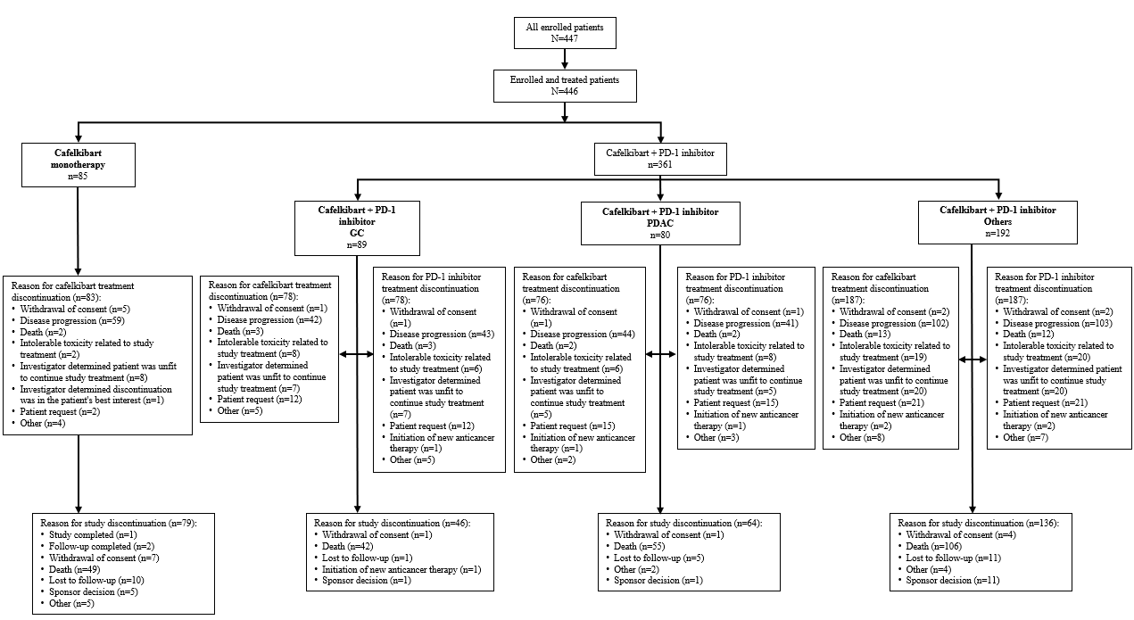GC, gastric cancer; PD-1, programmed cell death protein 1; PDAC, pancreatic ductal adenocarcinoma.
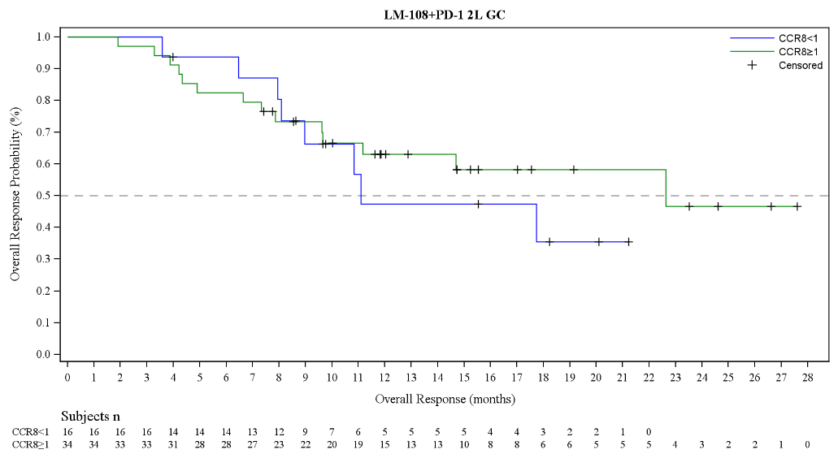
Supplementary Figure S2. Progression-free survival and overall survival in biomarker-defined subpopulations in patients with GC and PDAC receiving second-line cafelkibart (10 mg/kg) plus a PD-1 inhibitor.
B Cafelkibart + PD-1 inhibitor in 2L GC
A Cafelkibart + PD-1 inhibitor in 2L GC
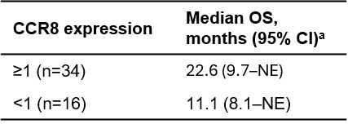
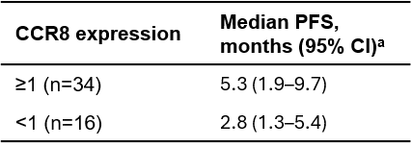
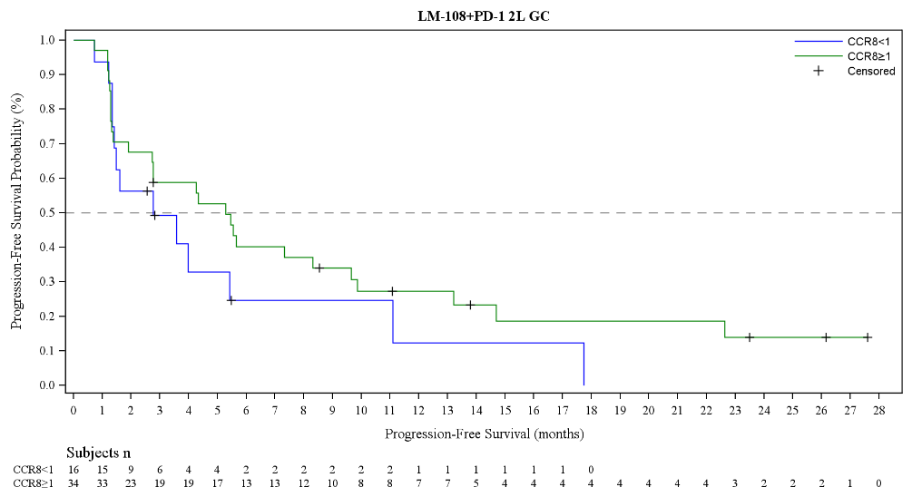

Progression-free Survival (months)

Patients, n

Overall Survival (months)
Patients, n
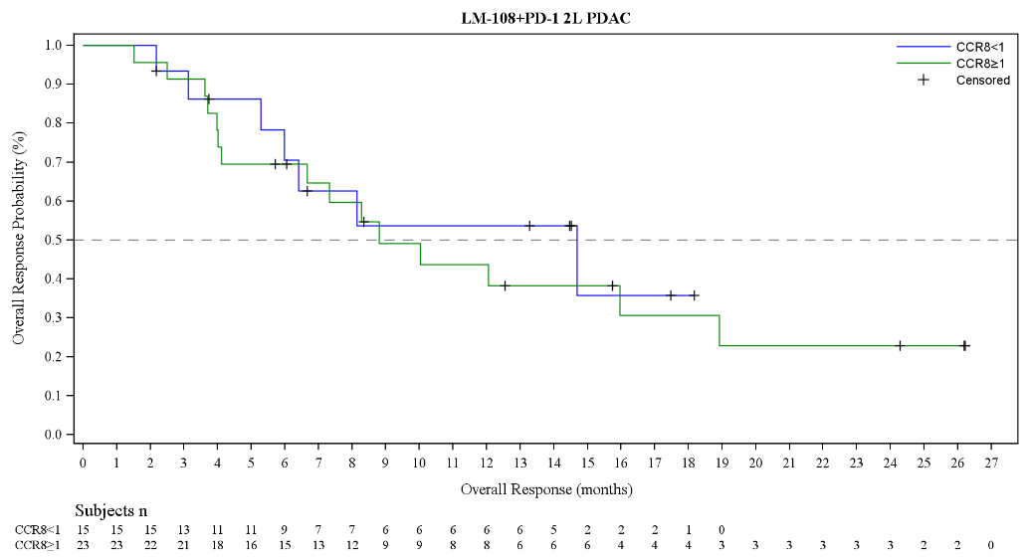
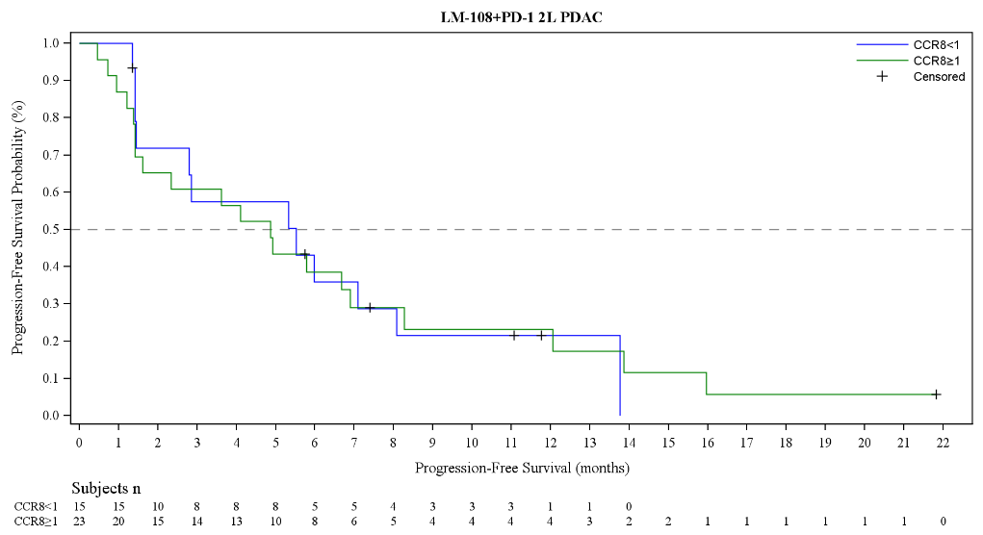
D Cafelkibart + PD-1 inhibitor in 2L PDAC
C Cafelkibart + PD-1 inhibitor in 2L PDAC
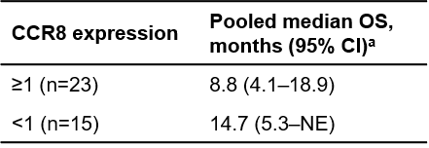
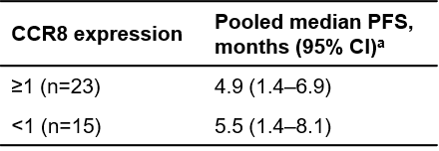

Progression-free Survival (months)

Patients, n
Patients, n
Overall Survival (months)

ª Efficacy outcomes for 10 mg/kg Q3W + anti-PD-1 Q3W.
2L, second line; CCR8, C-C motif chemokine receptor 8; CI, confidence interval; GC, gastric cancer; OS, overall survival; PD-1, programmed cell death protein 1; PDAC, pancreatic ductal adenocarcinoma; PFS, progression-free survival.
Supplementary Figure S3. Waterfall plot of cafelkibart monotherapy in patients with PDAC, stratified by CCR8 expression (<1 and ≥1).
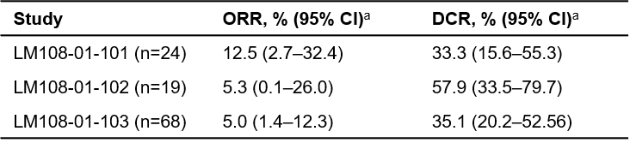
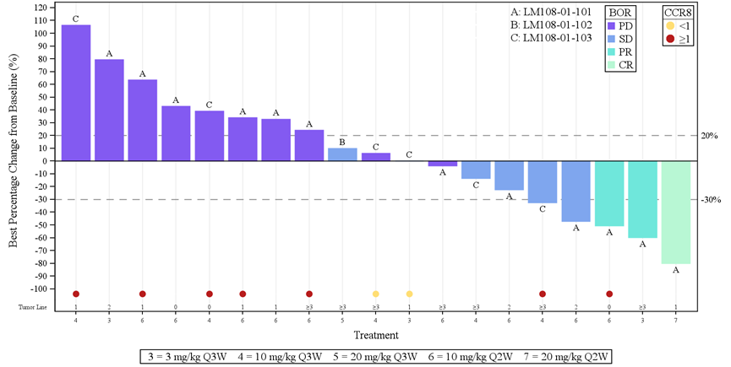

ª Efficacy outcomes for 10 mg/kg Q3W + anti-PD-1 Q3W.
BOR, best overall response; CCR8, C-C motif chemokine receptor 8; CI, confidence interval; CR, complete response; DCR, disease control rate; ORR, objective response rate; PD, progressive disease; PDAC, pancreatic ductal adenocarcinoma; PR, partial response; Q2W, every 2 weeks; Q3W, every 3 weeks.

Supplementary Figure S4. Representative CCR8 immunohistochemistry images.
GC CCR8 high (C01122, 21680399C, PS=2.53)
PDAC CCR8 high (C09012, 21680185C, PS=3.14)
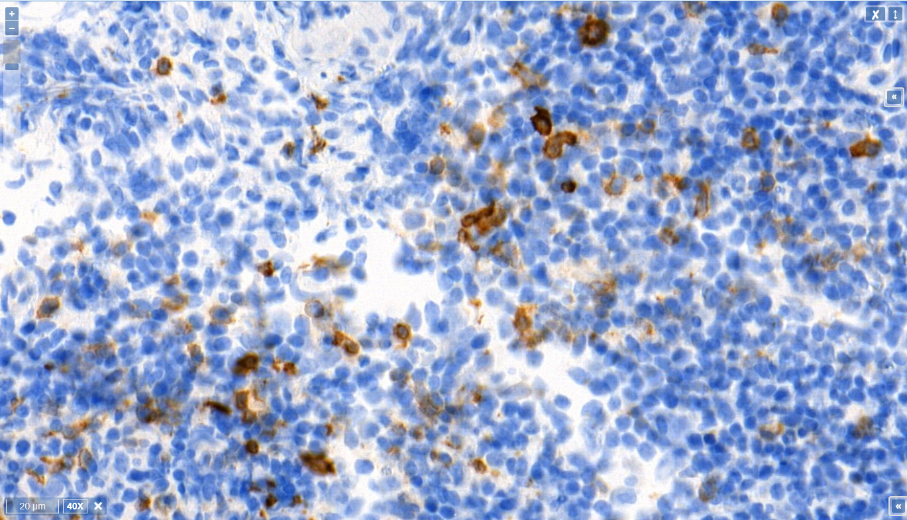
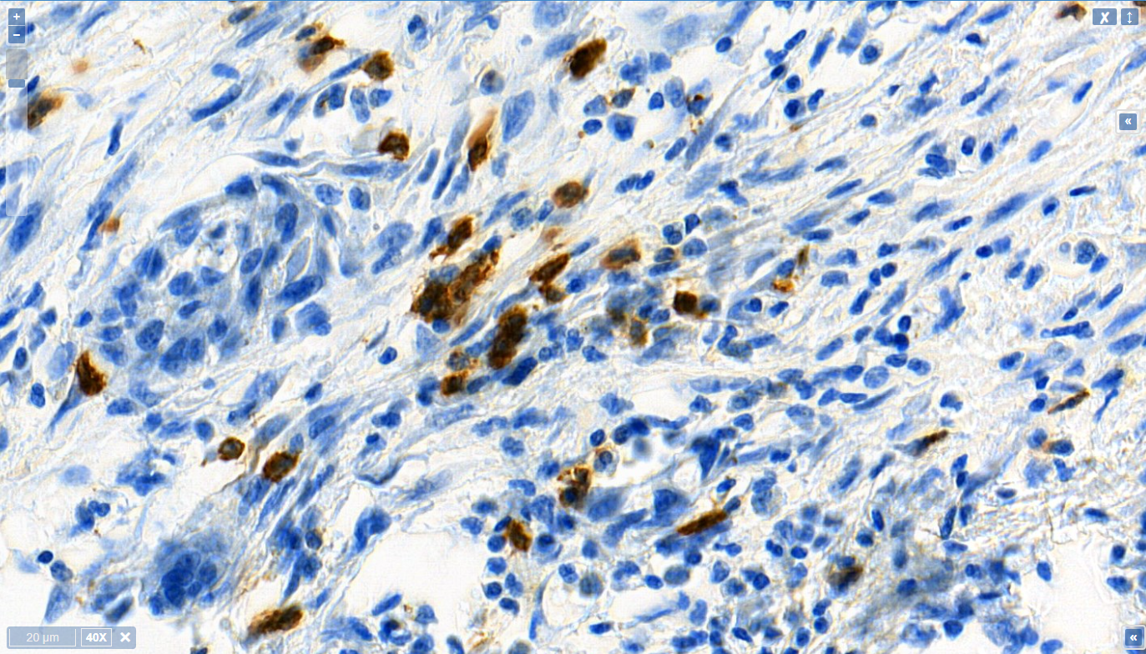

PDAC CCR8 low (C01064, 21680233C, PS=0.23)
GC CCR8 low (C11049, 21680323C, PS=0.26)
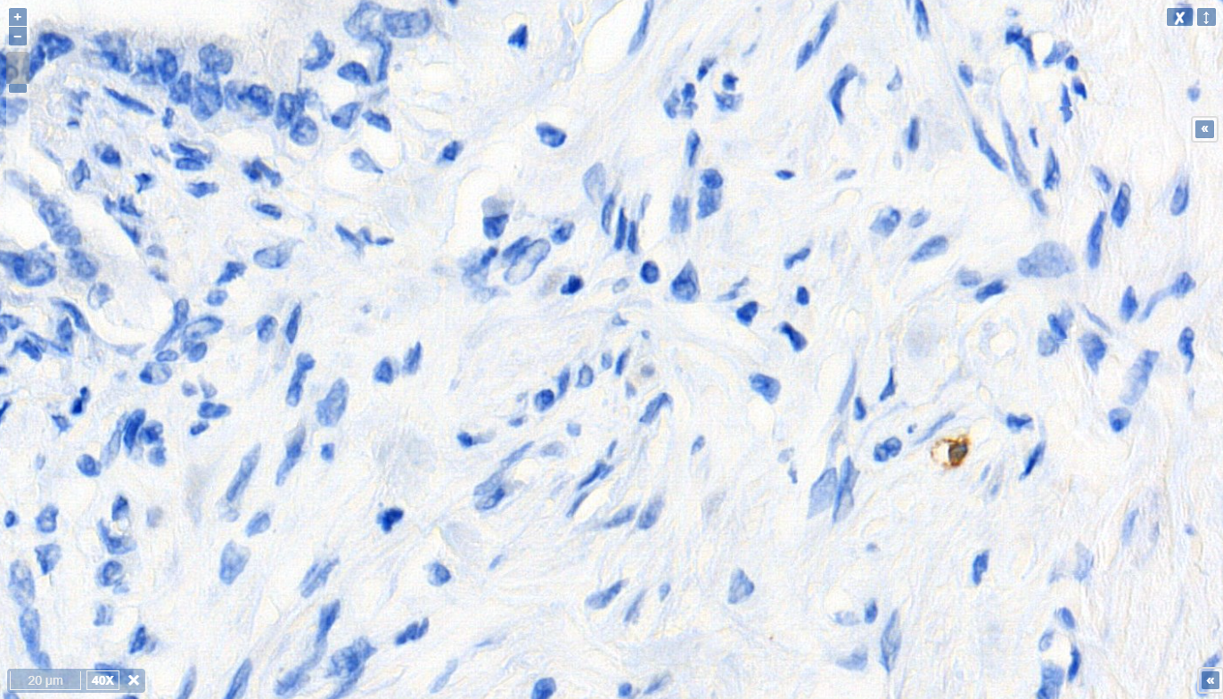
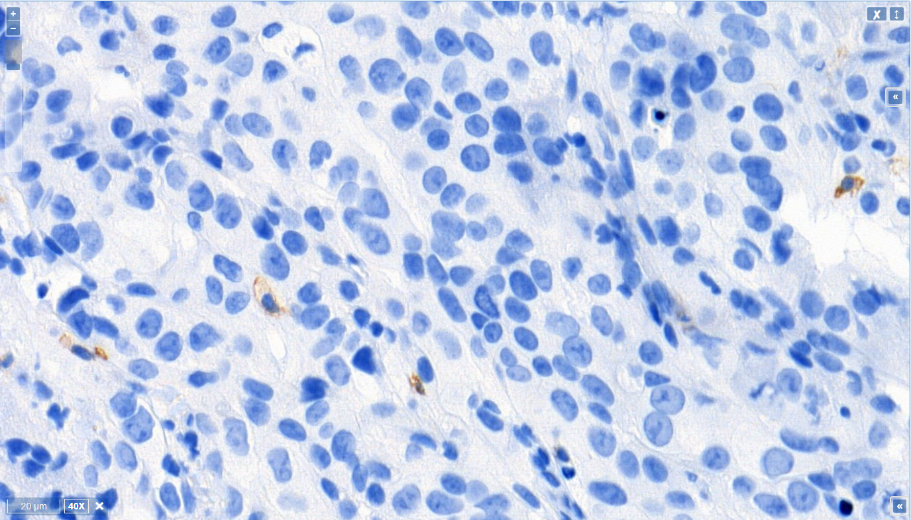

CCR8, C-C motif chemokine receptor 8; GC, gastric cancer; PDAC, pancreatic ductal adenocarcinoma; PS, pathology score.

