Supplementary Information
Intact metal/metal halide van der Waals junction enables reliable memristive switching with high endurance

Joo-Hong Lee^{1,†}, June-Mo Yang^{2,†}, So-Yeon Kim², Sungpyo Baek¹, Sungjoo Lee¹, Sung-Joon Lee^{3,}*, Nam-Gyu Park^{2,}*, Jin-Wook Lee^{1,}*
¹SKKU Advanced Institute of Nanotechnology (SAINT) and Department of Nanoengineering, Sungkyunkwan University, Suwon 16419, Republic of Korea.
²School of Chemical Engineering, Sungkyunkwan University, Suwon 16419, Republic of Korea.
³U.S. Naval Research Laboratory, Washington, DC 20375, United States.
†These authors contributed equally to this work.

*Corresponding authors:
S.-J.L. email: sungjoon.lee.ctr.ks@nrl.navy.mil
N.-G.P. email: npark@skku.edu
J-W.L. email: jw.lee@skku.edu

This supplement contains
Supplementary Figures 1-14
Supplementary Tables 1-4

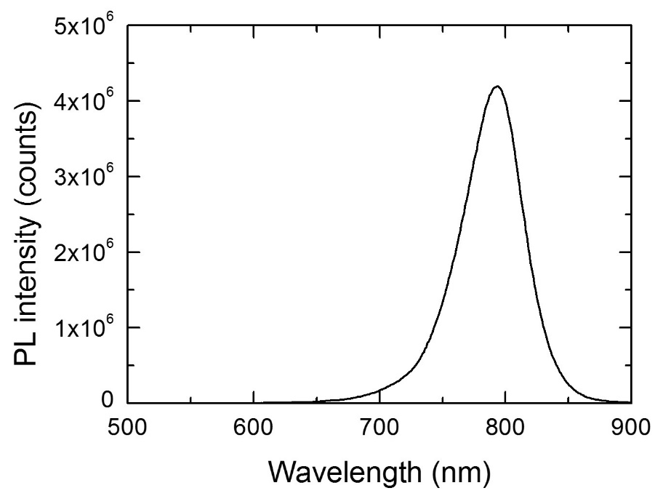
Supplementary Fig. 1 | Photoluminescence emission spectra of FAPbI₃ film annealed at 110 ℃ for 10 min.
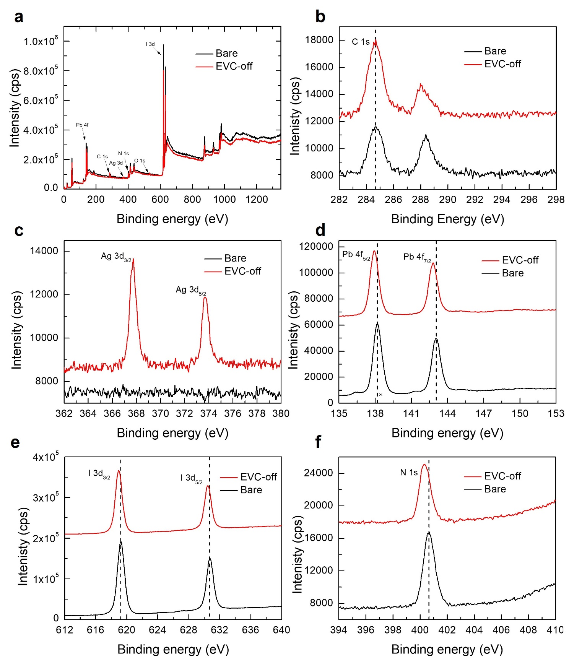
Supplementary Fig. 2 | a-f, X-ray photoelectron spectroscopy (XPS) data of bare FAPbI₃ film and the film after peeling off the EVC. Wide range XPS (a) and high resolution XPS spectra of C 1s (b), Ag 3d (c), Pb 4f (d), I 3d (e), and N 1s (f).
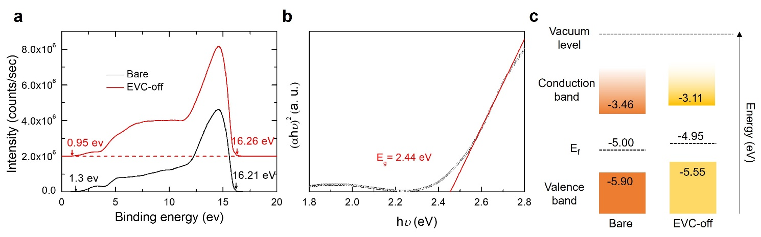
Supplementary Fig. 3 | a, Ultraviolet photoelectron spectroscopy (UPS) data of the bare δ-FAPbI₃ film and the film after peeling off the EVC (EVC-off). b, A Tauc plot of the δ-FAPbI₃ film. c, Energy band structure of the bare δ-FAPbI₃ film and EVC-off film determined from the UPS data.

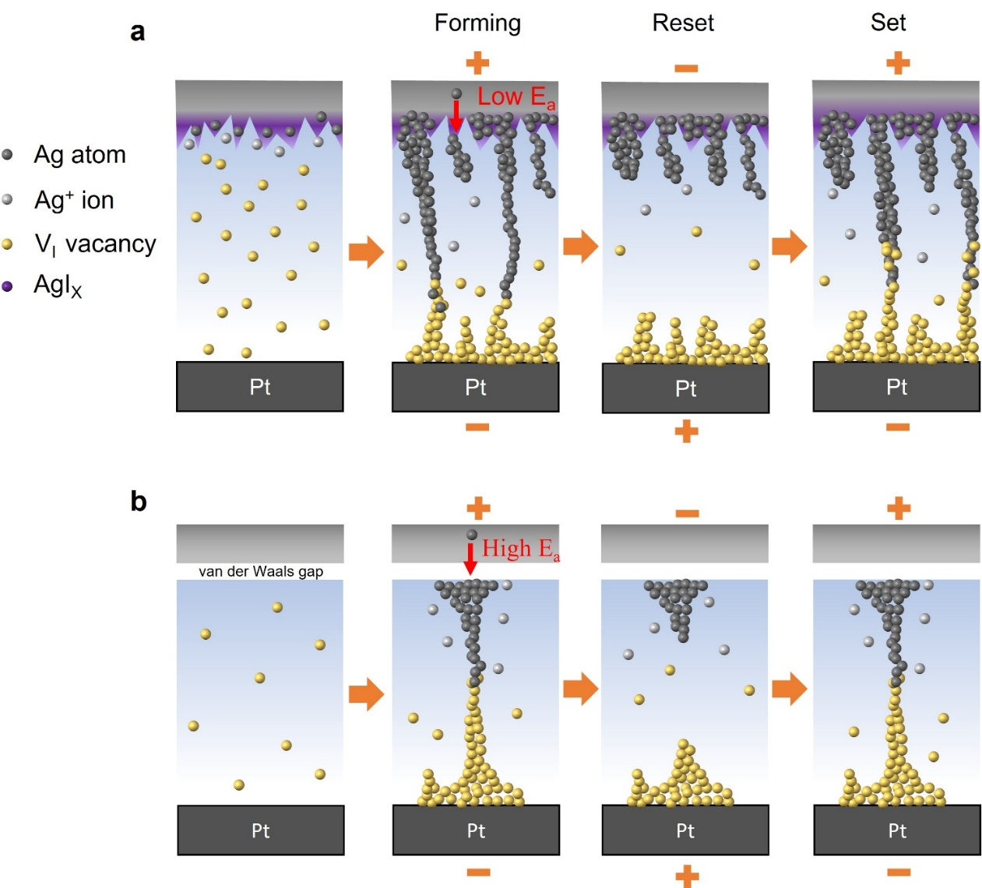
Supplementary Fig. 4 | a,b, Schematics of switching mechanism in the memristors based on EVC (a) and vdWC (b).
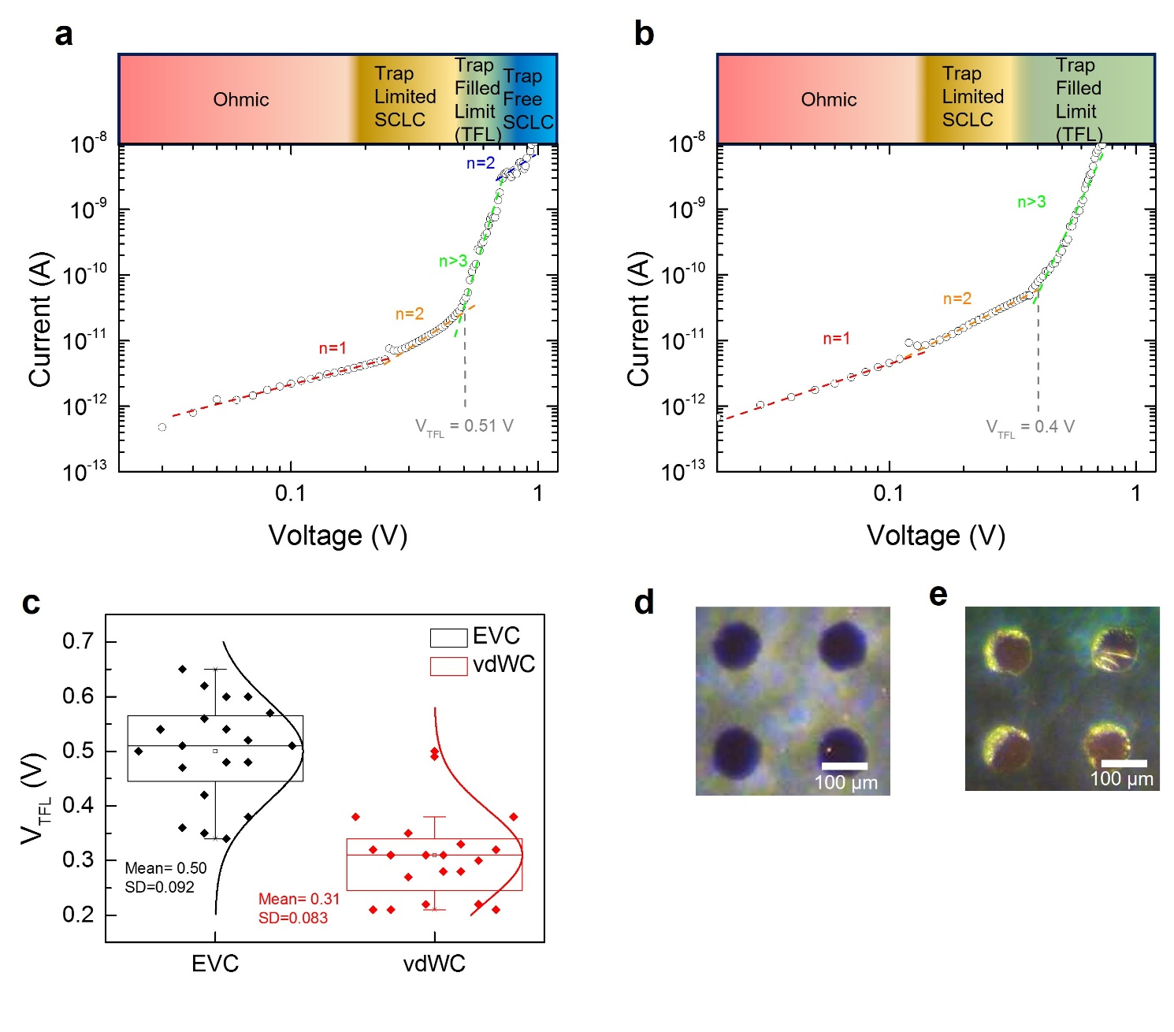
Supplementary Fig. 5 | a,b, Space charge limited current measurement of the devices with the ITO/FAPbI₃/Au structure based on EVC (a) and vdWC (b). c, A Box plot of the trap filling voltage (V_{TFL}) extracted from 20 different cells for each condition. d,e, Optical microscopy images of the Au EVC (d) and vdWC (e).
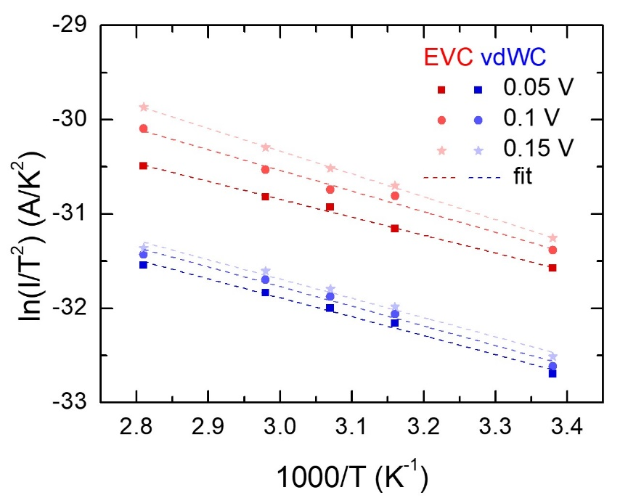
Supplementary Fig. 6 | A ln(I/T²)-1000/T plot of FAPbI₃ memristors based on EVC and vdWC in HRS region with different applied voltage. Filled symbols are measured data and dashed lines are linear fitting of the data.

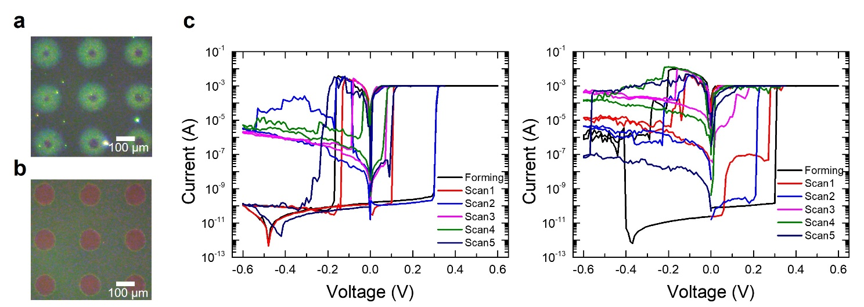
Supplementary Fig. 7 | a,b, Optical microscopy images of the EVC devices on different substrates in a same batch. The devices with intensive reaction between the EVC and FAPbI₃ (a). and the devices with the relatively less reaction (b). c, The I-V characteristics of the intensely reacted EVC devices.
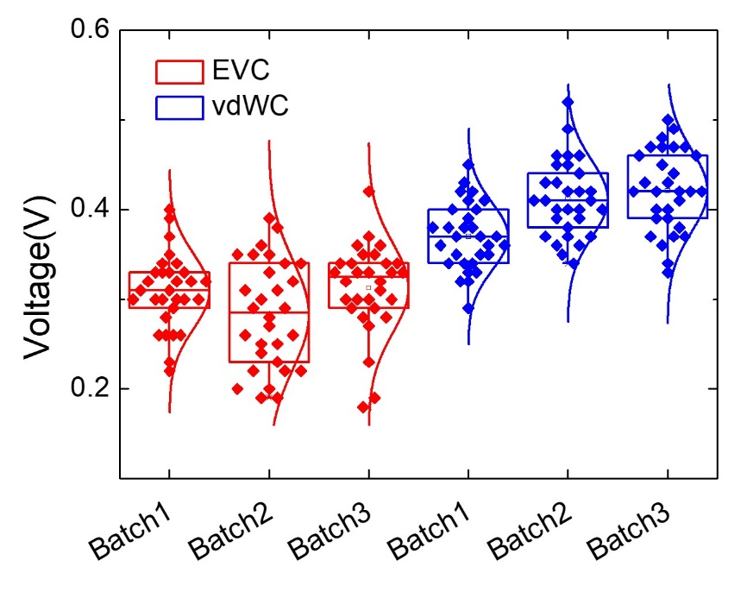
Supplementary Fig. 8 | Box plot of the forming voltages obtained from 30 different devices in 3 different batches based on the EVC and vdWC.

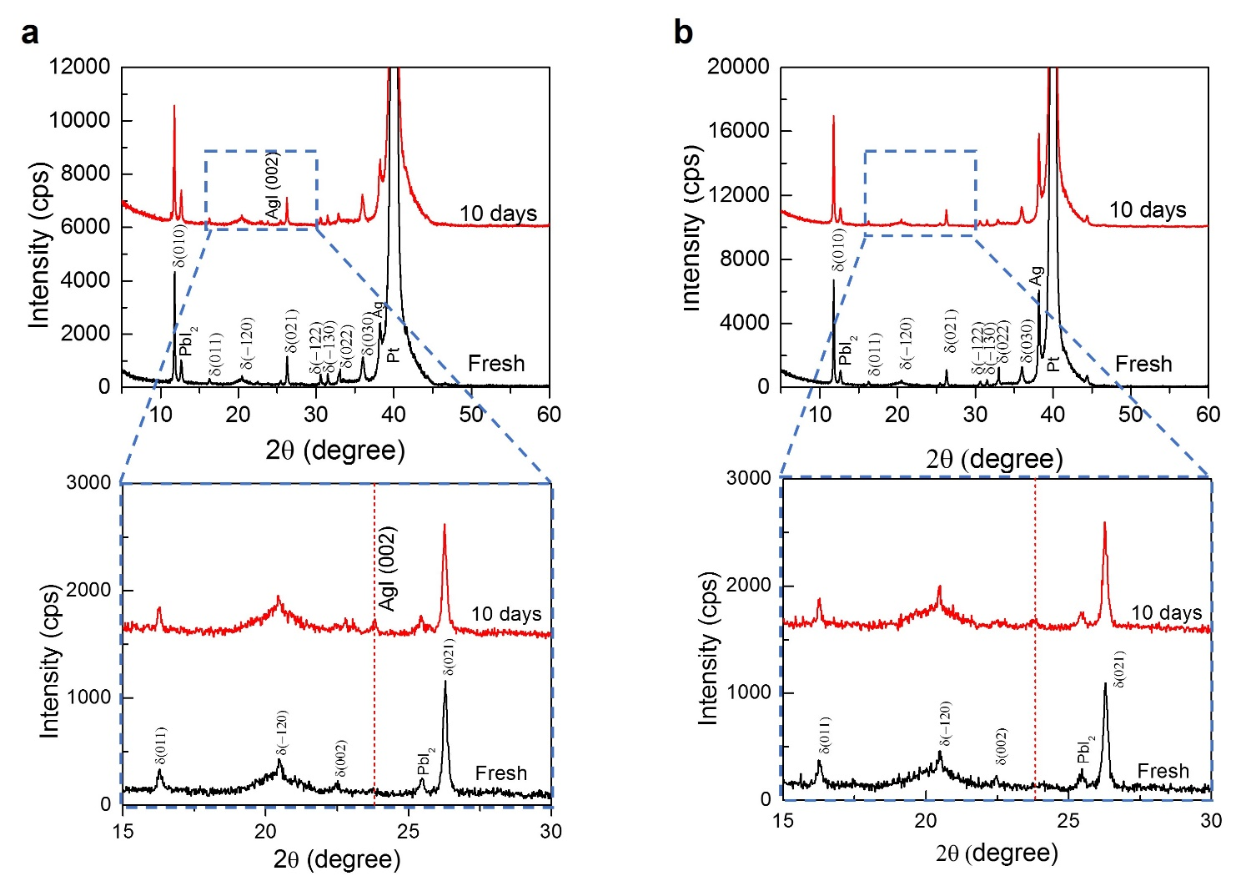
Supplementary Fig. 9 | a,b, X-ray diffraction patterns of fresh and aged (10 days) FAPbI₃ memristors based on EVC (a) and vdWC (b).
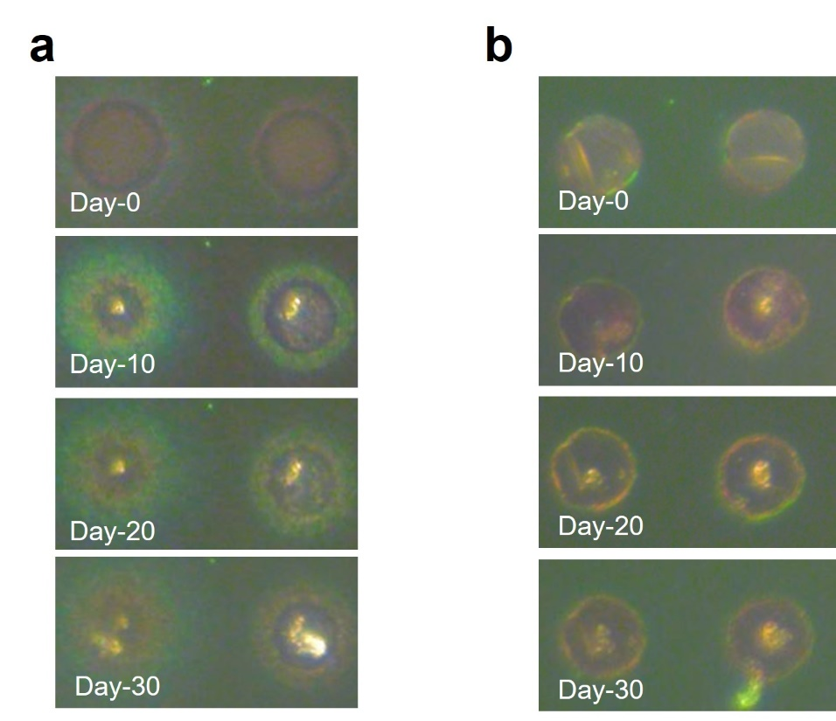
Supplementary Fig. 10 | a,b, Optical microscopy images of FAPbI₃ memristors based on EVC (a) and vdWC (b) with different aging times.

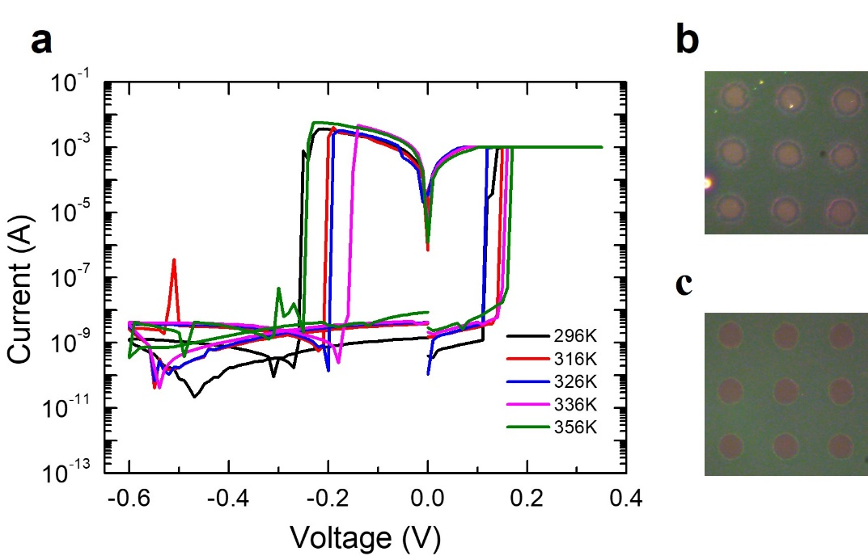
Supplementary Fig. 11 | a, Current-voltage (I-V) characteristics of the EVC device with relatively less reaction between the EVC and FAPbI₃ layer measured at various temperature from 296 K to 356 K. Optical microscopy images of different spots in a single substrate. b,c, Optical microscopy images of thermally unstable devices (b) and stable devices (c).
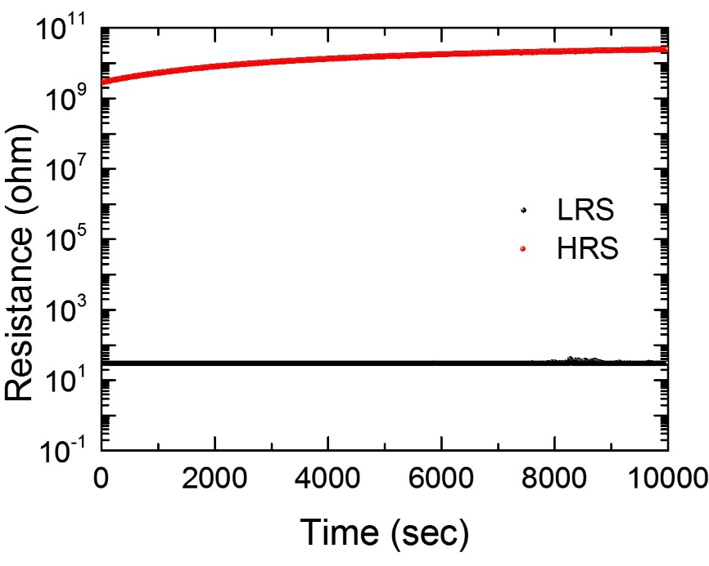
Supplementary Fig. 12 | The retention measurement of the FAPbI₃ memristors based on vdWC.

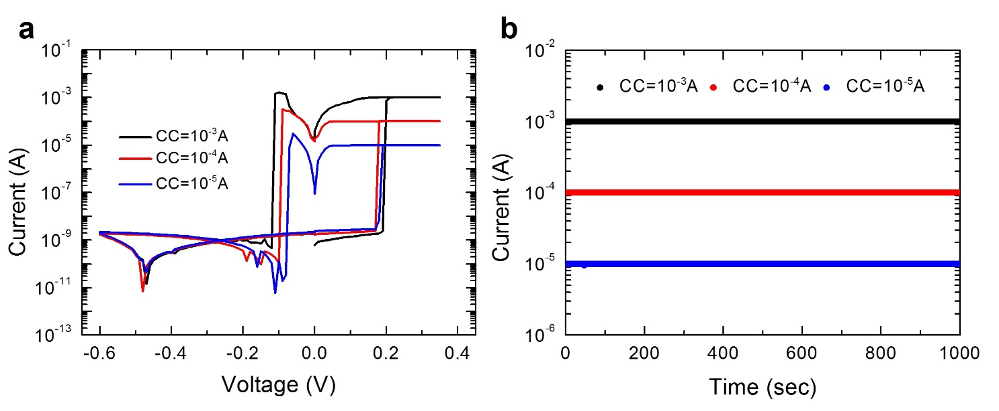
Supplementary Fig. 13 | Multi-level switching ability of FAPbI₃ memristor based on vdWC measured by changing the compliance current (CC). a, Current-voltage (I-V) characteristics of the device. b, Retention property of the multi-level storage capability with corresponding CC.

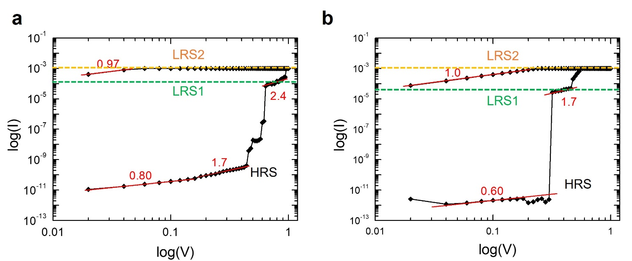
Supplementary Fig. 14 | a,b, log(I)-log(V) plot with linear fitting lines for the forming scan of Cs₃Cu₂I₅ memristors based on EVC (a) and vdWC (b).

Supplementary Table 1 | Statistical parameters of the operating voltage measured from 350 cells in the same batch
Condition | Voltage | Mean(V) | Median(V) | Max(V) | Min(V) | Std(V)
EVC | Forming | 0.27 | 0.26 | 0.42 | 0.17 | 0.051
EVC | Set | 0.19 | 0.19 | 0.34 | 0.10 | 0.050
EVC | Reset | -0.20 | -0.20 | -0.080 | -0.45 | 0.060
vdWC | Forming | 0.36 | 0.37 | 0.54 | 0.21 | 0.049
vdWC | Set | 0.16 | 0.15 | 0.29 | 0.10 | 0.036
vdWC | Reset | -0.23 | -0.24 | -0.090 | -0.38 | 0.060

Supplementary Table 2 | Statistical parameters of the forming voltage measured from 30 cells each in three different batches
Condition | Batch | Mean(V) | Median(V) | Max(V) | Min(V) | Std(V)
EVC | 1 | 0.31 | 0.31 | 0.40 | 0.22 | 0.041
EVC | 2 | 0.26 | 0.25 | 0.39 | 0.18 | 0.062
EVC | 3 | 0.31 | 0.33 | 0.42 | 0.18 | 0.049
vdWC | 1 | 0.37 | 0.37 | 0.45 | 0.29 | 0.036
vdWC | 2 | 0.41 | 0.41 | 0.52 | 0.34 | 0.041
vdWC | 3 | 0.42 | 0.42 | 0.5 | 0.33 | 0.045

Supplementary Table 3 | Statistical parameters of the set voltage measured from 30 cells each in three different batches
Condition | Batch | Mean(V) | Median(V) | Max(V) | Min(V) | Std(V)
EVC | 1 | 0.17 | 0.15 | 0.28 | 0.11 | 0.050
EVC | 2 | 0.16 | 0.16 | 0.28 | 0.07 | 0.052
EVC | 3 | 0.19 | 0.18 | 0.3 | 0.1 | 0.053
vdWC | 1 | 0.17 | 0.17 | 0.23 | 0.10 | 0.035
vdWC | 2 | 0.17 | 0.17 | 0.21 | 0.13 | 0.023
vdWC | 3 | 0.17 | 0.17 | 0.22 | 0.11 | 0.029

Supplementary Table 4 | Statistical parameters of the reset voltage measured from 30 cells each in three different batches
Condition | Batch | Mean(V) | Median(V) | Max(V) | Min(V) | Std(V)
EVC | 1 | -0.22 | -0.21 | -0.1 | -0.42 | 0.075
EVC | 2 | -0.24 | -0.24 | -0.08 | -0.38 | 0.067
EVC | 3 | -0.25 | -0.23 | -0.16 | -0.43 | 0.071
vdWC | 1 | -0.24 | -0.24 | -0.11 | -0.33 | 0.048
vdWC | 2 | -0.22 | -0.22 | -0.13 | -0.34 | 0.051
vdWC | 3 | -0.22 | -0.24 | -0.1 | -0.41 | 0.078

