Supplementary Information
Operando electrochemical spectroscopic ellipsometry:
Insights into electrochemical behavior of catalyst materials under realistic working conditions
René Sachse^{[a,b]}, Mario Sahre^{[a]}, Michael Bernicke^{[b]}, Denis Bernsmeier^{[b]}, Vasile-Dan Hodoroaba^{[a]}, Peter Strasser^{[b]}, Ralph Kraehnert* ^{[b]} and Andreas Hertwig* ^{[a]}
^{[a]} Federal Institute for Materials Research and Testing (BAM), Unter den Eichen 44-46, 12203 Berlin, Germany
^{[b]} Technische Universität Berlin, Faculty II Mathematics and Natural Sciences, Institute of Chemistry, Straße des 17. Juni 135, 10623 Berlin, Germany.

Corresponding Authors: *ralph.kraehnert@tu-berlin.de; *andreas.hertwig@bam.de

Keywords: operando spectroscopy, spectroscopic ellipsometry, oxygen evolution reaction, mesoporous iridium oxide films, platinum cyclic voltammetry

Table of content

Supplementary Information 1
SI1. Validation of the electrochemical behavior between a standard three electrode setup and the developed ECSE flow cell setup using bulk polycrystalline platinum 2
SI2. Ex-situ ellipsometric analysis and modeling of a bulk polycrystalline platinum surface 4
SI3. Developed ECSE flow cell setup 7
SI4. Dielectric function and optical constants of pure water / perchloric acid 9
SI5. Fit results and operando investigations of the dielectric functions of the Pt and PtO_{x} layer during cyclic voltammetry 10
SI6. X-ray reflectometry (XRR) measurements at different humidity conditions 12
SI7. Operando investigations of the mesoporous IrO_{x} film (375 °C) under OER conditions 13
SI8. Operando ECSE investigation of a non-conductive mesoporous titanium oxide film 16
SI9. Operando ECSE investigations of mesoporous IrO_{x} (375 °C) in the lower potential range 20
References 26

SI1. Validation of the electrochemical behavior between a standard three electrode setup and the developed ECSE flow cell setup using bulk polycrystalline platinum
Platinum is known for its highly reproducible characteristic cyclic voltammogram and is most likely the best known of all electrode materials.¹ Platinum surfaces have been intensively studied and the processes that contribute to the characteristic shape result from the formation and reduction of hydrogen and oxygen top layers. For the understanding of ellipsometric analysis in electrochemical investigations, cyclic voltammetry on a bulk polycrystalline platinum surface is used as a sensitive method to study the change in the measured Ψ and Δ spectra.
Typical platinum cyclic voltammograms recorded in a standard three-electrode setup (a) as well as in the flow cell setup (b) with a platinum wire as counter electrode and an Ag/AgCl reference electrode (3M NaCl, referred to RHE) are shown in Supplementary figure S1.1. In both setups, 0.1M HClO₄ served as electrolyte and a scan rate of 100 mV s⁻¹ was applied.
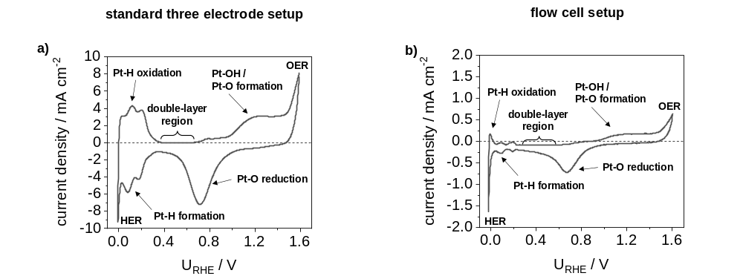
Supplementary figure S1.1: Cyclic voltammograms of platinum recorded in a standard three electrode setup (a) as well as in the developed flow cell setup (b) in a potential range between -0.28 V and 1.35 V against an Ag/AgCl reference electrode (+0.256 V vs. RHE at pH 1) in N₂-purged 0.1M HClO₄ and a scan rate of 100 mV s⁻¹. A platinum wire served as counter electrode and both CVs are corrected for ohmic losses (iR correction).
In the potential window of about 0.4 V_{RHE} to 0.6 V_{RHE}, a low current density (close to zero) is observed, which indicates the charging of the electrocatalytic double-layer (Supplementary figure S1.1a and b). In the forward scan to higher potentials, oxygen chemisorption occurs according to the following equations:
$$Pt+{OH}^{-}⟶Pt\text{-}OH+e^{-} \left(\sim 0.6 V_{RHE}\right)$$ | (I)
$$2 Pt\text{-}OH⟶Pt\text{-}O+H_{2}O \left(\sim 0.8 V_{RHE}\right)$$ | (II)

The oxygen evolution reaction (OER) starts at about 1.6 V_{RHE}. In the reverse scan, the oxygen layer is reduced and after a small double layer region the adsorption of hydrogen occurs as described as follows:
$$Pt+H_{2}O⟶Pt\text{-}H+{OH}^{-} \left(\sim 0.35 V_{RHE}\right)$$ | (III)
In case of strong negative potentials, the hydrogen evolution reaction (HER) takes place and hydrogen is formed.
The measured Pt CV in the standard three-electrode configuration (Supplementary figure S1.1a) illustrates the described processes of the Pt-H formation and oxidation, the double-layer region as well as the Pt-O formation and reduction contributing to the characteristic shape. The measurement in the flow cell setup (Supplementary figure S1.1b) exhibits the same characteristic processes and shape, with slightly lower signal intensity (current density response).

SI2. Ex-situ ellipsometric analysis and modeling of a bulk polycrystalline platinum surface
Polished bulk polycrystalline Pt was analyzed using a SE model consisting of two layers, metallic platinum (Pt) as substrate and an overlying oxide layer (PtOx) as an assumption of a partially oxidized surface. Here, the Pt substrate layer was parametrized with a model containing one Drude type (equation (1) and (2)) and two Lorentz type oscillators (equation (3)). The PtOx layer was modeled by a single Tauc-Lorentz oscillator (equation (4) and (5)) due to the semiconducting nature of this material. Supplementary figure S2.1 presents a) the fit results b) the real 𝜀1 and imaginary 𝜀2 part of the Pt substrate layer, and c) 𝜀1 and 𝜀2 of the PtOx layer.
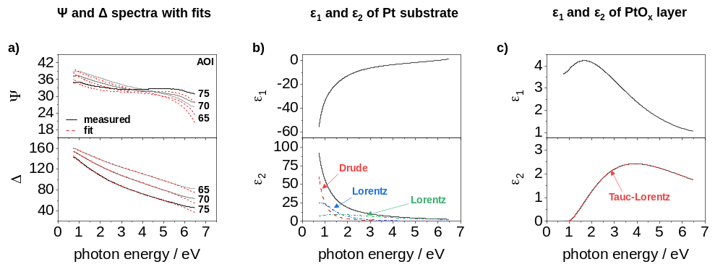
Supplementary figure S2.1: Ex-situ SE characterization of bulk platinum using a two-layer model consisting of a Pt substrate and a PtO_{x} top layer. a) $Ψ$ and $Δ$ spectra with their fit results of SE measurement. b) real $ε_{1}$ and imaginary $ε_{2}$ part of the Pt substrate layer, modeled using a summation of a Drude type and two Lorentz type oscillators. c) $ε_{1}$ and $ε_{2}$ of the PtO_{x} layer, modeled with a single Tauc-Lorentz oscillator.
Supplementary figure S2.1a shows the fit results of the ex-situ SE analysis using AOIs of 65°, 70° and 75°. The modeled spectra (dashed red lines) agree well with the measured data (grey to black lines) and only in the high photon energy region around 6 eV some large deviations are obtained.
The imaginary $ε_{2}$ part of the dielectric function of the Pt layer is dominated by the typical edge of conductive materials in the low photon energy range, which can be modeled by a Drude function (Supplementary figure S2.1b). In addition, two absorption peaks at about 1.0 eV and 3.3 eV can be observed, which can each be modeled with a Lorentz function. In the real $ε_{1}$ part of the dielectric function a slight decrease and from about 1.5 eV a strong decrease towards lower photon energies can be observed. Similar results were obtained in the literature for Pt from spectroscopic ellipsometric and reflectometric measurements using comparable parametrization models.²⁻⁵

For the parameterization of the PtO_{x} layer using a single Tauc-Lorentz oscillator (Supplementary figure S2.1c), a bandgap energy of 0.9 eV and a peak energy of 4.8 eV were assumed, according to the parametrization model of PtO₂ described by Knoops et al.² For the fitting, only the width and height of the Tauc-Lorentz oscillator were adjusted. The $ε_{2}$ spectrum shows a broad absorption peak, where $ε_{2}$ becomes zero at 0.9 eV. The $ε_{1}$ spectrum shows a peak at about 1.8 eV. The PtO_{x} spectra are also in good agreement with magnetron-sputtered platinum oxide films and PtO_{x} layers using remote plasma ALD reported in literature.^{2, 6}
As a result of the modeling of the bulk Pt material, the resistivity at the surface (Pt/PtO_{x}/air interface) and the layer thickness of PtO_{x} were obtained. The derived resistivity of the Pt surface amounts to 1.20 ∙ 10⁻⁵ Ohm cm, which is close to the bulk Pt value of 1.08 ∙ 10⁻⁵ Ohm cm reported in literature.² Possible reasons for the difference in conductivity may be the influence of the oxide layer on the metal captured due to the proximity to the surface of the ellipsometric measurement or differences in the microscopic metal structure between samples.
A PtOx layer thickness of about 0.33 ± 0.26 nm was derived from the model. The PtOx layer thickness indicates a high deviation, however ellipsometry is a highly surface sensitive technique even for (sub)monolayers and the thickness precision corresponds to 𝛿𝑑 = 0.1 Å.⁷⁻¹¹ For comparison of the accuracy of SE-derived film thicknesses, Erbe and co-workers reported on in-situ SE studies on the growth of a native oxide layer on zinc in different atmospheres and revealed a change of the layer thickness from about 0 nm to 1.1 nm with a growth rate of about 0.01 nm h⁻¹.¹²
The ex-situ characterization using SE leads to similar and comparable results of Pt and PtOx as described in the literature. The electrochemical investigation of the platinum surface with the developed flow cell setup shows a reasonable behavior compared to a standard three-electrode setup. These results serve as a starting point for the operando ECSE investigation.

Modelling functions:
- Drude function: The Drude function is applicable to free electron effects and was proposed by Paul Drude to describe transport properties of electrons in materials, especially metals.^{13, 14} In case of a semiconducting material, the absorption can be explained by electron transitions from the valence in the conduction band.¹⁵ The Drude model can be described with the resistivity $ρ_{R}$ and the mean scattering time $τ$ and is expressed by the following equation:
 | $$ε_{Drude}\left(E\right)=\frac{{-ℏ}^{2}}{ε_{0} ρ_{R} \left(τ E^{2}+i ℏ E\right)}$$ | (1)
with
 | $$ρ_{R}=\frac{m^{*}}{N q^{2} τ}=\frac{1}{q μ N}$$ | (2)
where $E$ is the photon energy ($E=hν=ħω$), $ℏ$ the reduced Planck constant, $ε_{0}$ the vacuum dielectric constant, $ρ_{R}$ the resistivity (Ohm cm), $τ$ the mean scattering time (fs), $m^{*}$ the electron effective mass (9.11 ∙ 10⁻³¹ kg), $N$ the free carrier concentration (cm⁻³), $q$ the electron charge (1.60 ∙ 10⁻¹⁹ C) and $μ$ the free carrier mobility (cm² V⁻¹ s⁻¹).¹⁶ Fit parameters for the Drude model are the resistivity $ρ_{R}$ and the mean scattering time $τ$.
- Lorentz function: The Lorentz function is based on the interaction between light and matter and is applicable to atomic transitions with homogeneous line broadening. This line broadening can be described in the classical approach by a harmonic oscillator in which an excited electron is damped by energy radiation.^{7, 17} The model can be used for frequency-dependent polarizations due to bound charge and can describe a direct interband transition. The Lorentz function is expressed as follows:
 | $$ε_{{Lorentz}_{n}}\left(E\right)=\frac{{Amp}_{n} Γ_{n} {En}_{n}}{{En}_{n}^{2}-E^{2}-i E Γ_{n}}$$ | (3)
with ${Amp}_{n}$ as the amplitude of the n^{th} oscillator (unitless), $Γ_{n}$ width (full width at half-maximum) of the n^{th} oscillator (eV) and ${En}_{n}$ the center energy of n^{th} oscillator (eV).¹⁸ The fit parameters of the Lorentz parametrization are the amplitude ${Amp}_{n}$, the width $Γ_{n}$ and the center energy ${En}_{n}$.

- Tauc-Lorentz function: The Tauc-Lorentz function is used to describe the optical properties of amorphous semiconductors near the band edge.¹⁹ For this purpose, the Lorentz oscillator is modified to consider the absorption near the band edge separately and is described in detail by G. E. Jellison Jr. and F. A. Modine.^{20, 21} The Tauc-Lorentz function can express as follows:
 | $$ε_{{T-L}_{n}}\left(E\right)=\frac{{Amp}_{n} {En}_{n} Γ_{n} {\left(E-E_{g}\right)}^{2}}{\left(E^{2}-{En}_{n}^{2}\right)+Γ_{n}^{2} E^{2}}∙\frac{1}{E} ; E≥E_{g}$$ | (4)
 | $$ε_{{T-L}_{n}}\left(E\right)=0 ; E≤E_{g}$$ | (5)
where ${Amp}_{n}$ is the amplitude of the n^{th} oscillator (eV), ${En}_{n}$the center energy of n^{th} oscillator (eV), $Γ_{n}$ the width (full width at half-maximum) of the n^{th} oscillator (eV) and $E_{g}$ the band-gap energy (eV). Fit parameters of the Tauc-Lorentz parametrization are the amplitude ${Amp}_{n}$, the width $Γ_{n}$, the center energy ${En}_{n}$.and the band-gap energy $E_{g}$.

SI3. Developed ECSE flow cell setup
For operando ECSE investigations a respective flow cell was developed. ECSE measurements were performed by mounting the flow cell on the mesoporous iridium oxide films on titanium substrates and fitted the setup into the spectroscopic ellipsometer (M2000 DI). The flow cell consists of polyether ether ketone (PEEK) and is attached to the catalyst film by means of a sealing ring (Viton® FKM, 22 x 1 mm; IR Dichtungstechnik). In addition, two uncoated quartz windows (12.5 x 2.0 mm, refractive index $n_{d}$ = 1.458, surface flatness: 1λ; Edmund Optics Inc) were each attached to the cell with two (in front and behind the window) sealing rings (Viton® FKM, 9.25 x 1.78 mm; IR Dichtungstechnik). For electrical conduction, a single side copper printed circuit board (conductive plate) was mounted under the titanium substrate. An Ag/AgCl reference electrode and a Pt wire as counter electrode were connected to the flow cell, while the mesoporous iridium oxide films on titanium substrates served as working electrode (1.473 cm²). N₂ purged 0.1M HClO₄ (Merck, 60%, 1.53 g cm⁻³) was used as electrolyte, which circulated through the cell with a flow rate of 85 ml min⁻¹ by using a peristaltic pump (Ismatec MCP Standard). Spectroscopic ellipsometry measurements were carried out in a spectral range between 1.1 eV and 6.4 eV (193 nm and 1127 nm) at an angle of incidence of 70° using the software CompleteEASE (v. 6.42). The acquisition time for each spectrum amounts to 0.978 s. The electrochemical measurements were performed with a Gamry interface 1000 (IFC1000) and the Gamry Framework Data Acquisition software (v. 7.07). Supplementary figure S3.1 illustrate the complete ECSE setup in detail.
Supplementary figure S3.1: Illustration of the developed electrochemical spectroscopic ellipsometry setup used for operando investigations. Mesoporous IrO_{x} films on Ti substrates served as working electrode and a Pt wire as counter electrode. All potentials were measured against an Ag/AgCl electrode, which was referred to an RHE (+0.256 V vs. RHE at pH 1) and corrected for ohmic losses. 0.1M HClO₄ served as electrolyte with a flow rate of 85 ml min⁻¹ via a peristaltic pump. Spectroscopic ellipsometry was performed in a spectra range between 1.1 eV and 6.4 eV (193 nm and 1127 nm) at an angle of incidence of 70°.

Prior to ECSE studies on mesoporous catalyst films, a silicon wafer with a known oxide thickness was analyzed for the quartz window correction. Afterwards, the N₂ purged electrolyte was analyzed using a model consists on the silicon wafer with known oxide thickness as substrate and a Sellmeier dispersion layer for the electrolyte, which is expressed as follows:
$$n={\left(ε\left(∞\right)+\frac{Amp λ^{2}}{λ^{2}-{En}^{2}}-E_{pole} λ^{2}\right)}^{1/2}$$ | (6)
where $ε\left(∞\right)$ is an index offset, $Amp$ the amplitude, $En$ the center energy, $λ$ the wavelength, and $E_{pole}$ the position of a pole in the infrared.²² Results and a comparison of the electrolyte analysis is described in SI 4.

SI4. Dielectric function and optical constants of pure water / perchloric acid
0.1M perchloric acid was analyzed using a silicon wafer with known oxide thickness after quartz window correction in the flow cell setup, in which the electrolyte flowed over the silicon wafers. The modeling was performed using a Sellmeier dispersion layer (equation (6)) and the obtained dielectric functions were used during ECSE analysis. The dielectric functions of 0.1M perchloric acid were determined before each measurement.
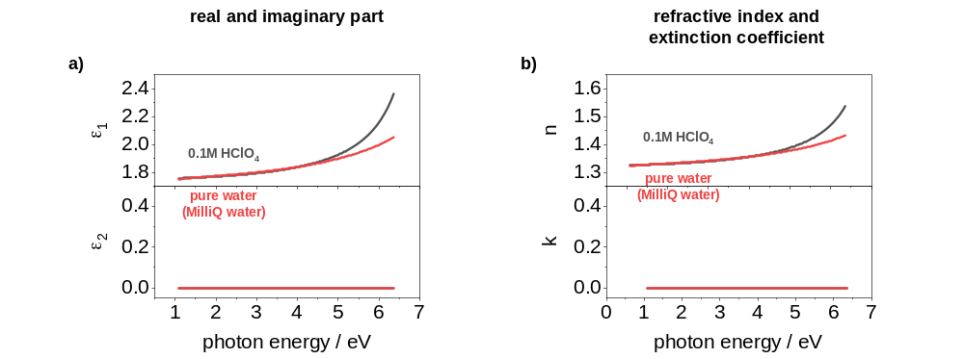
Supplementary figure S4.1: Spectroscopic ellipsometric analysis of 0.1M perchloric acid. Analysis was performed in the flow cell setup by using a silicon wafer with known oxide thickness. For comparison the dielectric functions and optical constants of pure water (MilliQ water) are displayed. a) dielectric functions of the 0.1M perchloric acid and pure water. b) optical constants of 0.1M perchloric acid and pure water.

SI5. Fit results and operando investigations of the dielectric functions of the Pt and PtO_{x} layer during cyclic voltammetry
Supplementary figure S5.1a displays the current density under operando conditions and
Supplementary figure S5.1b and c the spectra of Ψ and Δ (black lines) at selected photon energies of 2.0 eV, 3.0 eV and 5.0 eV with their fit results (red lines) against the acquisition time.
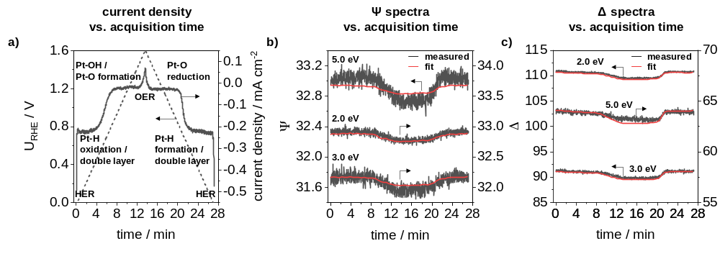
Supplementary figure S5.1: a) current density as a function of acquisition time under operando conditions with a scan rate of 2 mV s-1. b) 𝚿 values and c) 𝚫 values at photon energies of 2.0 eV, 3.0 eV and 5.0 eV as a function of acquisition time and fitting results of the model used.
Both spectra show noticeable changes during cyclic voltammetry, and the fit results are in good agreement with the measured spectra. In the HER regime and in the Pt-H oxidation range, small changes in the Ψ spectra are observed (0 min – 4 min) at higher photon energies (> 3 eV). After an acquisition time of about 8 min, Ψ and Δ slowly decrease until 12 min. This change corresponds to the plateau between the chemisorption (4 min – 8 min) and the beginning of the OER (at about 12 min) in the current density curve (Supplementary figure S5.1a). In this region, Pt-O formation occurs. In the OER regime (between 12 and 16 min) no further characteristic changes are observed. At about 18 min a rapid increase occurs, which is due to Pt-O reduction. The Pt-H formation and HER regime again show small changes only at higher photon energies in the Ψ spectra (24 min – 28 min).
From the results of the fitting of the bulk platinum during CV measurement, changes in the dielectric functions can be deduced, which provide information about band transitions. Supplementary figure S5.2 displays the spectra $ε_{1}$ (a) and $ε_{2}$ (b) of Pt and PtO_{x} at different potentials as a function of the photon energy, the $ε_{1}$ (c) and $ε_{2}$ (d) spectra of Pt, as well as the $ε_{1}$ (e) and $ε_{2}$ (f) spectra of PtO_{x} at a photon energy of 2.0 eV against the applied potential.
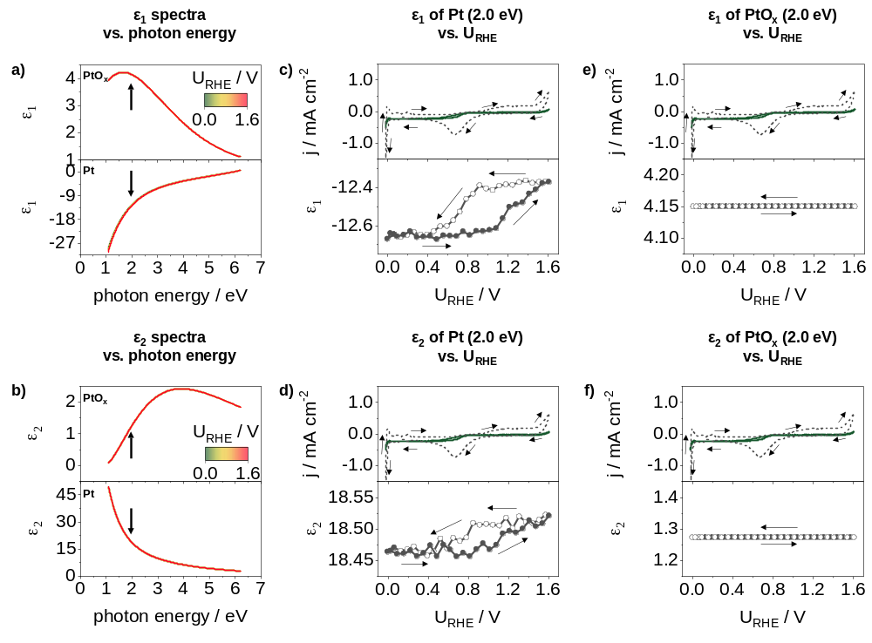
Supplementary figure S5.2: Dielectric functions of the Pt and PtO_{x} layer from the fitting results. Real $ε_{1}$ (a) and imaginary $ε_{2}$ (b) part of the dielectric function of Pt and PtO_{x} at different potentials as a function of photon energy. $ε_{1}$ (c) and $ε_{2}$ (d) of the Pt substrate and $ε_{1}$ (e) and $ε_{2}$ (f) of the PtO_{x} layer depending on the applied potential.
The $ε_{1}$ and $ε_{2}$ spectra of the Pt and PtO_{x} layer (Supplementary figure S5.2a, b) show slight changes in the low photon energy range for Pt and no visible changes for the PtO_{x} layer. For a better visualization, the $ε_{1}$ and $ε_{2}$ spectra of Pt (Supplementary figure S5.2c, d) and PtO_{x} (Supplementary figure S5.2e, f) were plotted against the potential exemplary at a photon energy of 2.0 eV. For the correlation of the spectra, the current density curves with scan rates of 100 mV s⁻¹ and 2 mV s⁻¹ are plotted. $ε_{1}$ of the Pt layer (Supplementary figure S5.2c) shows a roughly constant value between 0.0 V_{RHE} and 0.8 V_{RHE} for the scan to higher potentials (black circles). At about 0.8 V_{RHE}, $ε_{1}$ increases slightly to a potential of about 1.1 V_{RHE} and then increases more strongly to 1.6 V_{RHE}. In the back scan (white circles) an approximately constant behavior from 1.6 V_{RHE} to 0.9 V_{RHE} and a rapid decrease to a potential of about 0.4 V_{RHE} are observed, followed by a second constant behavior. A similar result can be also observed for the $ε_{2}$ spectra of the Pt layer (Supplementary figure S5.2d). In contrast, the dielectric functions ($ε_{1}$ and $ε_{2}$) of the PtO_{x} layer indicate no significant changes during the cyclic voltammetry measurement (Supplementary figure S5.2e, f).
The most significant changes in the dielectric functions during CV measurement occur for the Pt layer in the low photon energy region, indicating changes in the conductivity of the material at the Pt/PtO_{x}/electrolyte interface. The shape of these changes also suggests a relationship with the Pt oxidation/reduction mechanism described previously.

SI6. X-ray reflectometry (XRR) measurements at different humidity conditions
In order to investigate the influence of pore geometry and layer thickness in liquids, i.e. deformations due to swelling or capillary contractions, XRR was performed to determine the layer thickness at different humidity conditions.
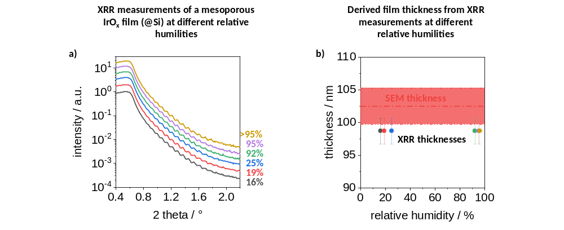
Supplementary figure S6.1: XRR measurements of mesoporous IrO_{x} films. a) XRR measurements at relative humidity values between 16% and approximately 100% of an IrO_{x} film calcined at 350 °C. b) derived film thicknesses from XRR measurements with a simple 3-layer model, consisting of a silicon substrate, a native oxide layer and an IrO₂ layer.
XRR relative humidity measurements (Supplementary figure S6.1a) were carried out by placing an attachment cell with X-ray windows consisting of a polyethylene film (amorphous, thickness nominally 4 µm) on the sample. Compressed air was mixed with water to set the desired humidity. After a constant humidity value, the air flow was introduced into the attachment cell with approx. 4-6 ml s⁻¹. Results of the XRR measurements of an IrO_{x} films calcined at 350 °C at different humidity conditions indicate defined Kiessig oscillations. The minima and maxima of these oscillations are identical for all measurements. By a simple layer modeling, consisting of a silicon substrate, a native oxide layer (2 nm) and an IrO₂ layer (literature values) the layer thickness of the individual measurements could be derived. As a result, the same layer thickness is obtained at all humidity values (Supplementary figure S6.1b).
In summary, the XRR measurements reveal that the layer thickness of the studied IrO_{x} films does not change at different humidity levels or in liquids, as is the case for instance of mesoporous silicon oxide films.²³

SI7. Operando investigations of the mesoporous IrO_{x} film (375 °C) under OER conditions
Supplementary figure S7.1 presents the cyclic voltammogram, recorded in a potential range of 1.20 V_{RHE} and 1.48 V_{RHE} with a scan rate of 1 mV s⁻¹ in N2-purged 0.1M HClO₄ and the corresponding ellipsometric quantities Ψ and Δ in a spectral range between 1.1 eV and 6.2 eV of the mesoporous IrO_{x} film calcined at 375 °C. The cyclovoltammetry measurement of the catalyst film (Supplementary figure S7.1a) shows a typical progress of the current response for a mesoporous IrO_{x} film reported in literature (see refs. 24, 25). The Ψ and Δ spectra display noticeable changes over the entire spectral range during the cyclovoltammetry measurement (Supplementary figure S7.1b).
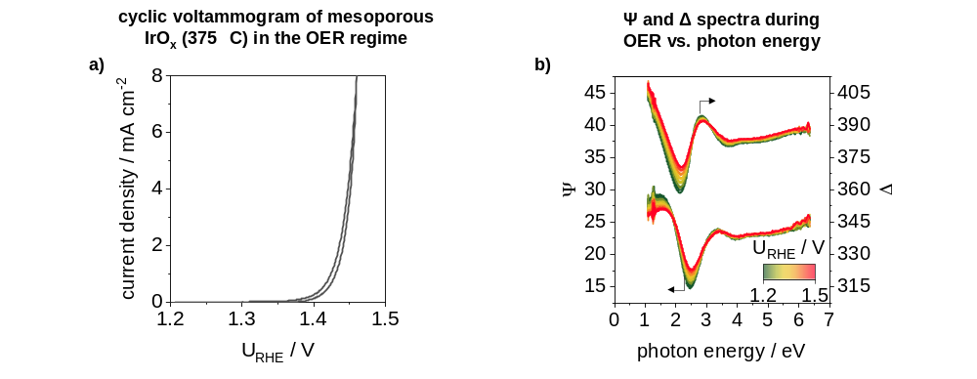
Supplementary figure S7.1: Operando ECSE investigations in the OER regime of the mesoporous IrO_{x} film calcined at 375 °C. a) cyclovoltammetry measurement in a potential range of 1.20 V_{RHE} and 1.48 V_{RHE} in N₂ purged 0.1M HClO₄ with a scan rate of 1 mV s⁻¹ and an electrolyte flow rate of 85 ml min⁻¹. Potentials were measured against an Ag/AgCl electrode, which referred to RHE (+0.256 V at pH 1). b) Ψ and Δ spectra measured during cyclic voltammetry.
The $ε_{1}$ and $ε_{2}$ spectra of the IrO_{x} material show changes over the entire spectral range in both cases (Supplementary figure S7.2a). This is based on the assumption that both the electrical properties and the interactions between Ir and O change during cyclovoltammetry. As described in Chapter 4.2, features in the $ε_{2}$ spectra below 2.0 eV can be mostly attributed to excitations of the conduction band and intraband transitions from filled to empty states of the t_{2g} sub-level. Absorption features above 2.0 eV can be correlated with transitions from the p-orbitals of oxygen to the d-bands of iridium. During cyclovoltammetry, changes in conduction band excitations (below 2.0 eV) and intraband transitions (near 1.0 eV) as well as in interband transitions (above 3.0 eV) can be observed in the $ε_{2}$ spectra (Supplementary figure S7.2a). The features in the $ε_{1}$ spectra at photon energies of 1.0 eV, 3.1 eV and 5.7 eV (see ref. 18 for the detailed ex-situ SE characterization of the mesoporous IrO_{x} film) also indicate noticeable changes.

By plotting the characteristic features against the potential, the variations can be correlated with the current density curve. The selected features in the $ε_{1}$ spectra show a linear decrease with increase of the potential, while at about 1.44 V_{RHE} a slight increase is visible (Supplementary figure S7.2b). Except for the curve at 1.1 eV, which indicates a small hysteresis loop, the spectra appear to be almost completely reversible. A similar behavior is also observed for the characteristics in the $ε_{2}$ spectra, whereas the features indicate an increase with increasing potential (Supplementary figure S7.2c).
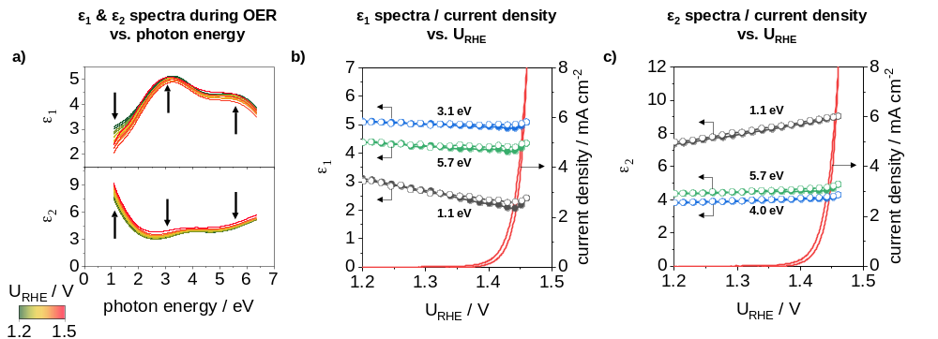
Supplementary figure S7.2: $ε_{1}$ and $ε_{2}$ spectra of the IrO_{x} material (matrix) derived from modeling during ECSE investigation. a) $ε_{1}$ and $ε_{2}$ spectra during cyclic voltammetry measurements. b) $ε_{1}$ at photon energies of 1.1 eV, 3.1 eV and 5.7 eV as well as c) $ε_{2}$ at photon energies of 1.1 eV, 4.0 eV and 5.7 eV.

Supplementary figure S7.3 displays a) the bulk ($-Im\left(ε^{-1}\right)$) VEELS, b) the center energy values of the identified peaks and c) the free carrier mobility as a function of the potential. The bulk VEELS clearly demonstrate the presence of two features, referred here as A and B peaks. These features can be assigned to transition energies from the O 2p orbital to the occupied (A peak) and unoccupied (B peak) Ir 5d t_{2g} orbital. A shift of the center energy is observed especially for the A peaks as well as a change in intensity for both A and B peaks.
Supplementary figure S7.3b displays the center energy of the A and B peak derived from the bulk VEELS together with the current density curve as a function of the potential. The A_{bulk} peak indicates a mostly linear shift of the center energy with an increase in potential. The maximum energy value is reached at a potential of about 1.44 V_{RHE} and then remains approximately constant. In contrast, the B_{bulk} peak demonstrates an almost constant energy value.
Supplementary figure S7.3c shows the free carrier mobility combined with the current density curve as a function of potential. The results of the free carrier mobility show a slight decrease of the values when increasing the potential and reaching higher current densities, as well as an almost completely reversible behavior.
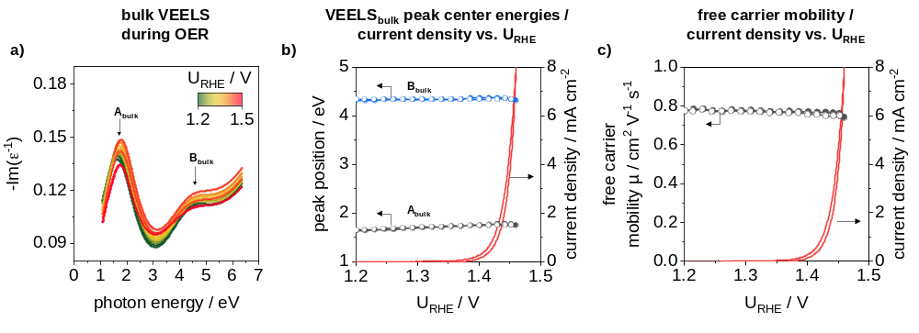
Supplementary figure S7.3: Valence electron energy loss spectra analysis during ECSE measurements in the OER regime. a) calculated bulk VEEL spectra at different potentials during OER. b) A and B peaks of the bulk VEELS and c) free carrier mobility as a function of the applied potential.

SI8. Operando ECSE investigation of a non-conductive mesoporous titanium oxide film
In order to verify independent potential effects on the modeled $Ψ$ and $Δ$ spectra, operando measurements are performed on a non-conductive mesoporous titanium oxide (TiO_{x}) film, calcined at 400 °C for 20 minutes in air, in the OER regime and in the potential range between 0.40 V_{RHE} and 1.40 V_{RHE}. The mesoporous TiO_{x} layer was model with an a-BEMA layer using a parametrization of two coupled Tauc-Lorentz (equation (4) and (5)). The electrolyte (0.1M HClO₄) was analyzed before ECSE measurements with a silicon wafer with known oxide layer. For the operando ECSE investigations, the pore anisotropic factor as well as the filling factor were used as free parameters. Supplementary figure S8.1 displays a) the cyclovoltammetry measurement, b) the $Ψ$ and $Δ$ spectra during CV measurements, c) the $Ψ$ spectra with fits and d) the $Δ$ spectra with fits at photon energies of 1.5 eV, 3.0 eV and 5.0 eV
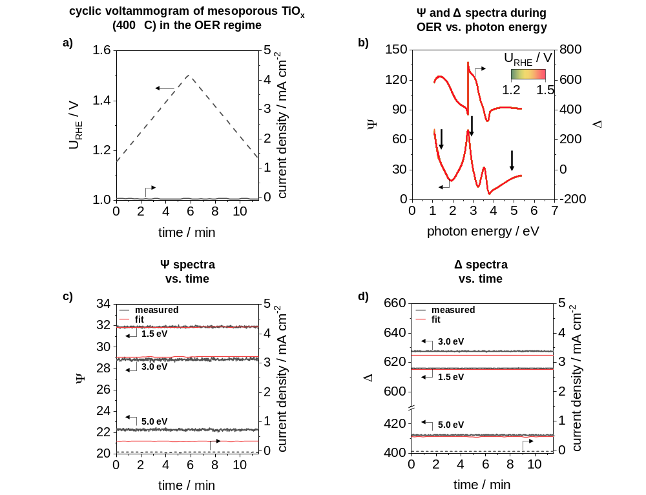
Supplementary figure S8.1: Operando ECSE investigations of a mesoporous TiO_{x} film calcined at 400 °C for 10 min in air in the OER regime. a) applied potential and current density as a function of time. b) $Ψ$ and $Δ$ spectra during CV. c) $Ψ$ and d) $Δ$ spectra at selected photon energies with fit results.
The CV measurement indicates a linear increase and decrease of the applied potential and no changes of the current density (Supplementary figure S8.1a). Also, the $Ψ$ and $Δ$ spectra reveal no changes in the complete spectra as well as at the selected photon energies (Supplementary figure S8.1b-d). Fitting results of the model are in good agreement with the measured spectra (Supplementary figure S8.1c and d).
Supplementary figure S8.2 shows a) the dielectric functions of the TiO_{x} material during EC measurements, b) $ε_{1}$ at photon energies of 2.5 eV, 3.9 eV and 5.0 eV as well as c) $ε_{2}$ at photon energies of 3.5 eV, 4.5 eV and 5.0 eV. The change of the filling factor is displayed Supplementary figure S8.2d.
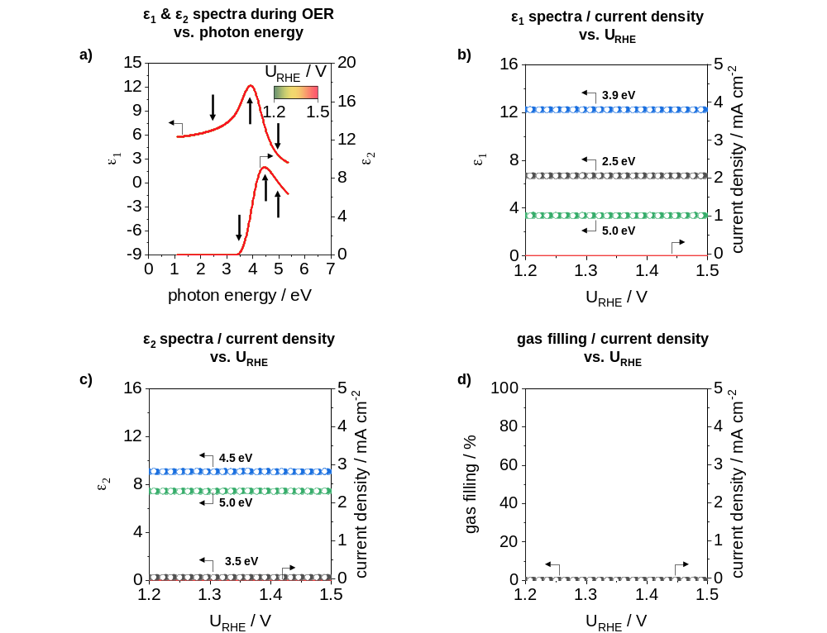
Supplementary figure S8.2: $ε_{1}$ and $ε_{2}$ spectra of the TiO_{x} material (matrix) derived from modeling during ECSE investigation in the OER regime. a) $ε_{1}$ and $ε_{2}$ spectra during cyclic voltammetry measurements. b) $ε_{1}$ at photon energies of 2.5 eV, 3.9 eV and 5.0 eV and c) $ε_{2}$ at photon energies of 3.5 eV, 4.5 eV and 5.0 eV. d) filling factor as a function of the applied potential.
The derived dielectric functions indicate no changes in the entire spectra during CV measurements in the OER regime as well as no indication of pore filling due to the change in volume fraction with produced gas.

The mesoporous TiO_{x} film was additionally used for the operando ECSE investigation in the potential range between 0.40 V_{RHE} and 1.40 V_{RHE}. Supplementary figure S8.3 displays a) the low-potential cyclic voltammogram, b) the changes of the $Ψ$ and $Δ$ spectra during the measurements as well as c) the $Ψ$ and d) the $Δ$ spectra at selected photon energies.
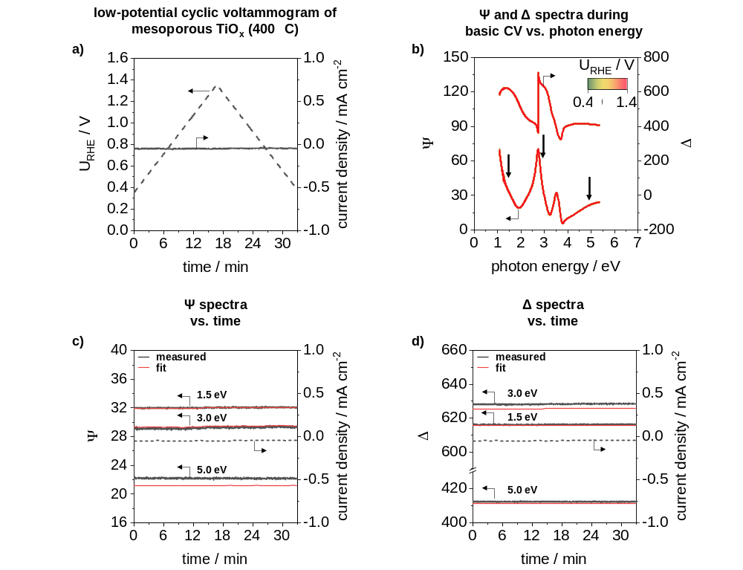
Supplementary figure S8.3: Operando ECSE investigations of a mesoporous TiO_{x} film in a potential range between 0.40 V_{RHE} and 1.40 V_{RHE}. a) applied potential and current density as a function of time. b) $Ψ$ and $Δ$ spectra during CV. c) $Ψ$ and d) $Δ$ spectra at selected photon energies with fit results.
As in the case of EC measurements in the OER regime, low-potential cyclovoltammetry measurements in the potential range of 0.40 V_{RHE} and 1.40 V_{RHE} indicate a linear increase and decrease of the applied potential and no further changes of current density (Supplementary figure S8.3a). The $Ψ$ and $Δ$ spectra thus reveal as well, no further changes in the complete spectra (Supplementary figure S8.3b). The fit results are for both spectra in good agreement (Supplementary figure S8.3c and d).

Supplementary figure S8.4 shows the a) the changes of the dielectric function during CV measurements, b)$ε_{1}$ at photon energies of 2.5 eV, 3.9 eV and 5.0 eV, c) $ε_{2}$ at photon energies of 3.5 eV, 4.5 eV and 5.0 eV and d) the filling factor.
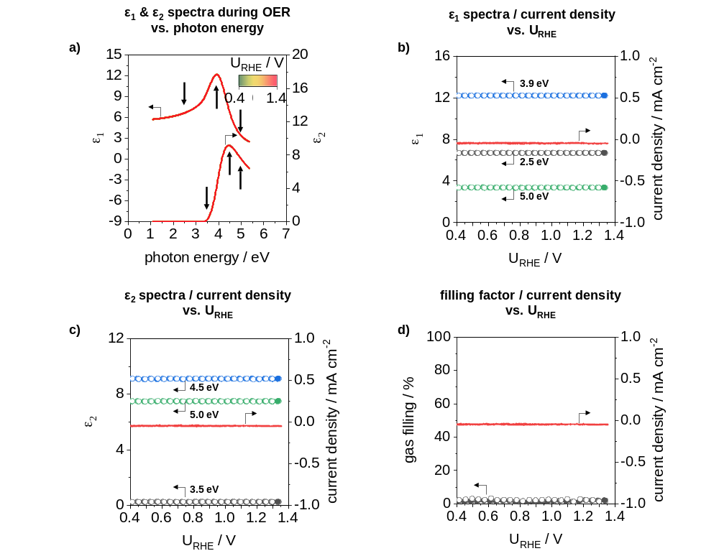
Supplementary figure S8.4: $ε_{1}$ and $ε_{2}$ spectra of the TiO_{x} material (matrix) during ECSE investigation in the potential window of 0.40 V_{RHE} and 1.40 V_{RHE}. a) $ε_{1}$ and $ε_{2}$ spectra during cyclic voltammetry measurements. b) $ε_{1}$ at photon energies of 2.5 eV, 3.9 eV and 5.0 eV and c) $ε_{2}$ at photon energies of 3.5 eV, 4.5 eV and 5.0 eV. d) filling factor as a function of the applied potential.
Similar to the investigations in the OER regime, no changes in the entire spectra of the dielectric function during CV measurements as well as no indication of pore filling due to the change in volume fraction with produced gas are derived from the modeling.

SI9. Operando ECSE investigations of mesoporous IrO_{x} (375 °C) in the lower potential range
The mesoporous IrO_{x} film calcined at 375 °C, was investigated by cyclovoltammetry in the lower potential window between 0.4 V_{RHE} and 1.4 V_{RHE} with spectroscopic ellipsometry. Within this potential range, changes in the Ir oxidation state can be observed and gives an indication of the accessible and/or available Ir due to the obtained anodic and cathodic charge. ECSE measurements were carried out with a scan rate of 1 mV s⁻¹ in N₂ purged 0.1M HClO₄ and a flow rate of 85 ml min⁻¹. For a better overview, the measured data are described first and discussed at the end of this Chapter.
Supplementary figure S9.1 displays a) the electrochemical studies in the lower potential range, b) the $Ψ$ and $Δ$ spectra as well as c) $Ψ$ and d) $Δ$ spectra and their fit results at selected photon energies in dependence on the measuring time.
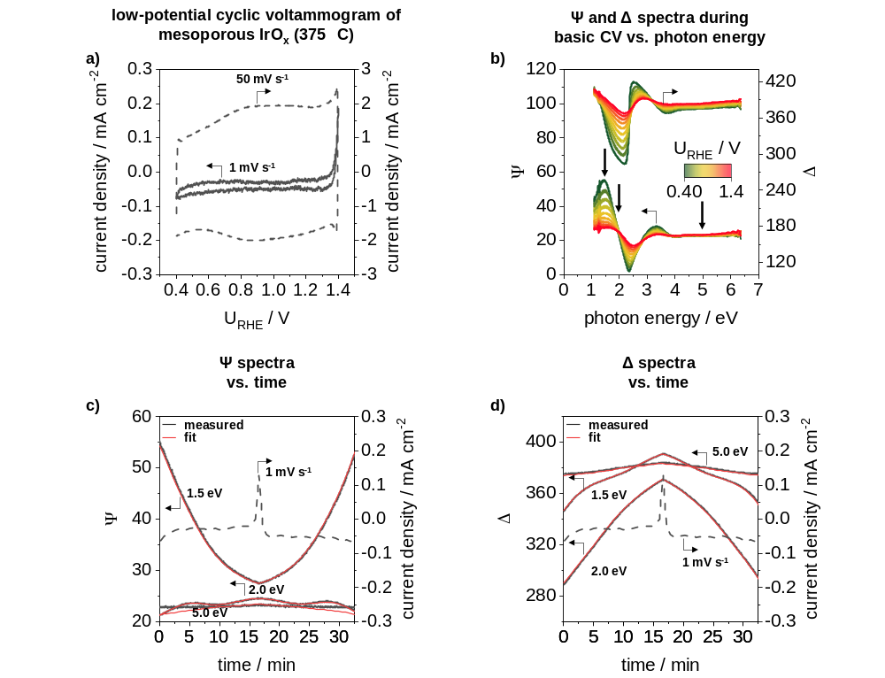
Supplementary figure S9.1: Operando ECSE investigations in a lower potential window of a mesoporous IrO_{x} film calcined at 375 °C. a) low-potential cyclovoltammetry measurements in a potential range of 0.40 V_{RHE} and 1.40 V_{RHE} in N₂ purged 0.1M HClO₄ with a scan rate of 1 mV s⁻¹ and 50 mV s⁻¹. For both measurements an electrolyte flow rate of 85 ml min⁻¹ was applied. Potentials were measured against an Ag/AgCl electrode, which referred to RHE (+0.256 V at pH 1). b) $Ψ$ and $Δ$ spectra measured during cyclic voltammetry. c) $Ψ$ and d) $Δ$ spectra with fit results at photon energies of 1.5 eV, 2.0 eV and 5.0 eV together with the current density curve obtained from the CV measurement with a scan rate of 1 mV s⁻¹ as a function of the measuring time.

The low-potential CV measurement with a scan rate of 50 mV s⁻¹ (Supplementary figure S9.1a, dashed line) is comparable to measurements on such mesoporous iridium oxide films reported in literature.^{24, 25} In this CV, two broad peaks at about 0.95 V_{RHE} are detected in the anodic and cathodic scan. These peaks can be associated with an Ir^{III}/Ir^{IV} redox couple.²⁶⁻²⁸ The CV measurement with a scan rate of 1 mV s⁻¹ (Supplementary figure S9.1a, solid line) indicates a very low surface charge, which can be explained by the lower scan rate. However, the low scan rate is necessary in order to allow the time-consuming ellipsometry measurement to be performed alongside the electrochemical measurement.
Supplementary figure S9.1b depicts the corresponding $Ψ$ and $Δ$ spectra for the CV measurement with a scan rate of 1 mV s⁻¹. Noticeable changes in the photon energy range from 1.0 eV to 4.0 eV are visible in both spectra. To correlate these changes with the CV curve, the spectra were plotted at energies of 1.5 eV, 2.0 eV and 5.0 eV together with the current density curve against the measuring time (Supplementary figure S9.1c, d). $Ψ$ values at a photon energy of 1.5 eV displays a strong decrease for the anodic scan (until a measuring time of about 16 min) and a strong increase for the cathodic scan. At 2.0 eV, three features at 6 min, 16 min, and 28 min are visible during the CV. At 5.0 eV, however, only a slight change in the $Ψ$ spectrum is observed. A similar behavior is detected for the $Δ$ spectra, where at 1.5 eV three features are visible and at 2.0 eV a strong increase in the anodic scan and a strong decrease in the cathodic scan can be observed (Supplementary figure S9.1d). The fit results from the model analysis (red lines) are in good agreement with the measured spectra, except for the $Ψ$ fit in the range of 5.0 eV, where a slight deviation is obtained.
As with the ECSE measurements in the OER region, the dielectric functions of the material can be derived from the fit results of the model analysis. Supplementary figure S9.2 shows the $ε_{1}$ (a) and $ε_{2}$ (b) spectra at different potentials of the low-potential cyclovoltammetry measurement as a function of the photon energy and $ε_{1}$ (c) and $ε_{2}$ (d) at selected photon energies together with the current response of the 1 mV s⁻¹ and 50 mV s⁻¹ scan in dependence on the potential.
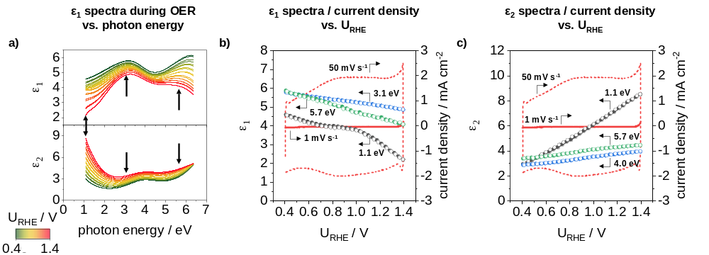
Supplementary figure S9.2: $ε_{1}$ and $ε_{2}$ spectra of the IrO_{x} material (matrix) derived from modeling during ECSE investigation in the lower potential window. a) $ε_{1}$ and $ε_{2}$ spectra at different potentials. b) $ε_{1}$ at photon energies of 1.1 eV, 3.1 eV and 5.7 eV as well as c) $ε_{2}$ at photon energies of 1.1 eV, 4.0 eV and 5.7 eV.

Both spectra show significant changes in the complete spectral range during cyclovoltammetry (Supplementary figure S9.2a). Similar to the spectra from the ECSE measurement in the OER region described in Chapter 6.2, changes in conduction band excitations (below 2.0 eV) and intraband transitions (near 1.0 eV) as well as in interband transitions (above 3.0 eV) are observed in the $ε_{2}$ spectra (Supplementary figure S9.2a). The characteristics in the $ε_{1}$ spectra at photon energies of 1.0 eV, 3.1 eV and 5.7 eV exhibit pronounced variation as well (Supplementary figure S9.2a). By plotting the characteristic features against the potential, a general decreasing trend with increase of the potential is observed in the $ε_{1}$ spectra (Supplementary figure S9.2b). At 1.1 eV, a kind of peak at about 0.95 V_{RHE} can be additionally detected. In contrast, the features in the $ε_{2}$ spectra increase with increasing potential, whereas at 1.1 eV a relatively strong behavior can be recognized (Supplementary figure S9.2c). Both spectra also indicate a fully reversible trend of the dielectric functions during the anodic and cathodic scan.
For a more detailed analysis of the electronic characteristic of the IrO_{x} material during the anodic and cathodic scan, VEEL spectra are calculated from the dielectric functions. Supplementary figure S9.3 depicts the bulk and surface VEELS (a), the A and B peaks of the bulk (b) und surface (c) spectra as well as intraband transition energies (d) from the Tauc relation.
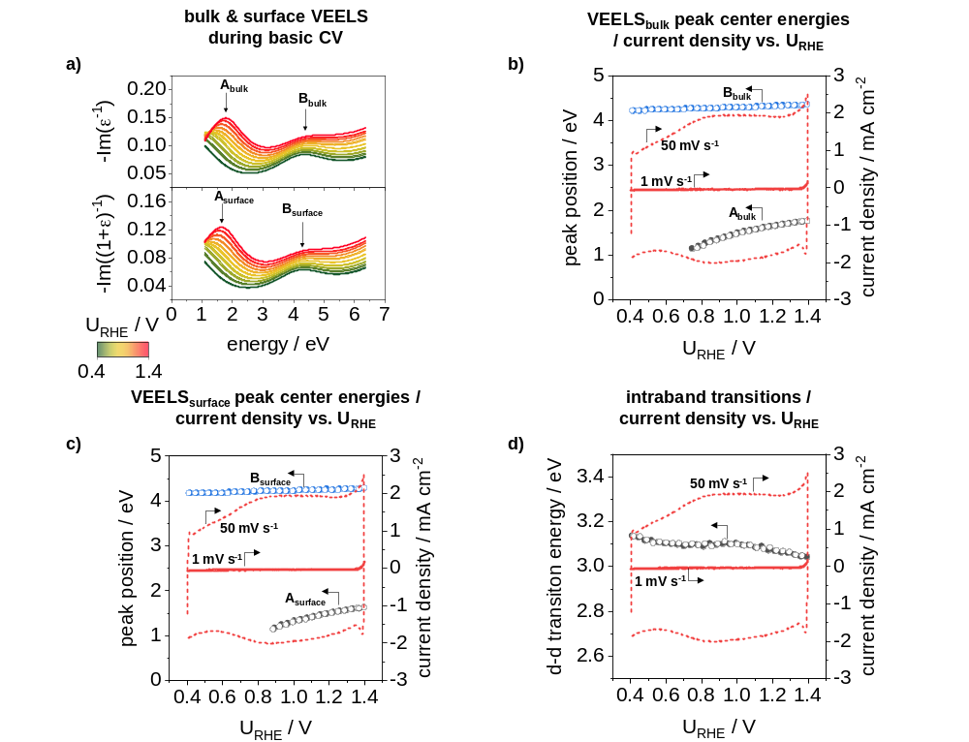
Supplementary figure S9.3: Valence electron energy loss spectra study during ECSE measurements in the lower potential range of 0.40 V_{RHE} and 1.40 V_{RHE}. a) Calculated bulk and surface VEEL spectra at different potentials. A und B peaks of b) bulk VEELS and c) surface VEELS as a function of the potential as well as derived intraband transition energies (d) between the Ir 5d t_{2g} and e_{g} band.
Similar to the dielectric functions, the VEEL spectra (Supplementary figure S9.3a) reveal significant changes during the anodic and cathodic scan, especially the A peaks, which are strongly shifted in their center energy. The center energy of the B peaks also shifts to higher values in the anodic scan and are completely reversable in the cathodic scan. Furthermore, the individual spectra differ strongly within their intensities.
The nonlinear shift of the center energy of the A peaks ranges from about 1.2 eV to 1.7 eV and from about 1.1 eV to 1.6 eV for the bulk and surface spectra, respectively (Supplementary figure S9.3b and c). Due to the strong shift, the center energy can only be detected until a potential of 0.78 V_{RHE} and 0.88 V_{RHE} in the bulk and surface spectra, respectively. In the low photon energy range (IR range), the strong interaction of light with the electrolyte and the associated molecule oscillations unfortunately lead to a low signal to noise ratio. In contrast, the B peaks in both spectra indicate a stepwise increase of the center energy in the anodic scan and a completely reversible behavior in the cathodic scan.
Transition energies between the Ir 5d t_{2g} and e_{g} band (Supplementary figure S9.3d) reveal a general decreasing trend with higher potentials. Additionally, a broad peak at around 0.95 V_{RHE} is observed, which can be attributed to the Ir^{III}/Ir^{IV} redox couple.
Electrical properties as well as the volume fraction of produced gas (filling factor) can also be derived from the modeling during the anodic and cathodic scan in the potential range between 0.40 V_{RHE} and 1.40 V_{RHE}. Supplementary figure S9.4 shows the filling factor (a), the resistivity (b) as well as the free carrier mobility (c) and free carrier concentration (d) of the IrO_{x} material in dependence on the potential.
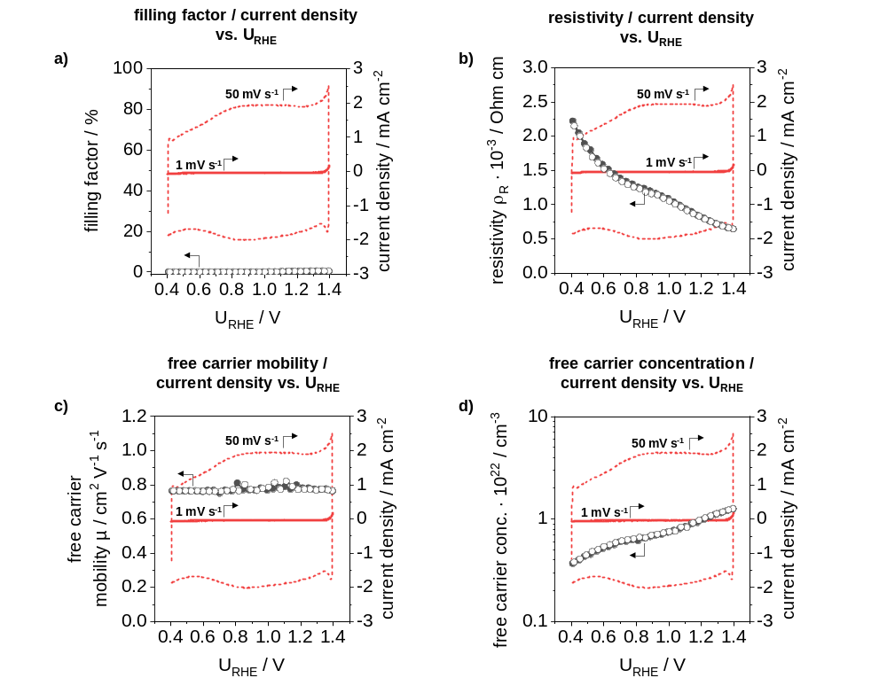
Supplementary figure S9.4: Deduced properties from model analysis during ECSE measurements in the potential rage of 0.40 V_{RHE} and 1.40 V_{RHE}. a) filling factor, b) resistivity, c) free carrier mobility, and d) free carrier concentration as a function of the potential.
As shown in Supplementary figure S9.4a, the filling factor deduced from the model analysis is close to zero over the whole scan range. This is in good agreement with the expectation that no oxygen gas is produced in this potential range.
The resistivity indicates a decrease from 0.40 V_{RHE} to 1.40 V_{RHE} and a slight peak at 0.95 V_{RHE} (Supplementary figure S9.4b). This behavior is completely reversable for the cathodic scan. The free carrier mobility (Supplementary figure S9.4c) reveal a slightly reduced value in the range of 0.40 V_{RHE} to 0.80 V_{RHE} compared to higher potentials (> 1.20 V_{RHE}) and between 0.80 V_{RHE} and 1.20 V_{RHE} a slight scattering in free carrier mobility. In contrast, the free carrier concentration (Supplementary figure S9.4d) decreases continuously with decreasing potential.
The results from ECSE analysis in the potential range between 0.40 V_{RHE} and 1.40 V_{RHE} can be correlated mostly with the Ir^{III}/Ir^{IV} redox couple.²⁶⁻²⁸ Thus, the dielectric functions show a pronounced change in the lower photon range, indicating a change in conduction band excitations and intraband transitions (Supplementary figure S9.2). Due to the reduction of the material during scanning to lower potentials and the change of the Ir oxidation state from Ir^{IV} to Ir^{III} when exceeding the potential of 0.95 V_{RHE}, there is also a change in the interactions of the O p and Ir d orbitals.
These changes are also evident in the VEEL spectra, where a strong decrease in the energy values of the interactions between the filled t_{2g} sub-level of the d-band of iridium and the p-band of oxygen (A peak) to lower potentials is observed (Supplementary figure S9.3).This behavior suggests enhanced adsorption of OH species and/or H₂O molecules, or conversion of O species to OH species.²⁹ In addition, the decrease in p-d interaction can be associated with a shift of the t_{2g} band to higher energies, leading to enhanced adsorption of O species (probably OH species).^{30, 31} This shift of the t_{2g} band is also directly reflected in the electrical properties such as resistivity (Supplementary figure S9.4b) and free carrier concentration (Supplementary figure S9.4d).
A change in the p-d interactions and the shift of the Ir 5d t_{2g} band also affect the d-d intraband transitions between the Ir 5d t_{2g} and the e_{g} bands (Supplementary figure S9.3d). The up shift of the t_{2g} band to higher energies leads to a lower d-orbital splitting and the t_{2g} and e_{g} bands become closer, probably resulting in a high spin configuration. In addition, the broad feature at about 0.95 V_{RHE} also indicates the change of the Ir oxidation state from Ir^{IV} to Ir^{III}.
In summary, operando ECSE investigations in the potential range between 0.40 V_{RHE} and 1.40 V_{RHE} of the exemplary tested mesoporous IrO_{x} film, which was calcined at 375 °C, provide noticeable changes within the material. The Ir^{III}/Ir^{IV} redox couple can be detected in the dielectric functions as well as in Ir d-d intraband transitions. The shift in the d-d intraband transition energies may also indicate a high spin configuration of the relative occupancy of the t_{2g} and e_{g} states. The change of the Ir oxidation state is also reflected in the electrical properties such as resistivity and free carrier concentration, where an increase or decrease is observed. Furthermore, the change of the oxidation state probably results in a shift of the Ir 5d t_{2g} sub-level to higher energies and an increased adsorption of O species.

References
1 Daubinger, P., Kieninger, J., Unmüssig, T. & Urban, G. A. Electrochemical characteristics of nanostructured platinum electrodes – a cyclic voltammetry study. Physical Chemistry Chemical Physics 16, 8392-8399, doi:10.1039/C4CP00342J (2014).
2 Knoops, H. C. M. et al. Remote Plasma ALD of Platinum and Platinum Oxide Films. Electrochemical and Solid-State Letters 12, G34-G36, doi:10.1149/1.3125876 (2009).
3 Yu, A. Y. C., Spicer, W. E. & Hass, G. Optical Properties of Platinum. Physical Review 171, 834-835, doi:10.1103/PhysRev.171.834 (1968).
4 Weaver, J. H. Optical properties of Rh, Pd, Ir, and Pt. Physical Review B 11, 1416-1425, doi:10.1103/PhysRevB.11.1416 (1975).
5 Rakić, A. D., Djurišić, A. B., Elazar, J. M. & Majewski, M. L. Optical properties of metallic films for vertical-cavity optoelectronic devices. Appl. Opt. 37, 5271-5283, doi:10.1364/AO.37.005271 (1998).
6 Neff, H. et al. Structural, optical, and electronic properties of magnetron‐sputtered platinum oxide films. Journal of Applied Physics 79, 7672-7675, doi:10.1063/1.362341 (1996).
7 Fujiwara, H. Spectroscopic ellipsometry: principles and applications. (John Wiley & Sons, 2007).
8 Smith, T. Ellipsometry for Measurements at and below Monolayer Coverage. Journal of the Optical Society of America 58, 1069-1079, doi:10.1364/JOSA.58.001069 (1968).
9 Hayden, B. E. & Nicholson, G. P. An ellipsometric study of potassium adsorption on TiO2(110). Surface Science 274, 277-286, doi:https://doi.org/10.1016/0039-6028(92)90532-B (1992).
10 Bootsma, G. A. & Meyer, F. Ellipsometry in the sub-monolayer region. Surface Science 14, 52-76, doi:https://doi.org/10.1016/0039-6028(69)90045-4 (1969).
11 Habraken, F. H. P. M., Gijzeman, O. L. J. & Bootsma, G. A. Ellipsometry of clean surfaces, submonolayer and monolayer films. Surface Science 96, 482-507, doi:https://doi.org/10.1016/0039-6028(80)90322-2 (1980).
12 Chen, Y., Schneider, P. & Erbe, A. Investigation of native oxide growth on zinc in different atmospheres by spectroscopic ellipsometry. physica status solidi (a) 209, 846-853, doi:doi:10.1002/pssa.201100542 (2012).
13 Drude, P. Optische Eigenschaften und Elektronentheorie. Annalen der Physik 319, 677-725 (1904).
14 Sommerfeld, A. & Bethe, H. Elektronentheorie der Metalle. Vol. 19 (Springer-Verlag, 2013).
15 Fujiwara, H. & Kondo, M. Effects of carrier concentration on the dielectric function of ZnO: Ga and In 2 O 3: Sn studied by spectroscopic ellipsometry: analysis of free-carrier and band-edge absorption. Physical Review B 71, 075109 (2005).
16 Tiwald, T. E., Thompson, D. W., Woollam, J. A., Paulson, W. & Hance, R. Application of IR variable angle spectroscopic ellipsometry to the determination of free carrier concentration depth profiles. Thin Solid Films 313-314, 661-666, doi:https://doi.org/10.1016/S0040-6090(97)00973-5 (1998).
17 Tompkins, H. & Irene, E. A. Handbook of Ellipsometry. (William Andrew Publishing, 2005).
18 Wooten, F. in Optical Properties of Solids (ed Frederick Wooten) 42-84 (Academic Press, 1972).
19 von Blanckenhagen, B., Tonova, D. & Ullmann, J. Application of the Tauc-Lorentz formulation to the interband absorption of optical coating materials. Appl. Opt. 41, 3137-3141 (2002).
20 Jellison Jr., G. E. & Modine, F. A. Parameterization of the optical functions of amorphous materials in the interband region. Applied Physics Letters 69, 371-373, doi:10.1063/1.118064 (1996).
21 Tauc, J., Grigorovici, R. & Vancu, A. Optical Properties and Electronic Structure of Amorphous Germanium. physica status solidi (b) 15, 627-637, doi:10.1002/pssb.19660150224 (1966).
22 Sellmeier, W. Ueber die durch die Aetherschwingungen erregten Mitschwingungen der Körpertheilchen und deren Rückwirkung auf die ersteren, besonders zur Erklärung der Dispersion und ihrer Anomalien. Annalen der Physik 223, 386-403, doi:10.1002/andp.18722231105 (1872).
23 Boudot, M., Elettro, H. & Grosso, D. Converting Water Adsorption and Capillary Condensation in Usable Forces with Simple Porous Inorganic Thin Films. ACS Nano 10, 10031-10040, doi:10.1021/acsnano.6b04648 (2016).
24 Sachse, R. et al. Assessing Optical and Electrical Properties of Highly Active IrOx Catalysts for the Electrochemical Oxygen Evolution Reaction via Spectroscopic Ellipsometry. ACS Catalysis 10, 14210-14223, doi:10.1021/acscatal.0c03800 (2020).
25 Bernicke, M. et al. Iridium Oxide Coatings with Templated Porosity as Highly Active Oxygen Evolution Catalysts: Structure‐Activity Relationships. ChemSusChem 8, 1908-1915, doi:doi:10.1002/cssc.201402988 (2015).
26 Geiger, S. et al. Activity and Stability of Electrochemically and Thermally Treated Iridium for the Oxygen Evolution Reaction. Journal of The Electrochemical Society 163, F3132-F3138, doi:10.1149/2.0181611jes (2016).
27 Steegstra, P., Busch, M., Panas, I. & Ahlberg, E. Revisiting the Redox Properties of Hydrous Iridium Oxide Films in the Context of Oxygen Evolution. The Journal of Physical Chemistry C 117, 20975-20981, doi:10.1021/jp407030r (2013).
28 Lettenmeier, P. et al. Nanosized IrOx–Ir Catalyst with Relevant Activity for Anodes of Proton Exchange Membrane Electrolysis Produced by a Cost-Effective Procedure. Angewandte Chemie International Edition 55, 742-746, doi:10.1002/anie.201507626 (2016).
29 Bockris, J. O. M. Kinetics of Activation Controlled Consecutive Electrochemical Reactions: Anodic Evolution of Oxygen. The Journal of Chemical Physics 24, 817-827, doi:10.1063/1.1742616 (1956).
30 Hammer, B. & Nørskov, J. K. Why gold is the noblest of all the metals. Nature 376, 238-240, doi:10.1038/376238a0 (1995).
31 Hammer, B. & Nørskov, J. K. Electronic factors determining the reactivity of metal surfaces. Surface Science 343, 211-220, doi:https://doi.org/10.1016/0039-6028(96)80007-0 (1995).

