Supplementary Material S1
Comprehensive Literature Search Documentation

For: Predictive Spatial Machine Learning in the Era of Big Data: A Critical Analysis of
Methods, Technical Advances, and Research Frontiers for Geophysical Applications

S1.1 Review Protocol
This supplementary material documents the complete literature search strategy and study selection process for the systematic review. The search strategy was developed a priori and documented before screening commenced, following PRISMA 2020 guidelines (Page et al., 2021) and the PRISMA-S extension for reporting literature searches (Rethlefsen et al., 2021).
The review protocol specified the following elements before the search was conducted:
Research question: What is the current state of predictive spatial machine learning frameworks, uncertainty quantification methods, and validation approaches for geophysical applications, and what are the key research gaps?
Population: Studies applying or developing machine learning methods with explicit spatial modelling components.
Intervention/Exposure: Spatial machine learning techniques including hybrid geostatistical-ML, spatial deep learning, locally varying models, spatial feature engineering, and physics-informed approaches.
Outcome: Prediction accuracy, uncertainty quantification quality, validation methodology, and applicability to geophysical domains.
Study design: Original research articles, methodological papers, and substantive review articles published in peer-reviewed journals or established conference proceedings.

S1.2 Database Search Strategies
The following search strategies were executed as documented below. Each strategy is presented as copied from the respective database interface, preserving exact syntax, field codes, and Boolean operators. Searches were conducted between January 15 and March 10, 2025.

S1.2.1 Scopus
Interface: Scopus (Elsevier), www.scopus.com
Search string (copied as run):
TITLE-ABS-KEY ( ( "spatial machine learning" OR "geostatistical machine learning" OR "spatial prediction" OR "geographically weighted" OR "spatial deep learning" OR "spatial random forest" OR "kriging" W/3 "machine learning" OR "spatial neural network" ) AND ( "uncertainty" OR "uncertainty quantification" OR "prediction uncertainty" OR "aleatory" OR "epistemic" OR "probabilistic prediction" OR "conformal prediction" OR "prediction interval" OR "quantile regression" ) ) AND ( LIMIT-TO ( PUBYEAR, 2025 ) OR LIMIT-TO ( PUBYEAR, 2024 ) OR LIMIT-TO ( PUBYEAR, 2023 ) OR LIMIT-TO ( PUBYEAR, 2022 ) OR LIMIT-TO ( PUBYEAR, 2021 ) OR LIMIT-TO ( PUBYEAR, 2020 ) OR LIMIT-TO ( PUBYEAR, 2019 ) OR LIMIT-TO ( PUBYEAR, 2018 ) OR LIMIT-TO ( PUBYEAR, 2017 ) OR LIMIT-TO ( PUBYEAR, 2016 ) OR LIMIT-TO ( PUBYEAR, 2015 ) ) AND ( LIMIT-TO ( LANGUAGE, "English" ) ) AND ( LIMIT-TO ( DOCTYPE, "ar" ) OR LIMIT-TO ( DOCTYPE, "re" ) OR LIMIT-TO ( DOCTYPE, "cp" ) )
Records retrieved: 312
Secondary Scopus search (geophysical applications focus):
TITLE-ABS-KEY ( ( "spatial machine learning" OR "geostatistical" W/3 "machine learning" OR "spatial prediction" OR "spatial deep learning" ) AND ( "geophysics" OR "seismic" OR "mineral exploration" OR "resource estimation" OR "hydrogeology" OR "groundwater" OR "subsurface" OR "geological model*" OR "environmental monitoring" OR "soil mapping" ) ) AND PUBYEAR > 2014 AND ( LIMIT-TO ( LANGUAGE, "English" ) )
Records retrieved: 198

S1.2.2 Web of Science
Interface: Web of Science Core Collection (Clarivate), www.webofscience.com
Databases within WoS: Science Citation Index Expanded (SCI-EXPANDED), Conference Proceedings Citation Index-Science (CPCI-S)
Search string (copied as run):
TS=("spatial machine learning" OR "geostatistical machine learning" OR "spatial prediction" OR "geographically weighted" OR "spatial deep learning" OR "spatial random forest" OR ("kriging" NEAR/3 "machine learning") OR "spatial neural network") AND TS=("uncertainty" OR "uncertainty quantification" OR "prediction uncertainty" OR "aleatory" OR "epistemic" OR "probabilistic prediction" OR "conformal prediction" OR "quantile regression") Refined by: Publication Years: 2015-2025 AND Languages: English AND Document Types: Articles OR Review Articles OR Proceedings Papers
Records retrieved: 247

S1.2.3 IEEE Xplore
Interface: IEEE Xplore Digital Library, ieeexplore.ieee.org
Search string (copied as run):
("spatial machine learning" OR "geostatistical machine learning" OR "spatial prediction" OR "geographically weighted" OR "spatial deep learning") AND ("uncertainty quantification" OR "prediction uncertainty" OR "aleatory" OR "epistemic" OR "probabilistic prediction") Filters: Year Range: 2015-2025, Content Type: Conferences, Journals
Records retrieved: 52

S1.2.4 Google Scholar (supplementary)
Interface: Google Scholar, scholar.google.com
Note: Google Scholar was used as a supplementary source to identify records not indexed in the primary databases. Due to Google Scholar's limited Boolean support and inability to export comprehensive results, the following simplified queries were used, with the first 200 results from each query screened by title:
Query 1: "spatial machine learning" "uncertainty quantification" geophysics
Query 2: "geostatistical machine learning" "spatial prediction" uncertainty
Query 3: "spatial validation" "cross-validation" "spatial autocorrelation" "machine learning"
Query 4: "spatial deep learning" "geophysics" OR "seismic" OR "geological" uncertainty
Records retrieved (unique after de-duplication with primary databases): 38
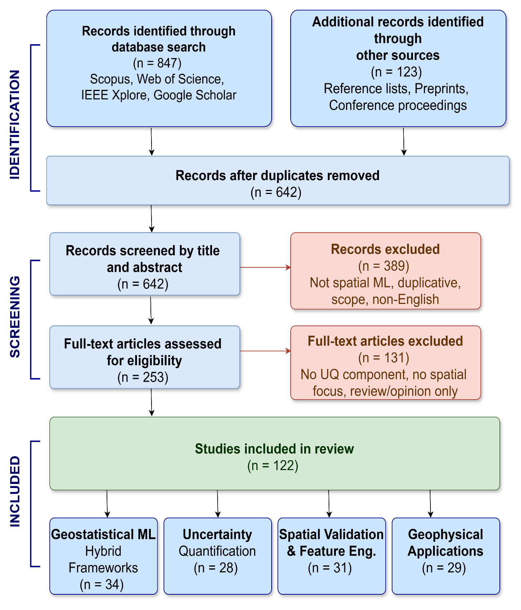
Figure S1: PRISMA 2020 flow diagram for the systematic literature review. The diagram documents the flow of information through the identification, screening, and inclusion phases of the review.

S1.3 Other Information Sources

S1.3.1 Reference List Screening
Reference lists of all included studies and key existing reviews were manually screened to identify additional relevant studies. The following reviews were specifically targeted for backward citation searching: Casali et al. (2022), Ma et al. (2019), Kopczewska (2022), Nikparvar and Thill (2021), Kubo et al. (2024), Anjom et al. (2024), Xu et al. (2025), Tyralis and Papacharalampous (2024), Reichstein et al. (2019).
Additional records identified: 67

S1.3.2 Citation Searching (Forward)
Forward citation searching was conducted using Google Scholar's "Cited by" feature for 15 seminal papers in the field, including Fouedjio and Klump (2019), Meyer et al. (2019), Schratz et al. (2019), Hengl et al. (2018), Roberts et al. (2017), Gal and Ghahramani (2016), and Kendall and Gal (2017). This identified studies that built upon these foundational works.
Additional records identified: 31

S1.3.3 Conference Proceedings
Conference proceedings from the following venues were searched for the period 2020-2025:
American Geophysical Union (AGU) Fall Meeting; European Geosciences Union (EGU) General Assembly; International Association for Mathematical Geosciences (IAMG) Congress; Geostatistics Congress; IEEE International Geoscience and Remote Sensing Symposium (IGARSS); ACM SIGKDD; NeurIPS (climate and geoscience workshops).
Additional records identified: 18

S1.3.4 Preprint Servers
The following preprint servers were searched using the same core search terms:
arXiv (cs.LG, stat.ML, physics.geo-ph sections), EarthArXiv, ESSOAr (Earth and Space Science Open Archive).
Additional records identified: 7
Total additional records from other sources: 123 (67 + 31 + 18 + 7)

S1.4 Search Filters and Limits
Filter/Limit | Setting | Rationale
Date range | 2015-2025 | Captures the period of major advancement in spatial ML; pre-2015 foundational works captured through reference list screening
Language | English | Primary language of the spatial ML and geoscience literature; non-English studies may be missed
Document type | Articles, review articles, conference papers | Excludes editorials, letters, book reviews, and non-peer-reviewed opinion pieces
Subject area (Scopus) | No subject area filter applied | Broad search to capture cross-disciplinary contributions
Citation indexes (WoS) | SCI-EXPANDED, CPCI-S | Captures journal articles and conference proceedings in science
Content type (IEEE) | Conferences, Journals | Captures both venue types within IEEE
Google Scholar | First 200 results per query | Google Scholar does not support comprehensive export; 200 captures the most relevant results per query based on Google's ranking

Justification for not using geographic or subject area filters: The review intentionally spans multiple geophysical domains (seismology, mineral exploration, hydrogeology, environmental monitoring) and draws on methodological contributions from statistics, computer science, and applied mathematics. Applying subject area filters would risk excluding relevant cross-disciplinary contributions.

S1.5 Inclusion and Exclusion Criteria

Inclusion Criteria
ID | Criterion | Operationalisation
I1 | Develops or applies ML with explicit spatial modelling | Study must incorporate spatial structure (coordinates, spatial weights, variograms, spatial lags, graph-based spatial relations) into the ML model or feature set, not merely use geographic data as input
I2 | Addresses prediction or spatial estimation | Study must produce spatial predictions, maps, or estimates at unsampled locations; pure classification without spatial prediction excluded
I3 | Addresses uncertainty quantification OR spatial validation | Study must include at least one of: prediction intervals, uncertainty maps, probabilistic outputs, spatial cross-validation, or spatially aware model assessment
I4 | Peer-reviewed or established venue | Published in peer-reviewed journals, or conference proceedings of established venues (AGU, EGU, IAMG, IEEE, ACM, NeurIPS)
I5 | English language | Full text available in English
I6 | Published 2015-2025 | Publication date within the review period (foundational pre-2015 works cited but not systematically reviewed)

Exclusion Criteria
ID | Criterion | Rationale
E1 | Standard ML without spatial considerations | Studies applying random forest, neural networks, etc. without incorporating spatial structure are outside the review scope
E2 | Pure image classification without spatial prediction | Pixel-wise classification of remote sensing imagery without spatial interpolation or prediction at unsampled locations
E3 | Editorials, commentaries, letters, book reviews | Non-substantive contributions lacking methodological detail
E4 | Duplicate content from same research group | When the same team published multiple papers on the same method without significant advancement, only the most complete version was retained
E5 | Non-English full text | Full text not available in English
E6 | No uncertainty or validation component | Studies focused solely on point prediction accuracy without any UQ or spatially aware validation
E7 | Published before 2015 | Outside the review period (cited as foundational references where relevant but not included in the systematic count)

S1.6 Screening Process and PRISMA Flow

S1.6.1 Screening Stages
Stage | Action | Records | Cumulative
Identification: databases | Search across Scopus, WoS, IEEE Xplore, Google Scholar | 847 | 847
Identification: other sources | Reference lists, citation searching, conferences, preprints | 123 | 970
Duplicate removal | Automated (Zotero) + manual verification | 328 removed | 642 unique
Title-abstract screening | Two reviewers independently; disagreements resolved by discussion | 389 excluded | 253 retained
Full-text assessment | Full-text read against inclusion/exclusion criteria | 131 excluded | 122 included

S1.6.2 Reasons for Full-Text Exclusion (n = 131)
Reason for Exclusion | Number | Percentage
No spatial prediction component (pure classification) | 38 | 29.0%
No uncertainty quantification or spatial validation | 34 | 26.0%
Standard ML without spatial modelling structure | 27 | 20.6%
Review/editorial without methodological contribution | 14 | 10.7%
Duplicate content from same research group | 9 | 6.9%
Full text not available / not in English | 5 | 3.8%
Published outside review period (pre-2015) | 4 | 3.1%
Total excluded at full-text stage | 131 | 100%

Note: Each excluded study was counted once against the primary reason for exclusion, even when multiple exclusion criteria applied. The primary reason was determined by the first criterion met in the order E1 through E7.
The PRISMA 2020 flow diagram documenting this process is provided as a separate supplementary figure (Figure S1).

S1.7 Data Extraction Template
The following data items were extracted from each included study using a standardised extraction form in a shared spreadsheet. Two reviewers independently extracted data from a random subset of 20 studies (16.4%) to assess inter-rater reliability; disagreements were resolved by discussion.
Data Item | Description | Response Options / Format
Study ID | Unique identifier | First author surname + year (e.g., Fouedjio2024)
Full citation | Complete bibliographic reference | Free text
Study type | Research article, methodological paper, or review | Original / Methodological / Review
ML method(s) | Machine learning algorithm(s) used | Free text (e.g., RF, CNN, GWR, XGBoost, BNN)
Geostatistical component | Whether geostatistics is integrated | None / Kriging / Variogram-based / Simulation / Other
Spatial structure incorporation | How spatial information enters the model | Coordinates as features / Spatial weights / Spatial lag / ESF / Graph / Variogram / Other
Uncertainty quantification | UQ method(s) used | None / QR / QRF / Bootstrap / BNN / MC Dropout / Kriging variance / Simulation / Conformal / UNEEC / Other
Uncertainty type addressed | Which uncertainty type is targeted | Aleatory only / Epistemic only / Both / Not specified
Validation approach | How model is validated | Random CV / Spatial CV / Temporal CV / IBCV / LGOCV / Block bootstrap / Other
Application domain | Primary application area | Seismology / Mineral exploration / Hydrogeology / Environmental / Subsurface / Other
Data type | Input data format | Point / Raster / Both / 3D / Time series
Study area scale | Geographic extent | Local (<100 km) / Regional (100-1000 km) / National / Continental / Global
Sample size | Number of spatial observations | Numeric value or range
Performance metric(s) | Accuracy measures reported | RMSE / MAE / R-squared / AUC / NSE / CRPS / Other
UQ metric(s) | Uncertainty quality measures | Coverage probability / Interval width / CRPS / Goodness / Calibration / Not assessed
Software/packages | Implementation tools reported | Free text (e.g., R: gstat, CAST; Python: sklearn, PyTorch)
Key finding | Primary methodological contribution or result | 1-2 sentence summary
Thematic code(s) | Review theme assignment | Hybrid geostat-ML / UQ / Validation / Feature eng. / Deep learning / Physics-informed / Local models / Geophysical application

S1.8 Thematic Coding Framework
Included studies were coded into four primary thematic categories (non-mutually exclusive, as studies may contribute to multiple themes). The coding framework was developed iteratively: an initial framework was created from the first 30 studies screened, refined after coding 60 studies, and finalised after all 122 studies were coded.
Theme | Code | Definition | Studies (n) | Manuscript Section
Geostatistical-ML hybrid frameworks | T1 | Studies that integrate traditional geostatistical methods (kriging, variogram analysis, conditional simulation) with ML algorithms in a unified or sequential framework | 34 | Section 4.1
Uncertainty quantification methods | T2 | Studies that develop or apply methods for quantifying prediction uncertainty in spatial contexts, including aleatory, epistemic, or both | 28 | Section 5
Spatial validation and feature engineering | T3 | Studies addressing spatially aware validation (cross-validation, bootstrap) or spatial feature engineering (distance fields, spatial lag, ESF, SRF) | 31 | Sections 4.3, 4.5
Geophysical domain applications | T4 | Studies demonstrating spatial ML in specific geophysical domains: seismology, mineral exploration, hydrogeology, environmental monitoring, subsurface characterisation | 29 | Section 6

Note: The sum of studies across themes (34 + 28 + 31 + 29 = 122) equals the total included studies because each study was assigned to its primary theme. However, 47 studies (38.5%) were additionally tagged with secondary themes. For example, Fouedjio and Klump (2019) is primarily coded as T2 (uncertainty quantification) but also tagged with T1 (hybrid geostatistical-ML). The thematic distribution informed the structure of the manuscript, with Sections 4-6 mapping directly to the coding framework.

S1.8.1 Key Statistics from Thematic Coding
The following statistics were derived from the systematic coding and are cited in the manuscript:
Of the 122 included studies, only 18 (14.8%) explicitly decomposed prediction uncertainty into aleatory and epistemic components (cited in Section 5.4 and Section 6.5 as 'fewer than 15%').
Among the 31 studies in theme T3 (validation), 19 (61.3%) used some form of spatial cross-validation, while 12 (38.7%) used only standard random cross-validation or holdout methods.
Software implementations were reported in 78 of 122 studies (63.9%). R was the most commonly reported language (52 studies, 42.6%), followed by Python (34 studies, 27.9%), with 8 studies reporting both.
The most frequently used ML methods across all 122 studies were: Random Forest and variants (47 studies, 38.5%), neural networks including CNN/RNN/GNN (38 studies, 31.1%), gradient boosting methods (24 studies, 19.7%), kriging-ML hybrids (22 studies, 18.0%), and Gaussian process regression (15 studies, 12.3%). Note that studies using multiple methods are counted under each method.

S1.9 List of Included Studies by Theme
The complete list of 122 included studies, organised by primary thematic code, is available in the main manuscript reference list. Studies are identified in the text by their citations. A machine-readable spreadsheet containing all extracted data items (Section S1.7) for the 122 included studies is available from the corresponding author upon reasonable request.

Availability of extraction data: The complete data extraction spreadsheet, containing all 18 data items (Section S1.7) for each of the 122 included studies, will be deposited in the Edith Cowan University Research Data Repository upon acceptance. The DOI for this dataset will be provided in the final version of the manuscript.

S1.10 PRISMA 2020 Checklist
The following table reports compliance with the PRISMA 2020 checklist items (Page et al., 2021). Item numbers follow the PRISMA 2020 Statement. Page numbers refer to the revised manuscript.
# | Item | Reported | Location
1 | Title: Identify the report as a systematic review | Yes | Title page
2 | Abstract: Structured summary | Yes | Abstract
3 | Rationale: Describe the rationale | Yes | Section 1.1
4 | Objectives: Provide explicit statement | Yes | Section 1.4
5 | Eligibility criteria | Yes | Section 2.2; Supp. S1.5
6 | Information sources | Yes | Section 2.1; Supp. S1.2-S1.3
7 | Search strategy | Yes | Supp. S1.2 (full strategies)
8 | Selection process | Yes | Section 2.3; Supp. S1.6
9 | Data collection process | Yes | Supp. S1.7
10 | Data items | Yes | Supp. S1.7 (18 items)
11 | Study risk of bias assessment | N/A | Not applicable (narrative review, not meta-analysis)
12 | Effect measures | N/A | Not applicable (narrative review)
13a | Synthesis methods (results) | Yes | Sections 4-6; Tables 2-5
13b | Synthesis methods (robustness) | Partial | Thematic coding with inter-rater check (S1.7)
14 | Study selection results | Yes | Section 2.3; PRISMA flow diagram
15 | Study characteristics | Yes | Tables 1-5; Supp. S1.8
16a | Results of syntheses | Yes | Sections 4-7; Tables 2-6
16b | Results of sensitivity analyses | N/A | Not applicable (narrative review)
17 | Reporting biases | Partial | Acknowledged in Section 2; English-language bias noted
18-20 | Certainty, results, discussion | Yes | Sections 6.5, 7, 8
21 | Registration and protocol | Yes | Supp. S1.1
22 | Support/funding | Yes | Declarations
23-27 | Other information | Yes | Declarations, data availability

S1.11 Limitations of the Search Strategy
The following limitations of the search strategy are acknowledged:
(1) Language bias: Restricting to English-language publications may exclude relevant work published in Chinese, German, French, or other languages, particularly in regional geoscience journals.
(2) Database coverage: While four major databases were searched, some relevant studies may be indexed only in domain-specific databases (e.g., GeoRef for geoscience literature) that were not included in the primary search.
(3) Grey literature: Conference abstracts, theses, and technical reports were not systematically searched, though conference proceedings from major venues were included.
(4) Google Scholar limitations: The inability to export comprehensive results from Google Scholar means that relevant studies beyond the first 200 results per query may have been missed.
(5) Publication bias: Studies reporting positive results or significant improvements may be overrepresented relative to studies with null or negative findings.
(6) Rapid field evolution: Given the fast pace of development in spatial ML, studies published after the search date cutoff may contain important methodological advances not captured in this review.

References for Supplementary Material
Page, M. J., et al. (2021). The PRISMA 2020 statement: an updated guideline for reporting systematic reviews. BMJ, 372, n71.
Rethlefsen, M. L., et al. (2021). PRISMA-S: an extension to the PRISMA Statement for Reporting Literature Searches in Systematic Reviews. Systematic Reviews, 10(1), 39.
Haddaway, N. R., et al. (2022). PRISMA2020: An R package and Shiny app for producing PRISMA 2020-compliant flow diagrams. Campbell Systematic Reviews, 18, e1230.

