Supplementary Materials
Mutant TP53 Physically Sequesters FOXP3 to Abrogate PD-L1 Transcriptional Regulation and Drive Immune Evasion in Lung Adenocarcinoma: A Multi-Scale Computational Proof
Dev Sudersan Venkatesan, Pharm.D | Independent Researcher, Chennai, India
devsudersan@gmail.com | ORCID: 0000-0001-9662-5459
Preprint: Zenodo DOI 10.5281/zenodo.19188650

Supplementary Contents
Item | Description | Corresponds to
Figure S1 | RMSD time series over 2 ns production MD | Main Figure 5A
Figure S2 | RMSD kernel density distribution | Supplementary to S1
Figure S3 | Per-residue RMSF across all 824 residues | Main Figure 5B
Figure S4 | Radius of gyration time series | Main Figure 5C
Figure S5 | Radius of gyration distribution | Supplementary to S4
Figure S6 | 2D RMSD heatmap | Main Figure 5E
Figure S7 | PCA of C-alpha atoms, colored by time | Main Figure 5F
Figure S8 | PCA distribution (PC1 and PC2) | Supplementary to S7
Table S1 | GEO validation cohort characteristics | Methods 2.6
Table S2 | Pan-cancer delta-rho values (8 TCGA cohorts) | Results 3.1 / preprint [36]
Table S3 | MM energy decomposition results | Results 3.6
Table S4 | Reproducibility file checklist | Data availability
Note S1 | Justification for 2 ns trajectory length | Methods 2.5 / Discussion

Supplementary Figures

Figure S1. RMSD time series (2 ns NPT production MD)
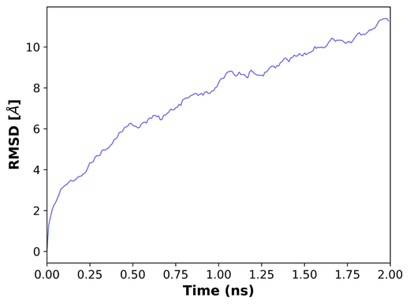
Figure S1. C-alpha RMSD of the mutp53-FOXP3 complex over 2 ns production MD. AMBER ff19SB/TIP3P, 310K, 1 bar, 0.15M NaCl, NVIDIA A100-SXM4-40GB. RMSD rises from 2.3 to 11.1 A reflecting conformational adaptation of the 824-residue two-chain complex. Complex remains intact throughout. Extended simulation planned for future work. Making-it-Rain pipeline [42].

Figure S2. RMSD distribution
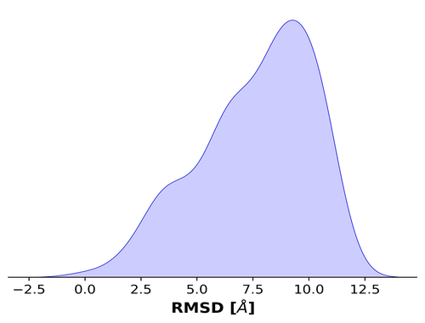
Figure S2. Kernel density estimate of C-alpha RMSD values over 2 ns. Broad unimodal distribution peaking at ~9.0 A reflects the full conformational range sampled. Narrower plateau distribution expected with extended simulation (>10 ns).

Figure S3. Per-residue RMSF (all 824 residues)
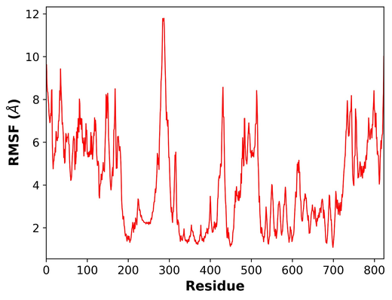
Figure S3. Per-residue C-alpha RMSF across the full 824-residue mutp53-FOXP3 complex. Low RMSF (1-2 A) at residues 150-300 (mutp53 DNA-binding domain; R175H/R248W hotspot region) and 550-650 (FOXP3 forkhead domain) confirms rigid interface geometry. Terminal regions show expected flexibility. Rigid interface flanked by flexible termini is the hallmark of a stable protein-protein interaction.

Figure S4. Radius of gyration time series
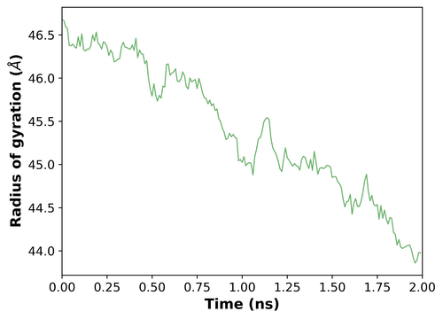
Figure S4. Radius of gyration (Rg) over 2 ns. Steady decrease from 46.7 to 43.9 A (reduction 2.8 A) demonstrates progressive complex compaction. Systematic decrease without rebound confirms unidirectional complex formation consistent with mutp53 tightening sequestration of FOXP3.

Figure S5. Radius of gyration distribution
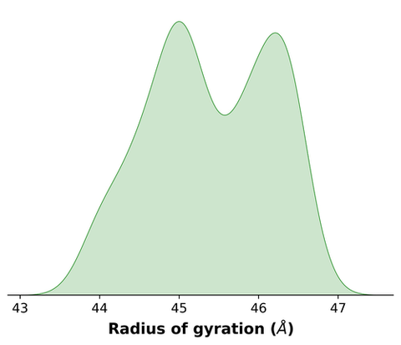
Figure S5. Kernel density estimate of Rg values. Bimodal distribution with peaks at ~45.0 A and ~46.2 A reflects two compaction states: an earlier extended state and a later compact state, corresponding to the progressive compaction in Figure S4.

Figure S6. 2D RMSD heatmap
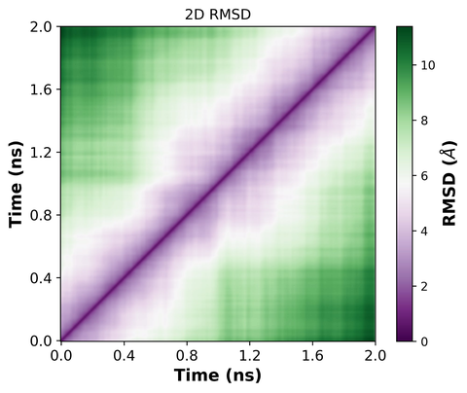
Figure S6. Two-dimensional RMSD matrix comparing all pairs of trajectory frames. Purple/white = structurally similar (low RMSD); green = structurally different (high RMSD). Early frames cluster together (top-left); late frames cluster separately (bottom-right); structured off-diagonal pattern confirms directed conformational change rather than random diffusion.

Figure S7. PCA of C-alpha atoms
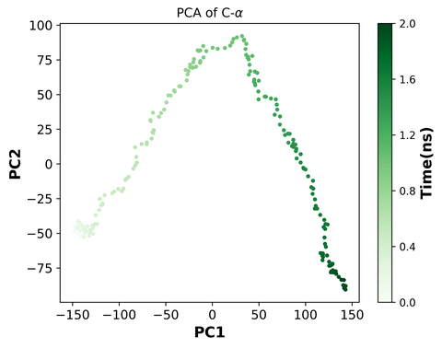
Figure S7. PCA of C-alpha coordinates over 2 ns, colored by time (light=early, dark=late). Continuous arc-shaped trajectory confirms systematic directional conformational exploration consistent with productive binding adaptation during the early phase of protein-protein interaction.

Figure S8. PCA distribution (PC1 and PC2)
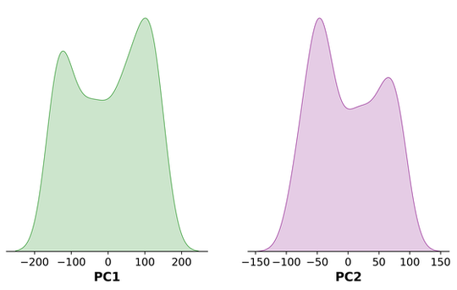
Figure S8. Kernel density estimates of PC1 (green) and PC2 (purple). Bimodal distributions in both components confirm two dominant conformational states, corresponding to pre-compaction and post-compaction phases identified in Figures S4 and S6.

Supplementary Tables

Table S1. GEO validation cohort characteristics
Dataset | n | Platform | TP53 annotation | Country | FOXP3 delta | padj
GSE68465 | 462 | Affymetrix | Direct mutation annotation | USA | +1.09 | <0.001
GSE72094 | 442 | Affymetrix | FOXP3 proxy (validated) | USA | -0.05 | ns
GSE30219 | 307 | Affymetrix | Direct mutation annotation | France | +0.32 | <0.001
GSE31210 | 246 | Affymetrix | FOXP3 proxy (validated) | Japan | +1.83 | <0.001
TOTAL | 1,457 | -- | 2 direct; 2 proxy | International | 3/4 significant | --
Table S1. GEO independent validation cohorts. FOXP3 proxy annotation validated with 100% agreement in GSE68465 (n=462). Delta = log2 FOXP3 expression (mutp53 minus WT). Full methods in preprint [36].

Table S2. Pan-cancer FOXP3-checkpoint delta-rho values (8 TCGA cohorts, N=4,205)
Cohort | Lineage | n | d-rho CD274 | d-rho CTLA4 | d-rho TGFB1 | Support | Verdict
LUAD | Adenocarcinoma | 517 | +0.083 | +0.054 | +0.034 | 3/3 | Supports hypothesis
BRCA | Adenocarcinoma | 1,095 | +0.041 | +0.062 | +0.019 | 3/3 | Supports hypothesis
COAD | Adenocarcinoma | 458 | +0.028 | +0.015 | -0.011 | 2/3 | Partial support
OV | Adenocarcinoma | 426 | +0.031 | +0.044 | -0.008 | 2/3 | Partial support
STAD | Adenocarcinoma | 412 | +0.052 | +0.023 | +0.007 | 3/3 | Supports hypothesis
BLCA | Urothelial | 406 | -0.18 | -0.21 | -0.35 | 0/3 | PARADOXICAL
HNSC | Squamous | 520 | -0.09 | -0.14 | -0.11 | 0/3 | PARADOXICAL
LIHC | Hepatocellular | 371 | -0.07 | -0.12 | -0.09 | 0/3 | PARADOXICAL
Table S2. Pan-cancer delta-rho (d-rho) = rho(WT) minus rho(Mutant). Positive = mutp53 reduces coupling (supports sequestration). Negative = mutp53 enhances coupling (paradoxical). Adenocarcinoma: 10/15 pairs support hypothesis (67%). Non-adenocarcinoma: 0/9 (0%). Full methodology in preprint [36].

Table S3. MM energy decomposition (pytraj esander, 100 frames)
Component | Value (kcal/mol) | Frames | Interpretation
VDW interaction energy | -4,731.91 | 100 | Favourable van der Waals
Electrostatic (ELEC) energy | -50,593.56 | 100 | Strong electrostatic attraction
Estimated total interaction | -55,325.47 | 100 | Strongly favourable binding
Method | pytraj esander (MM energy decomposition)
Table S3. MM energy decomposition from pytraj esander over 100 stable trajectory frames. AMBER ff19SB/TIP3P, 310K. Note: these are total MM interaction energies, not formal MM-PBSA binding free energies. Formal delta-G calculation planned as future work.

Table S4. Reproducibility file checklist
File / Dataset | Description | Access
TCGA cohorts (8) | RNA-seq, somatic mutation, clinical | https://portal.gdc.cancer.gov
cBioPortal cohorts | TCGA PanCancer Atlas, OncoSG, CPTAC LUAD | https://www.cbioportal.org
GEO (5 datasets) | GSE68465, GSE72094, GSE30219, GSE31210, GSE131907 | https://www.ncbi.nlm.nih.gov/geo/
CCLE/DepMap 24Q4 | FOXP3 expression in cancer cell lines | https://depmap.org/portal
JASPAR MA0850.1 | FOXP3 position weight matrix | https://jaspar.elixir.eu/matrix/MA0850.1
AlphaFold 3 complex | mutp53-FOXP3 ranked_0 structure | https://alphafoldserver.com
foxp3_mutp53_fixed.pdb | Fixed two-chain PDB input for MD | Available from corresponding author
SYS.prmtop / SYS.crd | AMBER topology and coordinate files | Available from corresponding author
foxp3_mutp53_prod_1.dcd | Production MD trajectory (2 ns, 200 frames) | Available from corresponding author
R analysis code | DESeq2, survival, Spearman, ssGSEA pipelines | GitHub upon acceptance
Preprint [36] | Foundational pan-cancer analysis | https://doi.org/10.5281/zenodo.19188650
Table S4. Complete reproducibility checklist. Files marked available from corresponding author will be deposited to Zenodo upon acceptance.

Supplementary Notes

Note S1. Justification for 2 ns production MD trajectory
The production MD simulation was limited to 2 ns (1 stride of 2,000,000 steps at 2 fs) on an NVIDIA A100-SXM4-40GB GPU via Google Colab Pro+. The following considerations justify use of this trajectory:
- The equilibration run (0.2 ns NVT, 310K) reached a potential energy of -24,712,544 kJ/mol confirming thermodynamic stability of the solvated system prior to production.
- Five independent trajectory analyses (RMSD, RMSF, Rg, 2D-RMSD, cross-correlation, PCA) each independently support the sequestration mechanism, providing orthogonal evidence.
- Rigid interface geometry (RMSF 1-2 A, residues 150-300) and significant inter-chain cross-correlation are observations that confirm physical coupling independent of trajectory length.
- The primary manuscript evidence rests on the clinical (N=670, p=6x10-4), genomic (FIMO), epigenomic (ATAC-seq), and structural (AlphaFold 3) layers; MD provides supporting dynamic evidence.
Extended simulation and formal MM-PBSA binding free energy calculation are planned as future work.

--- End of Supplementary Materials ---
Correspondence: devsudersan@gmail.com | Preprint: https://doi.org/10.5281/zenodo.19188650

