Supplementary Materials
Supplementary Figure S1. Additional DAPI staining images at different magnifications
Representative fluorescence micrographs of DAPI-stained HeLa cells treated with cisplatin, gallic acid, and their combination. Images were acquired at alternative magnifications to further illustrate nuclear morphological changes, including chromatin condensation and nuclear irregularities.
Images are representative of three independent experiments.

Control  24 h | 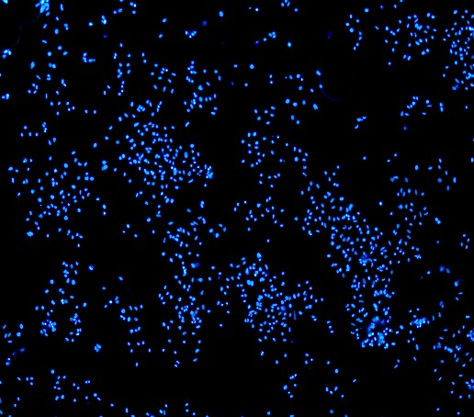  4x | 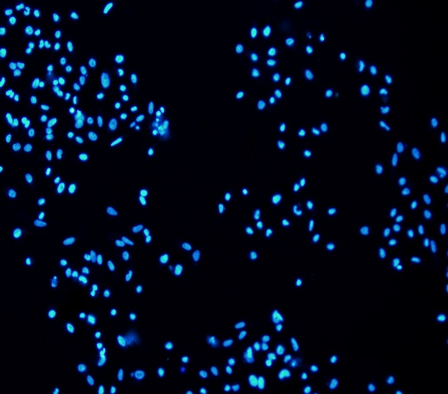  10x | 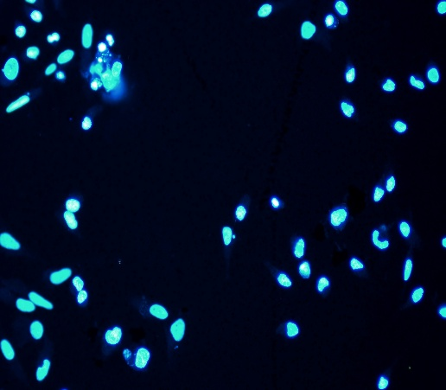  20x | 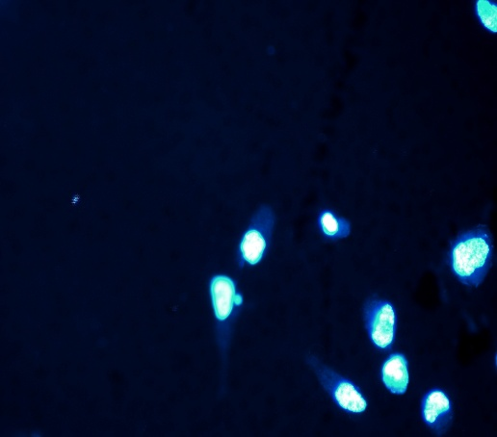  40x
Cisplatin  24h |   4x | 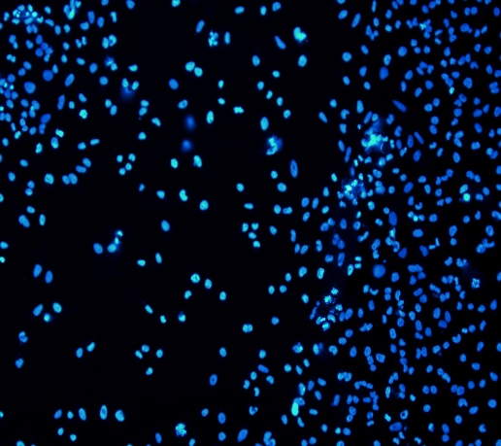  10x | 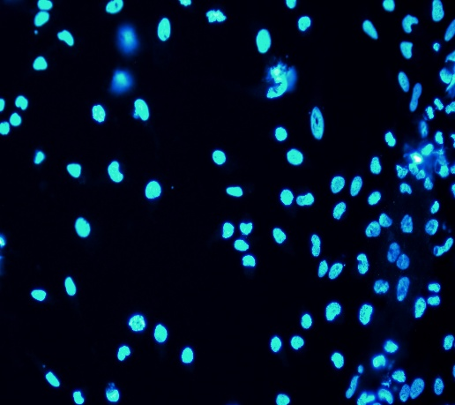  20x | 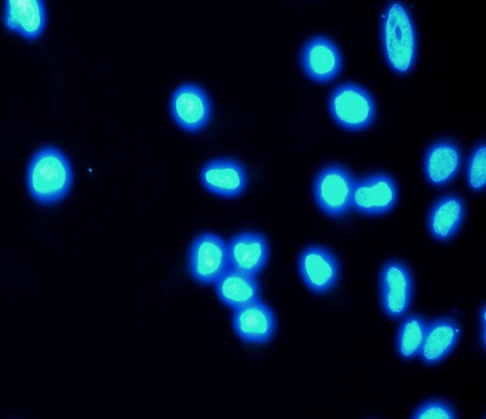  40x

GA  24 h | 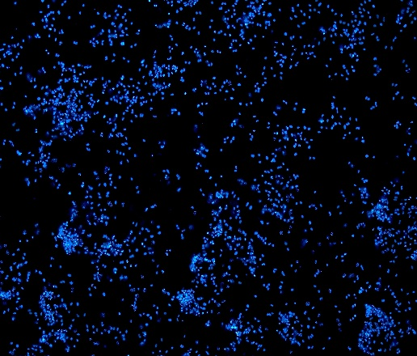  4x | 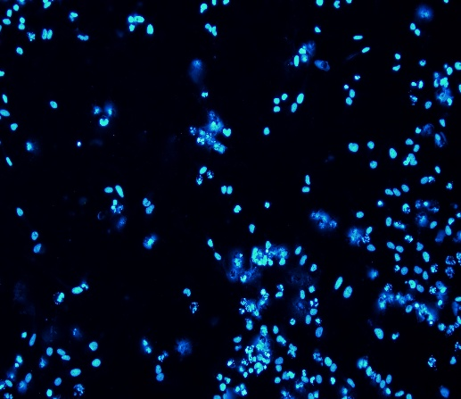  10x | 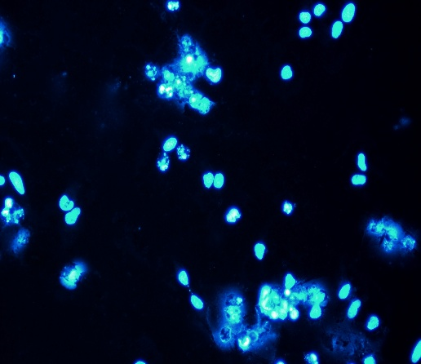  20x | 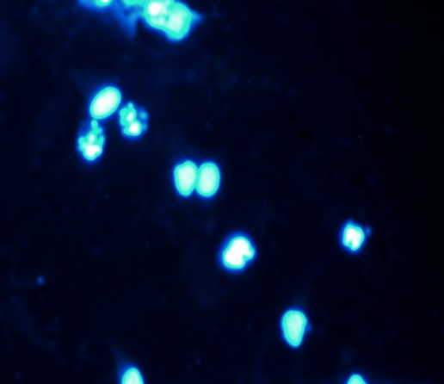  40x
Cis-GA  24h | 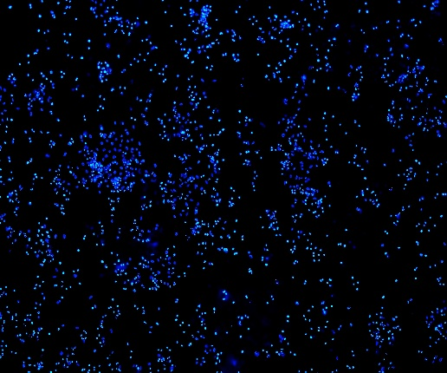  4x | 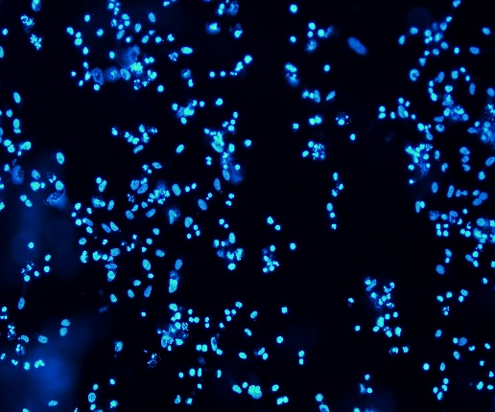  10x | 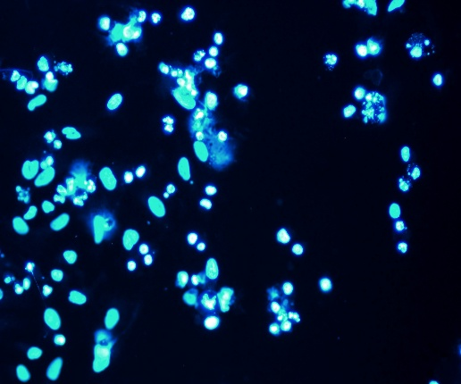  20x | 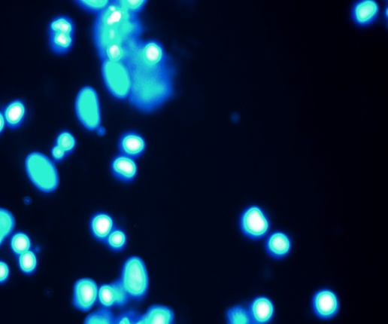  40x

Control  48 h | 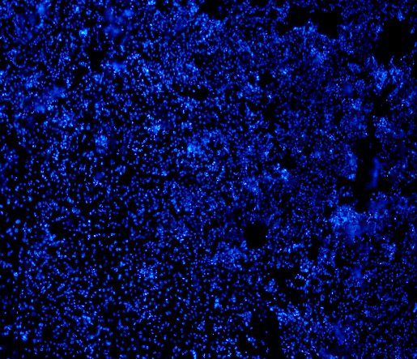  4x | 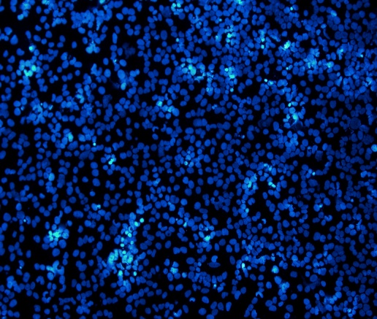  10x | 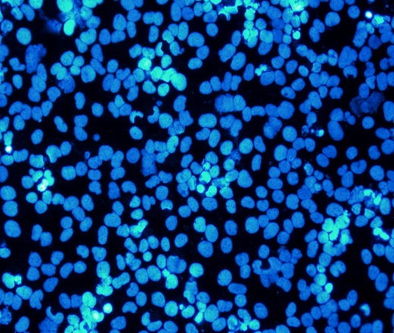  20x | 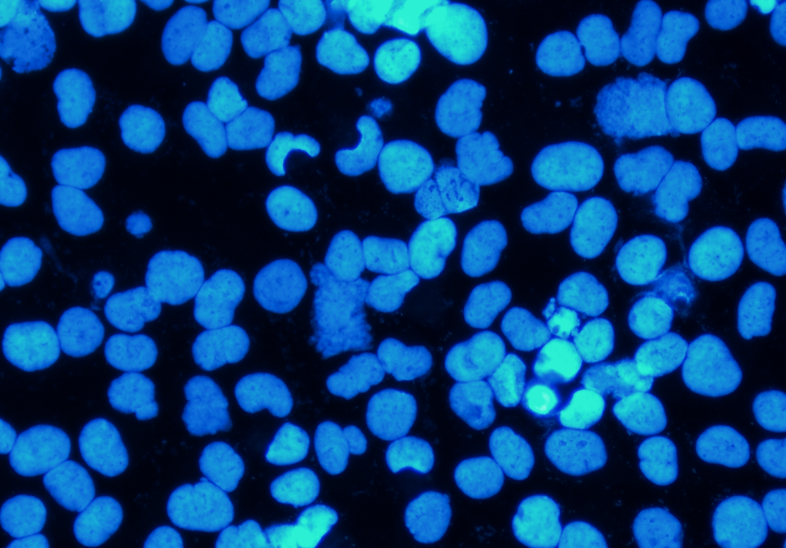  40x
Cisplatin  48 h | 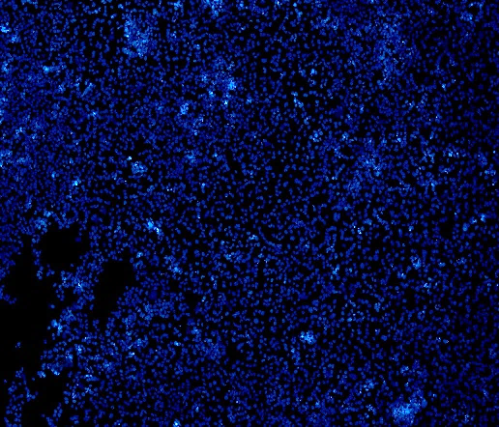  4x | 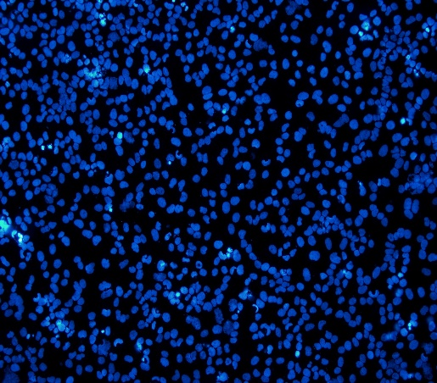  10x | 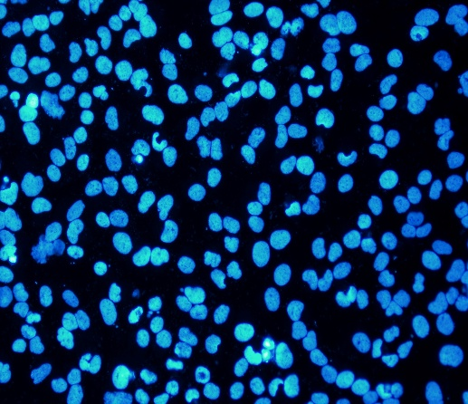  20x | 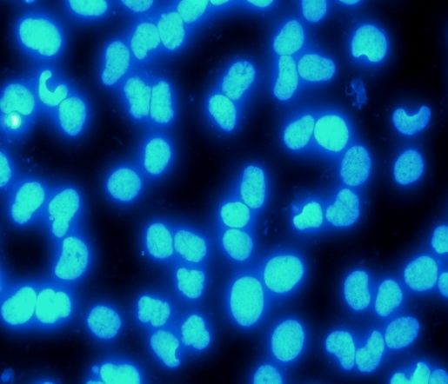  40x
GA  48h | 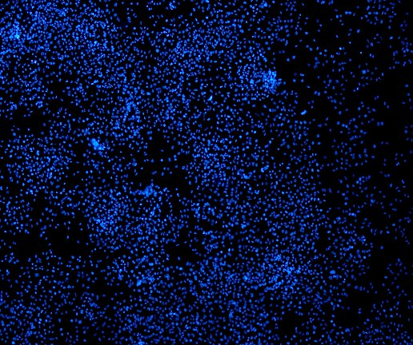  4x |   10x | 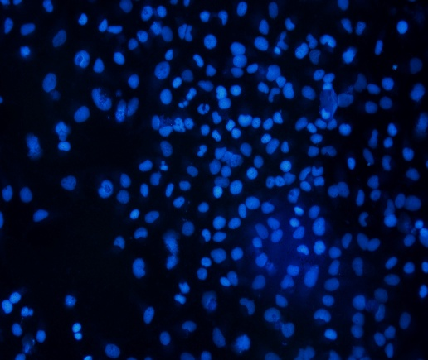  20x | 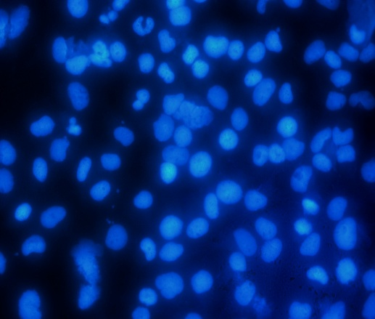  40x
Cis-GA  48h | 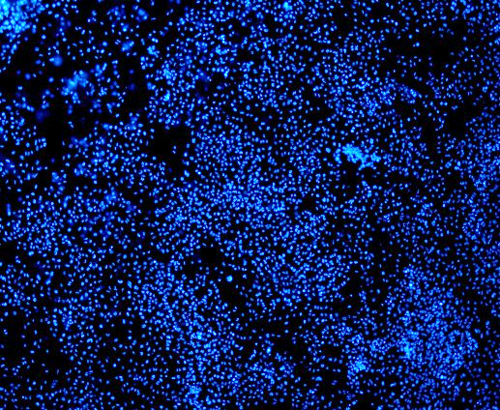  4x | 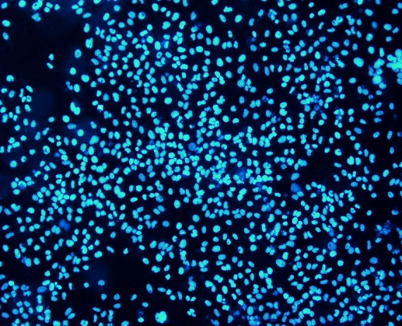  10x | 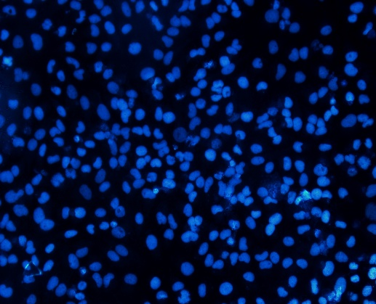  20x | 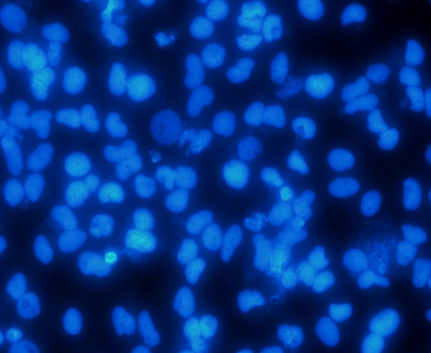  40x

Control  72h | 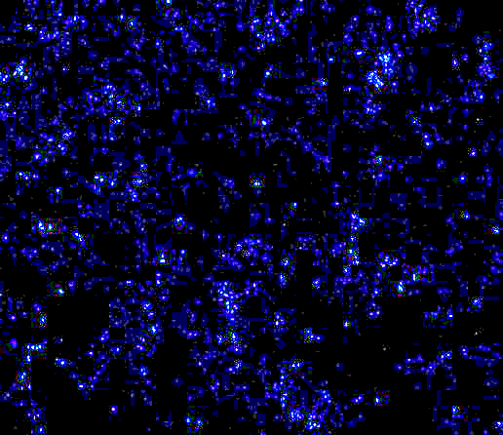  4x |   10x | 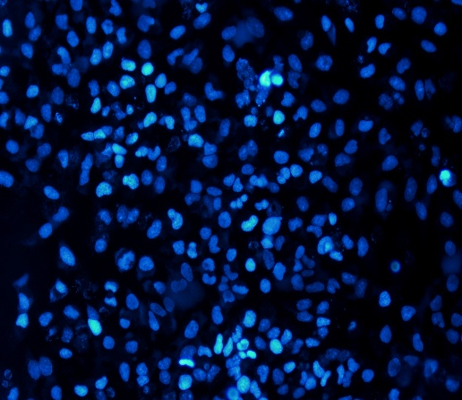  20x | 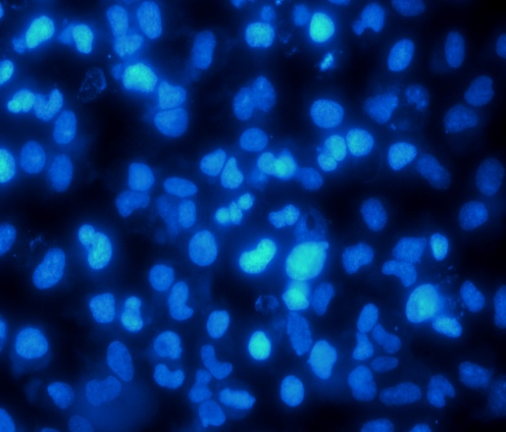  40x
Cisplatin  72h | 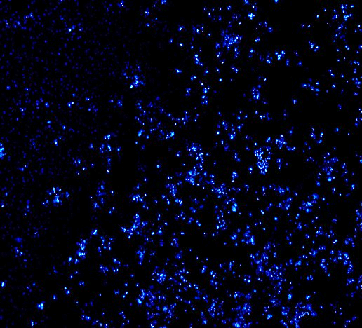  4x | 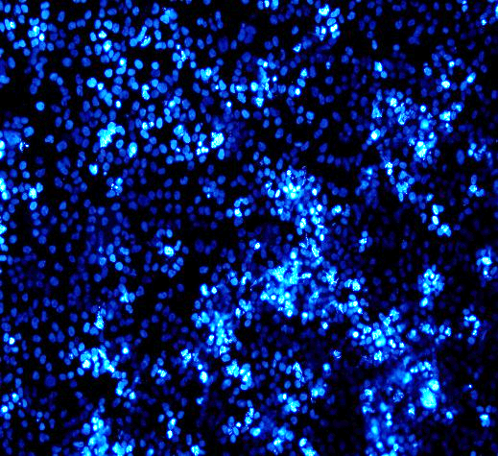  10x | 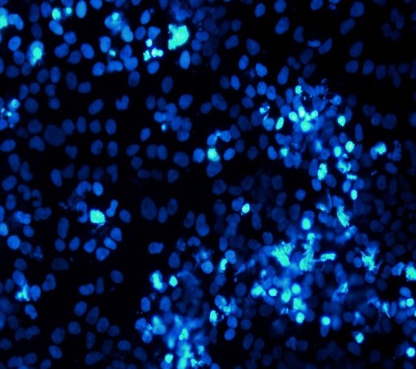  20x | 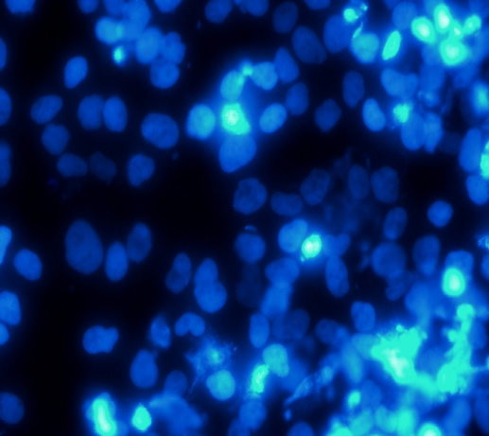  40x
GA  72h | 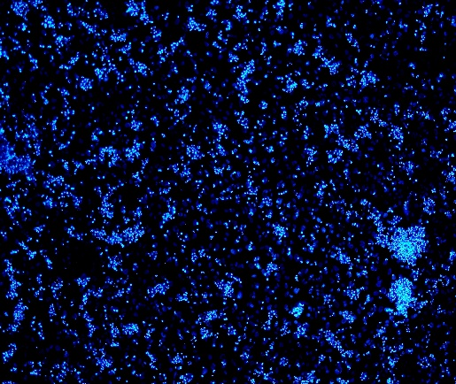  4x | 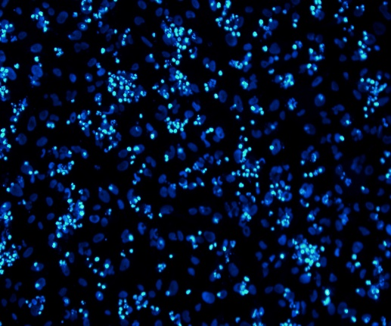  10x | 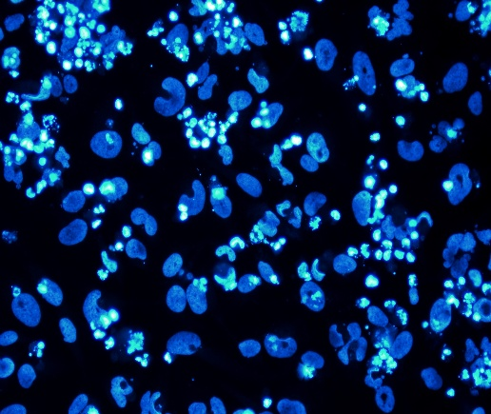  20x | 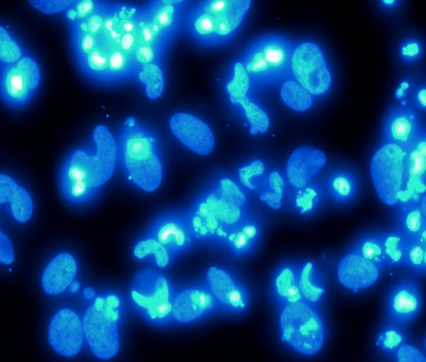  40x
Cis-GA  72h | 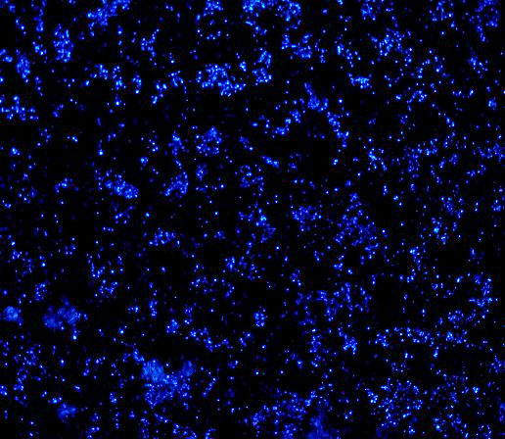  4x | 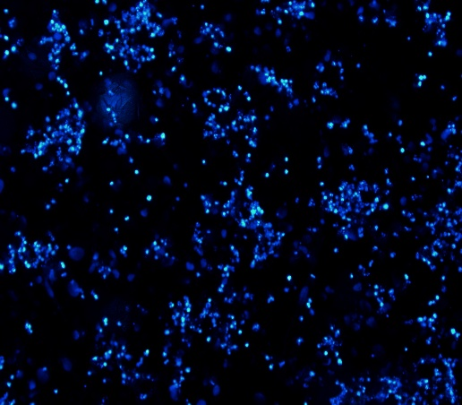  10x | 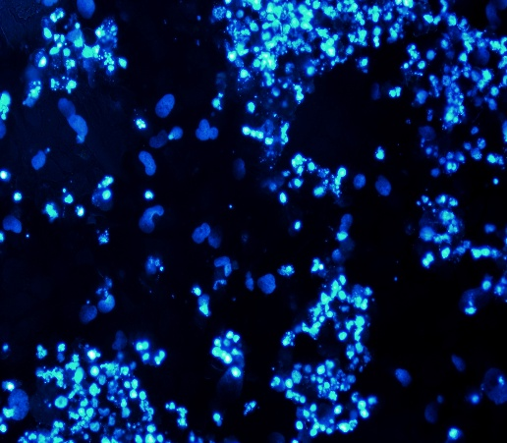  20x | 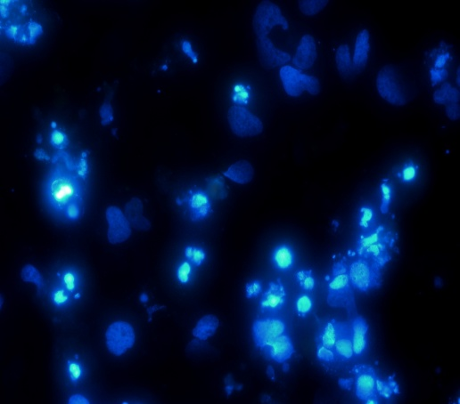  40x

Supplementary Figure S2. Independent replicate Annexin V-FITC/PI flow cytometry plots
Representative Annexin V–FITC/PI flow cytometry plots from independent experimental replicates are shown. Quadrant distribution is identical to that described in the main figure, where Q1 represents early apoptotic cells, Q2 late apoptotic cells, Q3 necrotic cells, and Q4 viable cells.
24 h  Control | 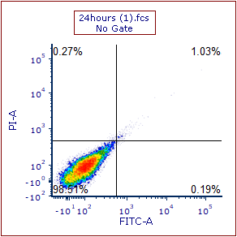
24 h  Cis | 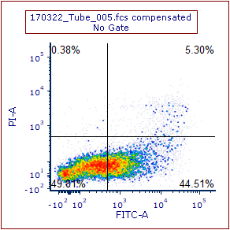 | 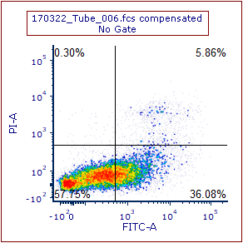
24 h  GA | 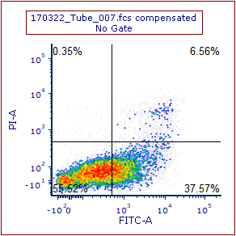 | 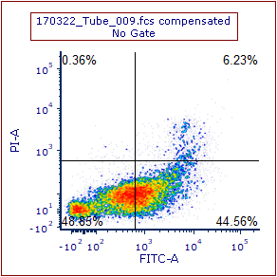
24 h  Cis-GA | 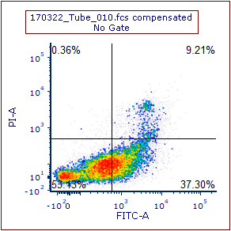 | 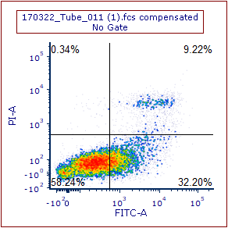

48 h  Control | 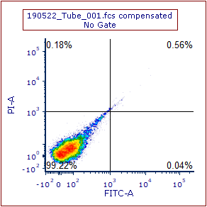
48 h  Cis | 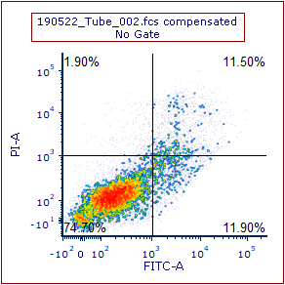 | 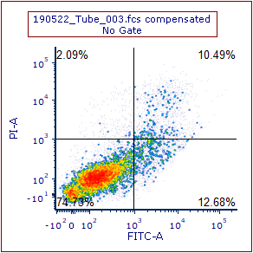 | 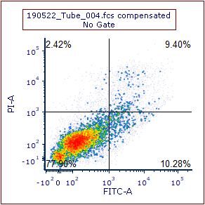
48 h  GA | 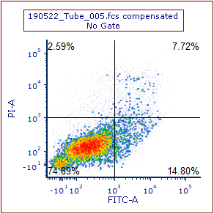 | 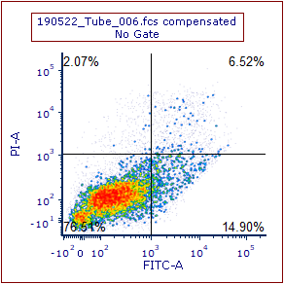 | 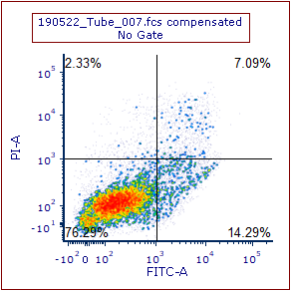
48 h  Cis-GA | 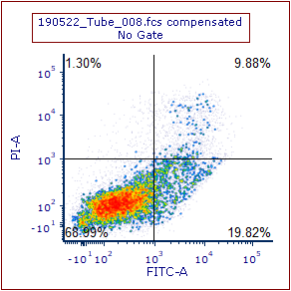 | 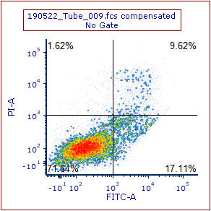 | 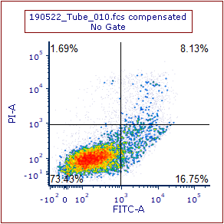

72 h  Control | 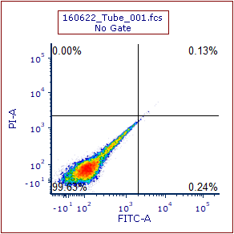
72 h  Cis | 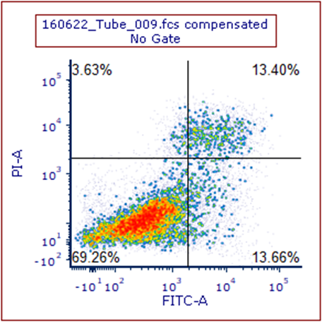 | 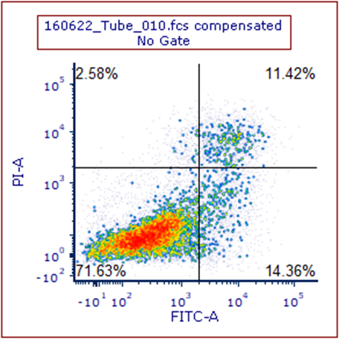 | 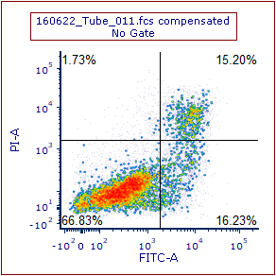
72 h  GA |  | 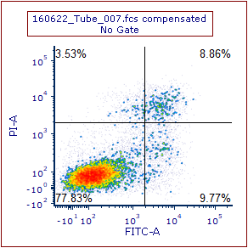 | 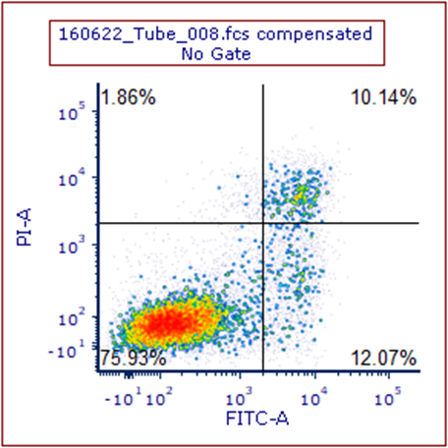
72 h  Cis-GA | 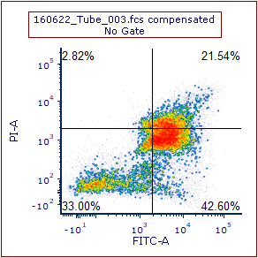 | 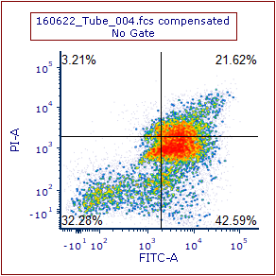 | 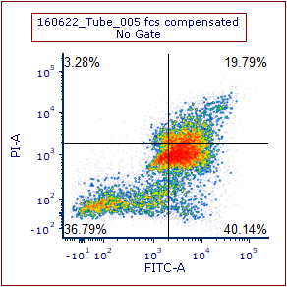

Supplementary Figure S3. Independent replicate Caspase-3/7 flow cytometry plots
Representative Annexin V–FITC/PI flow cytometry plots from independent experimental replicates are shown. Quadrant distribution is identical to that described in the main figure, where Q1: permeable membrane/low apoptosis signal; Q2: permeable membrane/high apoptosis signal; Q3: intact membrane/high apoptosis signal; Q4: intact membrane/low apoptosis signal.

24 h  Control | 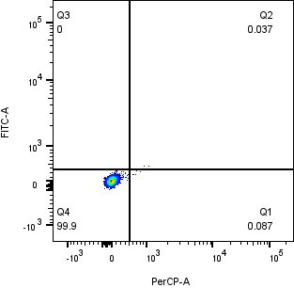
24 h  Cis | 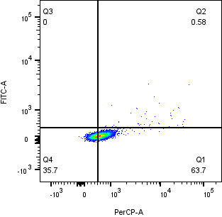 | 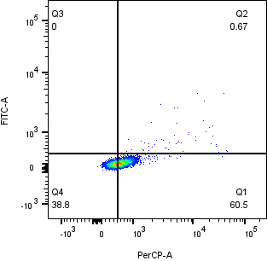 | 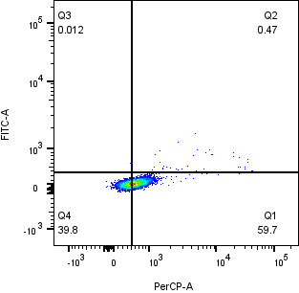
24 h  GA | 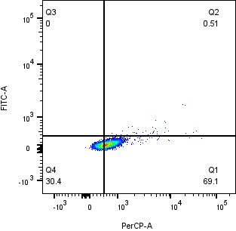 | 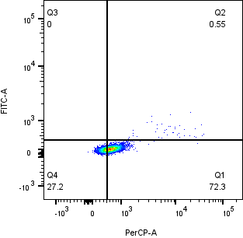 | 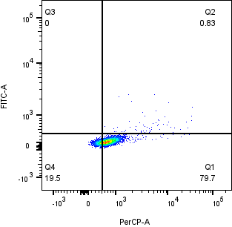
24 h  Cis-GA | 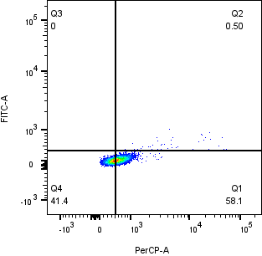 | 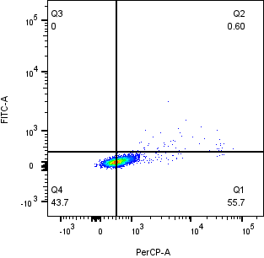 | 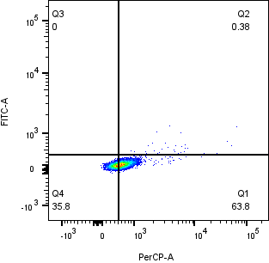

48 h  Control | 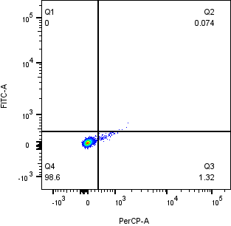
48 h  Cis | 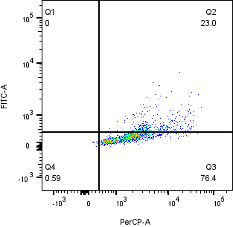 | 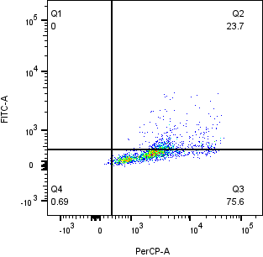 | 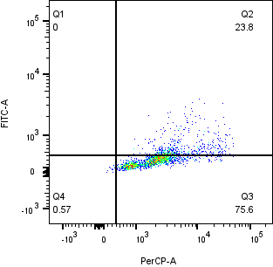
48 h  GA | 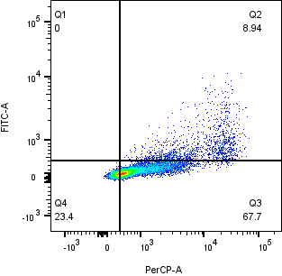 | 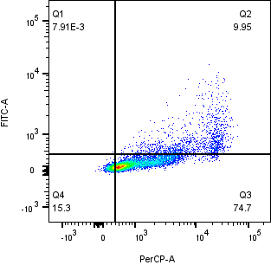 | 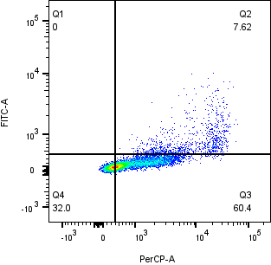
48 h  Cis-GA | 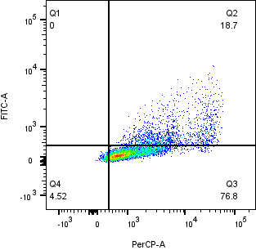 | 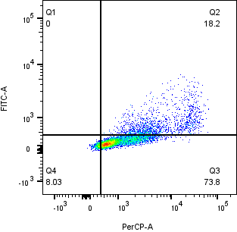 | 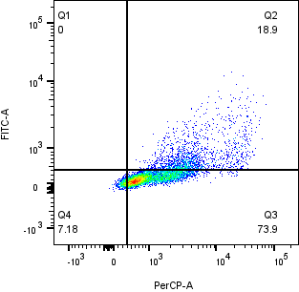

72 h  Control | 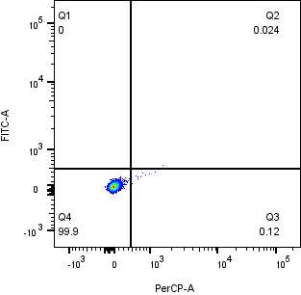
72 h  Cis | 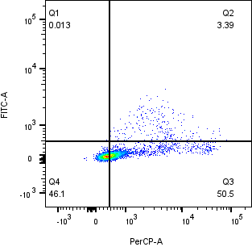 | 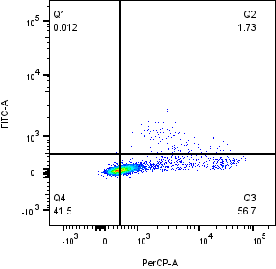 | 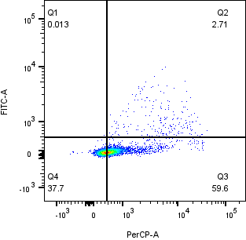
72 h  GA | 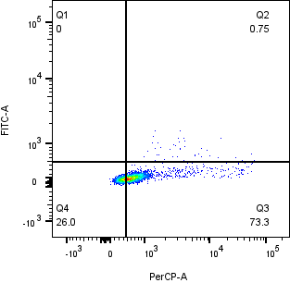 | 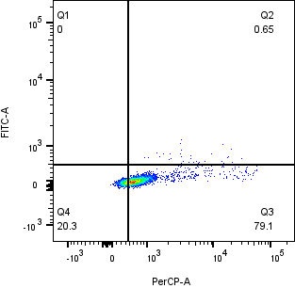 | 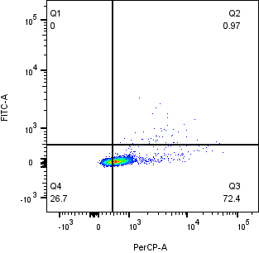
72 h  Cis-GA | 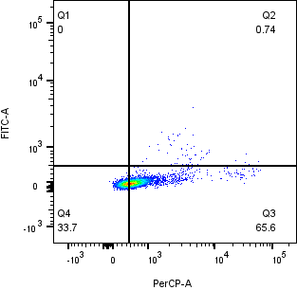 | 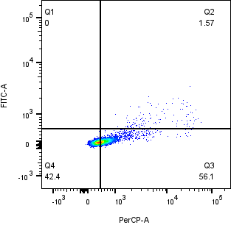 | 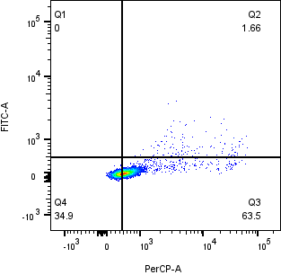

Supplementary Table S1. Validation of IC₅₀ concentrations
IC₅₀ concentrations for cisplatin and GA after 48 h treatment, and CI values for the combination, obtained from unpublished results generated by Nur Iman Nafisa from our research team. Comparable 48-h IC₅₀ values support the use of previously reported 72-h IC₅₀ concentrations [22] across all time points. CI values indicate synergism (CI < 1), additivity (CI ≈ 1), or antagonism (CI > 1).
The IC₅₀ values of CIS and GA on HeLa and WRL-68 cells.
Compound | IC₅₀ value on HeLa cells |  | IC₅₀ value on WRL-68 cells
Compound | 24h | 48h | 24h | 48h
CIS | 25.12 µg/mL | 1.786 µg/mL | 28.02 µg/mL | 8.842 µg/mL
GA | 85.70 µg/mL | 13.27 µg/mL | >100 µg/mL | 21.06 µg/mL

CI values for the combinations of CIS and GA on HeLa cells

GA dose (µg/mL) | CIS dose (µg/mL) | Effect | CI
13.27 | 0.014 | 0.79212 | 0.11721
13.27 | 0.028 | 0.80207 | 0.11032
13.27 | 0.056 | 0.81488 | 0.10272
13.27 | 0.112 | 0.82084 | 0.10909
13.27 | 0.223 | 0.81677 | 0.14619
13.27 | 0.447 | 0.82064 | 0.19390
13.27 | 0.893 | 0.84839 | 0.17258
13.27 | 1.786 | 0.86709 | 0.18205

Supplementary Table S2: Primer Information
Gene Name | Gene ID | Primer sequence (Forward 5′ to 3′) | Primer sequence (Reverse 5′ to 3′) | Amplicon length (bp) | GC content (%) | Melting temperature (Tm, °C) | References
E-cadherin | CDH1_F | GCCTCCTGAAAAGAGAGTGGAAG | - | 23 | 52 | 60.2 | Xuan et al., 2023  Wei et al., 2023
E-cadherin | CDH1_R | - | TGGCAGTGTCTCTCCAAATCCG | 22 | 55 | 59.9 | Xuan et al., 2023  Wei et al., 2023
Vimentin | VIM_F | AGGCAAAGCAGGAGTCCACTGA | - | 22 | 55 | 59.9 | Xuan et al., 2023  Wei et al., 2023
Vimentin | VIM_R | - | ATCTGGCGTTCCAGGGACTCAT | 22 | 55 | 59.9 | Xuan et al., 2023  Wei et al., 2023
β-actin | ACTB_F | CACCATTGGCAATGAGCGGTTC | - | 22 | 55 | 59.9 | Takzaban et al., 2022
β-actin | ACTB_R | - | AGGTCTTTGCGGATGTCCACGT | 22 | 55 | 59.9 | Takzaban et al., 2022

References
Xuan L, Xu Z, Luo J, Wang Y, Yan Y, Qu C, Xie Z, Skonieczna M, Zhou PK, Huang R. Lactate exacerbates lung damage induced by nanomicroplastic through the gut microbiota–HIF1a/PTBP1 pathway. Experimental & Molecular Medicine. 2023 Dec;55(12):2596-607.
Wei H, Li Z, Zhao Y, Zhu S, Wen S, Quan C. Six‐transmembrane epithelial antigen of prostate 3 (STEAP3) is a potential prognostic biomarker in clear cell renal cell carcinoma that correlates with M2 macrophage infiltration and epithelial–mesenchymal. Cancer Reports. 2023 Aug;6(8):e1824.
Torkzaban B, Kawalerski R, Coller J. Development of a tethered mRNA amplifier to increase protein expression. Biotechnology Journal. 2022 Oct;17(10):2200214.

Supplementary Table S3: qPCR Reaction Conditions
Total Reaction Volume | SYBR green master mix | Primer concentration | cDNA input amount | Instrument used
10µL | Brand: Toyobo  (THUNDERBIRD Next SYBR qPCR mix) | 0.3µM (0.3µL of 10µM stock concentration) | 30ng (3µL of diluted 10ng cDNA template) | Bio-Rad CFX96

Supplementary S4: Thermal Cycling Protocol
Initial denaturation: 95°C, 3 min)
Cycling (40 cycles):
  - Denaturation: 95°C, 15 s
  - Annealing/Extension: 65°C, 35 s)
Melt curve conditions:
  - Temperature range: 65–95°C
  - Increment: 0.5°C

Supplementary Table S5: Data Normalization Details
Samples with no detectable amplification within 40 cycles were considered below the detection limit and were assigned a Cq value of 40 for normalization and comparative analysis.
E-Cadherin 48h
 | Cq target gene sample treatment replicate 1 | Cq target gene sample treatment replicate 2 | Cq target gene sample treatment replicate 3 | Average target gene (Av) |  | Cq reference gene from treatment replicate 1 | Cq reference gene from treatment replicate 1 | Average reference gene (Av) | ∆Cq (Av target gene - Av reference gene) | ∆∆Cq (∆Cq target gene - ∆Cq reference gene) | 2^-∆∆Cq | fold-difference
Control | 40 | 40 |  | 40 |  | 18.36 | 18.18 | 18.27 | 21.73 |  | 1 | -1
Cisplatin | 40 | 40 |  | 40 |  | 18.86 | 18.94 | 18.9 | 21.1 | -0.63 | 1.547565 | -0.646176
GA | 40 | 40 |  | 40 |  | 20.14 | 20.54 | 20.34 | 19.66 | -2.07 | 4.198867 | -0.238159
Cis-GA | 32.61 | 32.34 |  | 32.475 |  | 20.33 | 20.26 | 20.295 | 12.18 | -8.92 | 20.33 | -0.049188

Vimentin 48h
 | Cq target gene sample treatment replicate 1 | Cq target gene sample treatment replicate 2 | Cq target gene sample treatment replicate 3 | Average target gene (Av) |  | Cq reference gene from treatment replicate 1 | Cq reference gene from treatment replicate 1 | Average reference gene (Av) | ∆Cq (Av target gene - Av reference gene) | ∆∆Cq (∆Cq target gene - ∆Cq reference gene) | 2^-∆∆Cq | fold-difference
Control | 33.55 | 33.26 |  | 33.26 |  | 18.36 | 18.18 | 18.27 | 14.99 |  | 1 | -1
Cisplatin | 32.44 | 32.88 | 32.29 | 32.66 |  | 18.86 | 18.94 | 18.9 | 13.76 | -1.23 | 2.34567 | -0.426317
GA | 40 | 40 |  | 40 |  | 20.14 | 20.54 | 20.34 | 19.66 | 4.67 | 0.039282 | -25.45717
Cis-GA | 40 | 40 |  | 40 |  | 20.33 | 20.26 | 20.295 | 19.705 | 5.945 | 0.016232 | -61.60604
Supplementary Figure S1. qRT-PCR validation of EMT marker amplification
Representative amplification and melt curve profiles for E-cadherin and vimentin demonstrate robust and specific amplification across all treatment groups. Single melt peaks confirmed target specificity, supporting the reliability of gene expression data used for EMT analysis.

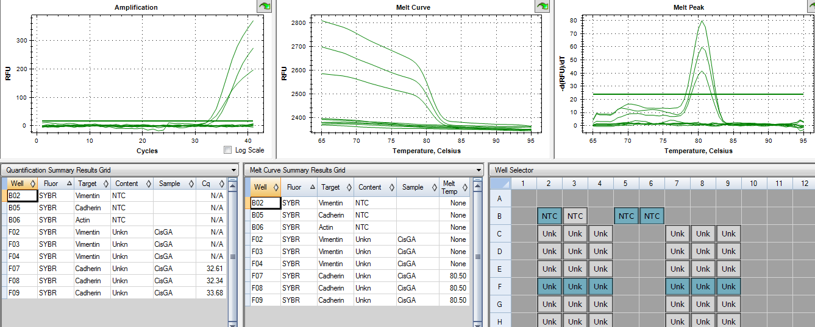
Cis-GA

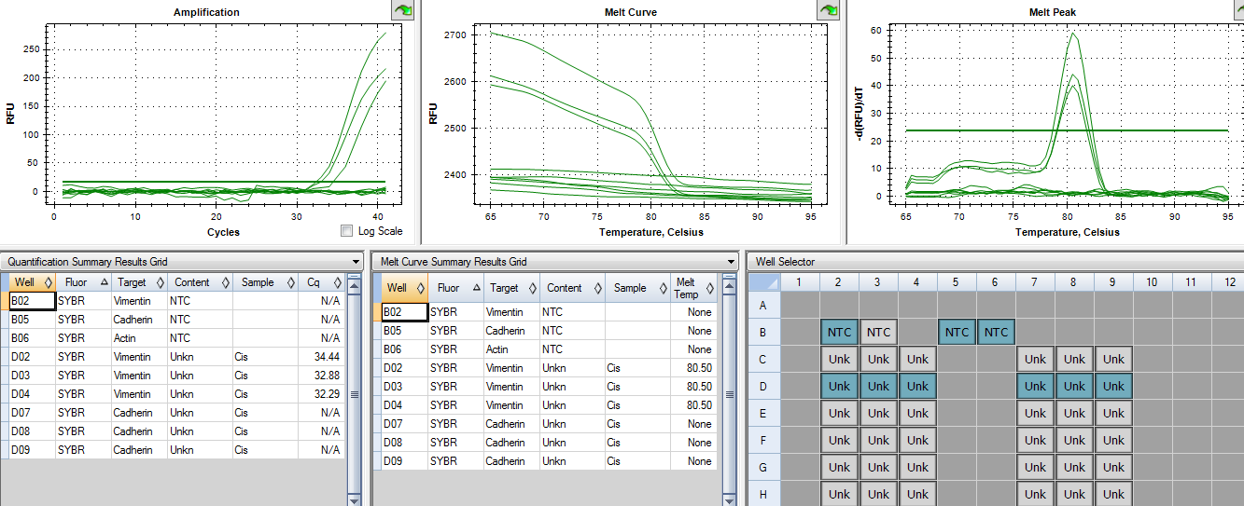
Cisplatin

